Agenda
Object-Oriented Programming
- Objects
- Classes
- Inheritance
- Polymorphism
- Object-Oriented Languages
- Components
Classes
- Classes as Structured Data
- Methods
- Constructors and Initialization
- Static Fields and Methods
- Constant and ReadOnly
More about Types
- Overview of Types in C#
- Value Types
- Boxing and Unboxing
- Reference Types
- Implicitly Typed Variables

Object-Oriented Programming
Object-Oriented Programming is a programming approach that organizes software around objects, rather than focusing only on functions & procedures.
What is an Object?
An object represents an entity that contains both data & behavior. OOP helps developers design applications that are modular, reusable, maintainable, scalable, & easier to understand.
Composition of Object
- Unique Identity
- Characteristics
- Behaviors & Responsibilities
Why is OOP important in C#?
- Code Reusability
- Modularity
- Maintainability
- Security
- Scalability
- Flexibility
Classes
A class is a blueprint or template used to create objects. It defines the data & behavior that objects of that class will possess.
Composition of Class
- Fields
- Properties
- Methods
- Constructors (Initializers)
- Events
- Indexers
- Nested Types
Objects
An object is an instance of a class.
When an object is created, it has its own state & can perform the behaviors defined by its class.
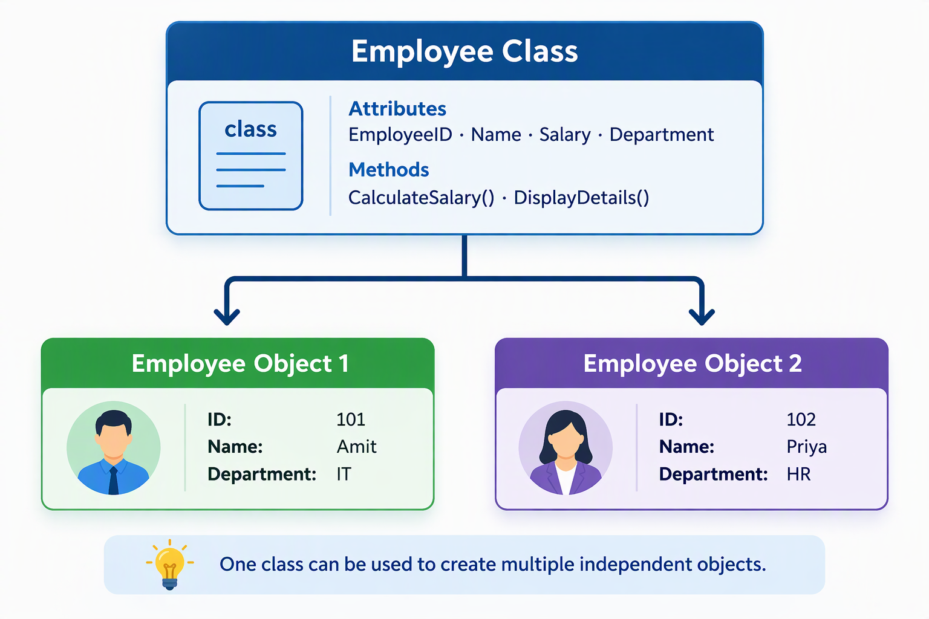
Class vs. Object
Class | Object
Blueprint or template | Instance of a class
Defines structure and behavior | Holds actual instance data
Does not require instance creation to define it | Created from a class
Can be used to create many objects | Represents one particular instance

Major Pillars of Object Oriented Programming
- Abstraction – Process of identifying the essential functionality
Implemented in C# using
  - Abstract classes/methods/properties
  - Interfaces
- Encapsulation – Process of combining data & methods that operate on that data into a single unit, usually a class, while controlling access to its internal members.
Access Modifiers used in C# for Encapsulation
  - public – accessible wherever the containing type is accessible.
  - private – accessible only within the containing type.
  - protected – accessible within the containing type & derived classes.
  - internal – accessible within the same assembly.
  - protected internal – accessible within the same assembly or derived classes in other assemblies.
  - private protected – accessible within the containing class or derived class in the same assembly.
- Inheritance – Ability of an object to derive its state & behaviors from another object via relationship (is-a, has-a).
Types of Inheritance
  - Single Inheritance
  - Multilevel Inheritance
  - Hierarchical Inheritance
  - Multiple Inheritance (Not supported in .NET)
- Polymorphism – It allows different objects or methods to be accessed through a common interface while exhibiting different behaviors.
Constructors & Destructors
A constructor (initializer) is special member method used to initialize a new instance of a class or structure.
A destructor (finalizer) is also a special member method used to clean up the members of the object.
Association
Represents a general relationship between two objects.
Aggregation
Represents a whole-part relationship where the parts can exist independently of the whole.
Composition
Represents a stronger whole-part relationship in which the containing object controls the lifecycle of its component objects.
Object-Oriented Languages
Any programming language strongly following the major pillars of OOP.
Components
Reusable modules.
Classes
- Classes as Structured Data
- Methods
- Constructors and Initialization
- Static Fields and Methods
- Constant and ReadOnly
Constant represents a value that is fixed at compile time.
Read-Only variables are the ones whose value is set once in constructor and then is restricted afterwards.
More about Types
- Overview of Types in C#
- Value Types
- Boxing and Unboxing
- Reference Types
- Implicitly Typed Variables

