Agenda
More about Types
- Overview of Types in C#
- Value Types
- Boxing and Unboxing
- Reference Types
- Implicitly Typed Variables
Methods, Properties and Operators
- Methods
- Parameter Passing
- Variable-Length Parameter Lists
- Properties
- Auto-Implemented Properties
More about Types
In C#, types are fundamental building blocks of programming. Every variable, object, and expression has a type that determines what kind of data it can hold, how the data is stored, and which operations can be performed on it.
C# is a strongly typed, statically typed programming language, meaning the compiler checks type compatibility to help prevent errors.
What is a Type?
A type defines the characteristics of the data in a C# application. It determines:
- Data Representation
- Memory requirements
- Valid operations
- Behavior
- Type Safety
Common Type System (CTS)
CTS defines how types are declared, used, & managed across .NET languages.
Its primary objectives are:
- Provides a consistent type system across .NET languages.
- Enable interoperability between languages.
- Support type safety.
- Define rules for inheritance, accessibility & type behavior.
- Provide a common foundation for memory management.
All C# types ultimately relate to .NET System.Object type.
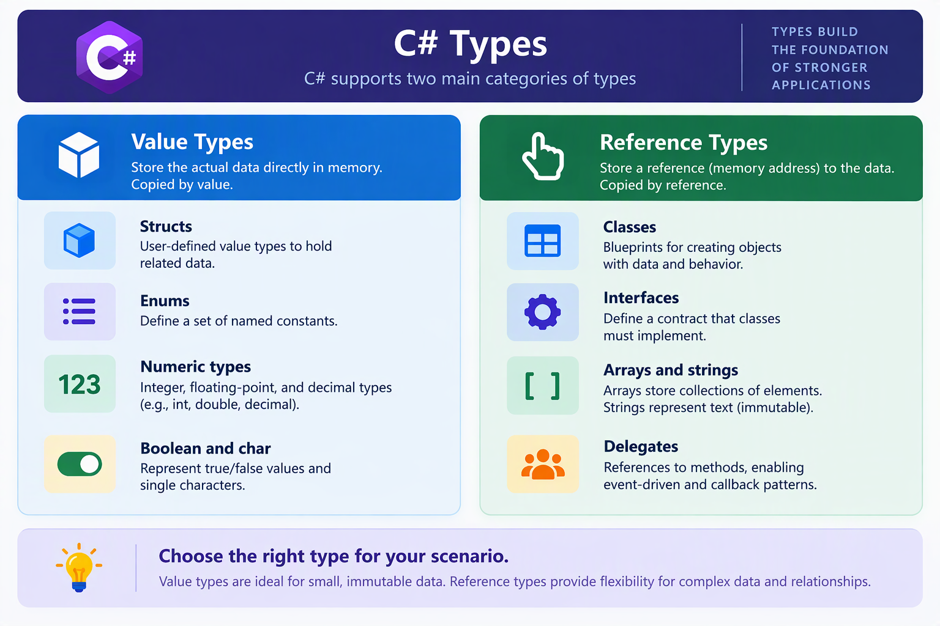
- Boxing and Unboxing
Boxing & Unboxing are mechanisms used to convert between value types & compatible reference types.
During Boxing:
- The runtime allocates an object on the managed heap.
- The value-type data is copied into that object.
- A reference to the boxed object is recorded on the stack memory.

e.g.
int a = 10;
object obj = a; //Boxing
Unboxing is the process of extracting a value type from a compatible boxed object(reference type).
e.g.
int j = Convert.ToInt32(obj); //Unboxing
obj=null;
During unboxing:
  - The runtime verifies that the boxed object contains the expected value type.
  - An explicit unboxing conversion obtains access to the contained value.
  - The value can then be copied into a value type variable.
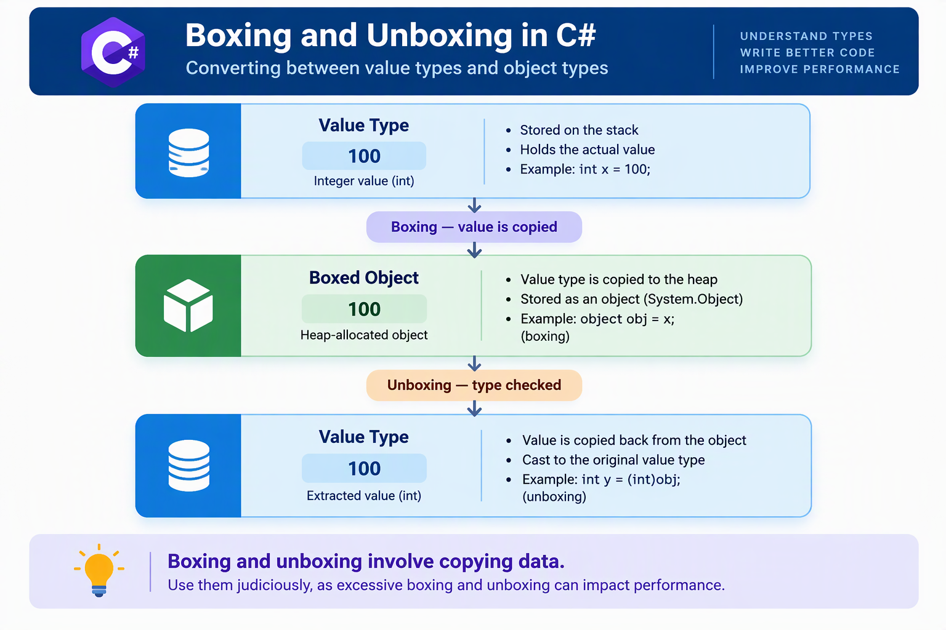

Boxing vs. Unboxing
Feature | Boxing | Unboxing
Direction | Value type to reference type | Boxed object to value type
Conversion | Generally implicit | Explicit
Allocation | Creates a boxed object | Does not create a new boxed object
Type checking | Uses a compatible target type | Requires runtime compatibility check
Performance | Allocation and copying overhead | Type checking and value extraction overhead
Error possibility | Usually compile-time compatibility checks | Invalid cast can fail at runtime

- Reference Types
Person p1=new Person(); //p1 0x110000101011
Person p2=p1;// p2 0x110000101011
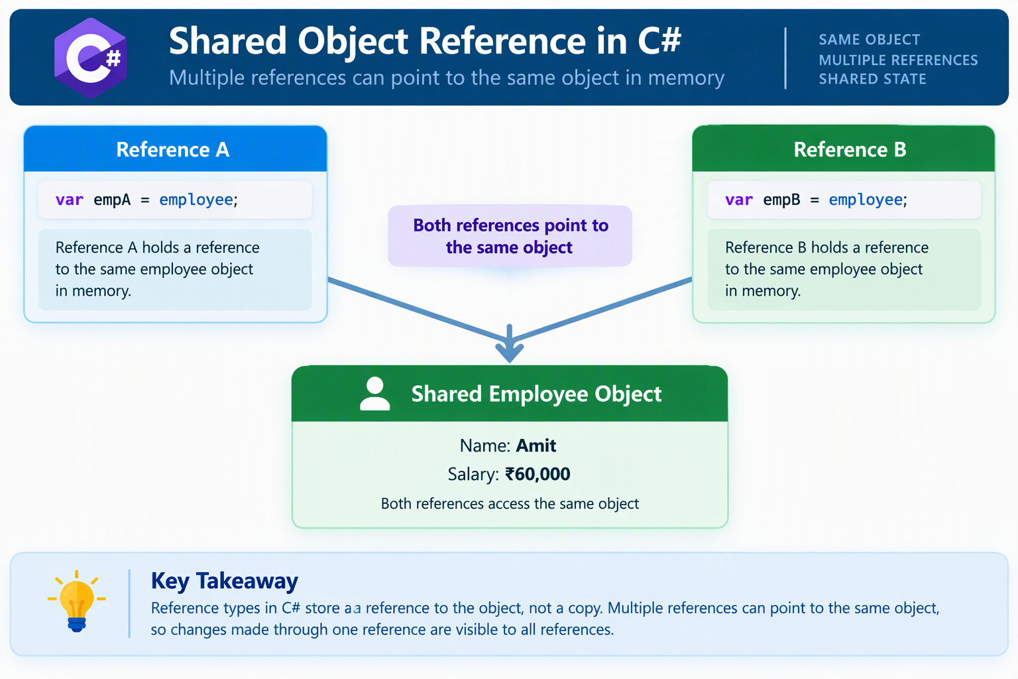

- Implicitly Typed Variables
Implicitly typed variables allow the C# compiler to determine the variable’s type automatically from its initialization expression.
e.g.
var a= 10;
var b=new Person();
var c = FunctionCall();
var d;Incorrect
d=20;
var e=null;incorrect
Explicit Typing vs. Implicit Typing
Feature | Explicit typing | Implicit typing
Type declaration | Written by programmer | Inferred by compiler
Compile-time checking | Yes | Yes
Type can change later | No | No
Readability | Type immediately visible | Depends on initialization
Code length | May be longer | Often shorter
Best suited for | Clear type declarations | Obvious or complex inferred types

Rules for Using var:
- Initialization is required
- Type is determined at compile time
- Cannot initialize with plain null;
- Primarily used for local variables
- Does not mean type is Object
Advantages of implicit typing
- Reduces repetitive type declarations
- Improves readability when the type is obvious
- Simplifies working with complex generic types
- Supports anonymous types
e.g.
var x= {name=”Saket”, city=”Pune”};
- Commonly used with LINQ queries
- Maintains compile-time type safety

Difference Between var, object, and dynamic
These three concepts are often confused.
Feature | var | object | dynamic
Meaning | Type inference keyword | Base .NET type | Defers many binding operations to runtime
Type checking | Compile time | Compile time | Runtime for dynamic operations
Can hold different types through assignment | No incompatible assignments | Yes | Yes
Member access | Based on inferred type | Based on object type unless cast | Resolved dynamically
Boxing possible | Depends on inferred type and usage | Yes, for value types | Yes, depending on value
Primary purpose | Reduce explicit type declarations | General object representation | Dynamic programming scenarios

Methods, Properties and Operators
- Methods
Methods and properties are fundamental concepts in C# programming. They help developers organize application logic, manage data, control access to information, and build reusable, maintainable applications.
These concepts are especially important in Object-Oriented Programming (OOP) because they define how objects behave and how their data is accessed or modified.
A method is a named block of instructions that performs a specific task or operation within a program. Methods are used to organize application functionality into smaller, reusable units.
In C#, methods are generally defined inside classes, structures, or records.

Main Components of a Method
A method generally consists of the following components:
Component | Description
Access Modifier | Controls where the method can be accessed
Return Type | Specifies the type of value returned
Method Name | Identifies the method
Parameters | Accept input values
Method Body | Contains the instructions to execute
Return Statement | Sends a result back to the caller, when required

Types of Methods in C#
- Instance Methods
Instance methods belong to an object of a class.
    - Require an object to be created before they can be called.
    - Can access instance fields and properties.
    - Can also access static members.
    - Are commonly used for object-specific operations.
- Static Methods
Static methods belong to the class or type itself rather than a particular object.
- Can be called without creating an object.
- Are declared using the static keyword.
- Cannot directly access instance members without an object reference.
- Are useful for common utility operations.
- Void Methods
Void methods perform an operation without returning a value.
- Use the void return type.
- May accept input parameters.
- Are commonly used for displaying information, updating data, or triggering operations.
- Value-Returning Methods
These methods perform operations and return results to the calling code.
- Have a declared return type.
- Usually use a return statement to provide the result.
- Can return primitive values, objects, collections, or other supported types.
- Asynchronous Methods
Asynchronous methods support operations that may take time to complete without unnecessarily blocking the calling thread.
- Commonly use the async and await keywords.
- Frequently return Task, Task<T>, or ValueTask-based results.
- Are useful for API requests, database access, and file operations.
Method Overloading
Method overloading allows multiple methods to have the same name but different parameter signatures.
Methods can be overloaded by changing:
- The number of parameters.
- The types of parameters.
- The order of parameter types.
- Certain parameter-passing modifiers.
Advantages of Methods
- Code reusability: The same functionality can be called repeatedly.
- Modularity: Large applications can be divided into smaller components.
- Maintainability: Changes can be made to individual methods.
- Readability: Well-named methods make application logic easier to understand.
- Testing: Individual methods can be tested independently.
Parameter Passing
Parameter passing is the process of providing values or references to a method when it is called.
Parameters allow methods to receive information from other parts of an application.
Two important terms are:
- Parameter: A variable declared in the method definition.
- Argument: The actual value or variable supplied when calling the method.
C# supports several parameter-passing mechanisms.
Types of Parameter Passing
A. Pass by Value
Pass by value is the default parameter-passing mechanism in C#.
When an argument is passed by value, the method receives a copy of the argument's value.
For value types, this means the method works with an independent copy of the original value.
Characteristics:
- The method receives its own parameter variable.
- Reassigning the parameter does not change the caller's variable.
- This is the default behavior when no parameter-passing modifier is specified.
For reference types, the reference itself is copied. Consequently, the method can modify the state of the referenced object, even though reassigning the parameter does not change the caller's reference.
B. Pass by Reference — ref
The ref keyword allows a method to work directly with the caller's variable.
Instead of receiving an independent copy, the method accesses the original variable through a reference.
Characteristics:
- The argument must be initialized before being passed.
- The method can read and modify the original variable.
- Changes to the parameter are reflected in the caller's variable.
- The ref keyword is normally required at both the method declaration and the call site.
C. Output Parameters — out
The out keyword is used when a method needs to assign a value to a caller's variable.
It is particularly useful when a method must produce more than one result.
Characteristics:
- The argument does not need to be initialized before the method call.
- The method must assign a value before returning normally.
- The assigned value becomes available to the caller.
- It is commonly used in methods that attempt conversions or retrieve multiple results.
D. Read-Only Reference Parameters — in
The in keyword passes an argument by reference while preventing the method from assigning a new value to that parameter.
Characteristics:
- The argument must be initialized before the call.
- The method cannot reassign the parameter.
- It can reduce copying costs for large value types.
- It is useful when a method only needs to inspect a value.

Comparison of Parameter-Passing Mechanisms
Feature | Value | ref | out | in
Passing mechanism | Copy of value | By reference | By reference | By reference
Initialization required before call | Yes | Yes | No | Yes
Method can assign to parameter | Yes | Yes | Yes, required | No
Assignment changes caller's variable | No | Yes | Yes | Not permitted
Primary purpose | Input | Read and update | Produce output | Read-only access

Optional Parameters
An optional parameter has a default value defined in the method declaration.
Optional parameters are useful for providing configurable behavior without requiring every caller to specify every setting.
Named Arguments
Named arguments allow developers to supply arguments using their corresponding parameter names.
They improve readability, particularly when methods contain multiple parameters of similar types.
They can also make calls easier to understand when optional parameters are involved.
Variable-Length Parameter Lists
A variable-length parameter list allows a method to accept a varying number of arguments.
Normally, a method has a fixed number of declared parameters. However, some operations require flexibility because the number of input values may not be known in advance.
C# supports variable-length parameter lists primarily through the params keyword.
Characteristics of Variable-Length Parameter Lists
- A method can accept different numbers of arguments.
- Only one parameter can be designated as params.
- The params parameter must be the last parameter in the method declaration.
- Other regular parameters may appear before it.
- It simplifies method calls that involve collections of values.
- In traditional array-based usage, zero arguments result in an empty parameter array.
Advantages
- Eliminates the need for multiple methods with different argument counts.
- Improves flexibility and code readability.
- Makes reusable utility methods easier to design.
- Simplifies operations involving a varying number of inputs.
Difference Between Normal Parameters and params
Normal Parameters | params Parameters
Fixed number of declared inputs | Variable number of arguments
Each parameter is declared separately | Multiple arguments are handled by one parameter
Suitable for known inputs | Suitable for flexible input counts
No special modifier required | Uses the params keyword

Properties
A property is a class or structure member that provides controlled access to data.
Properties allow developers to read, modify, or manage the state of an object without exposing its internal fields directly.
They are one of the main mechanisms used to implement encapsulation in C#.
Why Properties are Important
If class fields are directly accessible, other parts of the application may modify them without any validation.
Properties provide a controlled interface for accessing those fields.
They can:
- Validate values before accepting them.
- Prevent unauthorized modification.
- Expose values as read-only.
- Perform calculations when data is requested.
- Hide internal implementation details.
Property Accessors
- Get Accessor — get
- Set Accessor — set
Types of Properties
- Read-Write Properties
- Read-Only Properties
- Write-Only Properties
- Computed Properties
- Properties with Restricted Accessors
- Init-Only Properties
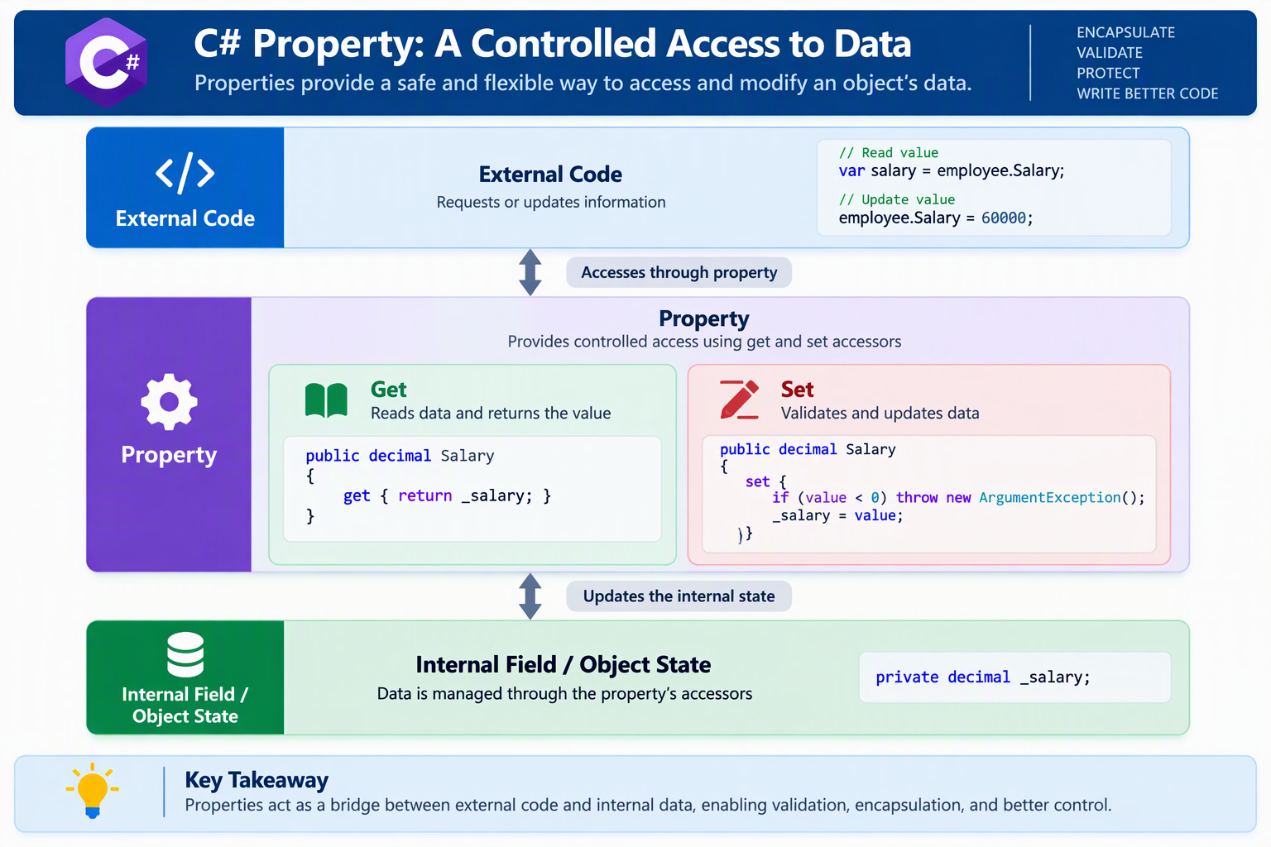

Difference Between Fields and Properties
Field | Property
Stores data directly | Provides access to data or computed values
Does not have accessors | Uses accessors such as get and set
Direct assignment has no built-in validation | Can validate assignments
Often kept private | Often exposed publicly
Represents internal state | Represents a controlled interface to state

Advantages of Properties
- Improve data encapsulation.
- Support validation and business rules.
- Provide controlled read and write access.
- Make code easier to maintain.
- Allow internal implementations to change without necessarily changing the public interface.

