**DBMS**

**EXPERIMENT - 13**

**RA1911003010414**

**Saket Kumar Baranwal**

|  |  |  |  |  |  |  |
| --- | --- | --- | --- | --- | --- | --- |
| **Exp. No** | **Conducted on** | **Submitted On** | **Date of Late Submission**  **(if Any)** | **Max Marks Allotted** | **Marks Obtained** | **Faculty Signature** |
| 1 | 22/04/2022 | 02/05/2022 |  | 10 |  |  |
| **Exp Title** | PL / SQL Exception Handling | | | | | |

**Aim**

To study the various PL/SQL exception handling operations on the database.

**Syntax**

DECLARE

declarations section;

BEGIN

executable command(s);

EXCEPTION

WHEN exception1 THEN

statement1;

WHEN exception2 THEN

statement2;

[WHEN others THEN]

/* default exception handling code */

END;

**Queries**

**create table student(s_id int , s_name varchar(20), marks int);**

**insert into student values(1, 'Suraj',100);**

**insert into student values(2, 'Praveen',97);**

**insert into student values(3, 'Jessie', 99);**

**DECLARE**

**temp varchar(20);**

**BEGIN**

**SELECT s_id into temp from student where s_name='Shashwat';**

**exception**

**WHEN no_data_found THEN**

**dbms_output.put_line('ERROR');**

**dbms_output.put_line('there is no name as');**

**dbms_output.put_line('Shashwat in student table');**

**end;**

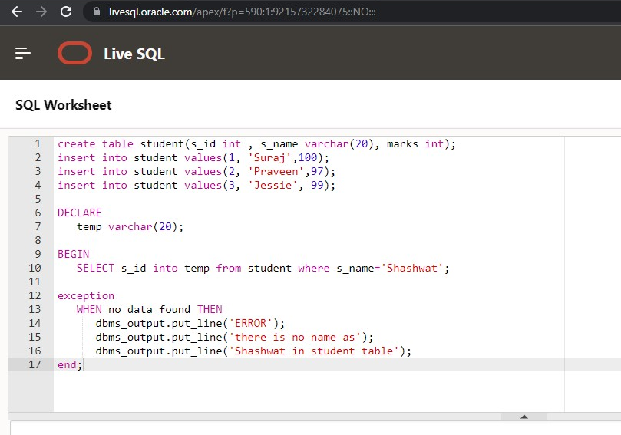

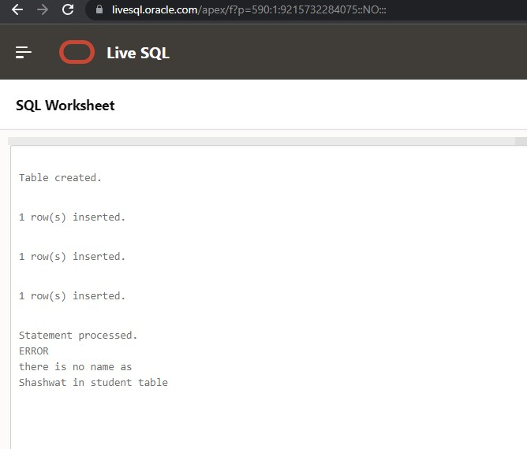

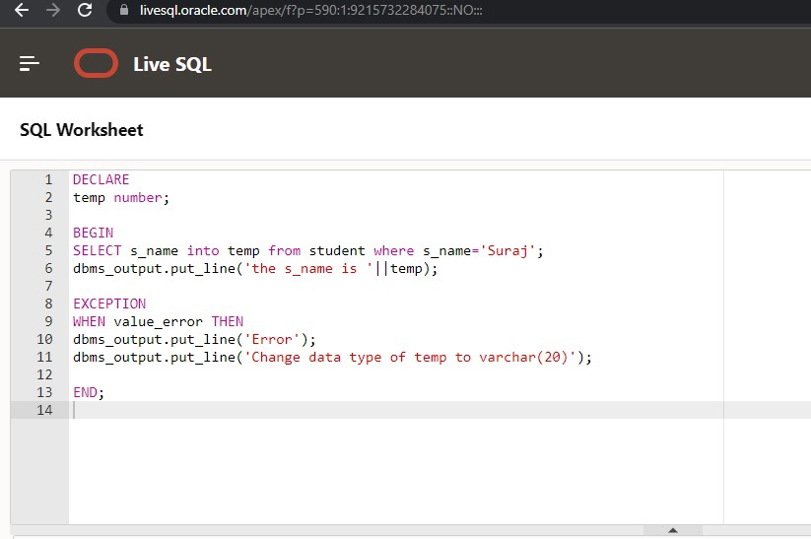

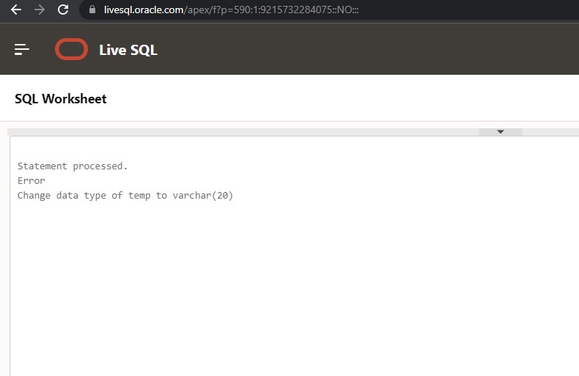

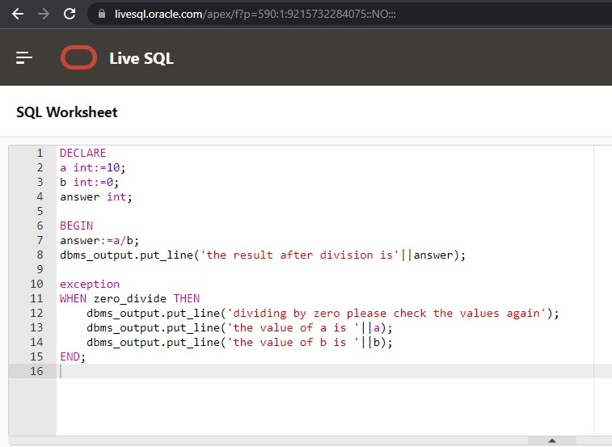

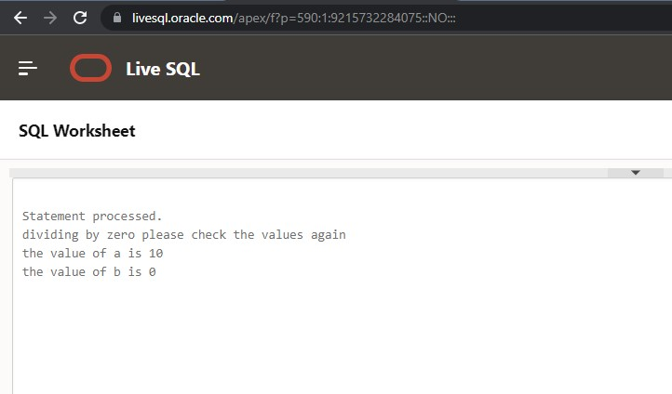

**Result:**

Thus the pl/sql have been executed successfully.