**DBMS**

**EXPERIMENT - 14**

**RA1911003010414**

**Saket Kumar Baranwal**

|  |  |  |  |  |  |  |
| --- | --- | --- | --- | --- | --- | --- |
| **Exp. No** | **Conducted on** | **Submitted On** | **Date of Late Submission**  **(if Any)** | **Max Marks Allotted** | **Marks Obtained** | **Faculty Signature** |
| 1 | 22/04/2022 | 02/05/2022 |  | 10 |  |  |
| **Exp Title** | PL / SQL Triggers | | | | | |

**Aim**

To study the various PL/SQL triggers on the database.

**Syntax**

The syntax for creating a trigger is −

CREATE [OR REPLACE ] TRIGGER trigger_name

{BEFORE | AFTER | INSTEAD OF }

{INSERT [OR] | UPDATE [OR] | DELETE}

[OF col_name]

ON table_name

[REFERENCING OLD AS o NEW AS n]

[FOR EACH ROW]

WHEN (condition)

DECLARE

Declaration-statements

BEGIN

Executable-statements

EXCEPTION

Exception-handling-statements

END;

**Queries**

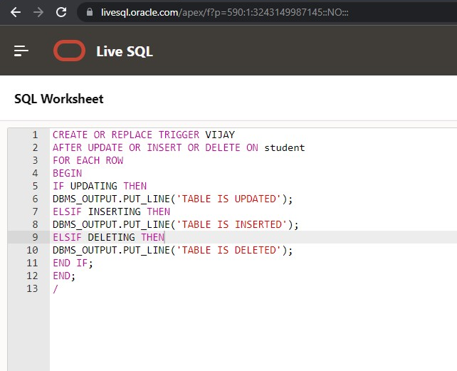

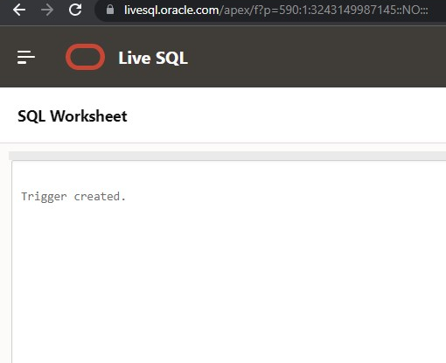

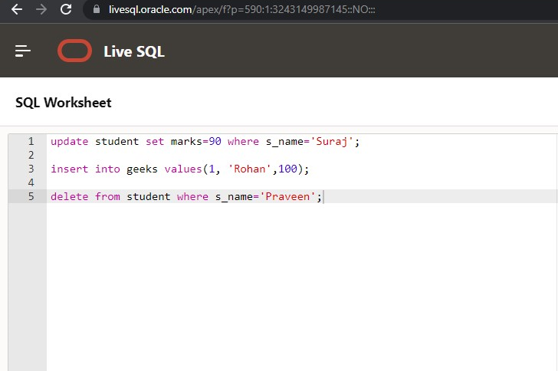

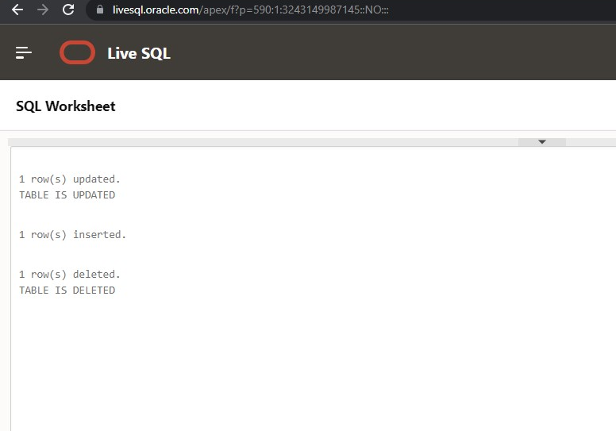

**Result:**

Thus the pl/sql have been executed successfully.