**RA1911003010419**

**SHASHWAT RAJ**

**DBMS**

**EXPERIMENT - 8**

| **Exp. No** | **Conducted on** | **Submitted On** | **Date of Late Submission**  **(if Any)** | **Max Marks Allotted** | **Marks Obtained** | **Faculty Signature** |
| --- | --- | --- | --- | --- | --- | --- |
| 1 | 16/03/2022 | 30/03/2022 |  | 10 |  |  |
| **Exp Title** | Set Operation and Views | | | | | |

**Aim**

To study the implementation of Set Operators and Views.

# **SQL Set Operation**

# The SQL Set operation is used to combine the two or more SQL SELECT statements.

# Types of Set Operation

1. Union
2. UnionAll
3. Intersect
4. Minus

**Queries:**

CREATE TABLE "AGENTS"

(

"AGENT_CODE" CHAR(6) NOT NULL PRIMARY KEY,

"AGENT_NAME" CHAR(40),

"WORKING_AREA" CHAR(35),

"COMMISSION" NUMBER(10,2),

"PHONE_NO" CHAR(15),

"COUNTRY" VARCHAR2(25)

);

INSERT INTO AGENTS VALUES ('A007', 'Ramasundar', 'Bangalore', '0.15', '077-25814763', '');

INSERT INTO AGENTS VALUES ('A003', 'Alex ', 'London', '0.13', '075-12458969', '');

INSERT INTO AGENTS VALUES ('A008', 'Alford', 'New York', '0.12', '044-25874365', '');

INSERT INTO AGENTS VALUES ('A011', 'Ravi Kumar', 'Bangalore', '0.15', '077-45625874', '');

INSERT INTO AGENTS VALUES ('A010', 'Santakumar', 'Chennai', '0.14', '007-22388644', '');

INSERT INTO AGENTS VALUES ('A012', 'Lucida', 'San Jose', '0.12', '044-52981425', '');

INSERT INTO AGENTS VALUES ('A005', 'Anderson', 'Brisban', '0.13', '045-21447739', '');

INSERT INTO AGENTS VALUES ('A001', 'Subbarao', 'Bangalore', '0.14', '077-12346674', '');

INSERT INTO AGENTS VALUES ('A002', 'Mukesh', 'Mumbai', '0.11', '029-12358964', '');

INSERT INTO AGENTS VALUES ('A006', 'McDen', 'London', '0.15', '078-22255588', '');

INSERT INTO AGENTS VALUES ('A004', 'Ivan', 'Torento', '0.15', '008-22544166', '');

INSERT INTO AGENTS VALUES ('A009', 'Benjamin', 'Hampshair', '0.11', '008-22536178', '');

select cust_name from customer

union

select agent_name from agents

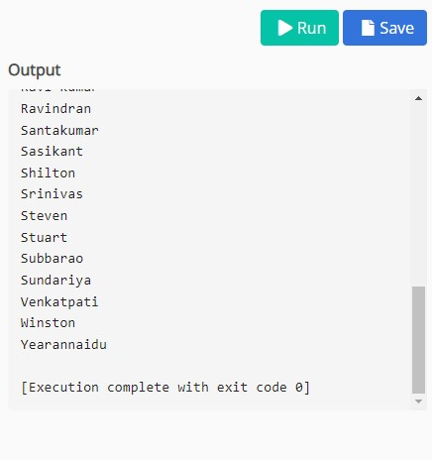

select cust_name from customer

union all

select agent_name from agents

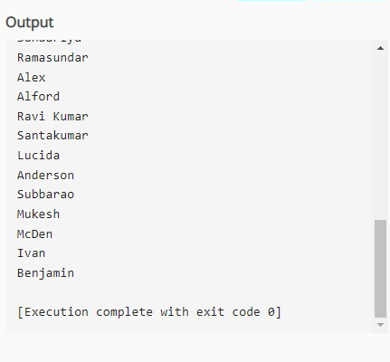

select cust_country from customer

union

select country from agents

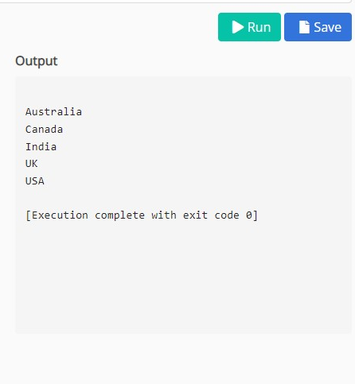

create view cust1 as

select cust_name,cust_city,phone_no from customer

where cust_country="India";

select * from cust1

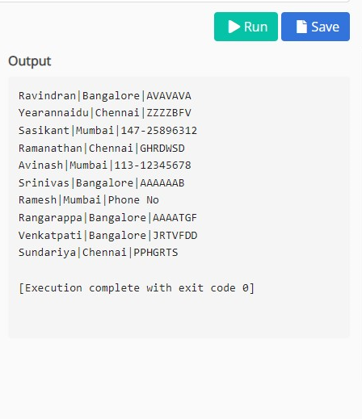

**Result**

Thus the Set Operators and Views were successfully executed and verified.