**DBMS**

**EXPERIMENT – 9**

**Saket Kumar Baranwal RA1911003010414**

|  |  |  |  |  |  |  |
| --- | --- | --- | --- | --- | --- | --- |
| **Exp. No** | **Conducted on** | **Submitted On** | **Date of Late Submission**  **(if Any)** | **Max Marks Allotted** | **Marks Obtained** | **Faculty Signature** |
| 1 | 23/03/2022 | 02/05/2022 |  | 10 |  |  |
| **Exp Title** | Pl / SQL Conditional and Iterative Statements | | | | | |

**Aim**

To study the various basic PL/SQL conditional and iterative operations on the database.

**PL/ SQL GENERAL SYNTAX FOR IF CONDITION:**

SQL> DECLARE ;

BEGIN

IF(CONDITION)THEN ;

END;

Coding for If Statement:

DECLARE

b number;

c number;

BEGIN B:=10;

C:=20;

if(C>B) THEN

dbms_output.put_line('C is maximum');

end if;

end;

/

**PL/ SQL GENERAL SYNTAX FOR IF AND ELSE CONDITION:**

SQL> DECLARE ;

BEGIN

IF (TEST CONDITION)THEN

ELSE ;

ENDIF;

END;

**Queries**

**declare**

**a number;**

**b number;**

**c number;**

**begin**

**a:=10;**

**b:=20;**

**c:= a+b;**

**dbms_output.put_line('sum of ' || a || ' and ' || b || ' is = '|| c);**

**end;**

**/**

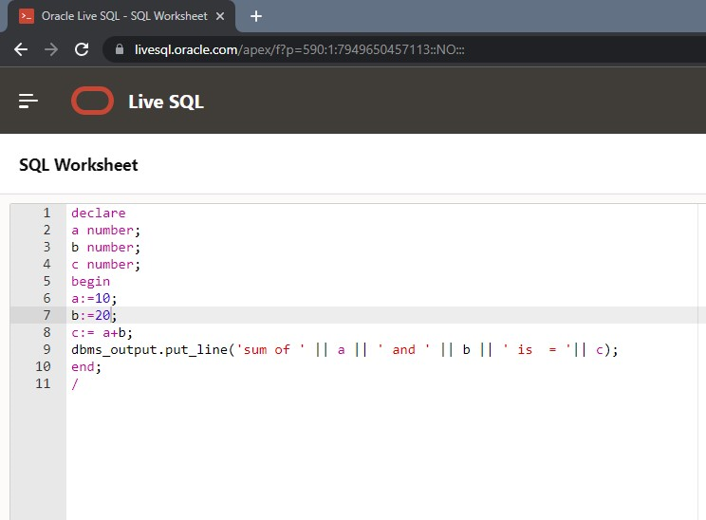

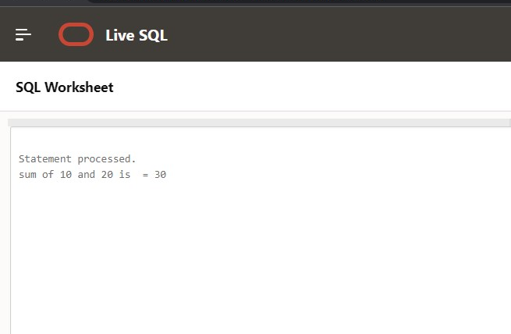

**declare**

**a number;**

**b number;**

**c number;**

**begin**

**a:=10;**

**b:=20;**

**c:=30;**

**if(a>b)and(a>c)then**

**dbms_output.put_line('A is maximum');**

**elsif (b > a) and (b > c) then**

**dbms_output.put_line('B is maximum');**

**else**

**dbms_output.put_line('C is maximum');**

**end if;**

**end;**

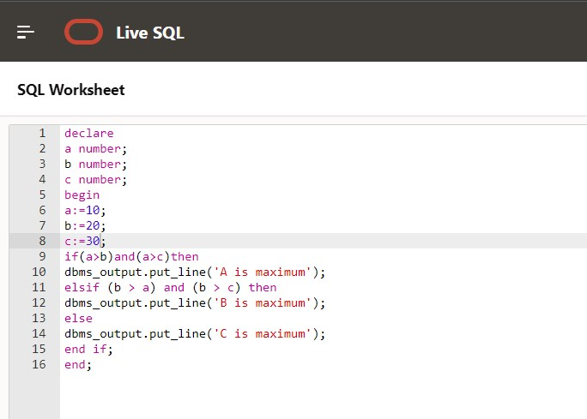

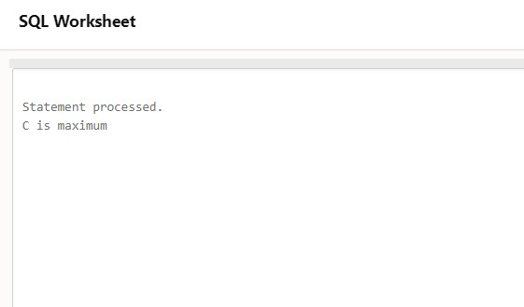

**declare**

**n number;**

**sum1 number default 0;**

**endvalue number;**

**begin**

**endvalue:=30;**

**n:=1;**

**for n in 1..endvalue loop**

**if mod(n,2)=1 then**

**sum1:=sum1+n;**

**end if;**

**end loop;**

**dbms_output.put_line('sum = ' || sum1);**

**end;**

**/**

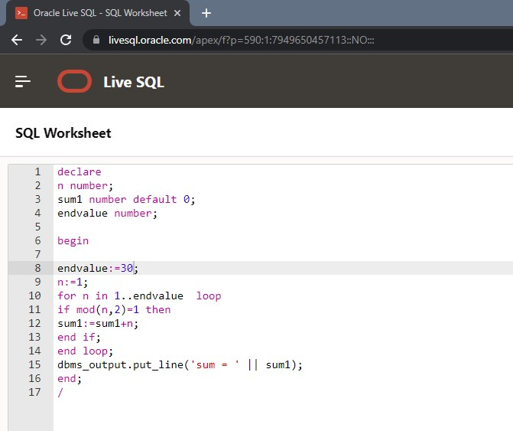

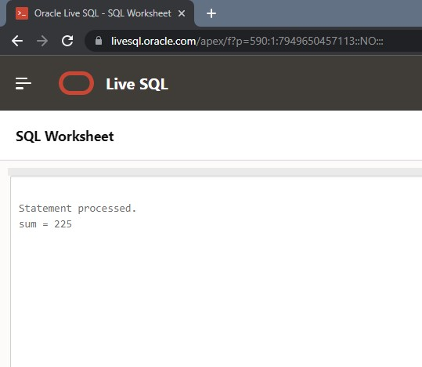

**Result:**

Thus the pl/sql have been executed successfully.