**NUMBER PLATE RECOGNITION USING OCR TECHNIQUE (Saket Kumar Jha)**

1. **INTRODUCTION**

Number plate recognition is a form of automatic vehicle identification. A number plate is the unique identification of vehicle. It is an image processing technology used to identify vehicles by their own number plates. Real time number plate recognition plays an important role in maintaining law enforcement and maintaining traffic rules. It has wide applications areas such as toll plaza, parking area, highly security areas, boarder’s areas etc. Number plate recognition is designed to identify the number plate and then recognize the vehicle number plate from a moving vehicle automatically. Automatic number plate recognition has three major parts: vehicle number plate extraction, character segmentation and Optical Character Recognition (OCR). Number plate extraction is that stage where vehicle number plate is detected. The detected number plate is pre-processed to remove the noise and then the result is passed to the segmentation part to segment the individually characters from the extracted number plate. The segmented characters are normalized and passed to an OCR algorithm. At last the optical character information will be converted into encoded text. The characters are recognized using Template matching. The final output must be in the form of string of characters.

1. **Number Plate Extraction**

The captured image is in capital RGB format. It is converted into grayscale image and into binary image.

1. **Character Segmentation**

The character segmentation part further segments the character individually from the extracted number plate. From input image the first process will be to crop out the number plate characters from starting to the ending point leaving all the extra wide spaces from top to below and from right to left as it is. Characters are equally fit in the plate region. For easy comparison of the input character with the character in the data base the result is normalized into the character set as the size of the images in the database.

1. **Optical Character Recognition**

The optical character recognition is a recognition method in which the input is an image and the output is string of character. OCR is a process which separates the different characters from each other taken from an image. Template matching is one of the approaches of OCR. The cropped image is compared with the template data stored in database. OCR automatically identifies and recognizes the characters without any indirect input. The characters on the number plate have uniform fonts then the OCR for number plate recognition is less complex as compared to other methods.

1. **Template Matching**

Template matching affects the accuracy of Automatic number plate recognition. The Template matching includes following steps shown in figure 1:

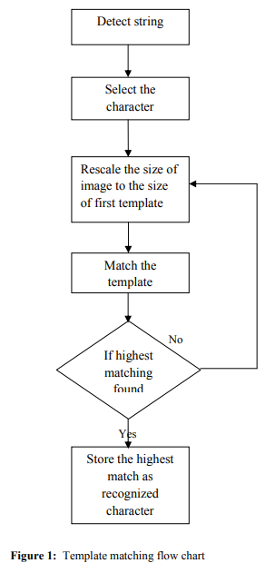

1. PROPOSED ALGORITHM In this paper the processes we have going through are as such. The first step is capturing the image approximately 1 meter from the number plate with camera. The purpose is to get a clear image without distortion. The second step is cropping the number plate from captured image. The cropped image is the input for the character recognition. The third step is character recognition. The OCR technique is used to recognize the character. The flowchart of the presented work is given in figure 2.

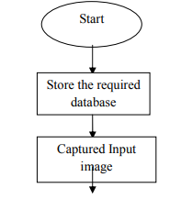

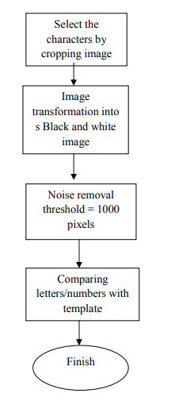

Figure 2: Proposed Model Flow Chart.