Decoder

The combinational circuit that change the binary information into 2N output lines is known as **Decoders.** The binary information is passed in the form of N input lines. The output lines define the 2N-bit code for the binary information. In simple words, the **Decoder** performs the reverse operation of the **Encoder**. At a time, only one input line is activated for simplicity. The produced 2N-bit output code is equivalent to the binary information.

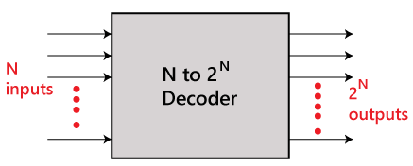

There are various types of decoders which are as follows:

2 to 4 line decoder:

In the 2 to 4 line decoder, there is a total of three inputs, i.e., A0, and A1 and E and four outputs, i.e., Y0, Y1, Y2, and Y3. For each combination of inputs, when the enable 'E' is set to 1, one of these four outputs will be 1. The block diagram and the truth table of the 2 to 4 line decoder are given below.

Block Diagram:

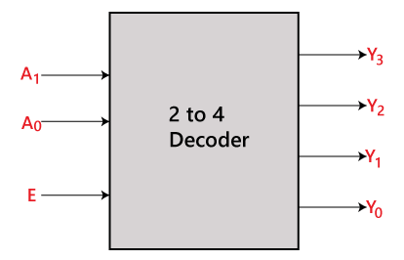

Truth Table:

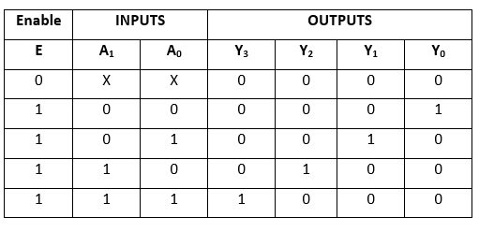

The logical expression of the term Y0, Y0, Y2, and Y3 is as follows:

Y3=E.A1.A0  
Y2=E.A1.A0'  
Y1=E.A1'.A0  
Y0=E.A1'.A0'

Logical circuit of the above expressions is given below:

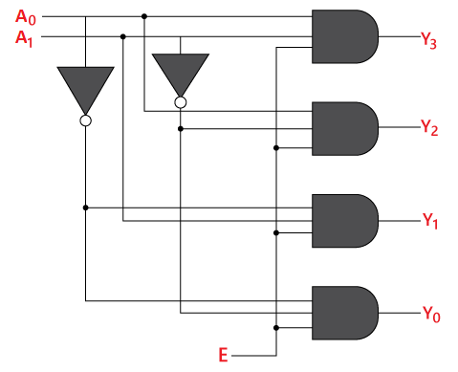

3 to 8 line decoder:

The 3 to 8 line decoder is also known as **Binary to Octal Decoder**. In a 3 to 8 line decoder, there is a total of eight outputs, i.e., Y0, Y1, Y2, Y3, Y4, Y5, Y6, and Y7 and three outputs, i.e., A0, A1, and A2. This circuit has an enable input 'E'. Just like 2 to 4 line decoder, when enable 'E' is set to 1, one of these four outputs will be 1. The block diagram and the truth table of the 3 to 8 line encoder are given below.

Block Diagram:

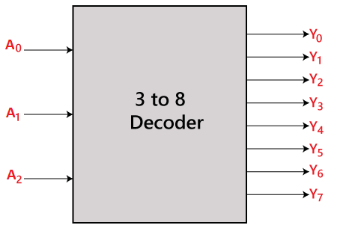

Truth Table:

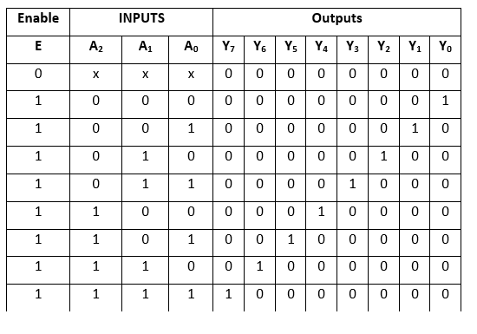

The logical expression of the term Y0, Y1, Y2, Y3, Y4, Y5, Y6, and Y7 is as follows:

Y0=A0'.A1'.A2'  
Y1=A0.A1'.A2'  
Y2=A0'.A1.A2'  
Y3=A0.A1.A2'  
Y4=A0'.A1'.A2  
Y5=A0.A1'.A2  
Y6=A0'.A1.A2  
Y7=A0.A1.A2

Logical circuit of the above expressions is given below:

