De-multiplexer

A De-multiplexer is a combinational circuit that has only 1 input line and 2N output lines. Simply, the demultiplexer is a single-input and multi-output combinational circuit. The information is received from the single input lines and directed to the output line. On the basis of the values of the selection lines, the input will be connected to one of these outputs. De-multiplexer is opposite to the multiplexer.

Unlike encoder and decoder, there are n selection lines and 2n outputs. So, there is a total of 2npossible combinations of outputs. De-multiplexer is also treated as **De-mux**.

There are various types of De-multiplexer which are as follows:

1×2 De-multiplexer:

In the 1 to 2 De-multiplexer, there are only two outputs, i.e., Y0, and Y1, 1 selection lines, i.e., S0, and single input, i.e., A. On the basis of the selection value, the input will be connected to one of the outputs. The block diagram and the truth table of the 1**×**2 multiplexer are given below.

Block Diagram:

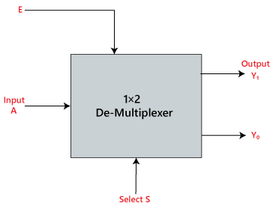

Truth Table:

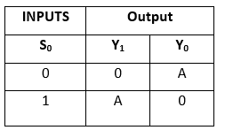

The logical expression of the term Y is as follows:

Y0=S0'.A  
Y1=S0.A

Logical circuit of the above expressions is given below:

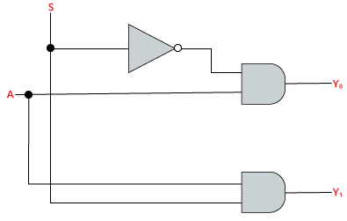

1×4 De-multiplexer:

In 1 to 4 De-multiplexer, there are total of four outputs, i.e., Y0, Y1, Y2, and Y3, 2 selection lines, i.e., S0 and S1 and single input, i.e., A. On the basis of the combination of inputs which are present at the selection lines S0 and S1, the input be connected to one of the outputs. The block diagram and the truth table of the 1**×**4 multiplexer are given below.

Block Diagram:

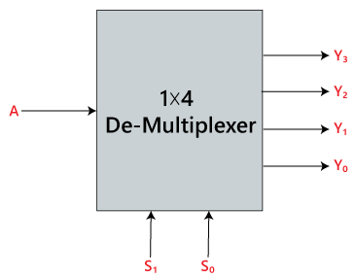

Truth Table:

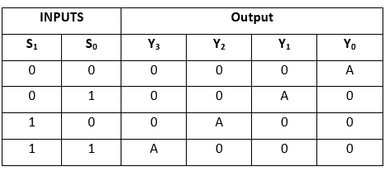

The logical expression of the term Y is as follows:

Y0=S1' S0' A  
y1=S1' S0 A  
y2=S1 S0' A  
y3=S1 S0 A

Logical circuit of the above expressions is given below:

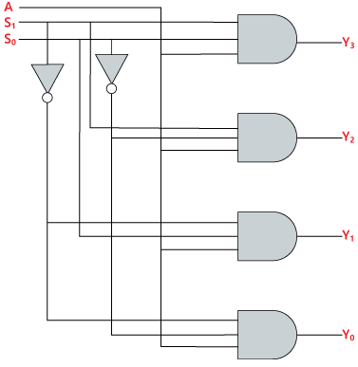

1×8 De-multiplexer

In 1 to 8 De-multiplexer, there are total of eight outputs, i.e., Y0, Y1, Y2, Y3, Y4, Y5, Y6, and Y7, 3 selection lines, i.e., S0, S1and S2 and single input, i.e., A. On the basis of the combination of inputs which are present at the selection lines S0, S1and S2, the input will be connected to one of these outputs. The block diagram and the truth table of the 1**×**8 de-multiplexer are given below.

Block Diagram:

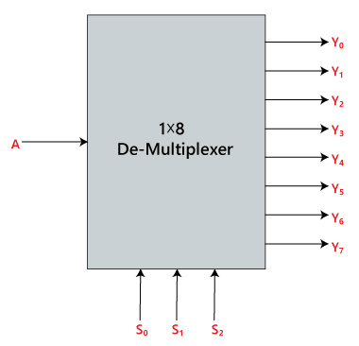

Truth Table:

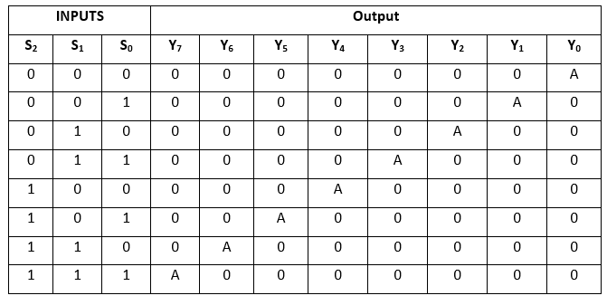

The logical expression of the term Y is as follows:

Y0=S0'.S1'.S2'.A  
Y1=S0.S1'.S2'.A  
Y2=S0'.S1.S2'.A  
Y3=S0.S1.S2'.A  
Y4=S0'.S1'.S2 A  
Y5=S0.S1'.S2 A  
Y6=S0'.S1.S2 A  
Y7=S0.S1.S3.A

Logical circuit of the above expressions is given below:

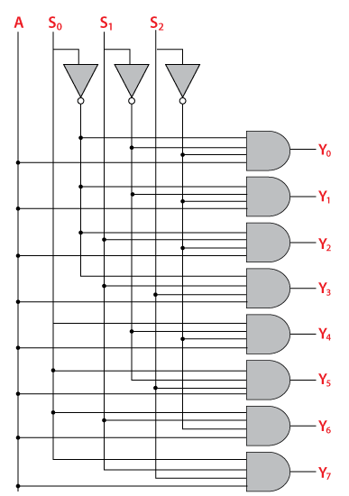

1×8 De-multiplexer using 1×4 and 1×2 de-multiplexer

We can implement the 1**×**8 de-multiplexer using a lower order de-multiplexer. To implement the 1**×**8 de-multiplexer, we need two 1**×**4 de-multiplexer and one 1**×**2 de-multiplexer. The 1**×**4 multiplexer has 2 selection lines, 4 outputs, and 1 input. The 1**×**2 de-multiplexer has only 1 selection line.

For getting 8 data outputs, we need two 1**×**4 de-multiplexer. The 1×2 de-multiplexer produces two outputs. So, in order to get the final output, we have to pass the outputs of 1×2 de-multiplexer as an input of both the 1**×**4 de-multiplexer. The block diagram of 1**×**8 de-multiplexer using 1**×**4 and 1**×**2 de-multiplexer is given below.

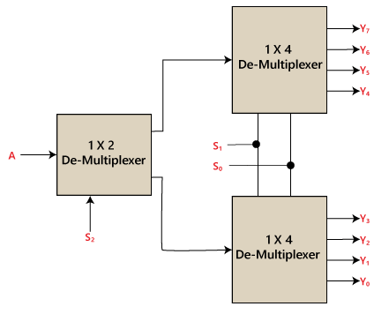

1 x 16 De-multiplexer

In 1×16 de-multiplexer, there are total of 16 outputs, i.e., Y0, Y1, …, Y16, 4 selection lines, i.e., S0, S1, S2, and S3 and single input, i.e., A. On the basis of the combination of inputs which are present at the selection lines S0, S1, and S2, the input will be connected to one of these outputs. The block diagram and the truth table of the 1**×**16 de-multiplexer are given below.

Block Diagram:

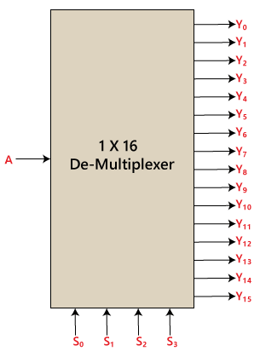

Truth Table:

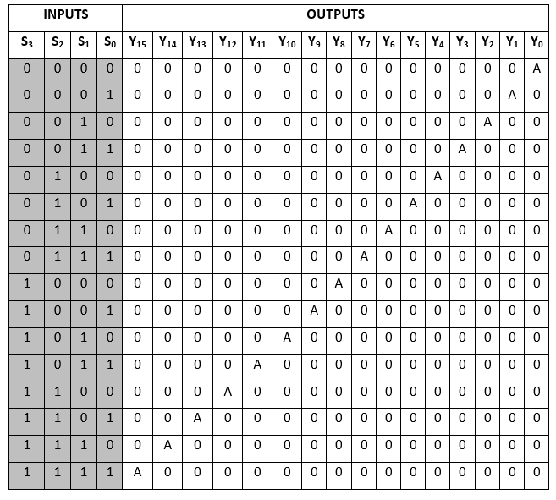

The logical expression of the term Y is as follows:

Y0=A.S0'.S1'.S2'.S3'  
Y1=A.S0'.S1'.S2'.S3  
Y2=A.S0'.S1'.S2.S3'  
Y3=A.S0'.S1'.S2.S3  
Y4=A.S0'.S1.S2'.S3'  
Y5=A.S0'.S1.S2'.S3  
Y6=A.S0'.S1.S2.S3'  
Y7=A.S0'.S1.S2.S3  
Y8=A.S0.S1'.S2'.S3'  
Y9=A.S0.S1'.S2'.S3  
Y10=A.S0.S1'.S2.S3'  
Y11=A.S0.S1'.S2.S3  
Y12=A.S0.S1.S2'.S3'  
Y13=A.S0.S1.S2'.S3  
Y14=A.S0.S1.S2.S3'  
Y15=A.S0.S1.S2'.S3

Logical circuit of the above expressions is given below:

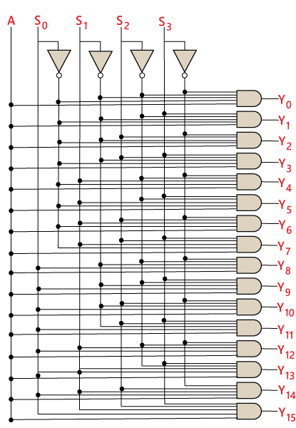

1×16 de-multiplexer using 1×8 and 1×2 de-multiplexer

We can implement the 1**×**16 de-multiplexer using a lower order de-multiplexer. To implement the 1**×**16 de-multiplexer, we need two 1**×**8 de-multiplexer and one 1**×**2 de-multiplexer. The 1**×**8 multiplexer has 3 selection lines, 1 input, and 8 outputs. The 1**×**2 de-multiplexer has only 1 selection line.

For getting 16 data outputs, we need two 1×8 de-multiplexer. The 1**×**8 de-multiplexer produces eight outputs. So, in order to get the final output, we need a 1**×**2 de-multiplexer to produce two outputs from a single input. Then we pass these outputs into both the de-multiplexer as an input. The block diagram of 1**×**16 de-multiplexer using 1**×**8 and 1**×**2 de-multiplexer is given below.

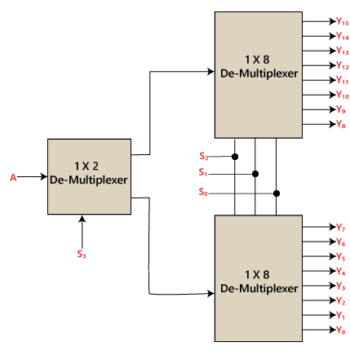

**Applications of Demultiplexer**

1. Demultiplexer is used to connect a single source to multiple destinations. The main application area of demultiplexer is communication system, where multiplexers are used. Most of the communication system are bidirectional i.e., they function in both ways (transmitting and receiving signals). Hence, for most of the applications, the multiplexer and demultiplexer work in sync.
2. **Communication System** – Communication system use multiplexer to carry multiple data like audio, video and other form of data using a single line for transmission. This process make the transmission easier.  The demultiplexer receive the output signals of the multiplexer and converts them back to the original form of the data at the receiving end. The multiplexer and demultiplexer work together to carry out the process of transmission and reception of data in communication system.
3. **ALU (Arithmetic Logic Unit)** – In an ALU circuit, the output of ALU can be stored in multiple registers or storage units with the help of demultiplexer. The output of ALU is fed as the data input to the demultiplexer. Each output of demultiplexer is connected to multiple register which can be stored in the registers.