Encoders

The combinational circuits that change the binary information into N output lines are known as **Encoders**. The binary information is passed in the form of 2N input lines. The output lines define the N-bit code for the binary information. In simple words, the **Encoder** performs the reverse operation of the **Decoder**. At a time, only one input line is activated for simplicity. The produced N-bit output code is equivalent to the binary information.

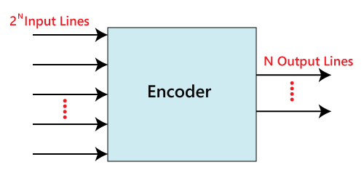

There are various types of encoders which are as follows:

4 to 2 line Encoder:

In 4 to 2 line encoder, there are total of four inputs, i.e., Y0, Y1, Y2, and Y3, and two outputs, i.e., A0 and A1. In 4-input lines, one input-line is set to true at a time to get the respective binary code in the output side. Below are the block diagram and the truth table of the 4 to 2 line encoder.

Block Diagram:

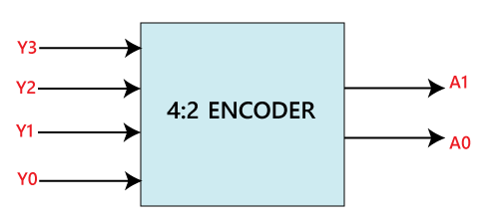

Truth Table:

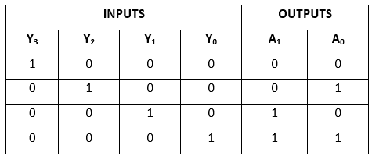

The logical expression of the term A0 and A1 is as follows:

A1=Y3+Y2  
A0=Y3+Y1

Logical circuit of the above expressions is given below:

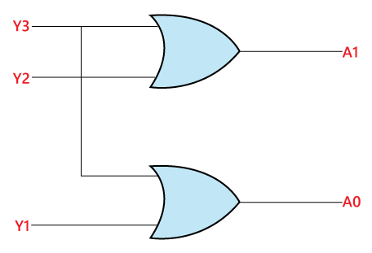

8 to 3 line Encoder:

The 8 to 3 line Encoder is also known as **Octal to Binary Encoder**. In 8 to 3 line encoder, there is a total of eight inputs, i.e., Y0, Y1, Y2, Y3, Y4, Y5, Y6, and Y7 and three outputs, i.e., A0, A1, and A2. In 8-input lines, one input-line is set to true at a time to get the respective binary code in the output side. Below are the block diagram and the truth table of the 8 to 3 line encoder.

Block Diagram:

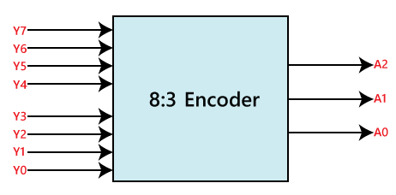

Truth Table:

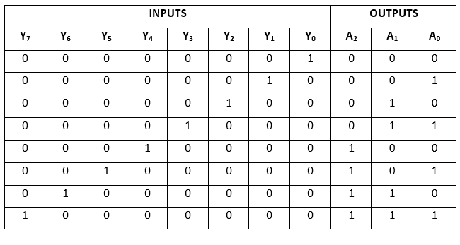

The logical expression of the term A0, A1, and A2 are as follows:

A2=Y4+Y5+Y6+Y7  
A1=Y2+Y3+Y6+Y7  
A0=Y7+Y5+Y3+Y1

Logical circuit of the above expressions is given below:

