Multiplexer

A multiplexer is a combinational circuit that has 2n input lines and a single output line. Simply, the multiplexer is a multi-input and single-output combinational circuit. The binary information is received from the input lines and directed to the output line. On the basis of the values of the selection lines, one of these data inputs will be connected to the output.

Unlike encoder and decoder, there are n selection lines and 2n input lines. So, there is a total of 2Npossible combinations of inputs. A multiplexer is also treated as **Mux**.

There are various types of the multiplexer which are as follows:

2×1 Multiplexer:

In 2×1 multiplexer, there are only two inputs, i.e., A0 and A1, 1 selection line, i.e., S0 and single outputs, i.e., Y. On the basis of the combination of inputs which are present at the selection line S0, one of these 2 inputs will be connected to the output. The block diagram and the truth table of the 2**×**1 multiplexer are given below.

Block Diagram:

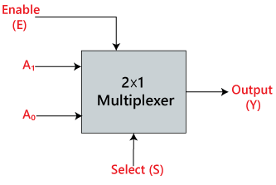

Truth Table:

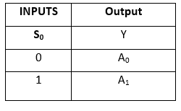

The logical expression of the term Y is as follows:

Y=S0'.A0+S0.A1

Logical circuit of the above expression is given below:

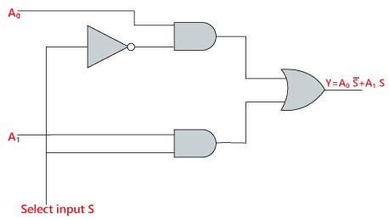

4×1 Multiplexer:

In the 4×1 multiplexer, there is a total of four inputs, i.e., A0, A1, A2, and A3, 2 selection lines, i.e., S0 and S1 and single output, i.e., Y. On the basis of the combination of inputs that are present at the selection lines S0 and S1, one of these 4 inputs are connected to the output. The block diagram and the truth table of the 4**×**1 multiplexer are given below.

Block Diagram:

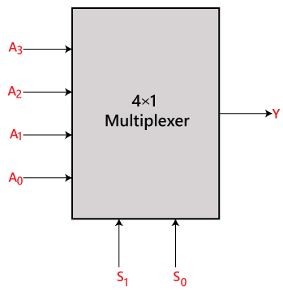

Truth Table:

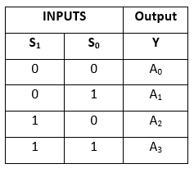

The logical expression of the term Y is as follows:

Y=S1' S0' A0+S1' S0 A1+S1 S0' A2+S1 S0 A3

Logical circuit of the above expression is given below:

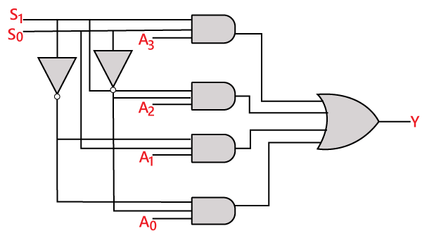

8 to 1 Multiplexer

In the 8 to 1 multiplexer, there are total eight inputs, i.e., A0, A1, A2, A3, A4, A5, A6, and A7, 3 selection lines, i.e., S0, S1and S2 and single output, i.e., Y. On the basis of the combination of inputs that are present at the selection lines S0, S1,and S2, one of these 8 inputs are connected to the output. The block diagram and the truth table of the 8**×**1 multiplexer are given below.

Block Diagram:

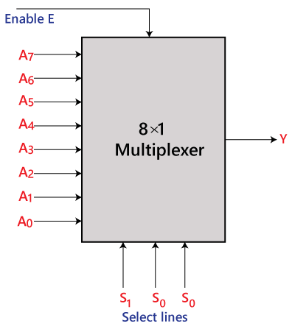

Truth Table:

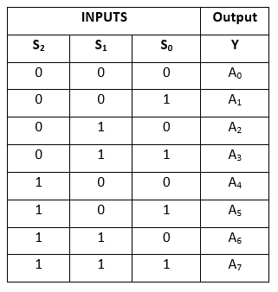

The logical expression of the term Y is as follows:

Y=S0'.S1'.S2'.A0+S0.S1'.S2'.A1+S0'.S1.S2'.A2+S0.S1.S2'.A3+S0'.S1'.S2 A4+S0.S1'.S2 A5+S0'.S1.S2 .A6+S0.S1.S3.A7

Logical circuit of the above expression is given below:

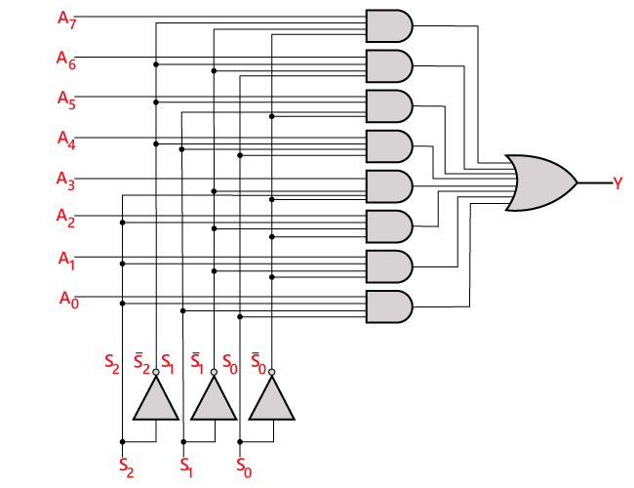

8 ×1 multiplexer using 4×1 and 2×1 multiplexer

We can implement the 8**×**1 multiplexer using a lower order multiplexer. To implement the 8**×**1 multiplexer, we need two 4**×**1 multiplexers and one 2**×**1 multiplexer. The 4**×**1 multiplexer has 2 selection lines, 4 inputs, and 1 output. The 2**×**1 multiplexer has only 1 selection line.

For getting 8 data inputs, we need two 4**×**1 multiplexers. The 4**×**1 multiplexer produces one output. So, in order to get the final output, we need a 2**×**1 multiplexer. The block diagram of 8**×**1 multiplexer using 4**×**1 and 2**×**1 multiplexer is given below.

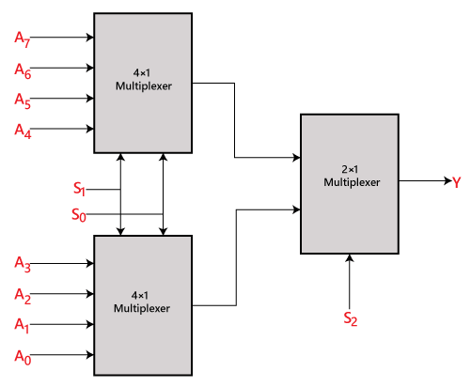

Multiplexer are used in various fields where multiple data need to be transmitted using a single line. Following are some of the applications of multiplexers –

1. **Communication System** – Communication system is a set of system that enable communication like transmission system, relay and tributary station, and communication network. The efficiency of communication system can be increased considerably using multiplexer. Multiplexer allow the process of transmitting different type of data such as audio, video at the same time using a single transmission line.
2. **Telephone Network** – In telephone network, multiple audio signals are integrated on a single line for transmission with the help of multiplexers. In this way, multiple audio signals can be isolated and eventually, the desire audio signals reach the intended recipients.
3. **Computer Memory** – Multiplexers are used to implement huge amount of memory into the computer, at the same time reduces the number of copper lines required to connect the memory to other parts of the computer circuit.
4. **Transmission from the Computer System of a Satellite** – Multiplexer can be used for the transmission of data signals from the computer system of a satellite or spacecraft to the ground system using the GPS (Global Positioning System) satellites.