**Views (Virtual Tables) in SQL**

SQL authorization mechanism to restrict access to relations, but security considerations may require that only certain data in a relation be hidden from a user.

Consider a clerk who needs to know an instructor’s ID, name, and department name, but does not have authorization to see the instructor’s salary amount. This person should see a relation described in SQL by:

select ID, name, dept name from instructor;

A view in SQL terminology is a single table that is derived from other tables. These other tables can be base tables or previously defined views. A view does not necessarily exist in physical form; it is considered to be a virtual table, in contrast to base tables, whose tuples are always physically stored in the database. This limits the possible update operations that can be applied to views, but it does not provide any limitations on querying a view.

**View Definition**

We define a view in SQL by using the create view command. To define a view, we must give the view a name and must state the query that computes the view.

The form of the create view command is:

create view v as <query expression>;

where <query expression> is any legal query expression. The view name is represented by v.

**Specification of Views in SQL**In SQL, the command to specify a view is CREATE VIEW. The view is given a (virtual) table name (or view name), a list of attribute names, and a query to specify the contents of the view.

The views in V1 and V2 create virtual tables whose schemas are illustrated in Figure 7.2 when applied to the database schema of Figure 5.5.

V1: CREATE VIEW WORKS_ON1 AS SELECT Fname, Lname, Pname, Hours FROM EMPLOYEE, PROJECT, WORKS_ON WHERE Ssn = Essn AND Pno = Pnumber;

V2: CREATE VIEW DEPT_INFO (Dept_name, No_of_emps, Total_sal) AS SELECT Dname, COUNT (*), SUM (Salary) FROM DEPARTMENT, EMPLOYEE WHERE Dnumber = Dno GROUP BY Dname;

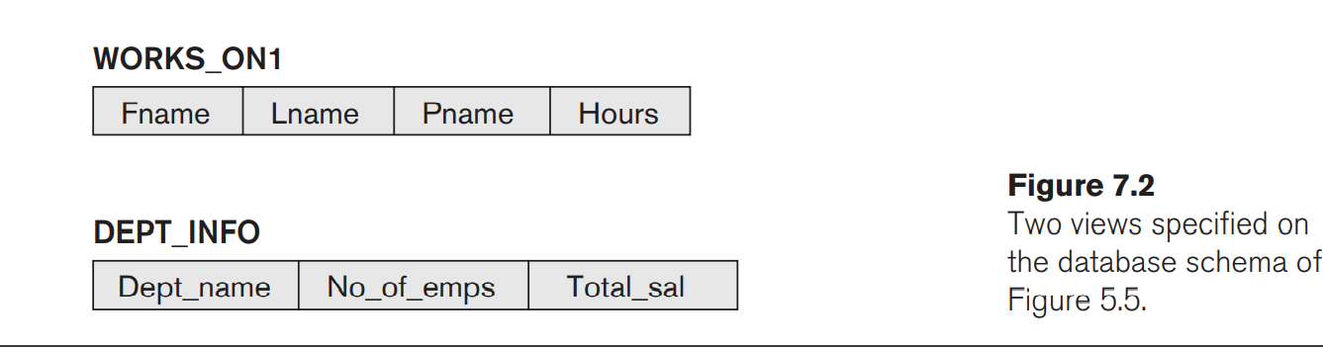

We can now specify SQL queries on a view—or virtual table—in the same way we specify queries involving base tables. For example, to retrieve the last name and first name of all employees who work on the ‘ProductX’ project, we can utilize the WORKS_ON1 view and specify the query as in

SELECT Fname, Lname FROM WORKS_ON1 WHERE Pname = ‘ProductX’;

CREATE VIEW DEPT5EMP AS

SELECT *

FROM EMPLOYEE

WHERE Dno = 5;

In a similar manner, a view can restrict a user to only see certain columns; for example, only the first name, last name, and address of an employee may be visible as follows:

CREATE VIEW BASIC_EMP_DATA AS

SELECT Fname, Lname, Address

FROM EMPLOYEE;

**DELETE VIEW**

If you want to delete a SQL view, It is done by SQL DROP command you should use the following syntax:

SQL DROP VIEW syntax:

DROP VIEW view_name