AgentHub: A Structured Multi-Agent DevOps Engine

Problem Statement
Modern AI coding systems are designed as single, generalized agents that attempt to handle architecture design, code generation, debugging, execution, and review simultaneously. While powerful, this “omni-agent” structure introduces critical weaknesses. Without enforced separation of concerns or structured peer review, these systems can hallucinate design decisions, violate architectural standards, enter recursive debugging loops, or generate code that functions superficially but lacks scalability, security, and maintainability.
In real-world engineering environments, software development follows a disciplined structure. Architecture must be approved before implementation. Code must pass review before integration. Testing and CI/CD validation act as mandatory gates before deployment. No single engineer operates without oversight. However, current AI systems collapse all responsibilities into one autonomous entity, eliminating the structural safeguards that ensure quality and reliability in professional software teams.
As development complexity increases and organizations demand faster release cycles, there is a growing need for an AI system that does not merely generate code, but operates like a structured engineering organization — enforcing hierarchy, specialization, and review mechanisms by design while integrating seamlessly into DevOps workflows.

Solution
AgentHub Core is an autonomous multi-agent engineering pipeline that restructures AI-driven software development into a role-based, hierarchical system inspired by real-world engineering teams. Built using CrewAI for orchestration and powered by Gemini 3 Flash Preview, AgentHub replaces the single-agent paradigm with a structured AI organization composed of specialized agents operating under enforced reporting relationships.
The system embeds deterministic workflow gates into its execution model. A Tech Lead Agent first analyzes the task, designs the architecture, defines interfaces, and approves the implementation plan. Only after this approval can the Junior Developer Agent write code according to the predefined blueprint. A QA Engineer Agent then generates and executes tests, initiating corrective loops if failures occur. Finally, a DevOps Agent handles dependency management, terminal execution, branch creation, and pull request generation. No agent can bypass another’s responsibility, ensuring the “Four Eyes” principle is structurally enforced.
The current prototype functions as a local Python-based orchestration engine that transforms natural language objectives into production-ready technical designs, folder structures, code snippets, and terminal commands. The future vision extends this into a fully autonomous DevOps pipeline capable of reading repositories, modifying files, executing commands, installing dependencies, and opening pull requests without human intervention.
By mathematically separating concerns and embedding peer review into its architecture, AgentHub transforms AI from a coding assistant into a scalable, self-regulating engineering organization capable of delivering enterprise-grade software with speed and consistency.

Tech Stack
Core Orchestration Framework – CrewAI
CrewAI is used to coordinate multiple specialized agents with defined roles and reporting hierarchies. It enables structured task delegation, inter-agent communication, and deterministic workflow enforcement, forming the backbone of AgentHub’s multi-agent architecture.
Primary Intelligence (LLM) – Gemini 3 Flash Preview
Gemini 3 Flash Preview powers the reasoning, architectural design, and code generation capabilities of each agent. It provides low-latency, high-context inference suitable for orchestrated multi-agent workflows.
Programming Language – Python 3.10+
Python serves as the orchestration and execution layer for AgentHub. It enables rapid development, file system interaction, CLI execution, tool integrations, and future DevOps automation.
Security & Configuration – python-dotenv
python-dotenv is used to securely manage API keys, environment variables, and sensitive credentials, ensuring safe local execution and separation of configuration from source code.

System Architecture
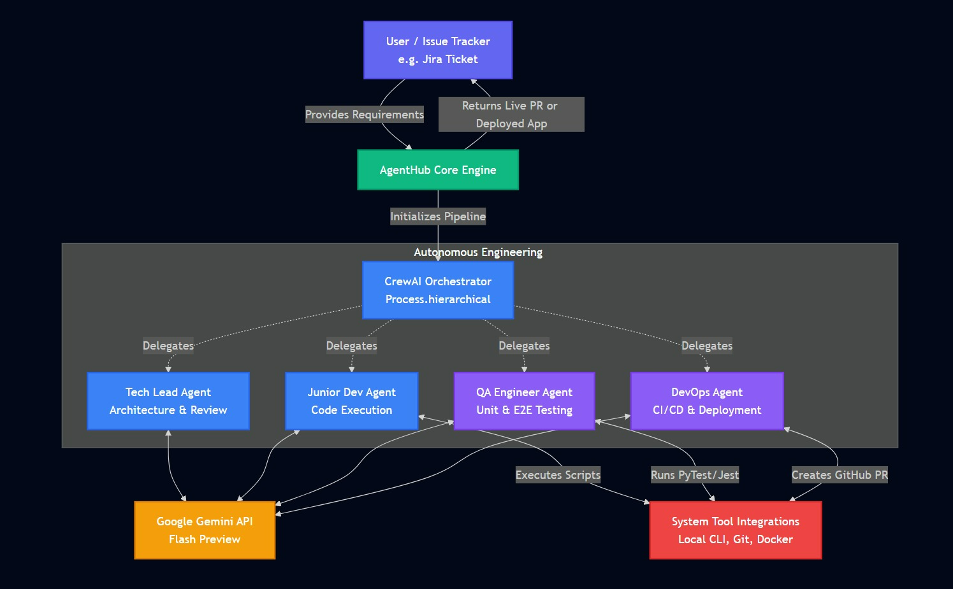

Usage Pipeline
