**VISVESVARAYA INSTITUTE OF TECHNOLOGY**

**Jnana Sangama, Belagavi-590010**



MINI PROJECT REPORT

ON

“**FARMER-CONSUMER DATABASE SYSTEM**”

Submitted in partial fulfillment for the requirements for the fifth semester curriculum

**BACHELOR OF ENGINEERING**

**IN**

**COMPUTER SCIENCE AND ENGINEERING**

For the Academic year 2018-2019

Submitted by:

**SHUBHAM KUMAR 1MV16CS095**

**SAKET SAURAV 1MV16CS085**

Project carried out at:

**Sir M. Visvesvaraya Institute of Technology**

Bengaluru-562157

Under the guidance of:

**Mrs. SUSHILA**

Asst. Professor, Department of CSE

Sir M. Visvesvaraya Institute of Technology, Bengaluru



**DEPARTMENT OF COMPUTER SCIENCE AND ENGINEERING**

**SIR. M VISVESVARAYA INSTITUTE OF TECHNOLOGY**

HUNASAMARANAHALLI, BENGALURU-562157

SIR M. VISVESVARAYA INSTITUTE OF TECHNOLOGY

BENGALURU -562157

  DEPARTMENT OF COMPUTER SCIENCE AND ENGINEERING



CERTIFICATE

It is certified that the project work entitled “**FARMER-CONSUMER DATABASE SYSTEM**” is a bona fide work carried out by **SAKET SAURAV (1MV16CS085), SHUBHAM KUMAR (1MV16CS095)** in partial fulfilment for the requirements of mini project for the V semester curriculum Bachelor of Engineering in Computer Science and Engineering of the Visvesvaraya Technological University, Belagavi during the year 2018-2019. It is certified that all corrections and suggestions indicated for Internal Assessment have been incorporated in the report. The project report has been approved as it satisfies the academic requirements in respect of Project work prescribed for the course of Bachelor of Engineering.

Name & Signature of Guide  Name & Signature of HOD

**Mrs. SUSHILA Prof. Bhanuprakash**

Asst. Prof & Internal Guide HOD, Dept. of CSE

Dept. Of CSE, Sir MVIT Sir MVIT Bengaluru - 562157 Bengaluru -562157

External Examination:

Name of the Examiners                                                        Signature with date

1)

2)

**ACKNOWLEDGEMENT**

It gives us immense pleasure to express our sincere gratitude to the management of **Sir M. Visvesvaraya Institute of Technology,** Bangalore for providing the opportunity and the resources to accomplish our project work in their premises.

On the path of learning, the presence of an experienced guide is indispensable and we would like to thank our guide **Mrs. SUSHILA,** Assistant Professor, Dept. of CSE, for her invaluable help and guidance.

We would also like to convey our regards and sincere thanks to **Prof. Bhanuprakash,** HOD, Dept. of CSE for his suggestions, constant support and encouragement, Heartfelt and sincere thanks to **Dr.V.R.Manjunath,** Principal, Sir. MVIT for providing us with the infrastructure and facilities needed to develop our project.

We would also like to thank the staff of Department of Computer Science and Engineering and lab-in-charges for their co-operation and suggestions. Finally, we would like to thank all our friends for their help and suggestions without which completing this project would not have been possible.

- Saket Saurav(1MV16CS085) -Shubham Kumar (1MV16CS095)

DECLARATION

We hereby declare that the entire mini project work embodied in this dissertation has been carried out by us and no part has been submitted for any degree or diploma of any institution previously.

Place: Bengaluru

Date:

Signature of Students:

SHUBHAM KUMAR (1MV16CS095)

SAKET SAURAV(1MV16CS085)

ABSTRACT

This project describes the management of different factories information in a relational database for further use. It has a login, signup system for user authentication, information about various factories such as product information, customer information, statistics of the factory etc. all together in one database. The objective of this project is to find out a smooth information flow model by developing online software for the apparel industry and to develop a model on Factory Information System.

**TABLE OF CONTENTS**

**Certificate I**

**Acknowledgement II**

**Declaration III**

**Abstract IV**

**Table of Contents V**

Chapter 1 **INTRODUCTION**

1.1 Project profile 8

1.2 Purpose 8

1.3 Project Scope 8

1.4 Definitions, Acronyms & Abbreviations 9

1.5 Overview 9

Chapter 2 **ABOUT THE SYSTEM**

2.1 Software Requirements Specifications 10

2.2 Performance Requirements 10

2.3 Security Requirements 11

2.4 Feasibility Study 11

2.5 Project Plan 12

Chapter 3 **DESIGN**

3.1 E-R Diagram 14

3.2 Class Diagram 14

3.3 Data Dictionary 15

3.4 Sequence Diagram 18

3.5 Use Case Diagram 19

3.6 Activity Diagram 20

Chapter 4 **RESULTS/SNAPSHOTS**  21

Chapter 5 **TESTING**

5.1 Testing Plan 26

5.11 Testing Process

5.12 Requirement Traceability

5.13 Testing Schedule

5.2 Testing Strategy 27

5.3 Test Cases 28

Chapter 6 **CONCLUSION**  28

Chapter 7 **FUTURE ENHANCEMENT**

7.1 Future Enhancement 28

7.2 References 29

Ch.1: Introduction:

1.1 Project Profile

* Name of the project: Farmer-Consumer Database Management System.
* Object Description: The project generally refers to a system which involves registering of factories, user authentication, product-customer’s user interface.
* Front End: HTML, CSS, JavaScript, Bootstrap, expressjs framework.
* Back End: MySQL Database, PHP

1.2 Purpose

This farmer-consumer database management system is developed to maintain a common platform for a number of farmers, transport agencies and consumers to manage the supply chain, also this software will provide the statistics of an area in that duration. This database will be having user authentication for different users i.e. different owners of different sector like farmers, transport agencies and consumers including hotels, restaurant, individuals etc... The search for a better player is cumbersome process and some time they fail in their search, this leads to realization to ease their work, which is possible with computers having sophisticated and user-friendly software.

1.3 Project Scope

This farmer-consumer database management system is very necessary for this growing world as the manual information is not reliable and also not feasible to store.

This system will store all the details of the different farmers, transport and consumers, and the useful information like products, customers, statistics etc.

Signup module: Signup module will help the users who are signing up for the first time. If they have already signed in with valid information, they can directly login.

Login Module: Login module will help in authentication of user accounts. Users who have valid login id and password can only login and register.

This System also includes product-information module, that will take input from the user of the products of their farms, vehicles, product demand and result in stabilising a supply chain.

What contribution would the project make?

This in an era of information technology where automation of each and every activity is gaining importance. This is better than offline struggles that the people involved in the market. The use of internet-based technologies to communicate information is one of the best approach to support the informational needs of various departments of the organization.

Computerized vs. Manual Database System:

* Time saving
* Avoidance of middle men
* Allows neat handling of data rather than error prone records
* Accuracy
* Auditing
* Data access and security

1.4 Definitions, Acronyms and Abbreviations:

Factory details: detail of farmers, transport agencies and consumer such as email-id, name, address, type etc.

Contact details: Details of contact associated with the owner individual.

MySQL: A RDBMS based on SQL which is used for adding, removing and modifying information in the database.

RDBMS: Relational Database Management System

PHP: It is an open-source server environment, uses JavaScript on the server .

1.5 Overview

The purpose of this document is to present a detailed description of the Farmer-Consumer Database Management System. It will explain the purpose and features of the software, the interfaces of the software, what actually the software does, the constraints under which the software works and how it reacts to external stimuli. This document is intended for the end users.

Ch 2: About the System:

* 1. Software Requirement Specification
* **Introduction**

This Software Requirements Specification (SRS) document is intended to give a complete overview of the Farmer-Consumer Database Management System. It will define how the software system will interact with all internal modules like product – customer relationships in the software, communication with other parts like availability of better price to everyone.

* **Product Perspective**

This product is an open-source, under the GNU general public license. It is a web based system implementing client-server model. It also has cross-platform support for different operating systems. N numbers of users are supported by the system.

**2.2 Performance Requirements**

Better performance will lead to better operating environment. For better environment the user needs a high speed internet so that the uploading of details and registration will be done better.

Also the system should have following requirements:

***Hardware***

* Pentium 4 processor or above(server)
* 512 MB RAM or higher(server)
* Minimum 300 MB hard disk space for deployment of dependencies(server).
* Any machine capable of running a web browser, or web app rendering engine. (client)

***Software***

* Linux/Windows Server operating system. (server)
* Python 2.7(server)
* MySQL server(server)
* JQuery
* Web Browser(Client)

**2.3 Security Requirements**

The login details must be kept confidential so that other user may not login using other's id and password. User authentication is very important criteria in farmer-consumer database for login of different sectors.

* 1. **Feasibility Study**

**Feasibility Analysis:**

* + A feasibility study is a short focused, which aims to answer a number of questions:
  + Does the system contribute to the overall objective of the supply chain?
  + Can the system be implemented using the current technology and within given cost and schedule constraints?
  + Can the system be integrated with system which is already in place?

**Economic Feasibility:**

The project is economically feasible as it only requires a desktop with its operating system. The users must be able to connect to internet and this would be the only cost incurred on the project.

**Technical Feasibility:**

To develop this desktop application, an internet connection, a database server, a web server and software are required. The current project is technically feasible as this desktop application was successfully deployed on our desktop.

**Behavioral Feasibility:**

The desktop application is behaviorally feasible since it requires no technical guidance, all the modules are user friendly and execute in a manner they were designed to.

* 1. **Project Plan**

At the beginning of the project, we scheduled meeting time for the group to discuss on the design and implementation of the software and what language to use in writing the software. We had several meetings to this effect. We then developed a time-line for the project and the estimated time. We also pondered on a suitable name to give to the project.

The workload was then divided among us and we worked on the parts of the code. We kept in touch with each other and whenever we had difficulties, we asked each other questions. On some occasions, we had to pretend we were the customer so as to try to figure out some of the things that user would desire, such as the friendliness of the user interface and ease of navigation through the software.

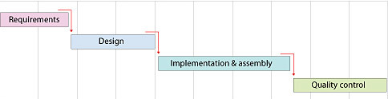

**Ch 3: DESIGN**

**3.1 E-R Diagram**

Entity-Relationship diagram is a detail & logical representation of entities and data elements for an organization. This technique is used in database that helps in an enterprise are related to each other. There are 3 types of E-R diagram:

1. **one to one:**

 It is a one to one relationship is an association between 2 entities.

1. **one to many:**

One-to-many relationship exists when one entity related to one or more entity.

1. **Many to many:**

It describes entities that may have many relationships among each other.

The basic symbols for E-R diagram are as described below:

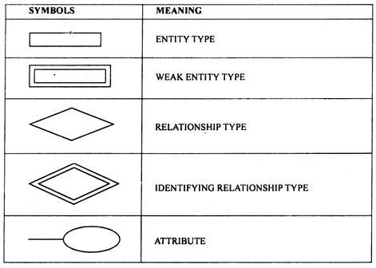

**THE E-R DIAGRAM FOR FARMER-CONSUMER DATABASE**

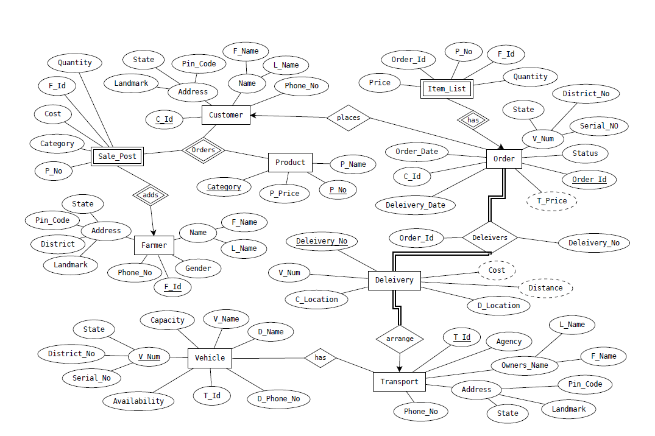

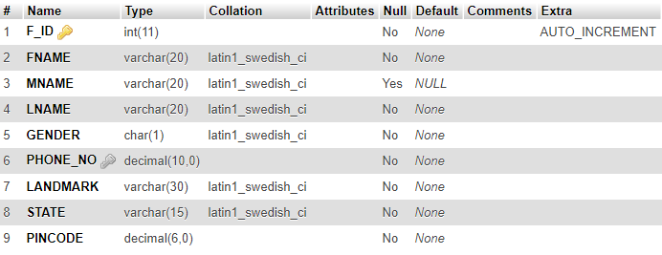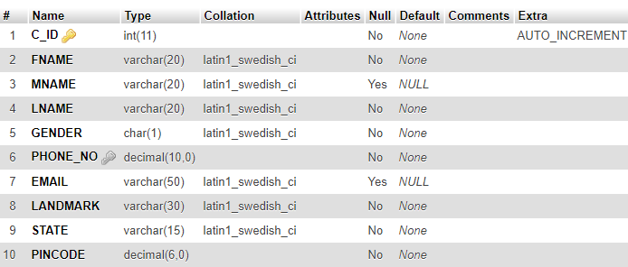

CUSTOMER DATABASE

FARMER DATABASE

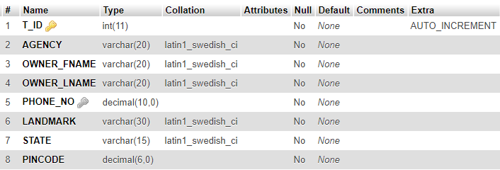

TRANSPORT DATABASE

ADMIN DATABASE

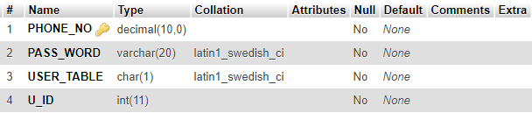

PRODUCT

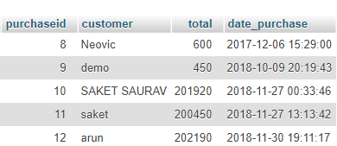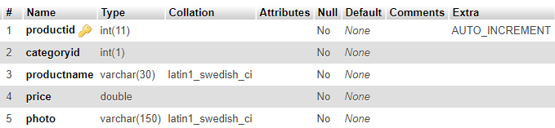

PURCHASE

**Sequence Diagram:**

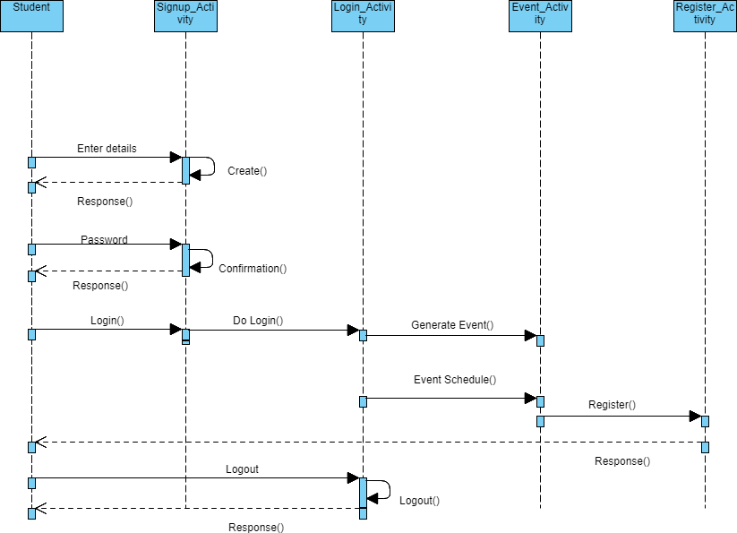

customer

**USE CASE DIAGRAM:**

**Figure: Use Case for CUSTOMER**

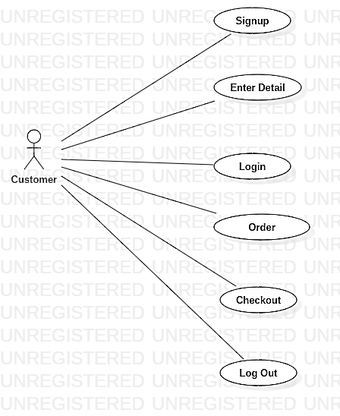

**ACTIVITY DIAGRAM Consumer Registration:**

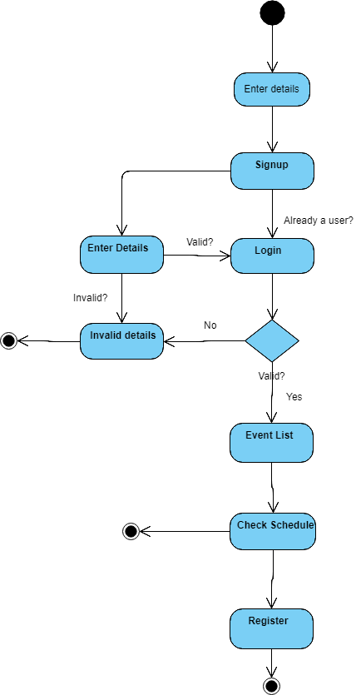

**CH 4: RESULTS/SNAPSHOTS**

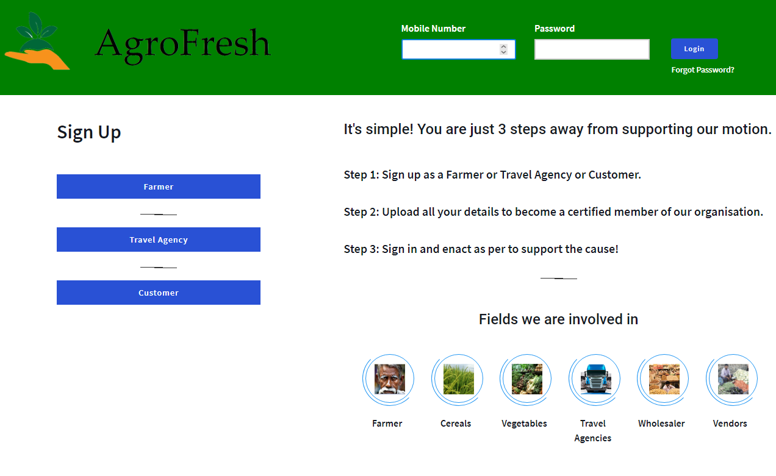

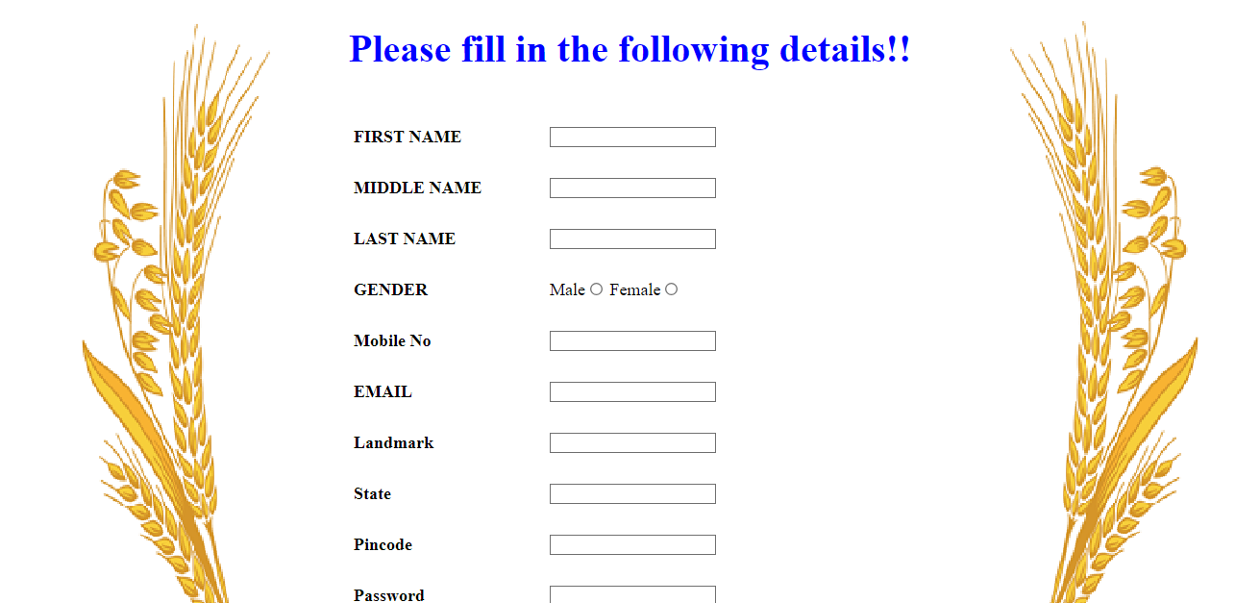

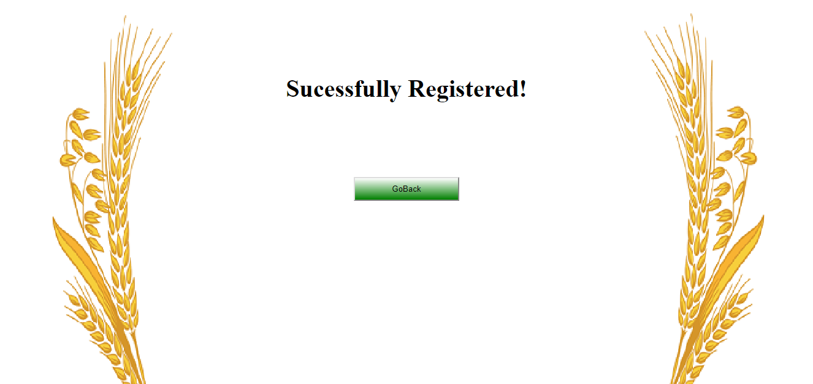

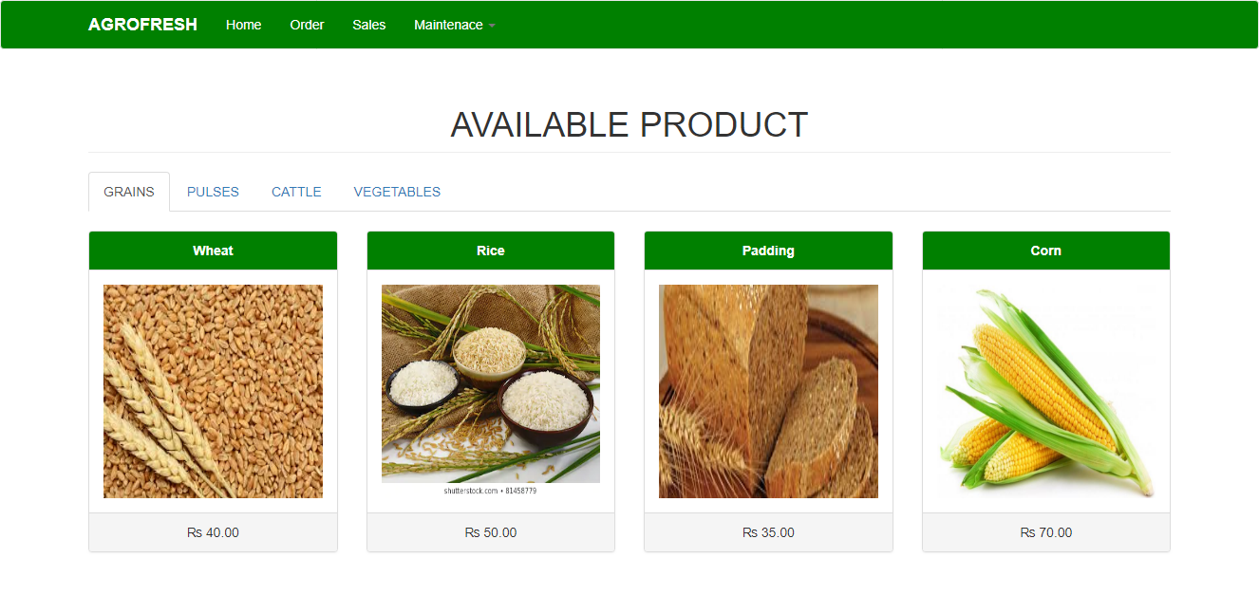

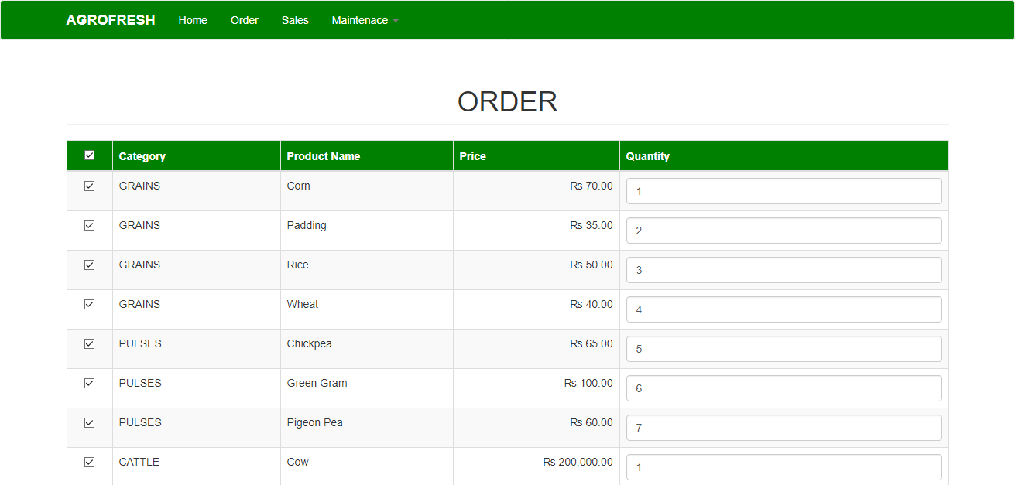

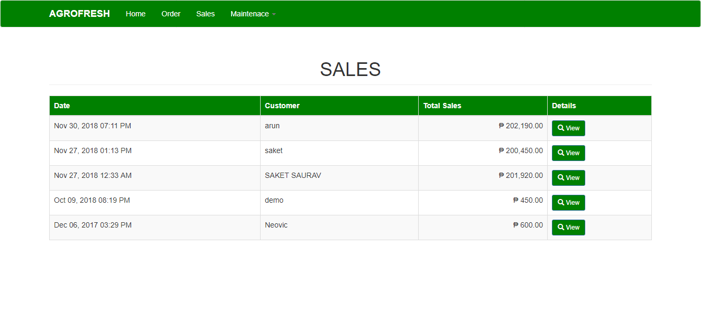

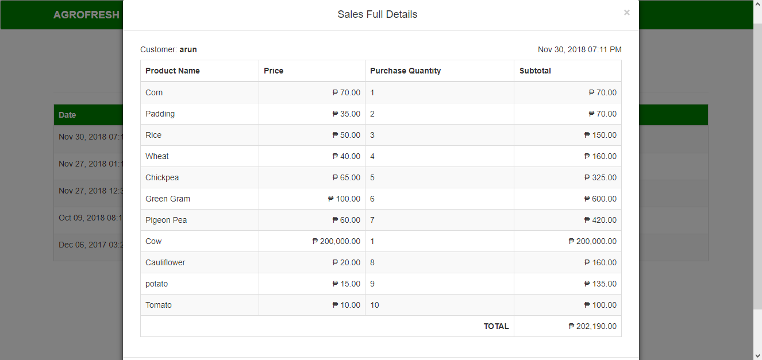

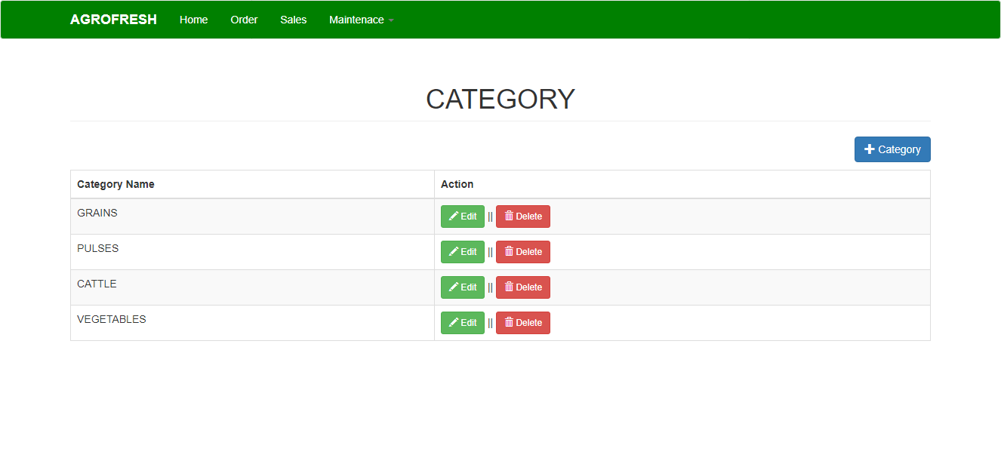

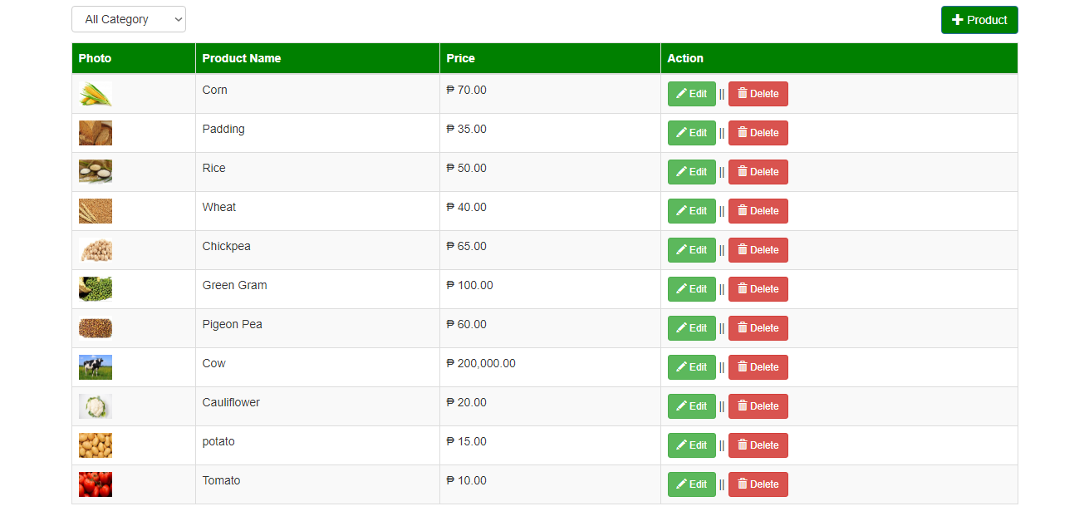

**Ch 5: TESTING:**

**5.1 Testing Plan**

**5.1.1 The Testing Process:**

 We have tested the software process activities such as design, implementation and requirement engineering because design errors are very costly to repair once system has been designed and once it has been started to operate. Therefore, it is quite obvious to repair at an early stage of the system. So analysis is the most important process of any project.

**5.1.2 Requirement Traceability:**

 As the most interested portion is whether the system is meeting its requirements or not, for that testing should be planned so that all requirements are individually tested. We have to check out that output of certain combinations of inputs gives the desirable results or not. Your requirement specification gives us the path to get the desirable result.

**5.1.3 Testing Schedule:**

We have tested each procedure back to back so that errors and omissions can be found as early as possible.

**5.2 Testing Strategy**

A strategy for the software testing integrates software test case design methods into a well-planned series of steps that result in the successful construction of software. The strategy provides a road map that describes the steps to be conducted as part of testing. When these steps are planned and then undertaken, very much efforts, time and resources are required. A software testing strategy should be flexible enough to promote a customized testing approach. At that same time it must be rigid enough to promote reasonable planning and management tracking as the project progresses.

* A software testing strategy has following characteristics:
* Testing begins at the component level and works outward towards the integration of the entire computer based system.
* Different testing techniques are appropriate at different points in time.
* Testing & Debugging are different activities but debugging must be accommodated in any testing strategy. We checked entire project thoroughly so not even a single mistake would be there.

**5.3 TEST CASES**

**Table: Testing New Individual Entries**

|  |  |  |  |  |  |  |
| --- | --- | --- | --- | --- | --- | --- |
| **Sr. No** | **Test Case** | **Validation or Requirement** | **Test Data** | **Expected Result** | **Actual Result** | **Modification** |
| 1 | New person Entry | All details are required | Adding a new User | New entry should be done successfully | Successful | No Modification |
| 2 | New person Entry | All data are required | All details | Successful entry | Successful | No Modification |
| 3 | New person Entry with an existing username | All data inserted | All details | Shows Error | Showing Error | No Modification |

**Table: Testing Login for Student**

|  |  |  |  |  |  |  |
| --- | --- | --- | --- | --- | --- | --- |
| **Sr. No** | **Test Case** | **Validation or Requirement** | **Test Data** | **Expected Result** | **Actual Result** | **Modification** |
| 1 | Right Login | Authentication | Username and Password entered | Login done successfully | Successful | No Modification |
| 2 | Wrong Login | Authentication | Username and Password entered | Login won't be successful | Unsuccessful | No Modification |

**Ch 6: CONCLUSION**

This desktop application leads to the new product for farmers, transport agencies and consumers which provide effective supply chain of food by avoiding middle men and providing benefits to farmers and very individuals. The wastage of time in searching a retailer offering good price for farmer, getting vehicles on wheels every time for transport agencies and searching a lower price offering retailer for customer is reduced here. The farmer will get a fair price for their product which will lead to decrement in market price.

**Ch 7: FUTURE ENHANCEMENT**

**7.1 Future Enhancement:**

* Website services:

The future needs of developing a website and providing this facility to supply in different part of country and further at international level.

* Email services:

When the users register, a service will be provided such that they get an email confirming their registration to the particular event with particular event id.

7.2 References

* Software requirement specifications from Internet
* [www.google.com](http://www.google.com/)
* www.wikipedia.com
* [www.slideshare.com](http://www.slideshare.com/)

**MYSQL (Structured Query Language):**

**MySQL** is an open source Relation Database Management System (RDBMS). MySQL is written in c and c++. MySQL is a central component of the LAMP open-source web application software stack (and other “AMP” stacks). LAMP is an acronym for “Linux apache MySQL python ".

**VSCODE:**

**Vscode** is a [source code editor](https://en.wikipedia.org/wiki/Source_code_editor) developed by [Microsoft](https://en.wikipedia.org/wiki/Microsoft) for [Windows](https://en.wikipedia.org/wiki/Windows), [Linux](https://en.wikipedia.org/wiki/Linux) and [macOS](https://en.wikipedia.org/wiki/MacOS). It includes support for [debugging](https://en.wikipedia.org/wiki/Debugging), embedded [Git](https://en.wikipedia.org/wiki/Git) control, [syntax highlighting](https://en.wikipedia.org/wiki/Syntax_highlighting), [intelligent code completion](https://en.wikipedia.org/wiki/Intelligent_code_completion), [snippets](https://en.wikipedia.org/wiki/Snippet_(programming)), and [code refactoring](https://en.wikipedia.org/wiki/Code_refactoring). It is also customizable, so users can change the editor's [theme](https://en.wikipedia.org/wiki/Theme_(computing)), [keyboard shortcuts](https://en.wikipedia.org/wiki/Keyboard_shortcut), and preferences. It is source, although the official download is under a [proprietary license](https://en.wikipedia.org/wiki/Proprietary_software).

Visual Studio Code is a [source code editor](https://en.wikipedia.org/wiki/Source_code_editor). It supports a number of programming languages and a set of features that may or may not be available for a given language, as shown in the following table. Many of Visual Studio Code features are not exposed through menus or the user interface. Rather, they are accessed via the command palette or via a .[json](https://en.wikipedia.org/wiki/JSON) file (e.g., user preferences). The command palette is a [command-line interface](https://en.wikipedia.org/wiki/Command-line_interface). However, it disappears if the user clicks anywhere outside it or presses a key combination on the keyboard to interact with something outside it. When this happens, the command in progress is cancelled.