**Transition from Natural Gas to Renewable Gas in Steam Plant with Gas Fuel Quality Sensor**

1. **Leadership**

*Principal Investigator:* Chan Seung Park, [cspark@wcgec.ucr.edu](mailto:cspark@wcgec.ucr.edu),

*Co-Principal Investigators:* Hamidreza Nazaripouya, [hamidn@ucr.edu](mailto:hamidn@ucr.edu)

Hossein Akhavan Hejazi, [seyed.akhavanhejazi@email.ucr.edu](mailto:seyed.akhavanhejazi@email.ucr.edu)

**2) Scope**

To this end, the large scale production, management and use of Renewable Natural Gas (RNG), is identified as a key priority area for transition away from the use of natural gas in its operations[1]. UC has committed to procure biogas up to 50% of current natural gas use. To this end, the UC is already implementing an experimental anaerobic digester that is using food waste to produce bio-methane, as well as a large fuel cell that generates 2.8 megawatts of electricity from a municipal wastewater treatment facility.

Should include a figure, which shows the low quality and variations in RNG

Can we generate a figure with the simulator?

One of the challenges in utilizing the RNG as an alternative fuel is the wide variations in their fuel quality and their typical lower energy content*[2]*. To address this problem, one solution is to perform comprehensive gas cleanup/ upgrading to meet NG fuel specifications. However, most RNG projects are small to medium scale by nature and the upgrading process is often not feasible from a project economics perspective.

*Figure 1: RNG WI Variation*

The well-known critical factor for evaluating fuel quality of RNG is Wobbe Index (WI). Figure 1 shows the seasonal variation of WI of RNG[3]. The variation in WI results in inefficiency in the combustion by 10%, as well as increase of NOx emission by 30%, since often steam boilers are designed to be operated by the fuel with fixed value of WI[4].

Our approach to address this challenge is to measure the fuel WI for real-time modification and control of combustion process in steam boilers to account for variation of WI, resulting in improved efficiency and reducing the CO2 emissions. More importantly, the quality (WI) sensor can enable the use of RNG without the upgrade process; thus, increase the viability of the RNG use. However, *there is currently no easy way to measure the quality of NG;* WI is typically measured using bulky, complex and expensive (over $50,000) analyzers that has been only used by the NG suppliers or large-scale NG power plants. The complex, destructive, and expensive nature of existing WI measurement prevents its widespread use in the small or medium scale industrial or consumer processes, such as boilers in the UC campus steam plants or various RNG to energy projects.

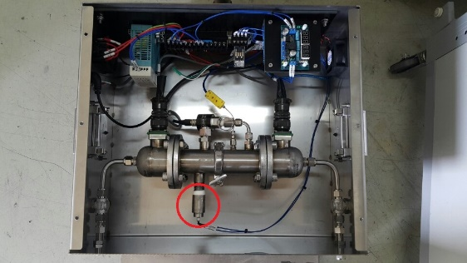

*Figure 2: Lab prototype Fuel Quality Sensor (in red circle) and its evaluation setup*

The project team at UCR have developed a low-cost, easy to implement, and non-intrusive sensor technology for WI measurement. This technology uses Artificial Intelligence (AI) based prediction approach from the simple measurement of the physical properties, which can detect the WI of the fuel within 5% accuracy[5],[6]. The PI has successfully developed and tested this technology in the laboratory settings. Figure 2 shows the current laboratory prototype sensor. The technology was also recently highlighted by American Gas Association.[7] Accordingly, this advanced sensor technology enables a practical, low cost, and scalable solution for reducing the CO2 emission that can be easily implemented and expanded to many small and medium scale boilers.

In addition, the team has the capability of generating the gas blende to emulate biogas and RNG. The facility consists of seven mass flow controller and capable of preparing the gas blende of six gases. The second rack contains two mass flow controller for CO2 which will be used to adjust the CO2 composition (low or high depending on the biogas source) with the CH4 in the biogas mixture. Figure 3 shows the gas inlet, outlet and communication parts of the device as well as software interface.

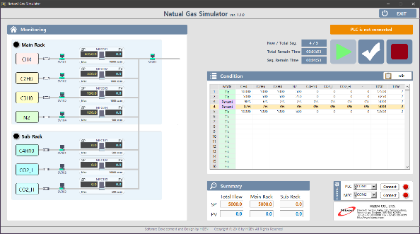

*Figure 3: RNG emulator- hardware and software interface*

The project team is proposing to integrate the patented WI sensor technology into the steam boiler at UCR campus and supply the boiler with RNG. The propose pilot project will demonstrate the efficient and cost effective operation of RNG steam boiler by integrating an intelligent and closed-loop control of combustion system, which optimize the boiler operation based on the sensor signal. This demonstration will not only contribute to substitution of natural gas with renewable gas and thus immediate reduction of UCR carbon emission, but also makes the idea more competitive for external funding through real-world performance validation of the proposed technology. The follow-up funding will be used to implement the technology in large scale across UC campuses and industry sectors. The objective of the proposed project is to enable the use of RNG as an alternative fuel for the steam plant through a pilot project demonstration in a controlled environment:This has potential to reduce the carbon emission by 80%, which is ~ yearly 16,000 MtCO2e.[8]

**3) Team**

The project relies on the qualifications, experience, and capabilities of a team of experts in electronics and sensor development, artificial intelligence, data analytics, mathematical modeling, operation and control design. The team include UC Riverside’s leading faculty researchers Dr. Chan Park, Dr. Hamidreza Nazaripouya, Dr. Hossein Akhavan Hejazi and Dr. Partho Roy. *Dr. Park* has his PhD in Chemistry with an emphasis in electronics and sensing. He is the inventor of the fuel quality sensor, also leading PI for this proposed project. He is currently developing the working prototype of fuel property sensor (TRL7) from the laboratory prototype sensor (TRL3). *Dr. Roy* is an expert in artificial intelligences who is responsible for developing the predictive algorithms, which is the essential part of the fuel quality sensor. Dr. Akhavan Hejazi is an expert in mathematical modeling and will develop models for thermal characterization of boilers in terms of WI. Dr. Nazaripouya is an expert in system dynamic modeling and control. He has multiple publications/patents in control design. He will develop feedback controller for the boiler system.

**4) Schedule**

In this project, the main objectives include reducing the upgrading process cost in RNG-fueled steam boiler by developing closed- loop control on air/fuel ratio according to gas fuel quality sensor signal. The objectives in this project will be realized through the following five main activities and timeline:

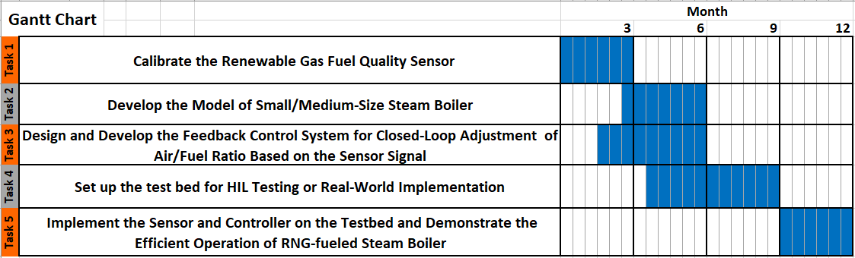

**5) Resources**

The requested baseline budget is $100k (Silver). The Silver budget will be allocated for installing the fuel quality sensor, collecting the data of fuel quality variation from RNG emulator, developing the full thermodynamic model of steam boiler, design and developing the closed-loop controller, and applying the controller to full thermodynamic model of the system to demonstrate the efficient operation of the boiler in a HIL setup. With Bronze budget ($75k), the verification of will be limited to simulation of the system operation instead of HIL testing or real-world implementation. The ideal funding of $125k (Gold budget) will allow the team to implement the controller in actual hardware, and perform real-world analysis. In addition, field prototype sensor (TRL7, prototype in relevant environment) can be developed and installed instead of advanced laboratory prototype (TRL5, in controlled environment).

|  |  |  |  |  |  |  |
| --- | --- | --- | --- | --- | --- | --- |
| **Budget** | **Install Sensor** | **Modeling** | **Develop Controller** | **Simulation** | **HIL Testing** | **Implementation** |
| **Gold** | ✓(TRL7) | ✓ | ✓ |  |  | ✓ |
| **Silver** | ✓(TRL5) | ✓ | ✓ |  | ✓ |  |
| **Bronze** | ✓(TRL5) | ✓ | ✓ | ✓ |  |  |

1. University of California Strategies for Decarbonization: Replacing Natural Gas, February 2018, <https://www.nceas.ucsb.edu/files/research/projects/UC-TomKat-Replacing-Natural-Gas-Report_2018.pdf>
2. Economic and Financial Aspect of Landfill Gas to Energy Project, California Energy Commission. 2005
3. CNG Vehicle Fuel Survey, Final Report, Southwest Research Institute. SwRI Project No. 18. 19236
4. Influence of fuel composition on the combustion and emission characteristic of natural gas. Renewable and Sustainable Energy Review, 38 (2014) 64-78
5. A U.S. patent application by UCOP No. 62/239,808 for the invention disclosure entitled "Online Wobbe Sensor for the natural gas by indirect measurement with chemo-metric data
6. Predicting Wobbe Index and methane number of a renewable natural gas by the measurement of simple physical properties, Fuel, 224(2018) 121-127
7. “Pipeline Innovation-Sensing Savings”, American Gas Magazine, May 2018
8. Carbon intensity of RNG is 12 gCO2/MJ or ~20% of that from N American CNG.LCFS lookup table by ARB, 2009