# **Department of Computer Science and Engineering Islamic University of Technology (IUT)** A subsidiary organ of OIC

# **Lab Report 01**

# CSE 4512 : Computer Networks Lab

## 

## **Name: Adib Sakhawat Student ID: 210042106 Section: B Semester: Winter Academic Year: 2022 - 23**

**Date of Submission: 26 January 2024**

### **Title:** Configure router using static routing to connect multiple networks in Cisco Packet Tracer

### **Objectives**:

1. Understand how to operate Cisco Packet Tracer
2. Learn to create and connect multiple networks using static routing
3. Understand wiring of different network components like router, switch, PC etc.
4. Configure router and switch interfaces
5. Verify connectivity of the network
6. Understand the basics of IP Subnetting
7. Learn to subnet a network following given specifications

### **Diagram of the experiment:**

(Provide screenshot of the final network topology. Make sure to label the network components.)

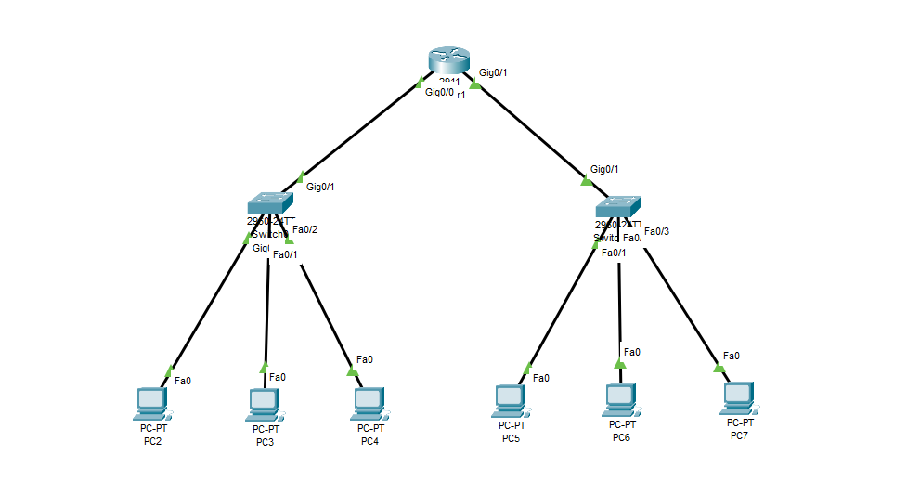

Figure 1 : The experiment

### **Working Procedure:**

**(**Explain in brief how you completed the tasks. Provide necessary screenshots of used commands for each task.)

* + - 1. Created the network tree using following components
         1. 1 Router 2911
         2. 2 Switch 2960-24TT
         3. 6 PC
         4. Copper Straight Threough Wiring

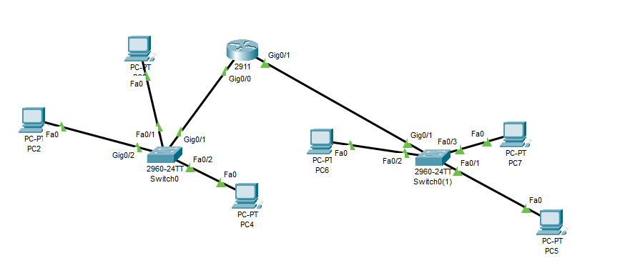

Figure 2 : Network Orientation

* + - 1. Assigned IP addresses to the PC’s
         1. PC – 1 : 192.168.6.10
         2. PC – 2 : 192.168.6.20
         3. PC – 3 : 192.168.6.30
         4. PC – 4 : 192.168.16.10
         5. PC – 5 : 192.168.16.20
         6. PC – 6 : 192.168.16.30
      2. Configured The Router – given the following commands
         * 106> enable
         * 106# configure terminal
         * 106(config)# interface gigabitEthernet 0/0
         * 106(config-if)# ip address 192.168.6.0 255.255.255.0
         * 106(config-if)# no shutdown
         * 106(config-if)# end
         * 106# configure terminal
         * 106(config)# interface gigabitEthernet 0/1
         * 106(config-if)# ip address 192.168.16.0 255.255.255.0
         * 106(config-if)# no shutdown
         * 106(config-if)# end
         * copy running-config startup-config
      3. now run ping command from every pc to every pc to show the connection is successful

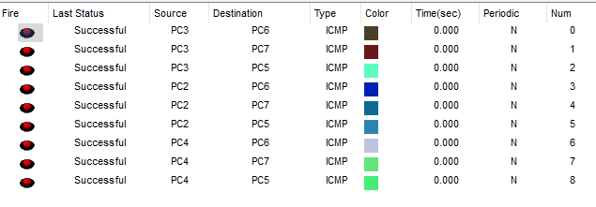

Figure 3 : Ping Results from every PC to every PC

### **Questions (Answer to the point)**:

**Q1.** **Write the command to check the status of all interfaces in a router.**

Ans: show ip interface brief

**Q2. Why do we use switches and not hubs?**

Ans: Switches are preferred over hubs due to their ability to create separate collision domains, operate at the data link layer, offer dedicated bandwidth per port, and provide improved security by selectively forwarding data based on MAC addresses.

**Q3.** **How do you make all the configuration changes in a cisco device persistent? What would happen if you don’t do this?**

Ans: we have to put the command,

copy running-config startup-config

This is used in Cisco devices to save the current running configuration to the startup configuration. This ensures that any configuration changes made during the current session become persistent and are retained even after a device reboot.

**Q4. What are the interfaces of the router? Why are they necessary?**

Ans: Interfaces in a router connect it to other devices and networks. They are necessary for facilitating data exchange and communication between different networks, enabling the router to send and receive data through physical or virtual connections.

**Q5. Why is default gateway necessary?**

Ans: A default gateway is necessary to enable devices on a local network to communicate with devices on other networks. It serves as the routing entry for traffic that doesn't have a specific route in the device's routing table. The default gateway is crucial for sending data to destinations outside the local subnet, acting as the exit point for traffic beyond the immediate network.

### **Challenges (if any):**

### 