# 

# **Department of Computer Science and Engineering Islamic University of Technology (IUT)** A subsidiary organ of OIC

# **Laboratory Report**

# CSE 4412: Data Communication and Networking Lab

## 

## **Name: Adib Sakhawat Student ID: 210042106 Section: B Semester: Summer Academic Year: 2022 - 23**

**Date of Submission: 1 March 2024**

### **Title:** Configuring and Verifying of RIP and OSPF in a network topology.

### **Objective**:

1. Explain what dynamic routing is.   
2. Describe the shortcomings of RIPv1 and the enhancements made to RIPv2.  
3. Using the guidelines provided, set up Routing Information Protocol (RIP) in a network topology.   
  
4. Explain the idea of OSPF and the terms that are associated with it.   
5. Describe the benefits of OSPF over RIP.   
6. Install OSPF in a network topology according to the guidelines provided.

### **Devices/ software Used**:

* + - 1. Laptop
      2. Cisco Packet Tracer

### **Theory:**

*(Explain in brief the listed keywords)*

**Routing Information Protocol (RIP)**

Among the earliest dynamic routing protocols still in use in computer networks is RIP. Its purpose is to enable regular routing information exchange between routers inside a network. To find the best path to a destination network, RIP employs hop count as a metric. Because it offers a fundamental understanding of dynamic routing protocols, RIP is still taught and understood even though its limitations have rendered it obsolete in many modern network environments.

**Forwarding Table used in RIP**

Routers that use RIP keep track of reachable destinations in the network in a routing table, also called a forwarding table. This table contains entries for different networks and metrics (hop counts in RIP, for example) that show how much it costs to get to those destinations. In order to forward packets to their destination, the router looks up the next hop in this table.

**Hop Count as cost**

The hop count is a RIP metric that's used to assess the "cost" of reaching a destination network. The number of routers, or hops, that a packet must pass through in order to reach its destination network is referred to as the "hop count." Reducing the number of hops between routers usually results in more efficient routing paths because each hop between routers usually causes some delay and resource consumption.

**Timers in RIP**

Multiple timers are used by RIP to coordinate the sharing of routing data and track changes in the network topology. RIP's major timers are as follows:  
  
• Update Timer: This timer establishes the frequency at which routers notify their neighbors about updates to their routing tables. By default, updates in RIP are sent every 30 seconds.  
  
• Invalid Timer: A router initiates an invalid timer when it no longer receives updates regarding a specific route. A route is deemed invalid if no updates are received for it within a predetermined amount of time, usually three times the update timer.  
  
• Hold-down Timer: The router initiates the hold-down timer when it deems a route invalid. In order to stop potentially false information from spreading during this time, the router suppresses any route updates it receives for the invalid route.

• Flush Timer: The router initiates the flush timer when the hold-down timer expires, suggesting that the route is probably stable once more. If no updates are received after the flush timer expires verifying the route's validity, the route is deleted from the routing table.

### **Diagram of the experiment:**

*(Provide screenshot of the final network topology. Make sure to label the network components.)*

**Task #01:**

**Task #02:**

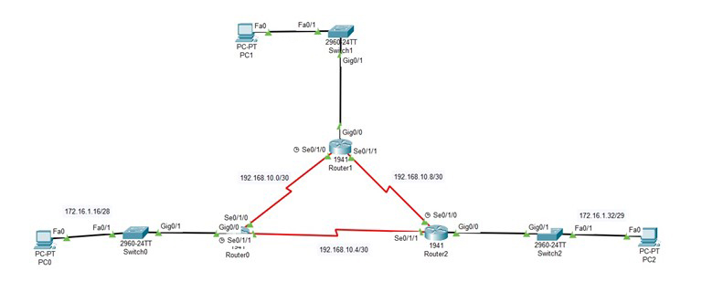

### **Working Procedure:**

***(****Explain in brief how you completed the tasks. Provide necessary screenshots of used commands for each task.)*

**Task #01:**

At first I changed the host name of the routers. Here I am providing codes for R1, then I configured the router. The process for router-2 is similar. To do this, I have used the following commands:

En

Config t

Hostname R1

Serial 0/1/0

Ip address 172.106.0.2 255.255.255.224

No shut

exit

Int gig 0/0

Ip address 172.140.0.1 255.255.255.192

No shut

Exit

Int gig 0/1

Ip address 172.140.0.150 255.255.255.192

No shut

Exit

Router rip

Network 172.106.0.0

Network 172.140.0.0

Exit

Then I set up the pc’s with correct ip addresses. After connection I checked with the ping.

**Task #02:**

At first I changed the host name of the routers. Here I am providing codes for R1, then I configured the router. The process for router-2 is similar. To do this, I have used the following commands:

En

Config t

Hostname R1

Int serial 0/1/0

Ip address 192.168.10.1 255.255.255.252

No shutdown

Int serial 0/1/1

Ip address 192.168.10.5 255.255.255.252

No shutdown

Int gig 0/0

Ip address 172.16.1.17 255.255.255.240

No shutdown

Exit

No ip domain-lookup

Network 172.16.1.16 0.0.0.15 area 0

Network 192.168.10.0 0.0.0.3 area 0

Network 192.168.10.4 0.0.0.3 area 0

end

### **Observation**:

### **Challenges (if any):**