Doc. No: VOD-IMP-PRC-0478 |  | SDQA Quality Assurance Strategy |  |  |  |  | Rev.1.2
Applicable areas of business  Network Programme Management |  |  |  | Company/Division/Area  Technology Efficiency Programme
Approval | Name |  | Job Title/ Role |  | Signature | Date
Owner | Masiza Qutu |  | QA Manager |  | Masiza Qutu | 2016/11/08
Edited by | Wilheminah Diale |  | Specialist QA |  | Wilheminah Diale | 2020/08/21
Approved by | Tony Nkhwashu |  | EHOD - NSD |  | Tony Nkhwashu | 2020/08/21
Approved by | Masiza Qutu |  | QA Manager |  | Masiza Qutu | 2020/08/21

Procedure, Process; Guide; Standard & Work Instructions Template

Doing what’s right

1 Introduction 3
1.1 Background 3
1.2 Document Synopsis 5
1.3 Objectives 5
2 Quality Assurance Resources 5
2.1 Key Points of Contact 5
2.2 Corporate Quality Strategy 6
2.3 The Definition of the QA Team Resources’ responsibilities 6
2.4 Competence 7
2.4.1 Test Analysts 7
2.4.2 Test Automation Engineers 8
2.5 QA Success Dependencies 8
2.5.1 Project Governance Measures 8
2.5.2 Change Management Governance 9
2.5.3 Effective Team Communications 9
3 Definitions 10
3.1 Test Management 10
3.2 Test Definition of Test Stages 10
3.2.1 Unit Testing 10
3.2.2 Integration Testing 10
3.2.3 Functional Testing 11
3.2.4 Regression Testing 11
3.2.5 Performance Testing 11
3.2.6 Rollback Testing 11
3.2.7 Factory Acceptance Testing 11
3.2.8 User Acceptance Testing 12
3.3 Test Strategy 12
3.4 Test Approach 12
3.5 Requirements 12
3.5.1 User Requirements 12
3.5.2 Business/Functional Requirements 13
3.5.3 Technical Requirements 13
3.5.4 Better Test Requirements and Test Cases equal better Test Packs 13
3.6 Moment of Involvement 14
3.7 Test Metrics 14
3.8 Defect Management 14
3.9 Quality Gates 15
3.9.1 Entry Criteria 15
3.9.2 Suspension Criteria 15
3.9.3 Exit Criteria 16
3.10 Process Optimisation 16
3.11 Test Tools 16
3.11.1 HP Quality Centre 16
3.11.2 Quick Test Professional 16
3.11.3 LoadRunner 17
3.11.4 Sigos 17
3.11.5 Appdynamics 17
3.11.6 IxLoad and IxCatapult 17
3.11.7 Qlikview/Qliksense 18
3.12 Application Environments 18
3.13 Test Data 18
4 Test Process Areas 18
4.1 Test Planning 19
4.2 Test Preparation 19
4.2.1 The SDLC V/W-Model within Preparation 20
4.3 Test Execution 21
4.4 Test Closure 23
4.5 Test Evaluation 24

Introduction

Background
This document will outline in relative detail, the general test process to be applied to the SDQA Stream. Whilst it is written to explain the overall process, there may not be a need to have all the elements applied to a particular project. The Test Plan that will accompany every test project will further detail the test process on the specific project, breaking down test types and test activities to accommodate the test project requirements.

The SDQA Stream needs to adapt to a refined process and strategy to achieve its objectives. The important word here is ‘refined’. This test process aims to fit and to define it, within the organisation so that it may be followed rigorously. Whilst there may be deemed a need for this lifecycle to change, this Test process may be the catalyst for such change.

Testing is based on requirements defined in the Business Requirements Specification. There should also be only one final version of this specific BRS and or SDD. Signoff needs to be done before the BRS goes to Development or QA (Test Analysts). It is understood however, that due to the nature of the dynamic nature of the Vodacom “production” environment, these requirements will change. As a result this test process is built with flexibility in mind rather than a rigid, follow each step approach. As a guide, this test process will:

- Force a testing reaction to every code handoff in the project
- Allow individual tests to be designed using information combined from various sources
- Allow tests to be redesigned as new sources of information appear
- Include feedback loops so that test design takes into account what’s learned by running tests
- Allow SDQA Stream to consider the possible savings of deferring test execution
- Mitigation of risks to the business
- Allow for ongoing operation, with minimal downtime to the Vodacom production systems
- By re-engineering due to testing, introduce cost-saving

This Test Process description and strategy is to be used as best practice for Test Stream to run the tests for the different systems and applications within the Vodacom NIT (ex-Engineering) environment (current and future). However, it is in no way rigid and will undergo change should experiences in its implementation force rethinking of particular areas. Testing should be a shape shifting process in its definition as well as its execution. The described test activities can be adapted either for test activities in new developed component or in improving the on-going/regression tests.

Since this document gives a guideline, which is the first step to standardize the test activities, the described deliverables and methods are mandatory for all commodities within the Test Cycle.

Because of the current projects’ situation faced by the SDQA Stream, the NIT systems which are already in production for some time, as well as projects which are just about to be implemented need to go through the full cycle as stipulated by the Testing Methodology and model.

To implement this standard, it is necessary to determine to what extent it will apply to each system. As such each test project will apply varying degrees of test activity according to the system under test. Some test activities may not need to be implemented, but become a built-in feature. These decisions will be discussed within the specific test projects Test Plans.

A summary diagram of the proposed test process is below. This will give a basic breakdown of the path to be followed. It highlights action, roles and deliverables.
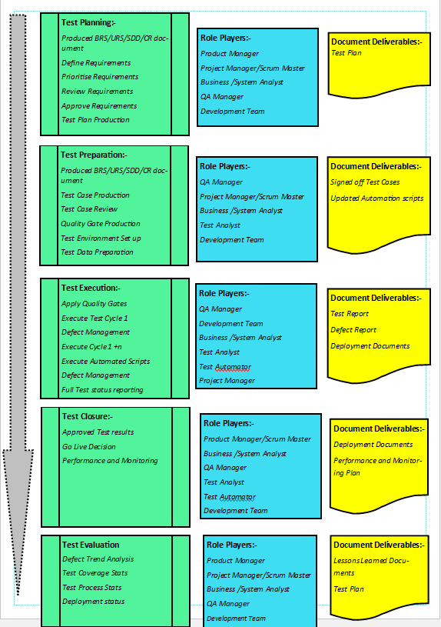

Document Synopsis
This document will include the following:
- The objectives of testing
- The testable items
- The approach to be used for the relevant testing
- The risks and contingencies associated with the testing of the requirements’ solutions

Objectives
Systems’ testing aims to prove that the software developed adheres to a certain level of quality and will provide the users with applications that are workable. To ensure that bugs are identified and handled accordingly. Risks should be made known to the relevant parties and the appropriate measures put in place to allow for contingencies. Integration testing aims to establish that the required communications do take place between the various systems’/product areas. Functional tests will be executed to ensure that new functionality performs in accordance with the specifications provided by the business. The final testing would be regression testing to ensure continuing services of current functionality. Certain portions of the testing will be done through automation to minimise the test effort. There is also a large section of testing that will need to cover Performance and Securities – for this purpose the Automation Analysts will also add the respective efforts required in the (1) Roles and Responsibilities, and the (2) Acknowledgement of Work sections of this document.

At a very high level, QA System Testing aims to prove the following:

- The developed solution for the requirements work according to the way they had been specified to
- The solutions meet and fulfil their business needs
- The solution is minimalist with regard to defects at time of deployment
- The solution does not impact on existing functionality within the system
- The solution’s resident defects are raised as risks
- That the risks raised are known to the business and suitably mitigated by all stakeholders prior to the deployment of the system/product/functionality
- Defects that cannot be fixed within time are highlighted to be fixed within a certain time to limit any impact upon business

Quality Assurance Resources
The compliment of resources based on the current resource model used for the Quality Test Centre stipulates that there will be approximately twelve Test Analysts, made up of a compliment of six (6) True - Functional Test Analysts together with six (6) Automation Engineers, whom can double as secondary Test Analysts as well. Based on the further value proposition that still can be established by the SDQA to the business, the resource compliment must be re-visited as from the previous SQA Maturity Assessment, it has already been noted that SDQA resources are being spread very thinly across multiple projects, which is leading to inefficiency/lower quality.

Key Points of Contact
Each of the relevant Test Analysts has been delegated an area/portfolio of the business for which they will be responsible. They must now be empowered with the new processes developed to (1) form strong relationships with the relevant Development, Business Analysts, Business and Project resources – this will also help build repertoire with key-stakeholders within the business and more importantly, credibility. They will also get to better understand and refine the entire workings and operation of their areas. They must represent the SDQA at all relevant meetings and give suitable feedback to the rest of the QA Team. This would promulgate knowledge sharing within the team and also help the relevant individuals become Experts for their relevant areas. They must communicate effectively to the Project team that they will be a part of, with regard to the quality assurance and testing functions. In empowering the analysts in such a way, this will start to create a sort of account management role, within the product streams, making them accountable for the servicing of their individual areas. This will also help build visibility and key co-operation, which was identified previously as being a missing link within this value chain proposition.

The cost effectiveness of testing is greatly increased by introducing testing into the Development Lifecycle at the requirements definition stage and test management at the CMB level.

Testing personnel should be involved in validating the business and technical requirement documentation, this testing technique is known as static testing.

Static Testing is the testing of a component or system at specification level without execution of the software. As mentioned previously, it is a known industry fact that anywhere between 54% and 70% of defects are can be attributed to incomplete, ambiguous, inconsistent or unclear specifications. Inspection of the requirements up front will contribute significantly to defect prevention.

Corporate Quality Strategy
Effective testing organisations have corporate quality policies that display Management commitment to software quality and testing. It is imperative that Vodacom adopts such a strategy effectively to expropriate the full level of Quality to all development. Points to be considered are:

- A clear policy and commitment to quality is formally established and stated
- Test Plans are produced for each and every release
- Business and technical requirements are considered vital and are clearly documented, maintained and vetted prior to release to development
- Software releases are deployed in the absence of critical or severe defects
- Metrics (Minimum requirements for deployment) are defined
- Key Risk areas identified and understood prior to authorisation to deploy
- Quality gates and responsibilities are defined
- The organisation, led by the SDQA team reject any scrappy product development from Suppliers
- Ability to run specified testing within realistic timelines as opposed to the “Test when Development has finished” approach
- As part of the Strategy’s policy, no defect with a severity of “Critical/Severe” nature shall be implemented into production

The Definition of the QA Team Resources’ responsibilities
Though the Team roles and responsibilities have been defined, there is no defined QA role that ascertains the quality and consistency of the work being performed, that standards are implemented and adhered to.

The implementation of the formal Edge-designed process into the SDLC for Vodacom will alleviate the day-to-day pressures and make the team more effective; however this may require the acquisition of short-term resources to manage the increased work load as a result of process change.

The role of “Test Manager” is absent within the team, project tasks are passed down to the team members and it is up to them to perform all of the necessary tasks which include the test management of the project from the SQA side. The necessary Test Manager will help alleviate some of the operational hiccups that are currently encountered by the team in terms of planning and key co-ordination with Project Managers, as well as manage the Test Analysts and Automators more effectively across projects allowing the QA Manager to play a more pivotal and strategic role in the positioning of the team within the broader Vodacom scope.

The Roles in the department need to be more clearly defined, viz. Test Manager, Test Analyst, Functional Automation Engineers, Performance Engineers, Security Engineers, and Quality Center Administrator. Team members are battling to perform their tasks efficiently when they are dividing themselves across too many disciplines. Better capacity planning must be employed however this may only suffice for the very short term, when the lack of adequate resource-compliment, may again impact upon the delivery. Edge recommends that specific Test roles can be put together for Vodacom with Key Result Areas for the relevant resource descriptions so as to assist the QA Manager in term of Career/Development Planning of the resources and better delivery from each resource.

Vodacom should employ one or more Test Managers to be better implement the process in order to manage test projects and ensure standards are adhered to within SQA. Having one or two points of contact for the project management team should also resolve the issues surrounding the moment of involvement for SDQA. Then, a minimum of four Test Analysts are required to cope with the increasing workload.

Competence
The Team is competent in managing all test requirements that eminate from NSD as well as other business units.

Test Analysts
All the projects requirements will be captured in the new Quality Center – known as ALM Octane – at which point the Test Analysts will be in a position to go in and from thereon continue with the Test Execution process. The results will also be captured on the same system, and can be extracted to Qliksense for external reporting.

However it must be noted that a manual Quality Gate must still be enforced after the Requirements capturing process. This, though still rudimentary will take on the form of a Requirements Review between a necessary party (Review Specialist/Test Manager) and the Test Analysts, whereby all of the requirements will be reviewed against the documentation provided. This process will either allow for the next step of Test Case extraction to commence if okayed or force an iteration to refine the requirements provided which already shows a potential of minimising any rework through early detection.

It is recommended that the Functional Test Analysts attend refresher training for the following:
- Testing Management overview and introduction
- Testing Techniques
- Technical Tool Training for Microfocus Tools
- Test Design for Automation

Standards for test requirements, test cases and test scripts need to be developed and implemented. Microfocus is capable of conducting the training for both of the above recommendations either on or off-site for Vodacom. At the end of the training, each resource will be evaluated through a simulation test to vet their learning of the course material. Thereafter they will again be evaluated within the next thirty (30) days, to see their (1) understanding of the course material after a suitable absorption-period and (2) application of the training within their given environment(s). This ultimately will ensure that the resources that comprise the SDQA are empowered from a skills point of view and that there is business value that can be derived from each resource.

As described in Section 2.3, the KRAs used to determine the different category resources can also be used as part of their PPDs (Personal Development Plans). This can help in evaluating each resource against a set of indices that need to be completed within, for instance a six (6) month period and then percentages attached to each of the indices’ deliverables.

Test Automation Engineers
The automation testing team members are highly skilled in their own right; however, they do assist in test analysis and design from time to time. They are also involved in all tool sets, they are responsible for test analysis functional, Performance, Security Testing and Monitoring.

Again to standardise the level of Automation, all Automation Engineers should attend the following training at least, to satisfy the need to the SDQA Automation area:
- Quality Test Professional
- LoadRunner
- Sigos
- Appdynamics
- IxLoad
- IxCatapult

QA Success Dependencies
Certain functions are required as critical components that enable the actual QA function to become more meaningful and effectively. Without which, the QA and Testing function remains rudimentary and cannot develop further that the point it is at due to the constraints introduced by these dependencies. These dependencies take the form of proper Project Governance management, Change Management Governance and excellent communication Cross flows amongst the relevant teams within co-ordinated within the project. With the introduction of these critical success “variables” being implemented within the organisation, the maturity slowly increases and has a directly-proportional impact upon the success factor of the QA Function as these variables allow for a broader spread of the testing activities over more phases within the SDLC and additional teams taking more responsibility and accountability for activities and the qualitative success of these activities.

Project Governance Measures
Major projects and initiatives are well managed through recognised project management methodologies (Prince2, Agile, Scrum, Kanban, Lean, XP etc.). While a formal project management methodology exists within Vodacom, on review of the documentation, the “methodology’s” integration of testing and quality assurance does appear to be consistent with the norm. There needs to be more open lines of communication between the Vodacom Project Managers and the third party vendors’ Project Managers. There is no formalised process to follow when it comes to a project management methodology as each company has their own methodology. It is also apparent that due to the day-to-day pressures of satisfying user demand, the process standards that are defined are not always complied with.

All Project Managers (Vodacom staff and third party) will have to decide on a methodology and ensure that they standardise their approach to the SDLC. This process will have to be documented and signed off by all involved. There could be an option of a centralised PMO set up that controls the projects through co-ordination of all projects both internal and external.

Change Management Governance
There is no clear and concise change management process within Vodacom Engineering.
Changes should be prioritised and allocated to releases based on:
- Priority based on business value or compliance to legislation (This does not mean which user shouts the loudest)
- Complexity (Higher complexity is proportional to business risk of deployment)
- Resource availability
- Budget
Vodacom’s releases are ad-hoc and there is no change management board to decide on whether the changes should be implemented or not.

The Change Management Board should consist of a number of IT disciplines, including the Test Manager and should also include an element of business as well.

The Board should review the prioritised list of projects, change requests and outstanding defects and allocate these items to future releases based on the criteria mentioned earlier. Changes across the application platforms and vendors should be better co-ordinated to ensure minimal impact and mitigation of risk.

Effective Team Communications
Project teams are aware that the SDQA function is integral to the quality of the software to be released. It sometimes happens that the SDQA team is left out of the loop when it comes to certain new projects and are only included later which results in the testing process being “Squeezed” and the test analysts cannot properly complete their tasks as they would like to. There appears to be significant communication amongst the IT team, it is apparent that this communication could be improved through a more formal and integrated approach across all of the teams. Business analysts do not believe that QA is involved early enough in the SDLC. The approach is that once a project manager is allocated to a project he/she then allocates testing and other resources to a project. There are also situations where the SDQA team is under resourced to be able to attend all sessions pertaining to their allocated projects.

Relevant members of the test team should be part of the Change Management Board to fully understand the upcoming release content. Although test plans are created, more attention needs to be paid to the performance and security requirements of each release. Test plans created are not used in a formal manner as a living document to be managed throughout the development of a release, nor are they signed-off to applicably manage the responsibility and accountability across the entire project team.

Test Analysts, Business Analysts and System Analysts/Architecture should communicate business and system requirements in order to test the requirements for accuracy and thereafter ascertain and develop appropriate test assets for functional, performance and security test execution in line with the Test Plan.

From a testing point of view to this end, it will be up to the SDQA team to drive out Requirements Management sign-off, Test Case Sign-off and Defect management status meetings, as part of effectively opening up the communication channels. The QA Manager must ensure that these happen and should be instrumental in making sure that the team handles these mechanisms suitably, as the first points of departure.

Definitions

Test Management

Software testing is either done in the framework of a project or as an on-going activity. To achieve desired, successful results it is essential to ensure that testing becomes an independently managed process. Test management addresses the following issues:
- Test Planning
- Test Preparation
- Test Execution
- Test Closure
- Test Evaluation

The Test Management concept is detailed to the needs and the structure of Test Stream. The Strategy can be used to support any Testing tool selected to support all test management issues. For Vodacom Engineering environment, the toolset is HP’s Quality Centre.

Test Definition of Test Stages
The proposed Test strategy will incorporate test activities that will be applied at various stages within the test process. Whilst there are many test stages and differing ways of defining them, these are the accepted best practices. These test stages will be defined in detail within the specific test plan for each project. Each of these test stages will have their own specific test pack. It is possible that specific projects may require test types to be grouped within stages of testing that differs from the recommendation below:

Unit Testing
This is the last step in writing of code. This testing will be the sole responsibility of the developers and, although beyond the scope of this document, it is expected that “White Box” testing techniques will be used. Unit Tests and test results must be accessible to the Test Analysts as the unit test results will be part of the Entry criteria into specific stages of testing. Once completed, the Development Lead/Manager hands the sign-off to the QA Manager for verification and control thereof.

Integration Testing
The testing of two or more modules or functions together with the intent of finding interface defects between the modules or functions. Testing completed as a part of unit testing and sometimes, becomes its own standalone test phase. On a larger level, integration testing can involve a putting together of groups of functions with the goal of completing and verifying that the system meets the system requirements. Test Types involved in this stage are:
- Inter-Flow Testing
- Configuration Testing

Functional Testing
Testing two or more modules together with the intent of finding defects, demonstrating that defects are not present, verifying that the module performs its intended functions as stated in the specification and establishing confidence that a program does what it is supposed to do.

These will be fully defined within the Test Plan of each specific development. Test Analysts will be responsible for the creation and execution of these tests. Management and responsibility lie with the QA Manager.

Regression Testing
To test with the intent of determining if bug fixes have been successful and have not created any new problems. Also, this type of testing is done to ensure that no degradation of baseline functionality has occurred. They are classified as:
- End to End testing
- Transaction Path Testing
- Parallel Testing

Regression testing will be heavily time consuming from a manual execution perspective. Regression testing is ideally automated for this reason. The Automation Analysts will be responsible for the creation and execution of these tests. The responsibility lies with the QA Manager.

Performance Testing
Testing with the intent of determining how quickly a product handles a variety of events. New Generation Automated test tools are geared specifically to test and fine-tune performance are used most often for this type of testing. Test Types involved in this process are:
- Volume Testing
- Stress Testing
- Scalability tests
- Performance Testing

Performance testing must have pre-defined goals/criteria in order to obtain effective results and ultimately, to carry out meaningful comparisons. This again should be tasked to the Automation Analysts within SDQA to execute.

Rollback Testing
These tests will ensure that the enhanced system can be rolled back safely to its original condition if the enhancement(s) fails. These tests will be created and executed by the Developer and to some degree, the Configuration Manager and QA Manager in more mature environments. Test Type involved in this process are:
- Recovery Tests (Testing of the Rollback procedures)

Factory Acceptance Testing
These tests ensure that after the systems testing cycle has been completed; it is acceptable to release the solution into the UAT phase. At this point final clarity is issued around installation, configuration and use of the system. FAT, is geared to operate in lesser-matured environments, as it becomes more of a quality gate rather than a defined phase.

User Acceptance Testing
UAT is the final acceptance test designed to confirm that the system operates according to the specified requirements. Test Analysts will produce the test cases for UAT in conjunction with the Business Analysts (BA) and users, and collate the results from it. However, the execution of the test cases will be the responsibility of the BA and assigned business users. Generally here, limited parts or access to the system is available to a specified community of users. Tests types involved are:
- End to End testing
- Business/Operational Process Testing (Model Office Testing)

Test Strategy
The complete test strategy is based on the quality goal defined for the product to be tested. The quality goals are the requirements for the test. They determine the Test stages and the quality goals. In order for this strategy to be implemented across the board by SDQA, current test activities will be centred on applications and functions within these applications. In future, to optimise the test activities and make solid planning possible, systems will be broken down into business process functions across the relevant multiple applications.

Test Approach
The adopting of Risk-based testing approach, in conjunction with METSE will be used. Based on analysis done thus far for the SDQA Team and Vodacom Engineering, this is ideally suited since it works from a business and risk perspective. This will also ensure that resource time is not wasted on over testing or expose the business to risk by under testing. Having identified the specific risks of concern, the areas or functions that need to be tested are identified, with a selection of test techniques to address these risks. This will thus be a win-win situation for the business and NIT.

Requirements
An inevitable prerequisite for testing are expected results or requirements. To get a better understanding it is helpful to divide requirements into different categories. The industry defines these as business/functional and technical requirements.

There are various documents which are utilised for deriving test requirements. Testing must not commence unless the following 3 mandatory input documents are presented to the SQA Lead/Test Manager:
- User Requirements Specification (URS, mandatory)
- Solution proposal (optional, depending on size/complexity of Project)
- Business Requirements Specification (BRS, mandatory)
- Technical Specification (TS/TDS, mandatory)

User Requirements
These documents are the actual source of the initiative/product. It is developed by the product specialists and is usually conceptual in nature identifying what the product is envisioned to do. The requirements may seem vague as there may be either very little formal information in terms of explanation of functionality nor any performance or security standards attached and especially what the user actually wants. This document will provide the high level test requirements expected for QA of the initiative/product.

Business/Functional Requirements
The business/functional requirements are documented by Business Analysts, in conjunction with the business owner or end user. This would be better documented as the Business Analyst will attempt to show how the solution for the initiative/product should be developed. There should be specifics in terms of functionality(s) needed, expected performance and security requirements, so that tests can be built around these specific and tested to validate whether these requirements have been reached in development or not.

Test Analysts would normally extract these requirements from the URS and BRS at least, to form the test basis. In line with the new process and the adoption of the Caliber “automated” requirements capture process, the Test Analysts will have to provide the Caliber QA Developer with their input documents. The Caliber QA Developer then proceeds to use the mapping setup, to extract the Requirements from these input documents. These requirements are stored within the Repository of Caliber. The QA Developer will then export the requirements into Quality Centre – the testable requirements will now appear within QC under the Test Requirements section. Should any requirements be changed within the SDLC of the initiative, it will be possible to update the relevant requirement and this will subsequently update the Test Requirements in QC accordingly.

The use of the QC tool will enable more effective control on requirements as well as increase the transparency of cross-application requirements. This may take place in the future once the test process has matured and effective application understanding and requirement specification is a common place.

Technical Requirements
The Systems Analyst/Solutions Architect/Developer based on the BRS provided, documents the Technical requirements. These can be presented in an MSWord Format as the Software/Technical Design Specification (SDS or TDS). They are built using the Unified Modelling Language (UML) and map application structure, behaviour, and architecture.

The SDS is used by Test Analysts to increase the depth of the scenarios produced for testing, especially around the technical portions of the testing to be run. This detail will be a minimum requirement set by SDQA for testing. It has been noted that in the past, this document comes very late in the process. The QA Manager or Test Manager must insist on the need to have the Design spec for the Technical Requirements much earlier in the process. This document is normally produced within the Design phase of the SDLC; therefore it is possible for the Supplier to provide at the very least a Drafted version of the Design Spec to the SDQA team.

Better Test Requirements and Test Cases equal better Test Packs
Testing time is normally granted for approximately two to three weeks; however, it is normally reduced to a week due to time constraints.

Parameterisation of test data in these tests is of utmost importance. A great deal of the data is ‘hard coded’ into the test design steps, this type of design does not allow for expansion of the test pack to include boundary or any other type of testing which requires a variation of data.

Parameterisation contributes to more effective maintenance effort for the team. There seems to be little capacity for the testing team to perform full regression testing manually for every project. Most of the test analysts’ time is spent only focussing on the new development testing and not on the existing functionality.

Moment of Involvement
Due to the fact that there are many third party vendors involved in the SDLC at Vodacom engineering, there are different methodologies being utilised. These differences affect the overall involvement of SQA in the SDLC. The test team have not been involved up to now, early enough in the SDLC to ensure that the specifications are validated prior to sign off to development.

The new processes have been developed to specifically alleviate such issues whereby the Test Analysts migrate toward more interaction with the business and similarly manage the delivery of Testers. Similarly, the Test Manager should be part of the Change Management Board in order to understand the nature and volume of projects, changes or bug fixes that are scheduled in each release. This information is vital for resource planning, risk assessment, creation of test plans and time frames available to the team.

Test Manager, along with other disciplines, must be included in the Change Management Board. Test analysts must be involved at the point where Business and Technical specifications are being developed. This process has to be documented and implemented by Vodacom as a standard that must be adhered to by all parties involved whether they are contracting or full time resources.

Test Metrics
The test metrics though defined for SDQA can be increased to report on additional information. Octane has the capability for customised fields and reporting should be reviewed to present the following:
- Requirements
  - Progress in test requirement definition
- Test Design
  - Progress in design development
  - Requirements coverage
- Test Execution
  - Progress
  - Pass/Fail Ratio
- Defects
  - Defect detection rate
  - Defect ageing
  - Defects by severity
  - Defects by route cause

Defect Management
Accurate defect management statistics should form part of the SQA process in order for the team to be able to more efficiently manage releases based on defect criticality and status. Any defects found in production should be recorded in Quality Center and have test cases developed that will form part of the regression test pack which will be run with every release ensure the defect doesn’t recur. The purpose of the regression testing would not be used to specifically find defects but instead to give the system a clean bill of health when necessary. Defect analysis should be performed to determine trends that may highlight areas of process improvement.

Quality Gates
The governance of the Quality Gates implementation must be enforced through the forums like the Change Management and Project Office, together with the QA Manager to manage the gates – as this will determine the entry and exit mechanism of each phase and in particular for this exercise, the Testing Phase and its deliverables, together with the quality of these.

In order to maintain quality control within the test process, quality gates exist. This allows Test Analysts to address the different quality goals separately and to be able to execute the test at the earliest possible moment in time. Quality gates between the different stages are the critical success factor.
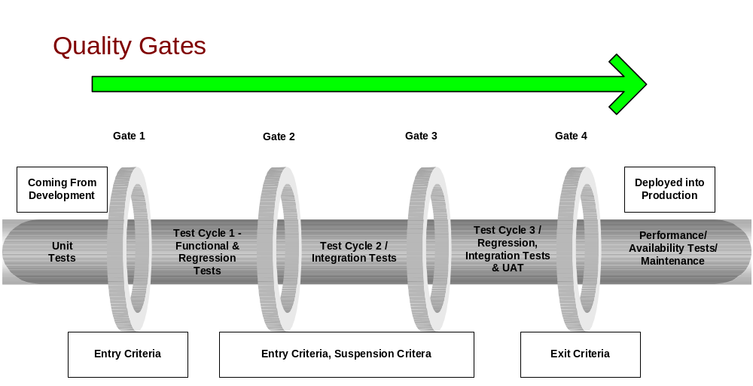
Initially there will be three quality-evaluation gates defined within this test process, namely Entry Criteria, Suspension Criteria and Exit Criteria. These will be as follows:

Entry Criteria
This will be applied to the development within the Test Lifecycle and test environment. This will confirm that the development is in a suitable state to move into the Test execution stage. These tests will be performed prior to each test cycle. There may be changes to them dependent on any requirement priority changes.
If the criteria are not met the developed solution will be rejected and returned to development. They will be re-applied when the development is deemed ready for testing until passed.
- All high priority Unit Tests passed. Results from Development will be stored in a generic Test Repository.
- 100% of the test cases for the critical and high priority Business Function are executed and there are no Critical or High priority defects open.

Suspension Criteria
Once the entry criteria tests have been run successfully, the development will move into the execution stage. To ensure a quality standard within the test execution stage, suspension criteria will be applied constantly. This may vary per project but will always have the following minimum standard.
- If the test case failure rate reaches 25% or higher, testing will be suspended.
- If the requirements change during a test phase, testing will be suspended until updates to the BRS and subsequent changes to the test activities are finalised and agreed.

If the testing of the development is suspended, it will be returned to development for re-working. Once deemed ready for testing the entry criteria will be applied again.

Exit Criteria
These tests will determine the suitability of the development to move to the UAT stage within the test execution phase.
- No Critical, High or medium defects must be open (i.e. re-tested, passed and closed) after full test execution

Process Optimisation
With the use of a number of the tools employed within Vodacom Engineering, a lot of the enabler-processes can be activated. The enabler-processes are those which assist the overall activity run more smoothly and efficiently

Test Tools

HP Quality Centre
Octance- that used to be Quality Center is the Test Management tool that is used. All projects are captured, executed, reported upon – based on the findings.

An upgrade from HP Quality Center to Microfofus Octane helped enhance the intergration of many tools under QA use such as Qliqsense, Intellij etc

Quick Test Professional
Test automation should only be applied when manual test efforts have been effectively applied and the application is stable enough to implement automated regression testing. Only then should a formal automation strategy be formulated focusing on aspects of the application that offer high business value and is resource intensive performing manual tests.

At this point, it is difficult to ascertain the impact of the implementation of the GAFX automation framework. Regression tests will need to be manufactured as soon as possible as there is a significant demand among the various systems role players for sanity checks that will be able to perform integration tests prior to going live with any piece of code. However, it has been experienced that this framework requires extensive specialised maintenance that cannot be easily obtained in the market.
It was noted that where automation scripts have been developed, these scripts are being saved on the personal machines of the engineers responsible for creating them. This poses a great deal of risk should anything happen to their hard drives. It is highly recommended that these scripts are saved into Quality Centre or a suitable shared drive as soon as possible to avoid any loss of testing assets.

There is a misconception that test automation is the “silver bullet” to software testing, it has been our experience that unless implemented in a careful and managed manner, the costs and negative impact that results from an informal implementation will deter an organisation from deriving the benefits that can be obtained from a formal and carefully planning implementation.

It is Edge’s opinion that a full assessment of Vodacom’s test automation assets be undertaken and that a formal test automation strategy be formulated that better serves the objectives of Vodacom Engineering.

LoadRunner
The formulation of performance assurance test plans and the requirements thereof are informal at best. There is a misconception that the SDQA team have to identify the need for performance, load and stress testing on any given project that they are busy testing. The requirements for any type of non-functional testing should be accompanied along with the functional requirements. This would save a lot of time at the end of the project with the avoidance of the non-functional being urgently created before go-live.

Performance test plans should be incorporated into the overall test plan highlighting component performance testing where necessary in the development or architecture construction phases, as well as overall performance testing in a pre-deployment environment.

Sigos
The Quality of Service testing and Quality of experience, this allows the team to be able to test the network quality, and can also simulate calls from remote areas’, making roaming testing simple. The Revenue assurance module helps dentify non-generation of CDRs, metering and rating errors
Protect roaming revenues from important countries.

Appdynamics
Actively monitor, analyse and optimize complex application environments at scale. AI-powered insights and automated actions coupled with our vision forward with Cisco.Visualize revenue paths and correlate customer and app experience to find and fix app issues.Enterprise-grade visibility and insights to monitor cloud-native technologies in real time.Optimize key business transactions with a complete view of the customer journey.Complete visibility across servers, network and containers whether on premises or in the cloud.

IxLoad and IxCatapult
IxLoad delivers comprehensive performance testing for validating user quality of experience. IxLoad works by emulating web, video, voice, storage, VPN, wireless, infrastructure, and encapsulation/security protocols to create realistic scenarios. The IxCatapult is a tool which help you to simulatea wide variety of wireless nodes to fully isolate the device or system under test. The user has un-matched flexibility and control in defining complex test scenarios for both positive and negative testing

Qlikview/Qliksense
Qlik Sense is a complete data analytics platform that sets the benchmark for a new generation of analytics. With its one-of-a-kind associative analytics engine, sophisticated AI, and high performance cloud platform, you can empower everyone in your organization to make better decisions daily, creating a truly data-driven enterprise. Provides an end-to-end platform which includes data integration, user-driven business intelligence and conversational analytics.

Application Environments
Vodacom currently have the following application environments;
- Development environment
- QA testing environment
- Pre-production (Not always available)
- Production environment
Change and configuration management is almost non-existent; it is not unheard of for developers to change code in any one of these environments, irrespective and with very little communication. This makes proper testing ineffective as different versions of codes can be deployed onto an environment on an ad-hoc basis making the testing perform null and void.

It is imperative that change and configuration management take place in a managed and disciplined fashion. Any change made in QA nullifies all testing preceding the change and could effectively result in a re-test of the entire application. In addition, there is a risk that a change made in production or QA may not be retrofitted into the Development environment. This practice adds risk and inefficiencies into the development lifecycle and should be “outlawed” with immediate effect. Only in absolute exceptional circumstances should this be performed and procedures implemented to ensure that such exceptions are carefully managed and focus applied to rapidly apply and re-test the exception in both QA and Development environments to ensure synchronisation.

More effective test planning and utilisation of cycles and releases within Quality Center may improve the test process to ensure testing of integrated functionality occurs when end-to-end testing is possible.

Test Data
Ideally Data should be stored in datasheets and any dynamic data i.e. dates of birth can be entered as a formula to suit the test.

Not having data stored for re-use, means that you are never performing exactly the same test. Performing the same test could easily re-create any errors.

Test Process Areas
As depicted earlier, the Test Process areas – Test Planning, Test Preparation, Test Execution, Test Closure and Test Evaluation shall be explained, together with tables of responsibilities within the SDLC. Each area will consist of a set of deliverables, roles and responsibilities that will be clearly defined within them.

Test Planning
Test planning incorporates the requirements analysis and extraction and test plan production. The following table will detail these tasks for testing purposes and the people responsible for those tasks. Note that this does not replace any SDLC activities, but makes reference specifically to the testing activities.

Table “Planning”

Task | Detail of Task | Responsibility | Consult/Involve/Inform
Define business/functional Requirements | The BRS will be the source for requirements. This will be version controlled. | BRS written by BA | Test Analysts
Extract, review and prioritise test requirements | - Requirements will be extracted and documented in Repository  - Review and amend requirements in the Test Tool  - Prioritise test requirements to enable setting of quality gates | - Test Analyst to extract Test requirements  - Test Analyst and QA Manager  - Test Analyst and QA Manager | - Review Test requirements with Business and Bus Analyst  - Business Analyst  - Proj/Programme Manager
Requirements Approval | Relevant parties to approve and sign off test requirements | Programme Manager and QA Manager | Developer, Business Analyst, QA Manager and Business representative
Test Plan | - Produce Test Plan Production  - Consolidated Master Test Plan | - Test Analysts  - QA Manager | Programme Manager and BA
Test Plan | Sign Off Test Plan | Programme Manager and QA Manager | Developer, Business Analyst and Business representative

Test Preparation
Test preparation incorporates the production of test cases, set up of the test environment, extraction, and test plan production. The following table will detail these tasks for testing purposes and the people responsible for those tasks. Note that this does not replace any SDLC activities, and makes reference specifically to the testing activities.

Table “Preparation”
Task | Detail of Task | Responsibility | Consult/Involve/Inform
Define Software Design Specification (SDS) | Completion of detailed SDS | Developer | Business Analyst and QA Manager
Define Software Design Specification (SDS) | Sign off of detailed SDS | Programme Manager | Developer, Business Analyst and QA Manager, Test Analyst
Test Case production | Produce test cases for all business/functional and Technical requirements covering Test Stages and types | Test Analysts | Business Analysts
Test Case review and sign off | Inspection and review of Test Cases and subsequent sign off | Test Analysts | Business Analyst and business representative
Unit Test Case production and sign off | Production and signoff of Unit test cases, which must be accessible to Test Analysts | Development | QA Manager
Production and sign off of entry criteria (one of the quality gates) | Compilation and sign off entry criteria based on prioritised business/functional requirements. (Quality gates are defined Link) | QA Manager, Test Analysts and Project Manager | Application Management and Development.
Test environment set up | Set up of applicable, stable test environment as well as the setup of relevant test data | QA Manager, Change Control, Test Analyst | Development and Business Analyst

The SDLC V/W-Model within Preparation
The SDLC V-Model is used for systems’ projects. The benefit of the V-Model over the Waterfall model is that the V-Model has corresponding activities for every development activity whereas the waterfall method only includes testing at the end of the phase, which does create bottlenecks for software quality testing.

The LHS (left hand side) of the model is predominantly for performing verification on LHS phases and RHS (right-hand side) for performing validation on RHS side. The effectiveness of this model is that at every stage of the process, there is a corresponding activity for testing i.e. when Business requirements Specification is completed, it must also contain the Acceptance Testing Criteria for business.

In the diagram depicted below, the outer-most activities represent the testing aspects of each stage. For e.g. Once the Requirements have been drawn up, the Test Team will Test the requirements, then once the System has been specified, the Test Team will then test the specification and so on. For this representation, the formation of the W-shape is illustrated. The W-Model is specific to Testing and many best practices are based on it. In its most generic form, the W-Model developed by Paul Herzlich in 1993, presents a standard development lifecycle with every development stage mirrored by an associated test activity.

The W-Model builds on the V-Models benefits. Many ask as to how it alleviates problems such as bottlenecks. The most practical illustration of the benefit is that during the earlier phases, prior to the writing of the actual code, many problems, defects or bugs can be picked up much earlier. What this means is that if a problem is detected for e.g. during the System Specification phase, it can be rectified before it actually gets designed. This is the difference between a correctly specified system and an incorrectly specified system. Had it not been resolved, there would be a situation later on in the cycle or probably later, where by the now latent defect must be resolved so that it meets the requirement. The cost for having such issues handled earlier on has been proven by international and local studies, and those done by Gartner, as to be reducing potential “derailment” by up to 250%, with a cost saving of approximately 80%. This means that the risk can be considerably reduced by resolving these earlier than when they are in production and fail. Put simply Working system Vs. System down!

Below depicted is a diagrammatic view of the W-Model with corresponding activities

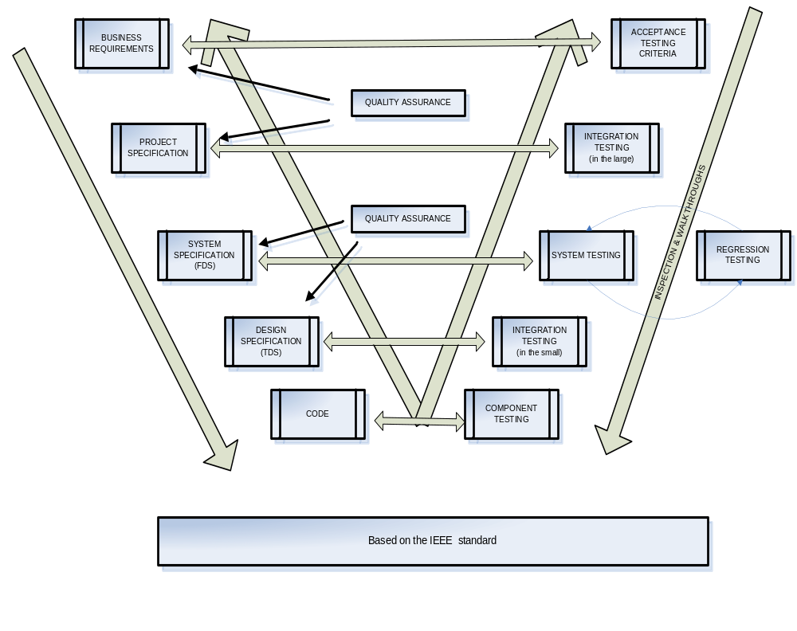

Test Execution
Test Execution incorporates the running of all test activities in sequence as defined in the Test Plan. The following table will detail these tasks and the people responsible for those them.

Table “Execution”

Task | Detail of Task | Responsibility | Consult/Involve/Inform
Unit Testing | Development performs unit tests from tests stored in Repository. Unit Test results and defects placed and managed in as well. | Development - Dev Lead/Manager and QA Manager | QA Manager and Test Analysts
Deployment to test environment | Once successful Unit testing is complete the test object will be deployed to the predefined test environment | Development - Dev Lead/Manager, QA Manager and Change Control | Developer and Business Analyst and Test Analysts
Entry Criteria applied | Pre-defined and signed off entry criteria applied to the Development within the development environment | Test Analysts | QA Manager, Business Analyst, Proj Manager and Business rep
Test Cycle 1
Test Cycle 1 | Test cycle is complete run of all tests on all requirements. Suspension Criteria applied within test cycle (for suspension criteria see Link). Test Stages and Test types are defined in Link2 | Test Analysts | Business Analyst, QA Manager and Business rep
Defect Management | Co-ordination, reporting and monitoring of all defects within Repository.  Initial review of defects  Defect meetings to be co-ordinated by QA Manager. | QA Manager  Development, BA’s and Test Analysts  Test Analyst | Test Analysts  Development  Development, Business Analyst and QA Manager
Requirement and quality gate definition | Test Analysts to revisit test requirements and test cases after defect fixing to ensure test accuracy. Adjustment to quality gates if necessary. Sign off of all changes | Test Analysts | QA Manager, Business Analyst, Proj Manager and Development.
Defect Resolution and deployment to test environment | Defect fixes applied to test environment. | Development, Change Control and QA Manager | Test Analysts, Business Analyst, Business Rep
Entry criteria re-applied | Pre-defined and signed off entry criteria applied to the Development within the development environment | Test Analysts | QA Manager, Business Analyst, Project Manager and Business rep
Test Cycle 2 and Cycle 3
Test Cycle 2/3 | Test cycle is complete run of all tests on all requirements. Suspension Criteria applied within test cycle (for suspension criteria see Link). Test Stages and Test types are defined in Link2 | Test Analysts | QA Manager and Project Manager
Defect Management | Co-ordination, reporting and monitoring of all defects within Test Management Tool.  Initial review of defects  Defect meetings to be co-ordinated by QA Manager | Test Analysts  Development, BA’s and Test Analysts  Test Analyst | Test Analysts  Development  Development, Business Analyst and QA Manager
Requirement and quality gate definition | Test Analysts to revisit test requirements and test cases after defect fixing to ensure test accuracy. Adjustment to exit criteria if necessary (for exit criteria see Link). Sign off of all changes | Test Analysts | QA Manager, Business Analyst, Proj Manager and Development.
Defect Resolution and deployment to test environment | Defect fixes applied to test environment. | QA Manager, Development and Change Control | Test Analysts, Business Analyst, Business Rep
Exit criteria applied | Pre-defined and signed off exit criteria applied within Test environment. | QA Manager and Test Analysts | Business Analyst, Programme Manager and Business super user
Deployment to UAT environment | Development applied to UAT environment. Project Manager and development to set up environment and data | Change Control, Development and QA Manager | Test Analysts, Business Analyst, Programme Manager and Business Testers
UAT Testing
UAT execution | UAT test cases  UAT test case sign off  mentor UAT testers in test case use and defect logging  UAT test management  Available at all times in UAT.  Collation of results by Test Analysts | BA’s and Business Users  BA’s, Business Users and Test Analysts  Test Analysts  QA Manager and  Test Analysts  Test Analysts | Project Manager, QA Manager
Defect Management | Co-ordination, reporting and monitoring of all defects  Initial review of defects  Defect meetings to be co-ordinated by QA Manager.  Full Defect reporting to enable go live decision | Test Analysts  Development, Business Analyst and Test Analysts  Business Analyst  QA Manager | Test Analysts  Development  Development, Business Analyst and  Proj Manager

Test Closure
Test Closure incorporates the production of full reports on all test activities executed. The following table will detail these tasks and the people responsible for those reports.

Table “Closure”

Task | Detail of Task | Responsibility | Consult/Involve/Inform
Test Sign off | Test Process results and sign off. (To include test case status, test coverage and defect status from all test types) | QA Manager and Test Analysts | Business Analyst,  Business Rep and Monitoring Rep (Internal Audit)
Go Live decision | Go Live decision  On-going performance testing and monitoring to be defined | Project Team and Business  Automation Analyst, QA Manager | Developer(s) – Deployment Team, Business Analyst and Internal Audit, if necessary  Developer(s), Solution/Enterprise Architect

Test Evaluation
Once test closure has been achieved, a period of Test evaluation can begin. This is the “metrics-gathering” phase, which will enable full analysis of the test process on each test project.

The evaluation encapsulates:
- Defects Trend Analysis – are there particular areas in the test project that had higher instances of defects than others. Why were there higher amounts of one classification of defects than other classifications? Root cause analysis on Critical, High and Medium defects etc.
- Test Coverage Statistics – were all tests run on the test project? Did one priority of test case fail more often than other priority test cases? Did the test cases have sufficient detail to entirely test a particular requirement
- Test Process statistics – was the test environment stable at all times? Was test data sufficient? Were changes to the requirements effectively managed? Was the test project stopped because of quality gate failure?

The required metrics can be discussed and implemented as formal deliverables for each test project as necessary.

Distribution List
Copy Number | Name | Group/ Division/Organisation
1 | QA Manager: Masiza Qutu | Engineering
2 | BSS Manager: Nozipho Nyandoro | Engineering
3 | SD-QA Team | Engineering
4 | SD EHOD:Tony Nkhwashu | Engineering

Abbreviation List
Term/Abbreviations | Description
TA | Test Analyst
BA | Business Analyst
FAT | Factory Acceptance Testing
UAT | User Acceptance Testing
METSE | Minimal Execution Testing Systems Evaluation
CUR | Common User Repository
MOC | Mobile Originating Call
SP | Service Provider
VSP | Vodacom Service Provider
AIA | Account In Arrears
UAT | User Acceptance Testing
FAT | Factory Acceptance Testing

Document History

Revision | Date | Summary of Changes
0.1 | 2010/08/07 | New
1 | 2016/11/08 | No changes
1.1 | 2020/08/21 | Wilheminah Diale - Updated 2.4.1 and 2.4.2.  Added additional test tools.
1.2 | 2022/11/11 | Wilheminah Diale – Added the Test Process diagram  - Edited and removed obsolete stuff

