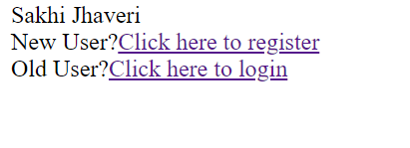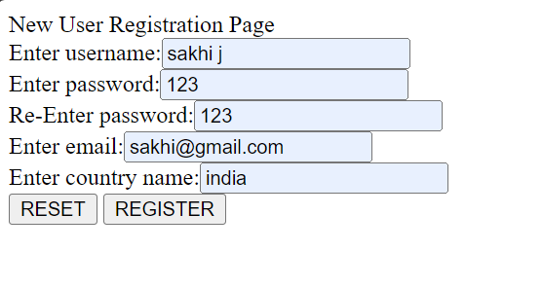

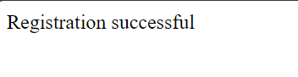

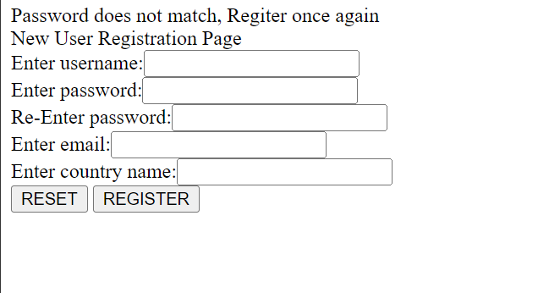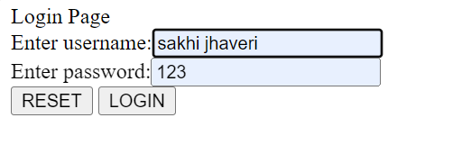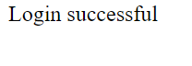

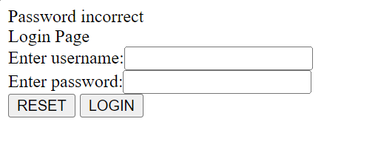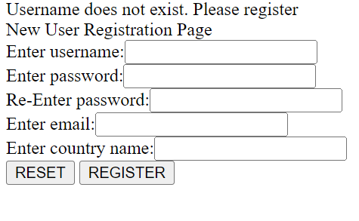

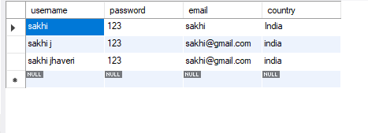

Index.html

<!DOCTYPE html>

<html>

<head>

<title>TODO supply a title</title>

<meta charset="UTF-8">

<meta name="viewport" content="width=device-width, initial-scale=1.0">

</head>

<body>

<div>Sakhi Jhaveri</div>

New User?<a href="Registration.html">Click here to register</a>

<br>

Old User?<a href="Login.html">Click here to login</a>

</body>

</html>

Registration.html

<html>

<head>

<title>TODO supply a title</title>

<meta charset="UTF-8">

<meta name="viewport" content="width=device-width, initial-scale=1.0">

</head>

<body>

<div>New User Registration Page</div>

<form action="Registration.jsp">

Enter username:<input type="text" name="uname">

<br>

Enter password:<input type="text" name="pass">

<br>

Re-Enter password:<input type="text" name="repass">

<br>

Enter email:<input type="text" name="email">

<br>

Enter country name:<input type="text" name="country">

<br>

<input type="submit" value="RESET">

<input type="submit" value="REGISTER">

</form>

</body>

</html>

Login.html

<html>

<head>

<title>TODO supply a title</title>

<meta charset="UTF-8">

<meta name="viewport" content="width=device-width, initial-scale=1.0">

</head>

<body>

<div>Login Page</div>

<form action="Login.jsp">

Enter username:<input type="text" name="uname">

<br>

Enter password:<input type="text" name="pass">

<br>

<input type="submit" value="RESET">

<input type="submit" value="LOGIN">

</form>

</body>

</html>

Registration.jsp

<%@page contentType="text/html" pageEncoding="UTF-8" import="java.sql.*"%>

<!DOCTYPE html>

<html>

<head>

<meta http-equiv="Content-Type" content="text/html; charset=UTF-8">

<title>JSP Page</title>

</head>

<body>

<%

//JSP script;ist

String s1=request.getParameter("uname");

String s2=request.getParameter("pass");

String s3=request.getParameter("repass");

String s4=request.getParameter("email");

String s5=request.getParameter("country");

if (s2.equals(s3))

{

//database connectivity code

try

{

Class.forName("com.mysql.jdbc.Driver");

Connection conn=DriverManager.getConnection("jdbc:mysql://localhost:3306/test","root","root");

PreparedStatement pst=conn.prepareStatement("insert into registration_039 values(?,?,?,?)");

pst.setString(1,s1);

pst.setString(2,s2);

pst.setString(3,s4);

pst.setString(4,s5);

int rows=pst.executeUpdate();

if(rows==1)

{

out.print("Registration successful");

}

else

{

out.print("Registration failed, Try again");

%>

<jsp:include page="Registration.html"></jsp:include>

<%

}

}

catch(Exception e)

{

out.println("Exception:" +e);

}

}

else

{

out.println("Password does not match, Regiter once again");

%>

<jsp:include page="Registration.html"></jsp:include>

<%

}

%>

</body>

</html>

Login.jsp

<%@page contentType="text/html" pageEncoding="UTF-8" %>

<!DOCTYPE html>

<html>

<head>

<meta http-equiv="Content-Type" content="text/html; charset=UTF-8">

<title>JSP Page</title>

</head>

<body>

Hello World!

</body>

</html>