BUDGET

* Why Module Pattern?

We use Module Pattern because we want to keep pieces of code that are related to one another - together – inside of separate , independent and organized units.

Each of these modules will have functions and variables which are private which means they are only accessible inside of the module. We want that so that no other code can override our data.

Besides this, We also have public methods , that we are going to expose , so that other functions and modules can excess them. This is the concept of Data Encapsulation.

Data encapsulation allows us to hide the implementation details from outside scope so that we only expose a public interface which is sometimes called an API.

* 3 Main modules :

1. Budget Controller
2. App Controller
3. UI Controller

PART ONE

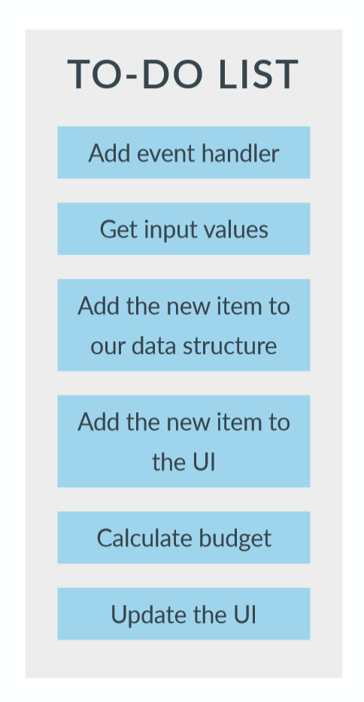

ARCHITECTURE STEP 1.

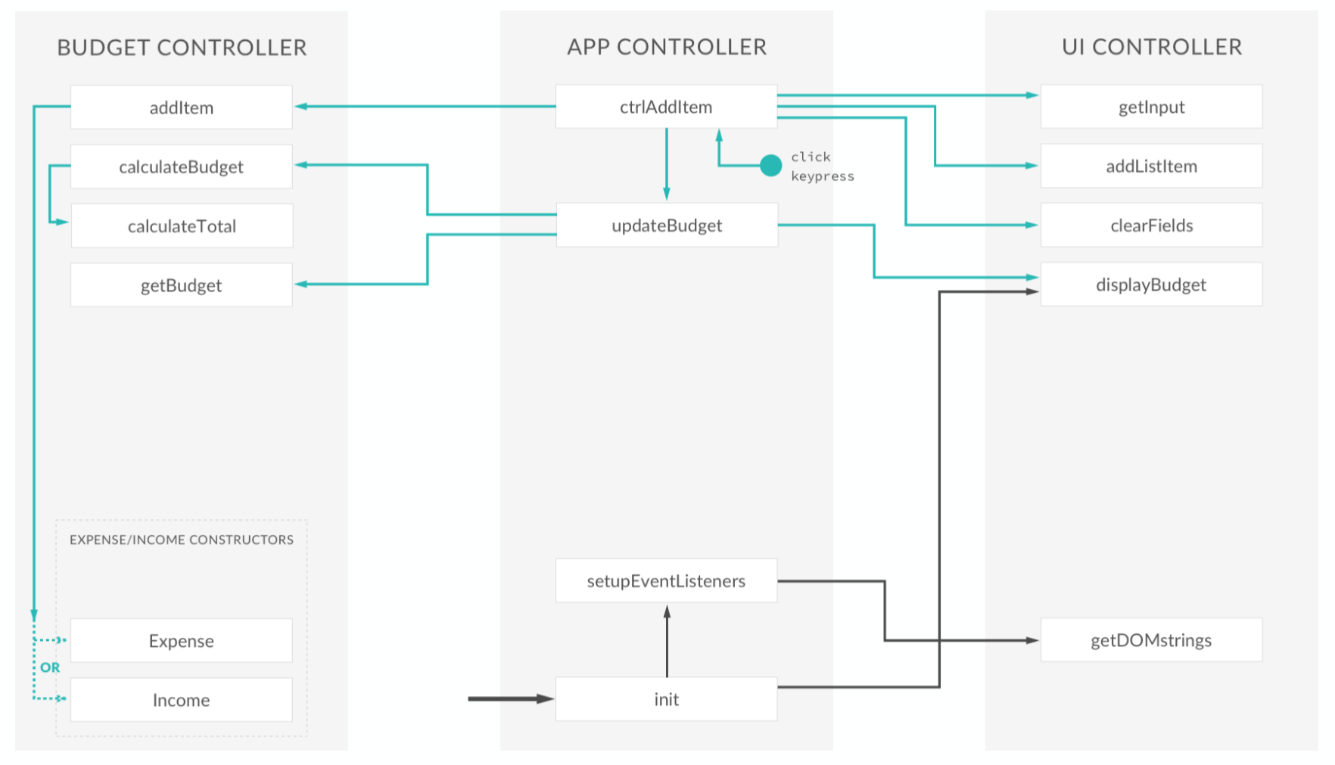

PART TWO.

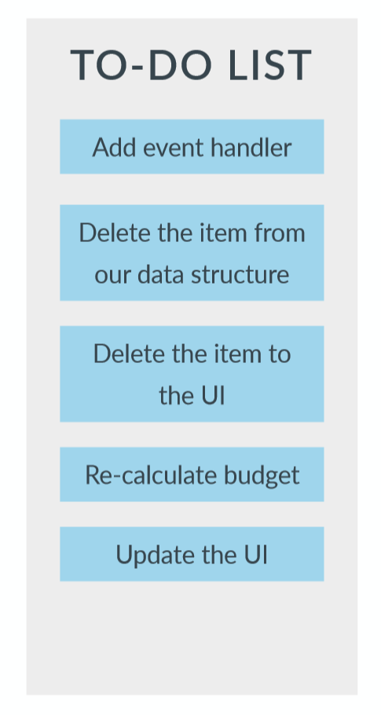

ARCHITECTURE STEP 2.

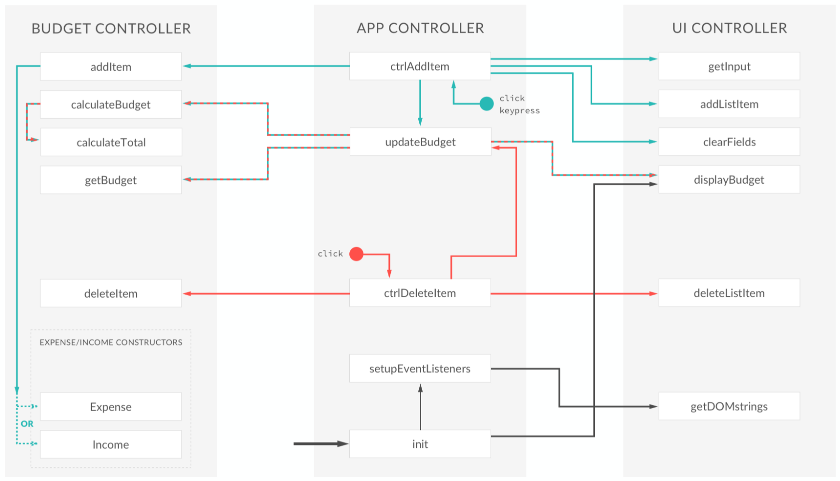

PART THREE

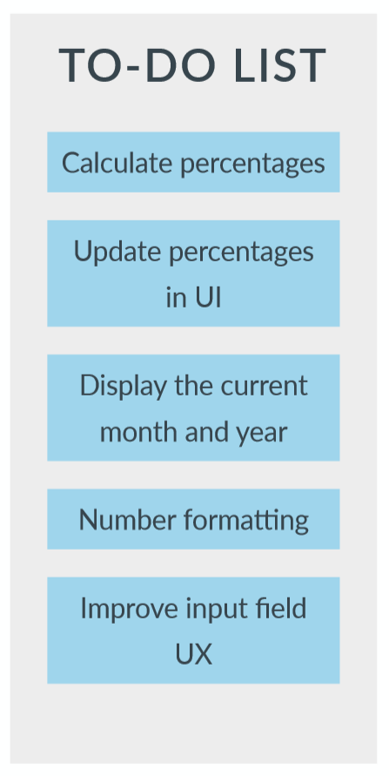

ARCHITECTURE STEP 3.

