docker network create app-network

waraba@Mob:~/documents/workspaceEfrei/dockerContainers/tp/Database$ docker run -p 8090:8080 --net app-network --name=adminer -d adminer
f646940e805eed2241eb86f0107eceec056a5c8ea0140c0fbe1e9d07f71d59d9
waraba@Mob:~/documents/workspaceEfrei/dockerContainers/tp/Database$ docker run -d --name my-db -e POSTGRES_DB=db -e POSTGRES_USER=sakho -e POSTGRES_PASSWORD=root --network app-network sakho/database
11f8216839dca1fd19b73832c52a8288a9ba0dd8251818bb5cf340f35d8f3d82

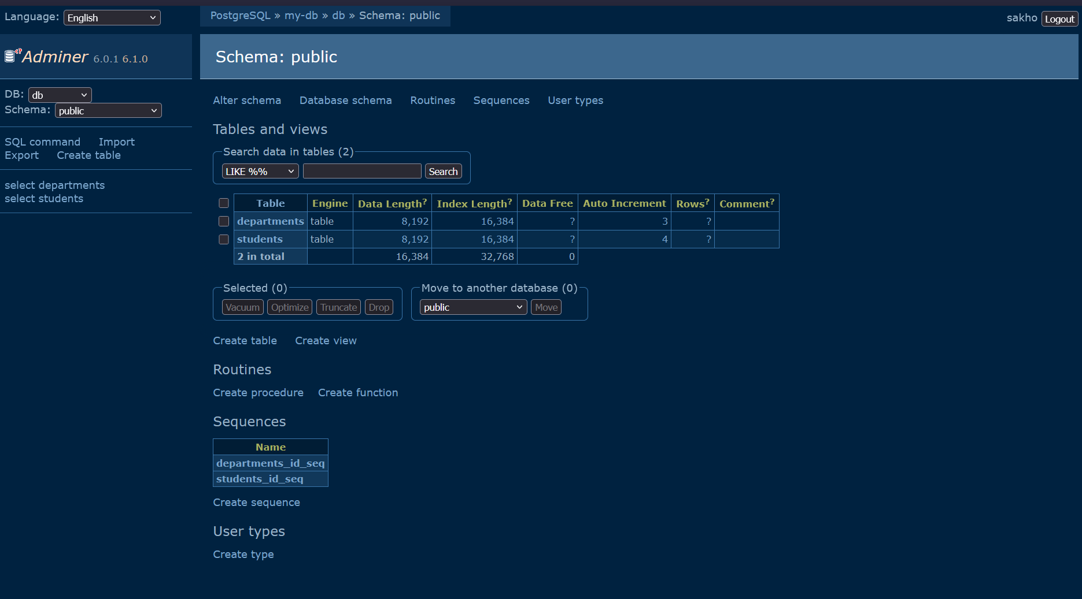

waraba@Mob:~/documents/workspaceEfrei/dockerContainers/tp/Database$ docker run -d --name my-db --network app-network -e POSTGRES_DB=db -e POSTGRES_USER=sakho -e POSTGRES_PASSWORD=root -v $(pwd)/data:/var/lib/postgresql/data sakho/database

persistence de la donnée après avoir supprimé puis relancer un container.

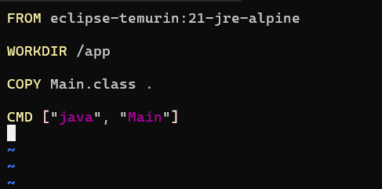
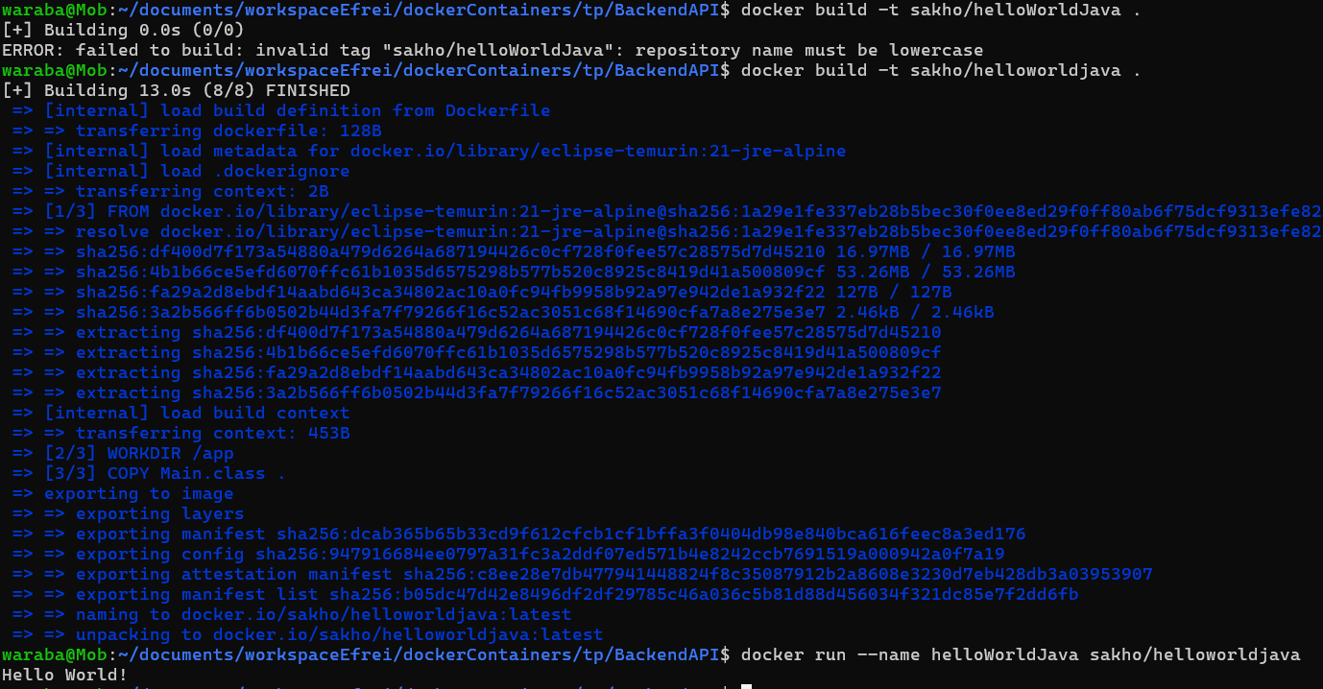

waraba@Mob:~/documents/workspaceEfrei/dockerContainers/tp/BackendAPI$ docker run --name testspringbootapp -p 8080:8080 sakho/springbootapp1

