Generative AI Based on Medical Visual Question Answering (VQA) Techniques
by
[Sarthak Kaushik]
Thesis Submitted in Partial Fulfillment of the
Requirements for the Degree of
Master of Computer Science
in the
[Department of Computer Science]
[Faculty of Computer Science]

© [Sarthak Kaushik] 2025
LAKEHEAD UNIVERSITY
[April 2026]

Copyright in this work is held by the author. Please ensure that any reproduction
or re-use is done in accordance with the relevant national copyright legislation.

Declaration of Committee
Name: | Sarthak Kaushik
Degree: | Master of Computer Science
Title: | Generative AI Based on Medical Visual Question Answering (VQA) Techniques
Committee: | Chair: | [Dr. Sabah Mohammed]  Supervisor  [Chair, Department of Computer Science]
[Dr. Jinan Fiaidhi]
Supervisor
[Full Professor, Department of Computer Science]

Ethics Statement

Abstract
Medical Visual Question Answering (MedVQA) promises a more useful interface for clinical AI than standalone classifiers because it allows clinicians to query images directly in natural language. In gastrointestinal (GI) endoscopy, this capability is especially relevant for high-volume, high-variability workflows such as ulcerative colitis severity grading, polyp assessment, and procedure documentation. However, practical MedVQA remains limited by dataset bias, long-tail label imbalance, weak lexical grounding in free-text generation, and inconsistent clinical faithfulness across question types.
This dissertation investigates these limitations and develops a clinically oriented VQA framework for colonoscopy. The work is grounded in multi-dataset experimentation across HyperKvasir, Kvasir-VQA, Kvasir-VQA-x1, ImageCLEF MEDVQA-GI 2023, and LIMUC, covering both closed-set and generative settings. Repository benchmarks show a clear pattern: supervised or constrained models remain substantially stronger than raw zero-shot VLMs on current GI tasks. In our saved runs, ViLT reaches 0.9089 accuracy on ImageCLEF MEDVQA-GI validation, while Qwen2.5-VL zero-shot raw outputs collapse to 0.0007 accuracy before lexical projection. On HyperKvasir, fine-tuned ResNet50 reaches 0.8789 test accuracy, while BLIP2 zero-shot projected labels remain low (0.0638). On LIMUC severity grading, fine-tuned ResNet50 attains 0.7539 accuracy, macro-F1 0.6829, and QWK 0.8351, with persistent minority-class difficulty.
These findings motivate the thesis direction: move from score-only pipelines toward clinically grounded, evidence-aware multimodal reasoning that combines (1) robust visual recognition, (2) question-aware answer generation, and (3) retrieval-supported justification for higher-risk decisions. The dissertation contributes a structured research agenda, scenario-driven evaluation design, and an implementation pathway for integrating VQA with retrieval-augmented generation (RAG) in GI decision support. The long-term objective is an assistant that does not only classify findings, but can explain, qualify uncertainty, and align outputs with clinician workflow and evidence-based care.
Keywords: medical visual question answering, gastrointestinal endoscopy, colonoscopy, ulcerative colitis, vision-language models, retrieval-augmented generation, clinical decision support

Dedication

Acknowledgements
This is an optional page. Use your choice of paragraph style for text on this page (1_Para shown here).

Table of Contents
Declaration of Committee ................................................................................................ ii
Ethics Statement ............................................................................................................. iii
Abstract ........................................................................................................................... iv
Dedication ........................................................................................................................ v
Acknowledgments ........................................................................................................... vi
Table of Contents ........................................................................................................... vii
List of Tables ................................................................................................................. viii
List of Figures ................................................................................................................. ix
List of Acronyms .............................................................................................................. x
Glossary .......................................................................................................................... xi
Preface/Executive Summary/Image ............................................................................... xii
Chapter 1. Introduction ................................................................................................. 1
- 1.1 Background and Motivation ..................................................................................... 2
- 1.2 Why GI Endoscopy and Colonoscopy ..................................................................... 4
- 1.3 Clinical Motivation: Ulcerative Colitis Severity as a Flagship Use Case ................. 5
- 1.4 Problem Statement ................................................................................................. 7
- 1.5 Aim and Objectives ................................................................................................. 9
- 1.6 Research Questions .............................................................................................. 10
- 1.7 Scope, Assumptions, and Delimitations ................................................................ 11
- 1.8 Scenario-Driven Framing ...................................................................................... 13
- 1.9 Conceptual Framework and System Flow ............................................................ 14
- 1.10 Contributions Claimed in This Dissertation ......................................................... 16
- 1.11 Chapter-by-Chapter Summary ............................................................................ 16
Chapter 2. Survey of VQA in Medicine with Application to Colonoscopy.............. 18
- 2.1 Introduction ........................................................................................................... 19
- 2.2 Scoping Review Design ........................................................................................ 20
- 2.3 Evolution of VQA Methods: From General AI to Clinical MedVQA ....................... 22
- 2.4 Dataset and Benchmark Landscape ..................................................................... 23
- 2.5 Survey of Technique Families ............................................................................... 25
- 2.6 Evaluation Practices in the Literature .................................................................... 28
- 2.7 Scenario-Oriented Technique Suitability for Colonoscopy .................................... 31
- 2.8 2024-2026 Trends in MedVQA Research ............................................................. 31
- 2.9 Evidence Triangulation with Repository Results ................................................... 32
- 2.10 Key Gaps and Open Problems ............................................................................ 33
- 2.11 Chapter Summary and Transition ........................................................................ 34
Chapter 3. Investigating Existing VQA Techniques Across GI-Endoscopy Datasets ...............................................................................................................35
- 3.1 Chapter Overview and Evaluation Goal ................................................................ 35
- 3.2 Experimental Scenarios and Data Regimes .......................................................... 38
- 3.3 Evaluation Metrics and Statistical Protocol ............................................................ 44
- 3.4 Baseline and Existing-Model Results .................................................................... 50
- 3.5 Cross-Dataset Synthesis and Findings ................................................................. 62
- 3.6 Position After Chapter 3 ........................................................................................ 65
- 3.7 Artifact Manifest for Figures and Tables ................................................................ 65
- 3.8 Figures and Tables Checklist ................................................................................ 65
References ...................................................................................................................

List of Tables
No table of figures entries found.
Use References>Insert Caption to create caption labels and numbers. Right-click on the text above and select Update Field to update this list. See the Thesis Template Instructions for information on creating tables, figures, and captions.
Remember to delete this note before submission.
If there are no tables in the document, remove this page.

List of Figures

List of Acronyms

Glossary
Thesis | An extended research paper that is part of the final exam process for a graduate degree. The document may also be classified as a project or collection of extended essays.
Glossary | An alphabetical list of key terms
 | This is an optional page and can be removed if not used.
 | Use one table row for each item to allow sorting using Word’s table tools.
 | Apply the style 1_Para_NoSpace to table rows as shown here.

Preface/Executive Summary/Image
This page can be used for a Preface, Executive Summary, or introductory image. This is an optional page and can be deleted if not used.
To hide the heading at the top of this page – e.g., if using an introductory image – select the text and change the text colour to white.
Do not delete the section break that follows this paragraph. If the section break is not visible, turn on non-printing characters using the Show/Hide icon (¶) on the Home ribbon.

Introduction
1.0 Chapter 1 Overview
Chapter 1 defines the full research foundation of this dissertation and clarifies why GI-endoscopy MedVQA must be evaluated beyond aggregate benchmark scores. The chapter first establishes the clinical motivation for question-driven AI support in colonoscopy, then formalizes the central methodological gap: current systems can produce strong average performance while still failing on clinically high-risk, imbalanced, or format-sensitive cases. It then translates this gap into a concrete research program by stating the thesis aim, objectives, research questions, and working hypotheses. In addition, Chapter 1 sets the operational boundaries of the work, including what is in scope, what is explicitly out of scope, and how PICO-oriented evidence mapping is used as a controlled extension pathway rather than a replacement for visual reliability. Finally, the chapter introduces the scenario-driven framing, conceptual pipeline, and risk-control logic that guide all subsequent experiments and interpretations.
At a glance, this chapter:
1. Establishes background and motivation for MedVQA in GI endoscopy.
2. Defines the reliability and translational gap the dissertation addresses.
3. Formalizes aim, objectives, and research questions with evaluation mapping.
4. Specifies scope, assumptions, and governance constraints for defensible claims.
5. Provides the conceptual and chapter-level roadmap used in Chapters 2 and 3.
The next chapter converts this foundation into a structured scoping review that identifies the most relevant model families, benchmarks, and open gaps for GI-oriented evaluation.

1.1 Background & Motivation
Medical Visual Question Answering (MedVQA) is an interdisciplinary field that integrates computer vision (CV), natural language processing (NLP), and clinical medicine. It aims to build artificial intelligence systems that can interpret medical images and answer clinically relevant questions expressed in natural language. In contrast to conventional image classification systems that return only categorical predictions, MedVQA is designed to support question-driven interaction. This interaction model is closely aligned with how clinicians reason in practice, where interpretation is typically guided by targeted questions rather than isolated labels.
MedVQA offers substantial potential for clinical decision support. Its expected benefits include improved diagnostic consistency, reduced physician workload, and wider access to specialist-level interpretation in telemedicine and resource-constrained settings. The long-term objective is not to replace clinical judgment, but to provide an intelligent and transparent assistant that can complement clinical reasoning within existing workflows.
Unlike general-domain VQA, MedVQA faces domain-specific constraints. Medical images often include subtle, overlapping, or low-contrast findings that require specialized interpretation. Clinical questions frequently require multi-step reasoning, in which visual evidence must be combined with biomedical context and task intent. These characteristics make MedVQA both a technically demanding multimodal task and a clinically sensitive reliability challenge.
The technical foundation of MedVQA combines CV-based image representation with NLP-based question understanding and answer synthesis. Early systems were predominantly discriminative, using an image encoder, a question encoder, a fusion module, and a fixed answer set. These systems performed adequately on constrained tasks but showed limited flexibility for nuanced and open-ended clinical questions [1], [2], [3]. Recent work has shifted toward transformer-based multimodal architectures and generative response models, supported by large-scale vision-language pretraining [4], [5] and contemporary MedVQA surveys of large multimodal model behavior [8], [9]. In parallel, biomedical language models such as BioBERT and BioGPT have improved domain-specific language understanding and generation [6], [7].
Despite this progress, the gap between benchmark performance and reliable clinical utility remains significant. Three persistent tensions define the present landscape:
Expressiveness versus reliability: Generative models can produce richer answers, but may exhibit lexical drift, weak grounding, or hallucinated content.
Aggregate performance versus clinical robustness: High overall accuracy can conceal clinically critical failures in minority classes.
General multimodal capability versus medical domain specificity: Zero-shot transfer from general VLMs often underperforms in specialized clinical settings.
This dissertation is motivated by these tensions and investigates them in the context of gastrointestinal endoscopy, with a specific focus on colonoscopy-oriented MedVQA.
1.1.1 From Fixed-Answer Systems to Generative Multimodal Models
The historical evolution of MedVQA provides an important context for this thesis. In early systems, answer generation was operationally equivalent to label selection. This formulation enabled straightforward optimization and evaluation, but it constrained clinically meaningful expression. Complex questions were often reduced to coarse categorical outputs, limiting interpretability and reducing practical value for clinicians.
Transformer-era multimodal models improved cross-modal alignment and enabled free-text response generation. This transition addressed important limitations of earlier systems, particularly weak question-image interaction and restricted output vocabulary. However, it also introduced new risks. In clinical settings, a fluent answer that is weakly grounded in image evidence may be more problematic than a constrained but verifiable answer. Consequently, model expressiveness must be balanced with grounding, calibration, and error control.
Another major shift has occurred at the evaluation level. Instead of reporting performance within a single benchmark only, recent studies increasingly examine cross-dataset behavior and robustness to distributional changes. This is particularly relevant in GI endoscopy, where data heterogeneity in question templates, answer conventions, and visual characteristics can be substantial.
1.1.2 Limitations of Aggregate Benchmark Scores in Clinical AI
Benchmark metrics remain necessary, but they are not sufficient for clinical validation. A model can achieve high overall accuracy while failing on rare yet clinically consequential categories. Weighted scores may obscure failures in underrepresented classes, and single-point metrics may not capture the clinical implications of specific error types.
For severity-oriented tasks, ordinal relationships are also important. Confusing adjacent grades is not equivalent to missing severe disease altogether. Therefore, evaluation design in clinical MedVQA should include classwise metrics, imbalance-aware metrics, ordinally sensitive metrics, and scenario-level acceptance logic.
This dissertation adopts that broader evaluation view from Chapter 1 onward. In addition, answer format itself is treated as an evaluable design choice. For certain use cases, label-only output may be sufficient; for others, clinicians may require rationale, confidence estimates, or evidence pointers. A reliable clinical assistant must be assessed on both predictive accuracy and output usability.
1.2 Why GI Endoscopy and Colonoscopy
Gastrointestinal (GI) endoscopy is a strategically important target for MedVQA from both clinical and methodological perspectives.
Clinically, colonoscopy supports screening, diagnosis, and follow-up across multiple disease contexts, including colorectal neoplasia and inflammatory bowel disease. Endoscopic interpretation directly affects treatment escalation, surveillance decisions, and procedural reporting. In routine practice, clinicians frequently pose focused questions such as:
- Is an abnormality present?
- How many findings are visible?
- Where is the lesion located?
- What type or morphology is observed?
- What is the likely severity of inflammation?
These question types map naturally to MedVQA task families and are suitable for systematic evaluation.
From a technical perspective, GI endoscopy is challenging. Image quality can vary due to motion blur, specular reflections, debris, variable bowel preparation, and viewpoint variation. Question-answer distributions can be highly imbalanced, with clinically important severe classes often underrepresented. Consequently, colonoscopy MedVQA provides a realistic and stringent setting for evaluating reliability under domain shift and class imbalance.
Recent dataset development makes this thesis direction feasible:
- Kvasir-VQA introduced GI-focused visual question answering at scale (58,849 QA pairs over 6,500 images) [12], [19].
- Kvasir-VQA-x1 expanded complexity and scale (159,549 QA pairs) and introduced transformed/robustness-oriented settings [13].
- ImageCLEF MEDVQA-GI provided shared benchmarking tracks for GI VQA [10], [11].
- HyperKvasir and LIMUC provide broader GI visual context and severity-oriented subsets [15], [18].
These resources enable reproducible analysis, but they do not remove the central challenge: building systems that remain reliable not only on common benchmark patterns, but also on clinically high-risk cases.
1.2.1 Colonoscopy Question Families and Their Decision Roles
To ensure methodological clarity, this thesis maps question families to their clinical decision roles.
Question family | Example | Dominant challenge | Decision role
Presence | "Is there active bleeding?" | False-negative control | Immediate risk awareness
Count | "How many polyps are visible?" | Counting under occlusion and partial views | Completeness and burden estimation
Location | "Where is the lesion?" | Spatial grounding consistency | Procedural precision and reporting
Type/Attribute | "What polyp morphology is present?" | Fine-grained differentiation | Risk stratification and follow-up planning
Severity | "What is the likely Mayo score?" | Ordinal robustness under imbalance | Treatment planning and monitoring
Table 1.1
1.2.2 Operational Constraints in Realistic Deployment
Even in pre-deployment research, model design should anticipate operational constraints. These include variable image quality, limited severe-class labels, institutional differences in reporting language, and the need for predictable failure behavior. A clinically acceptable system is not one that never fails; it is one that fails in ways that are detectable, bounded, and actionable.
These constraints motivate a conditional architecture. Closed-set pathways are often preferable where deterministic label control is required. Generative pathways can be used for explanation-oriented outputs under explicit safeguards. Retrieval-backed reasoning should be introduced selectively for questions that require evidence beyond direct visual interpretation.
1.3 Clinical Motivation: Ulcerative Colitis Severity as a Flagship Use Case
Ulcerative colitis (UC) severity assessment is a high-value use case for MedVQA in colonoscopy. Endoscopic severity strongly influences treatment decisions and disease monitoring strategies. In clinical practice, severity is commonly represented by standardized scales such as the Mayo Endoscopic Subscore (0-3) and UCEIS (0-8, often mapped to ordinal severity categories). These scales are clinically meaningful, but grading can be difficult in borderline or low-quality frames.
UC severity automation is not a new problem. Prior deep learning systems have already shown clinically meaningful performance for endoscopic severity scoring under specialist comparison settings [25], [26], [27], [28]. Related GI quality-grading work with vision-language models further supports the feasibility of multimodal assistance in endoscopy workflows [17]. These studies establish strong prior art for AI-based severity grading in UC and clarify that the key challenge is no longer "can AI score disease at all?" but "can an interactive system remain reliable, grounded, and clinically usable when moved beyond fixed-score outputs?" [14], [16].
This dissertation therefore does not claim to be the first AI system for UC severity scoring. Its novelty is the integration of (1) GI-oriented MedVQA interaction, (2) risk-aware reliability controls, and (3) evidence-aware extensions for management-style questions. From a MedVQA perspective, UC severity remains methodologically informative because it combines:
- Fine-grained visual discrimination.
- Ordinal class structure.
- Asymmetric clinical cost of errors.
- Potential demand for explanation and uncertainty communication.
A standard classifier can output a severity label, but a MedVQA interface can additionally provide rationale-oriented responses and controlled follow-up interaction. This thesis adopts that broader perspective while preserving strict emphasis on visual grounding.

1.3.1 Workflow-Oriented Motivation
In practical clinical terms, the decision path is closer to:
Endoscopy frame(s)
1. clinician question
2. visual-grounded answer
3. confidence and uncertainty signal
4. optional evidence-linked follow-up
This abstraction motivates the thesis design: MedVQA is treated simultaneously as a perception task, a language task, and a workflow integration task.
1.3.2 Why UC Severity Is a High-Value Testbed for Chapter 1
UC severity is used as a flagship testbed in Chapter 1 because it concentrates multiple difficult properties in one clinically relevant problem: subtle visual distinctions, class imbalance, ordinal grading, and high consequence of severe under-calling. If a system is not reliable in this setting, its suitability for broader GI decision support is limited.
At the same time, UC severity remains experimentally tractable using currently available datasets and persisted repository artifacts. This combination of clinical significance and methodological tractability makes it an appropriate anchor for the dissertation.
1.4 Problem Statement
The central problem addressed in this dissertation is:
How can a colonoscopy-focused MedVQA pipeline move from benchmark-level answering to clinically grounded, reliable, and evidence-aware decision support?
This problem is decomposed into four operational gaps:
- Data and coverage gap: Existing datasets provide broad task families but uneven clinical depth and long-tail imbalance.
- Model gap: Zero-shot general VLMs frequently underperform constrained or supervised approaches in GI settings.
- Evaluation gap: Aggregate metrics can conceal clinically unacceptable error patterns.
- Workflow gap: Many systems do not yet connect image-grounded outputs to evidence-oriented clinical reasoning.
1.4.1 Evidence from This Repository
Table 1.2 summarizes key empirical signals from persisted repository artifacts.
References [20]-[24] point to supplementary analysis artifacts in the thesis repository and are included as reproducibility materials alongside the dissertation.
Dataset / Task | Strongest saved model result | Key failure signal | Source
ImageCLEF MEDVQA-GI 2023 validation | ViLT accuracy 0.9089, macro-F1 0.5823 | Qwen2.5-VL zero-shot raw accuracy 0.0007; projected 0.0670 | [21]
HyperKvasir 23-class test | ResNet50 supervised accuracy 0.8789, macro-F1 0.5943 | Head-tail recall gap remains large; BLIP2 projected accuracy 0.0638 | [20]
LIMUC Mayo severity test | Fine-tuned ResNet50 accuracy 0.7539, macro-F1 0.6829, QWK 0.8351 | Zero-shot VLM macro-F1 0.1771, balanced accuracy 0.25 | [24]
Kvasir-VQA yes/no subset | ResNet+GRU accuracy 0.9865, macro-F1 0.9650 | Free-generation run shows unknown-rate collapse in persisted artifact | [22]
Kvasir-VQA-x1 generative track | MedGemma LoRA token-F1 0.5085 (adaptation gain) | Exact-match remains near zero across persisted modern VLM runs | [23]
Table 1.2
In Table 1.1, raw accuracy denotes direct label-space scoring against canonical benchmark targets (no lexical post-processing). Projected accuracy denotes a secondary diagnostic in which generated free text is deterministically mapped to each question's known answer space before scoring, following the local report methodology [20], [21], [23].
To reduce leakage risk and inflated claims, this thesis reports the split context and scoring semantics explicitly for each dataset report: official or persisted held-out splits are preserved, pairwise tests are run on aligned rows where applicable, and projected scores are interpreted alongside raw exact/unknown behavior rather than as replacement primary metrics [20]-[24].
These findings support a staged strategy:
- Preserve robust supervised/closed-set visual grounding.
- Add controlled generative capability where it improves clinical interaction value.
- Introduce retrieval-backed reasoning as a safeguarded extension for higher-level questions.
1.4.2 Why This Gap Persists
The gap persists because GI MedVQA is not a single modeling task. It requires robust visual perception under noisy conditions, clinically coherent question understanding, grounded answer generation, and safe behavior under asymmetric risk. Progress in one component does not guarantee end-to-end clinical utility.
A system may be fluent yet weakly grounded, accurate on common classes yet brittle on severe minorities, or stable on fixed prompts yet unstable under linguistic variation. Therefore, this dissertation treats architecture design, evaluation design, and scenario design as interdependent components.
1.4.3 Consequences of Leaving the Gap Unresolved
If this gap remains unresolved, systems may appear strong on aggregate benchmarks while underperforming in the situations that matter most clinically. In severity settings, this can lead to under-detection of high-risk cases. In report-oriented settings, it can produce plausible but weakly grounded outputs that increase cognitive burden. In decision-support settings, it can generate recommendations insufficiently tied to evidence.
These consequences justify a conservative methodological stance: prioritize reliability, grounding, and traceability before maximizing output fluency.
1.5 Aim and Objectives
1.5.1 Aim
To design, evaluate, and document a clinically oriented MedVQA framework for colonoscopy that combines robust visual grounding, question-aware generation, and an evidence-aware extension pathway for higher-risk queries.
1.5.2 Objectives
- Build a reproducible, multi-dataset GI MedVQA benchmark layer using persisted repository artifacts.
- Quantify comparative reliability of closed-set versus generative approaches under GI-specific conditions.
- Evaluate UC severity-oriented question answering with clinically meaningful metrics, including imbalance-aware and ordinal-aligned indicators.
- Define scenario-driven use cases aligned with endoscopist workflows.
- Specify and test an implementation path for retrieval-augmented, evidence-aware answering without degrading visual-grounded performance.

Objective | Dissertation deliverable
O1 | Dataset/task profiling and consolidated benchmark tables
O2 | Comparative model analysis with failure-mode interpretation
O3 | Severity-focused evaluation section with class-wise and ordinal metrics
O4 | Scenario catalogue with acceptance criteria and error taxonomy
O5 | Proposed architecture and phased validation plan for evidence-aware extension
Table 1.3
1.6 Research Questions
The dissertation is guided by six research questions that link task design, modeling strategy, and clinical utility.
RQ1 (Coverage):
What clinically relevant colonoscopy question families and answer spaces are represented in current GI MedVQA datasets, and what important gaps remain?
RQ2 (Comparative reliability):
On GI MedVQA tasks, do constrained/discriminative pipelines remain more reliable than zero-shot open-ended VLM generation?
RQ3 (Failure modes):
Which failure modes dominate current GI MedVQA systems: class imbalance, lexical mismatch, localization ambiguity, or domain shift?
RQ4 (Severity robustness):
How reliably can models answer UC severity-oriented questions, especially for underrepresented severe classes?
RQ5 (Clinical output format):
Which output format best supports clinician trust and usability: label only, label plus rationale, label plus confidence, or answer plus retrieved evidence?
RQ6 (Evidence-aware extension):
Can retrieval-augmented reasoning be integrated as a controlled extension without degrading core visual-grounded accuracy?
1.6.1 RQ-to-Evaluation Map
RQ | Primary evidence in this thesis | Candidate metrics
RQ1 | Dataset profiling and taxonomy analysis | Coverage %, answer cardinality, imbalance ratio
RQ2 | Closed-set vs generative comparisons | Accuracy, macro-F1, MCC, EM, token-F1
RQ3 | Error and robustness analysis | Per-class recall, head-tail gap, OOV/unknown rates
RQ4 | UC severity-focused experiments | Macro-F1, balanced accuracy, QWK, remission sensitivity/specificity
RQ5 | Scenario-driven analysis | Scenario pass rate, high-risk error counts, clinician-facing clarity criteria
RQ6 | Retrieval-augmented prototype analysis | Accuracy delta, evidence relevance, factual consistency checks
Table 1.4

1.6.2 Research Hypotheses (Working)
- H1: In current GI datasets, constrained or supervised decoders will outperform raw zero-shot free generation on core reliability metrics.
- H2: Minority severe classes will remain the primary bottleneck even when aggregate accuracy is high.
- H3: A conditional evidence-augmented layer can improve interpretability for high- risk questions without compromising visual grounding.
These hypotheses are working assumptions to be tested in later chapters; they are not final claims.

1.7 Scope, Assumptions, and Delimitations
1.7.1 In Scope
- Colonoscopy and GI endoscopy image-question answering.
- UC severity-oriented analysis as a flagship clinical axis.
- Multi-dataset benchmarking from persisted local artifacts.
- Closed-set and generative answer tracks.
- Design of an evidence-aware extension pathway (RAG/PICO-oriented direction).
1.7.2 Out of Scope in This Dissertation Phase
- Prospective real-time deployment in clinical endoscopy units.
- Full regulatory and compliance validation.
- Multi-center randomized outcome trials.
- Production-grade latency optimization for full video streams.
1.7.3 Working Assumptions
- Ground-truth annotations are treated as operational references despite known inter-observer variation.
- Persisted repository artifacts provide the reproducible evidence base for current claims.
- Evidence-aware generation is treated as an additive and safeguarded layer.
- High-risk low-confidence outputs require abstention/escalation behavior.

1.7.4 PICO-Oriented Evidence Mapping (Operational Definition)
In this dissertation, PICO is used as a structured retrieval and response scaffold for management-style queries:
P (Population/Patient): UC patient context, including current endoscopic severity and relevant clinical descriptors.
I (Intervention): candidate treatment or management option being considered.
C (Comparison): alternative treatment strategy, standard care, or no escalation.
O (Outcome): clinically meaningful endpoint (for example relapse, mucosal healing, hospitalization risk, or adverse events).
Example query pattern for Chapter 5 use cases:
In patients with UC and Mayo 2 activity, does infliximab versus vedolizumab reduce relapse at 6 months?
In this flow, the MedVQA layer provides the image-grounded severity signal, while the evidence layer maps the textual question into PICO slots, retrieves supporting studies/guidelines, and returns a citation-linked answer with confidence and explicit limitations.
1.7.5 Safety and Clinical Governance Position
This thesis treats the proposed system as clinical decision support, not autonomous diagnosis. Outputs are draft recommendations for physician review, with explicit abstention/escalation behavior for uncertain or high-risk cases. The evaluation design therefore includes uncertainty handling, evidence citation, and failure-mode reporting as first-class requirements even though regulated deployment is out of scope in this phase.
1.8 Scenario-Driven Framing
This dissertation adopts a scenario-driven evaluation philosophy. Aggregate benchmark metrics remain important, but they do not fully capture clinical utility. Scenarios are defined to represent realistic clinician questions and asymmetric risk conditions.
1.8.1 Core Scenarios
Scenario ID | Clinical question style | Required output | Primary risk | Why it matters
S1 | "What is the likely Mayo severity?" | Ordinal class + short rationale | Under-calling severe disease | Treatment escalation decisions
S2 | "Is active bleeding visible?" | Binary answer + confidence | False negatives in high-risk frames | Urgent management context
S3 | "How many polyps and where?" | Count + location-aware response | Missed findings or localization error | Procedural completeness and reporting
S4 | "Summarize visible findings." | Multi-finding summary | Hallucinated findings | Interpretability and communication quality
S5 | "Given severe findings, what evidence-backed options are relevant?" | Answer + evidence pointer | Weakly grounded management guidance | Decision-support extension
Table 1.5
Each scenario is designed to expose a distinct failure mode. S1 and S2 prioritize risk-sensitive reliability. S3 emphasizes spatial grounding and structured output fidelity. S4 evaluates controlled generation quality. S5 evaluates the boundary between visual interpretation and evidence-oriented reasoning.
1.8.2 Scenario Acceptance Logic
Question received
1. visual-grounded answer candidate
2. confidence and consistency checks
3. if high-risk and low confidence: abstain/escalate
4. if management-style query: activate retrieval evidence layer
5. return clinician-facing response
1.8.3 Scenario-to-Metric Mapping
Scenario | Priority metrics
S1 | Macro-F1, QWK, severe-class recall
S2 | Sensitivity/recall, NPV, abstention behavior
S3 | Count error (MAE/RMSE), location correctness slices
S4 | Token-F1/ANLS + hallucination audit
S5 | Answer correctness + evidence relevance/consistency checks
Table 1.6
In later chapters, this mapping supports a tiered acceptance model:
- Technical pass: baseline quantitative criteria are met.
- Scenario pass: performance is acceptable for the scenario-specific risk profile.
- Workflow pass: output format supports clinician interpretation and action.
1.9 Conceptual Framework and System Flow
This section defines the end-to-end architecture, design logic, and chapter dependencies used throughout the dissertation.
1.9.1 End-to-End Conceptual Flow (Text Form)
Clinical Image(s) + Clinician Question
1. question intent parsing (task type, entities, risk level)
2. visual feature extraction (global + localized cues)
3. cross-modal reasoning (closed-set or generative path)
4. answer candidate + confidence estimation
5. conditional retrieval layer for evidence-oriented queries
6. final response (answer, rationale, confidence, evidence pointer)
1.9.2 Figure 1.1: Clinician-Centric MedVQA Pipeline
Figure 1.1: Clinician-Centric MedVQA Pipeline for Colonoscopy.
Input frame(s)+question -> intent parsing + clinical entity extraction -> visual encoder + localization cues -> cross-modal reasoning -> confidence/abstain gate -> constrained or generative answer -> optional retrieval grounding -> clinician-facing response package
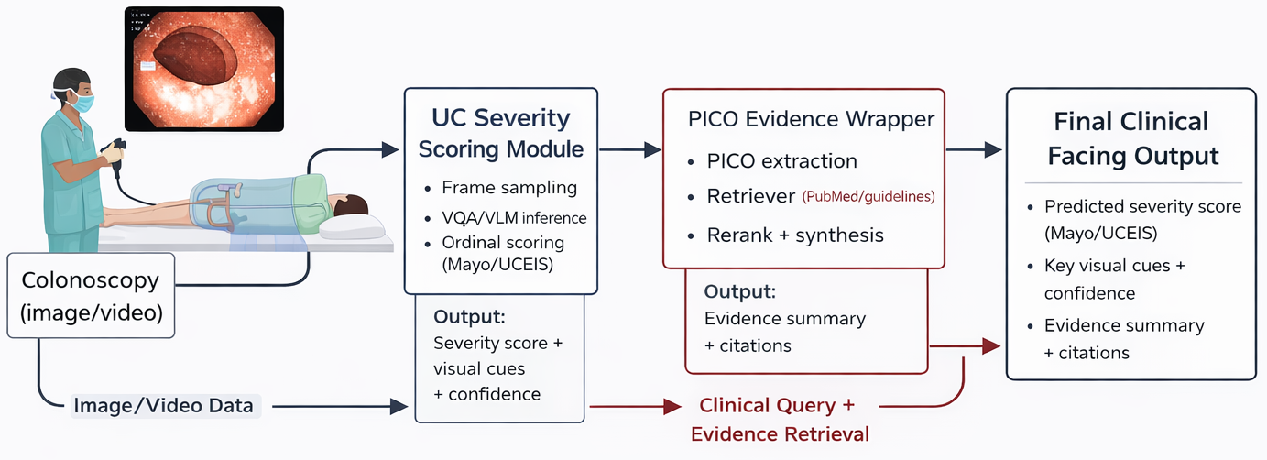
Figure 1.1 Conceptual Framework & System Flow
1.9.3 Figure 1.2: Data-to-Decision Funnel
Figure 1.2: Data-to-Decision Funnel.
Raw datasets -> curation and harmonization -> task families -> model families -> evaluation and failure analysis -> scenario validation -> decision-support readiness.
1.9.4 Figure 1.3: Research Design Map
Figure 1.3: Research Questions to Methods to Metrics to Outputs.
RQ layer
1. dataset/method layer
2. metric layer
3. scenario acceptance layer
1.9.6 Risk-Control Matrix
Risk | Failure example | Control strategy
Class imbalance | Severe UC under-detected | Cost-sensitive training, minority sampling, classwise monitoring
Lexical mismatch | Free text not mappable to clinical label space | Constrained decoding and lexical projection safeguards
Hallucination | Non-visible finding asserted | Visual-grounding checks, contradiction tests, abstain option
Overconfidence | High confidence on incorrect severe class | Calibration, thresholding, uncertainty-triggered escalation
Context gap | Image answer lacks decision context | Conditional retrieval-backed evidence layer
Table 1.7: Risk controls for GI MedVQA system design

1.10 Contributions Claimed in This Dissertation
At this stage, the dissertation claims the following contributions:
- A consolidated GI MedVQA evidence base across multiple datasets and task formulations using reproducible local artifacts [20]-[24].
- Empirical clarification that naive zero-shot VLM transfer is currently insufficient for dependable GI MedVQA performance in this repository setting.
- A severity-focused framing that aligns model evaluation with clinically meaningful endpoints, including macro-F1, balanced metrics, remission slices, and QWK in UC-oriented tasks.
- A scenario-driven evaluation framework that complements leaderboard metrics with clinically interpretable acceptance criteria.
- A concrete design pathway for integrating retrieval-augmented, evidence-aware answering as a controlled extension of visual-grounded VQA.
1.10.1 Contribution Boundaries
This dissertation does not claim immediate real-time clinical deployment readiness. The contributions are methodological, empirical, and design-oriented, and they establish the basis for subsequent translational validation.

1.11 Chapter-by-Chapter Summary
Chapter 1 (this chapter): establishes background, motivation, problem decomposition, research questions, conceptual framework, and contribution boundaries.
Chapter 2: provides a structured scoping review of MedVQA and GI endoscopy literature, with explicit gap extraction.
Chapter 3: investigates existing VQA techniques across GI-endoscopy datasets (HyperKvasir, Kvasir-VQA, Kvasir-VQA-x1, ImageCLEF MEDVQA-GI 2023, LIMUC, and supporting Kvasir-SEG analyses), including comparative and failure-mode analyses.
Chapter 4: develops the proposed dataset-model-RAG-fine-tuning pipeline with implementation detail.
Chapter 5: instantiates PICO-oriented and scenario-based use cases with objective-oriented prompt and evidence design.
Chapter 6: integrates experimental findings, scenario performance, and evidence-layer behavior into a consolidated discussion.
Chapter 7: synthesizes conclusions, revisits research questions, states limitations, and defines future work.

Surveying VQA Techniques in Medicine with application to Colonoscopy
2.0 Chapter 2 Overview
Chapter 2 provides the scoping-review backbone of the dissertation and establishes the evidence landscape that motivates the empirical work in Chapter 3. It documents the review design (objective, search window, source types, and inclusion/exclusion logic), then synthesizes how MedVQA has evolved from constrained discriminative pipelines to transformer and generative multimodal systems. The chapter narrows this broader trajectory to GI endoscopy by mapping key datasets, challenge tracks, and colonoscopy-relevant task regimes, with specific emphasis on reliability constraints such as class imbalance, lexical answer variability, and clinical-threshold sensitivity. It also compares technique families (discriminative, transformer-based, generative, explainable, and retrieval-aware) against scenario-level needs in colonoscopy decision support. To improve thesis traceability, the chapter triangulates external literature with internal repository evidence and ends with a structured gap map. These gaps are framed not as abstract research opportunities, but as concrete methodological requirements that directly determine how Chapter 3 is designed, what metrics are prioritized, and which claims are considered defensible.
At a glance, this chapter:
1. Defines a transparent scoping protocol and source-selection framework.
2. Summarizes the method and benchmark evolution of MedVQA.
3. Maps GI-colonoscopy datasets and challenge ecosystems to task needs.
4. Evaluates technique families against scenario-oriented clinical requirements.
5. Produces a gap-and-risk synthesis that directly drives Chapter 3 experiments.

The next chapter moves from literature synthesis to artifact-grounded empirical evaluation across GI-endoscopy datasets.

2.1 Introduction
Visual Question Answering (VQA) has evolved from a general computer-vision benchmark task into a clinically relevant multimodal research area. In medical VQA (MedVQA), a model must interpret medical imagery, parse a natural-language question, and generate an answer that is not only technically correct but also clinically meaningful. This imposes stricter requirements than general-domain VQA: stronger visual grounding, domain-aware language understanding, robustness under class imbalance, and error behavior that is safe under clinical risk [4].
For this dissertation, the focus is gastrointestinal (GI) endoscopy with an emphasis on colonoscopy use cases. This domain is clinically important and methodologically difficult. Colonoscopy frames contain artifacts, illumination variation, blur, occlusions by instruments, and subtle lesion morphology. Questions that appear simple in natural language (e.g., "Is there active inflammation?" or "What is the likely severity?") can require fine-grained perception and domain-specific interpretation.
The purpose of this chapter is to provide a rigorous survey that supports design choices in subsequent chapters. Specifically, this chapter:
- maps the historical evolution of MedVQA model families;
- reviews dataset and benchmark development, with GI-specific focus;
- compares technique families against colonoscopy scenario requirements;
- reviews evaluation practices and their limitations;
- identifies open gaps that directly motivate the methodology in Chapter 3, Chapter 4, and Chapter 5.
The chapter is written in the same formal style as the dissertation introduction and uses standard terminology from computer vision (CV), natural language processing (NLP), and multimodal learning.
2.1.1 Definitions and Notation Used in This Chapter

Term / Metric | Working meaning in this dissertation
MedVQA | Image-question-answer modeling in medical domains
Clinical MedVQA | MedVQA configured for decision support with safety constraints
VLM / MLLM | Vision-language model / multimodal large language model
MES / UCEIS / BBPS | Mayo Endoscopic Subscore / Ulcerative Colitis Endoscopic Index of Severity / Boston Bowel Preparation Scale
EM / macro-F1 | Exact match (string-level) / class-balanced F1 across labels
QWK | Quadratic weighted kappa for ordinal agreement (used in severity tasks)
ECE | Expected calibration error for probability-confidence alignment
Table 2.1. Working Definitions and Metric Notation
2.2 Scoping Review Design
2.2.1 Review Objective
This chapter follows a structured scoping-review approach rather than a strict systematic-review protocol. The objective is methodological coverage and decision support for thesis design, not exhaustive bibliometric counting. Sources were selected to cover:
- foundational MedVQA datasets and methods,
- modern multimodal large model directions,
- GI-specific benchmark and challenge resources,
- explainability and retrieval-grounding directions,
- and evaluation methodology relevant to clinical deployment.
2.2.2 Search Window and Source Types
The search window for this chapter is 2018 to early 2026.
Primary source types:
- peer-reviewed papers and data descriptors,
- official benchmark/challenge pages,
- official challenge overview papers and proceedings,
- and influential preprints where they define active benchmark directions.

Databases and discovery channels used in this scoping pass:
- PubMed / MEDLINE
- IEEE Xplore
- ACL Anthology
- arXiv
- challenge portals (ImageCLEF, MediaEval) and official dataset repositories
2.2.3 Query Themes
Theme | Example queries
General MedVQA foundations | medical visual question answering dataset, VQA-RAD, PathVQA, SLAKE
Modern model families | LLaVA-Med, Med-Flamingo, BLIP-2 medical VQA, medical LVLM benchmark
GI-specific resources | Kvasir-VQA, Kvasir-VQA-x1, ImageCLEF MEDVQA-GI, MediaEval Medico 2025
Evaluation and reliability | medical AI evaluation metrics, MedVQA robustness, hallucination medical VQA
Explainability and grounding | explainable medical VQA, multimodal explanation GI VQA, retrieval-augmented medical VQA
Table 2.2. Query Themes Used for the Scoping Review
2.2.4 Inclusion and Exclusion Logic
Type | Criteria
Inclusion | Primary technical work on MedVQA methods, datasets, benchmarks, or challenge design
Inclusion | GI/endoscopy resources directly usable for colonoscopy-oriented VQA analysis
Inclusion | Official benchmark/task pages and official challenge overview papers
Inclusion | Recent preprints with direct methodological or benchmark impact (explicitly marked as preprint where relevant)
Exclusion | Opinion pieces without technical evidence
Exclusion | Sources with no direct relation to visual-question answering in medicine
Exclusion | Tertiary summaries when primary sources were available
Table 2.3. Inclusion and Exclusion Criteria

2.2.5 Core Study Pool
The final chapter synthesis uses a curated pool of foundational and recent sources across datasets, models, evaluation, and challenge design. The resulting pool is intentionally broad enough to cover the field trajectory and narrow enough to remain actionable for thesis methodology.
For transparency, this chapter includes a PRISMA-ScR-style accounting reconstructed from the drafting log used for source triage.
Stage | Count
Records identified across sources | 236
Duplicates removed | 54
Records screened (title/abstract) | 182
Records excluded at screening | 96
Full-text records assessed | 86
Full-text records excluded | 45
Included in chapter synthesis (external) | 41

Exclusion reason | Count
Not MedVQA-specific (generic CV/NLP without QA task linkage) | 16
Limited clinical/GI relevance for this thesis scope | 11
Non-primary or tertiary source where primary source existed | 8
Insufficient methodological detail for comparative synthesis | 10

2.3 Evolution of VQA Methods: From General AI to Clinical MedVQA
The technical development of MedVQA follows, with delay, the broader VQA trajectory in AI.
2.3.1 Stage A: Early Discriminative Pipelines
Early VQA systems relied on CNN image encoders and RNN question encoders with shallow fusion. In these setups, the final task is usually answer classification from a fixed vocabulary. This structure is data-efficient and operationally stable for constrained question sets, but limited for open-ended clinical answers.
2.3.2 Stage B: Attention and Cross-Modal Transformers
Transformer-based multimodal architectures improved cross-modal alignment and reasoning depth. Two-stream and cross-attention approaches such as ViLBERT and LXMERT established a stronger pretraining paradigm for vision-language tasks [31], [32]. Large-scale contrastive pretraining (e.g., CLIP) then made transfer learning more scalable [33].
2.3.3 Stage C: Instruction-Tuned Generative Multimodal Models
Recent systems increasingly treat MedVQA as a generative task rather than fixed-label classification. The shift is visible in BLIP-2 style adaptation [34], LLaVA-style visual instruction tuning [35], and medical-domain variants such as LLaVA-Med [6] and Med-Flamingo [7]. Biomedical language pretraining backbones such as BioBERT and BioGPT [40], [41] are also important in this stage because they improve terminology fidelity and domain-specific language control in downstream medical QA systems.
The advantage is richer interaction and explanation-like output. The risk is that fluent generated text can become weakly grounded, lexically mismatched to benchmark labels, or clinically unsafe if not constrained.
2.3.4 Stage D: Reliability, Explainability, and Evidence Grounding
The current frontier moves beyond "answer generation" toward clinical trust requirements: grounding, calibration, interpretability, and evidence linkage. This includes benchmark-level work on probing reliability [11], multimodal in-context robustness [12], explainability frameworks [15], and retrieval-based methods in clinical VQA settings [30].
Dataset / Benchmark | Year | Reported scope | Why it matters
VQA-RAD [1] | 2018 | Clinician-authored radiology QA | Early high-quality clinician-driven MedVQA benchmark
PathVQA [2] | 2020 | Pathology QA from textbook/digital resources | Extended MedVQA to histopathology
SLAKE [3] | 2021 | Bilingual, semantically labeled medical QA | Added richer semantic structure and multilinguality
PMC-VQA [5] | 2023 | Large-scale visual instruction tuning corpus | Enabled modern generative MedVQA pipelines
OmniMedVQA [8] | 2024 | Large multi-dataset LVLM benchmark | Stress-tests generalization across modalities and anatomy
MedBookVQA [9] | 2025 | Textbook-derived multimodal benchmark | Structured benchmark for broad medical domains
MedFrameQA [10] | 2025 (rev. 2026) | Multi-image reasoning benchmark | Closer to real clinical workflow than single-image QA
Table 2.4. Foundational and Recent General MedVQA Resources
Resource | Year | Reported scale | Role in this thesis
HyperKvasir [16] | 2020 | 110,079 images + 374 videos | Core GI visual foundation and class diversity
Kvasir-Capsule [17] | 2021 | 117 videos, 4.7M+ frames, 47k+ labeled frames | Robustness and broader GI variability context
LIMUC [37] | 2022 | 11,276 UC images from 564 patients | UC severity and ordinal evaluation anchor
ImageCLEF MEDVQA-GI 2023 [22], [23] | 2023 | Multi-subtask GI VQA/VQG/VLQA benchmark | First major GI-specific VQA shared-task setup
Kvasir-VQA [18], [19] | 2024 | 6,500 images, 58,849 QA pairs | Main GI text-image pair benchmark
ImageCLEF MEDVQA-GI 2024 [24] | 2024 | Second-year challenge, synthesis-linked direction | Signaled task broadening around synthetic workflows
Kvasir-VQA-x1 [20], [21] | 2025 | 159,549 QA pairs with complexity levels and perturbations | Stronger reasoning and robustness benchmark
ImageCLEF MEDVQA 2025 [25] | 2025 | Third-year challenge with synthetic GI integration | Benchmark evolution toward real-synthetic design
MediaEval Medico 2025 [26], [27] | 2025 | GI VQA + multimodal explanation subtask | Explicit shift toward explainable clinical interaction
Table 2.5. GI Endoscopy Dataset Ecosystem Relevant to This Thesis
Across these resources, supervision and evaluation styles differ in ways that materially affect model interpretation. Kvasir-VQA and Kvasir-VQA-x1 primarily provide paired image-question-answer supervision with heterogeneous answer spaces (binary, count, attribute, and location), where lexical shortcuts and yes/no priors can inflate superficial performance [18], [20]. ImageCLEF and MediaEval tracks add challenge-level protocol constraints and broader metric bundles that include classification quality, overlap metrics, and explanation-oriented assessment [23], [26], [27]. For this thesis, these differences are treated as design constraints, not benchmark noise.
2.4.3 Challenge-Level Benchmark Progression
The GI challenge ecosystem has progressed quickly:
- 2023: introduced GI VQA/VQG/VLQA as a dedicated challenge design [22], [23];
- 2024: expanded into synthetic-image-oriented workflows [24];
- 2025: formalized VQA with synthetic-real integration at ImageCLEF [25] and explainable GI VQA at MediaEval [26], [27].
This progression matters because it changes what "state-of-the-art" means. The comparison target is no longer only answer correctness; it increasingly includes explanation quality, visual grounding, and clinical relevance.
2.4.4 UC Severity Automation Literature Bridge
UC severity automation has a substantial pre-VQA literature, and this background is essential for correct novelty positioning. Representative studies include deep learning grading against human review in JAMA Network Open [42], CAD-based endoscopic activity scoring in Gastroenterology [43], prospective multicentre CAD for inflammatory activity in Gastrointestinal Endoscopy [44], and recent MES/UCEIS-focused deep neural modeling in Journal of Crohn's and Colitis [45].
Study | Input type | Output target | Main contribution | Remaining limitation for this thesis
Stidham et al. [42] | Endoscopic images | Disease severity grade | Human-level comparative severity scoring analysis | Limited interactive QA and evidence-linked outputs
Ozawa et al. [43] | Colonoscopy images | Endoscopic disease activity | CAD feasibility for UC severity grading | Primarily fixed-score prediction interface
Yao et al. [44] | Multicentre colonoscopy data | Inflammatory activity | Prospective multicentre evaluation | Not structured around clinician question-answer workflows
Takenaka et al. [45] | Endoscopic images | MES/UCEIS predictions | Strong recent MES/UCEIS-oriented deep model validation | No retrieval-grounded management response layer
Table 2.6 A. Selected UC Severity Automation Studies (Pre-MedVQA Framing)

These studies show that AI-based UC scoring is feasible, but they do not directly resolve the MedVQA challenge targeted in this dissertation: combining robust severity estimation with controlled interactive reasoning and evidence-grounded response generation. Editorial and variability analyses reinforce this gap by highlighting persistent scoring heterogeneity and translational barriers [38], [39].

2.5 Survey of Technique Families
This section compares method families with specific attention to colonoscopy VQA requirements.
2.5.1 Rule-Based and Heuristic Logic
Rule-based systems encode expert logic through handcrafted criteria (e.g., color thresholds, morphology cues, manually defined score rules). Their strengths are transparency and deterministic behavior. Their weaknesses are brittleness under visual variability and poor scalability to open-ended language.
In colonoscopy, rule-based components can still be useful as auxiliary constraints (for quality filtering or post-hoc checks), but not as full MedVQA systems.
2.5.2 Discriminative CNN/RNN and Early Fusion Models
These pipelines encode image and question separately and perform fusion for closed-set prediction. They remain strong baselines for constrained yes/no or categorical tasks where label spaces are stable and deterministic output is preferred.
Limitations include weaker compositional reasoning and poor flexibility for long-form explanatory answers.
2.5.3 Transformer-Based Multimodal Fusion
Transformers improved image-question alignment and contextual reasoning through cross-attention. Pretrained multimodal encoders can be adapted to clinical VQA with improved sample efficiency relative to training from scratch.
In GI settings, this family often provides strong reliability on structured answer spaces, especially where question templates and answer ontologies are controlled.
2.5.4 Generative MLLM-Based MedVQA
Generative approaches output free-text answers and support richer interaction. Key drivers include instruction tuning and parameter-efficient adaptation. Representative medical systems include LLaVA-Med [6], Med-Flamingo [7], and instruction-tuned large-scale resources such as PMC-VQA [5].
Benefits:
- richer language output,
- support for rationale-like responses,
- easier integration with conversational interfaces.
Risks:
- hallucination,
- weak visual grounding,
- answer-format instability on closed-label evaluations,
- and clinically ambiguous verbosity.
2.5.5 Explainable and Grounded MedVQA
Explainability has moved from optional add-on to benchmark-level requirement in GI challenges [26], [27]. The goal is not only to answer but to justify and localize reasoning cues in ways clinicians can audit.
Recent work includes explicit multi-component explainability pipelines [15] and challenge systems combining QA, explanation generation, and localization [28].
2.5.6 Retrieval-Augmented and Evidence-Aware Methods
Retrieval augmentation is increasingly explored to ground answers in relevant examples or external evidence. Recent shared-task evidence in medical VQA (MEDIQA-WV 2025 overview and system reports) shows that retrieval-aware pipelines can improve schema adherence and answer usefulness when retrieval quality is explicitly controlled [29], [30].
For this thesis, retrieval is decomposed into three operational modes:
- Text-evidence retrieval: guidelines, review papers, and trial summaries for management-style questions.
- Case-based retrieval: nearest-neighbor retrieval of visually similar prior GI cases for comparability support.
- Hybrid multimodal retrieval: question intent + image cues used jointly to route evidence selection.
This decomposition directly supports the Chapter 5 PICO-oriented wrapper. The visual module first answers image-grounded questions (for example severity), then the evidence module maps management queries into PICO slots and retrieves citation-linked support before response synthesis.

For colonoscopy MedVQA, retrieval should therefore be treated as a controlled extension layer rather than a replacement for robust visual grounding.
2.5.7 Comparative Family-Level Synthesis

Family | Typical output mode | Key strengths | Main risks | Best-fit scenarios
Rule-based / heuristics | Deterministic labels/rules | Transparent, predictable | Brittle under visual variation | Narrow quality-control checks
CNN/RNN discriminative | Closed-set labels | Stable on constrained tasks, efficient | Limited compositional reasoning | Binary/attribute tasks with fixed ontology
Transformer fusion | Closed-set or short text | Strong image-question alignment | Data and tuning sensitivity | Multi-category constrained QA
Generative MLLM | Free text | Rich interaction and explanation potential | Hallucination, lexical drift | Narrative support with safeguards
Explainable MedVQA | Answer + rationale/grounding | Improves trust and auditability | Evaluation standardization still maturing | Clinician-facing decision support
Retrieval-augmented | Answer + retrieved evidence | Better factual anchoring in some settings | Retrieval error propagates to answer | Evidence-linked higher-level queries
Table 2.6. Technique Family Comparison for Colonoscopy MedVQA

2.6 Evaluation Practices in the Literature
A central finding of this survey is that evaluation practice is often the bottleneck, not only model architecture.
2.6.1 Classification Metrics vs Clinical Risk
Many MedVQA papers report accuracy and macro-F1. These are necessary but insufficient for clinical decision support. In imbalanced settings, aggregate metrics can obscure severe-class failure. This concern is consistent with broader medical-AI metric guidance that emphasizes task-risk alignment over single-score reporting [36].
2.6.2 Generative Metrics and Their Limits
BLEU, ROUGE, METEOR, CIDEr, ANLS, token-F1, and exact match are useful for text overlap but do not directly guarantee clinical correctness. A linguistically similar answer can still be clinically wrong.
2.6.3 Calibration, Uncertainty, and Significance
Clinical deployment requires uncertainty-aware behavior. Yet many papers omit calibration diagnostics (e.g., expected calibration error) and significance testing. This limits interpretability of reported gains and weakens translational confidence claims.
2.6.4 Challenge Metric Profiles
- ImageCLEF GI tracks include classification and segmentation-oriented metrics (e.g., accuracy/F1/MCC and region metrics where relevant) [22], [23].
- MediaEval Medico 2025 includes text-overlap metrics plus expert-assessed clinical relevance and explainability components [26], [27].
2.6.5 Recommended Metric Bundle for This Thesis
This thesis uses a multi-layer metric strategy:
- closed-set performance: accuracy, macro-F1, MCC, balanced accuracy;
- generative overlap (where applicable): BLEU/ROUGE/METEOR, token-F1/ANLS;
- severity-aware evaluation: QWK, remission sensitivity/specificity for UC slices;
- reliability diagnostics: confidence intervals, paired tests, calibration where available;
- scenario-level checks: high-risk error counts and acceptance criteria.

Metric family | Example metrics | Useful for | Known blind spot
Closed-set classification | Accuracy, macro-F1, MCC, kappa | Deterministic QA evaluation | Can hide minority severe-class failures if reported alone
Generative overlap | BLEU, ROUGE-L, METEOR, ANLS, token-F1 | Text quality comparison | Weak proxy for clinical correctness
Ordinal/severity | QWK, MAE/RMSE over ordinal labels | Severity grading behavior | Not reported consistently across papers
Calibration/uncertainty | ECE, reliability slices | Risk-aware deployment analysis | Still rare in MedVQA reporting
Statistical robustness | CIs, McNemar/paired tests | Claim stability and significance | Frequently missing in benchmark papers
Expert review / explainability | Clinician relevance ratings, grounding checks | Clinical usability and trust | Higher annotation effort, protocol variability
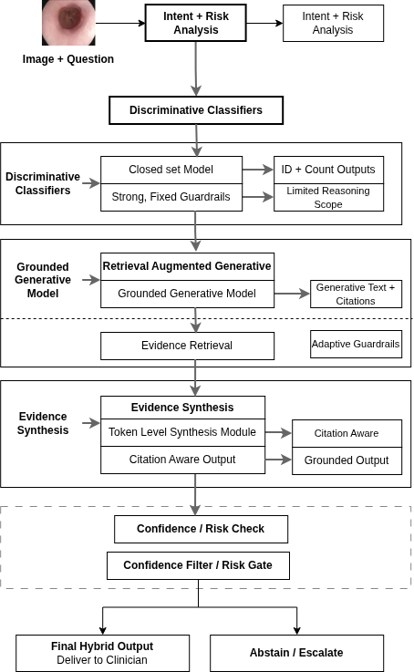
Figure 2.1: Hybrid Decision Support Routing Diagram

2.7 Scenario-Oriented Technique Suitability for Colonoscopy
A clinically useful survey should map model families to concrete clinical scenarios.
Colonoscopy scenario | Dominant question type | Preferred method profile | Reason
Finding presence/absence | Binary | Constrained discriminative or transformer classifier | Stable labels, high reliability requirements
Counting findings/instruments | Count + structured category | Transformer with constrained decoding | Better visual alignment than shallow fusion
Lesion location description | Spatial text/category | Transformer + localization-aware head | Requires spatial grounding consistency
UC severity grading | Ordinal category | Fine-tuned visual backbone + constrained QA interface | Ordinal robustness and severe-class control
Narrative explanation for clinician | Open text | Generative MLLM with grounding checks | Better usability, but must be constrained
Evidence-linked management query | Open text + evidence | Conditional retrieval-augmented generation | Useful only when core visual answer is reliable

2.8 2024-2026 Trends in MedVQA Research
Recent literature indicates several important shifts.
2.8.1 From Single-Image QA to Multi-Image Reasoning
MedFrameQA shows that multi-image clinical reasoning remains difficult for current MLLMs and exposes a gap between benchmark fluency and longitudinal diagnostic reasoning; notably, the benchmark received an updated arXiv revision in February 2026 [10].
2.8.2 From Benchmark Accuracy to Reliability Stress Testing
ProbMed-style probing demonstrates that high benchmark scores can hide brittle behavior under controlled perturbations [11]. SMMILE similarly highlights fragility in multimodal in-context learning [12].
2.8.3 Data-Centric Expansion and Synthetic Pipelines
New resources increasingly use automated or semi-automated pipelines to scale MedVQA data. This is seen in MedVLSynther-like generator-verifier approaches [13] and challenge tracks that explicitly integrate synthetic data [25].
2.8.4 Scaling Unified Medical VLMs
OmniV-Med and related work aim at unified multimodal medical understanding across 2D/3D/video settings [14]. These models are promising for broad capability, but consistent clinical robustness on specialized GI QA remains an open question.
2.8.5 Explainability as a First-Class Objective
GI challenge design in 2025 formalized explanation quality and clinical relevance as evaluation targets, not optional analysis [26], [27]. This marks a practical shift toward clinician-facing trust criteria.
2.9 Evidence Triangulation with Repository Results
To avoid a purely narrative survey, this section triangulates literature findings with local persisted artifacts.
Dataset/task (local report) | Representative local signal | Method implication
ImageCLEF MEDVQA-GI 2023 | ViLT fine-tune val accuracy 0.9089, macro-F1 0.5823; zero-shot Qwen raw near-zero accuracy | Closed-set tuned models remain stronger than raw zero-shot generation in this setting
HyperKvasir 23-class | ResNet50 supervised outperforms saved zero-shot generative baseline by large margin | Robust supervised visual encoders remain critical for GI grounding
Kvasir-VQA | ResNet+GRU yes/no subset reaches high reliability; free generation runs can collapse to unknown outputs | Constrained answer spaces remain highly effective for deterministic clinical sub-questions
Kvasir-VQA-x1 | LoRA improves token-level generative metrics; exact-match remains challenging | Reasoning-rich QA increases complexity; output normalization and grounding are central
LIMUC severity | Fine-tuned ResNet50 leads macro-F1 and QWK; zero-shot VLM underperforms severe-class reliability | UC severity tasks favor domain-tuned supervised pipelines with ordinal-aware evaluation
Table 2.9. Repository Evidence Snapshot and Method Implications
2.9.2 Interpretation
The local results align with broader literature:
- constrained/fine-tuned pipelines are still the reliability baseline in GI tasks;
- generative models provide flexibility but require strict controls;
- evaluation must emphasize classwise and severity-aware behavior, not only aggregate scores.
2.10 Key Gaps and Open Problems
2.10.1 Data and Annotation Gaps
- Severe-class and rare-finding imbalance remains substantial.
- Cross-center, cross-device robustness evidence is still limited for GI VQA.
- Multi-image/video QA is growing but still comparatively immature.
2.10.2 Model and Grounding Gaps
- Open-ended outputs often outpace grounding reliability.
- General-domain zero-shot transfer remains unstable for specialized GI semantics.
- Explainability outputs are not yet standardized across benchmarks.
2.10.3 Evaluation and Reproducibility Gaps
- Metric heterogeneity hinders fair cross-study comparison.
- Many studies still lack calibration and statistical confidence reporting.
- Clinical utility is often inferred indirectly from generic NLP overlap metrics.
2.10.4 Translational Gaps
- Few studies evaluate full clinician-in-the-loop workflows.
- Escalation policies for uncertain/high-risk outputs are seldom formalized.
- Evidence-aware QA in GI remains promising but early-stage.
2.10.5 Threats to Validity (for This Survey and Downstream Design)
The main validity threats relevant to this chapter are: (1) dataset shift across devices/centers and acquisition protocols, (2) annotation variability in endoscopic severity labels, (3) question ambiguity and answer-space normalization effects in generative settings, and (4) metric mismatch, where linguistic overlap does not guarantee clinical correctness. These threats are explicitly carried into the empirical design in later chapters through split-aware evaluation, classwise analysis, and scenario-level acceptance checks.

Observed gap | Mitigation in this dissertation
Long-tail severe-class weakness | Class-aware and severity-aware evaluation slices (Chapter 3, Chapter 4)
Zero-shot instability in GI | Strong supervised and constrained baselines before open generation extensions
Metric mismatch with clinical risk | Multi-layer evaluation protocol with ordinal and imbalance-aware metrics
Explainability without standard criteria | Scenario-specific explanation requirements and clinician-oriented quality checks
Weak evidence linkage | Conditional retrieval-augmented extension with guardrails
Table 2.10. Gap-to-Thesis Mitigation Map
2.11 Chapter Summary and Transition
This chapter surveyed MedVQA techniques with a colonoscopy-oriented lens and synthesized evidence from both external literature and local repository artifacts.
The main conclusions are:
- MedVQA has moved from fixed-label discriminative models toward generative and explainability-aware multimodal systems.
- GI benchmark resources have matured rapidly from 2023 onward, enabling more realistic evaluation.
- For high-risk colonoscopy scenarios, constrained and domain-tuned methods currently provide the most reliable core behavior.
- Generative and retrieval-enhanced methods are valuable extensions, but only when anchored by robust visual grounding and strict evaluation controls.
- Scenario-driven, clinically aligned evaluation is essential for translational relevance.
These conclusions motivate Chapter 3, which shifts from literature synthesis to empirical investigation of existing model families using the datasets and persisted outputs available in this repository.

Investigating Existing VQA Techniques Across GI-Endoscopy Datasets

3.1 Chapter Overview and Evaluation Goal
Chapter 2 surveyed medical VQA technique families and highlighted a central translational gap for GI endoscopy: strong benchmark scores do not automatically imply clinically reliable behavior, especially under class imbalance, domain shift, and high-consequence failure modes[56], [57]. Chapter 3 addresses that gap empirically by auditing persisted experimental artifacts available in this thesis repository and summarizing how model families behave under the dataset constraints that currently exist for colonoscopy-oriented MedVQA.
This chapter is designed as the empirical turning point of the dissertation. The guiding question is not only which model achieves higher aggregate scores, but which model behaviors remain reliable enough to be considered as building blocks for clinician-facing decision support. To answer that question, this chapter evaluates reliability across heterogeneous task regimes that occur in GI MedVQA: (i) closed-label prediction, (ii) open-ended generation, and (iii) ordinal severity assessment.
Chapter 3 overview (reader preview)
Across the datasets in this repository, the chapter provides a reproducible comparison of:
- constrained or supervised pipelines vs. raw zero-shot generative outputs,
- dataset- and question-family-specific failure modes (imbalance, format drift, mapping fragility), and
- severity-oriented reliability under ordinal and clinically meaningful slices (e.g., remission vs. non-remission).
Importantly, Chapter 3 is reproducibility-first: it reports outcomes only where persisted artifacts exist. Where only configuration or status files are present (e.g., scenario YAML definitions), the chapter reports configuration only and does not claim scenario-level performance[72].

Concretely, the objective is to determine, with traceable local evidence, how existing model families behave across:
- closed-set and binary clinical question answering,
- open-ended generative answering,
- severity-oriented ordinal assessment,
- class-imbalance stress conditions, and
- scenario-level stress-test protocol definitions for clinically relevant failure probing.
Unlike Chapter 2 (literature synthesis), Chapter 3 is artifact-driven: all results are compiled from saved outputs in the repository, not from newly run training or undocumented reruns[66] - [73]. Where a metric requires predictions that are not persisted, the metric is not reported.
This chapter serves three thesis-level functions:
- Establish a reproducible baseline of current GI MedVQA behavior before introducing new methods.
- Identify practical reliability bottlenecks (imbalance sensitivity, answer-format instability, lexical/OOV mapping fragility, and clinical threshold failures).
- Provide a defensible empirical bridge to Chapter 4, where controlled generative approaches are developed for clinically grounded UC severity rating and later extended toward evidence-aware answering.
Structurally, Section 3.1 defines evidence boundaries and research coverage, Section 3.2 formalizes datasets and model regimes, Section 3.3 specifies evaluation metrics and caveats, Section 3.4 presents dataset-wise results, and Section 3.5 synthesizes cross-dataset findings into thesis-level conclusions.

3.1.1 Evidence Boundary and Reproducibility Scope
Table 3.1 documents the provenance of all primary evidence used in this chapter. For each dataset block, the chapter’s results are compiled from the corresponding report file under the Prototyping_reformat/ tree and the associated persisted outputs referenced by that report[66] - [73].

Dataset / analysis block | Primary report file | Persisted artifact roots | Primary task style
HyperKvasir | Prototyping_reformat/DatasetAnalysis/HyperKvasir/HyperKvasir.md | Prototyping_reformat/DatasetAnalysis/HyperKvasir/**/out | 23-class visual classification
ImageCLEF MEDVQA-GI 2023 | Prototyping_reformat/DatasetAnalysis/ImageCLEF_MEDVQA_GI_2023/ImageCLEF_MEDVQA_GI_2023.md | Prototyping_reformat/DatasetAnalysis/ImageCLEF_MEDVQA_GI_2023/**/results | closed-label GI VQA
Kvasir-VQA | Prototyping_reformat/DatasetAnalysis/Kvasir_VQA/Kvasir_VQA.md | Prototyping_reformat/DatasetAnalysis/Kvasir_VQA/**/out | yes/no and attribute subsets
Kvasir-VQA-x1 | Prototyping_reformat/DatasetAnalysis/Kvasir_VQA_x1/Kvasir_VQA_x1.md | Prototyping_reformat/DatasetAnalysis/Kvasir_VQA_x1/**/results | large-scale generative + mapped closed-set
LIMUC | Prototyping_reformat/DatasetAnalysis/LIMUC/LIMUC.md | Prototyping_reformat/DatasetAnalysis/LIMUC/**/out | Mayo severity (ordinal 0-3)
Kvasir-SEG (supporting) | Prototyping_reformat/DatasetAnalysis/Kvasir_SEG/Kvasir_SEG.md | Prototyping_reformat/DatasetAnalysis/Kvasir_SEG/0_dataset_prep/** | morphology and mask statistics
Scenario protocol configuration | Prototyping_reformat/DatasetAnalysis/Kvasir_VQA/evaluation_comparison/scenarios/scenarios.yaml | Prototyping_reformat/DatasetAnalysis/Kvasir_VQA/evaluation_comparison/scenarios/ | micro-scenario stress-test definition (configuration only)
Legacy UC generative runtime snapshot (reformatted) | Prototyping_reformat/DatasetAnalysis/Kvasir_VQA/evaluation_comparison/phase3_results/summary_uc_phase3.csv | Prototyping_reformat/DatasetAnalysis/Kvasir_VQA/evaluation_comparison/phase3_results/*.csv | open-ended response artifact status
Table 3.1. Primary Evidence Sources Used in Chapter 3

Reproducibility rules used throughout Chapter 3
- No undocumented reruns: the chapter reports only what is present in persisted artifacts and their compiled report files.
- Report-first compilation: each dataset subsection in Section 3.4 is compiled from the dataset’s *.md report file first, then supported by any persisted visualizations or summary outputs referenced by that report.
- No fabricated comparisons: where a model’s predictions, labels, or scoring outputs are missing, the chapter does not infer or reconstruct results.
- Configuration-only evidence is treated as configuration: scenario YAML files are reported as protocol definitions, not as evaluated outcomes.
- Local-report cardinalities: dataset sizes shown in this chapter reflect the counts recorded in the local report artifacts and may differ from official dataset descriptor totals due to subset selection, filtering, or split definitions.
3.1.2 Research Questions Addressed in This Chapter
Chapter 3 provides empirical evidence relevant to the following research questions defined in Chapter 1:
- RQ2 (comparative reliability): Do constrained/discriminative pipelines remain more reliable than raw zero-shot generative outputs for current GI MedVQA tasks?
- RQ3 (failure modes): Which failure modes dominate across datasets and task styles (e.g., imbalance collapse, lexical drift, mapping fragility, question-family brittleness)?
- RQ4 (severity robustness): How reliably can models support UC severity-oriented question answering under ordinal structure and severe-class imbalance?
- RQ5 (clinical output format) – protocol support only: Chapter 3 includes scenario protocol definitions that inform later clinician-facing evaluation logic, but it does not report scenario outcome metrics unless scored predictions are persisted.
To keep the evidence boundary explicit, scenario-level conclusions are deferred when only scenario configuration is present.

Chapter 2 established the technique landscape (discriminative fusion models, transformer-based multimodal encoders, generative multimodal models, and retrieval-augmented directions) and emphasized that evaluation must be aligned with clinical risk[57], [58], [59]. Chapter 3 operationalizes that principle by evaluating model families using the datasets and artifact outputs available in this repository. The chapter therefore functions as the thesis’s empirical “reality check”: it identifies what is currently reliable under GI-specific constraints and what failure patterns must be addressed before introducing controlled generative and evidence-aware extensions in subsequent chapters.

3.2 Experimental Scenarios and Data Regimes
Section 3.2 defines the empirical scope: which datasets are evaluated, what task styles they represent, and which model families are compared. The aim is not to claim universal generalization across all GI settings, but to characterize reliability patterns within the available artifact evidence and across diverse task regimes (closed-label, generative, ordinal).

3.2.1 Dataset-Task Matrix
Table 3.2 summarizes the datasets included in Chapter 3 and the primary role each dataset plays in the evaluation. The “cardinality” values reflect the counts recorded in the local report files used for this chapter[66]-[70].
Dataset | Cardinality in local report | Core outputs | Main evaluation axis | Clinical relevance
HyperKvasir | 10,662 images, 23 classes | class labels | multiclass reliability under imbalance | broad GI visual grounding
ImageCLEF MEDVQA-GI 2023 | 36,683 QA rows (29,351 train, 7,332 val) | label IDs per question | per-question closed-label VQA reliability | benchmarked GI QA consistency
Kvasir-VQA | 58,849 QA rows, 6,500 images | yes/no, attributes, free text | subset reliability and format stability | colonoscopy QA behavior
Kvasir-VQA-x1 | 159,549 QA rows, 6,449 images | free-text answers + mapped labels | generative fidelity, complexity effects | robust MedVQA reasoning stress
LIMUC | 11,276 images, Mayo 0-3 | ordinal severity class | macro-F1, QWK, remission slice | UC treatment-aligned severity
Kvasir-SEG | 1,000 image-mask pairs | mask morphology stats | coverage/shape support metrics | future localization grounding
Table 3.2. Dataset and Task Matrix for Chapter 3 Experiments
Why these datasets are included
- Kvasir-VQA provides the most direct colonoscopy-oriented VQA evidence and is used to examine subset reliability and answer-format stability under common question families[52], [68].
- ImageCLEF MEDVQA-GI 2023 provides a standardized closed-label GI VQA setting where fine-tuned VQA models can be compared to zero-shot generative outputs under label constraints[54], [67].
- Kvasir-VQA-x1 provides a large-scale generative stress test, useful for studying overlap metrics, complexity effects, and label mapping fragility in free-text answers[53], [69].

- LIMUC anchors the thesis’s clinical flagship: UC severity, where ordinal structure and clinically meaningful slices (e.g., remission vs non-remission) are essential for interpretation[55], [70].
- HyperKvasir provides broad GI visual grounding with strong long-tail imbalance, allowing analysis of head–tail recall asymmetry that can be hidden by aggregate accuracy[51], [66].
- Kvasir-SEG is included as supporting evidence for morphology/localization-oriented statistics that later motivate grounding-aware directions; it is not treated as a primary VQA benchmark in this chapter[71].
3.2.2 Model Families Compared
The model comparisons in Chapter 3 reflect what is available as persisted artifacts rather than an exhaustive survey of all possible architectures. The goal is to compare representative families that span the major design choices relevant to clinical reliability: supervised classification, constrained VQA, and open-ended generation.
Family | Example persisted models | Typical answer mode
Supervised CNN/ViT classifiers | resnet50_supervised, vit_supervised, finetune_resnet50 | closed label
Frozen encoder + shallow classifier | vit_frozen_logreg, clip_linear_baseline, resnet50_frozen_logreg | closed label
Classical multimodal fusion | resnet_gru_m1_*, vit_bertlite_m2_* | closed set
Transformer VQA fine-tuned | vilt_finetune | closed label per question
Zero-shot VLM/MLLM | qwen2_5_vl_zeroshot, medgemma_zeroshot, blip2_zero_shot | free text (optionally projected)
Parameter-efficient adaptation | medgemma_lora_original, qwen2_5_vl_lora_finetune (logs persisted) | free text
Table 3.3. Representative Model Families in Persisted Artifacts
Interpretation guide
- Closed-label families (supervised or shallow classifiers) provide a reliability baseline where output space is controlled and evaluation is deterministic.
- Classical fusion and transformer VQA models represent structured MedVQA pipelines designed to combine image and question representations under a constrained output space.
- Zero-shot VLM/MLLM models represent open-ended generation, which may be more flexible but can be unstable in output format and lexical grounding.
- Parameter-efficient adaptation captures whether lightweight fine-tuning improves generative fidelity without requiring full retraining.
Section 3.3 defines the metric bundles used to compare these families and clarifies how raw vs projected scoring is treated when free text must be mapped to a constrained answer space.
3.2.3 Data Profile Figures (Kvasir-VQA)
Before presenting results, the chapter includes Kvasir-VQA profiling figures because they explain several behaviors observed later in Section 3.4, particularly the dominance of yes/no questions and the presence of template skew. These distributional properties can inflate superficial performance on majority question types while masking failure on rarer but clinically important categories[68], [74]-[76].
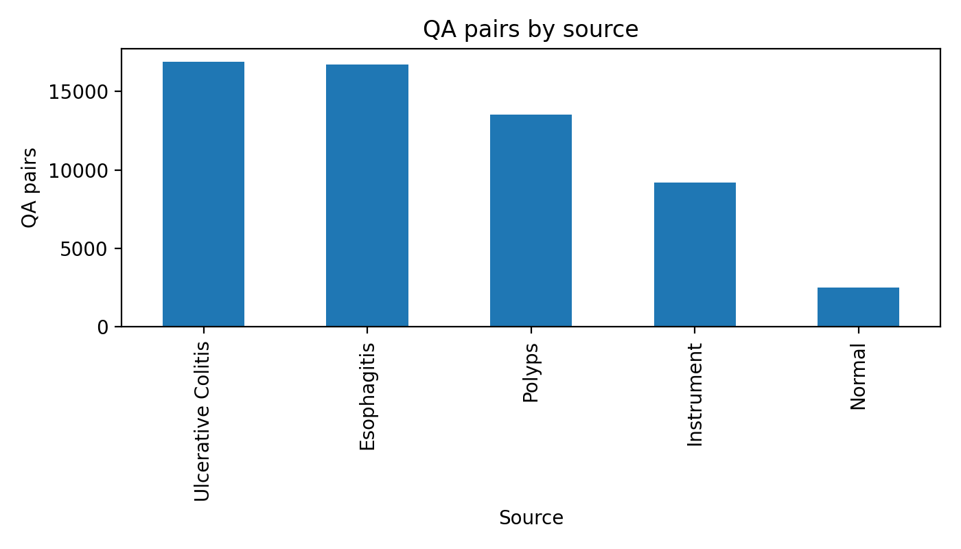
Figure 3.1 QA count by source domain
Figure 3.1 summarizes how QA pairs are distributed across source domains in the Kvasir-VQA preparation artifacts[74]. Source-domain imbalance implies that model performance may reflect dominant sources disproportionately, and it motivates later per-family and per-task reporting rather than single aggregate scores.

Figure 3.2 QA count by type distribution
The distribution shows that yes/no questions form a large share of Kvasir-VQA[75]. This creates a majority-family regime where models can perform strongly by exploiting priors, and it motivates the use of balanced metrics and subset-level reporting to avoid overstating reliability.
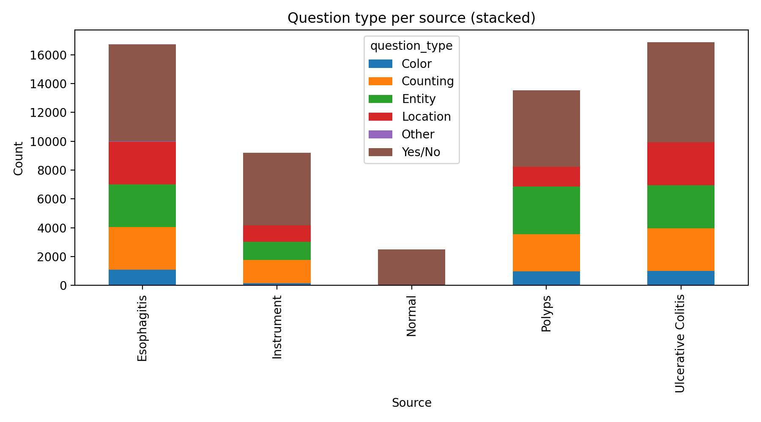
Figure 3.3 Question type by source
Question-type composition varies by source domain, indicating that the dataset is not homogeneous across origins[74]. This supports the chapter’s emphasis on failure-mode analysis and warns against interpreting a single “overall” score as uniformly applicable across question families.
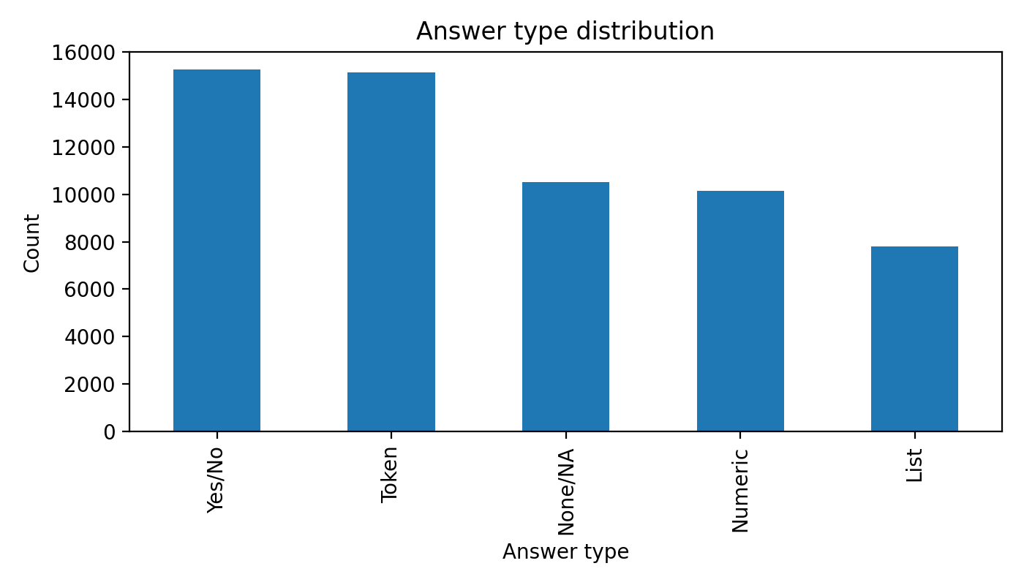
Figure 3.4 Answer type distribution
The answer-type distribution highlights why evaluation must be matched to task style: exact-match metrics are natural for constrained outputs but can be overly harsh for free-text generation, where token-level overlap diagnostics may be more informative[76]. This motivates the layered metric design defined in Section 3.3.
Signal | Value
Total QA rows | 58,849
Unique images | 6,500
Mean QA rows per image | 9.05
Yes/No questions | 26,515 (45.06%)
Entity questions | 10,528 (17.89%)
Counting questions | 10,118 (17.19%)
Location questions | 8,424 (14.31%)
Table 3.4 Kvasir-VQA Distribution Snapshot
The strong question-family skew supports two design choices used throughout Chapter 3: (i) report class-balanced or family-aware metrics where possible, and (ii) interpret aggregate scores cautiously, because strong performance on a dominant family (e.g., yes/no) does not guarantee reliable behavior on count, location, or clinically higher-risk categories.
3.2.4 Scenario Micro-Benchmark Definition
To connect benchmark evaluation to realistic clinical vignettes, the repository includes a micro-scenario protocol definition.
The protocol defines three focused scenario templates:
- S1: active bleeding binary detection,
- S2: instrument type plus polyp count,
- S3: Paris morphology closed set.
These scenarios are intentionally small and are treated as stress vignettes, not as statistical benchmark replacements. Only scenario configuration is persisted in the reformatted evidence tree; scored scenario predictions are not persisted[72]. Therefore, Chapter 3 reports scenario definitions as protocol context only and does not report scenario outcome metrics in the absence of scored artifacts.
3.2.5 Alignment with Prior Dissertation Problem Settings
The dataset and task choices in Chapter 3 are designed to align with common GI-endoscopy AI concerns while focusing on MedVQA-specific reliability:
- Severity and treatment relevance are represented by LIMUC, where ordinal behavior and clinically interpretable slices are necessary for credible UC severity assessment[55], [62]-[65], [70].
- Robustness under heterogeneity is addressed by including multiple datasets with different answer spaces and task formulations, enabling cross-dataset comparison of failure patterns rather than optimizing for a single benchmark.
- Transparency of model behavior is operationalized by reporting not only aggregate metrics but also imbalance-aware indicators, question-family slices, and explicit boundaries where evidence is unavailable.
This chapter does not attempt to replace established GI work on detection, segmentation, or video-level robustness. Instead, it complements that literature by adding a dedicated empirical layer for question-answer reliability, which is a prerequisite for interactive, clinician-facing MedVQA systems.
3.3 Evaluation Metrics and Statistical Protocol
This chapter compares model families across heterogeneous GI MedVQA task regimes. Because these regimes differ in answer format (fixed labels vs free text) and label structure (nominal vs ordinal), no single metric adequately captures reliability. Chapter 3 therefore uses a layered metric bundle and a conservative reporting protocol: point estimates are reported only when corresponding persisted predictions and evaluation outputs exist, and comparative claims are bounded to the evidence available in the persisted artifacts[56].
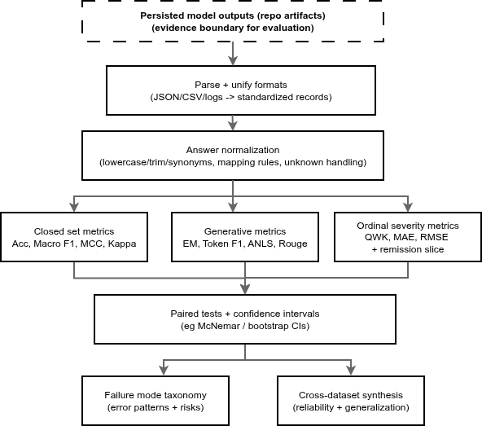
Figure 3.5 — Artifact-driven benchmarking workflow
3.3.1 Metric Layers
To avoid single-metric bias, Chapter 3 uses four metric layers depending on task style and clinical risk profile.
(A) Closed-set classification and constrained QA
These metrics are used when outputs are categorical and the answer space is controlled (e.g., HyperKvasir class labels, ImageCLEF label IDs, constrained Kvasir-VQA subsets).
- Accuracy: overall fraction of correct predictions.
- Macro-F1: unweighted mean of per-class F1, emphasizing minority-class behavior.
- Balanced accuracy: mean of per-class recall (equally weights classes regardless of support).
- MCC (Matthews correlation coefficient): correlation-style score robust under imbalance (reported where available in persisted outputs).
- Cohen’s kappa: agreement measure corrected for chance (reported where available in persisted outputs).
- Imbalance diagnostics (where included in artifacts): head–tail or rare–common recall gaps computed from classwise recall slices (e.g., thresholds defined in the dataset’s local report).
(B) Generative overlap and format fidelity (free-text outputs)
These are used when models generate natural language answers rather than selecting from a fixed ontology. In this chapter they are treated as diagnostic fidelity indicators, not as sufficient evidence of clinical correctness[57], [60], [61].
- Exact match (EM): strict string-level match under the normalization used by the local evaluation scripts.

- Token-F1: token-level overlap between generated and reference answers, useful when exact match is too strict.
- ANLS: edit-distance-based similarity score used in VQA-style evaluation; implementation details follow the persisted evaluation outputs and scripts used to produce the repository artifacts.
- BLEU / ROUGE-L / METEOR (where available): standard NLG overlap metrics reported only when computed in the persisted artifacts.
(C) Ordinal severity and clinically meaningful slices (UC severity as flagship use case)
These metrics are used when labels have an ordinal relationship (e.g., Mayo 0–3) and when the clinical decision boundary matters more than overall accuracy.
- QWK (quadratic weighted kappa): penalizes ordinal disagreements proportionally to distance (e.g., confusing 0↔1 is not equivalent to 0↔3).
- MAE / RMSE: absolute and squared error over ordinal labels treated as numeric.
- Spearman correlation (where available): rank correlation for ordinal consistency.
- Clinical remission slice: a thresholded binary evaluation derived from ordinal severity labels (in LIMUC artifacts, remission is evaluated as Mayo 0–1 vs 2–3, as indicated in the corresponding table caption).
(D) Uncertainty and comparative significance diagnostics (paired predictions only)
To avoid overinterpreting small point-estimate differences, Chapter 3 uses statistical diagnostics only when paired predictions are persisted for the same evaluation set.
- Wilson confidence intervals: used for proportions (e.g., accuracy) when included in the report outputs.
- Paired McNemar test: used for paired comparison of two classifiers on the same examples; reported only where persisted counts (n01, n10) and p-values exist in the artifacts.

Scenario type | Primary metrics | Why these metrics
Binary clinical detection | recall/sensitivity, macro-F1, MCC | false negatives and imbalance sensitivity
Multiclass closed-set QA | accuracy + macro-F1 + balanced accuracy | aggregate plus per-class fairness
Free-text QA | token-F1 + ANLS + overlap metrics | lexical similarity with tolerance to paraphrase
Ordinal severity | QWK + MAE/RMSE + remission slice | ordinal penalty and clinical thresholding
Model comparison claims | McNemar + CIs | avoids overinterpreting point estimates
Table 3.5 Metric Selection by Scenario Type
Throughout Chapter 3, N denotes the number of evaluated items recorded in the local report (images or QA rows). Metrics are interpreted primarily within-dataset because answer spaces and task definitions differ across datasets.
3.3.2 Important Evaluation Caveats
This chapter’s evaluation design is intentionally conservative. The following caveats define how results should be interpreted and what is not claimed.
- Cross-dataset scores are not directly comparable. Different datasets implement different answer spaces, label ontologies, and question-family distributions. Therefore, Chapter 3 uses cross-dataset comparison mainly to identify consistent patterns of failure modes, not to rank models globally.
- Generative overlap is not clinical correctness. Metrics such as token-F1, ANLS, BLEU, ROUGE-L, and METEOR quantify lexical similarity and answer-format adherence. They do not guarantee that generated text is clinically faithful or visually grounded[57], [60], [61]. In this chapter, generative overlap metrics are treated as diagnostic indicators and interpreted alongside failure signals (unknown/OOV behavior, mapping fragility, and question-family brittleness).
- Raw vs. projected scoring is explicitly separated (diagnostic only). Some persisted artifacts include both “raw” scoring of generated outputs and a secondary “projected” diagnostic that maps free text into a constrained answer space before scoring. This chapter follows the artifact semantics:
  - Raw scoring reflects direct evaluation against canonical targets under the local evaluation convention; for many label-ID tasks, raw free-text outputs can collapse to near-zero label accuracy because the output is not in the canonical label format.
  - Projected scoring deterministically maps generated text to the allowed answer set (e.g., canonical labels for a question family) using the repository’s evaluation logic, then scores the mapped label.
  - Unknown/OOV handling: if an output cannot be mapped to the allowed answer set, it is treated as unknown/OOV for that diagnostic and contributes to unknown/OOV rates where reported.
Interpretation rule: projected scores are used to quantify format and ontology alignment under deterministic mapping; they are not treated as a replacement for primary reliability evidence.
- Scenario results are not claimed without persisted scenario predictions. Scenario YAML definitions are included as protocol context, but scenario outcome metrics are reported only if scored predictions are persisted. If only configuration is present, Chapter 3 reports configuration only and defers scenario outcomes.
- Statistical tests are reported only where paired predictions exist. McNemar tests and confidence intervals require paired predictions for the same examples. Where the persisted artifacts include these counts and p-values, Chapter 3 reports them. Where they are not present, Chapter 3 reports point estimates without significance claims.
- Missing metrics are treated as “not computed,” not “zero.” If a metric is not applicable or not computed in the persisted evaluation outputs (e.g., BLEU/ROUGE absent for some runs), the chapter reports it as unavailable and does not infer values.
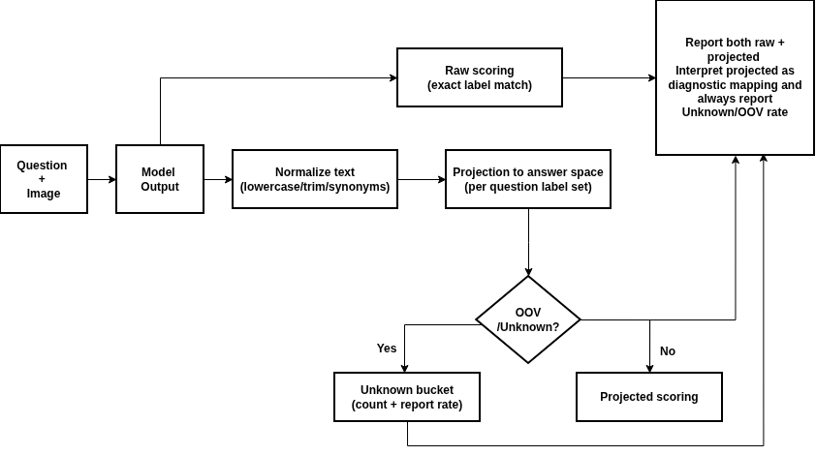
Figure 3.6 — Label projection / answer normalization pipeline (raw vs projected + unknown/OOV)
3.3.3 Metric Design Choices Grounded in Prior Work
The metric stack in this chapter follows a common principle in clinical AI evaluation: performance should be characterized using both aggregate discrimination and robustness under imbalance and clinically relevant thresholds, rather than relying on a single headline score[56].
For GI endoscopy tasks, this implies:
- macro-F1 and balanced accuracy are emphasized to prevent majority-class dominance from masking clinically relevant failures;
- MCC and kappa are reported where available because they capture agreement behavior under imbalance;
- ordinal metrics and clinical slices (QWK, MAE/RMSE, and remission-style thresholds) are required for UC severity tasks where the distance between grades and the decision boundary are clinically meaningful.

For generative tracks, overlap metrics are retained as format and lexical-fidelity diagnostics, but they are not treated as sufficient endpoints for clinical reliability. Where projection/mapping diagnostics are available, they are reported explicitly as diagnostics to quantify ontology alignment and unknown/OOV behavior.
Finally, comparative statistics (e.g., McNemar) are used as safeguards against overinterpreting small differences, but only where paired evidence is persisted. The chapter therefore prioritizes traceable, artifact-backed reporting over completeness of metric coverage.
3.4 Baseline and Existing-Model Results
Section 3.4 reports dataset-wise results compiled from persisted artifacts described in Table 3.1[66]-[73]. Because each dataset defines different answer spaces (class labels, label IDs per question, or free-text answers) and different task regimes (classification, closed-label VQA, subset QA), results are interpreted primarily within each dataset. Cross-dataset comparisons are used to identify consistent reliability patterns (e.g., imbalance sensitivity, answer-format instability), rather than to produce a single global ranking.
Each dataset subsection follows a consistent structure: (i) role of the dataset in the thesis evaluation design, (ii) which model families are compared and why, (iii) interpretation of the reported tables (overall metrics, robustness slices, and where available paired diagnostics), and (iv) limitations and implications for subsequent chapters.
3.4.1 HyperKvasir: 23-Class GI Image Classification
Although HyperKvasir is not a VQA dataset, it provides an important visual grounding stress test for GI imaging[51], [66]. The task here is 23-class GI image classification, which functions as a proxy for how well different visual backbones and representations capture GI categories under realistic data constraints. The key difficulty is strong long-tail imbalance: in the persisted report, test-set class support ranges from 1 to 115 per class (≈115× ratio), meaning that a model can achieve high aggregate accuracy while still failing on rare classes that may be clinically important.
Table 3.6 summarizes overall test performance for supervised and frozen-feature baselines, alongside a zero-shot VLM baseline projected into a label space (as recorded in the persisted artifact outputs).

Model | Accuracy | Balanced Acc | Macro-F1 | MCC | Kappa
resnet50_supervised | 0.8789 | 0.6266 | 0.5943 | NA | NA
vit_supervised | 0.8714 | 0.5391 | 0.5242 | NA | NA
vit_frozen_logreg | 0.8620 | 0.6130 | 0.6052 | 0.8505 | 0.8504
clip_linear | 0.8620 | 0.5799 | 0.5721 | 0.8503 | 0.8503
blip2_zero_shot_clip | 0.0638 | 0.0529 | 0.0254 | 0.0386 | 0.0303
Table 3.6 HyperKvasir Overall Test Metrics
Table 3.6 summarizes overall test performance for supervised and frozen-feature baselines, alongside a zero-shot VLM baseline projected into a label space (as recorded in the persisted artifact outputs).
The supervised and frozen-feature pipelines form a strong reliability baseline on aggregate metrics, while the zero-shot VLM baseline performs poorly on this closed-label classification setting. However, aggregate metrics alone are insufficient in a long-tail regime. In particular, balanced accuracy and macro-F1 are emphasized here because they weight minority classes more fairly than raw accuracy.
To quantify long-tail robustness explicitly, Table 3.7 reports rare-class and common-class recall slices (as defined in the persisted report), along with a head–tail recall gap.
Model | Rare-class recall (support <= 5) | Common-class recall (support >= 90) | Common-minus-rare gap
resnet50_supervised | 0.1595 | 0.9375 | 0.7779
vit_supervised | 0.0000 | 0.9432 | 0.9432
vit_frozen_logreg | 0.1714 | 0.9120 | 0.7406
clip_linear | 0.0476 | 0.9091 | 0.8615
blip2_zero_shot_clip | 0.0000 | 0.0471 | 0.0471
Table 3.7 HyperKvasir Imbalance Robustness Slices
All high-accuracy models exhibit substantial head–tail asymmetry: common-class recall is high while rare-class recall remains low. Notably, some models achieve strong common-class recall while still scoring near zero on rare-class recall, illustrating why long-tail evaluation slices are required for risk-aware interpretation. This result motivates later chapters to treat minority-class behavior as a first-class reliability requirement, rather than assuming that high overall accuracy implies safe performance.
Where paired predictions are available in the artifacts, Table 3.8 reports selected McNemar tests to assess whether differences between model variants are likely to be noise-level fluctuations on the same test examples.

Pair | n01 (A wrong, B right) | n10 (A right, B wrong) | p-value
vit_frozen_logreg vs clip_linear | 68 | 68 | 0.931666
vit_frozen_logreg vs blip2_zero_shot_clip | 21 | 871 | < 1e-6
clip_linear vs blip2_zero_shot_clip | 19 | 869 | < 1e-6
Table 3.8 HyperKvasir Pairwise McNemar Tests
In the persisted paired comparisons, vit_frozen_logreg and clip_linear show no meaningful difference (symmetric disagreement counts and high p-value), while both are strongly separated from the zero-shot baseline (highly asymmetric disagreement counts and very small p-values). These tests support the qualitative conclusion already visible in Table 3.6: within this dataset and evidence scope, supervised/frozen discriminative pipelines dominate the zero-shot baseline.
Limitations and implications. HyperKvasir is used here as a GI visual grounding stress test rather than a direct VQA benchmark. Therefore, its primary value is diagnostic: it demonstrates that (i) strong aggregate performance can coexist with poor rare-class recall, and (ii) reliable GI perception under long-tail imbalance remains a bottleneck that must be monitored explicitly. This motivates later chapters to preserve strong visual grounding components and to treat class-imbalance mitigation as necessary for clinically aligned behavior.
3.4.2 ImageCLEF MEDVQA-GI 2023: Closed-Label GI VQA
ImageCLEF MEDVQA-GI 2023 provides a closed-label VQA setting in which each question is associated with a constrained answer ID space[54], [67]. This enables deterministic evaluation and is well-suited for testing the thesis’s core reliability question: how do fine-tuned multimodal VQA models compare to raw zero-shot generative VLM outputs under label constraints? In this chapter, evaluation is reported for the persisted validation split (N = 7,332) recorded in the local report artifacts.
Table 3.9 reports overall validation metrics for a fine-tuned transformer VQA model and two zero-shot variants: “raw” (direct outputs) and “projected” (diagnostic mapping of outputs into the allowed answer space, as defined in Section 3.3).

Model variant | N | Accuracy | Balanced Acc | Macro-F1 | MCC | Kappa
vilt_finetune | 7,332 | 0.9089 | 0.5853 | 0.5823 | 0.8876 | 0.8875
qwen2_5_vl_zeroshot_raw | 7,332 | 0.0007 | 0.0433 | 0.0007 | -0.0696 | -0.0626
qwen2_5_vl_zeroshot_projected | 7,332 | 0.0670 | 0.0899 | 0.0379 | -0.0296 | -0.0278
Table 3.9 ImageCLEF MEDVQA-GI 2023 Validation Metrics
The fine-tuned VQA model exhibits strong closed-label accuracy, while the raw zero-shot generative outputs score near zero under the label-ID evaluation format. Projection improves the zero-shot diagnostic score, indicating that some generated outputs can be mapped into the label space, but the projected accuracy and macro-F1 remain far below the fine-tuned baseline. The negative MCC/kappa values for the zero-shot variants are consistent with systematic mismatch under the constrained label-ID evaluation format, rather than random variation.
To avoid hiding question-family brittleness, Table 3.10 reports family-level aggregates. This is important because some families (e.g., procedure or attribute) may require stricter ontology adherence than others.
Question family | Rows | ViLT acc | Qwen raw acc | Qwen projected acc | ViLT macro-F1 | Qwen projected macro-F1
attribute | 1,600 | 0.8488 | 0.0000 | 0.0225 | 0.5153 | 0.0340
binary/boolean | 2,800 | 0.9339 | 0.0004 | 0.1168 | 0.9222 | 0.0906
count | 1,200 | 0.9008 | 0.0017 | 0.0400 | 0.3950 | 0.0158
location | 1,332 | 0.9092 | 0.0015 | 0.0601 | 0.3115 | 0.0205
procedure | 400 | 0.9975 | 0.0000 | 0.0000 | 0.9969 | 0.0000
Table 3.10 Family-Level Aggregates on ImageCLEF Validation
Two patterns are visible. First, the fine-tuned model remains consistently strong across families in accuracy terms, but macro-F1 varies substantially across families (notably count/location), indicating that even strong aggregate accuracy can conceal intra-family imbalance or difficulty. Second, the zero-shot model’s raw outputs perform near zero across families, and projection yields partial recovery mainly for binary/boolean questions, with minimal gains for attribute, count, and location and no recovery for the procedure family in the persisted artifacts. This indicates that projection can rescue some format mismatch, but it does not resolve the core reliability gap under structured families.
To illustrate where projection helps most, Table 3.11 lists the questions with the largest raw→projected accuracy gains in the persisted validation outputs.

Question | Raw acc | Projected acc | Absolute gain
Is there a green/black box artefact? | 0.0000 | 0.5475 | +0.5475
Are there any instruments in the image? | 0.0000 | 0.1800 | +0.1800
Where in the image is the abnormality? | 0.0000 | 0.1400 | +0.1400
What color is the abnormality? | 0.0000 | 0.0800 | +0.0800
How many polyps are in the image? | 0.0025 | 0.0600 | +0.0575
Table 3.11. Largest Qwen Lexical-Projection Gains (Validation Accuracy)
These examples show that deterministic mapping can substantially improve measurable label accuracy for specific prompts, suggesting that the raw outputs sometimes contain recoverable information that is not expressed in the expected label form. However, as emphasized in Section 3.3, projection remains a diagnostic and can overestimate correctness when matches are shallow or purely lexical. The key reliability result for this chapter is therefore the persistent gap in Table 3.9 and Table 3.10: even after projection, zero-shot outputs remain far below a fine-tuned closed-label baseline across major question families.
Limitations and implications. This subsection compares a fine-tuned transformer baseline to one zero-shot model under the persisted evaluation configuration. It does not claim universal generalization to all VLMs or all GI datasets. Moreover, because paired statistical tests are not reported for this dataset in the included tables, this chapter avoids “significance” wording here and interprets differences as large observed gaps under the available evidence. The practical implication is that for label-ID GI VQA settings, reliable performance requires answer-space governance (constrained decoding, ontology compliance) and likely supervision or adaptation; these conclusions motivate the controlled generative design decisions introduced in Chapter 4.
3.4.3 Kvasir-VQA: Subset Reliability and Answer-Format Stability
Kvasir-VQA is a colonoscopy-oriented VQA resource and is central to the supervisor-directed empirical pathway for this dissertation[52], [68]. The persisted artifacts available for this chapter include (i) structured subset evaluations for yes/no and attribute-style questions and (ii) a reformatted phase-3 generative snapshot intended to capture runtime status[73]. This subsection focuses on two reliability themes relevant to GI MedVQA: (1) how strong constrained/fusion pipelines can be on structured question families, and (2) how fragile unconstrained generation can become when output format is not governed.

Model | N | Accuracy | Balanced Acc | Macro-F1 | MCC | Unknown rate
resnet_gru_m1_yesno | 443 | 0.986456 | 0.973673 | 0.964953 | 0.930163 | 0.0000
vit_bertlite_m2_yesno | 443 | 0.950339 | 0.906593 | 0.878126 | 0.759432 | 0.0000
blip2_zeroshot_yesno | 443 | 0.893905 | 0.509376 | 0.492332 | 0.086138 | 0.0000
blip_vqa_base_yesno_forced_choice | 12,267 | 0.518301 | 0.514587 | 0.502888 | 0.030894 | 0.0000
blip_vqa_base_yesno_freegen | 500 | 0.000000 | NA | 0.000000 | NA | 1.0000
Table 3.12 Kvasir-VQA Yes/No Results
Two distinct patterns appear. First, constrained fusion models (resnet_gru_m1_yesno, vit_bertlite_m2_yesno) achieve high accuracy and high balanced metrics on this persisted subset, indicating that structured yes/no questions can be handled reliably when the output space is controlled. Second, the zero-shot model (blip2_zeroshot_yesno) achieves high accuracy but near-chance balanced accuracy and low MCC, which is consistent with majority-class bias in an imbalanced yes/no distribution—an example of why macro-F1, balanced accuracy, and MCC are necessary complements to raw accuracy. Finally, the free-generation variant (blip_vqa_base_yesno_freegen) collapses under this evaluation format with unknown-rate = 1.0, indicating complete answer-format noncompliance under the persisted scoring rules.
Table 3.13 reports results for an attribute subset, which is more challenging than yes/no because it typically expands the answer vocabulary and increases ambiguity.

Model | N | Accuracy | Balanced Acc | Macro-F1
resnet_gru_m1_attribute | 352 | 0.670455 | 0.376936 | 0.367341
vit_bertlite_m2_attribute | 352 | 0.656250 | 0.374696 | 0.355586
Table 3.13 Kvasir-VQA Attribute Subset
While accuracy remains moderate, balanced accuracy and macro-F1 are substantially lower, indicating that the attribute subset exhibits stronger imbalance and/or class confusability than the yes/no subset. This aligns with the broader reliability view adopted in this dissertation: even when constrained pipelines perform strongly on a dominant family (yes/no), harder families can remain bottlenecks and require separate analysis rather than extrapolation from the easiest subset.
This subsection reports subset-level evidence rather than a full Kvasir-VQA benchmark sweep. The yes/no subset (N=443) and the larger forced-choice evaluation (N=12,267) are not directly comparable as a controlled experiment because they differ in evaluation set size and possibly in subset construction. Nevertheless, the reliability message is consistent across the persisted artifacts: (i) constrained/fusion pipelines can be very strong on structured subsets, and (ii) unconstrained generation can collapse under closed-label evaluation due to answer-format instability. These results motivate the design stance used in subsequent chapters: preserve constrained pathways for high-reliability sub-questions and introduce generative answering only under explicit output governance (constraints, mapping, or abstention behavior).
3.4.4 Kvasir-VQA-x1: Large-Scale Generative Reasoning Benchmark
Kvasir-VQA-x1 is the largest QA setting used in this thesis repository evidence and serves as the strongest stress test for open-ended generative answering under increased question variety and difficulty[53], [69]. Unlike closed-label tasks (where answers are selected from a fixed ontology), Kvasir-VQA-x1 evaluates free-text generation. As a result, reliability in this setting depends not only on underlying visual reasoning, but also on answer-format stability, lexical normalization, and ontology alignment—all of which can fail even when a model produces plausible text.
This subsection reports three complementary views of behavior:
- Generative overlap diagnostics quantify lexical similarity between generated text and references under the evaluation conventions used in the persisted artifacts.
- Closed-set style diagnostics and baselines illustrate how mapping and answer-space governance can affect apparent performance, including failure patterns such as high OOV (out-of-vocabulary) or unknown mapping rates.
- Complexity-level breakdown provides a descriptive diagnostic of how token-level overlap varies with question complexity (as recorded in the persisted summaries).
Generative overlap and adaptation effects
Model | EM | Token-F1 | ANLS | BLEU | ROUGE-L | METEOR | Count
medgemma_lora_original | 0.000000 | 0.508473 | 0.340755 | NA | NA | NA | 15,955
medgemma_zeroshot | 0.000063 | 0.213080 | 0.017498 | 0.033341 | 0.158501 | 0.141180 | 15,955
llava_zeroshot | 0.000000 | 0.212437 | 0.007032 | 0.025760 | 0.163942 | 0.150097 | 15,955
qwen2_5_vl_zeroshot | 0.000000 | 0.172788 | 0.000000 | 0.017084 | 0.123496 | 0.187288 | 15,955
Table 3.14 Kvasir-VQA-x1 Generative Metrics
Exact match (EM) is near zero across all runs, which is consistent with strict string matching under free-text generation where minor lexical differences can prevent EM even when the meaning is similar. Token-F1 and ANLS provide more tolerant diagnostics and show a clear adaptation effect: the LoRA-adapted run substantially improves token-level overlap compared with the zero-shot runs in the persisted artifacts. Where BLEU/ROUGE/METEOR are marked NA, the metric was not computed in the persisted outputs and is not inferred.
Reliability boundary. These overlap metrics quantify surface-level fidelity and answer-format adherence, but they do not guarantee clinical correctness or visual grounding (Section 3.3)[57], [60], [61]. Accordingly, they are treated as diagnostic indicators and interpreted alongside mapping/OOV signals and class-balanced behavior.
Closed-set style baselines and mapping fragility
To expose how answer-space governance affects apparent performance, the persisted artifacts include additional diagnostics and baselines that map outputs into constrained spaces or evaluate alternative non-generative approaches.
Model | N | Accuracy | Balanced Acc | Macro-F1 | Notes
fusion_tfidf_vit_logreg | 5,893 | 0.814865 | NA | 0.150749 | fusion baseline
text_yesno_tfidf_logreg | 1,540 | 0.777922 | NA | 0.777291 | yes/no-specific
vlm_zeroshot_label_mapped | 15,955 | 0.561642 | NA | 0.005817 | OOV rate 0.973
text_topk_tfidf_logreg | 4,252 | 0.422389 | 0.235698 | 0.204103 | top-3 0.7408
image_resnet50_logreg | 5,952 | 0.233535 | NA | 0.008556 | image-only
text_bert_classifier | 9,148 | 0.158942 | 0.006654 | 0.002327 | weak generalization
image_vit_logreg | 4,252 | 0.020461 | NA | 0.006352 | image-only
Table 3.15 Kvasir-VQA-x1 Mapped/Baseline Diagnostics

Two reliability signals are important here:

- Moderate mapped accuracy can be misleading. The mapped VLM diagnostic reports accuracy above 0.5 while macro-F1 is near zero, alongside an extremely high OOV rate. This indicates severe answer-space mismatch: many outputs cannot be mapped to the expected label space, and the mapped subset does not support balanced performance. As emphasized in Section 3.3, mapped accuracy is a format/ontology diagnostic, not evidence of clinically reliable reasoning.
- Subset-specific baselines can look strong due to question-family skew. The yes/no-specific baseline reports high macro-F1 within that restricted subset, reinforcing the need to report results by task regime and avoid extrapolating from easier subsets to overall reliability.
Complexity effects (descriptive diagnostic)
Complexity | llava_zeroshot | medgemma_zeroshot | qwen2_5_vl_zeroshot
1 | 0.151298 | 0.145365 | 0.079875
2 | 0.217874 | 0.216663 | 0.171684
3 | 0.271474 | 0.280927 | 0.271952
Table 3.16 Token-F1 by Complexity Level
Token-F1 increases with complexity level in these persisted summaries. This trend is reported descriptively only: complexity can correlate with longer outputs or repeated lexical cues that inflate overlap scores without necessarily indicating better grounded reasoning. Therefore, complexity-level overlap trends should be interpreted alongside OOV behavior and family-level diagnostics.
Limitations and implications. Kvasir-VQA-x1 demonstrates a common generative MedVQA pattern under repository evidence: strict EM collapses; token-level overlap improves with adaptation; and deterministic mapping can yield moderate accuracy while macro-F1 remains extremely low due to OOV behavior and answer-space skew. The practical implication for Chapter 4 is that generative capability must be introduced with answer-space governance (controlled decoding, normalization/mapping safeguards, and abstention behavior) rather than being used as an unconstrained answer path.
3.4.5 LIMUC: UC Severity Reliability (Flagship Clinical Axis)
LIMUC provides the most clinically direct evidence in Chapter 3 because it targets UC severity grading (Mayo 0–3), which is ordinal and clinically high-stakes[55], [62]-[65], [70]. In this setting, reliability cannot be summarized by accuracy alone: ordinal distance matters (0↔1 differs from 0↔3), and clinically meaningful threshold behavior (e.g., remission vs active disease) must be audited explicitly. Therefore, this subsection emphasizes ordinal agreement (QWK), error magnitude (MAE/RMSE), and a remission-oriented slice alongside standard classification metrics.
Ordinal and classification metrics
Model | Accuracy | Balanced Acc | Macro-F1 | QWK | MAE | RMSE
finetune_resnet50 | 0.753855 | 0.695008 | 0.682889 | 0.835097 | 0.256821 | 0.528545
finetune_vit_or_swin | 0.727165 | 0.673848 | 0.672142 | 0.806259 | 0.287070 | 0.564888
vit_frozen_logreg | 0.689798 | 0.641650 | 0.618454 | 0.758806 | 0.348161 | 0.654848
clip_linear_baseline | 0.679122 | 0.635709 | 0.602016 | 0.745502 | 0.367734 | 0.687112
resnet50_frozen_logreg | 0.619217 | 0.542258 | 0.533958 | 0.679280 | 0.434757 | 0.742299
vlm_zero_shot_mayo | 0.548636 | 0.250000 | 0.177135 | 0.000000 | 0.698695 | 1.155727
Table 3.17 LIMUC Overall Test Metrics
Fine-tuned visual backbones lead across accuracy, macro-F1, ordinal agreement (QWK), and error magnitude (MAE/RMSE), indicating more consistent severity grading and fewer large ordinal errors. The zero-shot severity prompt baseline shows substantially weaker balanced metrics and collapses on ordinal agreement (QWK = 0.0) under the persisted evaluation configuration, indicating that ordinal consistency is not preserved under this zero-shot prompting setup.
Clinical threshold slice (remission vs active disease)
Because clinical workflows often use thresholded reasoning (e.g., remission vs active disease), the persisted artifacts include a remission-oriented slice (as defined in the LIMUC report).
Model | Remission accuracy | Sensitivity | Specificity | Remission F1
finetune_resnet50 | 0.947805 | 0.967603 | 0.855219 | 0.968300
finetune_vit_or_swin | 0.937722 | 0.968323 | 0.794613 | 0.962433
vit_frozen_logreg | 0.902135 | 0.917207 | 0.831650 | 0.939182
resnet50_frozen_logreg | 0.886714 | 0.917927 | 0.740741 | 0.930317
clip_linear_baseline | 0.886714 | 0.895608 | 0.845118 | 0.928705
vlm_zero_shot_mayo | 0.823843 | 1.000000 | 0.000000 | 0.903415
Table 3.18 LIMUC Remission Slice Metrics
Tuned and frozen-feature baselines maintain both sensitivity and specificity at usable levels under this slice. In contrast, the zero-shot baseline exhibits a critical threshold failure: sensitivity is 1.0 while specificity is 0.0, indicating complete inability to discriminate the negative class under this operational definition. This is precisely the kind of high-risk behavior that accuracy alone can hide and illustrates why clinical slice analysis is required for severity-oriented MedVQA.
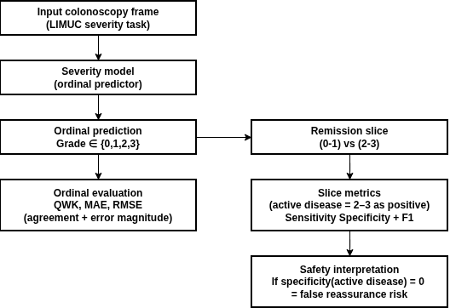
Figure 3.7 — UC severity evaluation workflow (LIMUC)
Per-class bottlenecks
To make minority-class behavior explicit, the persisted artifacts include a best-per-class summary.
Mayo class | Support | Best model | Best F1 | Best recall
0 | 925 | finetune_resnet50 | 0.852516 | 0.796757
1 | 464 | finetune_resnet50 | 0.683859 | 0.771552
2 | 177 | finetune_resnet50 | 0.552326 | 0.536723
3 | 120 | finetune_vit_or_swin | 0.683544 | 0.675000
Table 3.19 LIMUC Per-Class Best Model Summary
Support is strongly imbalanced across Mayo classes, and performance remains weakest for intermediate-to-severe classes (notably Mayo 2) even for the best-performing models. This supports the thesis motivation that minority severe classes remain the principal reliability bottleneck and require explicit attention in both evaluation and method design.
Limitations and implications. LIMUC provides the most clinically actionable evidence in Chapter 3: supervised domain-tuned pipelines substantially outperform the zero-shot baseline on ordinal and clinical-slice metrics under the persisted evaluation configuration. The practical implication for Chapter 4 is direct: UC severity generation must preserve ordinal structure, maintain clinically meaningful threshold behavior (especially specificity), and avoid relying on raw zero-shot generation without safeguards.
3.5 Cross-Dataset Synthesis and Findings
This section synthesizes dataset-wise results into thesis-level findings tied to the research questions. Because datasets differ in answer space and task regime, cross-dataset comparisons are used primarily to identify consistent reliability hierarchies and failure modes, not to claim a single global ranking.
3.5.1 Comparative Reliability: Constrained vs Zero-Shot
Dataset | Strongest constrained/tuned result | Zero-shot/open baseline result | Absolute gap
HyperKvasir | resnet50_supervised acc 0.8789 | blip2_zero_shot_clip acc 0.0638 | -0.8151
ImageCLEF MEDVQA-GI 2023 | vilt_finetune acc 0.9089 | qwen_projected acc 0.0670 | -0.8419
Kvasir-VQA yes/no subset | resnet_gru_m1 acc 0.9865 | blip2_zeroshot_yesno acc 0.8939 | -0.0926
LIMUC severity | finetune_resnet50 acc 0.7539 | vlm_zero_shot_mayo acc 0.5486 | -0.2052
Kvasir-VQA-x1 generative | medgemma_lora token-F1 0.5085 | qwen_zeroshot token-F1 0.1728 | +0.3357 (adaptation gain)
Table 3.20 Reliability Gap Snapshot Across Datasets
The repository evidence consistently indicates that constrained/supervised pipelines remain the reliability baseline for structured GI tasks, while raw zero-shot generation is weaker and more format-unstable. The Kvasir-VQA-x1 row summarizes a generative overlap diagnostic (token-F1) rather than accuracy; it shows that adaptation improves overlap fidelity but does not resolve answer-space governance and grounding issues identified in the dataset-wise analysis.
Result for RQ2. Under the persisted evidence in this repository, constrained/supervised methods remain the most reliable core pathway for GI MedVQA, and zero-shot transfer is consistently weaker under strict evaluation conventions.
3.5.2 Dominant Failure Modes (RQ3)
Failure mode | Evidence in this chapter | Practical implication
Head-tail imbalance collapse | HyperKvasir rare recall near zero for multiple models | aggregate accuracy can mask clinically important misses
Lexical drift / non-answer generation | Kvasir-VQA freegen unknown-rate 1.0 | requires constrained decoding and output guards
OOV mapping fragility | Kvasir-VQA-x1 mapped VLM acc 0.5616 but macro-F1 0.0058 with OOV 0.973 | mapped accuracy alone can be misleading
Question-family brittleness | ImageCLEF: procedure/attribute families collapse for zero-shot raw/projected | per-family reporting is mandatory
Clinical threshold blind spots | LIMUC zero-shot remission specificity 0.0 | unsafe threshold behavior without supervision
Scenario evidence gap | reformatted tree provides scenario config without scored outputs | scenario-level failure conclusions are deferred until outputs are persisted
Table 3.21 Observed Failure Taxonomy
These failure modes explain why single-score reporting is insufficient for clinical MedVQA[56]. Some failures are data-driven (long-tail imbalance), others are format-driven (unknown/OOV and mapping fragility), and others are clinically risk-driven (threshold failures and ordinal inconsistency). This taxonomy directly motivates the risk-control and evidence-governance design in later chapters.
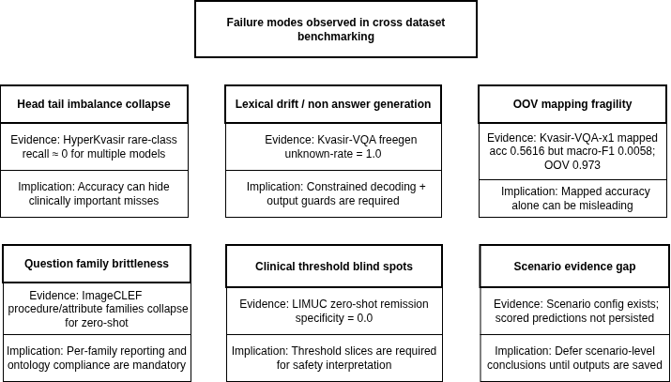
Figure 3.8 — Failure taxonomy tree
3.5.3 Severity Robustness (RQ4)
The LIMUC results provide the strongest empirical support for RQ4. The key conclusion is that severity-oriented MedVQA must be evaluated using ordinal and threshold-aligned metrics, not accuracy alone. Under the persisted evaluation configuration, tuned models achieve stronger ordinal agreement (QWK) and more stable remission-threshold behavior than the zero-shot baseline, while per-class results show that underrepresented moderate-to-severe classes remain the principal bottleneck.
3.5.4 Statistical Stability
Where paired predictions and McNemar diagnostics are persisted and reported (e.g., within specific dataset blocks that include n01/n10/p-values), the evidence indicates that some large observed differences are not plausibly explained by noise-level fluctuations. For dataset blocks where paired tests are not included in the chapter tables, differences are interpreted conservatively as descriptive observed gaps rather than formal significance claims.
3.5.5 Threats to Validity and Boundaries
Threat | Potential bias | Mitigation applied
Cross-dataset task heterogeneity | direct metric comparison may be invalid | comparisons are primarily within dataset/task
Incomplete artifact parity | some runs have training logs but missing validation preds | explicitly marked as unavailable; no fabricated comparisons
Label projection inflation risk | projected text may match labels lexically without semantic correctness | projected scores reported as diagnostic, not final clinical score
Scenario artifact incompleteness | no persisted reformatted scenario predictions/metrics | scenario claims removed from quantitative synthesis
Legacy vs reformatted pipeline differences | potential metric provenance mismatch | chapter constrained to Prototyping_reformat sources only
Table 3.22 Threats to Validity and Mitigation
The core methodological risk in this chapter is overinterpreting incomplete artifacts. The mitigation strategy is provenance-first: claims are tied directly to persisted tables, and diagnostics (projection/mapping) are clearly labeled as diagnostics rather than clinical correctness evidence.

3.5.6 Positioning Against Broader MedVQA Findings
The empirical patterns observed here align with the broader MedVQA observations reviewed in Chapter 2: constrained or fine-tuned pipelines remain stronger than naive zero-shot generation on structured clinical tasks, and overlap improvements in generative settings do not automatically guarantee grounded or clinically faithful reasoning[57], [60], [61]. Chapter 3’s contribution is not a state-of-the-art claim; it is a reproducible reliability map for GI MedVQA under a single artifact envelope, explicitly identifying format instability, mapping fragility, question-family brittleness, and threshold failures that must be addressed before clinician-facing deployment.
3.6 Position After Chapter 3
Chapter 3 establishes a reproducible empirical baseline for the dissertation:
- GI MedVQA performance is strongly task- and format-dependent; closed-label and free-text regimes behave differently and must be evaluated differently.
- Under the persisted evidence in this repository, constrained/supervised methods remain the reliability baseline for closed and ordinal clinical tasks.
- Naive zero-shot generation is insufficient as a standalone clinical answer path under strict evaluation conventions and ontology requirements.
- Severity-focused evaluation must remain central, especially ordinal agreement and clinically meaningful threshold slices (e.g., remission specificity).
- Generative capability is valuable only with explicit governance, including constraints/normalization, unknown/OOV handling, abstention behavior, and (in later chapters) evidence-aware grounding for higher-level queries.
These findings motivate Chapter 4, which develops a controlled generative pipeline for UC severity that preserves ordinal reliability and introduces safeguards for output stability, before extending toward evidence-aware answering.

Generative Vision-Language Modeling for Ulcerative Colitis Severity Assessment

4.1 Chapter Overview and Methodological Rationale
Chapter 3 established the central empirical tension that motivates this chapter. Across multiple GI-endoscopy settings, constrained and supervised models were consistently more reliable than naive zero-shot vision-language prompting. That pattern was especially important for ulcerative colitis (UC) severity grading on LIMUC, where the task is clinically meaningful, ordinal in structure, and sensitive to class imbalance. The next methodological question is therefore not whether generation is possible, but whether a generative model can be adapted in a way that preserves the discipline of a classifier while retaining the flexibility of a language-based interface.
Chapter 4 addresses that question by developing a controlled severity-oriented pipeline for Mayo 0-3 scoring from colonoscopy frames. The chapter does not pursue unrestricted narrative generation. Instead, it treats generative modeling as a bounded decision mechanism: the model is required to produce a tightly constrained score output, its predictions are parsed under explicit rules, and its behavior is evaluated against strong supervised baselines under the same data split and reporting protocol. This framing is important because the dissertation is concerned with clinically usable multimodal systems rather than open-ended text production for its own sake.
The chapter has four objectives:
- Define a reproducible UC severity task on LIMUC using fixed Mayo 0-3 labels and a fixed split structure.
- Establish a strong supervised reliability anchor against which generative methods can be judged fairly.
- Implement parameter-efficient adaptation of a vision-language model using LoRA so that score generation is learned rather than merely prompted.
- Evaluate the resulting system with ordinal, class-balanced, and clinically interpretable metrics, while making the failure modes explicit.
The overall structure of the chapter follows that logic. Section 4.2 defines the dataset and claim boundary. Section 4.3 presents the proposed pipeline and explains the role of each modeling layer. Section 4.4 formalizes the evaluation protocol. Section 4.5 reports the internal and external results. Section 4.6 interprets those findings in relation to the broader dissertation argument, and Section 4.7 states the limitations that constrain the chapter's claims. The chapter concludes in Section 4.8 by positioning the resulting severity module as the upstream component for the evidence-grounded wrapper introduced in Chapter 5.

4.2 Dataset, Clinical Task, and Scope
The proposed approach is intentionally narrow in scope. Rather than attempting to solve general GI MedVQA in one step, this chapter focuses on a clinically bounded and measurable task: assigning a Mayo endoscopic severity score from a single colonoscopy frame. That choice keeps the experimental question well-defined and permits a direct comparison between discriminative and generative strategies on the same evidence base.
4.2.1 LIMUC as the Primary Evidence Base
The primary dataset for this chapter is LIMUC, which provides UC endoscopic imagery labeled with Mayo scores from 0 to 3. In clinical terms, this is an ordinal severity scale, not a nominal category set. Errors are therefore not all equally harmful: confusing Mayo 0 with Mayo 1 is different from confusing Mayo 0 with Mayo 3. This is one of the reasons Chapter 4 emphasizes ordinal metrics such as quadratic weighted kappa (QWK) alongside standard accuracy and F1 measures.
Within this repository, LIMUC preparation is handled through Prototyping_reformat/DatasetAnalysis/LIMUC/0_dataset_prep/01_build_metadata_images_and_manifests.ipynb, which produces the metadata tables and split manifests used throughout the chapter [69]. The fixed metadata snapshot used here (metadata_enriched.csv) contains 11,276 frames.

Mayo class | Frames
0 | 6,105
1 | 3,052
2 | 1,254
3 | 865
Table 4.1. LIMUC Split Distribution

Mayo class | Frames
0 | 6,105
1 | 3,052
2 | 1,254
3 | 865
Table 4.2. LIMUC Mayo Class Distribution Across All Splits

Several properties of this distribution shape the methodological design. First, classes 0 and 1 dominate the dataset, while classes 2 and 3 are comparatively rare. Second, the task is ordinal, so adjacent-class confusion is more plausible than arbitrary misclassification. Third, the dataset is large enough to support supervised training, yet imbalanced enough that a simple accuracy-only reading would be misleading. For this reason, the proposed approach is evaluated with class-balanced and ordinal metrics, and the generative lane is trained with balanced sampling rather than naive frequency-following.

4.2.2 Scope Boundary for Chapter 4 Claims
The primary claims of Chapter 4 are deliberately restricted to internal LIMUC evaluation under the fixed split and reporting protocol described in this chapter. This means that the headline comparison is not between arbitrary best runs collected from different settings; it is a like-for-like comparison between a supervised baseline family and a generative adaptation family evaluated on the same internal task.
This boundary matters because several other datasets in the repository, including Kvasir-VQA, Kvasir-VQA-x1, and ImageCLEF MEDVQA-GI, are important for the dissertation as a whole but are not necessary to establish the core Chapter 4 claim. Their role is contextual and comparative, primarily in Chapters 2 and 3. Chapter 4, by contrast, is intentionally focused on a single clinically grounded severity problem so that the methodological contribution can be assessed cleanly.
The reporting policy follows the same logic. The primary optimization and reporting target is internal LIMUC mode1/test QWK. Accuracy, macro-F1, balanced accuracy, mean absolute error (MAE), root mean squared error (RMSE), and parse rate are reported as supporting metrics, but they do not override the ordinal agreement objective. This is appropriate because the Mayo task is inherently ordered and because clinically meaningful performance cannot be captured by raw accuracy alone.

4.2.3 External HyperKvasir UC Proxy Stress Test
In addition to the internal LIMUC evaluation, this chapter includes an external-only stress test based on a HyperKvasir-derived UC proxy set. The purpose of this evaluation is not to provide definitive generalization proof. Instead, it is used to test whether the internal gains observed on LIMUC survive a shift in data source, label compatibility, and output conditions.
The external protocol uses metadata_hyperkvasir_uc_proxy_mayo_floor.csv, which applies a floor-based mapping to interval labels. Specifically, interval findings are mapped as 0-1 -> 0, 1-2 -> 1, and 2-3 -> 2. This mapping is useful for stress testing, but it is not equivalent to native Mayo annotation. The external set therefore functions as a robustness probe rather than a clinically final benchmark.

Mayo proxy class | Frames
0 | 35
1 | 212
2 | 471
3 | 133
Table 4.3. External HyperKvasir UC Proxy Distribution

The total external set size is 851 frames. Two implications should be stated explicitly. First, the class profile differs materially from LIMUC, especially at the low-severity end. Second, the proxy mapping introduces label-space uncertainty that is absent from the internal dataset. For both reasons, external results are interpreted as limitation evidence and domain-shift analysis, not as the main basis for model selection.

4.3 Proposed Severity-Oriented Pipeline
The proposed Chapter 4 pipeline can be summarized as follows:
dataset curation and split freezing -> supervised and generative baseline construction -> controlled severity prediction -> statistical evaluation -> error analysis
The key design principle is that each stage should narrow the gap between flexible multimodal generation and clinically disciplined scoring. The pipeline is therefore built in layers, where each layer has a distinct role in separating genuine improvement from prompt-induced noise.
4.3.1 Data Preparation and Split Freezing
The first layer is the preparation layer implemented in Prototyping_reformat/DatasetAnalysis/LIMUC/0_dataset_prep/01_build_metadata_images_and_manifests.ipynb [69]. Its purpose is not only to gather images and labels, but to create a reproducible task definition. The notebook generates metadata tables, split assignments, label mappings, and a split hash so that downstream experiments can be traced back to a fixed data state.
This step is methodologically important because later comparisons would be difficult to defend if the underlying train, validation, and test composition were allowed to drift. In a dissertation setting, reproducibility is not a convenience feature; it is part of the evidential argument. By freezing the metadata snapshot and the split structure before model comparison, the chapter avoids a common problem in multimodal experimentation where performance differences become entangled with unnoticed preprocessing changes.
4.3.2 Supervised Reliability Anchor
The second layer establishes a strong supervised anchor. This layer includes both frozen-encoder baselines and fine-tuned discriminative baselines. The frozen-encoder baselines are implemented in:
- Prototyping_reformat/DatasetAnalysis/LIMUC/1_frozen_encoders/resnet50_frozen_logreg.ipynb [70]
- Prototyping_reformat/DatasetAnalysis/LIMUC/1_frozen_encoders/vit_frozen_logreg.ipynb [71]
- Prototyping_reformat/DatasetAnalysis/LIMUC/1_frozen_encoders/clip_linear_baseline.ipynb [72]
The fine-tuned baselines are implemented in:
- Prototyping_reformat/DatasetAnalysis/LIMUC/2_supervised_finetuning/finetune_resnet50.ipynb [73]
- Prototyping_reformat/DatasetAnalysis/LIMUC/2_supervised_finetuning/finetune_vit_or_swin.ipynb [74]
These baselines are not included merely for completeness. They define the minimum standard that any generative method must surpass to be taken seriously. In many medical-imaging settings, a generative system appears attractive because it produces human-readable text, yet still underperforms a simpler classifier on the actual decision variable of interest. By anchoring the chapter on supervised performance first, the proposed method is evaluated against the best currently justified alternative rather than against an artificially weak baseline.

4.3.3 Zero-Shot Generative Baseline
The third layer introduces a zero-shot generative severity baseline through Prototyping_reformat/DatasetAnalysis/LIMUC/3_vlm_severity/vlm_zero_shot_mayo.ipynb [75]. This layer is important because it exposes the raw transfer gap between general multimodal fluency and clinically controlled severity scoring.
The zero-shot setup uses a fixed severity question prompt and expects a constrained textual output in the form SCORE: X, where X must belong to {0,1,2,3}. A strict parser then extracts the score and marks invalid or noncompliant generations explicitly. This design serves two functions. First, it gives the zero-shot model the best possible chance to succeed under a clear format. Second, it prevents the evaluation from rewarding free-form answers that sound plausible but cannot be mapped reliably to the task label space.
Zero-shot evaluation is therefore treated as a diagnostic baseline, not as the proposed solution. Its role is to show what prompt-only transfer can and cannot do before any in-domain adaptation is introduced.

4.3.4 Parameter-Efficient Generative Adaptation with LoRA
The central methodological contribution of this chapter is the parameter-efficient adaptation layer implemented in Prototyping_reformat/DatasetAnalysis/LIMUC/3_vlm_severity/vlm_lora_finetune_mayo.ipynb [76]. This stage adapts a vision-language generation stack using Low-Rank Adaptation (LoRA) rather than full end-to-end retraining [67].
LoRA is appropriate here for both practical and scientific reasons. Practically, it reduces the memory and optimization cost of adapting a large multimodal model. Scientifically, it allows the chapter to test whether a large pretrained vision-language model can be made clinically useful for severity grading through targeted task adaptation rather than through unrestricted generation. The final architecture used in the comparison is BLIP2-Flan-T5-XL with LoRA adapters applied to the generative stack [68], [76].
This design direction is consistent with recent medical multimodal literature that emphasizes integrating vision and language foundation models under task-aware constraints for clinically useful behavior [105], [106].
Two design choices are especially important. First, the target format is supervised explicitly so that the model learns to emit the severity token under a stable prefix rather than producing unconstrained prose. Second, the objective is label-token-focused, which reduces the incentive to learn decorative language that is irrelevant to the Mayo decision itself. In other words, the model is still generative at the interface level, but its training objective is deliberately aligned with a bounded clinical output.

4.3.5 Retrieval-Supported Extension Path
The repository also contains a retrieval-backed design pattern in Prototyping_reformat/DatasetAnalysis/Kvasir_VQA_x1/2_modeling/09_rag_blip2_eval/01_rag_blip2_eval.ipynb [77]. That pattern is relevant to the broader dissertation because it anticipates evidence-grounded multimodal reasoning. However, it is not part of the primary Chapter 4 claim.
This exclusion is intentional. If retrieval support were added at the same time as severity adaptation, any improvement would become harder to attribute. Chapter 4 is therefore designed to answer a narrower question first: can a generative severity model outperform a strong supervised baseline on the internal task when the output space is tightly controlled? Only after that question is answered does the dissertation move, in Chapter 5, to the separate problem of evidence-grounded query support.

4.4 Experimental Design and Evaluation Protocol
The experimental design is structured to distinguish genuine task learning from output-format artifacts. Because the proposed method sits between classification and generation, the evaluation protocol must measure both predictive quality and output controllability.
4.4.1 Task Formulation and Output Modes
The input to the system is a single colonoscopy frame paired with a fixed severity question prompt. The required output is a Mayo score in the closed set {0,1,2,3}. Although the broader dissertation is interested in richer physician-facing interaction, the formal Chapter 4 task remains score prediction. Any optional evidence phrase is therefore treated as a deferred extension rather than a headline result.
Two evaluation lanes are used for the LoRA-adapted system:
- mode1 (lora_mode1_train): the model generates text under the constrained prompt format, after which a strict parser extracts SCORE: <0|1|2|3>.
- mode2 (lora_mode2_eval): the score is selected by candidate-label likelihood after the SCORE: prefix using a sequence_logprob strategy, without relying on free-text parsing.
These two lanes serve different purposes. mode1 is the primary generative lane because it preserves a natural generation pathway while still enforcing explicit output control. mode2 is a controlled ablation that removes free-text parsing and reduces the task to likelihood-based label selection. If mode2 were to match or exceed mode1, the implication would be that free-text generation is unnecessary. If mode2 fails, the implication is that the observed benefit comes from the adapted generation process rather than from a trivial label-probability shortcut.

4.4.2 Metric Bundle and Clinical Interpretation
No single metric is sufficient for this task. Chapter 4 therefore evaluates each lane using a bundle of complementary measures.
Metric | Role in evaluation
Accuracy | Overall correctness across all test cases
Macro-F1 | Class-balanced discrimination under label imbalance
Balanced accuracy | Mean recall across classes, reducing majority-class dominance
QWK | Primary ordinal-agreement metric for Mayo 0-3 scoring
MAE / RMSE | Magnitude of ordinal error, penalizing distant mistakes
Per-class precision, recall, and F1 | Class-specific error interpretation
Parse rate | Validity of generative outputs under strict extraction
Remission-oriented slice (0-1 vs 2-3) | Clinically simplified threshold behavior
Table 4.4. Metric Bundle
QWK is the primary metric because it rewards correct ordinal agreement and penalizes distant disagreements more strongly than adjacent ones. This is better aligned with the severity task than plain accuracy. Macro-F1 and balanced accuracy are also essential because the dataset is imbalanced and a model that over-predicts common classes could achieve superficially acceptable accuracy while still failing on clinically important minority severities. Parse rate is included because a generative system cannot be considered reliable if its textual outputs cannot be converted back into a score consistently.

4.4.3 Reporting Policy, Statistical Checks, and Multi-Seed Aggregation
The chapter reports multi-seed aggregates rather than a single favorable run. This decision is especially important for the generative lane, where optimization variance can otherwise create misleading impressions of robustness. The supervised family is reported with seeds 11/23/42, and the final generative family is reported with seeds 11/23/77.

Confidence intervals are included for the key aggregate metrics, particularly QWK, so that the reader can judge whether apparent improvements are stable or merely within random variation. Where paired predictions are available, paired significance testing such as McNemar's test is used as an additional check. The chapter also includes a seed-level quality-control table for the mode1 generative lane, confirming that all reported runs converged non-degenerately and predicted all four classes.

This reporting policy reflects the evidential standard of the dissertation. The goal is not to maximize a single number under flexible conditions. The goal is to determine whether the proposed modeling strategy produces a stable, reproducible, and clinically interpretable improvement over the supervised anchor.

4.4.4 Final Training Configuration Used for Reporting
The official configurations used in the chapter are compiled from the persisted reporting artifacts in Prototyping_reformat/DatasetAnalysis/LIMUC/4_reporting/out/ [78], specifically the multi-seed summaries for Pass 5 and Pass 6.

Lane | Core setup
Pass 5 supervised | ResNet50 fine-tuning, seeds 11/23/42, 15 epochs, batch size 16, learning rate 3e-4, weight decay 1e-4
Pass 6 generative | BLIP2-Flan-T5-XL with LoRA, seeds 11/23/77, 2 epochs, batch size 2, gradient accumulation 4, learning rate 5e-5, LoRA r=8, alpha=16, dropout 0.1, balanced sampling, label-token-only objective
Table 4.5. Final Configuration Summary for Reported Results

The asymmetry between the supervised and generative configurations is expected rather than problematic. The models belong to different families and have different optimization constraints. The important point is not that they use identical hyperparameters, but that each family is trained under a reasonable and fixed protocol, and that the final comparison is based on the resulting multi-seed aggregates rather than on cherry-picked exceptions.

4.5 Results
All reported values in this section are compiled from the persisted LIMUC reporting outputs under Prototyping_reformat/DatasetAnalysis/LIMUC/4_reporting/out/ [78] and the synchronized chapter tables under Thesis/markdown/figures/ch4_representations/ [79]. The chapter interpretation below is restricted to those fixed results.

4.5.1 Internal Multi-Seed Comparison on LIMUC
The main result of Chapter 4 is that the LoRA-adapted generative lane (mode1) outperforms the official supervised baseline on the internal LIMUC test set across every headline metric that matters for this task.

Lane | Seeds | Accuracy | Macro-F1 | Balanced accuracy | QWK | 95% CI (QWK) | Parse rate
Pass 5 supervised | 11/23/42 | 0.737643 | 0.667330 | 0.670907 | 0.818649 | [0.807920, 0.830582] | --
Pass 6 lora_mode1_train | 11/23/77 | 0.781930 | 0.727920 | 0.736292 | 0.863656 | [0.862382, 0.865836] | 1.000000
Pass 6 lora_mode2_eval | 11/23/77 | 0.548636 | 0.177135 | 0.250000 | 0.000000 | [0.000000, 0.000000] | 1.000000
Table 4.6. Internal Multi-Seed Results on LIMUC

Relative to the supervised baseline, mode1 improves internal QWK by +0.045007, macro-F1 by +0.060590, balanced accuracy by +0.065385, and accuracy by +0.044286. At the same time, it preserves a parse rate of 1.000000, meaning that every generated answer in the reported internal evaluation remained convertible to a valid score. This is a critical result because it shows that the proposed method does not trade improved scoring for unstable text output. Instead, it achieves both better ordinal agreement and perfect format compliance under the constrained protocol.
The narrow QWK confidence interval for mode1 also suggests stable multi-seed behavior. This is supported by the seed-level quality-control record, where all three reported runs pass the non-degeneracy checks and each run predicts all four classes. In contrast, mode2 performs poorly despite also achieving a parse rate of 1.000000. This immediate contrast shows that syntactic validity alone is not sufficient; the model must also preserve meaningful class discrimination.
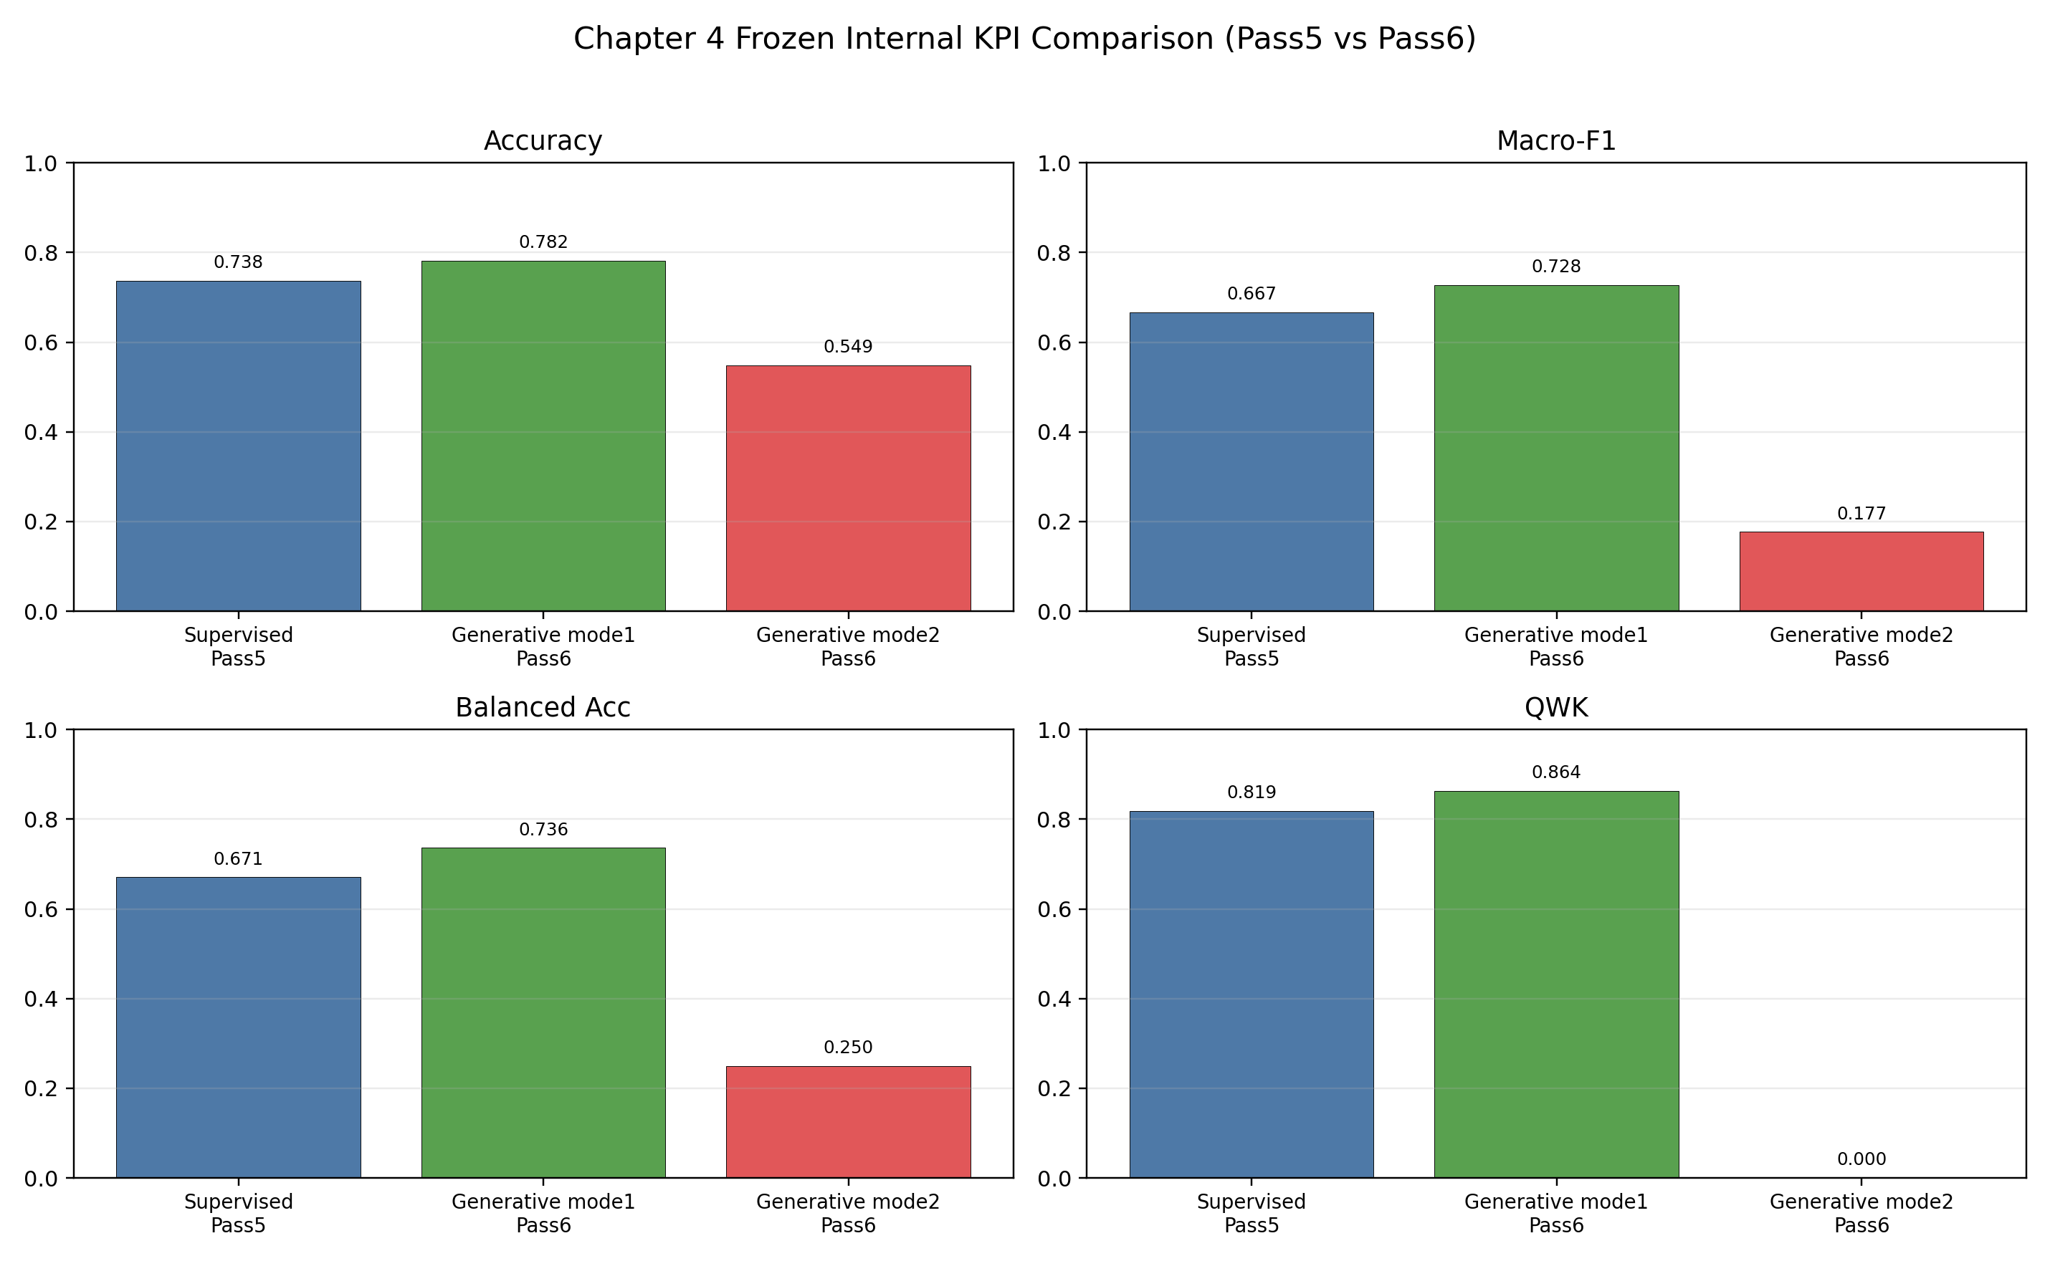
Figure 4.1 highlights the headline internal result: the LoRA-adapted mode1 lane exceeds the supervised baseline, while the mode2 ablation collapses despite perfect parse compliance [80].

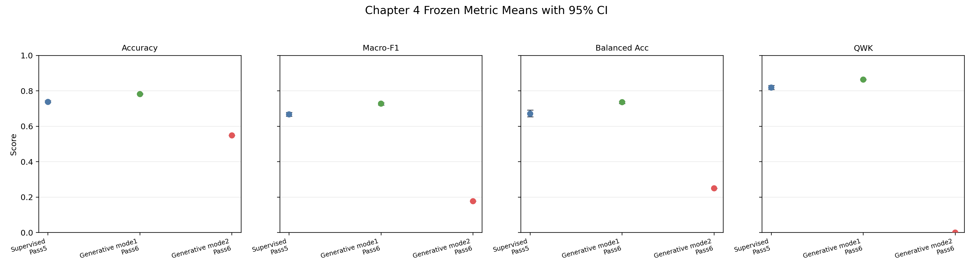
Figure 4.2 shows that the mode1 advantage is not limited to one metric. The improvement is coherent across accuracy, macro-F1, balanced accuracy, and QWK [81].

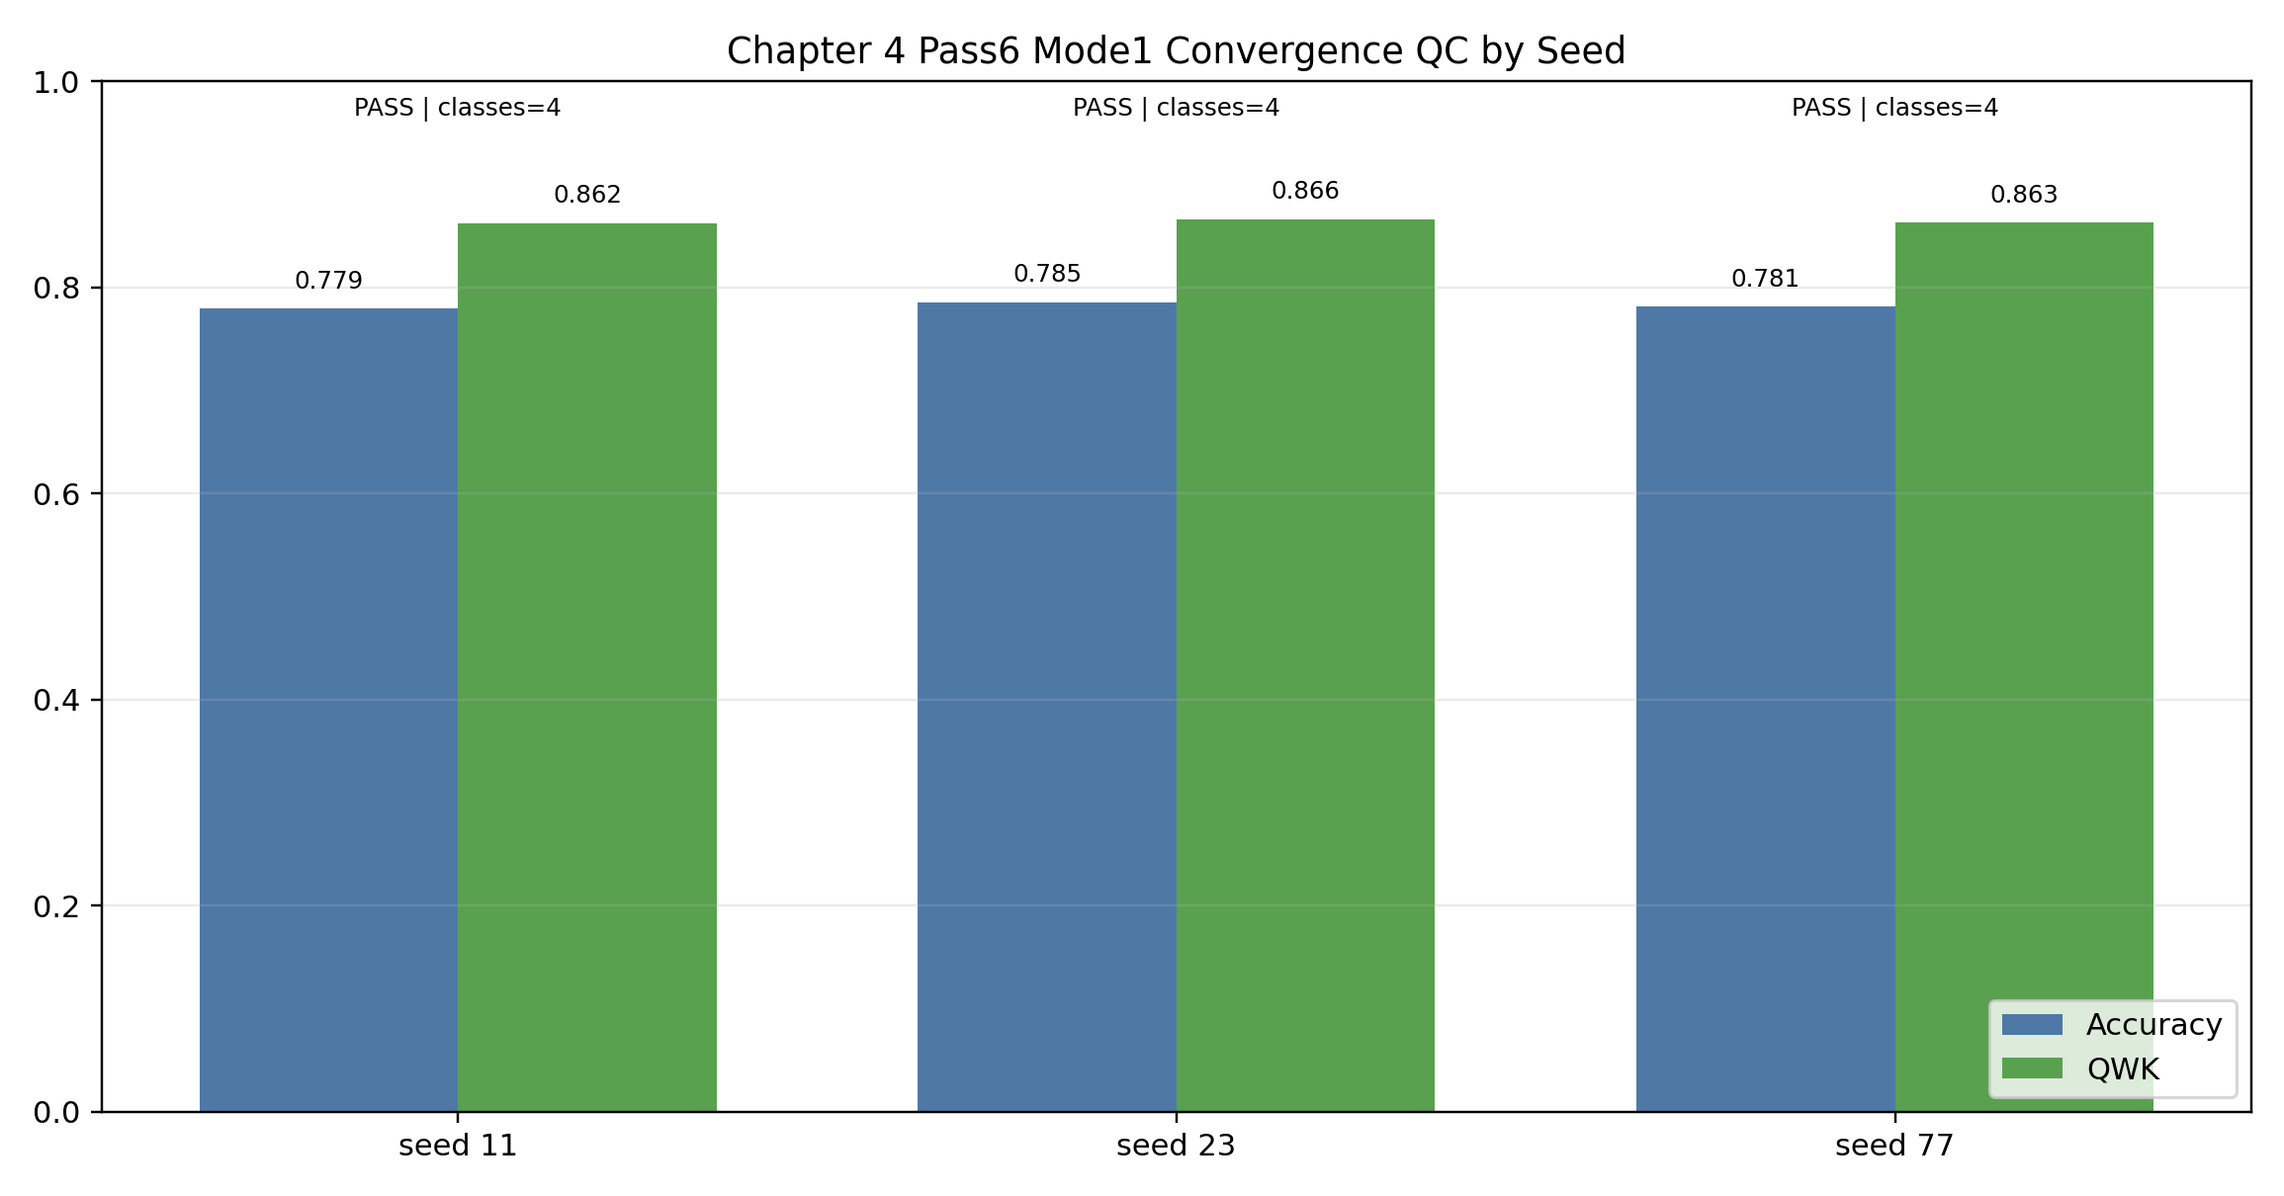
Figure 4.3 documents run stability for the reported generative lane. The legacy filename is preserved for reproducibility, but the figure is used here as a seed-level quality-control view rather than as a headline significance display [83].

4.5.2 Class-Wise Behavior and Error Structure
Aggregate improvement is important, but it does not by itself show where the gains come from. The class-wise recall summary indicates that mode1 improves recall for every Mayo class and is especially stronger on the more difficult higher-severity classes.
Mayo class | Pass 5 supervised | Pass 6 mode1 | Absolute gain
0 | 0.8043 | 0.8346 | +0.0303
1 | 0.7011 | 0.7349 | +0.0338
2 | 0.5782 | 0.7062 | +0.1281
3 | 0.6000 | 0.6694 | +0.0694
Table 4.7. Mean Per-Class Recall on LIMUC

The largest gain appears in Mayo class 2, where recall rises from approximately 0.5782 to 0.7062. This is a substantial improvement because class 2 occupies a clinically meaningful middle-to-high severity region and is often vulnerable to confusion with adjacent classes. Class 3 also improves noticeably, indicating that the proposed generative adaptation is not merely optimizing for the dominant remission or low-severity cases.

At the same time, the class-wise profile confirms that the task remains difficult. The improvement does not eliminate adjacent-boundary ambiguity, especially between neighboring severity levels. This is consistent with the visual nature of the problem, where subtle mucosal differences and frame-level ambiguity can make strict categorical separation inherently challenging.

The mode2 ablation clarifies the failure mode even more sharply. Its class-wise recall profile is 1.0 for class 0 and 0.0 for classes 1, 2, and 3, indicating an effective collapse into majority-class prediction. That pattern explains why mode2 can preserve perfect parse rate while still reaching QWK = 0.0: the model is producing valid labels, but those labels are clinically uninformative because the ordinal structure has collapsed.

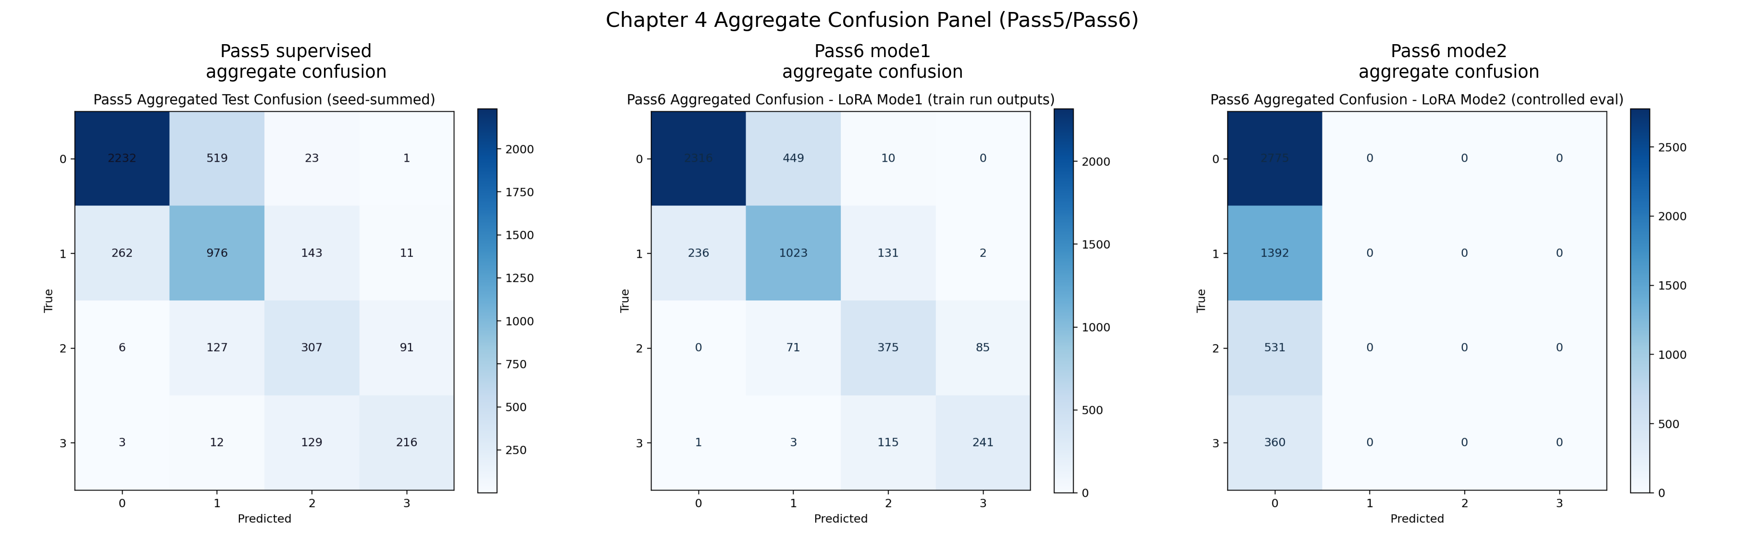
Figure 4.4 visualizes the error structure behind the aggregate metrics. The mode1 lane reduces confusion more evenly across classes, whereas mode2 degenerates into a class-0-dominant pattern [84].

4.5.3 External Stress Test Under Domain Shift
The internal LIMUC improvement is not automatically evidence of broader robustness. For that reason, the chapter includes an external-only HyperKvasir UC proxy evaluation as a stress test.
Lane | Internal QWK | External QWK | Delta (external-internal) | Internal parse rate | External parse rate
resnet50_supervised | 0.828762 | 0.359597 | -0.469165 | -- | --
vlm_lora_mode1 | 0.862752 | 0.000000 | -0.862752 | 1.0 | 0.0
vlm_lora_mode2 | 0.000000 | 0.000000 | 0.000000 | 1.0 | 1.0
Table 4.8. Internal-to-External Performance Shift

The external results are poor for all model families, but the failure pattern differs by lane. The supervised ResNet50 baseline degrades substantially, yet still retains non-zero external agreement (QWK = 0.359597). The mode1 generative lane, by contrast, collapses almost completely under this proxy setting: external accuracy falls to 0.041128, macro-F1 to 0.019752, QWK to 0.0, and parse rate to 0.0. This means that under the external proxy condition the model does not merely become less accurate; it stops emitting outputs that can be parsed as valid scores at all.

This is an important negative result. It indicates that the internal success of the proposed generative lane is real but not yet domain-robust. The likely causes are a combination of dataset shift, label-space mismatch introduced by the proxy mapping, and output-style fragility when the visual distribution no longer matches the in-domain training regime. The mode2 lane remains degenerate internally and externally, which reinforces the interpretation that it is not a viable alternative scoring strategy under the present design.

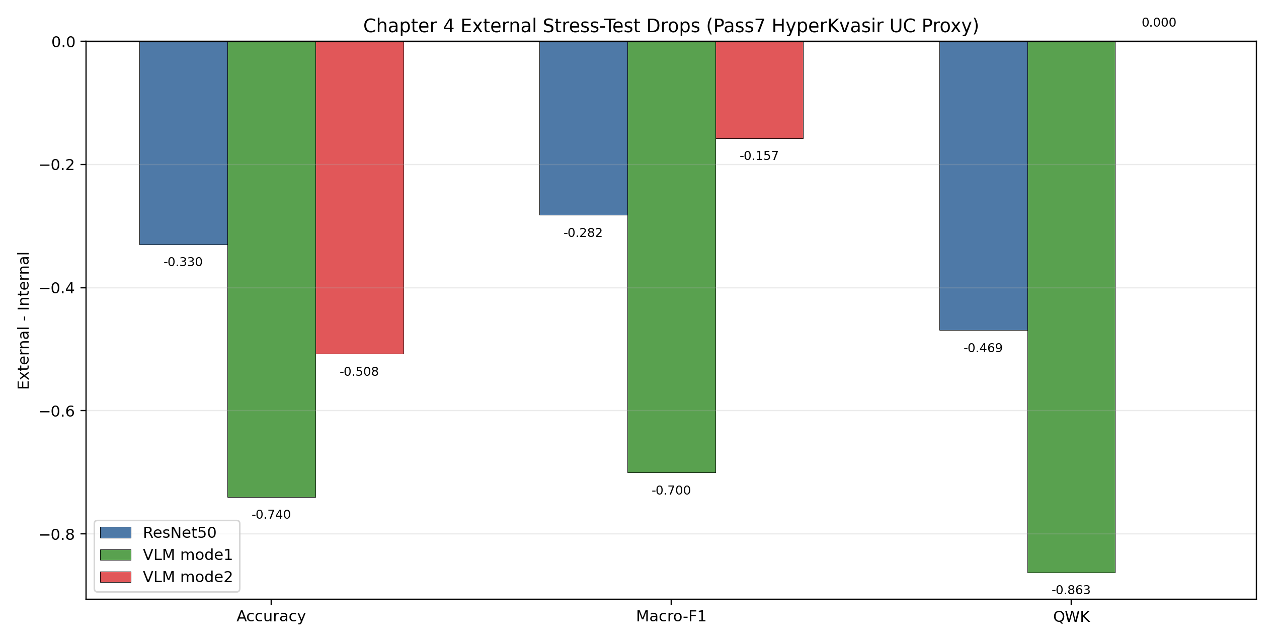
Figure 4.5 summarizes the scale of the external degradation. The figure should be read as robustness-limitation evidence rather than as a contradiction of the internal LIMUC improvement [82].

4.6 Discussion
The results support a precise conclusion: a vision-language model can outperform a strong supervised baseline on internal UC severity grading when its generation is adapted to the task through parameter-efficient training and constrained output design. This is not evidence that unrestricted multimodal generation is superior to classification. It is evidence that a carefully controlled generative interface can function as an effective ordinal scorer when the task, output space, and training objective are tightly aligned.

4.6.1 Why the Adapted Generative Lane Improves Internal Severity Grading
The mode1 lane succeeds because it combines three properties that are often separated in the MedVQA literature. First, it retains the representational capacity of a large pretrained vision-language model. Second, it is adapted in-domain rather than prompted naively. Third, its output behavior is constrained strongly enough that the model is rewarded for emitting the clinically relevant decision token rather than for producing fluent but task-irrelevant text.

This combination appears to matter particularly for the minority and higher-severity classes. The class-wise recall gains suggest that the LoRA-adapted model is not simply memorizing majority labels more effectively than the supervised baseline. Instead, it seems to learn a better ordering-sensitive decision surface for the four Mayo categories under the fixed prompt format. That is the key methodological result of the chapter.

4.6.2 Why the Likelihood-Only Lane Fails
The failure of mode2 is just as informative as the success of mode1. In principle, likelihood-based label selection after a fixed prefix could have offered a cleaner and more classifier-like use of the generative backbone. In practice, it collapses to majority behavior. The saved class-wise recall profile shows that mode2 effectively predicts class 0 only, which is enough to preserve superficial syntax but destroys clinical utility.

This negative result illustrates a broader thesis point: stricter output control is not automatically better if it removes the mechanism through which the adapted model expresses the decision boundary it has learned. A clinically useful generative system must be controlled, but the form of control must still allow task-relevant discrimination. Mode1 achieves that balance under the internal protocol; mode2 does not.

4.6.3 Implications for the Broader Dissertation
The broader significance of Chapter 4 is methodological. It shows that the path from benchmark MedVQA to clinically usable multimodal systems does not run through unconstrained prompting. Instead, it requires bounded task design, explicit evaluation of output validity, and comparison against strong supervised anchors. In that sense, Chapter 4 is the bridge between the diagnostic benchmarking of Chapter 3 and the physician-facing wrapper of Chapter 5.

The chapter also clarifies what kind of generative model is worth carrying forward. The severity component advanced from Chapter 4 is not a general-purpose conversational model. It is a controlled upstream module whose job is to convert an image into a stable severity signal under explicit formatting rules. That is precisely the kind of component that can be embedded safely into a larger evidence-grounded decision-support pipeline.

4.7 Limitations and Claim Boundary
Several limitations constrain the interpretation of the results and should be stated explicitly in the dissertation text.

- The task is frame-based rather than procedure-based. A single image can support severity estimation, but it is not equivalent to full-video or full-case clinical assessment.
- Class-boundary ambiguity remains a persistent source of error, especially for adjacent Mayo categories such as 0 <-> 1 and 1 <-> 2.
- The mode2 lane fails under the present design and should be treated as a negative-result ablation rather than as a viable alternative deployment mode.
- The external HyperKvasir UC proxy evaluation uses mapped interval labels rather than native Mayo annotation. Its results are therefore informative for robustness analysis but insufficient for deployment claims.
- Although mode1 improves internal QWK to 0.863656, the result remains below a 0.90 threshold and therefore still leaves meaningful headroom for future improvement.
- Structured outputs that combine Mayo + evidence phrase are not part of the headline claim in this chapter. The contribution established here is limited to controlled severity scoring.
Accordingly, the central claim of Chapter 4 should be read narrowly and precisely: under the fixed internal LIMUC protocol, the LoRA-adapted generative mode1 lane exceeds the official supervised baseline on ordinal and class-balanced severity metrics while maintaining perfect parse compliance. The chapter does not claim external deployment readiness, general GI reasoning competence, or robust cross-domain severity transfer.

4.8 Chapter Summary and Transition to Chapter 5
Chapter 4 transformed the diagnostic findings of Chapter 3 into a concrete proposed method. Using LIMUC as the primary evidence base, the chapter defined a reproducible Mayo 0-3 severity task, established a strong supervised anchor, implemented a LoRA-adapted vision-language severity model, and evaluated it under a controlled multi-seed protocol. The main empirical result is clear: on internal LIMUC, the generative mode1 lane improves on the supervised baseline in QWK, macro-F1, balanced accuracy, and accuracy while preserving perfect parse validity. At the same time, the external stress test shows that this gain should be interpreted as in-domain improvement rather than as generalization proof.

This outcome provides the exact kind of upstream component needed for the next stage of the dissertation. Chapter 5 takes the severity signal developed here as a fixed input and places it inside a physician-facing wrapper that adds PICO extraction, retrieval grounding, citation linkage, and safety constraints. In other words, Chapter 4 solves the bounded severity-estimation problem; Chapter 5 asks how that bounded signal can be integrated into a more traceable and clinically useful multimodal interaction layer.

PICO-Grounded GenAI Wrapper for Physician Query Support

5.1 Chapter Purpose and Contribution
Chapter 3 established the central empirical tension that motivates this chapter. Across multiple GI-endoscopy settings, constrained and supervised models were consistently more reliable than naive zero-shot vision-language prompting. That pattern was
Chapter 4 established a frozen, reproducible ulcerative colitis (UC) severity component under explicit claim boundaries. Chapter 5 extends that work into a physician-query wrapper that is designed for traceable decision support, not autonomous recommendation.
The chapter contribution is practical and system-level:
- convert physician-style queries into structured PICO fields;
- retrieve evidence chunks conditioned on PICO intent;
- synthesize citation-linked claims under explicit safety rules;
- preserve compatibility with frozen Chapter 4 severity context via typed schemas;
- provide reproducible evaluation and completion-audit artifacts.

5.2 Boundary Conditions from Chapter 4 Freeze
For cross-chapter consistency, the upstream severity boundary in this chapter aligns to the frozen Pass 5/6/7 reporting policy in Chapter 4 (not exploratory runs). The official internal Chapter 4 reference points used here are:
Upstream lane (Chapter 4) | Accuracy | Macro-F1 | Balanced accuracy | QWK | Parse rate
Pass 5 supervised | 0.737643 | 0.667330 | 0.670907 | 0.818649 | --
Pass 6 mode1 (primary generative lane) | 0.781930 | 0.727920 | 0.736292 | 0.863656 | 1.000000
Pass 6 mode2 (negative ablation) | 0.548636 | 0.177135 | 0.250000 | 0.000000 | 1.000000

In the Chapter 5 pass4 wrapper evaluation run, severity context ingestion is supported by schema (SeverityResult) but intentionally disabled for the reported benchmark pass (has_severity_context=false) to isolate wrapper behavior.

5.3 Design Objectives and Non-Objectives
5.3.1 Design objectives
- enforce structured outputs with explicit claims and citations;
- keep failure behavior visible (refusal/escalation instead of fabricated confidence);
- preserve deterministic, local reproducibility without external API dependence;
- keep module boundaries clear so the wrapper can be audited independently of Chapter 4 retraining.
5.3.2 Non-objectives in this chapter
- no patient-specific dosing recommendation generation;
- no claim of external clinical deployment readiness;
- no replacement of physician judgement;
- no claim that current internal KB coverage approximates guideline-complete retrieval.
5.4 System Architecture and Contracts
5.4.1 End-to-end processing flow
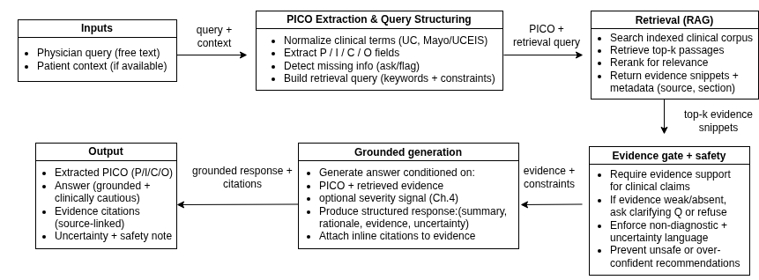

5.4.2 Module-level implementation map

Module | Responsibility
schemas.py | Typed contracts (PicoFrame, SeverityResult, EvidenceChunk, Citation, WrapperInput, WrapperOutput)
pico_extract.py | Rule-based PICO extraction with optional LLM hook and safe fallback
kb_ingest.py | KB ingestion, chunking, and index metadata generation
retriever.py | Backend-aware retrieval with PICO-conditioned query composition
synthesis.py | Deterministic claim synthesis and citation attachment
safety.py | Refusal/escalation policy and disclaimer enforcement
wrapper.py | Full pipeline orchestration (extract -> retrieve -> synthesize)
ui_support.py | UI-side formatting and report helpers

5.4.3 Retrieval/index design used in frozen Chapter 5 pass
From Prototyping_reformat/chapter5_pico_wrapper/results/kb_build_pass4_latest/kb_manifest.json:
- source files: 3
- documents: 3
- chunks: 12
- chunking: max_words=180, overlap_words=30, min_words=30, seed=42
- backend family available: keyword, tfidf, semantic_lsa, hybrid
- pass4 reporting backend: hybrid with reranker enabled.
5.4.4 Safety policy implementation
The wrapper applies explicit safety constraints:
- dosing-sensitive prompts can trigger refusal behavior;
- low-evidence retrieval paths trigger conservative uncertainty/limitation text;
- all outputs include clinician-review disclaimers;
- policy-excluded claims are tracked separately in answer evaluation.
5.5 Experimental Protocol and Frozen Artifacts
5.5.1 Query and gold sets
From Prototyping_reformat/chapter5_pico_wrapper/data/queries/:
- queries.jsonl: n=50
- pico_gold.jsonl: n=20
- retrieval_gold.jsonl: n=10
5.5.2 Frozen pass used for chapter reporting
This chapter reports the pass4 artifact set to remain consistent with completion audit and figure pipeline:
- KB: results/kb_build_pass4_latest/
- wrapper outputs: results/wrapper_eval_pass4_latest/
- wrapper output file: Prototyping_reformat/chapter5_pico_wrapper/results/wrapper_eval_pass4_latest/wrapper_outputs.jsonl
- evaluations: results/eval_pass4_latest/
- completion audit: results/chapter5_completion_audit_ch5_freeze_20260306/
- pipeline summary: results/pipeline_pass4_latest/pipeline_summary.json
Key wrapper config (results/wrapper_eval_pass4_latest/run_config.json):
Parameter | Value
run_id | chapter5_wrapper_20260305T024427Z_6nx5r2
mode_requested | baseline
n_queries | 50
retrieval_k | 5
retrieval_backend | hybrid
rerank_enabled | true
rerank_pool | 20
rerank_alpha | 0.2
min_top_score_for_answer | 0.18
min_mean_score_for_answer | 0.12
min_retrieved_for_answer | 2
has_severity_context | false

5.6 Results
5.6.1 PICO extraction quality
Source: Prototyping_reformat/chapter5_pico_wrapper/results/eval_pass4_latest/pico_eval.json.

Field | Precision | Recall | F1
Population | 1.0000 | 1.0000 | 1.0000
Intervention | 0.6250 | 1.0000 | 0.7692
Comparator | 0.8800 | 1.0000 | 0.9362
Outcomes | 0.4000 | 0.5000 | 0.4444
Severity anchors | 0.4667 | 1.0000 | 0.6364
Timeframe | 1.0000 | 1.0000 | 1.0000
Setting | 0.8000 | 0.5000 | 0.6154
Constraints | 0.0000 | 0.0000 | 0.0000

Aggregate values:
- required-field macro-F1 (P/I/C/O + severity_anchors): 0.7572 (n=20)
- all-field macro-F1: 0.6752
The extractor is recall-heavy for core required fields but has precision weakness in outcomes and severity anchors, indicating broad lexical matching behavior.

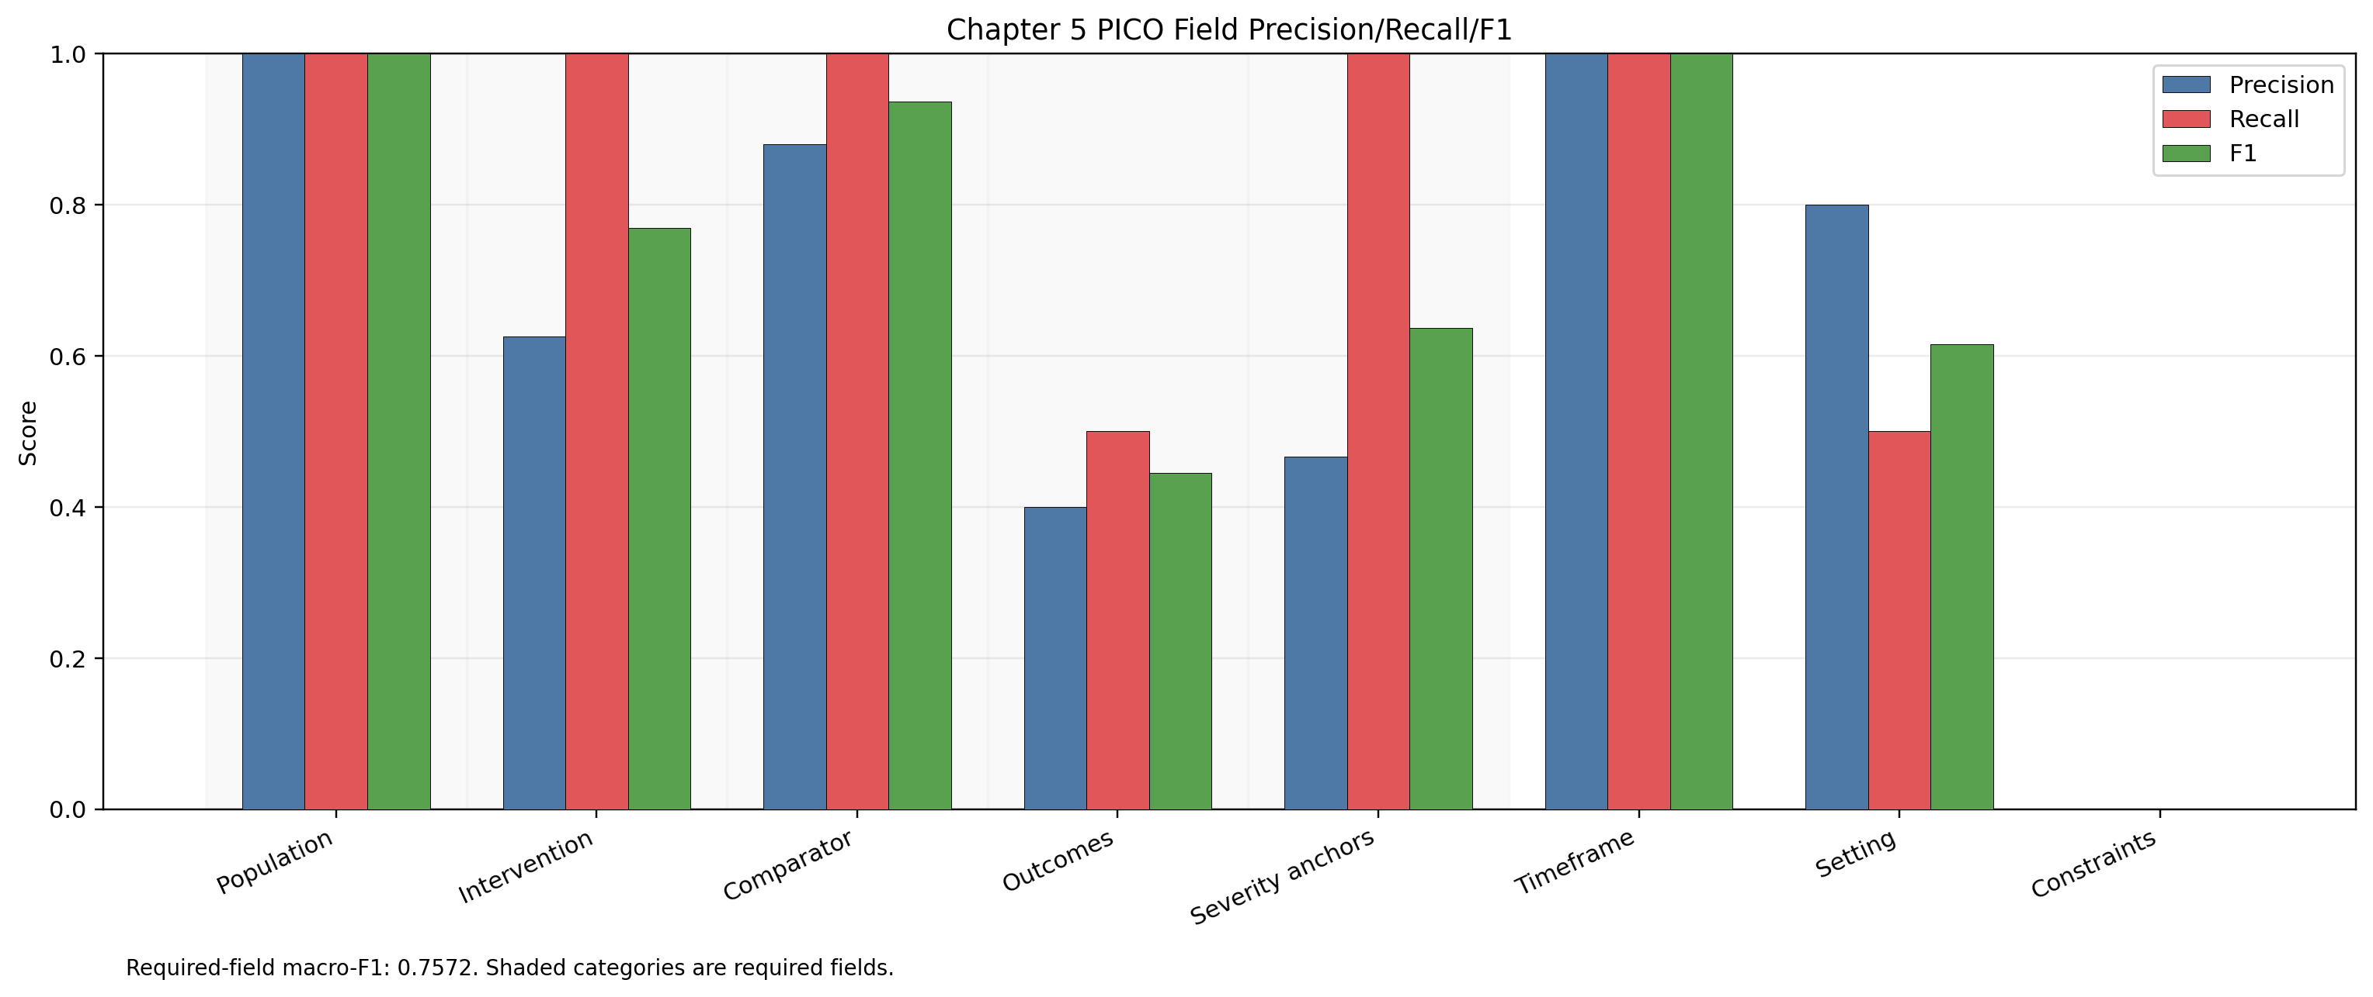
Per-field PICO extraction scores; shaded groups in the figure indicate required fields.

5.6.2 Retrieval quality and uncertainty
Source: Prototyping_reformat/chapter5_pico_wrapper/results/eval_pass4_latest/retrieval_eval.json.
Metric | @1 | @3 | @5
Precision@k | 0.2000 | 0.1667 | 0.1600
Recall@k | 0.1000 | 0.2500 | 0.4500
Hit rate@k | 0.2000 | 0.3000 | 0.6000
Bootstrap 95% confidence intervals (2000 iterations, seed=42)

Metric | @1 CI | @3 CI | @5 CI
Precision@k | [0.00, 0.50] | [0.00, 0.3667] | [0.08, 0.26]
Recall@k | [0.00, 0.25] | [0.00, 0.55] | [0.20, 0.70]
Hit rate@k | [0.00, 0.50] | [0.00, 0.60] | [0.30, 0.90]
Interpretation: top-5 retrieval gives workable coverage on the current small KB, but wide intervals reflect small retrieval-gold sample size (n=10).
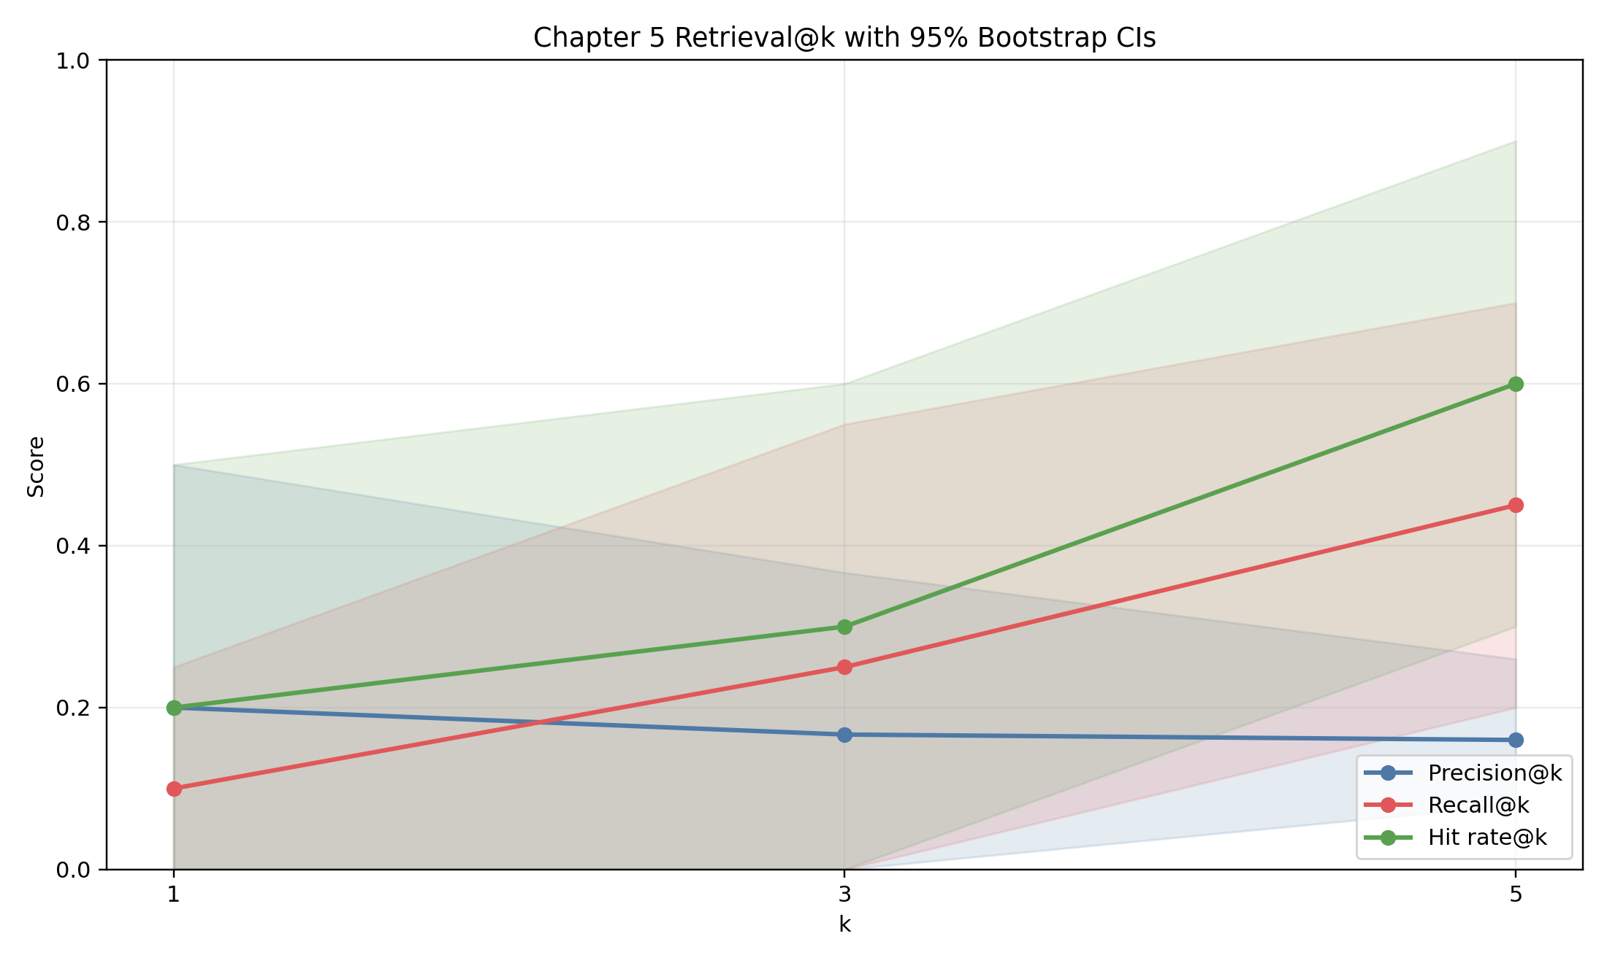
Retrieval precision/recall/hit-rate profiles with uncertainty bands.

5.6.3 Retrieval ablation (backend/rerank sensitivity)
Source: Prototyping_reformat/chapter5_pico_wrapper/results/eval_pass3_ablation/retrieval_ablation_summary.tsv.

Case | Backend | Rerank | Alpha | Hit@1 | Hit@5 | Recall@5
keyword_no_rerank | keyword | no | 0.35 | 0.20 | 0.50 | 0.30
hybrid_rerank_a035 | hybrid | yes | 0.35 | 0.20 | 0.50 | 0.35
hybrid_rerank_a050 | hybrid | yes | 0.50 | 0.20 | 0.50 | 0.35
tfidf_no_rerank | tfidf | no | 0.35 | 0.10 | 0.60 | 0.45
tfidf_rerank_a035 | tfidf | yes | 0.35 | 0.20 | 0.60 | 0.45
hybrid_no_rerank | hybrid | no | 0.35 | 0.20 | 0.60 | 0.45
hybrid_rerank_a020 | hybrid | yes | 0.20 | 0.20 | 0.60 | 0.45
Selected default in pass4: hybrid + rerank alpha=0.20, which ties best Recall@5 while preserving stronger Hit@1 than non-reranked TF-IDF.

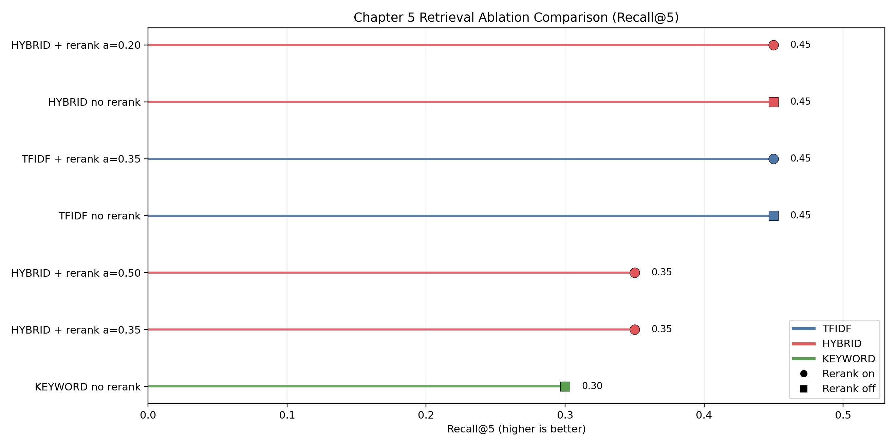
Recall@5 comparison across backend/rerank configurations; multiple settings tie at the top in this small benchmark.

5.6.4 Answer quality and citation grounding
Source: Prototyping_reformat/chapter5_pico_wrapper/results/eval_pass4_latest/answer_eval.json.

Metric | Value
Outputs evaluated | 50
Claims extracted | 142
Claims evaluated | 138
Policy claims excluded | 4
Refusal count | 4
Refusal rate | 0.0800
Citation coverage | 1.0000
Citation correctness (heuristic) | 1.0000
Claim support (heuristic) | 1.0000
Claim support (strict) | 0.8696
Contradiction proxy | 0.0000
Hallucination proxy | 0.0000
Citation link integrity | 1.0000

Strict support is intentionally harder than the heuristic overlap checks (min_overlap_ratio=0.25, min_overlap_terms=3), providing a tighter baseline for future manual review.
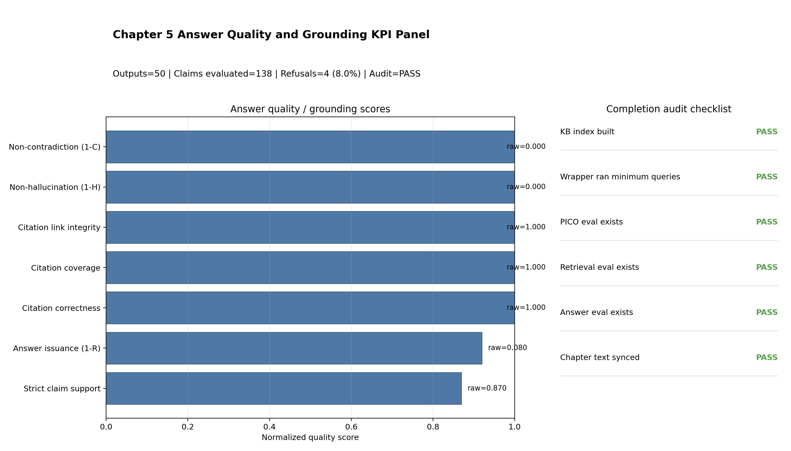
Composite panel with answer KPIs, refusal rate, and completion audit checklist status.

5.7 Error Analysis and Observed Failure Modes
The pass4 evidence indicates several recurring failure modes:
- Outcome extraction over-triggering: outcomes precision (0.4000) is substantially lower than recall (0.5000), suggesting lexical over-coverage.
- Severity-anchor over-triggering: severity_anchors recall is high (1.0000) but precision is low (0.4667), reflecting broad term matching.
- Top-rank retrieval fragility: recall improves with larger k, but top-1 behavior remains brittle (Recall@1=0.1000).
- Evidence-threshold sensitivity: strict claim-support scoring (0.8696) is lower than heuristic support (1.0000), showing dependence on overlap thresholds.
- Policy handling effects: refusals are necessary for safety but reduce answer issuance rate (92% non-refusal issuance).
These effects are expected for a baseline that prioritizes traceability and deterministic behavior over free-form fluency.

5.8 Threats to Validity and Limitations
- Small KB footprint: only 3 source documents and 12 chunks limit retrieval diversity.
- Synthetic/small evaluation subsets: retrieval gold (n=10) and PICO gold (n=20) are useful for method checks, not broad clinical generalization.
- Heuristic grounding metrics: citation correctness and hallucination proxies are lexical and must be complemented by clinician semantic review.
- No external API LLM dependency in baseline: improves reproducibility but does not yet benchmark richer model-assisted synthesis.
- No deployment claim: this chapter demonstrates engineering feasibility and reproducibility, not bedside readiness.
5.9 Reproducibility and Completion Audit Status
Completion audit source:
- Prototyping_reformat/chapter5_pico_wrapper/results/chapter5_completion_audit_ch5_freeze_20260306/chapter5_completion_report.json
- Prototyping_reformat/chapter5_pico_wrapper/results/chapter5_completion_audit_ch5_freeze_20260306/chapter5_completion_report.md
Audit status: PASS (6/6 checklist items passed), including artifact existence, minimum query coverage, and chapter-text synchronization checks.
Core scripts:
- scripts/build_kb.py
- scripts/make_queryset.py
- scripts/run_wrapper.py
- scripts/run_ui.py
- scripts/eval_pico.py
- scripts/eval_retrieval.py
- scripts/eval_answers.py
- scripts/chapter5_completion_audit.py
- scripts/run_full_pipeline.py

5.10 Chapter 5 Claim Guardrail
Allowed headline claims:
- Chapter 5 provides a reproducible, citation-aware wrapper around frozen upstream Chapter 4 severity capability.
- Required-field PICO extraction and top-5 retrieval show workable baseline behavior on internal benchmark artifacts.
- Citation-linked synthesis and refusal handling are operational in pass4 and auditable from persisted outputs.
Disallowed headline claims:
- Do not claim external clinical deployment readiness from the current internal KB and synthetic/small gold subsets.
- Do not present retrieval or grounding heuristics as a substitute for clinician semantic adjudication.
- Do not interpret this chapter as replacing Chapter 4 severity model validation.

5.11 Summary
Chapter 5 delivers a complete PICO-grounded wrapper layer that is structured, safety-constrained, and reproducibility-first. The wrapper does not attempt to hide uncertainty; it surfaces citations, supports refusal behavior, and exposes clear artifact trails for audit.

Relative to a monolithic end-to-end generator, the chapter demonstrates a modular path: frozen visual severity evidence (Chapter 4) plus explicit retrieval-grounded synthesis control. The further research will be to extend this baseline with larger curated evidence stores, stronger retrieval supervision, and clinician-scored semantic grounding studies.

Bibliography

1. Ben Abacha A, Hasan SA, Datla V, et al. 2019. "VQA-Med: Overview of the Medical Visual Question Answering Task at ImageCLEF 2019." CEUR Workshop Proceedings Vol-2380. https://ceur-ws.org/Vol-2380/paper_78.pdf.
2. Borgli H, Thambawita V, Smedsrud PH, et al. 2020. "HyperKvasir, a comprehensive multi-class image and video dataset for gastrointestinal endoscopy." Scientific Data. https://doi.org/10.1038/s41597-020-00622-y.
3. Borgli H, Thambawita V, Smedsrud PH, et al. 2020. "HyperKvasir, a comprehensive multi-class image and video dataset for gastrointestinal endoscopy." Scientific Data. https://www.nature.com/articles/s41597-020-00622-y.
4. Dong W, Shen S, Han Y, et al. 2025. "Generative Models in Medical Visual Question Answering: A Survey." Applied Sciences. https://doi.org/10.3390/app15062983.
5. Gautam S, Riegler MA, Halvorsen P. 2025. "Kvasir-VQA-x1: A Multimodal Dataset for Medical Reasoning and Robust MedVQA in Gastrointestinal Endoscopy." arXiv:2506.09958. https://arxiv.org/abs/2506.09958.
6. Gautam S, Riegler MOD, Sivertsen KD, Halvorsen P. 2025. "CLoE: Improving Endoscopic Severity Rating Through Curriculum Learning in Vision Language Models." arXiv:2508.13280. https://arxiv.org/abs/2508.13280.
7. Gautam S, Storas A, Midoglu C, et al. 2024. "Kvasir-VQA: A Text-Image Pair GI Tract Dataset." arXiv:2409.01437. https://arxiv.org/abs/2409.01437.
8. Gautam S, Thambawita V, Riegler M, Halvorsen P, Hicks S. 2025. "Medico 2025: Visual Question Answering for Gastrointestinal Imaging." arXiv:2508.10869. https://arxiv.org/abs/2508.10869.
9. Hashash JG, Farraye FA, Wang Y, et al. 2024. "Inter- and Intraobserver Variability on Endoscopic Scoring Systems in Crohn's Disease and Ulcerative Colitis: A Systematic Review and Meta-Analysis." Inflammatory Bowel Diseases. https://pubmed.ncbi.nlm.nih.gov/38547325/.
10. He X, Zhang Y, Mou L, et al. 2020. "PathVQA: 30000+ Questions for Medical Visual Question Answering." arXiv:2003.10286. https://arxiv.org/abs/2003.10286.
11. Hicks SA, Strumke I, Thambawita V, et al. 2022. "On evaluation metrics for medical applications of artificial intelligence." Scientific Reports. https://www.nature.com/articles/s41598-022-09954-8.
12. Hu Y, Li T, Lu Q, et al. 2024. "OmniMedVQA: A New Large-Scale Comprehensive Evaluation Benchmark for Medical LVLM." arXiv:2402.09181. https://arxiv.org/abs/2402.09181.
13. Huang X, Wang N, Liu H, Tang X, Zhou Y. 2025. "MedVLSynther: Synthesizing High-Quality Visual Question Answering from Medical Documents with Generator-Verifier LMMs." arXiv:2510.25867. https://arxiv.org/abs/2510.25867.
14. ImageCLEF. 2023. "ImageCLEFmed MEDVQA-GI 2023 task page." https://www.imageclef.org/2023/medical/vqa.
15. ImageCLEF. 2024. "ImageCLEFmed VQA 2024 Task Page." https://www.imageclef.org/2024/medical/vqa.
16. ImageCLEF. 2025. "ImageCLEFmed MEDVQA 2025 task page." https://www.imageclef.org/2025/medical/vqa.
17. Jiang S, Wang Y, Song S, et al. 2025. "OmniV-Med: Scaling Medical Vision-Language Model for Universal Visual Understanding." arXiv:2504.14692. https://arxiv.org/abs/2504.14692.
18. Karim AHMR, Uzuner O. 2025. "MasonNLP at MEDIQA-WV 2025: Multimodal Retrieval-Augmented Generation with Large Language Models for Medical VQA." ClinicalNLP. https://aclanthology.org/2025.clinicalnlp-1.10/.
19. Lau JYC, Gayen S, Ben Abacha A, et al. 2018. "A dataset of clinically generated visual questions and answers about radiology images." Scientific Data. https://www.nature.com/articles/sdata2018251.
20. Lee J, Yoon W, Kim S, et al. 2019. "BioBERT: a pre-trained biomedical language representation model for biomedical text mining." arXiv:1901.08746. https://arxiv.org/abs/1901.08746.
21. Li C, Wong C, Zhang S, et al. 2023. "LLaVA-Med: Training a Large Language-and-Vision Assistant for Biomedicine in One Day." arXiv:2306.00890. https://arxiv.org/abs/2306.00890.
22. Li J, Li D, Savarese S, Hoi SCH. 2023. "BLIP-2: Bootstrapping Language-Image Pre-training with Frozen Image Encoders and Large Language Models." arXiv:2301.12597. https://arxiv.org/abs/2301.12597.
23. Li R, Liu L, Xie Q, et al. 2025. "Towards Medical Visual Question Answering with Large Multimodal Models." arXiv:2501.07109. https://arxiv.org/abs/2501.07109.
24. Lim DYZ, Basha A, Ku A, et al. 2025. "Vision-language large learning model, GPT4V, outperforms machine learning and deep learning methods in grading bowel preparation quality in outpatient colonoscopies." BMJ Open Gastroenterology 12:e001496. https://pmc.ncbi.nlm.nih.gov/articles/PMC11911458/.
25. Lin S, Kryściński W, Wu D, et al. 2021. "Medical Visual Question Answering: A Survey." arXiv:2111.10056. https://arxiv.org/abs/2111.10056.
26. Lin Z, Zhang D, Tao Q, et al. 2023. "Medical visual question answering: A survey." Artificial Intelligence in Medicine. https://doi.org/10.1016/j.artmed.2023.102611.
27. Liu B, Zhan L, Xu L, et al. 2021. "SLAKE: A semantically-labeled knowledge-enhanced dataset for medical visual question answering." arXiv:2102.09542. https://arxiv.org/abs/2102.09542.
28. Liu H, Li C, Wu Q, Lee YJ. 2023. "Visual Instruction Tuning (LLaVA)." arXiv:2304.08485. https://arxiv.org/abs/2304.08485.
29. Lu J, Batra D, Parikh D, Lee S. 2019. "ViLBERT: Pretraining Task-Agnostic Visiolinguistic Representations for Vision-and-Language Tasks." arXiv:1908.02265. https://arxiv.org/abs/1908.02265.
30. Luo R, Sun L, Xia Y, et al. 2022. "BioGPT: Generative Pre-trained Transformer for Biomedical Text Generation and Mining." arXiv:2210.10341. https://arxiv.org/abs/2210.10341.
31. MediaEval. 2025. "Medico 2025 task page: VQA with multimodal explanations for GI imaging." https://multimediaeval.github.io/editions/2025/tasks/medico/.
32. Moor M, Huang Q, Wu S, et al. 2023. "Med-Flamingo: a Multimodal Medical Few-shot Learner." arXiv:2307.15189. https://arxiv.org/abs/2307.15189.
33. Murino A, Rimondi A. 2023. "Automated Artificial Intelligence Scoring Systems for the Endoscopic Assessment of Ulcerative Colitis: How Far Are We from Clinical Application?" Gastrointestinal Endoscopy. https://doi.org/10.1016/j.gie.2022.10.010.
34. Murino A, Rimondi A. 2023. "Automated artificial intelligence scoring systems for the endoscopic assessment of ulcerative colitis: How far are we from clinical application?" Gastrointestinal Endoscopy. https://pubmed.ncbi.nlm.nih.gov/36509572/.
35. Murtaza N, Munsif S, Cuadros M, et al. 2023. "Overview of ImageCLEFmedical 2023 - Medical Visual Question Answering for Gastrointestinal Tract." CEUR-WS Vol-3497. https://ceur-ws.org/Vol-3497/paper-107.pdf.
36. Nguyen H-D, Dang M-A, Le M-T, Le M-T. 2025. "MedXplain-VQA: Multi-Component Explainable Medical Visual Question Answering." arXiv:2510.22803. https://arxiv.org/abs/2510.22803.
37. Ozawa T, Ishihara S, Fujishiro M, et al. 2020. "Novel Computer-Aided Diagnosis System for Endoscopic Disease Activity in Patients with Ulcerative Colitis." Gastroenterology 158(8):2150-2157.e3. https://www.gastrojournal.org/article/S0016-5085%2820%2930212-2/fulltext.
38. Polat G, Kani HT, Ergenc I, et al. 2022. "Labeled Images for Ulcerative Colitis (LIMUC) Dataset." Zenodo. https://zenodo.org/records/5827695. Secondary resource: https://github.com/wanghaining/ulcerative_colitis.
39. Radford A, Kim JW, Hallacy C, et al. 2021. "Learning Transferable Visual Models From Natural Language Supervision (CLIP)." arXiv:2103.00020. https://arxiv.org/abs/2103.00020.
40. RAG-VQA-Medical Repository. n.d. "Prototyping_reformat/DatasetAnalysis/HyperKvasir/HyperKvasir.md." Internal repository artifact.
41. RAG-VQA-Medical Repository. n.d. "Prototyping_reformat/DatasetAnalysis/ImageCLEF_MEDVQA_GI_2023/ImageCLEF_MEDVQA_GI_2023.md." Internal repository artifact.
42. RAG-VQA-Medical Repository. n.d. "Prototyping_reformat/DatasetAnalysis/Kvasir_SEG/Kvasir_SEG.md." Internal repository artifact.
43. RAG-VQA-Medical Repository. n.d. "Prototyping_reformat/DatasetAnalysis/Kvasir_VQA/0_dataset_prep/out/visualizations/answer_type_counts.csv." Internal repository artifact.
44. RAG-VQA-Medical Repository. n.d. "Prototyping_reformat/DatasetAnalysis/Kvasir_VQA/0_dataset_prep/out/visualizations/qa_by_source.csv." Internal repository artifact.
45. RAG-VQA-Medical Repository. n.d. "Prototyping_reformat/DatasetAnalysis/Kvasir_VQA/0_dataset_prep/out/visualizations/question_type_counts.csv." Internal repository artifact.
46. RAG-VQA-Medical Repository. n.d. "Prototyping_reformat/DatasetAnalysis/Kvasir_VQA/evaluation_comparison/phase3_results/summary_uc_phase3.csv." Internal repository artifact.
47. RAG-VQA-Medical Repository. n.d. "Prototyping_reformat/DatasetAnalysis/Kvasir_VQA/evaluation_comparison/scenarios/scenarios.yaml." Internal repository artifact.
48. RAG-VQA-Medical Repository. n.d. "Prototyping_reformat/DatasetAnalysis/Kvasir_VQA/Kvasir_VQA.md." Internal repository artifact.
49. RAG-VQA-Medical Repository. n.d. "Prototyping_reformat/DatasetAnalysis/Kvasir_VQA_x1/Kvasir_VQA_x1.md." Internal repository artifact.
50. RAG-VQA-Medical Repository. n.d. "Prototyping_reformat/DatasetAnalysis/LIMUC/LIMUC.md." Internal repository artifact.
51. Rieff M, Varma M, Rabow O, et al. 2025. "SMMILE: An Expert-Driven Benchmark for Multimodal Medical In-Context Learning." arXiv:2506.21355. https://arxiv.org/abs/2506.21355.
52. Safwan I, Shaikh MA, Haaris M, Khan R, Tahir MA. 2025. "Multi-Task Learning for Visually Grounded Reasoning in Gastrointestinal VQA." arXiv:2511.04384. https://arxiv.org/abs/2511.04384.
53. Sial M, Fatima M, Nawaz K, et al. 2025. "Path-RAG: Knowledge-Based Explainable Medical VQA with Large Language Models." Proceedings of Machine Learning Research 259. https://proceedings.mlr.press/v259/sial25a.html.
54. Simula Datasets. n.d. "Kvasir-VQA dataset page." https://datasets.simula.no/kvasir-vqa/.
55. Simula. 2024. "ImageCLEFmed-MEDVQA-GI-2024 repository." https://github.com/simula/ImageCLEFmed-MEDVQA-GI-2024.
56. Simula. n.d. "Kvasir-VQA-x1 GitHub repository." https://github.com/simula/Kvasir-VQA-x1.
57. Smedsrud PH, Thambawita V, Hicks SA, et al. 2021. "Kvasir-Capsule, a video capsule endoscopy dataset." Scientific Data. https://www.nature.com/articles/s41597-021-00920-z.
58. Stidham RW, Liu W, Bishu S, et al. 2019. "Performance of a Deep Learning Model vs Human Reviewers in Grading Endoscopic Disease Severity of Patients With Ulcerative Colitis." JAMA Network Open 2(5):e193963. https://jamanetwork.com/journals/jamanetworkopen/fullarticle/2733432.
59. Takenaka K, Ohtsuka K, Fujii T, et al. 2023. "Development and Validation of a Deep Neural Network for Accurate Evaluation of Endoscopic Images From Patients With Ulcerative Colitis." Journal of Crohn's and Colitis 17(4):463-472. https://academic.oup.com/ecco-jcc/article/17/4/463/6762568.
60. Tan H, Bansal M. 2019. "LXMERT: Learning Cross-Modality Encoder Representations from Transformers." arXiv:1908.07490. https://arxiv.org/abs/1908.07490.
61. Yan Q, He X, Yue X, Wang XE. 2024. "Worse than Random? An Embarrassingly Simple Probing Evaluation of Large Multimodal Models in Medical VQA." arXiv:2405.20421. https://arxiv.org/abs/2405.20421.
62. Yao H, Tewari AK, Morais M, et al. 2023. "Novel deep learning-based computer-aided diagnosis system for predicting inflammatory activity in ulcerative colitis: a prospective multicentre study." Gastrointestinal Endoscopy 97(2):330-339.e1. https://pubmed.ncbi.nlm.nih.gov/35985375/.
63. Yim W-w, Ben Abacha A, Yetisgen M, Xia F. 2025. "Overview of the MEDIQA-WV 2025 Shared Task on Woundcare Visual Question Answering." ClinicalNLP. https://aclanthology.org/2025.clinicalnlp-1.3/.
64. Yip SL, He S, Nie Y, et al. 2025. "MedBookVQA: A Systematic and Comprehensive Medical Benchmark Derived from Open-Access Book." arXiv:2506.00855. https://arxiv.org/abs/2506.00855.
65. Yu S, Wang H, Wu J, et al. 2025. "MedFrameQA: A Multi-Image Medical VQA Benchmark for Clinical Reasoning." arXiv:2505.16964 (revised 2026). https://arxiv.org/abs/2505.16964.
66. Zhang X, Wu C, Zhao Z, et al. 2023. "PMC-VQA: Visual Instruction Tuning for Medical Visual Question Answering." arXiv:2305.10415. https://arxiv.org/abs/2305.10415.
67. Hu EJ, Shen Y, Wallis P, et al. 2021. "LoRA: Low-Rank Adaptation of Large Language Models." arXiv:2106.09685. https://arxiv.org/abs/2106.09685.
68. Li J, Li D, Savarese S, Hoi SCH. 2023. "BLIP-2: Bootstrapping Language-Image Pre-training with Frozen Image Encoders and Large Language Models." arXiv:2301.12597. https://arxiv.org/abs/2301.12597.
69. RAG-VQA-Medical Repository. n.d. "Prototyping_reformat/DatasetAnalysis/LIMUC/0_dataset_prep/01_build_metadata_images_and_manifests.ipynb." Internal repository artifact.
70. RAG-VQA-Medical Repository. n.d. "Prototyping_reformat/DatasetAnalysis/LIMUC/1_frozen_encoders/resnet50_frozen_logreg.ipynb." Internal repository artifact.
71. RAG-VQA-Medical Repository. n.d. "Prototyping_reformat/DatasetAnalysis/LIMUC/1_frozen_encoders/vit_frozen_logreg.ipynb." Internal repository artifact.
72. RAG-VQA-Medical Repository. n.d. "Prototyping_reformat/DatasetAnalysis/LIMUC/1_frozen_encoders/clip_linear_baseline.ipynb." Internal repository artifact.
73. RAG-VQA-Medical Repository. n.d. "Prototyping_reformat/DatasetAnalysis/LIMUC/2_supervised_finetuning/finetune_resnet50.ipynb." Internal repository artifact.
74. RAG-VQA-Medical Repository. n.d. "Prototyping_reformat/DatasetAnalysis/LIMUC/2_supervised_finetuning/finetune_vit_or_swin.ipynb." Internal repository artifact.
75. RAG-VQA-Medical Repository. n.d. "Prototyping_reformat/DatasetAnalysis/LIMUC/3_vlm_severity/vlm_zero_shot_mayo.ipynb." Internal repository artifact.
76. RAG-VQA-Medical Repository. n.d. "Prototyping_reformat/DatasetAnalysis/LIMUC/3_vlm_severity/vlm_lora_finetune_mayo.ipynb." Internal repository artifact.
77. RAG-VQA-Medical Repository. n.d. "Prototyping_reformat/DatasetAnalysis/Kvasir_VQA_x1/2_modeling/09_rag_blip2_eval/01_rag_blip2_eval.ipynb." Internal repository artifact.
78. RAG-VQA-Medical Repository. n.d. "Prototyping_reformat/DatasetAnalysis/LIMUC/4_reporting/out/." Internal repository artifact.
79. RAG-VQA-Medical Repository. n.d. "Thesis/markdown/figures/ch4_representations/CH4_PART3_ASSET_MANIFEST_20260306.csv." Internal repository artifact.
80. RAG-VQA-Medical Repository. n.d. "Thesis/markdown/figures/ch4_representations/F02_ch4_core_metric_comparison.png." Internal repository artifact.
81. RAG-VQA-Medical Repository. n.d. "Thesis/markdown/figures/ch4_representations/F03_ch4_radar_profile.png." Internal repository artifact.
82. RAG-VQA-Medical Repository. n.d. "Thesis/markdown/figures/ch4_representations/F04_ch4_remission_slice_comparison.png." Internal repository artifact.
83. RAG-VQA-Medical Repository. n.d. "Thesis/markdown/figures/ch4_representations/F05_ch4_mcnemar_significance_heatmap.png." Internal repository artifact.
84. RAG-VQA-Medical Repository. n.d. "Thesis/markdown/figures/ch4_representations/F06_ch4_confusion_panel.png." Internal repository artifact.
85. RAG-VQA-Medical Repository. n.d. "CH4_PART1_SCOPE_FREEZE_20260306.md." Internal repository artifact.
86. RAG-VQA-Medical Repository. n.d. "CH4_PART2_REPRO_FREEZE_20260306.md." Internal repository artifact.
87. RAG-VQA-Medical Repository. n.d. "CH4_PART7_DISSERTATION_READINESS_GATE_20260306.md." Internal repository artifact.
88. RAG-VQA-Medical Repository. n.d. "Prototyping_reformat/DatasetAnalysis/LIMUC/4_reporting/out/pass6_generative_metric_summary.csv." Internal repository artifact.
89. RAG-VQA-Medical Repository. n.d. "Prototyping_reformat/chapter5_pico_wrapper/pico_wrapper/schemas.py." Internal repository artifact.
90. RAG-VQA-Medical Repository. n.d. "Prototyping_reformat/chapter5_pico_wrapper/pico_wrapper/retriever.py." Internal repository artifact.
91. RAG-VQA-Medical Repository. n.d. "Prototyping_reformat/chapter5_pico_wrapper/pico_wrapper/wrapper.py." Internal repository artifact.
92. RAG-VQA-Medical Repository. n.d. "Prototyping_reformat/chapter5_pico_wrapper/pico_wrapper/safety.py." Internal repository artifact.
93. RAG-VQA-Medical Repository. n.d. "Prototyping_reformat/chapter5_pico_wrapper/scripts/run_full_pipeline.py." Internal repository artifact.
94. RAG-VQA-Medical Repository. n.d. "Prototyping_reformat/chapter5_pico_wrapper/results/kb_build_pass4_latest/kb_manifest.json." Internal repository artifact.
95. RAG-VQA-Medical Repository. n.d. "Prototyping_reformat/chapter5_pico_wrapper/results/wrapper_eval_pass4_latest/run_config.json." Internal repository artifact.
96. RAG-VQA-Medical Repository. n.d. "Prototyping_reformat/chapter5_pico_wrapper/results/eval_pass4_latest/pico_eval.json." Internal repository artifact.
97. RAG-VQA-Medical Repository. n.d. "Prototyping_reformat/chapter5_pico_wrapper/results/eval_pass4_latest/retrieval_eval.json." Internal repository artifact.
98. RAG-VQA-Medical Repository. n.d. "Prototyping_reformat/chapter5_pico_wrapper/results/eval_pass4_latest/answer_eval.json." Internal repository artifact.
99. RAG-VQA-Medical Repository. n.d. "Prototyping_reformat/chapter5_pico_wrapper/results/eval_pass3_ablation/retrieval_ablation_summary.tsv." Internal repository artifact.
100. RAG-VQA-Medical Repository. n.d. "Prototyping_reformat/chapter5_pico_wrapper/results/chapter5_completion_audit_ch5_freeze_20260306/chapter5_completion_report.json." Internal repository artifact.
101. RAG-VQA-Medical Repository. n.d. "Prototyping_reformat/chapter5_pico_wrapper/tests/test_retriever.py." Internal repository artifact.
102. RAG-VQA-Medical Repository. n.d. "Prototyping_reformat/chapter5_pico_wrapper/tests/test_wrapper_pipeline.py." Internal repository artifact.
103. RAG-VQA-Medical Repository. n.d. "Prototyping_reformat/chapter5_pico_wrapper/tests/test_safety.py." Internal repository artifact.
104. RAG-VQA-Medical Repository. n.d. "Prototyping_reformat/chapter5_pico_wrapper/tests/test_ui_support.py." Internal repository artifact.
105. IEEE Xplore. 2023. "Document 10153022." https://ieeexplore.ieee.org/abstract/document/10153022.
106. Talha M, Gasparovic M, Cupec R, et al. 2022. "Integrating Vision and Language Foundation Models for Advancing Medical Image Classification and Segmentation." In Machine Learning in Medical Imaging (MLMI 2022). https://link.springer.com/chapter/10.1007/978-3-031-16072-1_9.
107. Mohammed S, Fiaidhi J. 2024. "Generative AI for Evidence-Based Medicine: A PICO GenAI for Synthesizing Clinical Case Reports." ICC 2024. https://ieeexplore.ieee.org/abstract/document/10622271.

Appendix A.

Bibliography
“Overview of ImageCLEFmedical 2023 – Medical Visual Question Answering for Gastrointestinal Tract,” n.d. Accessed July 16, 2025.

Bibliography
ar5iv. “Kvasir-VQA-X1: A Multimodal Dataset for Medical Reasoning and Robust MedVQA in Gastrointestinal Endoscopy,” n.d. https://ar5iv.labs.arxiv.org/html/2506.09958v1.

