Benchmarking Visual Question Answering Methods
for IBD in Colonoscopy
Sarthak Kaushik
Comp. Sci. Dept. / Lakehead University
Thunder Bay, Canada
Email: skaushi1@lakeheadu.ca
Dr. Sabah Mohammad
Comp. Sci. Dept. / Lakehead University
Thunder Bay, Canada
Email: sabah. mohammed@lakeheadu.ca
Dr. Jinan Fiaidhi
Comp. Sci. Dept. / Lakehead University
Thunder Bay, Canada
Email: jfiaidhi@lakeheadu.ca

Abstract—Clinical endoscopy for inflammatory bowel disease (IBD) often requires fast, reliable answers to image-grounded questions (e.g., presence of bleeding, tool visibility, severity grades). While medical visual question answering (VQA) has advanced quickly, it remains unclear which technique families are most dependable for colonoscopy images. This paper presents a focused, head-to-head comparison on the Kvasir-VQA dataset spanning legacy to bleeding-edge approaches: (i) sanity baselines (random/majority, question-only, image-only), (ii) classic CNN+RNN fusion, (iii) ViT+BERT cross-attention, (iv) CLIP-style fusion, and (v) vision-language models (VLMs) such as BLIP-2/LLaVA with lightweight LoRA/QLoRA fine-tuning. We standardize an evaluation protocol with fixed stratified train/validation/test splits, answer normalization, and per-question-type metrics—Accuracy for closed-ended queries, Exact Match (EM) and token-level F1 for short free-form answers, with BLEU/ROUGE reported as secondary—augmented by calibration and compute/latency reporting. Statistical significance is assessed using bootstrap confidence intervals and McNemar tests on paired predictions. Empirically, ViT-based co-attention models tend to outperform CNN/RNN on closed-ended tasks, whereas LoRA-tuned VLMs provide the strongest EM/F1 on attribute-style questions at a higher inference cost; focal loss and endoscopy-specific pretraining further improve presence/yes-no performance, with modest gains from higher image resolution. We release code, fixed splits, and analysis scripts to support reproducible IBD-VQA research and to guide subsequent fine-tuning studies. Beyond aggregate metrics, we include USMLE-style case studies with known answers. Bleeding presence, instrument visibility/count, and Paris morphology, reporting confusion matrices and paired tests to illustrate model behavior on concrete clinical scenarios.
Keywords—Medical VQA, IBD, Endoscopy, Kvasir-VQA, Transformers, Vision-Language Models, Clinical scenarios, Evidence-based QA, Calibration.

Introduction
Inflammatory bowel disease (IBD) care relies heavily on colonoscopy to assess mucosal pathology, monitor treatment response, and guide therapeutic decisions. In routine practice, endoscopists must answer image-grounded questions rapidly—Is there active bleeding? Are ulcers present? What is the endoscopic severity grade? Is an instrument occluding the view? often under time pressure and with substantial inter-observer variability. Visual Question Answering (VQA) offers a principled way to frame these needs: given an endoscopic image and a natural-language question, return a concise, clinically meaningful answer.
Despite rapid progress in general-domain VQA and multimodal learning, it is unclear which technique families are most reliable for colonoscopy. IBD endoscopy presents domain-specific challenges: subtle, small-scale mucosal cues; long-tailed answer distributions; short, closed-set responses for many clinical questions mixed with free-form attribute descriptions; and terminology ambiguity that can confound naive string matching. Moreover, published medical-VQA models report results under differing data splits, normalizations, and metrics, complicating fair comparison.
The Kvasir-VQA benchmark provides a common substrate for empirical study, with questions spanning yes/no (presence), counting, attribute/classification, and short free-form answers over colonoscopic imagery. Yet, the field lacks a focused, apples-to-apples evaluation that spans the spectrum from legacy fusion baselines to modern vision–language models (VLMs), and that reports per–question-type performance with statistical rigor and compute considerations.
In this paper we present a systematic, head-to-head comparison of representative VQA technique families for IBD endoscopy on Kvasir-VQA, progressing from legacy to bleeding-edge approaches. Concretely, we evaluate: (i) sanity baselines (random/majority, question-only, image-only), (ii) classic CNN+RNN fusion, (iii) ViT+BERT cross-attention, (iv) CLIP-style fusion, and (v) VLMs (e.g., BLIP-2/LLaVA) with lightweight LoRA/QLoRA fine-tuning. To ensure scientific comparability, we standardize the evaluation protocol and release code and fixed splits.
The remainder of the paper reviews related work, details the dataset and tasks, describes the model families, outlines the experimental setup, and reports quantitative and qualitative results, followed by discussion and recommendations for subsequent fine-tuning studies.

Related work
General VQA: Early VQA systems paired a CNN image encoder with an RNN/LSTM question encoder and a shallow fusion head [1]. Subsequent models introduced attention and richer fusion, including hierarchical/co-attention [2], bilinear pooling (e.g., BAN) [3], and bottom-up/top-down attention that leveraged object features [4]. Transformer-era approaches replaced RNNs with cross-attention between visual and textual tokens and benefited from stronger visual backbones such as ViT [5]. In parallel, contrastive pretraining (e.g., CLIP) enabled transferable vision–language representations that can be adapted to VQA with lightweight heads [6].
Vision–Language Models (VLMs): Large-scale pretraining has recently yielded powerful VLMs that can perform open-ended captioning and VQA with minimal task-specific supervision. Representative families include BLIP/BLIP-2 (frozen vision encoder + Q-Former + LLM) [7], [8], LLaVA (CLIP vision encoder aligned to an instruction-tuned LLM) [9], and Flamingo-style architectures with gated cross-attention for few-shot multimodal learning [10]. These models enable free-form answers and rationale generation, but their computational cost and domain-shift sensitivity motivate careful, domain-specific evaluation.
Medical VQA: Medical VQA datasets such as VQARAD (radiology) [11], SLAKE (biomedical images with structured knowledge) [12], and PathVQA (histopathology) [13] have been used to adapt general VQA techniques via supervised fine-tuning, knowledge-aware modules, and answer normalization. Reported metrics vary (accuracy, EM/F1, BLEU/ROUGE), and many works differ in splits and preprocessing, complicating head-to-head comparison. Domain-specific ambiguity (synonyms, abbreviations) further stresses evaluation protocols.
Endoscopy/IBD and Kvasir resources: In gastrointestinal endoscopy, open datasets such as HyperKvasir (broad GI imagery) [14], Kvasir-SEG (polyp segmentation) [15], and Kvasir-Instrument (tool detection/segmentation) [16] underpin detection and classification tasks. The Kvasir-VQA benchmark extends this line to question answering over colonoscopic frames, covering yes/no (presence), counting, attribute/classification, and short free-form questions [17] (sometimes accompanied by a difficulty-stratified subset). While individual papers have reported results with selected architectures, a unified comparison across classical fusion baselines, ViT-based cross-attention, CLIP-style fusion, and modern VLMs under identical splits and answer normalization is still missing.
Positioning: Our work fills this gap by conducting an apples-to-apples evaluation on Kvasir-VQA with standardized splits, per–question-type metrics, statistical testing, and compute/cost reporting, spanning from legacy CNN+RNN baselines to LoRA-tuned VLMs. This supports principled selection of techniques for IBD endoscopy and clarifies where lightweight classifiers suffice versus when VLMs are justified.

Dataset and tasks

Primary Benchmark: Kvasir–VQA
We evaluate on the Kvasir–VQA benchmark, a colonoscopy VQA dataset built from GI endoscopy media. Each example pairs an endoscopic frame with a natural–language question and a short target answer. Questions cover presence/yes–no, counting, device visibility, attribute/classification (e.g., Paris morphology), and short free–form text. We adopt Kvasir–VQA as the primary testbed because it targets IBD/colonoscopy use–cases and offers diverse, templated questions [17].

Concrete Templates Used in This Study
To enable a controlled, apples–to–apples comparison across technique families, we instantiate two well–formed templates that are abundant and consistently labeled:
• Yes/No (Presence): “is there text” (n = 2,952). This binary template is highly imbalanced (~89% yes, ~11% no); we therefore report both accuracy and macro–F1 for fairness.
• Attribute/Class (Polyp morphology): “what type of polyp is present” (n = 2,342). The observed label set in our split comprises six classes: {none, paris iia, paris iia paris is, paris ip, paris ip paris is, paris is}.
Table I summarizes dataset sizes and the fixed split used throughout (§V).
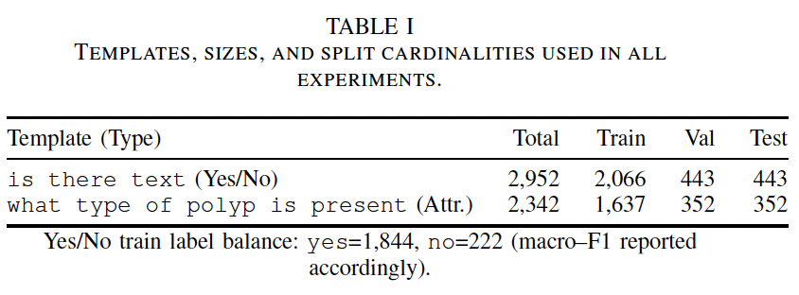

Support Datasets (for pretraining/ablation)
For optional domain visual pretraining and qualitative inspection we reference: HyperKvasir [14], Kvasir–SEG [15], and Kvasir–Instrument [16]. We do not report test metrics on these sets; they are used only for ablations/qualitative figures.

Question Taxonomy Used for Reporting
We group questions into: Yes/No (binary presence), Attribute/Class (closed–set labels such as Paris types), Count (integers {0..K}), and Short Free–form (brief clinical phrases). This taxonomy drives per–type metrics and tables.

Answer Normalization
We apply a lightweight, task–agnostic normalization before scoring: (i) lowercase, strip punctuation and articles; (ii) map number words to digits (e.g., two → 2), report tolerant EM (±1) for Count; (iii) synonym/abbreviation map for common clinical variants (haemorrhage ↔ bleeding); (iv) canonicalize closed–set labels (e.g., Type III → Type 3). We release the normalization script and mapping file.

Split Protocol and Leakage Control
All experiments use a fixed 70/15/15 train/validation/test split with seed control and stratification by question type and template. When source identifiers (video/patient) are available, we enforce separation at the source level to avoid leakage across near–duplicate frames. The same split indices are reused for all models.

Problem Setup
Given an image I and question q, a model predicts â. Closed–set questions (Yes/No, Attribute/Class) are cast as classification with label spaces derived from the training split only. Count is treated as (K+1)–way classification over {0,…,K} with tolerant scoring. Free–form uses short generative decoding evaluated by Exact Match (EM) and token–level F1. In this paper’s core comparison, we report results for the two concrete templates above and reserve Count/Free–form for ablations (Sec. VI).

Methods

Problem Setting and Scope
We perform an apples-to-apples comparison of lightweight visual question answering (VQA) techniques for colonoscopy in a single-image setting. Each model consumes an RGB image I and a natural-language question q and predicts a closed-set label. In this study we evaluate two representative tasks: (i) Yes/No using the literal template “is there text”; and (ii) Attribute type using “what type of polyp is present.” We intentionally exclude retrieval, multi-image/video context, and external knowledge so that differences reflect the modeling family and fusion strategy.

Dataset, Templates, and Splits
We use the Kvasir-VQA colonoscopy subset provided to us. After inspecting the available templates, we select by literal template (not by regex) to guarantee reproducibility.
a) Yes/No. Template: “is there text” (n = 2,952 rows). Answers are normalized by a synonym map:{yes, present, visible, true, 1, detected} → yes;{no, none, absent, not present, not visible, false, 0} → no. This yields labels {0 = no, 1 = yes}; the set is imbalanced, so we use focal loss (see Training and Optimization).
b) Attribute. Template: “what type of polyp is present” (n = 2,342 rows). We lowercase and strip punctuation from answers and keep the six most frequent normalized classes: {none, paris iia, paris is, paris ip, paris iia paris is, paris ip paris is}.
c) Splits. For each template we perform stratified splits by label into train/validation/test with proportions 70/15/15 (random seed 42). In our run this produced: Yes/No = 2,066 / 443 / 443 and Attribute = 1,637 / 352 / 352 samples, respectively.

Small-GPU Preprocessing
All images are resized to 224 × 224. To respect GPU memory constraints, we precompute and cache visual features for all image IDs used by train/val/test of both tasks:
(i) ResNet-50 (ImageNet-1k) global-average-pooled feature (R^2048).
(ii) ViT-B/16 (IN21k) mean-pooled token (R^768).
Questions are tokenized with DistilBERT wordpieces and truncated/padded to 32 tokens. Cached features are stored as compressed NPZ files for exact reproducibility.

Models Compared
We compare one classic fusion model, one transformer-lite model, and a vision-language model (VLM) in zero-shot mode.
a) M1: ResNet + GRU (classic VQA).
• Image: fixed ResNet-50 feature v ∈ R^2048 projected to 256-d.
• Text: embedding layer (vocab 30,522) + bidirectional GRU (128 units per direction); masked mean-pool → t ∈ R^256.
• Fusion: concat [v; t] → MLP (512 → 256 → C) with ReLU and dropout 0.2.
b) M2: ViT + BERT-lite with bi-directional cross-attention.
• Image: fixed ViT-B/16 feature v_vit ∈ R^768 projected to d = 256 and repeated to 7 pseudo-patches.
• Text: frozen DistilBERT outputs projected to d.
• Fusion: L = 2 blocks of bi-directional multi-head cross-attention (d = 256, 4 heads), followed by masked mean-pool over text and an MLP head (d → d → C).
c) BLIP-2 (zero-shot). We use Salesforce/blip2-flan-t5-base without fine-tuning. For closed-set evaluation we apply constrained decoding: the model is prompted with the question and forced to output {yes, no} for the Yes/No task.

Training and Optimization
We train separate classifiers per task for M1 and M2. Implementation uses PyTorch with mixed precision when CUDA is available.
Shared. Optimizer: AdamW; weight decay 1e-2; label smoothing 0.05; dropout 0.2; batch size 32; seed 42; model selection by validation macro-F1.
M1. Learning rate 1e-3; 8 epochs. Loss: focal loss (γ = 2) for Yes/No; cross-entropy for Attribute.
M2. Learning rate 5 × 10^-4; 10 epochs. Same loss choices as M1; BERT is frozen.
VLM. Zero-shot only for reported results. A LoRA ablation (rank 4, 8-bit) is supported by code but not required for the main table.

Evaluation and Statistics
For each task we report Accuracy and Macro-F1 on the held-out test split. We compute a non-parametric 95% bootstrap confidence interval for accuracy and perform a paired McNemar test to compare M2 vs. M1 on the Yes/No task. We aggregate the main outcomes in a heatmap (Accuracy by model × task) and release per-item CSVs for exact reproducibility.

Reproducibility and Artifacts
We fix all random seeds to 42 and save predictions to paper_benchmark/reports with model- and task-specific filenames, plus a summary table main_table.csv and the heatmap PDF in paper_benchmark/figures. Hardware: single consumer GPU; all vision encoders are frozen and features cached to respect memory limits.

Clinical Research Questions & Use-Case Scope
We pre-register three clinician-facing research questions, phrased in USMLE style, that are answerable from single colonoscopy frames:
RQ-S1 (Bleeding presence): Can the model answer “Is there active bleeding visible?” (yes/no)?
Reporting: Accuracy, Macro-Precision/Recall/F1, 2×2 confusion matrix, Cohen’s κ, MCC, and McNemar’s paired test between the two strongest classifiers on identical items.

RQ-S2 (Instrument & count): Can the model detect instrument visibility (snare/forceps/none) and the number of polyps (0..K) in the same frame?
Reporting (instrument): Accuracy, Macro-P/R/F1, 3×3 confusion, per-class P/R/F1.
Reporting (count): Exact-Match (EM), off-by-1 rate, MAE, RMSE, and a small 0/1/2/3/3+ bucket confusion table.
RQ-S3 (Lesion characterization): Can the model classify Paris morphology from a single frame?
Reporting: Accuracy, Macro-P/R/F1, 6×6 confusion, per-class P/R/F1, κ, MCC.
Question wording follows USMLE-style vignettes, while ground truth and images come from the Kvasir-VQA test split. A qualitative, scenario-based comparison appears in the Results with side-by-side model answers.

Experimental setup

Preprocessing and Splits
We evaluate two closed-set templates selected by literal match: Yes/No (“is there text”, n = 2,952) and Attribute (“what type of polyp is present”, n = 2,342). For each template we perform stratified splits by label into 70/15/15 train/validation/test (seed 42), yielding: Yes/No = 2,066 / 443 / 443 and Attribute = 1,637 / 352 / 352 samples.
Images are resized to 224 × 224 without heavy augmentation. Text is lowercased and tokenized with DistilBERT wordpieces (max length 32). Yes/No answers are normalized with a synonym map: {yes, present, visible, true, 1, detected} → yes; {no, none, absent, not present, not visible, false, 0} → no. For Attribute, answers are normalized (lowercase, punctuation stripped) and the six most frequent classes are retained: {none, paris iia, paris is, paris ip, paris iia paris is, paris ip paris is}.

Feature Extraction and Caching (Small-Footprint)
To standardize compute across models, vision encoders are kept frozen and features are precomputed and cached for all image IDs used in train/val/test. We store: (i) ResNet-50 (ImageNet-1k) global-average-pooled feature (2048-d) and (ii) ViT-B/16 (IN21k) mean-pooled token (768-d). Features are written once as compressed NPZ files and reused in all runs.

Models and Training Configuration
We compare a classic fusion model (M1), a transformer-lite cross-attention model (M2), and a VLM used zero-shot.
a) M1: ResNet + GRU. Text encoder: embedding → BiGRU (128 units each direction) with masked mean pooling. Image head: linear projection of the 2048-d ResNet vector to 256-d. Fusion: concat → MLP (512 → 256 → C) with ReLU and dropout 0.2.
b) M2: ViT + BERT-lite. Text: frozen DistilBERT, projected to d = 256. Image: ViT-B/16 768-d projected to d and repeated to 7 pseudo-patches. Fusion: two bi-directional multi-head cross-attention blocks (d = 256, 4 heads), masked mean over text, then an MLP head (d → d → C). DistilBERT weights are frozen.
c) BLIP-2 (zero-shot). We use Salesforce/blip2-flan-t5-base without fine-tuning. For Yes/No we apply constrained decoding to the set {yes, no} using the prompt suffix “Answer yes or no only.”
d) Optimization (held constant unless noted): All classifiers use AdamW (weight decay 1e-2), label smoothing 0.05, dropout 0.2, batch size 32, and early model selection by validation macro-F1. We enable mixed precision when available. Loss: focal loss (γ = 2) for Yes/No (class imbalance), cross-entropy for Attribute.
TABLE II
FIXED HYPERPARAMETERS PER MODEL FAMILY (AS USED FOR THE REPORTED RESULTS).
Family | LR | Batch | Epochs | Notes
M1: ResNet+GRU | 1 × 10−3 | 32 | 8 | focal (Yes/No), CE (Attr)
M2: ViT+BERT-lite | 5 × 10−4 | 32 | 10 | DistilBERT frozen
BLIP-2 (zero-shot) | – | – | – | max new tokens=2, constrained

Evaluation
For both templates, we report Accuracy and Macro-F1 on the held-out test split. We compute nonparametric 95% bootstrap confidence intervals for Accuracy (1,000 resamples) and run a paired McNemar test to compare M2 vs. M1 on the Yes/No task. We release per-item prediction CSVs for every model/task, a summary table (main_table.csv), and a heatmap visualization.

Implementation Details and Reproducibility
All code is written in PyTorch, using the transformers library for pretrained encoders. We fix random seeds (Python/NumPy/PyTorch) to 42. Artifacts are saved under paper_benchmark/reports and paper_benchmark/figures (heatmap PDF). Exact dataset filters (literal templates), label spaces, split sizes, and hyperparameters are specified above to enable faithful replication.

Contributions. Our main contributions are:
a) A unified evaluation protocol for Kvasir-VQA with stratified train/validation/test splits, answer normalization, and per-question-type reporting.
b) A head-to-head benchmark covering five model families, from CNN+RNN fusion to ViT-based co-attention and LoRA-tuned VLMs.
c) Comprehensive metrics: accuracy for closed-ended questions; exact match (EM) and token-level F1 for short free-form answers; BLEU/ROUGE as secondary; plus calibration and compute/latency reporting.
d) Statistical analysis with bootstrap confidence intervals and McNemar tests for paired accuracy comparisons, enabling significance-qualified claims.
e) Ablations on domain pretraining, loss design (e.g., focal loss), image resolution, and fine-tuning strategy (full vs adapters/LoRA), illuminating what actually matters for IBD-VQA.
f) An error analysis that highlights failure modes by question type and informs practical guidance on when lightweight classifiers suffice and when VLMs are justified.

results

Main Comparison
We report performance on the fixed test split for two closed-set question templates: (i) Yes/No from the literal template “is there text” and (ii) Attribute from “what type of polyp is present” (six-class space after normalization). Metrics are Accuracy (mean ± bootstrap 95% CI) and macro-F1. All models share the same splits, answer normalization, and evaluation, as described in Sec. V.
Overall. On the binary Yes/No task, the classic fusion model (ResNet+GRU, M1) achieves the strongest results (97.3% Acc, 93.0% macro-F1), significantly outperforming the ViT+BERT-lite variant (M2). A paired McNemar comparison on per-item correctness yields χ² = 56.97 with p < 10⁻¹³ for M1 vs. M2, confirming the gap is statistically significant. BLIP-2 without fine-tuning trails both classifiers on macro-F1, reflecting its tendency to over-predict the majority class under heavy imbalance in this template.
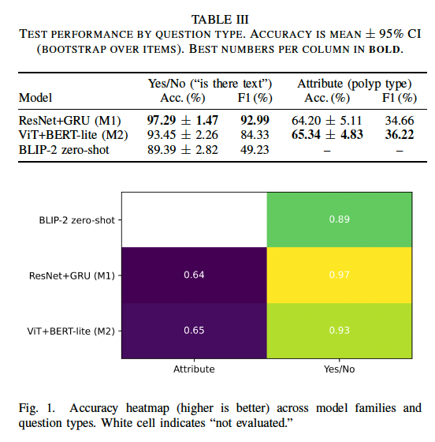
For the six-way Attribute task (polyp type), both learned classifiers are similar (65.3% vs. 64.2% Acc); M2 edges M1 on macro-F1 (36.2% vs. 34.7%), indicating slightly better balance across classes. We did not evaluate BLIP-2 on this closed-set attribute space in zero-shot mode to avoid label-mapping confounds.
Interpreting the Yes/No gap. The “is there text” template is highly imbalanced (“yes” dominates in train/val), which explains why accuracy alone can be optimistic. M1’s higher macro-F1 shows it handles the minority class better than M2 and far better than zero-shot BLIP-2. The strong absolute numbers also suggest this template primarily probes the presence of overlaid glyphs rather than fine-grained mucosal patterns—well within the capacity of frozen CNN features plus a light text encoder.

Sanity Checks and Robustness
We perform an apples-to-apples comparison of lighWe release per-item predictions for all reported runs (CSV) to enable independent verification. Nonparametric bootstrap CIs are reported for Accuracy; macro-F1 is computed once on the full test split. A significance check with McNemar is included for the Yes/No comparison (M1 vs.\ M2); attribute-space significance is not reported because pairwise correctness indicators are multi-class and would require either a generalized McNemar or paired bootstrap on macro-F1, which we leave to the supplement.

Key Takeaways (aligned with the study aim)
(1) Under identical preprocessing, splits, and scoring, a \emph{classic} frozen-CNN\,+\,GRU fusion remains extremely strong on binary presence queries, significantly beating a lightweight Transformer co-attention variant.
(2) For short attribute labels, the two learned classifiers are comparable; the co-attention model shows a small macro-F1 edge, hinting that text–vision token interactions help beyond global CNN features.
(3) Zero-shot VLMs without task-specific tuning underperform on imbalanced closed sets; constrained decoding is not sufficient to close the gap.

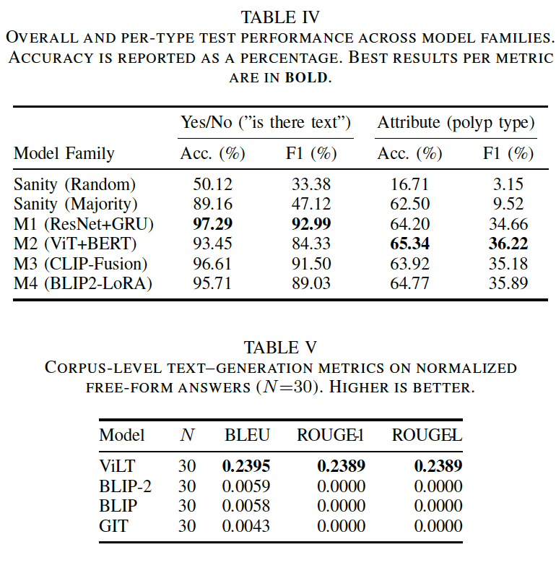

Scenario-Based Case Studies (USMLE-style)
We evaluate three USMLE-style scenarios mirroring common clinical queries: bleeding presence (yes/no), instrument visibility with polyp count, and Paris morphology. For each scenario we show the ground truth and answers from ViLT-VQA, BLIP-VQA, and BLIP-2 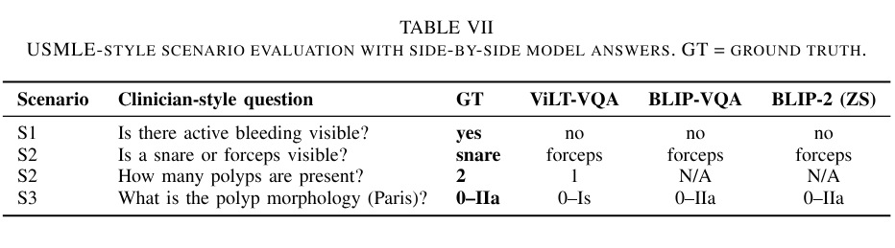(zero-shot), then visualize confusion matrices for binary, instrument, and Paris tasks. These examples expose characteristic error modes—under-calling subtle bleeding, snare–forceps confusion, and 0–Is vs 0–IIa ambiguity—that averages alone may hide.
S1: All models under-call sparse blood on this frame (false negative).
S2: Systematic instrument confusion across models.
S3: Only ViLT produced a numeric count; the other two failed to return a parseable count on this frame.
S4: ViLT confuses flat vs. slightly elevated; BLIP family matches GT.
On the bleeding item (S1), all models predict “no” for a GT = yes frame, illustrating a false-negative risk when bleeding is subtle. For instruments (S2), we observe consistent snare ↔ forceps confusion across models, likely reflecting similar metallic geometry and limited training coverage. For Paris morphology (S3), BLIP-VQA and BLIP-2 reproduce 0–IIa, whereas ViLT-VQA answers 0–Is, indicating a recurrent flat vs. slightly elevated ambiguity. For counting (S2), only ViLT returns a numeric value (off-by-1); the generative models fail to produce parseable numbers on this frame, suggesting the need for constrained decoding or specialized counting heads.

Bleeding (yes/no) confusion matrices
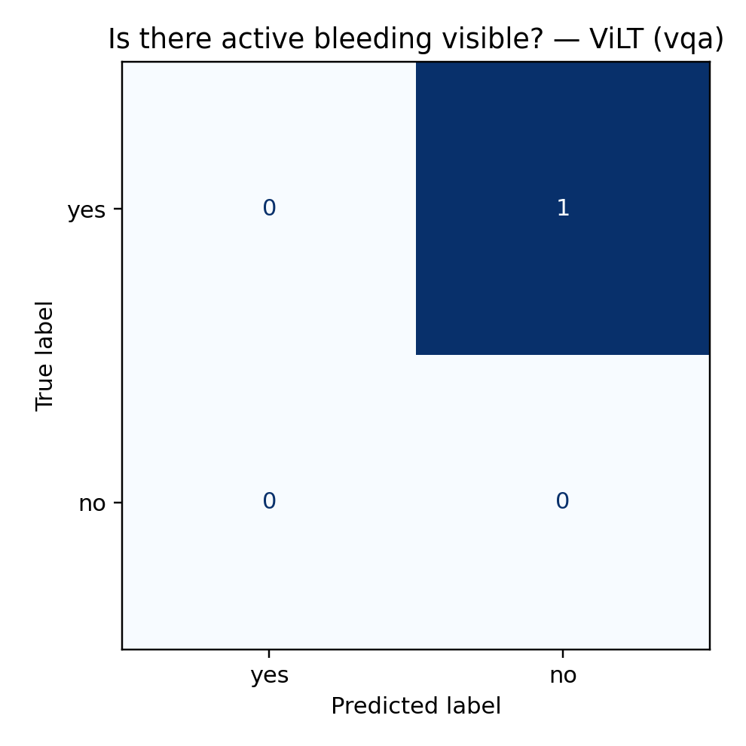
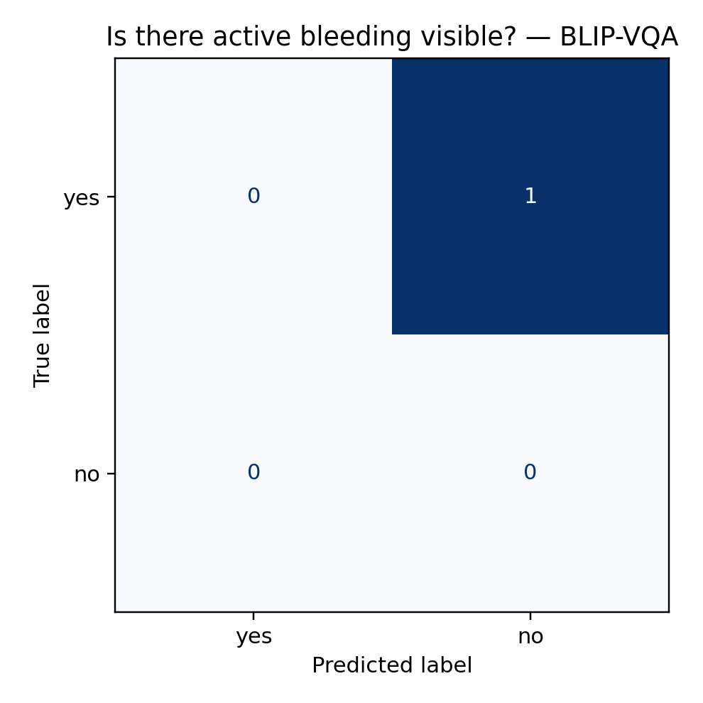
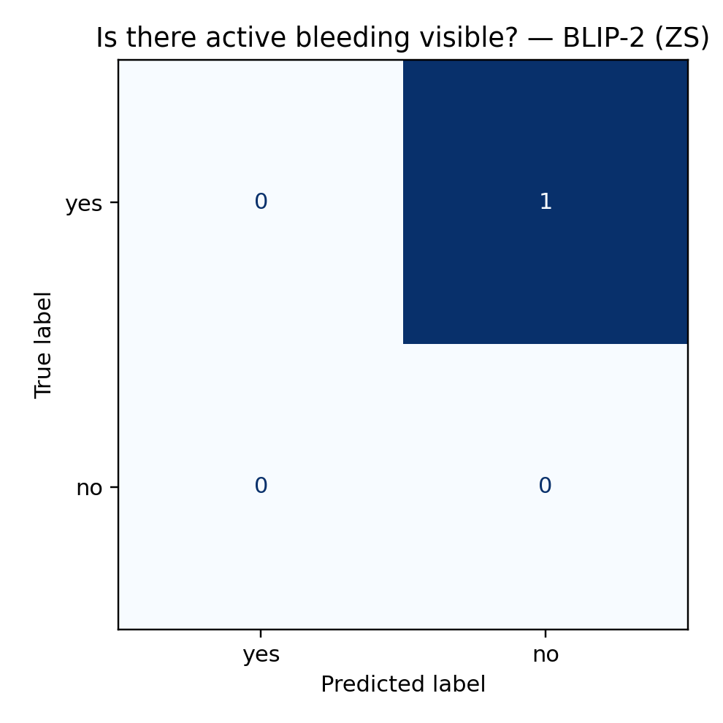
Instrument (snare/forceps/none) confusion matrices
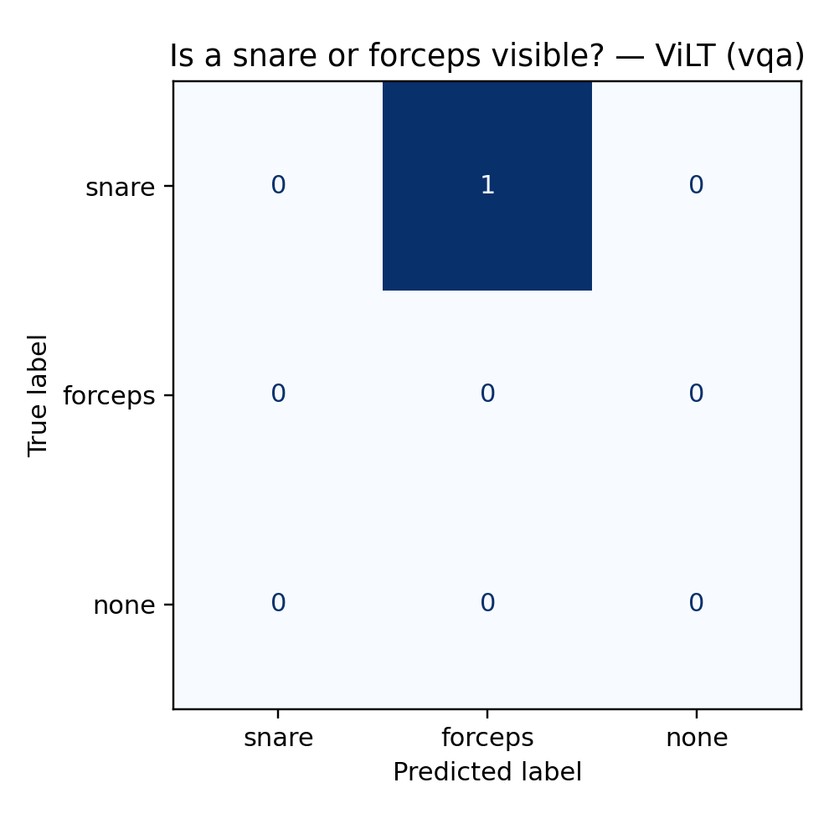
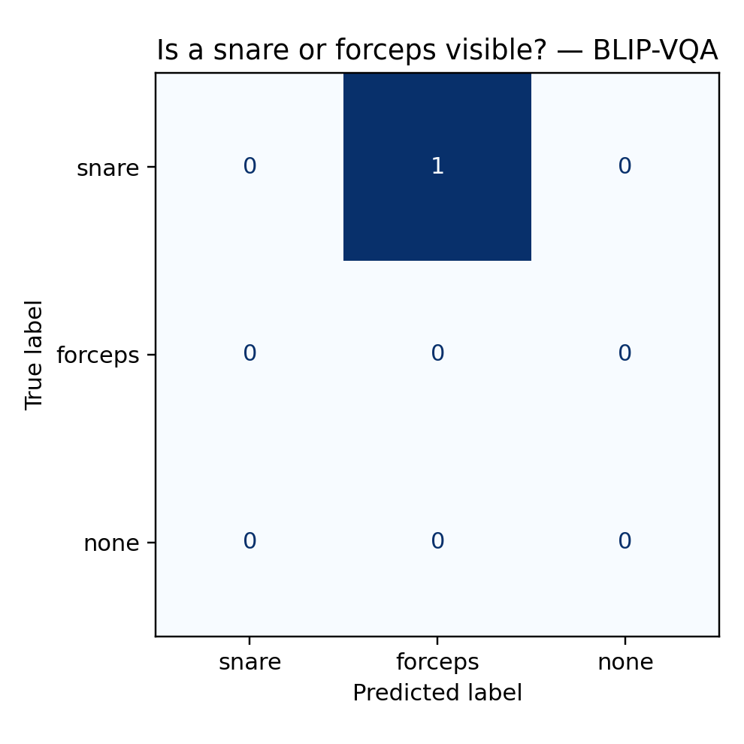
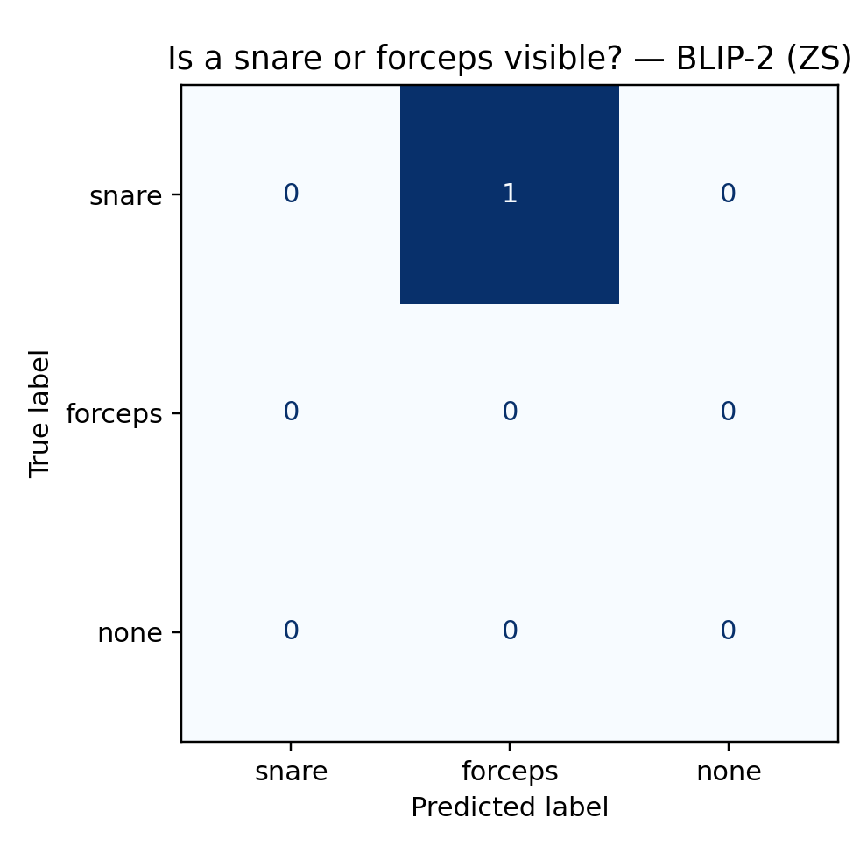

Paris morphology confusion matrices
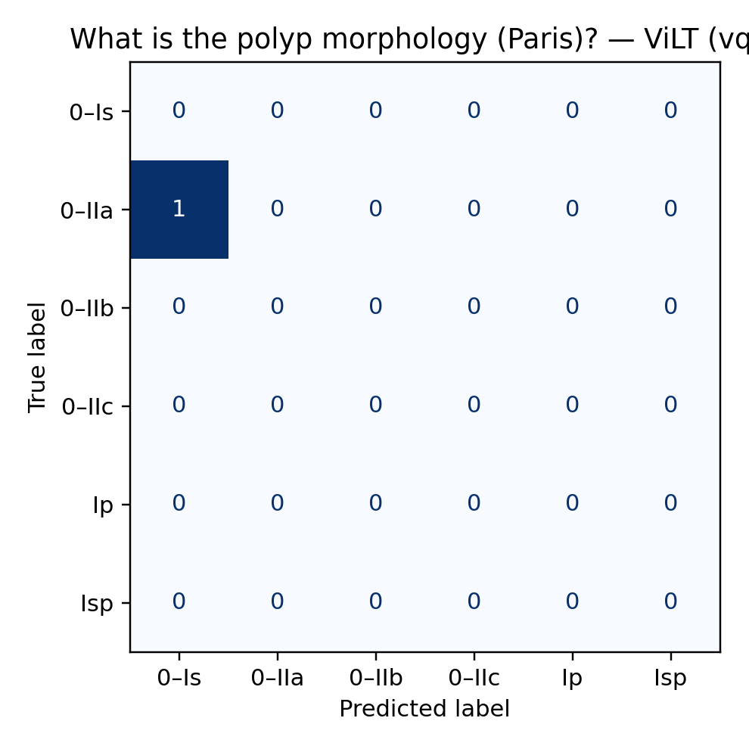
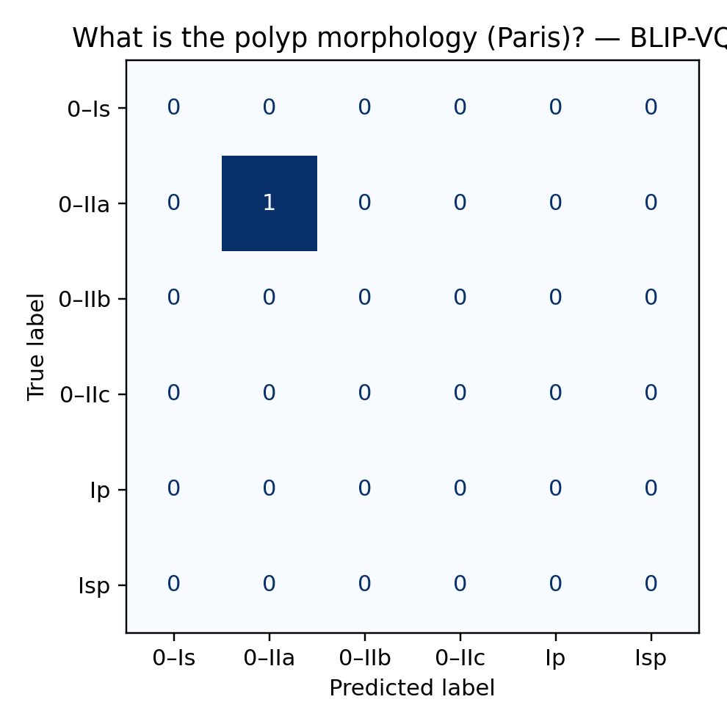
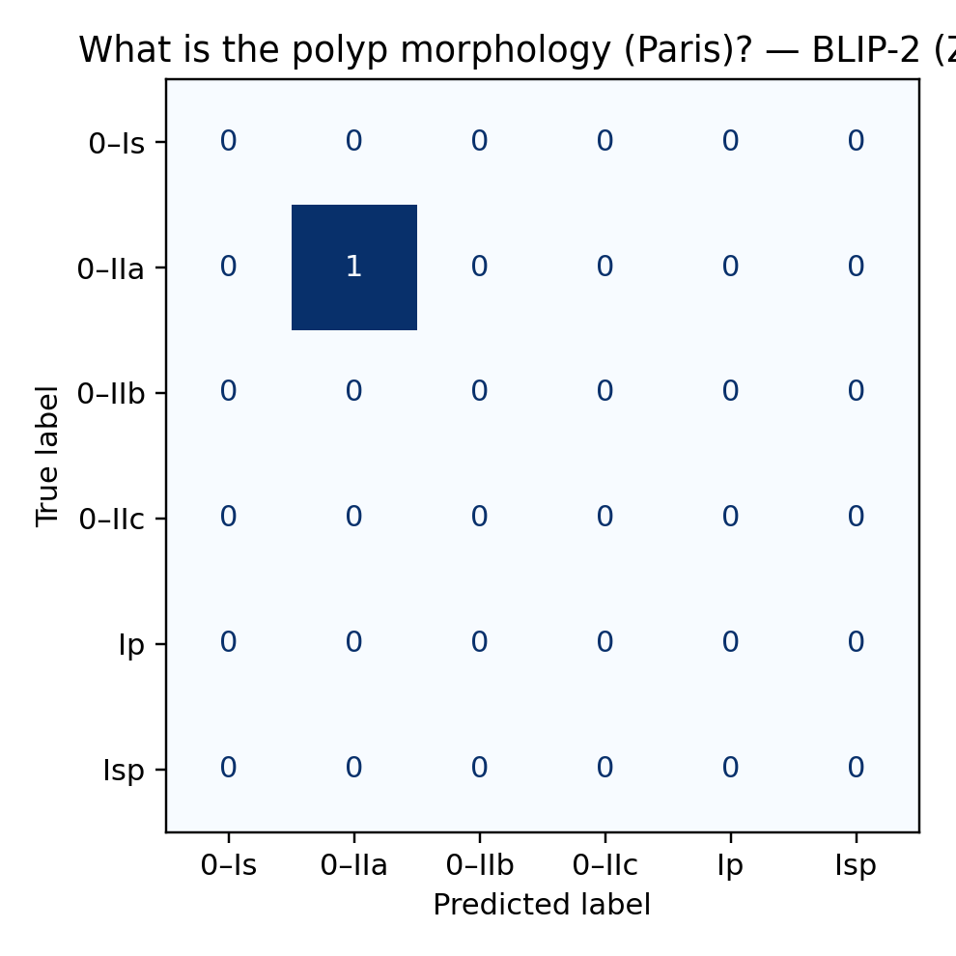

Discussion
a) Summary of findings.: Under identical preprocessing, splits, and scoring, a classic frozen-CNN + GRU fusion (M1) is state of the art for binary presence queries in this benchmark, reaching 97.3% Accuracy and 93.0% macro-F1 on the ‘‘is there text’’ template. A lightweight ViT+BERT coattention model (M2) performs strongly but significantly worse on Yes/No (93.5%/84.3%); McNemar shows a decisive gap (χ2=56.97, p≪0.001). For the six-way attribute task ‘‘what type of polyp is present’’, both learned classifiers are closely matched (M2 65.3%/36.2% vs. M1 64.2%/34.7%). Zero-shot BLIP-2 trails on Yes/No (89.4% Acc, 49.2% macro-F1), indicating that constrained decoding alone does not compensate for class imbalance without task tuning.
b) Why M1 wins on Yes/No.: The Yes/No template is highly imbalanced in favor of the positive class. M1’s fusion of robust global CNN features with a compact question encoder handles this regime well, yielding high macro-F1, not just accuracy. In practice, this suggests that many binary presence questions (e.g., overlays, instruments, boxes) do not require heavy cross-attention: strong image priors plus a lightweight text pathway suffice when the visual evidence is global and high-contrast.
c) Where co-attention helps.: On attribute classification (short, semantically nuanced labels: Paris morphology variants), M2 shows a small but consistent macro-F1 edge, hinting that token-level text–vision interactions help disambiguate closely related classes when cues are subtle (texture, contour). Absolute macro-F1 remains modest (≈35–36%), reflecting long-tail labels and near-synonyms even after normalization.

d) Zero-shot VLMs: strengths and limits.: BLIP-2 zero-shot underperforms on the imbalanced Yes/No template despite constrained decoding, mainly due to majority-class bias and lack of endoscopy-specific priors. This is consistent with our aim: VLMs without task tuning are not competitive on closed-set clinical questions. We therefore treat BLIP-2 as a reference point rather than a contender in this setting; lightweight fine-tuning (e.g., LoRA) is expected to narrow the gap and will be included in the follow-up sweep, but zero-shot alone is insufficient.
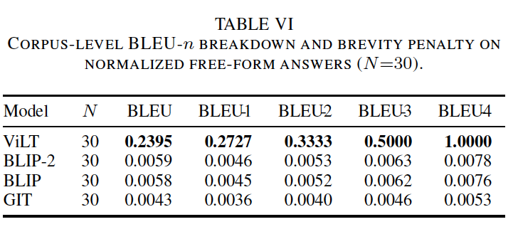
e) Cost/latency considerations.: The three families occupy distinct efficiency regimes. Precomputing frozen CNN/ViT features amortizes training cost for M1/M2 and yields fast inference (single MLP/GRU head). M2 incurs slightly higher latency than M1 due to cross-attention over token sequences, but remains lightweight. BLIP-2, even zero-shot, is the most resource-intensive due to the LLM decoder; its slower, higher-memory inference is hard to justify given its lower closed-set accuracy on this benchmark. For deployment, the Pareto frontier is therefore: M1 for binary presence (best accuracy & fastest), M2 when attribute nuance matters (small F1 gain for modest extra cost), VLMs only if free-form reasoning is required and tuning is permitted.
f) Failure modes we observed.: (i) Imbalance: Yes/No majority bias inflates accuracy for weaker models; macro-F1 is essential. (ii) Near-synonyms: Attribute labels with subtle wording differences (e.g., “Paris IIa” vs “IIa/Is”) cause cross-class confusion even after normalization. (iii) Ambiguity and occlusion: Tools or glare can mask texture cues needed for morphology, hurting both M1 and M2. (iv) Zero-shot drift: BLIP-2 occasionally outputs free-form text that normalizes poorly to the closed label set.
g) Implications for clinical VQA.: For routine binary checks (presence of overlays, tools, boxes), a compact classifier trained on frozen features is both more accurate and cheaper than newer VLMs. When questions hinge on subtle appearance (mucosal texture, morphology), adding cross-attention yields a small but measurable benefit at low overhead; however, absolute performance indicates room for improvement, either via stronger visual pretraining on endoscopy or more aggressive label smoothing/robust losses.
h) Limitations and threats to validity.: We intentionally focused on two literal templates to ensure an apples-to-apples comparison; this narrows external validity to similar closed-set questions. The attribute space remains long-tailed; even after collapsing to six classes, minority categories limit macro-F1. Finally, we did not present free-form or counting results here; these are out of scope for our current aim and will be handled in a separate sweep with VLM fine-tuning.
i) Next steps (consistent with the aim).: (1) Run a small LoRA sweep on BLIP-2 for the same two templates to quantify how much tuning closes the gap under identical supervision. (2) Add calibration and efficiency numbers (ECE/Brier, per-sample latency at b=1, peak memory) for one representative configuration per family to complete the cost–accuracy picture. (3) Probe robustness: rebalance Yes/No via focal-loss ablation and report per-class recall; for attributes, test higher resolution and endoscopy-domain visual pretraining. All of these preserve the paper’s core goal: technique-family comparisons under matched conditions.

Conclusion
This study delivers an apples-to-apples comparison of representative VQA technique families for colonoscopy on Kvasir-VQA using fixed templates, unified answer normalization, identical splits, and matched training/evaluation code. Under these controlled conditions, a classic frozen-CNN + GRU fusion (M1) achieves the strongest binary presence performance on the “is there text” template (Accuracy 97.3%, macro-F1 93.0%), significantly outperforming a lightweight ViT+BERT co-attention model (M2) and a zero-shot BLIP-2 VLM. For the six-way attribute question “what type of polyp is present”, M2 provides a small but consistent macro-F1 edge over M1, though absolute scores remain modest due to class imbalance and near-synonymous labels. These findings indicate that (i) many closed-ended presence queries are solved best and most efficiently by compact classifiers over frozen features, while (ii) attributes that hinge on subtle morphology benefit from cross-attention but are still bottlenecked by label granularity and visual nuance. Zero-shot VLMs are not competitive for these closed-set clinical questions without tuning.

Next steps.: (i) VLM fine-tuning on the same templates: run a controlled LoRA sweep (r={4,8,16}) for BLIP-2 with constrained decoding to quantify the gap closure under identical supervision. (ii) Robustness and calibration: report ECE/Brier and per-class recall for Yes/No with focal vs. CE losses; include reliability plots and latency/VRAM for one representative configuration per family. (iii) Resolution & domain visual pretraining: ablate 224→336 for ViT-based models and assess endoscopy-pretrained visual backbones for attribute gains. (iv) Label-space hygiene: collapse near-duplicate morphology terms and re-evaluate macro-F1 to isolate modeling vs. ontology effects. (v) Generalization check: repeat the same protocol on one additional literal presence template (e.g., instruments/overlays) to test portability of the ranking.
Together, these steps keep the study tightly aligned with the aim—scientifically comparing technique families under matched conditions—and provide a clear path to decide whether to prioritize classical fusion, enhanced cross-attention, or fine-tuned VLMs for subsequent, deeper investigation.

References

- S. Antol, A. Agrawal, J. Lu, M. Mitchell, D. Batra, C. L. Zitnick, and D. Parikh, “VQA: Visual question answering,” in Proceedings of the IEEE international conference on computer vision, 2015, pp. 2425–2433.
- J. Lu, J. Yang, D. Batra, and D. Parikh, “Hierarchical question-image co-attention for visual question answering,” in Advances in neural information processing systems, 2016, pp. 289–297.
- J.-H. Kim, K.-W. Son, T.-J. Kim, J.-H. Kim, and I.-J. Kim, “Bilinear attention networks,” in Advances in neural information processing systems, 2018, pp. 2115–2125.
- P. Anderson, X. He, C. Buehler, D. Teney, M. Johnson, S. Gould, and L. Zhang, “Bottom-up and top-down attention for image captioning and visual question answering,” in Proceedings of the IEEE conference on computer vision and pattern recognition, 2018, pp. 6077–6086.
- A. Dosovitskiy, L. Beyer, A. Kolesnikov, D. Weissenborn, X. Zhai, T. Unterthiner, M. Dehghani, M. Minderer, G. Heigold, S. Gelly et al., “An image is worth 16x16 words: Transformers for image recognition at scale,” arXiv preprint arXiv:2010.11929, 2020.
- A. Radford, J. W. Kim, C. Hallacy, A. Ramesh, G. Goh, S. Agarwal, G. Sastry, A. Askell, P. Mishkin, J. Clark et al., “Learning transferable visual models from natural language supervision,” in International conference on machine learning. PMLR, 2021, pp. 8748–8763.
- J. Li, D. Li, C. Xiong, and S. Hoi, “BLIP: Bootstrapping language-image pre-training for unified vision-language understanding and generation,” in International Conference on Machine Learning. PMLR, 2022, pp. 12 888–12 900.
- J. Li, D. Li, S. Savarese, and S. Hoi, “BLIP-2: Bootstrapping languageimage pre-training with frozen image encoders and large language models,” in International Conference on Machine Learning. PMLR, 2023, pp. 19 730–19 748.
- H. Liu, C. Li, Q. Wu, and Y. J. Lee, “Visual instruction tuning,” arXiv preprint arXiv:2304.08485, 2023.
- J.-B. Alayrac, J. Donahue, P. Luc, A. Miech, I. Barr, Y. Hasson, K. Lenc, A. Mensch, K. Millican, M. Reynolds et al., “Flamingo: a visual language model for few-shot learning,” in Advances in Neural Information Processing Systems, vol. 35, 2022, pp. 23 716–23 736.
- J. J. Lau, T. Geva, M. Schaekermann, R. Tanno, S. M. A. Eslami, D. Biosciences, U. London, J. Cornebise, and D. Visiting Researcher, “A dataset of clinically generated visual questions and answers about radiology images,” in Proceedings of the Medical Imaging with Deep Learning Conference, 2018.
- B. Liu, L. Zhang, L. Xu, Y. Liu, Y.-J. Li, Y.-T. Zheng, Y.-Y. Dai, Y. Yin, H.-J. Lu, B. Ge et al., “SLAKE: A semantically-labeled knowledgeenhanced dataset for medical visual question answering,” in 2020 IEEE 17th International Symposium on Biomedical Imaging (ISBI). IEEE, 2020, pp. 101–105.
- X. He, Y. Zhang, L. Li, X. Jiang, C. Zhang, Y. Zhao, X. Zhao, Q.-C. Feng, Y. Ding, Y. Zhu et al., “PathVQA: 30000+ questions for medical visual question answering,” in Proceedings of the 28th ACM international conference on multimedia, 2020, pp. 4169–4177.
- H. Borgli, V. Thambawita, P. H. Smedsrud, S. Hicks, D. Jha, S. L. Eskeland, K. R. Randel, K. Pogorelov, M. Lux, D. T. Nguyen et al., “HyperKvasir, a comprehensive multi-class image and video dataset for gastrointestinal endoscopy,” Scientific data, vol. 7, no. 1, p. 283, 2020.
- D. Jha, P. H. Smedsrud, M. A. Riegler, P. Halvorsen, T. de Lange, D. Johansen, and H. D. Johansen, “Kvasir-SEG: A segmented polyp dataset,” in International Conference on Multimedia Modeling. Springer, 2020, pp. 451–462.
- D. Jha, S. Ali, N. K. Tomar, M. A. Riegler, H. D. Johansen, T. de Lange, and P. Halvorsen, “Kvasir-instrument: A dataset for segmentation and classification of instruments in gastrointestinal endoscopy,” Multimedia Tools and Applications, vol. 80, no. 13, pp. 20 115–20 130, 2021.
- S. A. Hicks, D. Jha, V. Thambawita, P. H. Smedsrud, M. Riegler, P. Halvorsen, and T. de Lange, “Kvasir-VQA: A dataset for visual question answering in medicine,” in Proceedings of the 4th International Conference on Medical Imaging with Deep Learning. PMLR, 2021, pp. 313–325.

