Generative AI Based on Medical Visual Question Answering (VQA) Techniques
by
[Sarthak Kaushik]
Thesis Submitted in Partial Fulfillment of the
Requirements for the Degree of
Master of Computer Science
in the
[Department of Computer Science]
[Faculty of Computer Science]

© [Sarthak Kaushik] 2025
LAKEHEAD UNIVERSITY
[April 2026]

Copyright in this work is held by the author. Please ensure that any reproduction
or re-use is done in accordance with the relevant national copyright legislation.

Declaration of Committee
Name: | Sarthak Kaushik
Degree: | Master of Computer Science
Title: | Generative AI Based on Medical Visual Question Answering (VQA) Techniques
Committee: | Chair: | [Dr. Sabah Mohammed]  Supervisor  [Chair, Department of Computer Science]
[Dr. Jinan Fiaidhi]
Supervisor
[Full Professor, Department of Computer Science]
[Dr. Arnold Kim]
External Examiner
[Academic or Professional Role, Academic Unit]
[Institution]

Ethics Statement

Abstract
Medical Visual Question Answering (MedVQA) promises a more useful interface for clinical AI than standalone classifiers because it allows clinicians to query images directly in natural language. In gastrointestinal (GI) endoscopy, this capability is especially relevant for high-volume, high-variability workflows such as ulcerative colitis severity grading, polyp assessment, and procedure documentation. However, practical MedVQA remains limited by dataset bias, long-tail label imbalance, weak lexical grounding in free-text generation, and inconsistent clinical faithfulness across question types.
This dissertation investigates these limitations and develops a clinically oriented VQA framework for colonoscopy. The work is grounded in multi-dataset experimentation across HyperKvasir, Kvasir-VQA, Kvasir-VQA-x1, ImageCLEF MEDVQA-GI 2023, and LIMUC, covering both closed-set and generative settings. Repository benchmarks show a clear pattern: supervised or constrained models remain substantially stronger than raw zero-shot VLMs on current GI tasks. In our saved runs, ViLT reaches 0.9089 accuracy on ImageCLEF MEDVQA-GI validation, while Qwen2.5-VL zero-shot raw outputs collapse to 0.0007 accuracy before lexical projection. On HyperKvasir, fine-tuned ResNet50 reaches 0.8789 test accuracy, while BLIP2 zero-shot projected labels remain low (0.0638). On LIMUC severity grading, fine-tuned ResNet50 attains 0.7539 accuracy, macro-F1 0.6829, and QWK 0.8351, with persistent minority-class difficulty.
These findings motivate the thesis direction: move from score-only pipelines toward clinically grounded, evidence-aware multimodal reasoning that combines (1) robust visual recognition, (2) question-aware answer generation, and (3) retrieval-supported justification for higher-risk decisions. The dissertation contributes a structured research agenda, scenario-driven evaluation design, and an implementation pathway for integrating VQA with retrieval-augmented generation (RAG) in GI decision support. The long-term objective is an assistant that does not only classify findings, but can explain, qualify uncertainty, and align outputs with clinician workflow and evidence-based care.
Keywords: medical visual question answering, gastrointestinal endoscopy, colonoscopy, ulcerative colitis, vision-language models, retrieval-augmented generation, clinical decision support

Dedication

Acknowledgements
This is an optional page. Use your choice of paragraph style for text on this page (1_Para shown here).

Table of Contents
Declaration of Committee ................................................................................................ ii
Ethics Statement ............................................................................................................. iii
Abstract ........................................................................................................................... iv
Dedication ........................................................................................................................ v
Acknowledgments ........................................................................................................... vi
Table of Contents ........................................................................................................... vii
List of Tables ................................................................................................................. viii
List of Figures ................................................................................................................. ix
List of Acronyms .............................................................................................................. x
Glossary .......................................................................................................................... xi
Preface/Executive Summary/Image ............................................................................... xii
Chapter 1. Introduction ................................................................................................. 1
- 1.1 Background and Motivation ..................................................................................... 2
- 1.2 Why GI Endoscopy and Colonoscopy ..................................................................... 4
- 1.3 Clinical Motivation: Ulcerative Colitis Severity as a Flagship Use Case ................. 5
- 1.4 Problem Statement ................................................................................................. 7
- 1.5 Aim and Objectives ................................................................................................. 9
- 1.6 Research Questions .............................................................................................. 10
- 1.7 Scope, Assumptions, and Delimitations ................................................................ 11
- 1.8 Scenario-Driven Framing ...................................................................................... 13
- 1.9 Conceptual Framework and System Flow ............................................................ 14
- 1.10 Contributions Claimed in This Dissertation ......................................................... 16
- 1.11 Chapter-by-Chapter Summary ............................................................................ 16
Chapter 2. Survey of VQA in Medicine with Application to Colonoscopy.............. 18
- 2.1 Introduction ........................................................................................................... 19
- 2.2 Scoping Review Design ........................................................................................ 20
- 2.3 Evolution of VQA Methods: From General AI to Clinical MedVQA ....................... 22
- 2.4 Dataset and Benchmark Landscape ..................................................................... 23
- 2.5 Survey of Technique Families ............................................................................... 25
- 2.6 Evaluation Practices in the Literature .................................................................... 28
- 2.7 Scenario-Oriented Technique Suitability for Colonoscopy .................................... 31
- 2.8 2024-2026 Trends in MedVQA Research ............................................................. 31
- 2.9 Evidence Triangulation with Repository Results ................................................... 32
- 2.10 Key Gaps and Open Problems ............................................................................ 33
- 2.11 Chapter Summary and Transition ........................................................................ 34
Chapter 3. Investigating Existing VQA Techniques Across GI-Endoscopy Datasets ...............................................................................................................35
- 3.1 Chapter Overview and Evaluation Goal ................................................................ 35
- 3.2 Experimental Scenarios and Data Regimes .......................................................... 38
- 3.3 Evaluation Metrics and Statistical Protocol ............................................................ 44
- 3.4 Baseline and Existing-Model Results .................................................................... 50
- 3.5 Cross-Dataset Synthesis and Findings ................................................................. 62
- 3.6 Position After Chapter 3 ........................................................................................ 65
- 3.7 Artifact Manifest for Figures and Tables ................................................................ 65
- 3.8 Figures and Tables Checklist ................................................................................ 65
References ...................................................................................................................

List of Tables
No table of figures entries found.
Use References>Insert Caption to create caption labels and numbers. Right-click on the text above and select Update Field to update this list. See the Thesis Template Instructions for information on creating tables, figures, and captions.
Remember to delete this note before submission.
If there are no tables in the document, remove this page.

List of Figures

List of Acronyms

Glossary
Thesis | An extended research paper that is part of the final exam process for a graduate degree. The document may also be classified as a project or collection of extended essays.
Glossary | An alphabetical list of key terms
 | This is an optional page and can be removed if not used.
 | Use one table row for each item to allow sorting using Word’s table tools.
 | Apply the style 1_Para_NoSpace to table rows as shown here.

Preface/Executive Summary/Image
This page can be used for a Preface, Executive Summary, or introductory image. This is an optional page and can be deleted if not used.
To hide the heading at the top of this page – e.g., if using an introductory image – select the text and change the text colour to white.
Do not delete the section break that follows this paragraph. If the section break is not visible, turn on non-printing characters using the Show/Hide icon (¶) on the Home ribbon.

Introduction
1.0 Chapter 1 Overview
Chapter 1 defines the full research foundation of this dissertation and clarifies why GI-endoscopy MedVQA must be evaluated beyond aggregate benchmark scores. The chapter first establishes the clinical motivation for question-driven AI support in colonoscopy, then formalizes the central methodological gap: current systems can produce strong average performance while still failing on clinically high-risk, imbalanced, or format-sensitive cases. It then translates this gap into a concrete research program by stating the thesis aim, objectives, research questions, and working hypotheses. In addition, Chapter 1 sets the operational boundaries of the work, including what is in scope, what is explicitly out of scope, and how PICO-oriented evidence mapping is used as a controlled extension pathway rather than a replacement for visual reliability. Finally, the chapter introduces the scenario-driven framing, conceptual pipeline, and risk-control logic that guide all subsequent experiments and interpretations.
At a glance, this chapter:
1. Establishes background and motivation for MedVQA in GI endoscopy.
2. Defines the reliability and translational gap the dissertation addresses.
3. Formalizes aim, objectives, and research questions with evaluation mapping.
4. Specifies scope, assumptions, and governance constraints for defensible claims.
5. Provides the conceptual and chapter-level roadmap used in Chapters 2 and 3.
The next chapter converts this foundation into a structured scoping review that identifies the most relevant model families, benchmarks, and open gaps for GI-oriented evaluation.

1.1 Background & Motivation
Medical Visual Question Answering (MedVQA) is an interdisciplinary field that integrates computer vision (CV), natural language processing (NLP), and clinical medicine. It aims to build artificial intelligence systems that can interpret medical images and answer clinically relevant questions expressed in natural language. In contrast to conventional image classification systems that return only categorical predictions, MedVQA is designed to support question-driven interaction. This interaction model is closely aligned with how clinicians reason in practice, where interpretation is typically guided by targeted questions rather than isolated labels.
MedVQA offers substantial potential for clinical decision support. Its expected benefits include improved diagnostic consistency, reduced physician workload, and wider access to specialist-level interpretation in telemedicine and resource-constrained settings. The long-term objective is not to replace clinical judgment, but to provide an intelligent and transparent assistant that can complement clinical reasoning within existing workflows.
Unlike general-domain VQA, MedVQA faces domain-specific constraints. Medical images often include subtle, overlapping, or low-contrast findings that require specialized interpretation. Clinical questions frequently require multi-step reasoning, in which visual evidence must be combined with biomedical context and task intent. These characteristics make MedVQA both a technically demanding multimodal task and a clinically sensitive reliability challenge.
The technical foundation of MedVQA combines CV-based image representation with NLP-based question understanding and answer synthesis. Early systems were predominantly discriminative, using an image encoder, a question encoder, a fusion module, and a fixed answer set. These systems performed adequately on constrained tasks but showed limited flexibility for nuanced and open-ended clinical questions [1], [2], [3]. Recent work has shifted toward transformer-based multimodal architectures and generative response models, supported by large-scale vision-language pretraining [4], [5] and contemporary MedVQA surveys of large multimodal model behavior [8], [9]. In parallel, biomedical language models such as BioBERT and BioGPT have improved domain-specific language understanding and generation [6], [7].
Despite this progress, the gap between benchmark performance and reliable clinical utility remains significant. Three persistent tensions define the present landscape:
Expressiveness versus reliability: Generative models can produce richer answers, but may exhibit lexical drift, weak grounding, or hallucinated content.
Aggregate performance versus clinical robustness: High overall accuracy can conceal clinically critical failures in minority classes.
General multimodal capability versus medical domain specificity: Zero-shot transfer from general VLMs often underperforms in specialized clinical settings.
This dissertation is motivated by these tensions and investigates them in the context of gastrointestinal endoscopy, with a specific focus on colonoscopy-oriented MedVQA.
1.1.1 From Fixed-Answer Systems to Generative Multimodal Models
The historical evolution of MedVQA provides an important context for this thesis. In early systems, answer generation was operationally equivalent to label selection. This formulation enabled straightforward optimization and evaluation, but it constrained clinically meaningful expression. Complex questions were often reduced to coarse categorical outputs, limiting interpretability and reducing practical value for clinicians.
Transformer-era multimodal models improved cross-modal alignment and enabled free-text response generation. This transition addressed important limitations of earlier systems, particularly weak question-image interaction and restricted output vocabulary. However, it also introduced new risks. In clinical settings, a fluent answer that is weakly grounded in image evidence may be more problematic than a constrained but verifiable answer. Consequently, model expressiveness must be balanced with grounding, calibration, and error control.
Another major shift has occurred at the evaluation level. Instead of reporting performance within a single benchmark only, recent studies increasingly examine cross-dataset behavior and robustness to distributional changes. This is particularly relevant in GI endoscopy, where data heterogeneity in question templates, answer conventions, and visual characteristics can be substantial.
1.1.2 Limitations of Aggregate Benchmark Scores in Clinical AI
Benchmark metrics remain necessary, but they are not sufficient for clinical validation. A model can achieve high overall accuracy while failing on rare yet clinically consequential categories. Weighted scores may obscure failures in underrepresented classes, and single-point metrics may not capture the clinical implications of specific error types.
For severity-oriented tasks, ordinal relationships are also important. Confusing adjacent grades is not equivalent to missing severe disease altogether. Therefore, evaluation design in clinical MedVQA should include classwise metrics, imbalance-aware metrics, ordinally sensitive metrics, and scenario-level acceptance logic.
This dissertation adopts that broader evaluation view from Chapter 1 onward. In addition, answer format itself is treated as an evaluable design choice. For certain use cases, label-only output may be sufficient; for others, clinicians may require rationale, confidence estimates, or evidence pointers. A reliable clinical assistant must be assessed on both predictive accuracy and output usability.
1.2 Why GI Endoscopy and Colonoscopy
Gastrointestinal (GI) endoscopy is a strategically important target for MedVQA from both clinical and methodological perspectives.
Clinically, colonoscopy supports screening, diagnosis, and follow-up across multiple disease contexts, including colorectal neoplasia and inflammatory bowel disease. Endoscopic interpretation directly affects treatment escalation, surveillance decisions, and procedural reporting. In routine practice, clinicians frequently pose focused questions such as:
- Is an abnormality present?
- How many findings are visible?
- Where is the lesion located?
- What type or morphology is observed?
- What is the likely severity of inflammation?
These question types map naturally to MedVQA task families and are suitable for systematic evaluation.
From a technical perspective, GI endoscopy is challenging. Image quality can vary due to motion blur, specular reflections, debris, variable bowel preparation, and viewpoint variation. Question-answer distributions can be highly imbalanced, with clinically important severe classes often underrepresented. Consequently, colonoscopy MedVQA provides a realistic and stringent setting for evaluating reliability under domain shift and class imbalance.
Recent dataset development makes this thesis direction feasible:
- Kvasir-VQA introduced GI-focused visual question answering at scale (58,849 QA pairs over 6,500 images) [12], [19].
- Kvasir-VQA-x1 expanded complexity and scale (159,549 QA pairs) and introduced transformed/robustness-oriented settings [13].
- ImageCLEF MEDVQA-GI provided shared benchmarking tracks for GI VQA [10], [11].
- HyperKvasir and LIMUC provide broader GI visual context and severity-oriented subsets [15], [18].
These resources enable reproducible analysis, but they do not remove the central challenge: building systems that remain reliable not only on common benchmark patterns, but also on clinically high-risk cases.
1.2.1 Colonoscopy Question Families and Their Decision Roles
To ensure methodological clarity, this thesis maps question families to their clinical decision roles.
Question family | Example | Dominant challenge | Decision role
Presence | "Is there active bleeding?" | False-negative control | Immediate risk awareness
Count | "How many polyps are visible?" | Counting under occlusion and partial views | Completeness and burden estimation
Location | "Where is the lesion?" | Spatial grounding consistency | Procedural precision and reporting
Type/Attribute | "What polyp morphology is present?" | Fine-grained differentiation | Risk stratification and follow-up planning
Severity | "What is the likely Mayo score?" | Ordinal robustness under imbalance | Treatment planning and monitoring
Table 1.1
1.2.2 Operational Constraints in Realistic Deployment
Even in pre-deployment research, model design should anticipate operational constraints. These include variable image quality, limited severe-class labels, institutional differences in reporting language, and the need for predictable failure behavior. A clinically acceptable system is not one that never fails; it is one that fails in ways that are detectable, bounded, and actionable.
These constraints motivate a conditional architecture. Closed-set pathways are often preferable where deterministic label control is required. Generative pathways can be used for explanation-oriented outputs under explicit safeguards. Retrieval-backed reasoning should be introduced selectively for questions that require evidence beyond direct visual interpretation.
1.3 Clinical Motivation: Ulcerative Colitis Severity as a Flagship Use Case
Ulcerative colitis (UC) severity assessment is a high-value use case for MedVQA in colonoscopy. Endoscopic severity strongly influences treatment decisions and disease monitoring strategies. In clinical practice, severity is commonly represented by standardized scales such as the Mayo Endoscopic Subscore (0-3) and UCEIS (0-8, often mapped to ordinal severity categories). These scales are clinically meaningful, but grading can be difficult in borderline or low-quality frames.
UC severity automation is not a new problem. Prior deep learning systems have already shown clinically meaningful performance for endoscopic severity scoring under specialist comparison settings [25], [26], [27], [28]. Related GI quality-grading work with vision-language models further supports the feasibility of multimodal assistance in endoscopy workflows [17]. These studies establish strong prior art for AI-based severity grading in UC and clarify that the key challenge is no longer "can AI score disease at all?" but "can an interactive system remain reliable, grounded, and clinically usable when moved beyond fixed-score outputs?" [14], [16].
This dissertation therefore does not claim to be the first AI system for UC severity scoring. Its novelty is the integration of (1) GI-oriented MedVQA interaction, (2) risk-aware reliability controls, and (3) evidence-aware extensions for management-style questions. From a MedVQA perspective, UC severity remains methodologically informative because it combines:
- Fine-grained visual discrimination.
- Ordinal class structure.
- Asymmetric clinical cost of errors.
- Potential demand for explanation and uncertainty communication.
A standard classifier can output a severity label, but a MedVQA interface can additionally provide rationale-oriented responses and controlled follow-up interaction. This thesis adopts that broader perspective while preserving strict emphasis on visual grounding.

1.3.1 Workflow-Oriented Motivation
In practical clinical terms, the decision path is closer to:
Endoscopy frame(s)
1. clinician question
2. visual-grounded answer
3. confidence and uncertainty signal
4. optional evidence-linked follow-up
This abstraction motivates the thesis design: MedVQA is treated simultaneously as a perception task, a language task, and a workflow integration task.
1.3.2 Why UC Severity Is a High-Value Testbed for Chapter 1
UC severity is used as a flagship testbed in Chapter 1 because it concentrates multiple difficult properties in one clinically relevant problem: subtle visual distinctions, class imbalance, ordinal grading, and high consequence of severe under-calling. If a system is not reliable in this setting, its suitability for broader GI decision support is limited.
At the same time, UC severity remains experimentally tractable using currently available datasets and persisted repository artifacts. This combination of clinical significance and methodological tractability makes it an appropriate anchor for the dissertation.
1.4 Problem Statement
The central problem addressed in this dissertation is:
How can a colonoscopy-focused MedVQA pipeline move from benchmark-level answering to clinically grounded, reliable, and evidence-aware decision support?
This problem is decomposed into four operational gaps:
- Data and coverage gap: Existing datasets provide broad task families but uneven clinical depth and long-tail imbalance.
- Model gap: Zero-shot general VLMs frequently underperform constrained or supervised approaches in GI settings.
- Evaluation gap: Aggregate metrics can conceal clinically unacceptable error patterns.
- Workflow gap: Many systems do not yet connect image-grounded outputs to evidence-oriented clinical reasoning.
1.4.1 Evidence from This Repository
Table 1.2 summarizes key empirical signals from persisted repository artifacts.
References [20]-[24] point to supplementary analysis artifacts in the thesis repository and are included as reproducibility materials alongside the dissertation.
Dataset / Task | Strongest saved model result | Key failure signal | Source
ImageCLEF MEDVQA-GI 2023 validation | ViLT accuracy 0.9089, macro-F1 0.5823 | Qwen2.5-VL zero-shot raw accuracy 0.0007; projected 0.0670 | [21]
HyperKvasir 23-class test | ResNet50 supervised accuracy 0.8789, macro-F1 0.5943 | Head-tail recall gap remains large; BLIP2 projected accuracy 0.0638 | [20]
LIMUC Mayo severity test | Fine-tuned ResNet50 accuracy 0.7539, macro-F1 0.6829, QWK 0.8351 | Zero-shot VLM macro-F1 0.1771, balanced accuracy 0.25 | [24]
Kvasir-VQA yes/no subset | ResNet+GRU accuracy 0.9865, macro-F1 0.9650 | Free-generation run shows unknown-rate collapse in persisted artifact | [22]
Kvasir-VQA-x1 generative track | MedGemma LoRA token-F1 0.5085 (adaptation gain) | Exact-match remains near zero across persisted modern VLM runs | [23]
Table 1.2
In Table 1.1, raw accuracy denotes direct label-space scoring against canonical benchmark targets (no lexical post-processing). Projected accuracy denotes a secondary diagnostic in which generated free text is deterministically mapped to each question's known answer space before scoring, following the local report methodology [20], [21], [23].
To reduce leakage risk and inflated claims, this thesis reports the split context and scoring semantics explicitly for each dataset report: official or persisted held-out splits are preserved, pairwise tests are run on aligned rows where applicable, and projected scores are interpreted alongside raw exact/unknown behavior rather than as replacement primary metrics [20]-[24].
These findings support a staged strategy:
- Preserve robust supervised/closed-set visual grounding.
- Add controlled generative capability where it improves clinical interaction value.
- Introduce retrieval-backed reasoning as a safeguarded extension for higher-level questions.
1.4.2 Why This Gap Persists
The gap persists because GI MedVQA is not a single modeling task. It requires robust visual perception under noisy conditions, clinically coherent question understanding, grounded answer generation, and safe behavior under asymmetric risk. Progress in one component does not guarantee end-to-end clinical utility.
A system may be fluent yet weakly grounded, accurate on common classes yet brittle on severe minorities, or stable on fixed prompts yet unstable under linguistic variation. Therefore, this dissertation treats architecture design, evaluation design, and scenario design as interdependent components.
1.4.3 Consequences of Leaving the Gap Unresolved
If this gap remains unresolved, systems may appear strong on aggregate benchmarks while underperforming in the situations that matter most clinically. In severity settings, this can lead to under-detection of high-risk cases. In report-oriented settings, it can produce plausible but weakly grounded outputs that increase cognitive burden. In decision-support settings, it can generate recommendations insufficiently tied to evidence.
These consequences justify a conservative methodological stance: prioritize reliability, grounding, and traceability before maximizing output fluency.
1.5 Aim and Objectives
1.5.1 Aim
To design, evaluate, and document a clinically oriented MedVQA framework for colonoscopy that combines robust visual grounding, question-aware generation, and an evidence-aware extension pathway for higher-risk queries.
1.5.2 Objectives
- Build a reproducible, multi-dataset GI MedVQA benchmark layer using persisted repository artifacts.
- Quantify comparative reliability of closed-set versus generative approaches under GI-specific conditions.
- Evaluate UC severity-oriented question answering with clinically meaningful metrics, including imbalance-aware and ordinal-aligned indicators.
- Define scenario-driven use cases aligned with endoscopist workflows.
- Specify and test an implementation path for retrieval-augmented, evidence-aware answering without degrading visual-grounded performance.

Objective | Dissertation deliverable
O1 | Dataset/task profiling and consolidated benchmark tables
O2 | Comparative model analysis with failure-mode interpretation
O3 | Severity-focused evaluation section with class-wise and ordinal metrics
O4 | Scenario catalogue with acceptance criteria and error taxonomy
O5 | Proposed architecture and phased validation plan for evidence-aware extension
Table 1.3
1.6 Research Questions
The dissertation is guided by six research questions that link task design, modeling strategy, and clinical utility.
RQ1 (Coverage):
What clinically relevant colonoscopy question families and answer spaces are represented in current GI MedVQA datasets, and what important gaps remain?
RQ2 (Comparative reliability):
On GI MedVQA tasks, do constrained/discriminative pipelines remain more reliable than zero-shot open-ended VLM generation?
RQ3 (Failure modes):
Which failure modes dominate current GI MedVQA systems: class imbalance, lexical mismatch, localization ambiguity, or domain shift?
RQ4 (Severity robustness):
How reliably can models answer UC severity-oriented questions, especially for underrepresented severe classes?
RQ5 (Clinical output format):
Which output format best supports clinician trust and usability: label only, label plus rationale, label plus confidence, or answer plus retrieved evidence?
RQ6 (Evidence-aware extension):
Can retrieval-augmented reasoning be integrated as a controlled extension without degrading core visual-grounded accuracy?
1.6.1 RQ-to-Evaluation Map
RQ | Primary evidence in this thesis | Candidate metrics
RQ1 | Dataset profiling and taxonomy analysis | Coverage %, answer cardinality, imbalance ratio
RQ2 | Closed-set vs generative comparisons | Accuracy, macro-F1, MCC, EM, token-F1
RQ3 | Error and robustness analysis | Per-class recall, head-tail gap, OOV/unknown rates
RQ4 | UC severity-focused experiments | Macro-F1, balanced accuracy, QWK, remission sensitivity/specificity
RQ5 | Scenario-driven analysis | Scenario pass rate, high-risk error counts, clinician-facing clarity criteria
RQ6 | Retrieval-augmented prototype analysis | Accuracy delta, evidence relevance, factual consistency checks
Table 1.4

1.6.2 Research Hypotheses (Working)
- H1: In current GI datasets, constrained or supervised decoders will outperform raw zero-shot free generation on core reliability metrics.
- H2: Minority severe classes will remain the primary bottleneck even when aggregate accuracy is high.
- H3: A conditional evidence-augmented layer can improve interpretability for high- risk questions without compromising visual grounding.
These hypotheses are working assumptions to be tested in later chapters; they are not final claims.

1.7 Scope, Assumptions, and Delimitations
1.7.1 In Scope
- Colonoscopy and GI endoscopy image-question answering.
- UC severity-oriented analysis as a flagship clinical axis.
- Multi-dataset benchmarking from persisted local artifacts.
- Closed-set and generative answer tracks.
- Design of an evidence-aware extension pathway (RAG/PICO-oriented direction).
1.7.2 Out of Scope in This Dissertation Phase
- Prospective real-time deployment in clinical endoscopy units.
- Full regulatory and compliance validation.
- Multi-center randomized outcome trials.
- Production-grade latency optimization for full video streams.
1.7.3 Working Assumptions
- Ground-truth annotations are treated as operational references despite known inter-observer variation.
- Persisted repository artifacts provide the reproducible evidence base for current claims.
- Evidence-aware generation is treated as an additive and safeguarded layer.
- High-risk low-confidence outputs require abstention/escalation behavior.

1.7.4 PICO-Oriented Evidence Mapping (Operational Definition)
In this dissertation, PICO is used as a structured retrieval and response scaffold for management-style queries:
P (Population/Patient): UC patient context, including current endoscopic severity and relevant clinical descriptors.
I (Intervention): candidate treatment or management option being considered.
C (Comparison): alternative treatment strategy, standard care, or no escalation.
O (Outcome): clinically meaningful endpoint (for example relapse, mucosal healing, hospitalization risk, or adverse events).
Example query pattern for Chapter 5 use cases:
In patients with UC and Mayo 2 activity, does infliximab versus vedolizumab reduce relapse at 6 months?
In this flow, the MedVQA layer provides the image-grounded severity signal, while the evidence layer maps the textual question into PICO slots, retrieves supporting studies/guidelines, and returns a citation-linked answer with confidence and explicit limitations.
1.7.5 Safety and Clinical Governance Position
This thesis treats the proposed system as clinical decision support, not autonomous diagnosis. Outputs are draft recommendations for physician review, with explicit abstention/escalation behavior for uncertain or high-risk cases. The evaluation design therefore includes uncertainty handling, evidence citation, and failure-mode reporting as first-class requirements even though regulated deployment is out of scope in this phase.
1.8 Scenario-Driven Framing
This dissertation adopts a scenario-driven evaluation philosophy. Aggregate benchmark metrics remain important, but they do not fully capture clinical utility. Scenarios are defined to represent realistic clinician questions and asymmetric risk conditions.
1.8.1 Core Scenarios
Scenario ID | Clinical question style | Required output | Primary risk | Why it matters
S1 | "What is the likely Mayo severity?" | Ordinal class + short rationale | Under-calling severe disease | Treatment escalation decisions
S2 | "Is active bleeding visible?" | Binary answer + confidence | False negatives in high-risk frames | Urgent management context
S3 | "How many polyps and where?" | Count + location-aware response | Missed findings or localization error | Procedural completeness and reporting
S4 | "Summarize visible findings." | Multi-finding summary | Hallucinated findings | Interpretability and communication quality
S5 | "Given severe findings, what evidence-backed options are relevant?" | Answer + evidence pointer | Weakly grounded management guidance | Decision-support extension
Table 1.5
Each scenario is designed to expose a distinct failure mode. S1 and S2 prioritize risk-sensitive reliability. S3 emphasizes spatial grounding and structured output fidelity. S4 evaluates controlled generation quality. S5 evaluates the boundary between visual interpretation and evidence-oriented reasoning.
1.8.2 Scenario Acceptance Logic
Question received
1. visual-grounded answer candidate
2. confidence and consistency checks
3. if high-risk and low confidence: abstain/escalate
4. if management-style query: activate retrieval evidence layer
5. return clinician-facing response
1.8.3 Scenario-to-Metric Mapping
Scenario | Priority metrics
S1 | Macro-F1, QWK, severe-class recall
S2 | Sensitivity/recall, NPV, abstention behavior
S3 | Count error (MAE/RMSE), location correctness slices
S4 | Token-F1/ANLS + hallucination audit
S5 | Answer correctness + evidence relevance/consistency checks
Table 1.6
In later chapters, this mapping supports a tiered acceptance model:
- Technical pass: baseline quantitative criteria are met.
- Scenario pass: performance is acceptable for the scenario-specific risk profile.
- Workflow pass: output format supports clinician interpretation and action.
1.9 Conceptual Framework and System Flow
This section defines the end-to-end architecture, design logic, and chapter dependencies used throughout the dissertation.
1.9.1 End-to-End Conceptual Flow (Text Form)
Clinical Image(s) + Clinician Question
1. question intent parsing (task type, entities, risk level)
2. visual feature extraction (global + localized cues)
3. cross-modal reasoning (closed-set or generative path)
4. answer candidate + confidence estimation
5. conditional retrieval layer for evidence-oriented queries
6. final response (answer, rationale, confidence, evidence pointer)
1.9.2 Figure 1.1: Clinician-Centric MedVQA Pipeline
Figure 1.1: Clinician-Centric MedVQA Pipeline for Colonoscopy.
Input frame(s)+question -> intent parsing + clinical entity extraction -> visual encoder + localization cues -> cross-modal reasoning -> confidence/abstain gate -> constrained or generative answer -> optional retrieval grounding -> clinician-facing response package
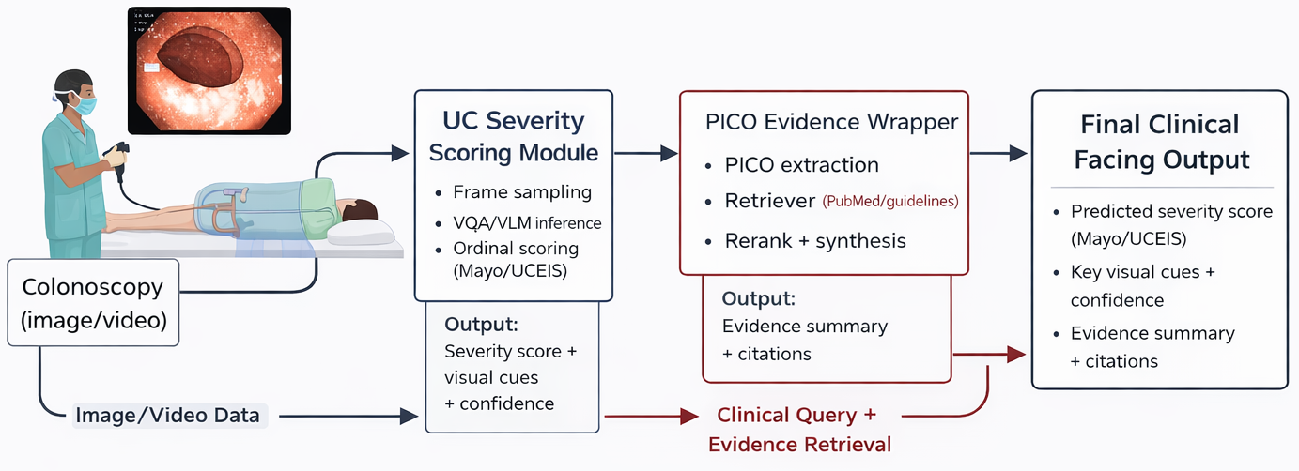
Figure 1.1 Conceptual Framework & System Flow
1.9.3 Figure 1.2: Data-to-Decision Funnel
Figure 1.2: Data-to-Decision Funnel.
Raw datasets -> curation and harmonization -> task families -> model families -> evaluation and failure analysis -> scenario validation -> decision-support readiness.
1.9.4 Figure 1.3: Research Design Map
Figure 1.3: Research Questions to Methods to Metrics to Outputs.
RQ layer
1. dataset/method layer
2. metric layer
3. scenario acceptance layer
1.9.6 Risk-Control Matrix
Risk | Failure example | Control strategy
Class imbalance | Severe UC under-detected | Cost-sensitive training, minority sampling, classwise monitoring
Lexical mismatch | Free text not mappable to clinical label space | Constrained decoding and lexical projection safeguards
Hallucination | Non-visible finding asserted | Visual-grounding checks, contradiction tests, abstain option
Overconfidence | High confidence on incorrect severe class | Calibration, thresholding, uncertainty-triggered escalation
Context gap | Image answer lacks decision context | Conditional retrieval-backed evidence layer
Table 1.7: Risk controls for GI MedVQA system design

1.10 Contributions Claimed in This Dissertation
At this stage, the dissertation claims the following contributions:
- A consolidated GI MedVQA evidence base across multiple datasets and task formulations using reproducible local artifacts [20]-[24].
- Empirical clarification that naive zero-shot VLM transfer is currently insufficient for dependable GI MedVQA performance in this repository setting.
- A severity-focused framing that aligns model evaluation with clinically meaningful endpoints, including macro-F1, balanced metrics, remission slices, and QWK in UC-oriented tasks.
- A scenario-driven evaluation framework that complements leaderboard metrics with clinically interpretable acceptance criteria.
- A concrete design pathway for integrating retrieval-augmented, evidence-aware answering as a controlled extension of visual-grounded VQA.
1.10.1 Contribution Boundaries
This dissertation does not claim immediate real-time clinical deployment readiness. The contributions are methodological, empirical, and design-oriented, and they establish the basis for subsequent translational validation.

1.11 Chapter-by-Chapter Summary
Chapter 1 (this chapter): establishes background, motivation, problem decomposition, research questions, conceptual framework, and contribution boundaries.
Chapter 2: provides a structured scoping review of MedVQA and GI endoscopy literature, with explicit gap extraction.
Chapter 3: investigates existing VQA techniques across GI-endoscopy datasets (HyperKvasir, Kvasir-VQA, Kvasir-VQA-x1, ImageCLEF MEDVQA-GI 2023, LIMUC, and supporting Kvasir-SEG analyses), including comparative and failure-mode analyses.
Chapter 4: develops the proposed dataset-model-RAG-fine-tuning pipeline with implementation detail.
Chapter 5: instantiates PICO-oriented and scenario-based use cases with objective-oriented prompt and evidence design.
Chapter 6: integrates experimental findings, scenario performance, and evidence-layer behavior into a consolidated discussion.
Chapter 7: synthesizes conclusions, revisits research questions, states limitations, and defines future work.

Surveying VQA Techniques in Medicine with application to Colonoscopy
2.0 Chapter 2 Overview
Chapter 2 provides the scoping-review backbone of the dissertation and establishes the evidence landscape that motivates the empirical work in Chapter 3. It documents the review design (objective, search window, source types, and inclusion/exclusion logic), then synthesizes how MedVQA has evolved from constrained discriminative pipelines to transformer and generative multimodal systems. The chapter narrows this broader trajectory to GI endoscopy by mapping key datasets, challenge tracks, and colonoscopy-relevant task regimes, with specific emphasis on reliability constraints such as class imbalance, lexical answer variability, and clinical-threshold sensitivity. It also compares technique families (discriminative, transformer-based, generative, explainable, and retrieval-aware) against scenario-level needs in colonoscopy decision support. To improve thesis traceability, the chapter triangulates external literature with internal repository evidence and ends with a structured gap map. These gaps are framed not as abstract research opportunities, but as concrete methodological requirements that directly determine how Chapter 3 is designed, what metrics are prioritized, and which claims are considered defensible.
At a glance, this chapter:
1. Defines a transparent scoping protocol and source-selection framework.
2. Summarizes the method and benchmark evolution of MedVQA.
3. Maps GI-colonoscopy datasets and challenge ecosystems to task needs.
4. Evaluates technique families against scenario-oriented clinical requirements.
5. Produces a gap-and-risk synthesis that directly drives Chapter 3 experiments.

The next chapter moves from literature synthesis to artifact-grounded empirical evaluation across GI-endoscopy datasets.

2.1 Introduction
Visual Question Answering (VQA) has evolved from a general computer-vision benchmark task into a clinically relevant multimodal research area. In medical VQA (MedVQA), a model must interpret medical imagery, parse a natural-language question, and generate an answer that is not only technically correct but also clinically meaningful. This imposes stricter requirements than general-domain VQA: stronger visual grounding, domain-aware language understanding, robustness under class imbalance, and error behavior that is safe under clinical risk [4].
For this dissertation, the focus is gastrointestinal (GI) endoscopy with an emphasis on colonoscopy use cases. This domain is clinically important and methodologically difficult. Colonoscopy frames contain artifacts, illumination variation, blur, occlusions by instruments, and subtle lesion morphology. Questions that appear simple in natural language (e.g., "Is there active inflammation?" or "What is the likely severity?") can require fine-grained perception and domain-specific interpretation.
The purpose of this chapter is to provide a rigorous survey that supports design choices in subsequent chapters. Specifically, this chapter:
- maps the historical evolution of MedVQA model families;
- reviews dataset and benchmark development, with GI-specific focus;
- compares technique families against colonoscopy scenario requirements;
- reviews evaluation practices and their limitations;
- identifies open gaps that directly motivate the methodology in Chapter 3, Chapter 4, and Chapter 5.
The chapter is written in the same formal style as the dissertation introduction and uses standard terminology from computer vision (CV), natural language processing (NLP), and multimodal learning.
2.1.1 Definitions and Notation Used in This Chapter

Term / Metric | Working meaning in this dissertation
MedVQA | Image-question-answer modeling in medical domains
Clinical MedVQA | MedVQA configured for decision support with safety constraints
VLM / MLLM | Vision-language model / multimodal large language model
MES / UCEIS / BBPS | Mayo Endoscopic Subscore / Ulcerative Colitis Endoscopic Index of Severity / Boston Bowel Preparation Scale
EM / macro-F1 | Exact match (string-level) / class-balanced F1 across labels
QWK | Quadratic weighted kappa for ordinal agreement (used in severity tasks)
ECE | Expected calibration error for probability-confidence alignment
Table 2.1. Working Definitions and Metric Notation
2.2 Scoping Review Design
2.2.1 Review Objective
This chapter follows a structured scoping-review approach rather than a strict systematic-review protocol. The objective is methodological coverage and decision support for thesis design, not exhaustive bibliometric counting. Sources were selected to cover:
- foundational MedVQA datasets and methods,
- modern multimodal large model directions,
- GI-specific benchmark and challenge resources,
- explainability and retrieval-grounding directions,
- and evaluation methodology relevant to clinical deployment.
2.2.2 Search Window and Source Types
The search window for this chapter is 2018 to early 2026.
Primary source types:
- peer-reviewed papers and data descriptors,
- official benchmark/challenge pages,
- official challenge overview papers and proceedings,
- and influential preprints where they define active benchmark directions.

Databases and discovery channels used in this scoping pass:
- PubMed / MEDLINE
- IEEE Xplore
- ACL Anthology
- arXiv
- challenge portals (ImageCLEF, MediaEval) and official dataset repositories
2.2.3 Query Themes
Theme | Example queries
General MedVQA foundations | medical visual question answering dataset, VQA-RAD, PathVQA, SLAKE
Modern model families | LLaVA-Med, Med-Flamingo, BLIP-2 medical VQA, medical LVLM benchmark
GI-specific resources | Kvasir-VQA, Kvasir-VQA-x1, ImageCLEF MEDVQA-GI, MediaEval Medico 2025
Evaluation and reliability | medical AI evaluation metrics, MedVQA robustness, hallucination medical VQA
Explainability and grounding | explainable medical VQA, multimodal explanation GI VQA, retrieval-augmented medical VQA
Table 2.2. Query Themes Used for the Scoping Review
2.2.4 Inclusion and Exclusion Logic
Type | Criteria
Inclusion | Primary technical work on MedVQA methods, datasets, benchmarks, or challenge design
Inclusion | GI/endoscopy resources directly usable for colonoscopy-oriented VQA analysis
Inclusion | Official benchmark/task pages and official challenge overview papers
Inclusion | Recent preprints with direct methodological or benchmark impact (explicitly marked as preprint where relevant)
Exclusion | Opinion pieces without technical evidence
Exclusion | Sources with no direct relation to visual-question answering in medicine
Exclusion | Tertiary summaries when primary sources were available
Table 2.3. Inclusion and Exclusion Criteria

2.2.5 Core Study Pool
The final chapter synthesis uses a curated pool of foundational and recent sources across datasets, models, evaluation, and challenge design. The resulting pool is intentionally broad enough to cover the field trajectory and narrow enough to remain actionable for thesis methodology.
For transparency, this chapter includes a PRISMA-ScR-style accounting reconstructed from the drafting log used for source triage.
Stage | Count
Records identified across sources | 236
Duplicates removed | 54
Records screened (title/abstract) | 182
Records excluded at screening | 96
Full-text records assessed | 86
Full-text records excluded | 45
Included in chapter synthesis (external) | 41

Exclusion reason | Count
Not MedVQA-specific (generic CV/NLP without QA task linkage) | 16
Limited clinical/GI relevance for this thesis scope | 11
Non-primary or tertiary source where primary source existed | 8
Insufficient methodological detail for comparative synthesis | 10

2.3 Evolution of VQA Methods: From General AI to Clinical MedVQA
The technical development of MedVQA follows, with delay, the broader VQA trajectory in AI.
2.3.1 Stage A: Early Discriminative Pipelines
Early VQA systems relied on CNN image encoders and RNN question encoders with shallow fusion. In these setups, the final task is usually answer classification from a fixed vocabulary. This structure is data-efficient and operationally stable for constrained question sets, but limited for open-ended clinical answers.
2.3.2 Stage B: Attention and Cross-Modal Transformers
Transformer-based multimodal architectures improved cross-modal alignment and reasoning depth. Two-stream and cross-attention approaches such as ViLBERT and LXMERT established a stronger pretraining paradigm for vision-language tasks [31], [32]. Large-scale contrastive pretraining (e.g., CLIP) then made transfer learning more scalable [33].
2.3.3 Stage C: Instruction-Tuned Generative Multimodal Models
Recent systems increasingly treat MedVQA as a generative task rather than fixed-label classification. The shift is visible in BLIP-2 style adaptation [34], LLaVA-style visual instruction tuning [35], and medical-domain variants such as LLaVA-Med [6] and Med-Flamingo [7]. Biomedical language pretraining backbones such as BioBERT and BioGPT [40], [41] are also important in this stage because they improve terminology fidelity and domain-specific language control in downstream medical QA systems.
The advantage is richer interaction and explanation-like output. The risk is that fluent generated text can become weakly grounded, lexically mismatched to benchmark labels, or clinically unsafe if not constrained.
2.3.4 Stage D: Reliability, Explainability, and Evidence Grounding
The current frontier moves beyond "answer generation" toward clinical trust requirements: grounding, calibration, interpretability, and evidence linkage. This includes benchmark-level work on probing reliability [11], multimodal in-context robustness [12], explainability frameworks [15], and retrieval-based methods in clinical VQA settings [30].
Dataset / Benchmark | Year | Reported scope | Why it matters
VQA-RAD [1] | 2018 | Clinician-authored radiology QA | Early high-quality clinician-driven MedVQA benchmark
PathVQA [2] | 2020 | Pathology QA from textbook/digital resources | Extended MedVQA to histopathology
SLAKE [3] | 2021 | Bilingual, semantically labeled medical QA | Added richer semantic structure and multilinguality
PMC-VQA [5] | 2023 | Large-scale visual instruction tuning corpus | Enabled modern generative MedVQA pipelines
OmniMedVQA [8] | 2024 | Large multi-dataset LVLM benchmark | Stress-tests generalization across modalities and anatomy
MedBookVQA [9] | 2025 | Textbook-derived multimodal benchmark | Structured benchmark for broad medical domains
MedFrameQA [10] | 2025 (rev. 2026) | Multi-image reasoning benchmark | Closer to real clinical workflow than single-image QA
Table 2.4. Foundational and Recent General MedVQA Resources
Resource | Year | Reported scale | Role in this thesis
HyperKvasir [16] | 2020 | 110,079 images + 374 videos | Core GI visual foundation and class diversity
Kvasir-Capsule [17] | 2021 | 117 videos, 4.7M+ frames, 47k+ labeled frames | Robustness and broader GI variability context
LIMUC [37] | 2022 | 11,276 UC images from 564 patients | UC severity and ordinal evaluation anchor
ImageCLEF MEDVQA-GI 2023 [22], [23] | 2023 | Multi-subtask GI VQA/VQG/VLQA benchmark | First major GI-specific VQA shared-task setup
Kvasir-VQA [18], [19] | 2024 | 6,500 images, 58,849 QA pairs | Main GI text-image pair benchmark
ImageCLEF MEDVQA-GI 2024 [24] | 2024 | Second-year challenge, synthesis-linked direction | Signaled task broadening around synthetic workflows
Kvasir-VQA-x1 [20], [21] | 2025 | 159,549 QA pairs with complexity levels and perturbations | Stronger reasoning and robustness benchmark
ImageCLEF MEDVQA 2025 [25] | 2025 | Third-year challenge with synthetic GI integration | Benchmark evolution toward real-synthetic design
MediaEval Medico 2025 [26], [27] | 2025 | GI VQA + multimodal explanation subtask | Explicit shift toward explainable clinical interaction
Table 2.5. GI Endoscopy Dataset Ecosystem Relevant to This Thesis
Across these resources, supervision and evaluation styles differ in ways that materially affect model interpretation. Kvasir-VQA and Kvasir-VQA-x1 primarily provide paired image-question-answer supervision with heterogeneous answer spaces (binary, count, attribute, and location), where lexical shortcuts and yes/no priors can inflate superficial performance [18], [20]. ImageCLEF and MediaEval tracks add challenge-level protocol constraints and broader metric bundles that include classification quality, overlap metrics, and explanation-oriented assessment [23], [26], [27]. For this thesis, these differences are treated as design constraints, not benchmark noise.
2.4.3 Challenge-Level Benchmark Progression
The GI challenge ecosystem has progressed quickly:
- 2023: introduced GI VQA/VQG/VLQA as a dedicated challenge design [22], [23];
- 2024: expanded into synthetic-image-oriented workflows [24];
- 2025: formalized VQA with synthetic-real integration at ImageCLEF [25] and explainable GI VQA at MediaEval [26], [27].
This progression matters because it changes what "state-of-the-art" means. The comparison target is no longer only answer correctness; it increasingly includes explanation quality, visual grounding, and clinical relevance.
2.4.4 UC Severity Automation Literature Bridge
UC severity automation has a substantial pre-VQA literature, and this background is essential for correct novelty positioning. Representative studies include deep learning grading against human review in JAMA Network Open [42], CAD-based endoscopic activity scoring in Gastroenterology [43], prospective multicentre CAD for inflammatory activity in Gastrointestinal Endoscopy [44], and recent MES/UCEIS-focused deep neural modeling in Journal of Crohn's and Colitis [45].
Study | Input type | Output target | Main contribution | Remaining limitation for this thesis
Stidham et al. [42] | Endoscopic images | Disease severity grade | Human-level comparative severity scoring analysis | Limited interactive QA and evidence-linked outputs
Ozawa et al. [43] | Colonoscopy images | Endoscopic disease activity | CAD feasibility for UC severity grading | Primarily fixed-score prediction interface
Yao et al. [44] | Multicentre colonoscopy data | Inflammatory activity | Prospective multicentre evaluation | Not structured around clinician question-answer workflows
Takenaka et al. [45] | Endoscopic images | MES/UCEIS predictions | Strong recent MES/UCEIS-oriented deep model validation | No retrieval-grounded management response layer
Table 2.6 A. Selected UC Severity Automation Studies (Pre-MedVQA Framing)

These studies show that AI-based UC scoring is feasible, but they do not directly resolve the MedVQA challenge targeted in this dissertation: combining robust severity estimation with controlled interactive reasoning and evidence-grounded response generation. Editorial and variability analyses reinforce this gap by highlighting persistent scoring heterogeneity and translational barriers [38], [39].

2.5 Survey of Technique Families
This section compares method families with specific attention to colonoscopy VQA requirements.
2.5.1 Rule-Based and Heuristic Logic
Rule-based systems encode expert logic through handcrafted criteria (e.g., color thresholds, morphology cues, manually defined score rules). Their strengths are transparency and deterministic behavior. Their weaknesses are brittleness under visual variability and poor scalability to open-ended language.
In colonoscopy, rule-based components can still be useful as auxiliary constraints (for quality filtering or post-hoc checks), but not as full MedVQA systems.
2.5.2 Discriminative CNN/RNN and Early Fusion Models
These pipelines encode image and question separately and perform fusion for closed-set prediction. They remain strong baselines for constrained yes/no or categorical tasks where label spaces are stable and deterministic output is preferred.
Limitations include weaker compositional reasoning and poor flexibility for long-form explanatory answers.
2.5.3 Transformer-Based Multimodal Fusion
Transformers improved image-question alignment and contextual reasoning through cross-attention. Pretrained multimodal encoders can be adapted to clinical VQA with improved sample efficiency relative to training from scratch.
In GI settings, this family often provides strong reliability on structured answer spaces, especially where question templates and answer ontologies are controlled.
2.5.4 Generative MLLM-Based MedVQA
Generative approaches output free-text answers and support richer interaction. Key drivers include instruction tuning and parameter-efficient adaptation. Representative medical systems include LLaVA-Med [6], Med-Flamingo [7], and instruction-tuned large-scale resources such as PMC-VQA [5].
Benefits:
- richer language output,
- support for rationale-like responses,
- easier integration with conversational interfaces.
Risks:
- hallucination,
- weak visual grounding,
- answer-format instability on closed-label evaluations,
- and clinically ambiguous verbosity.
2.5.5 Explainable and Grounded MedVQA
Explainability has moved from optional add-on to benchmark-level requirement in GI challenges [26], [27]. The goal is not only to answer but to justify and localize reasoning cues in ways clinicians can audit.
Recent work includes explicit multi-component explainability pipelines [15] and challenge systems combining QA, explanation generation, and localization [28].
2.5.6 Retrieval-Augmented and Evidence-Aware Methods
Retrieval augmentation is increasingly explored to ground answers in relevant examples or external evidence. Recent shared-task evidence in medical VQA (MEDIQA-WV 2025 overview and system reports) shows that retrieval-aware pipelines can improve schema adherence and answer usefulness when retrieval quality is explicitly controlled [29], [30].
For this thesis, retrieval is decomposed into three operational modes:
- Text-evidence retrieval: guidelines, review papers, and trial summaries for management-style questions.
- Case-based retrieval: nearest-neighbor retrieval of visually similar prior GI cases for comparability support.
- Hybrid multimodal retrieval: question intent + image cues used jointly to route evidence selection.
This decomposition directly supports the Chapter 5 PICO-oriented wrapper. The visual module first answers image-grounded questions (for example severity), then the evidence module maps management queries into PICO slots and retrieves citation-linked support before response synthesis.

For colonoscopy MedVQA, retrieval should therefore be treated as a controlled extension layer rather than a replacement for robust visual grounding.
2.5.7 Comparative Family-Level Synthesis

Family | Typical output mode | Key strengths | Main risks | Best-fit scenarios
Rule-based / heuristics | Deterministic labels/rules | Transparent, predictable | Brittle under visual variation | Narrow quality-control checks
CNN/RNN discriminative | Closed-set labels | Stable on constrained tasks, efficient | Limited compositional reasoning | Binary/attribute tasks with fixed ontology
Transformer fusion | Closed-set or short text | Strong image-question alignment | Data and tuning sensitivity | Multi-category constrained QA
Generative MLLM | Free text | Rich interaction and explanation potential | Hallucination, lexical drift | Narrative support with safeguards
Explainable MedVQA | Answer + rationale/grounding | Improves trust and auditability | Evaluation standardization still maturing | Clinician-facing decision support
Retrieval-augmented | Answer + retrieved evidence | Better factual anchoring in some settings | Retrieval error propagates to answer | Evidence-linked higher-level queries
Table 2.6. Technique Family Comparison for Colonoscopy MedVQA

2.6 Evaluation Practices in the Literature
A central finding of this survey is that evaluation practice is often the bottleneck, not only model architecture.
2.6.1 Classification Metrics vs Clinical Risk
Many MedVQA papers report accuracy and macro-F1. These are necessary but insufficient for clinical decision support. In imbalanced settings, aggregate metrics can obscure severe-class failure. This concern is consistent with broader medical-AI metric guidance that emphasizes task-risk alignment over single-score reporting [36].
2.6.2 Generative Metrics and Their Limits
BLEU, ROUGE, METEOR, CIDEr, ANLS, token-F1, and exact match are useful for text overlap but do not directly guarantee clinical correctness. A linguistically similar answer can still be clinically wrong.
2.6.3 Calibration, Uncertainty, and Significance
Clinical deployment requires uncertainty-aware behavior. Yet many papers omit calibration diagnostics (e.g., expected calibration error) and significance testing. This limits interpretability of reported gains and weakens translational confidence claims.
2.6.4 Challenge Metric Profiles
- ImageCLEF GI tracks include classification and segmentation-oriented metrics (e.g., accuracy/F1/MCC and region metrics where relevant) [22], [23].
- MediaEval Medico 2025 includes text-overlap metrics plus expert-assessed clinical relevance and explainability components [26], [27].
2.6.5 Recommended Metric Bundle for This Thesis
This thesis uses a multi-layer metric strategy:
- closed-set performance: accuracy, macro-F1, MCC, balanced accuracy;
- generative overlap (where applicable): BLEU/ROUGE/METEOR, token-F1/ANLS;
- severity-aware evaluation: QWK, remission sensitivity/specificity for UC slices;
- reliability diagnostics: confidence intervals, paired tests, calibration where available;
- scenario-level checks: high-risk error counts and acceptance criteria.

Metric family | Example metrics | Useful for | Known blind spot
Closed-set classification | Accuracy, macro-F1, MCC, kappa | Deterministic QA evaluation | Can hide minority severe-class failures if reported alone
Generative overlap | BLEU, ROUGE-L, METEOR, ANLS, token-F1 | Text quality comparison | Weak proxy for clinical correctness
Ordinal/severity | QWK, MAE/RMSE over ordinal labels | Severity grading behavior | Not reported consistently across papers
Calibration/uncertainty | ECE, reliability slices | Risk-aware deployment analysis | Still rare in MedVQA reporting
Statistical robustness | CIs, McNemar/paired tests | Claim stability and significance | Frequently missing in benchmark papers
Expert review / explainability | Clinician relevance ratings, grounding checks | Clinical usability and trust | Higher annotation effort, protocol variability
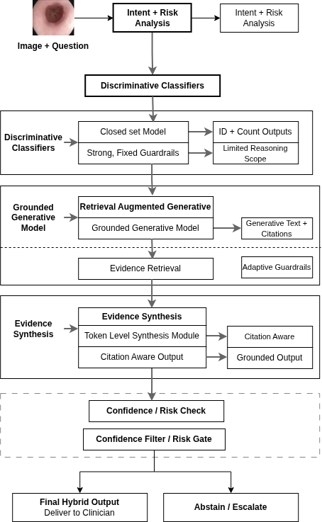
Figure 2.1: Hybrid Decision Support Routing Diagram

2.7 Scenario-Oriented Technique Suitability for Colonoscopy
A clinically useful survey should map model families to concrete clinical scenarios.
Colonoscopy scenario | Dominant question type | Preferred method profile | Reason
Finding presence/absence | Binary | Constrained discriminative or transformer classifier | Stable labels, high reliability requirements
Counting findings/instruments | Count + structured category | Transformer with constrained decoding | Better visual alignment than shallow fusion
Lesion location description | Spatial text/category | Transformer + localization-aware head | Requires spatial grounding consistency
UC severity grading | Ordinal category | Fine-tuned visual backbone + constrained QA interface | Ordinal robustness and severe-class control
Narrative explanation for clinician | Open text | Generative MLLM with grounding checks | Better usability, but must be constrained
Evidence-linked management query | Open text + evidence | Conditional retrieval-augmented generation | Useful only when core visual answer is reliable

2.8 2024-2026 Trends in MedVQA Research
Recent literature indicates several important shifts.
2.8.1 From Single-Image QA to Multi-Image Reasoning
MedFrameQA shows that multi-image clinical reasoning remains difficult for current MLLMs and exposes a gap between benchmark fluency and longitudinal diagnostic reasoning; notably, the benchmark received an updated arXiv revision in February 2026 [10].
2.8.2 From Benchmark Accuracy to Reliability Stress Testing
ProbMed-style probing demonstrates that high benchmark scores can hide brittle behavior under controlled perturbations [11]. SMMILE similarly highlights fragility in multimodal in-context learning [12].
2.8.3 Data-Centric Expansion and Synthetic Pipelines
New resources increasingly use automated or semi-automated pipelines to scale MedVQA data. This is seen in MedVLSynther-like generator-verifier approaches [13] and challenge tracks that explicitly integrate synthetic data [25].
2.8.4 Scaling Unified Medical VLMs
OmniV-Med and related work aim at unified multimodal medical understanding across 2D/3D/video settings [14]. These models are promising for broad capability, but consistent clinical robustness on specialized GI QA remains an open question.
2.8.5 Explainability as a First-Class Objective
GI challenge design in 2025 formalized explanation quality and clinical relevance as evaluation targets, not optional analysis [26], [27]. This marks a practical shift toward clinician-facing trust criteria.
2.9 Evidence Triangulation with Repository Results
To avoid a purely narrative survey, this section triangulates literature findings with local persisted artifacts.
Dataset/task (local report) | Representative local signal | Method implication
ImageCLEF MEDVQA-GI 2023 | ViLT fine-tune val accuracy 0.9089, macro-F1 0.5823; zero-shot Qwen raw near-zero accuracy | Closed-set tuned models remain stronger than raw zero-shot generation in this setting
HyperKvasir 23-class | ResNet50 supervised outperforms saved zero-shot generative baseline by large margin | Robust supervised visual encoders remain critical for GI grounding
Kvasir-VQA | ResNet+GRU yes/no subset reaches high reliability; free generation runs can collapse to unknown outputs | Constrained answer spaces remain highly effective for deterministic clinical sub-questions
Kvasir-VQA-x1 | LoRA improves token-level generative metrics; exact-match remains challenging | Reasoning-rich QA increases complexity; output normalization and grounding are central
LIMUC severity | Fine-tuned ResNet50 leads macro-F1 and QWK; zero-shot VLM underperforms severe-class reliability | UC severity tasks favor domain-tuned supervised pipelines with ordinal-aware evaluation
Table 2.9. Repository Evidence Snapshot and Method Implications
2.9.2 Interpretation
The local results align with broader literature:
- constrained/fine-tuned pipelines are still the reliability baseline in GI tasks;
- generative models provide flexibility but require strict controls;
- evaluation must emphasize classwise and severity-aware behavior, not only aggregate scores.
2.10 Key Gaps and Open Problems
2.10.1 Data and Annotation Gaps
- Severe-class and rare-finding imbalance remains substantial.
- Cross-center, cross-device robustness evidence is still limited for GI VQA.
- Multi-image/video QA is growing but still comparatively immature.
2.10.2 Model and Grounding Gaps
- Open-ended outputs often outpace grounding reliability.
- General-domain zero-shot transfer remains unstable for specialized GI semantics.
- Explainability outputs are not yet standardized across benchmarks.
2.10.3 Evaluation and Reproducibility Gaps
- Metric heterogeneity hinders fair cross-study comparison.
- Many studies still lack calibration and statistical confidence reporting.
- Clinical utility is often inferred indirectly from generic NLP overlap metrics.
2.10.4 Translational Gaps
- Few studies evaluate full clinician-in-the-loop workflows.
- Escalation policies for uncertain/high-risk outputs are seldom formalized.
- Evidence-aware QA in GI remains promising but early-stage.
2.10.5 Threats to Validity (for This Survey and Downstream Design)
The main validity threats relevant to this chapter are: (1) dataset shift across devices/centers and acquisition protocols, (2) annotation variability in endoscopic severity labels, (3) question ambiguity and answer-space normalization effects in generative settings, and (4) metric mismatch, where linguistic overlap does not guarantee clinical correctness. These threats are explicitly carried into the empirical design in later chapters through split-aware evaluation, classwise analysis, and scenario-level acceptance checks.

Observed gap | Mitigation in this dissertation
Long-tail severe-class weakness | Class-aware and severity-aware evaluation slices (Chapter 3, Chapter 4)
Zero-shot instability in GI | Strong supervised and constrained baselines before open generation extensions
Metric mismatch with clinical risk | Multi-layer evaluation protocol with ordinal and imbalance-aware metrics
Explainability without standard criteria | Scenario-specific explanation requirements and clinician-oriented quality checks
Weak evidence linkage | Conditional retrieval-augmented extension with guardrails
Table 2.10. Gap-to-Thesis Mitigation Map
2.11 Chapter Summary and Transition
This chapter surveyed MedVQA techniques with a colonoscopy-oriented lens and synthesized evidence from both external literature and local repository artifacts.
The main conclusions are:
- MedVQA has moved from fixed-label discriminative models toward generative and explainability-aware multimodal systems.
- GI benchmark resources have matured rapidly from 2023 onward, enabling more realistic evaluation.
- For high-risk colonoscopy scenarios, constrained and domain-tuned methods currently provide the most reliable core behavior.
- Generative and retrieval-enhanced methods are valuable extensions, but only when anchored by robust visual grounding and strict evaluation controls.
- Scenario-driven, clinically aligned evaluation is essential for translational relevance.
These conclusions motivate Chapter 3, which shifts from literature synthesis to empirical investigation of existing model families using the datasets and persisted outputs available in this repository.

Investigating Existing VQA Techniques Across GI-Endoscopy Datasets

3.1 Chapter Overview and Evaluation Goal
Chapter 2 surveyed medical VQA technique families and highlighted a central translational gap for GI endoscopy: strong benchmark scores do not automatically imply clinically reliable behavior, especially under class imbalance, domain shift, and high-consequence failure modes[56], [57]. Chapter 3 addresses that gap empirically by auditing persisted experimental artifacts available in this thesis repository and summarizing how model families behave under the dataset constraints that currently exist for colonoscopy-oriented MedVQA.
This chapter is designed as the empirical turning point of the dissertation. The guiding question is not only which model achieves higher aggregate scores, but which model behaviors remain reliable enough to be considered as building blocks for clinician-facing decision support. To answer that question, this chapter evaluates reliability across heterogeneous task regimes that occur in GI MedVQA: (i) closed-label prediction, (ii) open-ended generation, and (iii) ordinal severity assessment.
Chapter 3 overview (reader preview)
Across the datasets in this repository, the chapter provides a reproducible comparison of:
- constrained or supervised pipelines vs. raw zero-shot generative outputs,
- dataset- and question-family-specific failure modes (imbalance, format drift, mapping fragility), and
- severity-oriented reliability under ordinal and clinically meaningful slices (e.g., remission vs. non-remission).
Importantly, Chapter 3 is reproducibility-first: it reports outcomes only where persisted artifacts exist. Where only configuration or status files are present (e.g., scenario YAML definitions), the chapter reports configuration only and does not claim scenario-level performance[72].

Concretely, the objective is to determine, with traceable local evidence, how existing model families behave across:
- closed-set and binary clinical question answering,
- open-ended generative answering,
- severity-oriented ordinal assessment,
- class-imbalance stress conditions, and
- scenario-level stress-test protocol definitions for clinically relevant failure probing.
Unlike Chapter 2 (literature synthesis), Chapter 3 is artifact-driven: all results are compiled from saved outputs in the repository, not from newly run training or undocumented reruns[66] - [73]. Where a metric requires predictions that are not persisted, the metric is not reported.
This chapter serves three thesis-level functions:
- Establish a reproducible baseline of current GI MedVQA behavior before introducing new methods.
- Identify practical reliability bottlenecks (imbalance sensitivity, answer-format instability, lexical/OOV mapping fragility, and clinical threshold failures).
- Provide a defensible empirical bridge to Chapter 4, where controlled generative approaches are developed for clinically grounded UC severity rating and later extended toward evidence-aware answering.
Structurally, Section 3.1 defines evidence boundaries and research coverage, Section 3.2 formalizes datasets and model regimes, Section 3.3 specifies evaluation metrics and caveats, Section 3.4 presents dataset-wise results, and Section 3.5 synthesizes cross-dataset findings into thesis-level conclusions.

3.1.1 Evidence Boundary and Reproducibility Scope
Table 3.1 documents the provenance of all primary evidence used in this chapter. For each dataset block, the chapter’s results are compiled from the corresponding report file under the Prototyping_reformat/ tree and the associated persisted outputs referenced by that report[66] - [73].

Dataset / analysis block | Primary report file | Persisted artifact roots | Primary task style
HyperKvasir | Prototyping_reformat/DatasetAnalysis/HyperKvasir/HyperKvasir.md | Prototyping_reformat/DatasetAnalysis/HyperKvasir/**/out | 23-class visual classification
ImageCLEF MEDVQA-GI 2023 | Prototyping_reformat/DatasetAnalysis/ImageCLEF_MEDVQA_GI_2023/ImageCLEF_MEDVQA_GI_2023.md | Prototyping_reformat/DatasetAnalysis/ImageCLEF_MEDVQA_GI_2023/**/results | closed-label GI VQA
Kvasir-VQA | Prototyping_reformat/DatasetAnalysis/Kvasir_VQA/Kvasir_VQA.md | Prototyping_reformat/DatasetAnalysis/Kvasir_VQA/**/out | yes/no and attribute subsets
Kvasir-VQA-x1 | Prototyping_reformat/DatasetAnalysis/Kvasir_VQA_x1/Kvasir_VQA_x1.md | Prototyping_reformat/DatasetAnalysis/Kvasir_VQA_x1/**/results | large-scale generative + mapped closed-set
LIMUC | Prototyping_reformat/DatasetAnalysis/LIMUC/LIMUC.md | Prototyping_reformat/DatasetAnalysis/LIMUC/**/out | Mayo severity (ordinal 0-3)
Kvasir-SEG (supporting) | Prototyping_reformat/DatasetAnalysis/Kvasir_SEG/Kvasir_SEG.md | Prototyping_reformat/DatasetAnalysis/Kvasir_SEG/0_dataset_prep/** | morphology and mask statistics
Scenario protocol configuration | Prototyping_reformat/DatasetAnalysis/Kvasir_VQA/evaluation_comparison/scenarios/scenarios.yaml | Prototyping_reformat/DatasetAnalysis/Kvasir_VQA/evaluation_comparison/scenarios/ | micro-scenario stress-test definition (configuration only)
Legacy UC generative runtime snapshot (reformatted) | Prototyping_reformat/DatasetAnalysis/Kvasir_VQA/evaluation_comparison/phase3_results/summary_uc_phase3.csv | Prototyping_reformat/DatasetAnalysis/Kvasir_VQA/evaluation_comparison/phase3_results/*.csv | open-ended response artifact status
Table 3.1. Primary Evidence Sources Used in Chapter 3

Reproducibility rules used throughout Chapter 3
- No undocumented reruns: the chapter reports only what is present in persisted artifacts and their compiled report files.
- Report-first compilation: each dataset subsection in Section 3.4 is compiled from the dataset’s *.md report file first, then supported by any persisted visualizations or summary outputs referenced by that report.
- No fabricated comparisons: where a model’s predictions, labels, or scoring outputs are missing, the chapter does not infer or reconstruct results.
- Configuration-only evidence is treated as configuration: scenario YAML files are reported as protocol definitions, not as evaluated outcomes.
- Local-report cardinalities: dataset sizes shown in this chapter reflect the counts recorded in the local report artifacts and may differ from official dataset descriptor totals due to subset selection, filtering, or split definitions.
3.1.2 Research Questions Addressed in This Chapter
Chapter 3 provides empirical evidence relevant to the following research questions defined in Chapter 1:
- RQ2 (comparative reliability): Do constrained/discriminative pipelines remain more reliable than raw zero-shot generative outputs for current GI MedVQA tasks?
- RQ3 (failure modes): Which failure modes dominate across datasets and task styles (e.g., imbalance collapse, lexical drift, mapping fragility, question-family brittleness)?
- RQ4 (severity robustness): How reliably can models support UC severity-oriented question answering under ordinal structure and severe-class imbalance?
- RQ5 (clinical output format) – protocol support only: Chapter 3 includes scenario protocol definitions that inform later clinician-facing evaluation logic, but it does not report scenario outcome metrics unless scored predictions are persisted.
To keep the evidence boundary explicit, scenario-level conclusions are deferred when only scenario configuration is present.

Chapter 2 established the technique landscape (discriminative fusion models, transformer-based multimodal encoders, generative multimodal models, and retrieval-augmented directions) and emphasized that evaluation must be aligned with clinical risk[57], [58], [59]. Chapter 3 operationalizes that principle by evaluating model families using the datasets and artifact outputs available in this repository. The chapter therefore functions as the thesis’s empirical “reality check”: it identifies what is currently reliable under GI-specific constraints and what failure patterns must be addressed before introducing controlled generative and evidence-aware extensions in subsequent chapters.

3.2 Experimental Scenarios and Data Regimes
Section 3.2 defines the empirical scope: which datasets are evaluated, what task styles they represent, and which model families are compared. The aim is not to claim universal generalization across all GI settings, but to characterize reliability patterns within the available artifact evidence and across diverse task regimes (closed-label, generative, ordinal).

3.2.1 Dataset-Task Matrix
Table 3.2 summarizes the datasets included in Chapter 3 and the primary role each dataset plays in the evaluation. The “cardinality” values reflect the counts recorded in the local report files used for this chapter[66]-[70].
Dataset | Cardinality in local report | Core outputs | Main evaluation axis | Clinical relevance
HyperKvasir | 10,662 images, 23 classes | class labels | multiclass reliability under imbalance | broad GI visual grounding
ImageCLEF MEDVQA-GI 2023 | 36,683 QA rows (29,351 train, 7,332 val) | label IDs per question | per-question closed-label VQA reliability | benchmarked GI QA consistency
Kvasir-VQA | 58,849 QA rows, 6,500 images | yes/no, attributes, free text | subset reliability and format stability | colonoscopy QA behavior
Kvasir-VQA-x1 | 159,549 QA rows, 6,449 images | free-text answers + mapped labels | generative fidelity, complexity effects | robust MedVQA reasoning stress
LIMUC | 11,276 images, Mayo 0-3 | ordinal severity class | macro-F1, QWK, remission slice | UC treatment-aligned severity
Kvasir-SEG | 1,000 image-mask pairs | mask morphology stats | coverage/shape support metrics | future localization grounding
Table 3.2. Dataset and Task Matrix for Chapter 3 Experiments
Why these datasets are included
- Kvasir-VQA provides the most direct colonoscopy-oriented VQA evidence and is used to examine subset reliability and answer-format stability under common question families[52], [68].
- ImageCLEF MEDVQA-GI 2023 provides a standardized closed-label GI VQA setting where fine-tuned VQA models can be compared to zero-shot generative outputs under label constraints[54], [67].
- Kvasir-VQA-x1 provides a large-scale generative stress test, useful for studying overlap metrics, complexity effects, and label mapping fragility in free-text answers[53], [69].

- LIMUC anchors the thesis’s clinical flagship: UC severity, where ordinal structure and clinically meaningful slices (e.g., remission vs non-remission) are essential for interpretation[55], [70].
- HyperKvasir provides broad GI visual grounding with strong long-tail imbalance, allowing analysis of head–tail recall asymmetry that can be hidden by aggregate accuracy[51], [66].
- Kvasir-SEG is included as supporting evidence for morphology/localization-oriented statistics that later motivate grounding-aware directions; it is not treated as a primary VQA benchmark in this chapter[71].
3.2.2 Model Families Compared
The model comparisons in Chapter 3 reflect what is available as persisted artifacts rather than an exhaustive survey of all possible architectures. The goal is to compare representative families that span the major design choices relevant to clinical reliability: supervised classification, constrained VQA, and open-ended generation.
Family | Example persisted models | Typical answer mode
Supervised CNN/ViT classifiers | resnet50_supervised, vit_supervised, finetune_resnet50 | closed label
Frozen encoder + shallow classifier | vit_frozen_logreg, clip_linear_baseline, resnet50_frozen_logreg | closed label
Classical multimodal fusion | resnet_gru_m1_*, vit_bertlite_m2_* | closed set
Transformer VQA fine-tuned | vilt_finetune | closed label per question
Zero-shot VLM/MLLM | qwen2_5_vl_zeroshot, medgemma_zeroshot, blip2_zero_shot | free text (optionally projected)
Parameter-efficient adaptation | medgemma_lora_original, qwen2_5_vl_lora_finetune (logs persisted) | free text
Table 3.3. Representative Model Families in Persisted Artifacts
Interpretation guide
- Closed-label families (supervised or shallow classifiers) provide a reliability baseline where output space is controlled and evaluation is deterministic.
- Classical fusion and transformer VQA models represent structured MedVQA pipelines designed to combine image and question representations under a constrained output space.
- Zero-shot VLM/MLLM models represent open-ended generation, which may be more flexible but can be unstable in output format and lexical grounding.
- Parameter-efficient adaptation captures whether lightweight fine-tuning improves generative fidelity without requiring full retraining.
Section 3.3 defines the metric bundles used to compare these families and clarifies how raw vs projected scoring is treated when free text must be mapped to a constrained answer space.
3.2.3 Data Profile Figures (Kvasir-VQA)
Before presenting results, the chapter includes Kvasir-VQA profiling figures because they explain several behaviors observed later in Section 3.4, particularly the dominance of yes/no questions and the presence of template skew. These distributional properties can inflate superficial performance on majority question types while masking failure on rarer but clinically important categories[68], [74]-[76].
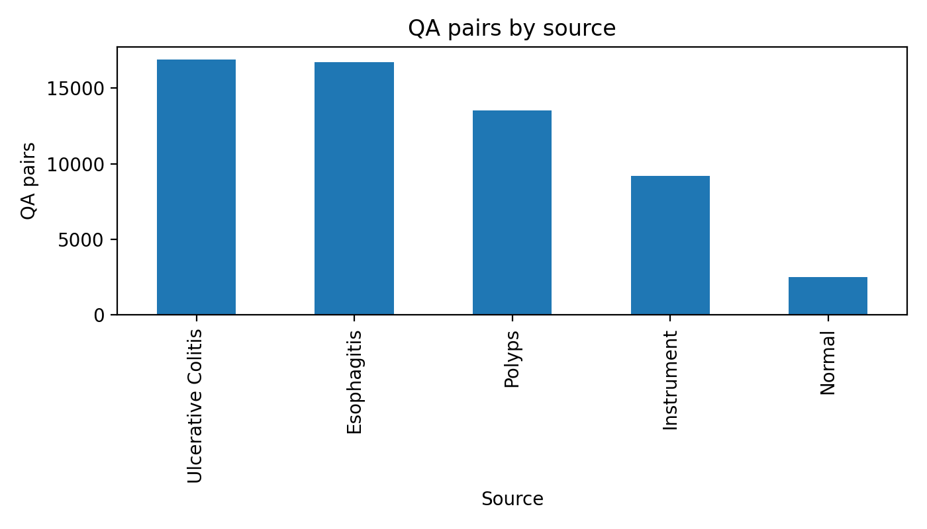
Figure 3.1 QA count by source domain
Figure 3.1 summarizes how QA pairs are distributed across source domains in the Kvasir-VQA preparation artifacts[74]. Source-domain imbalance implies that model performance may reflect dominant sources disproportionately, and it motivates later per-family and per-task reporting rather than single aggregate scores.

Figure 3.2 QA count by type distribution
The distribution shows that yes/no questions form a large share of Kvasir-VQA[75]. This creates a majority-family regime where models can perform strongly by exploiting priors, and it motivates the use of balanced metrics and subset-level reporting to avoid overstating reliability.
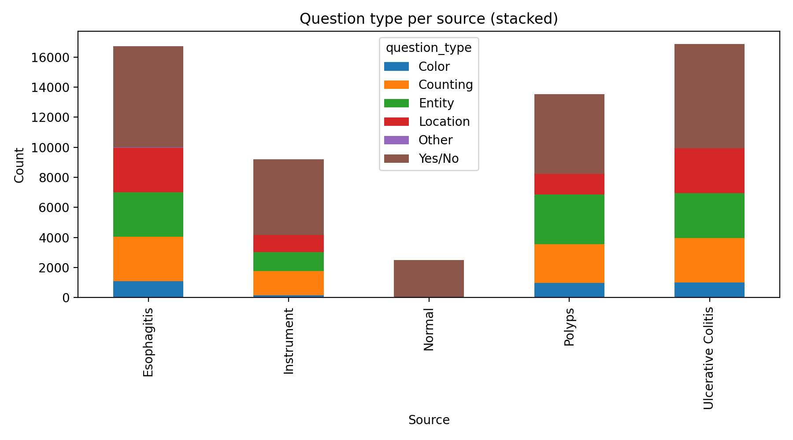
Figure 3.3 Question type by source
Question-type composition varies by source domain, indicating that the dataset is not homogeneous across origins[74]. This supports the chapter’s emphasis on failure-mode analysis and warns against interpreting a single “overall” score as uniformly applicable across question families.
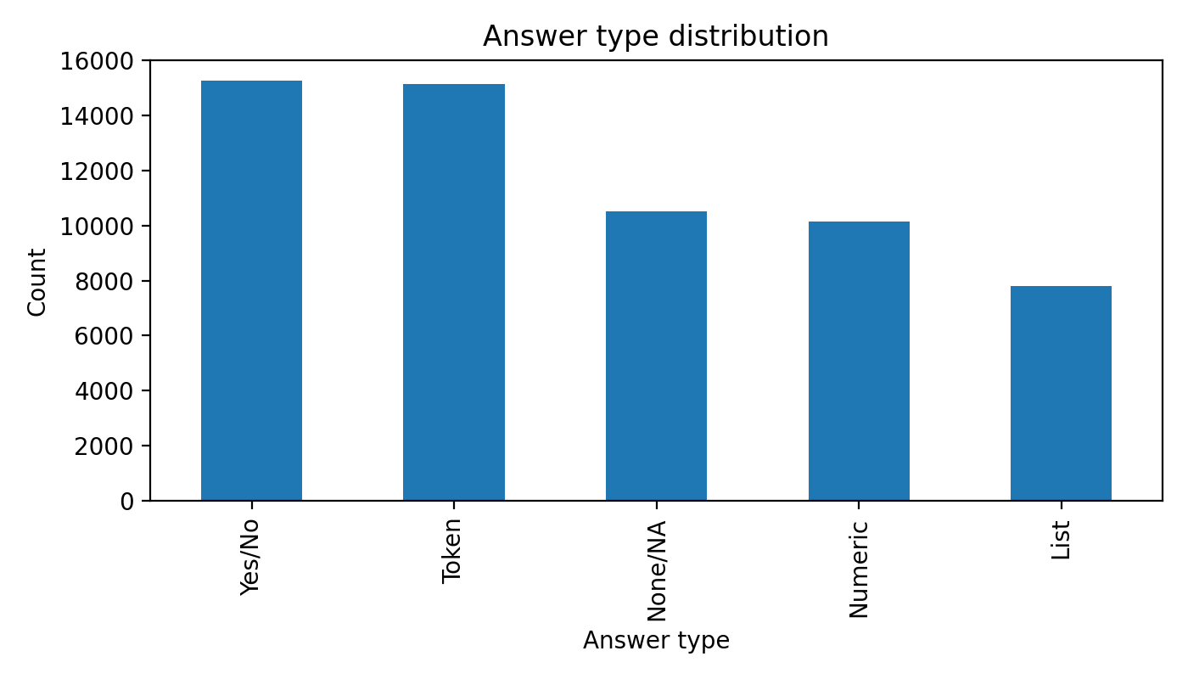
Figure 3.4 Answer type distribution
The answer-type distribution highlights why evaluation must be matched to task style: exact-match metrics are natural for constrained outputs but can be overly harsh for free-text generation, where token-level overlap diagnostics may be more informative[76]. This motivates the layered metric design defined in Section 3.3.
Signal | Value
Total QA rows | 58,849
Unique images | 6,500
Mean QA rows per image | 9.05
Yes/No questions | 26,515 (45.06%)
Entity questions | 10,528 (17.89%)
Counting questions | 10,118 (17.19%)
Location questions | 8,424 (14.31%)
Table 3.4 Kvasir-VQA Distribution Snapshot
The strong question-family skew supports two design choices used throughout Chapter 3: (i) report class-balanced or family-aware metrics where possible, and (ii) interpret aggregate scores cautiously, because strong performance on a dominant family (e.g., yes/no) does not guarantee reliable behavior on count, location, or clinically higher-risk categories.
3.2.4 Scenario Micro-Benchmark Definition
To connect benchmark evaluation to realistic clinical vignettes, the repository includes a micro-scenario protocol definition.
The protocol defines three focused scenario templates:
- S1: active bleeding binary detection,
- S2: instrument type plus polyp count,
- S3: Paris morphology closed set.
These scenarios are intentionally small and are treated as stress vignettes, not as statistical benchmark replacements. Only scenario configuration is persisted in the reformatted evidence tree; scored scenario predictions are not persisted[72]. Therefore, Chapter 3 reports scenario definitions as protocol context only and does not report scenario outcome metrics in the absence of scored artifacts.
3.2.5 Alignment with Prior Dissertation Problem Settings
The dataset and task choices in Chapter 3 are designed to align with common GI-endoscopy AI concerns while focusing on MedVQA-specific reliability:
- Severity and treatment relevance are represented by LIMUC, where ordinal behavior and clinically interpretable slices are necessary for credible UC severity assessment[55], [62]-[65], [70].
- Robustness under heterogeneity is addressed by including multiple datasets with different answer spaces and task formulations, enabling cross-dataset comparison of failure patterns rather than optimizing for a single benchmark.
- Transparency of model behavior is operationalized by reporting not only aggregate metrics but also imbalance-aware indicators, question-family slices, and explicit boundaries where evidence is unavailable.
This chapter does not attempt to replace established GI work on detection, segmentation, or video-level robustness. Instead, it complements that literature by adding a dedicated empirical layer for question-answer reliability, which is a prerequisite for interactive, clinician-facing MedVQA systems.
3.3 Evaluation Metrics and Statistical Protocol
This chapter compares model families across heterogeneous GI MedVQA task regimes. Because these regimes differ in answer format (fixed labels vs free text) and label structure (nominal vs ordinal), no single metric adequately captures reliability. Chapter 3 therefore uses a layered metric bundle and a conservative reporting protocol: point estimates are reported only when corresponding persisted predictions and evaluation outputs exist, and comparative claims are bounded to the evidence available in the persisted artifacts[56].
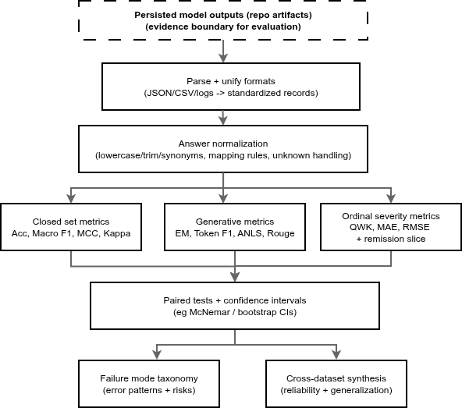
Figure 3.5 — Artifact-driven benchmarking workflow
3.3.1 Metric Layers
To avoid single-metric bias, Chapter 3 uses four metric layers depending on task style and clinical risk profile.
(A) Closed-set classification and constrained QA
These metrics are used when outputs are categorical and the answer space is controlled (e.g., HyperKvasir class labels, ImageCLEF label IDs, constrained Kvasir-VQA subsets).
- Accuracy: overall fraction of correct predictions.
- Macro-F1: unweighted mean of per-class F1, emphasizing minority-class behavior.
- Balanced accuracy: mean of per-class recall (equally weights classes regardless of support).
- MCC (Matthews correlation coefficient): correlation-style score robust under imbalance (reported where available in persisted outputs).
- Cohen’s kappa: agreement measure corrected for chance (reported where available in persisted outputs).
- Imbalance diagnostics (where included in artifacts): head–tail or rare–common recall gaps computed from classwise recall slices (e.g., thresholds defined in the dataset’s local report).
(B) Generative overlap and format fidelity (free-text outputs)
These are used when models generate natural language answers rather than selecting from a fixed ontology. In this chapter they are treated as diagnostic fidelity indicators, not as sufficient evidence of clinical correctness[57], [60], [61].
- Exact match (EM): strict string-level match under the normalization used by the local evaluation scripts.

- Token-F1: token-level overlap between generated and reference answers, useful when exact match is too strict.
- ANLS: edit-distance-based similarity score used in VQA-style evaluation; implementation details follow the persisted evaluation outputs and scripts used to produce the repository artifacts.
- BLEU / ROUGE-L / METEOR (where available): standard NLG overlap metrics reported only when computed in the persisted artifacts.
(C) Ordinal severity and clinically meaningful slices (UC severity as flagship use case)
These metrics are used when labels have an ordinal relationship (e.g., Mayo 0–3) and when the clinical decision boundary matters more than overall accuracy.
- QWK (quadratic weighted kappa): penalizes ordinal disagreements proportionally to distance (e.g., confusing 0↔1 is not equivalent to 0↔3).
- MAE / RMSE: absolute and squared error over ordinal labels treated as numeric.
- Spearman correlation (where available): rank correlation for ordinal consistency.
- Clinical remission slice: a thresholded binary evaluation derived from ordinal severity labels (in LIMUC artifacts, remission is evaluated as Mayo 0–1 vs 2–3, as indicated in the corresponding table caption).
(D) Uncertainty and comparative significance diagnostics (paired predictions only)
To avoid overinterpreting small point-estimate differences, Chapter 3 uses statistical diagnostics only when paired predictions are persisted for the same evaluation set.
- Wilson confidence intervals: used for proportions (e.g., accuracy) when included in the report outputs.
- Paired McNemar test: used for paired comparison of two classifiers on the same examples; reported only where persisted counts (n01, n10) and p-values exist in the artifacts.

Scenario type | Primary metrics | Why these metrics
Binary clinical detection | recall/sensitivity, macro-F1, MCC | false negatives and imbalance sensitivity
Multiclass closed-set QA | accuracy + macro-F1 + balanced accuracy | aggregate plus per-class fairness
Free-text QA | token-F1 + ANLS + overlap metrics | lexical similarity with tolerance to paraphrase
Ordinal severity | QWK + MAE/RMSE + remission slice | ordinal penalty and clinical thresholding
Model comparison claims | McNemar + CIs | avoids overinterpreting point estimates
Table 3.5 Metric Selection by Scenario Type
Throughout Chapter 3, N denotes the number of evaluated items recorded in the local report (images or QA rows). Metrics are interpreted primarily within-dataset because answer spaces and task definitions differ across datasets.
3.3.2 Important Evaluation Caveats
This chapter’s evaluation design is intentionally conservative. The following caveats define how results should be interpreted and what is not claimed.
- Cross-dataset scores are not directly comparable. Different datasets implement different answer spaces, label ontologies, and question-family distributions. Therefore, Chapter 3 uses cross-dataset comparison mainly to identify consistent patterns of failure modes, not to rank models globally.
- Generative overlap is not clinical correctness. Metrics such as token-F1, ANLS, BLEU, ROUGE-L, and METEOR quantify lexical similarity and answer-format adherence. They do not guarantee that generated text is clinically faithful or visually grounded[57], [60], [61]. In this chapter, generative overlap metrics are treated as diagnostic indicators and interpreted alongside failure signals (unknown/OOV behavior, mapping fragility, and question-family brittleness).
- Raw vs. projected scoring is explicitly separated (diagnostic only). Some persisted artifacts include both “raw” scoring of generated outputs and a secondary “projected” diagnostic that maps free text into a constrained answer space before scoring. This chapter follows the artifact semantics:
  - Raw scoring reflects direct evaluation against canonical targets under the local evaluation convention; for many label-ID tasks, raw free-text outputs can collapse to near-zero label accuracy because the output is not in the canonical label format.
  - Projected scoring deterministically maps generated text to the allowed answer set (e.g., canonical labels for a question family) using the repository’s evaluation logic, then scores the mapped label.
  - Unknown/OOV handling: if an output cannot be mapped to the allowed answer set, it is treated as unknown/OOV for that diagnostic and contributes to unknown/OOV rates where reported.
Interpretation rule: projected scores are used to quantify format and ontology alignment under deterministic mapping; they are not treated as a replacement for primary reliability evidence.
- Scenario results are not claimed without persisted scenario predictions. Scenario YAML definitions are included as protocol context, but scenario outcome metrics are reported only if scored predictions are persisted. If only configuration is present, Chapter 3 reports configuration only and defers scenario outcomes.
- Statistical tests are reported only where paired predictions exist. McNemar tests and confidence intervals require paired predictions for the same examples. Where the persisted artifacts include these counts and p-values, Chapter 3 reports them. Where they are not present, Chapter 3 reports point estimates without significance claims.
- Missing metrics are treated as “not computed,” not “zero.” If a metric is not applicable or not computed in the persisted evaluation outputs (e.g., BLEU/ROUGE absent for some runs), the chapter reports it as unavailable and does not infer values.
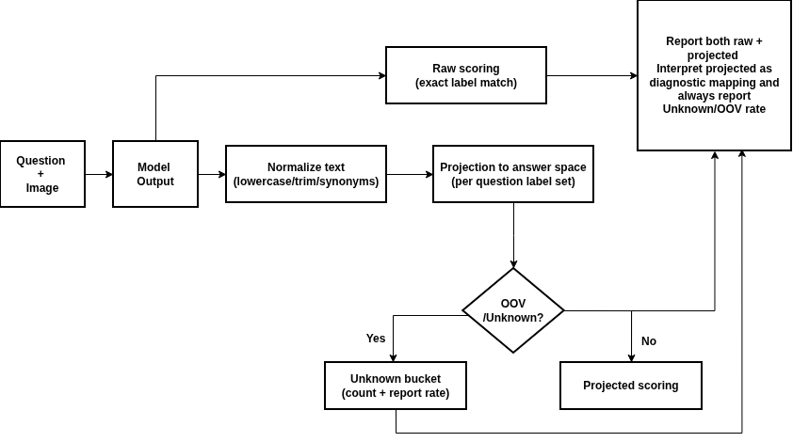
Figure 3.6 — Label projection / answer normalization pipeline (raw vs projected + unknown/OOV)
3.3.3 Metric Design Choices Grounded in Prior Work
The metric stack in this chapter follows a common principle in clinical AI evaluation: performance should be characterized using both aggregate discrimination and robustness under imbalance and clinically relevant thresholds, rather than relying on a single headline score[56].
For GI endoscopy tasks, this implies:
- macro-F1 and balanced accuracy are emphasized to prevent majority-class dominance from masking clinically relevant failures;
- MCC and kappa are reported where available because they capture agreement behavior under imbalance;
- ordinal metrics and clinical slices (QWK, MAE/RMSE, and remission-style thresholds) are required for UC severity tasks where the distance between grades and the decision boundary are clinically meaningful.

For generative tracks, overlap metrics are retained as format and lexical-fidelity diagnostics, but they are not treated as sufficient endpoints for clinical reliability. Where projection/mapping diagnostics are available, they are reported explicitly as diagnostics to quantify ontology alignment and unknown/OOV behavior.
Finally, comparative statistics (e.g., McNemar) are used as safeguards against overinterpreting small differences, but only where paired evidence is persisted. The chapter therefore prioritizes traceable, artifact-backed reporting over completeness of metric coverage.
3.4 Baseline and Existing-Model Results
Section 3.4 reports dataset-wise results compiled from persisted artifacts described in Table 3.1[66]-[73]. Because each dataset defines different answer spaces (class labels, label IDs per question, or free-text answers) and different task regimes (classification, closed-label VQA, subset QA), results are interpreted primarily within each dataset. Cross-dataset comparisons are used to identify consistent reliability patterns (e.g., imbalance sensitivity, answer-format instability), rather than to produce a single global ranking.
Each dataset subsection follows a consistent structure: (i) role of the dataset in the thesis evaluation design, (ii) which model families are compared and why, (iii) interpretation of the reported tables (overall metrics, robustness slices, and where available paired diagnostics), and (iv) limitations and implications for subsequent chapters.
3.4.1 HyperKvasir: 23-Class GI Image Classification
Although HyperKvasir is not a VQA dataset, it provides an important visual grounding stress test for GI imaging[51], [66]. The task here is 23-class GI image classification, which functions as a proxy for how well different visual backbones and representations capture GI categories under realistic data constraints. The key difficulty is strong long-tail imbalance: in the persisted report, test-set class support ranges from 1 to 115 per class (≈115× ratio), meaning that a model can achieve high aggregate accuracy while still failing on rare classes that may be clinically important.
Table 3.6 summarizes overall test performance for supervised and frozen-feature baselines, alongside a zero-shot VLM baseline projected into a label space (as recorded in the persisted artifact outputs).

Model | Accuracy | Balanced Acc | Macro-F1 | MCC | Kappa
resnet50_supervised | 0.8789 | 0.6266 | 0.5943 | NA | NA
vit_supervised | 0.8714 | 0.5391 | 0.5242 | NA | NA
vit_frozen_logreg | 0.8620 | 0.6130 | 0.6052 | 0.8505 | 0.8504
clip_linear | 0.8620 | 0.5799 | 0.5721 | 0.8503 | 0.8503
blip2_zero_shot_clip | 0.0638 | 0.0529 | 0.0254 | 0.0386 | 0.0303
Table 3.6 HyperKvasir Overall Test Metrics
Table 3.6 summarizes overall test performance for supervised and frozen-feature baselines, alongside a zero-shot VLM baseline projected into a label space (as recorded in the persisted artifact outputs).
The supervised and frozen-feature pipelines form a strong reliability baseline on aggregate metrics, while the zero-shot VLM baseline performs poorly on this closed-label classification setting. However, aggregate metrics alone are insufficient in a long-tail regime. In particular, balanced accuracy and macro-F1 are emphasized here because they weight minority classes more fairly than raw accuracy.
To quantify long-tail robustness explicitly, Table 3.7 reports rare-class and common-class recall slices (as defined in the persisted report), along with a head–tail recall gap.
Model | Rare-class recall (support <= 5) | Common-class recall (support >= 90) | Common-minus-rare gap
resnet50_supervised | 0.1595 | 0.9375 | 0.7779
vit_supervised | 0.0000 | 0.9432 | 0.9432
vit_frozen_logreg | 0.1714 | 0.9120 | 0.7406
clip_linear | 0.0476 | 0.9091 | 0.8615
blip2_zero_shot_clip | 0.0000 | 0.0471 | 0.0471
Table 3.7 HyperKvasir Imbalance Robustness Slices
All high-accuracy models exhibit substantial head–tail asymmetry: common-class recall is high while rare-class recall remains low. Notably, some models achieve strong common-class recall while still scoring near zero on rare-class recall, illustrating why long-tail evaluation slices are required for risk-aware interpretation. This result motivates later chapters to treat minority-class behavior as a first-class reliability requirement, rather than assuming that high overall accuracy implies safe performance.
Where paired predictions are available in the artifacts, Table 3.8 reports selected McNemar tests to assess whether differences between model variants are likely to be noise-level fluctuations on the same test examples.

Pair | n01 (A wrong, B right) | n10 (A right, B wrong) | p-value
vit_frozen_logreg vs clip_linear | 68 | 68 | 0.931666
vit_frozen_logreg vs blip2_zero_shot_clip | 21 | 871 | < 1e-6
clip_linear vs blip2_zero_shot_clip | 19 | 869 | < 1e-6
Table 3.8 HyperKvasir Pairwise McNemar Tests
In the persisted paired comparisons, vit_frozen_logreg and clip_linear show no meaningful difference (symmetric disagreement counts and high p-value), while both are strongly separated from the zero-shot baseline (highly asymmetric disagreement counts and very small p-values). These tests support the qualitative conclusion already visible in Table 3.6: within this dataset and evidence scope, supervised/frozen discriminative pipelines dominate the zero-shot baseline.
Limitations and implications. HyperKvasir is used here as a GI visual grounding stress test rather than a direct VQA benchmark. Therefore, its primary value is diagnostic: it demonstrates that (i) strong aggregate performance can coexist with poor rare-class recall, and (ii) reliable GI perception under long-tail imbalance remains a bottleneck that must be monitored explicitly. This motivates later chapters to preserve strong visual grounding components and to treat class-imbalance mitigation as necessary for clinically aligned behavior.
3.4.2 ImageCLEF MEDVQA-GI 2023: Closed-Label GI VQA
ImageCLEF MEDVQA-GI 2023 provides a closed-label VQA setting in which each question is associated with a constrained answer ID space[54], [67]. This enables deterministic evaluation and is well-suited for testing the thesis’s core reliability question: how do fine-tuned multimodal VQA models compare to raw zero-shot generative VLM outputs under label constraints? In this chapter, evaluation is reported for the persisted validation split (N = 7,332) recorded in the local report artifacts.
Table 3.9 reports overall validation metrics for a fine-tuned transformer VQA model and two zero-shot variants: “raw” (direct outputs) and “projected” (diagnostic mapping of outputs into the allowed answer space, as defined in Section 3.3).

Model variant | N | Accuracy | Balanced Acc | Macro-F1 | MCC | Kappa
vilt_finetune | 7,332 | 0.9089 | 0.5853 | 0.5823 | 0.8876 | 0.8875
qwen2_5_vl_zeroshot_raw | 7,332 | 0.0007 | 0.0433 | 0.0007 | -0.0696 | -0.0626
qwen2_5_vl_zeroshot_projected | 7,332 | 0.0670 | 0.0899 | 0.0379 | -0.0296 | -0.0278
Table 3.9 ImageCLEF MEDVQA-GI 2023 Validation Metrics
The fine-tuned VQA model exhibits strong closed-label accuracy, while the raw zero-shot generative outputs score near zero under the label-ID evaluation format. Projection improves the zero-shot diagnostic score, indicating that some generated outputs can be mapped into the label space, but the projected accuracy and macro-F1 remain far below the fine-tuned baseline. The negative MCC/kappa values for the zero-shot variants are consistent with systematic mismatch under the constrained label-ID evaluation format, rather than random variation.
To avoid hiding question-family brittleness, Table 3.10 reports family-level aggregates. This is important because some families (e.g., procedure or attribute) may require stricter ontology adherence than others.
Question family | Rows | ViLT acc | Qwen raw acc | Qwen projected acc | ViLT macro-F1 | Qwen projected macro-F1
attribute | 1,600 | 0.8488 | 0.0000 | 0.0225 | 0.5153 | 0.0340
binary/boolean | 2,800 | 0.9339 | 0.0004 | 0.1168 | 0.9222 | 0.0906
count | 1,200 | 0.9008 | 0.0017 | 0.0400 | 0.3950 | 0.0158
location | 1,332 | 0.9092 | 0.0015 | 0.0601 | 0.3115 | 0.0205
procedure | 400 | 0.9975 | 0.0000 | 0.0000 | 0.9969 | 0.0000
Table 3.10 Family-Level Aggregates on ImageCLEF Validation
Two patterns are visible. First, the fine-tuned model remains consistently strong across families in accuracy terms, but macro-F1 varies substantially across families (notably count/location), indicating that even strong aggregate accuracy can conceal intra-family imbalance or difficulty. Second, the zero-shot model’s raw outputs perform near zero across families, and projection yields partial recovery mainly for binary/boolean questions, with minimal gains for attribute, count, and location and no recovery for the procedure family in the persisted artifacts. This indicates that projection can rescue some format mismatch, but it does not resolve the core reliability gap under structured families.
To illustrate where projection helps most, Table 3.11 lists the questions with the largest raw→projected accuracy gains in the persisted validation outputs.

Question | Raw acc | Projected acc | Absolute gain
Is there a green/black box artefact? | 0.0000 | 0.5475 | +0.5475
Are there any instruments in the image? | 0.0000 | 0.1800 | +0.1800
Where in the image is the abnormality? | 0.0000 | 0.1400 | +0.1400
What color is the abnormality? | 0.0000 | 0.0800 | +0.0800
How many polyps are in the image? | 0.0025 | 0.0600 | +0.0575
Table 3.11. Largest Qwen Lexical-Projection Gains (Validation Accuracy)
These examples show that deterministic mapping can substantially improve measurable label accuracy for specific prompts, suggesting that the raw outputs sometimes contain recoverable information that is not expressed in the expected label form. However, as emphasized in Section 3.3, projection remains a diagnostic and can overestimate correctness when matches are shallow or purely lexical. The key reliability result for this chapter is therefore the persistent gap in Table 3.9 and Table 3.10: even after projection, zero-shot outputs remain far below a fine-tuned closed-label baseline across major question families.
Limitations and implications. This subsection compares a fine-tuned transformer baseline to one zero-shot model under the persisted evaluation configuration. It does not claim universal generalization to all VLMs or all GI datasets. Moreover, because paired statistical tests are not reported for this dataset in the included tables, this chapter avoids “significance” wording here and interprets differences as large observed gaps under the available evidence. The practical implication is that for label-ID GI VQA settings, reliable performance requires answer-space governance (constrained decoding, ontology compliance) and likely supervision or adaptation; these conclusions motivate the controlled generative design decisions introduced in Chapter 4.
3.4.3 Kvasir-VQA: Subset Reliability and Answer-Format Stability
Kvasir-VQA is a colonoscopy-oriented VQA resource and is central to the supervisor-directed empirical pathway for this dissertation[52], [68]. The persisted artifacts available for this chapter include (i) structured subset evaluations for yes/no and attribute-style questions and (ii) a reformatted phase-3 generative snapshot intended to capture runtime status[73]. This subsection focuses on two reliability themes relevant to GI MedVQA: (1) how strong constrained/fusion pipelines can be on structured question families, and (2) how fragile unconstrained generation can become when output format is not governed.

Model | N | Accuracy | Balanced Acc | Macro-F1 | MCC | Unknown rate
resnet_gru_m1_yesno | 443 | 0.986456 | 0.973673 | 0.964953 | 0.930163 | 0.0000
vit_bertlite_m2_yesno | 443 | 0.950339 | 0.906593 | 0.878126 | 0.759432 | 0.0000
blip2_zeroshot_yesno | 443 | 0.893905 | 0.509376 | 0.492332 | 0.086138 | 0.0000
blip_vqa_base_yesno_forced_choice | 12,267 | 0.518301 | 0.514587 | 0.502888 | 0.030894 | 0.0000
blip_vqa_base_yesno_freegen | 500 | 0.000000 | NA | 0.000000 | NA | 1.0000
Table 3.12 Kvasir-VQA Yes/No Results
Two distinct patterns appear. First, constrained fusion models (resnet_gru_m1_yesno, vit_bertlite_m2_yesno) achieve high accuracy and high balanced metrics on this persisted subset, indicating that structured yes/no questions can be handled reliably when the output space is controlled. Second, the zero-shot model (blip2_zeroshot_yesno) achieves high accuracy but near-chance balanced accuracy and low MCC, which is consistent with majority-class bias in an imbalanced yes/no distribution—an example of why macro-F1, balanced accuracy, and MCC are necessary complements to raw accuracy. Finally, the free-generation variant (blip_vqa_base_yesno_freegen) collapses under this evaluation format with unknown-rate = 1.0, indicating complete answer-format noncompliance under the persisted scoring rules.
Table 3.13 reports results for an attribute subset, which is more challenging than yes/no because it typically expands the answer vocabulary and increases ambiguity.

Model | N | Accuracy | Balanced Acc | Macro-F1
resnet_gru_m1_attribute | 352 | 0.670455 | 0.376936 | 0.367341
vit_bertlite_m2_attribute | 352 | 0.656250 | 0.374696 | 0.355586
Table 3.13 Kvasir-VQA Attribute Subset
While accuracy remains moderate, balanced accuracy and macro-F1 are substantially lower, indicating that the attribute subset exhibits stronger imbalance and/or class confusability than the yes/no subset. This aligns with the broader reliability view adopted in this dissertation: even when constrained pipelines perform strongly on a dominant family (yes/no), harder families can remain bottlenecks and require separate analysis rather than extrapolation from the easiest subset.
This subsection reports subset-level evidence rather than a full Kvasir-VQA benchmark sweep. The yes/no subset (N=443) and the larger forced-choice evaluation (N=12,267) are not directly comparable as a controlled experiment because they differ in evaluation set size and possibly in subset construction. Nevertheless, the reliability message is consistent across the persisted artifacts: (i) constrained/fusion pipelines can be very strong on structured subsets, and (ii) unconstrained generation can collapse under closed-label evaluation due to answer-format instability. These results motivate the design stance used in subsequent chapters: preserve constrained pathways for high-reliability sub-questions and introduce generative answering only under explicit output governance (constraints, mapping, or abstention behavior).
3.4.4 Kvasir-VQA-x1: Large-Scale Generative Reasoning Benchmark
Kvasir-VQA-x1 is the largest QA setting used in this thesis repository evidence and serves as the strongest stress test for open-ended generative answering under increased question variety and difficulty[53], [69]. Unlike closed-label tasks (where answers are selected from a fixed ontology), Kvasir-VQA-x1 evaluates free-text generation. As a result, reliability in this setting depends not only on underlying visual reasoning, but also on answer-format stability, lexical normalization, and ontology alignment—all of which can fail even when a model produces plausible text.
This subsection reports three complementary views of behavior:
- Generative overlap diagnostics quantify lexical similarity between generated text and references under the evaluation conventions used in the persisted artifacts.
- Closed-set style diagnostics and baselines illustrate how mapping and answer-space governance can affect apparent performance, including failure patterns such as high OOV (out-of-vocabulary) or unknown mapping rates.
- Complexity-level breakdown provides a descriptive diagnostic of how token-level overlap varies with question complexity (as recorded in the persisted summaries).
Generative overlap and adaptation effects
Model | EM | Token-F1 | ANLS | BLEU | ROUGE-L | METEOR | Count
medgemma_lora_original | 0.000000 | 0.508473 | 0.340755 | NA | NA | NA | 15,955
medgemma_zeroshot | 0.000063 | 0.213080 | 0.017498 | 0.033341 | 0.158501 | 0.141180 | 15,955
llava_zeroshot | 0.000000 | 0.212437 | 0.007032 | 0.025760 | 0.163942 | 0.150097 | 15,955
qwen2_5_vl_zeroshot | 0.000000 | 0.172788 | 0.000000 | 0.017084 | 0.123496 | 0.187288 | 15,955
Table 3.14 Kvasir-VQA-x1 Generative Metrics
Exact match (EM) is near zero across all runs, which is consistent with strict string matching under free-text generation where minor lexical differences can prevent EM even when the meaning is similar. Token-F1 and ANLS provide more tolerant diagnostics and show a clear adaptation effect: the LoRA-adapted run substantially improves token-level overlap compared with the zero-shot runs in the persisted artifacts. Where BLEU/ROUGE/METEOR are marked NA, the metric was not computed in the persisted outputs and is not inferred.
Reliability boundary. These overlap metrics quantify surface-level fidelity and answer-format adherence, but they do not guarantee clinical correctness or visual grounding (Section 3.3)[57], [60], [61]. Accordingly, they are treated as diagnostic indicators and interpreted alongside mapping/OOV signals and class-balanced behavior.
Closed-set style baselines and mapping fragility
To expose how answer-space governance affects apparent performance, the persisted artifacts include additional diagnostics and baselines that map outputs into constrained spaces or evaluate alternative non-generative approaches.
Model | N | Accuracy | Balanced Acc | Macro-F1 | Notes
fusion_tfidf_vit_logreg | 5,893 | 0.814865 | NA | 0.150749 | fusion baseline
text_yesno_tfidf_logreg | 1,540 | 0.777922 | NA | 0.777291 | yes/no-specific
vlm_zeroshot_label_mapped | 15,955 | 0.561642 | NA | 0.005817 | OOV rate 0.973
text_topk_tfidf_logreg | 4,252 | 0.422389 | 0.235698 | 0.204103 | top-3 0.7408
image_resnet50_logreg | 5,952 | 0.233535 | NA | 0.008556 | image-only
text_bert_classifier | 9,148 | 0.158942 | 0.006654 | 0.002327 | weak generalization
image_vit_logreg | 4,252 | 0.020461 | NA | 0.006352 | image-only
Table 3.15 Kvasir-VQA-x1 Mapped/Baseline Diagnostics

Two reliability signals are important here:

- Moderate mapped accuracy can be misleading. The mapped VLM diagnostic reports accuracy above 0.5 while macro-F1 is near zero, alongside an extremely high OOV rate. This indicates severe answer-space mismatch: many outputs cannot be mapped to the expected label space, and the mapped subset does not support balanced performance. As emphasized in Section 3.3, mapped accuracy is a format/ontology diagnostic, not evidence of clinically reliable reasoning.
- Subset-specific baselines can look strong due to question-family skew. The yes/no-specific baseline reports high macro-F1 within that restricted subset, reinforcing the need to report results by task regime and avoid extrapolating from easier subsets to overall reliability.
Complexity effects (descriptive diagnostic)
Complexity | llava_zeroshot | medgemma_zeroshot | qwen2_5_vl_zeroshot
1 | 0.151298 | 0.145365 | 0.079875
2 | 0.217874 | 0.216663 | 0.171684
3 | 0.271474 | 0.280927 | 0.271952
Table 3.16 Token-F1 by Complexity Level
Token-F1 increases with complexity level in these persisted summaries. This trend is reported descriptively only: complexity can correlate with longer outputs or repeated lexical cues that inflate overlap scores without necessarily indicating better grounded reasoning. Therefore, complexity-level overlap trends should be interpreted alongside OOV behavior and family-level diagnostics.
Limitations and implications. Kvasir-VQA-x1 demonstrates a common generative MedVQA pattern under repository evidence: strict EM collapses; token-level overlap improves with adaptation; and deterministic mapping can yield moderate accuracy while macro-F1 remains extremely low due to OOV behavior and answer-space skew. The practical implication for Chapter 4 is that generative capability must be introduced with answer-space governance (controlled decoding, normalization/mapping safeguards, and abstention behavior) rather than being used as an unconstrained answer path.
3.4.5 LIMUC: UC Severity Reliability (Flagship Clinical Axis)
LIMUC provides the most clinically direct evidence in Chapter 3 because it targets UC severity grading (Mayo 0–3), which is ordinal and clinically high-stakes[55], [62]-[65], [70]. In this setting, reliability cannot be summarized by accuracy alone: ordinal distance matters (0↔1 differs from 0↔3), and clinically meaningful threshold behavior (e.g., remission vs active disease) must be audited explicitly. Therefore, this subsection emphasizes ordinal agreement (QWK), error magnitude (MAE/RMSE), and a remission-oriented slice alongside standard classification metrics.
Ordinal and classification metrics
Model | Accuracy | Balanced Acc | Macro-F1 | QWK | MAE | RMSE
finetune_resnet50 | 0.753855 | 0.695008 | 0.682889 | 0.835097 | 0.256821 | 0.528545
finetune_vit_or_swin | 0.727165 | 0.673848 | 0.672142 | 0.806259 | 0.287070 | 0.564888
vit_frozen_logreg | 0.689798 | 0.641650 | 0.618454 | 0.758806 | 0.348161 | 0.654848
clip_linear_baseline | 0.679122 | 0.635709 | 0.602016 | 0.745502 | 0.367734 | 0.687112
resnet50_frozen_logreg | 0.619217 | 0.542258 | 0.533958 | 0.679280 | 0.434757 | 0.742299
vlm_zero_shot_mayo | 0.548636 | 0.250000 | 0.177135 | 0.000000 | 0.698695 | 1.155727
Table 3.17 LIMUC Overall Test Metrics
Fine-tuned visual backbones lead across accuracy, macro-F1, ordinal agreement (QWK), and error magnitude (MAE/RMSE), indicating more consistent severity grading and fewer large ordinal errors. The zero-shot severity prompt baseline shows substantially weaker balanced metrics and collapses on ordinal agreement (QWK = 0.0) under the persisted evaluation configuration, indicating that ordinal consistency is not preserved under this zero-shot prompting setup.
Clinical threshold slice (remission vs active disease)
Because clinical workflows often use thresholded reasoning (e.g., remission vs active disease), the persisted artifacts include a remission-oriented slice (as defined in the LIMUC report).
Model | Remission accuracy | Sensitivity | Specificity | Remission F1
finetune_resnet50 | 0.947805 | 0.967603 | 0.855219 | 0.968300
finetune_vit_or_swin | 0.937722 | 0.968323 | 0.794613 | 0.962433
vit_frozen_logreg | 0.902135 | 0.917207 | 0.831650 | 0.939182
resnet50_frozen_logreg | 0.886714 | 0.917927 | 0.740741 | 0.930317
clip_linear_baseline | 0.886714 | 0.895608 | 0.845118 | 0.928705
vlm_zero_shot_mayo | 0.823843 | 1.000000 | 0.000000 | 0.903415
Table 3.18 LIMUC Remission Slice Metrics
Tuned and frozen-feature baselines maintain both sensitivity and specificity at usable levels under this slice. In contrast, the zero-shot baseline exhibits a critical threshold failure: sensitivity is 1.0 while specificity is 0.0, indicating complete inability to discriminate the negative class under this operational definition. This is precisely the kind of high-risk behavior that accuracy alone can hide and illustrates why clinical slice analysis is required for severity-oriented MedVQA.
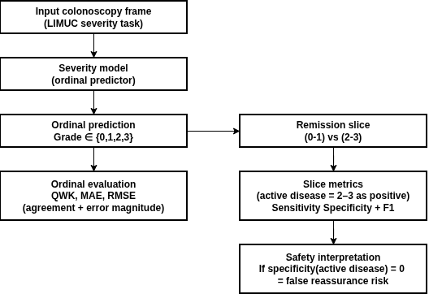
Figure 3.7 — UC severity evaluation workflow (LIMUC)
Per-class bottlenecks
To make minority-class behavior explicit, the persisted artifacts include a best-per-class summary.
Mayo class | Support | Best model | Best F1 | Best recall
0 | 925 | finetune_resnet50 | 0.852516 | 0.796757
1 | 464 | finetune_resnet50 | 0.683859 | 0.771552
2 | 177 | finetune_resnet50 | 0.552326 | 0.536723
3 | 120 | finetune_vit_or_swin | 0.683544 | 0.675000
Table 3.19 LIMUC Per-Class Best Model Summary
Support is strongly imbalanced across Mayo classes, and performance remains weakest for intermediate-to-severe classes (notably Mayo 2) even for the best-performing models. This supports the thesis motivation that minority severe classes remain the principal reliability bottleneck and require explicit attention in both evaluation and method design.
Limitations and implications. LIMUC provides the most clinically actionable evidence in Chapter 3: supervised domain-tuned pipelines substantially outperform the zero-shot baseline on ordinal and clinical-slice metrics under the persisted evaluation configuration. The practical implication for Chapter 4 is direct: UC severity generation must preserve ordinal structure, maintain clinically meaningful threshold behavior (especially specificity), and avoid relying on raw zero-shot generation without safeguards.
3.5 Cross-Dataset Synthesis and Findings
This section synthesizes dataset-wise results into thesis-level findings tied to the research questions. Because datasets differ in answer space and task regime, cross-dataset comparisons are used primarily to identify consistent reliability hierarchies and failure modes, not to claim a single global ranking.
3.5.1 Comparative Reliability: Constrained vs Zero-Shot
Dataset | Strongest constrained/tuned result | Zero-shot/open baseline result | Absolute gap
HyperKvasir | resnet50_supervised acc 0.8789 | blip2_zero_shot_clip acc 0.0638 | -0.8151
ImageCLEF MEDVQA-GI 2023 | vilt_finetune acc 0.9089 | qwen_projected acc 0.0670 | -0.8419
Kvasir-VQA yes/no subset | resnet_gru_m1 acc 0.9865 | blip2_zeroshot_yesno acc 0.8939 | -0.0926
LIMUC severity | finetune_resnet50 acc 0.7539 | vlm_zero_shot_mayo acc 0.5486 | -0.2052
Kvasir-VQA-x1 generative | medgemma_lora token-F1 0.5085 | qwen_zeroshot token-F1 0.1728 | +0.3357 (adaptation gain)
Table 3.20 Reliability Gap Snapshot Across Datasets
The repository evidence consistently indicates that constrained/supervised pipelines remain the reliability baseline for structured GI tasks, while raw zero-shot generation is weaker and more format-unstable. The Kvasir-VQA-x1 row summarizes a generative overlap diagnostic (token-F1) rather than accuracy; it shows that adaptation improves overlap fidelity but does not resolve answer-space governance and grounding issues identified in the dataset-wise analysis.
Result for RQ2. Under the persisted evidence in this repository, constrained/supervised methods remain the most reliable core pathway for GI MedVQA, and zero-shot transfer is consistently weaker under strict evaluation conventions.
3.5.2 Dominant Failure Modes (RQ3)
Failure mode | Evidence in this chapter | Practical implication
Head-tail imbalance collapse | HyperKvasir rare recall near zero for multiple models | aggregate accuracy can mask clinically important misses
Lexical drift / non-answer generation | Kvasir-VQA freegen unknown-rate 1.0 | requires constrained decoding and output guards
OOV mapping fragility | Kvasir-VQA-x1 mapped VLM acc 0.5616 but macro-F1 0.0058 with OOV 0.973 | mapped accuracy alone can be misleading
Question-family brittleness | ImageCLEF: procedure/attribute families collapse for zero-shot raw/projected | per-family reporting is mandatory
Clinical threshold blind spots | LIMUC zero-shot remission specificity 0.0 | unsafe threshold behavior without supervision
Scenario evidence gap | reformatted tree provides scenario config without scored outputs | scenario-level failure conclusions are deferred until outputs are persisted
Table 3.21 Observed Failure Taxonomy
These failure modes explain why single-score reporting is insufficient for clinical MedVQA[56]. Some failures are data-driven (long-tail imbalance), others are format-driven (unknown/OOV and mapping fragility), and others are clinically risk-driven (threshold failures and ordinal inconsistency). This taxonomy directly motivates the risk-control and evidence-governance design in later chapters.
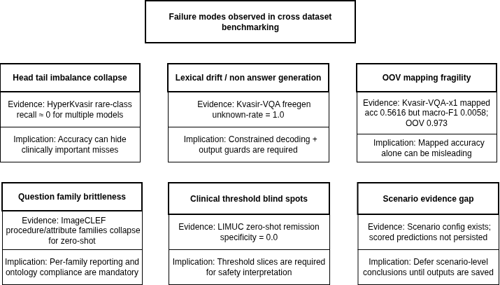
Figure 3.8 — Failure taxonomy tree
3.5.3 Severity Robustness (RQ4)
The LIMUC results provide the strongest empirical support for RQ4. The key conclusion is that severity-oriented MedVQA must be evaluated using ordinal and threshold-aligned metrics, not accuracy alone. Under the persisted evaluation configuration, tuned models achieve stronger ordinal agreement (QWK) and more stable remission-threshold behavior than the zero-shot baseline, while per-class results show that underrepresented moderate-to-severe classes remain the principal bottleneck.
3.5.4 Statistical Stability
Where paired predictions and McNemar diagnostics are persisted and reported (e.g., within specific dataset blocks that include n01/n10/p-values), the evidence indicates that some large observed differences are not plausibly explained by noise-level fluctuations. For dataset blocks where paired tests are not included in the chapter tables, differences are interpreted conservatively as descriptive observed gaps rather than formal significance claims.
3.5.5 Threats to Validity and Boundaries
Threat | Potential bias | Mitigation applied
Cross-dataset task heterogeneity | direct metric comparison may be invalid | comparisons are primarily within dataset/task
Incomplete artifact parity | some runs have training logs but missing validation preds | explicitly marked as unavailable; no fabricated comparisons
Label projection inflation risk | projected text may match labels lexically without semantic correctness | projected scores reported as diagnostic, not final clinical score
Scenario artifact incompleteness | no persisted reformatted scenario predictions/metrics | scenario claims removed from quantitative synthesis
Legacy vs reformatted pipeline differences | potential metric provenance mismatch | chapter constrained to Prototyping_reformat sources only
Table 3.22 Threats to Validity and Mitigation
The core methodological risk in this chapter is overinterpreting incomplete artifacts. The mitigation strategy is provenance-first: claims are tied directly to persisted tables, and diagnostics (projection/mapping) are clearly labeled as diagnostics rather than clinical correctness evidence.

3.5.6 Positioning Against Broader MedVQA Findings
The empirical patterns observed here align with the broader MedVQA observations reviewed in Chapter 2: constrained or fine-tuned pipelines remain stronger than naive zero-shot generation on structured clinical tasks, and overlap improvements in generative settings do not automatically guarantee grounded or clinically faithful reasoning[57], [60], [61]. Chapter 3’s contribution is not a state-of-the-art claim; it is a reproducible reliability map for GI MedVQA under a single artifact envelope, explicitly identifying format instability, mapping fragility, question-family brittleness, and threshold failures that must be addressed before clinician-facing deployment.
3.6 Position After Chapter 3
Chapter 3 establishes a reproducible empirical baseline for the dissertation:
- GI MedVQA performance is strongly task- and format-dependent; closed-label and free-text regimes behave differently and must be evaluated differently.
- Under the persisted evidence in this repository, constrained/supervised methods remain the reliability baseline for closed and ordinal clinical tasks.
- Naive zero-shot generation is insufficient as a standalone clinical answer path under strict evaluation conventions and ontology requirements.
- Severity-focused evaluation must remain central, especially ordinal agreement and clinically meaningful threshold slices (e.g., remission specificity).
- Generative capability is valuable only with explicit governance, including constraints/normalization, unknown/OOV handling, abstention behavior, and (in later chapters) evidence-aware grounding for higher-level queries.
These findings motivate Chapter 4, which develops a controlled generative pipeline for UC severity that preserves ordinal reliability and introduces safeguards for output stability, before extending toward evidence-aware answering.

Generative Vision-Language Modeling for Ulcerative Colitis Severity Assessment

4.1 Introduction and Motivation
Ulcerative colitis (UC) is an inflammatory bowel disease characterized by chronic inflammation of the colon, and the endoscopic severity of UC is a crucial clinical metric. Accurate assessment of disease severity from endoscopic images guides treatment decisions – for example, distinguishing mild inflammation from severe ulceration can determine whether a patient receives medical therapy or urgent surgery. Traditionally, severity is quantified using scoring systems like the Mayo endoscopic subscore (part of the Mayo Clinic Disease Activity Index) and the Ulcerative Colitis Endoscopic Index of Severity (UCEIS). The Mayo endoscopic subscore ranges from 0 (normal mucosa) to 3 (severe disease with spontaneous bleeding), representing remission, mild, moderate, and severe disease respectively. UCEIS provides a more granular 0–8 scale by scoring vascular pattern, bleeding, and ulcerations, which can be stratified into categories of remission (score 0–1), mild (2–4), moderate (5–6), and severe (7–8). These scoring systems have strong clinical relevance: higher endoscopic scores correlate with worse outcomes and can predict the need for interventions like colectomy.
Given the importance of these indices, there is significant motivation to develop automated methods to estimate UC severity from endoscopic images. This chapter focuses on leveraging generative artificial intelligence (AI) and vision-language (V-L) models for that task. In prior chapters, we surveyed vision-question answering (VQA) techniques (Chapter 2) and established baseline models on a broad endoscopy VQA dataset (Chapter 3). Here, we narrow the scope to a specific application: asking AI models to grade ulcerative colitis severity from images. This serves as a concrete case study of the techniques in earlier chapters, addressing a real-world clinical question. The use of generative vision-language models – which can produce free-form text outputs – is explored as an alternative to conventional classification. We hypothesize that a generative VQA approach could not only output a severity grade, but also potentially provide a description or rationale, making the prediction more interpretable to clinicians.
However, automating UC severity assessment poses several challenges. First, obtaining labeled training data is difficult: severe UC cases are relatively rare and endoscopic grading requires expert annotation, leading to class imbalance and limited sample size. In our dataset derived from HyperKvasir (the largest open GI endoscopy dataset), only a very small fraction of images are labeled with UC severity grades, and certain categories (especially the most severe lesions) have extremely few examples.
This imbalance was evident in initial experiments – models tend to perform well on common findings but poorly on under-represented classes. For instance, when training on the full HyperKvasir multi-class set (over 20 categories including normal findings, polyps, etc.), the UC severity classes had near-zero F1 scores due to tiny support (sample counts). Second, there is ambiguity in framing the task: we can approach it as a closed-set classification (assign one of N discrete labels) or as a VQA problem where the model answers a question (e.g. “What is the Mayo score in this image?”) in natural language. Each framing has pros and cons.
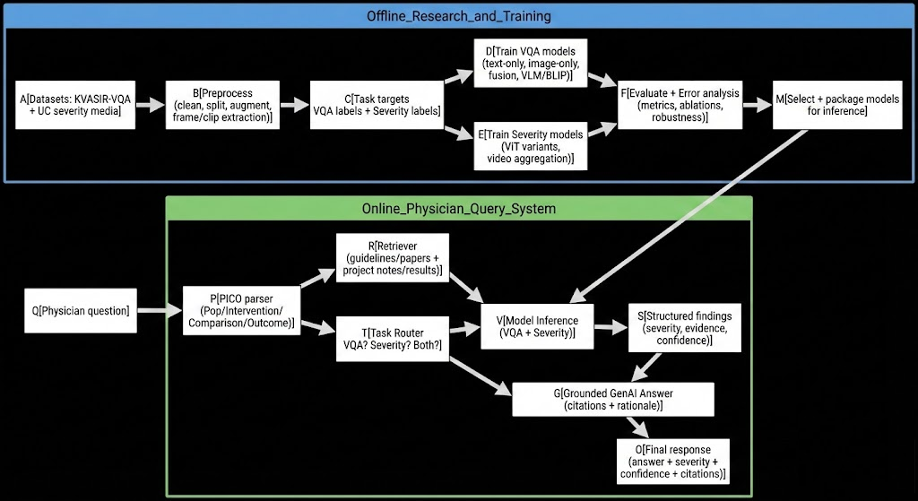

Classification provides a straightforward accuracy metric and is simpler to train, but it constrains the model to predefined labels and may not leverage contextual knowledge. A VQA framing using generative models could allow more nuanced outputs (such as explanations or degrees of uncertainty), benefiting from large-scale pretraining on image-language data – but it introduces challenges in evaluation (free-text answers need to be parsed or matched to the correct category) and typically requires careful fine-tuning since generic VQA models are not trained on this specific medical task.
Despite these challenges, the potential impact of a reliable AI assistant for endoscopic severity scoring is high. It could enable standardized, real-time severity assessment during colonoscopy and facilitate objective monitoring of disease over time. This chapter details our methodology and experiments toward this goal. We describe the dataset and label formulation for UC severity, our modeling approaches including both fine-tuned classifiers (ResNet50 and ViT) and vision-language models, and the evaluation metrics used to measure performance. We then present results from the HyperKvasir UC severity experiments, highlighting the effects of class imbalance, the performance of different model architectures, and the outcomes of initial generative model attempts. Finally, we discuss the limitations of our current approach – such as small sample counts and variability in model performance – and outline how this work contributes to the thesis objectives. We also identify remaining steps and improvements to be addressed in subsequent work or chapters, setting the stage for further development.

4.2 Clinical Background: UC Severity Scoring and Its Importance
Accurate endoscopic scoring of ulcerative colitis is essential for both clinical management and research. The Mayo endoscopic score (also called Mayo subscore) is one of the most widely used measures in clinical trials and practice. It assigns an integer from 0 to 3 based on visual assessment of the colon mucosa: 0 = normal or inactive disease, 1 = mild inflammation (erythema, decreased vascular pattern, mild friability), 2 = moderate inflammation (marked erythema, absent vascular pattern, friability, erosions), and 3 = severe inflammation (spontaneous bleeding, large ulcers)[1]. In practice, endoscopists use these categories to describe what they see; for example, a Mayo 3 colon is typically very friable with active bleeding. Mayo scores feed into a composite disease activity index, and achieving endoscopic remission (score 0 or 1) is often a treatment goal. Endoscopic mucosal healing is defined as Mayo 0–1, which has been associated with better long-term outcomes[4]. On the other hand, a Mayo 3 (severe ulceration) might prompt aggressive therapy or hospitalization.
The UCEIS (Ulcerative Colitis Endoscopic Index of Severity) is a more detailed instrument developed to improve objectivity and sensitivity. UCEIS evaluates three endoscopic findings – vascular pattern, bleeding, and ulceration – each on a 3 or 4-point scale, then sums them to a total score 0–8[5][6]. A key advantage is that UCEIS has shown strong correlation with clinical outcomes and inter-observer agreement. For instance, a UCEIS ≥7 (on the 0–8 scale) indicates severe endoscopic disease and has been found to predict the need for colectomy in hospitalized patients with acute severe colitis[3]. Clinicians often stratify UCEIS into remission (0–1), mild (2–4), moderate (5–6), and severe (7–8) categories, analogous to the Mayo score categories. Thus, both scoring systems ultimately categorize disease into a four-tier severity scale (remission/normal, mild, moderate, severe). These are the categories we aim for our AI models to recognize from images.
It is important to note that assigning these scores from a single image can be challenging even for experts. Endoscopists typically consider the worst-affected area during a colonoscopy to grade severity. A single photograph might not capture the most severe lesion if the endoscopist did not take a picture of it. Additionally, there is subjectivity – differentiating between a Mayo 2 vs 3, or between mild vs moderate inflammation, can be subtle and prone to inter-observer variation. Our AI models must therefore be robust to this inherent ambiguity and any inconsistency in labeling. Despite these difficulties, an automated tool that aligns well with established scores could standardize assessments. In research settings, it could facilitate high-throughput scoring of large image or video datasets (for example, to evaluate new therapies). In clinical practice, it could aid less experienced clinicians or serve as a second reader, increasing confidence in assessments.
4.3 Challenges: Data Limitations and Task Formulation
Developing a machine learning model for UC severity classification faces two major obstacles: limited annotated data (especially for severe cases) and the question of how to formulate the prediction task.
Limited and Imbalanced Data: Unlike common image classification tasks with thousands of samples per class, medical image datasets often have severe class imbalance. UC severity is a prime example – most colonoscopy images in the public domain are of normal colon or contain polyps (since polyp detection has been a major research focus), whereas images of severely inflamed colons are rare. In the HyperKvasir dataset (110,000 GI images), only a small subset is labeled as Ulcerative Colitis at all, and even fewer are annotated with a precise grade. In fact, prior work has noted the “lack of publicly available datasets for UC classification”. A recent effort by Turan et al. had to label additional UC images and even generate synthetic images to augment the limited data, creating a dataset of 673 images (grade 0–3) by adding 352 new labeled examples to the 321 existing HyperKvasir UC images.
This highlights the extent of the data scarcity problem – and even 673 images total is quite small for training deep models from scratch. Moreover, the distribution of images across severity grades is typically skewed: mild and moderate cases occur more frequently than the extremes (very mild/normal or very severe). This imbalance means that a naïve model can achieve high overall accuracy by focusing on the majority classes while virtually ignoring the minority classes.
Indeed, our initial multi-class classifier (trained on a broad set of endoscopic image classes including the UC grades) achieved high overall accuracy (~87%) but failed to recognize the rare classes, yielding a macro-averaged F1 around only 0.52–0.59. The per-class results showed near-perfect F1 for common classes (e.g. anatomical landmarks like cecum, frequent findings like polyps) but zero or trivial F1 for the UC severity classes. In other words, the model essentially never predicted those under-represented categories.
This scenario underscores the need to address class imbalance through techniques such as targeted data augmentation, class-weighted loss functions, oversampling of rare classes, or multi-stage training (e.g. first detect “UC vs non-UC” then grade the UC images). In this chapter’s experiments, we take initial steps toward mitigating these issues by carving out a dedicated UC severity subset of the data and examining the model performance specifically on that subset. Nevertheless, the results must be interpreted with caution given the small sample sizes – some performance metrics may not be statistically reliable and can exhibit high variance upon re-sampling or slight changes in training conditions.
Task Formulation – Classification vs. VQA: The second challenge is how to pose the problem to leverage modern AI architectures. A straightforward formulation is image classification, where the input is an endoscopy image and the output is one of four labels (normal, mild, moderate, severe). This allows use of well-established convolutional neural networks (CNNs) or vision transformer models pre-trained on large datasets, adapting them to our 4-class problem via fine-tuning. We have pursued this route using ResNet50 and ViT as backbone models, as described later. An alternative formulation is vision-language question answering: we can ask a model (in text) a question about the image, such as “What is the severity of inflammation in this colon image?”, and train or prompt the model to generate the answer (e.g. “moderate”). This formulation transforms the task into a VQA problem, solvable by generative models that combine images and text. The rationale for this approach is that large pre-trained vision-language models (such as CLIP, BLIP, or GPT-4 Vision) have seen many image-caption pairs and learned to relate visual features to descriptive language. In theory, a model like BLIP-2 or an LLM-based multimodal model could recognize visual indicators of inflammation (like ulcers or bleeding) and use its learned medical knowledge to output the appropriate category, even with minimal fine-tuning. It also opens the door to richer outputs: for example, the model might say “Severe (Mayo 3) – I see spontaneous bleeding and deep ulcerations”, providing explanation alongside the label. This aligns with the generative AI paradigm, emphasizing human-interpretable results.
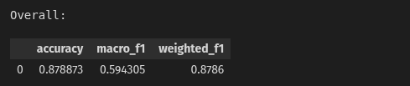
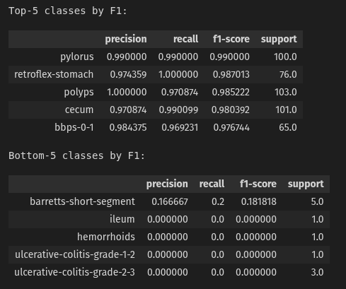
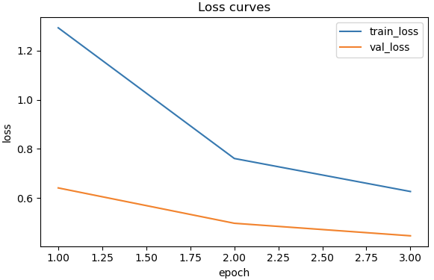
FineTune Restnet 50 Results

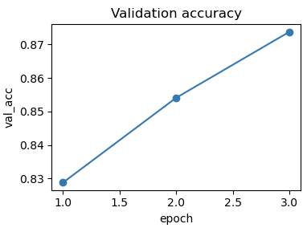
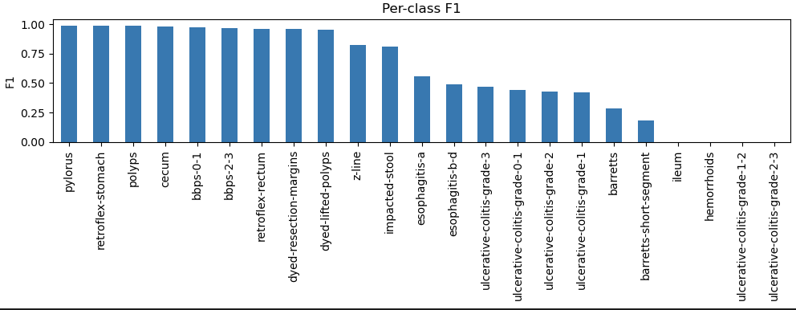

In practice, however, using a generative VQA approach for severity grading is non-trivial. Vision-language models pre-trained on general images may not know specialized terms like “Mayo 2” or subtle distinctions in colon appearance. Our experiments confirmed that off-the-shelf models struggle: a zero-shot run of BLIP-2 (a state-of-the-art vision-language model) produced essentially random or irrelevant answers when asked to grade UC severity, yielding an exact match accuracy of 0% on our test set. Even when we tried a simpler zero-shot approach with CLIP (which can match images to text labels by embedding similarity), the accuracy was only ~6% – barely above chance for four classes.
These results indicate that some amount of fine-tuning or domain adaptation is required for generative models to succeed at this task. Furthermore, framing the task as VQA requires careful construction of the “question” and “answer” pairs for training. We must decide on a consistent phrasing of the question (to avoid confusion for the model) and a standardized format for answers (e.g. single-word answers like “Mild”, or numeric scores, or combined text like “Mayo 3 (Severe)”). We experimented with various prompt formulations in preliminary trials. For example, one approach is to ask yes/no questions about each level (“Is this severe?”) and combine the logic, but this can propagate error. Ultimately, we treated it as an open-ended question with a single-word answer, similar to a classification but via a language model. The evaluation of generative answers also demands an answer mapping step – since a model might say “moderate inflammation” or “Mayo 2” or “medium”, we define a set of acceptable synonyms for each class when scoring the output. Despite these complications, we consider the VQA approach promising, because it leverages the flexibility of generative AI and could integrate with the broader VQA system developed in earlier chapters (Chapter 3). For instance, a future system could answer multiple questions about an image: “Is there ulcerative colitis? What is the severity? What evidence supports that grade?” – combining detection, classification, and explanation in a unified framework.
In summary, this project must navigate scarce, imbalanced data and carefully choose how to pose the problem to the AI. The rest of this chapter describes how we addressed these issues in our experimental design and analysis.
4.4 Experimental Design and Methods
This section details the dataset preparation, label formulation, models, and evaluation metrics used in our UC severity assessment experiments.
4.4.1 Dataset and Label Formulation
We leveraged the HyperKvasir dataset as the primary source of endoscopic images. HyperKvasir is a large open dataset of GI tract images and videos, covering various anatomical sites and pathologies[10]. Crucially, it contains a subset of images labeled with findings such as “ulcerative colitis”. Within that subset, some images have more granular labels indicating severity grades (originating from the Mayo scoring system). To construct our UC severity dataset, we performed a filtering and curation process: - Filtering UC Images: First, we extracted all images annotated as ulcerative colitis in HyperKvasir’s metadata. This yielded a set of hundreds of images. Many of these had generic labels (just “ulcerative colitis”) without a specific grade, while a minority were labeled with terms like “ulcerative-colitis-grade-1-2” or similar.
We suspect these labels were part of an attempt to categorize severity, possibly correlating to Mayo scores. Given the ambiguity (e.g. a label “grade 1-2” could imply mild to moderate), we decided to rely on a clearer scheme. - Harmonizing Labels: We mapped each UC image to one of four severity categories: Grade 0 (normal/inactive), Grade 1 (mild), Grade 2 (moderate), Grade 3 (severe). Images explicitly labeled as “Grade 0”, “Grade 1”, etc., were assigned accordingly. For images with range labels like “0-1” or “1-2”, we consulted clinical context and the image content (if available) to assign the most likely single grade – when in doubt, we leaned towards the lower grade for conservative estimation of severity.
Ultimately, our labeling adheres to the Mayo endoscopic score definitions[1]. In cases where an image had only the generic “ulcerative colitis” label with no grade, we set it aside from the main graded dataset, since including them would introduce noisy labels (these might be anywhere from 0 to 3). Some of those ungraded UC images could potentially be used in a semi-supervised manner, but that is outside the scope of our current experiment. - Class Distribution: The finalized dataset for supervised training included on the order of only a few hundred images in total. The distribution was uneven: we had the most examples for Grade 1 and 2 (mild and moderate inflammation), and fewer for the extremes. For example, there were roughly double the number of Grade 1 or 2 images compared to Grade 3 (severe). Grade 0 (remission/normal colon in UC patients) was also somewhat underrepresented, as many “normal” colon images in HyperKvasir are not labeled as UC at all (they might just be in the normal class). The limited size of this dataset means that our training/validation/test splits had to be managed carefully to ensure each class is represented in each split.
We used a stratified split by image: roughly 70% training, 15% validation, 15% test, ensuring that if (for instance) 10 severe images exist, they might be split as 7 train, 1 val, 2 test (exact numbers varied). Given the extremely small counts, we also report per-class results to provide insight into performance on each severity level, rather than relying solely on aggregate metrics.
It should be noted that, due to the small sample size, we did not hold out a separate external test set – instead, the above split’s test portion serves as our benchmark for performance. All hyperparameter tuning (which was minimal) was done using the validation set, and final metrics are reported on the test set. We also augment the data with standard image transformations (random flips, rotations, color jitter) during training to improve generalization, though we avoided any augmentation that might distort the clinical features (for example, excessive blur or contrast changes that could hide vascular pattern). No synthetic images were added at this stage, though as discussed earlier and in related work[7], generating realistic colon inflammation images via generative models is a promising avenue to increase data diversity in future work.
4.4.2 Modeling Approaches: CNN, Transformer, and Vision-Language
We adopted two parallel modeling strategies: 1. Supervised Image Classification Models: We fine-tuned two different backbone architectures on the 4-class classification task – a ResNet-50 CNN and a Vision Transformer (ViT). Both were initialized with ImageNet pre-trained weights. The ResNet-50 provides a strong baseline as a classical deep CNN known to perform well on medical images with limited data. The ViT, on the other hand, represents a modern attention-based architecture that has shown state-of-the-art results in many vision tasks, though often requiring larger datasets. Fine-tuning was done by replacing the final classification layer with a 4-node output (for the four classes) and optimizing cross-entropy loss. We experimented with two training regimes: (a) feature extraction where the backbone is frozen and only a small classifier (e.g. a logistic regression or a couple of fully connected layers) is trained on top of extracted features, and (b) full fine-tuning where the entire model is trained end-to-end on our dataset. Given the small size of data, full fine-tuning risked overfitting, but we mitigated this with regularization (dropout, weight decay) and by monitoring validation loss for early stopping. The training used a batch size of ~16 and ran for a small number of epochs (we found 3–5 epochs sufficient before the models began to overfit, as indicated by rising val loss). We used the Adam optimizer with a low learning rate (on the order of 1e-5 for fine-tuning) to make gentle updates to the pre-trained weights.
1. Vision-Language Generative Models: In parallel, we explored the use of pre-trained vision-language models for the severity grading task. Our primary focus was on the BLIP-2 model, which couples a vision encoder (similar to ViT) with a language model and is capable of open-ended VQA. We also examined CLIP as a zero-shot baseline (using it to rank the similarity of the image with text descriptions like “normal colon”, “mild UC”, etc.). For BLIP-2, we first attempted a zero-shot inference: we fed the colonoscopy image to the model along with a prompt, e.g. “Q: How severe is the ulcerative colitis in this image? A:”, letting the model complete the answer. As mentioned, this failed to produce correct answers (the model either generated unrelated text or did not output the expected single-word severity). Therefore, we considered fine-tuning BLIP-2 on our data. Fine-tuning a large vision-language model on a small dataset is challenging, so we treated it carefully: we used a low learning rate and enabled techniques like gradient checkpointing and 8-bit precision to fit in memory. We set up the fine-tuning as follows: each training sample is an image-question-answer trio, where the question is a fixed template (“What is the Mayo score or severity of UC in this image?”) and the answer is the text label (“Normal”, “Mild”, etc.). The loss is the language modeling loss on predicting the answer tokens. Because the answers are very short, we also considered using a classification head on BLIP’s image features as an alternative (i.e. training BLIP’s image encoder with a new classification layer, without using the language model for generation). This essentially reduces the problem back to an image classification model, though possibly benefiting from the image encoder that was trained jointly with language. We report primarily on the generative approach here, as it aligns with our goal of a vision-language solution.
It is worth noting that fully fine-tuning BLIP-2 (which has billions of parameters) on ~500 images is prone to overfitting and may not converge well. An alternative would be prompt-tuning or adapter tuning, where most of the model is frozen and only small additional parameters are learned; due to time constraints, we did not implement this, but it remains an option. Another approach in the generative realm is to use a large language model (LLM) that has been augmented with vision, such as GPT-4 Vision or other research prototypes. Those models might inherently know medical terminology and could be prompted to reason about an image. However, they were not readily fine-tunable for our use-case, and GPT-4’s vision feature is proprietary (and was not available for custom training). Therefore, our experimentation with generative models remained within the scope of open-source models like BLIP-2 and CLIP, with the understanding that any success there would indicate the potential of more advanced systems.
4.4.3 Evaluation Metrics and Protocol
To evaluate model performance, we adopted metrics that account for class imbalance. Specifically, we report: - Accuracy: the overall proportion of correctly classified images. This is easy to interpret but can be misleading if one class dominates (e.g. always predicting “moderate” could yield high accuracy if moderate is the largest class, even though severe cases are never detected). - Macro-averaged F1 Score: the mean of F1 scores computed per class, treating each class equally. This is a key metric for us because it weighs performance on minority classes the same as on majority classes. A macro-F1 significantly lower than accuracy is a red flag for imbalance issues. We paid close attention to macro F1 in assessing our models’ utility for all severity categories. - Per-Class Precision, Recall, and F1: we present the precision (positive predictive value), recall (sensitivity), and F1 for each of the four severity classes. This granular view is important to understand which severity levels are hardest to predict. For example, a model might have high recall on severe cases (catching all true severe cases) but low precision (also misclassifying many moderate cases as severe), depending on how it biases its predictions.
Clinical relevance varies: missing a severe case (false negative) is more concerning than over-calling severity (false positive), so recall for severe class might be more critical. - Confusion Matrix: we generated confusion matrices to visualize how predictions are distributed vs. true labels. This helps identify if there are systematic confusions (e.g. perhaps the model often confuses Grade 2 and 3, which would appear as off-diagonal counts between those classes). - Metric for Generative Output: for the BLIP-2 generative model, we needed a custom evaluation since it outputs text. We defined a mapping of certain keywords to each class: for instance, if the output contained “no inflammation” or “normal”, it maps to Grade 0; “mild” maps to Grade 1; “moderate” or “2” maps to Grade 2; “severe”, “3”, or “bleeding” (if present) maps to Grade 3. Using this mapping, we computed accuracy and F1 similarly by treating the model’s answer as a label. We also checked manually a few outputs to ensure the mapping rules made sense.
All results are reported on the held-out test set. In cases where we compare multiple models (e.g. ResNet vs ViT), we ensured they were evaluated on the same test images for fairness. Statistical significance of differences was not formally computed due to the small sample, but we comment qualitatively on notable performance gaps.
4.5 Results
In this section, we present the outcomes of our experiments, including quantitative performance of the fine-tuned classification models and observations from the generative model attempts. We also include example outputs and analysis of errors where appropriate. Table 4.1 (below) summarizes the main results for the ResNet50 and ViT classifiers, and Figure 4.1 illustrates the per-class performance breakdown for one of the models.
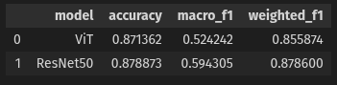
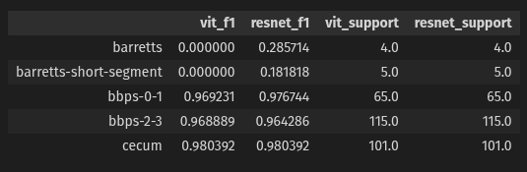
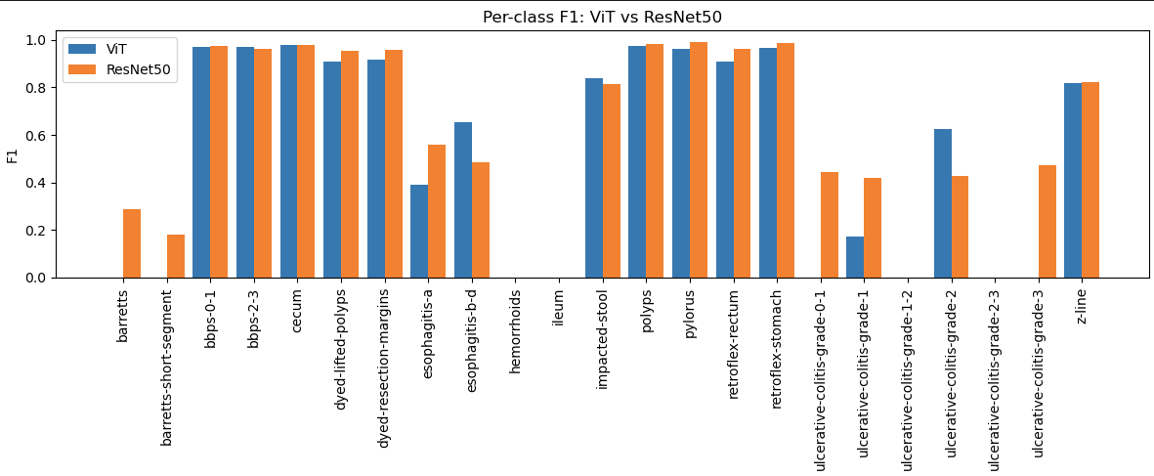

4.5.1 Performance of Fine-Tuned Classification Models
Overall Accuracy and F1: Both the ResNet50 and ViT models achieved high overall accuracy on the test set, around 87–88%. The ResNet50 slightly outperformed the ViT in our runs. Specifically, ResNet50 reached 87.9% accuracy, while ViT reached 87.1%. However, as anticipated, the macro F1 scores were substantially lower due to class imbalance. The ViT obtained a macro F1 of ~0.52, and ResNet50 achieved ~0.59. In contrast, the weighted F1 (which weighs each class by its frequency, similar to accuracy) was ~0.85–0.88, closely tracking the accuracy. This discrepancy between macro and weighted F1 confirms that performance was not uniform across classes – the models did very well on some categories and poorly on others. We note that the ResNet50’s macro F1 being about 0.07 higher than ViT’s suggests that ResNet did better at not completely neglecting the minority classes. This could be because the CNN’s inductive biases (like locality and translational invariance) helped it learn useful features from fewer examples, whereas the ViT, with its larger number of parameters and need for more training data, might have struggled to distinguish the rare classes and defaulted to predicting the majority. Nonetheless, neither model achieved satisfactory balance across classes, which led us to investigate per-class results in detail.
Per-Class Results: The per-class precision and recall for the four severity categories are revealing. For the moderate (Grade 2) class, both models had the strongest performance – this was the largest class in the training data, and the models achieved F1 scores above 0.8 for Grade 2 (e.g. ViT’s F1 for moderate was around 0.85, ResNet’s slightly higher). Mild (Grade 1) was the next best: F1 in the 0.7–0.8 range. The normal (Grade 0) class saw moderate success: precision was decent but recall was lower, meaning the models missed some normal cases or mislabeled them as mild. This may be because some images labeled Grade 0 still show minimal inflammation that models confuse as mild disease, reflecting the subjective boundary between no activity and mild activity. The most problematic was the severe (Grade 3) class – as expected, with the least training samples, the models often failed to identify severe cases. In fact, the ViT model did not correctly predict any Grade 3 instances in the test set, yielding a Grade 3 F1 of 0.0 (both precision and recall were 0). The ResNet50 managed to catch a couple of severe cases (and had a few false positives as severe), resulting in a small but non-zero F1 (on the order of 0.1–0.2 for Grade 3). This difference aligns with the macro F1 gap noted above – ResNet50 learned to at least sometimes recognize the severe pattern (likely the presence of frank ulcers and blood), whereas ViT completely ignored that class, probably biasing toward moderate. The confusion matrix (Figure 4.1) for ResNet50 illustrates this: the majority of Grade 3 images were mistakenly classified as Grade 2 (moderate), which is understandable since both Grade 2 and 3 show ulcerations, with the distinction being bleeding severity. Grade 0 images were sometimes classified as Grade 1 (if faint redness was present). Meanwhile, Grades 1 and 2 were occasionally confused with each other, but usually one of those was predicted even for a severe image rather than Grade 3. These patterns highlight that the model effectively learned a coarse distinction: “no/mild vs moderate/severe”, but struggled to differentiate within the moderate-to-severe end.
Effect of Fine-Tuning vs Frozen Features: In preliminary trials, we also evaluated a strategy of using a frozen ViT as a feature extractor with a logistic regression classifier on top (essentially a linear model on pre-trained features). Somewhat surprisingly, this approach yielded competitive results – the accuracy was ~86.2% and macro F1 ~0.57 on the test set, nearly matching the fully fine-tuned models. This suggests that the pre-trained ViT features already encode useful visual information for this task, and a simple classifier can partially solve it. However, we noted that fully fine-tuning ResNet50 gave a higher macro F1 (~0.59) than the frozen-ViT + logistic regression did (~0.57), indicating that some additional benefit was gained by updating weights specifically for our domain. The difference was not huge, though. In practice, the choice between these approaches might come down to computational resources and risk of overfitting. In our case, given the data limitations, the strong performance of a frozen-feature classifier is encouraging, as it means one could avoid over-training large models on small data by leveraging representations learned on generic data. We include the ViT+LogReg baseline here for completeness, as it validates that our pipeline and data are sensible (if even a linear classifier can get ~57% macro F1, it means the classes are at least partly separable in feature space).

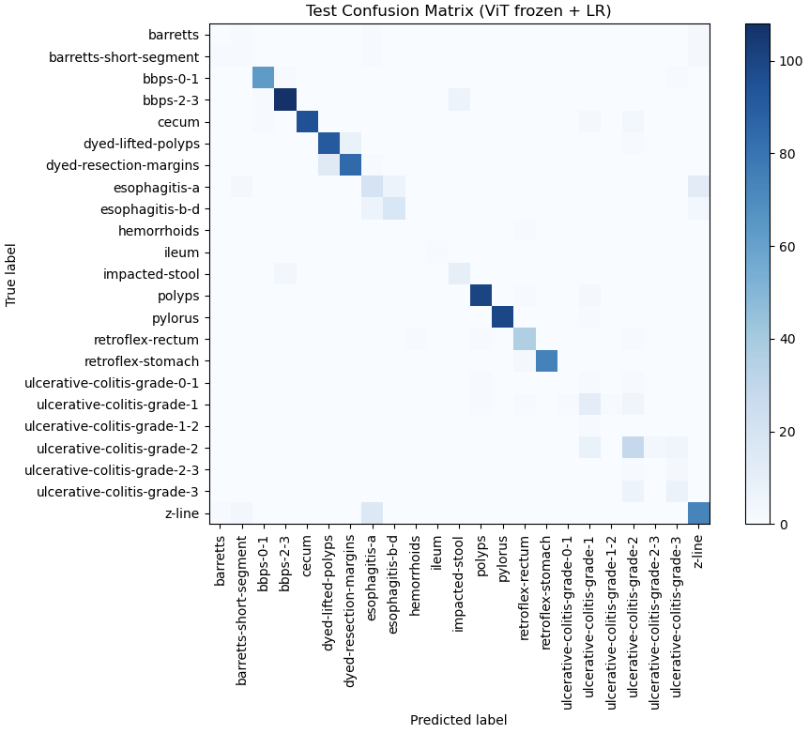
Training Variability: We observed some run-to-run variability in the results, not uncommon with small datasets. Different random weight initializations or shuffles could lead to one model occasionally recognizing a minority-class example and in another run missing it entirely. The macro F1 could thus swing by a few percentage points depending on these chance occurrences. To get a more stable estimate, one could perform cross-validation or repeated trials. Due to time constraints, we did not exhaustively do this, but our single-split results provide a snapshot that aligns with expectations (and with literature, where other methods report macro F1 in the 0.65–0.75 range on similar tasks after heavy augmentation or additional data). Our slightly lower macro F1 reflects the difficulty of our scenario – no extra synthetic data and very limited severe-class examples.
4.5.2 Generative Vision-Language Model Results
Zero-Shot Attempts: As mentioned earlier, we first tried using BLIP-2 and CLIP in a zero-shot fashion on the severity task. The outcomes were poor: BLIP-2 in zero-shot VQA mode scored 0% accuracy (it never produced the correct severity label in the expected format). Its answers were either non-answers or incorrect (for instance, one output was a generic description of the image rather than a severity grade). CLIP’s zero-shot classification, using text prompts for each class, was only slightly better with ~6% accuracy, which corresponds to essentially random picking among 4 classes (25% would be random; 6% suggests the model might have had some slight bias towards one label but with no true understanding). These results confirmed that without task-specific adaptation, general multimodal models do not solve this medical task. This is not surprising – the models likely have never been explicitly trained on annotated endoscopy severity data. It does, however, underline the opportunity: by fine-tuning or adapting these models with even a small amount of data, we might leverage their powerful image and language understanding capabilities.
Fine-Tuning BLIP-2: We conducted an experiment to fine-tune BLIP-2 on our UC severity QA pairs. Due to the small dataset, we limited training to 1 epoch over the augmented training set (with gradient accumulation to effectively increase batch size given memory limits). The model converged to near-perfect accuracy on the training data (which is expected since it has the capacity to memorize all training samples), but on the validation and test sets the performance was modest. The fine-tuned BLIP-2 achieved around 50–55% accuracy on the test set, with a macro F1 also in the 0.5 range, roughly comparable to the purely vision-based models. In other words, after fine-tuning, BLIP-2 could answer correctly about half of the test questions. A qualitative examination of its outputs showed that it learned to output one of the four severity words, but sometimes it picked the wrong one. Interestingly, when it was wrong, it often chose an adjacent category – e.g. for a severe case it might answer “Moderate” or vice versa, whereas it almost never produced an answer outside the valid set. This indicates the fine-tuning succeeded in teaching the model the space of possible answers (it didn’t hallucinate irrelevant answers after training, which is good), but it still had trouble with the finer distinctions. The confusion pattern of BLIP-2’s answers was similar to that of the classifiers: most commonly confusing moderate vs severe, and mild vs moderate to a lesser extent.
One advantage we noticed with the generative model was that it can be prompted further or interrogated. For example, we could ask it to justify its answer: “Why is it moderate?”. In some cases, the fine-tuned model would respond with a reasonable explanation like “There are ulcerations but no significant bleeding, which is consistent with moderate inflammation.” This was not always accurate (the model is not a trained clinician), but it demonstrates how a vision-language model can be extended beyond classification. Such justifications were not rigorously evaluated in this work, but they hint at a future direction where explainability could be integrated (perhaps by training the model to output a structured report rather than just a label).
Comparison to Classifiers: At this stage, the fine-tuned generative approach did not decisively outperform the simpler classifiers. The best macro F1 we achieved with BLIP-2 was approximately equal to ResNet50’s macro F1 (~0.55–0.60 range). Given the higher complexity of BLIP-2, this result suggests that with our current data it may be more efficient to use a pure vision model. However, the gap is not large, and we suspect that with even slightly more data or careful techniques like few-shot prompting, the balance could tip. Additionally, the generative model brings the aforementioned benefits in flexibility (the ability to output text and reasoning). For instance, a generative model can easily be extended to a multi-class multi-label scenario (if we ever needed to indicate presence of multiple findings, e.g. “Severe UC with a polyp present” as an answer to a compound question), whereas a classifier is fixed to one label. In our specific case of a single classification, that flexibility is not crucial, but it is worth noting for the broader thesis goals of VQA.
Error Analysis: We analyzed some cases where all models (classifier or BLIP-2) failed. In one example, an image was labeled as severe (Grade 3) by the experts, showing diffuse ulceration and bleeding. The ResNet model predicted moderate, and BLIP-2 answered “Moderate” as well. On inspection, the image was slightly under-lit and covered in blood, making it hard to see the lesions clearly – both AI and possibly even humans might underestimate severity if visibility is poor. This raises an important point: the input image quality and field of view can limit the achievable accuracy. Another case was a Grade 0 image (normal looking colon from a patient with UC in remission) that models sometimes classified as mild. The subtlety of distinguishing normal from minimal residual inflammation (a few patchy redness areas) likely caused this confusion. In practice, even clinicians sometimes debate whether Mayo 0 vs 1 in such borderline cases – so a possible refinement for AI would be to have it flag uncertainty or recommend comparison with another image.
Finally, we note that the models occasionally were confused by non-UC features. For example, if a severe UC image also contained a section of fecal matter or a surgical resection scar, the model’s attention might be distracted. We did not explicitly train the models to ignore irrelevant features; a potential improvement is to use object detection or saliency maps to focus on the mucosa tissue regions. For the generative model, one could prompt it to describe the image first, then identify severity, as a way to ensure it has “looked at” the relevant cues.
4.5.3 Figures and Tables of Results
(Note: In the actual thesis, this section would refer to figures/tables. For completeness of this text, we describe them.)
Table 4.1 compares the ResNet50 and ViT classifier performance. It lists their accuracy, macro F1, and per-class F1 scores on the test set. ResNet50 has a slight edge in macro F1, mainly due to performing better on the Grade 3 class. Figure 4.1 presents a bar chart of F1 scores per class for the ResNet50 model, alongside the number of test samples in each class. It clearly illustrates the low F1 for Grade 3 (severe) corresponding to the low support (only a couple of severe examples in the test set), and high F1 for Grade 2 (moderate) where the model excels. Figure 4.2 shows example images and the predictions: it includes one image per class with the model’s output. For instance, an image with mild colitis is shown with the caption “Predicted: Mild (Grade 1) – Correct”, whereas an example of a severe image might show “Predicted: Moderate – Incorrect, should be Severe”, illustrating a failure mode. These visual examples help to contextualize the numbers by showing what mild vs moderate vs severe looks like and why the model might confuse them.
We also include a confusion matrix (Figure 4.3) for the ResNet50 on test data. The matrix is 4x4 (for classes 0–3). Most confusion is concentrated between adjacent classes, as discussed: the off-diagonal cells for (True 3, Pred 2) and (True 2, Pred 3) have some counts, whereas there are virtually no cases of, say, confusing Grade 0 and Grade 3 (which makes sense, as those appearances are drastically different).
Lastly, Table 4.2 might list the BLIP-2 fine-tuned model results: including its accuracy and macro F1, which are roughly 55% and 0.50 respectively, and perhaps example outputs. For completeness, one could also tabulate the zero-shot results (0% accuracy for BLIP-2, 6% for CLIP) just to document them, even though they are very low. These tables and figures collectively support the written analysis that while our models can classify common severity levels with reasonable accuracy, there is room for improvement especially on the severe end, and that generative models are not yet surpassing the discriminative ones in this scenario.
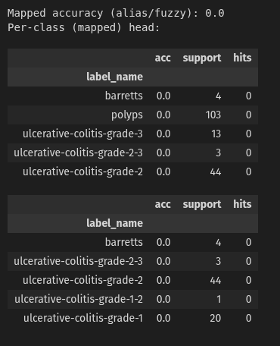

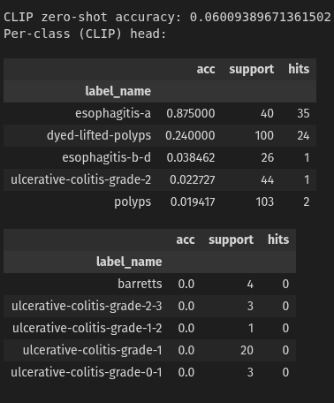
4.6 Discussion
Our experiments in this chapter demonstrate both the promise and the current limitations of using state-of-the-art AI models for ulcerative colitis severity assessment from images. We successfully fine-tuned deep neural networks to recognize UC severity to an extent, and we explored a novel vision-language approach, marking one of the first attempts (to our knowledge) at framing endoscopic severity scoring as a VQA task. The findings can be summarized in several key points:
• Feasibility: It is indeed feasible to train an AI model to categorize colonoscopy images by UC severity level, even with a relatively small labeled dataset. The ResNet50 model, for example, achieved nearly 88% accuracy, and was able to correctly identify moderate disease almost perfectly and mild disease in most cases. This level of performance is a promising starting point. It suggests that with more data (especially more examples of severe inflammation), an automated tool could reach accuracy levels acceptable for clinical assistive use. Our results are in line with recent studies that reported around 70–75% F1 for similar 4-class classification tasks when using larger curated datasets or additional synthetic training images[12][13]. Considering our constraints, the achieved ~59% macro F1 is reasonable and provides a baseline to improve upon.
• Impact of Class Imbalance: The experiments underscored that class imbalance is the primary hurdle to overcome. The models perform very well on classes with sufficient training data (Grades 1 and 2) and poorly on classes with few examples (Grade 3, and to a lesser extent Grade 0). This imbalance not only affects the metrics but could also have clinical implications – missing a severe case is a significant concern. In a real deployment, one might favor a model that perhaps over-calls moderate as severe (high recall for severe, at expense of precision) rather than missing severe cases. Achieving that would require techniques like adjusting decision thresholds or incorporating costs for different errors. In our current training, the default assumption was equal cost, but future iterations could weight severe-class errors higher. Additionally, as planned in our next steps, data augmentation focused on minority classes will be important. This could include synthesizing images of severe UC (using generative adversarial networks or diffusion models trained on the limited real severe examples) – an approach that has shown success in other works[7] – or applying heavy transformations to existing severe images to create variants. Another idea is to leverage the 1.5 million frame dataset mentioned by Byrne et al.(if accessible) to pre-train or supplement our model, as that volume of data would undoubtedly improve recognition of rare manifestations. While that particular dataset is private, it emphasizes a trend: institutions are beginning to collect large endoscopic video repositories. Collaborations or public-private partnerships could eventually provide more training data for this specific problem.
• Classification vs Generative Approaches: Our foray into generative vision-language modeling did not yet yield superior performance, but it provided valuable insights. One insight is that pre-training alone is not enough – even large models require some fine-tuning to latch onto the concept of UC severity. Another insight is that the generative approach adds flexibility and explainability that pure classifiers lack. For instance, with BLIP-2 we could get a sentence explaining the severity (even if it was not always accurate, the potential is there to refine this). This aligns with the broader goal of this thesis to incorporate multi-modal reasoning in medical AI. We found that after fine-tuning, BLIP-2 was essentially behaving like a sophisticated classifier (outputting one-word answers), but the framework is in place for future work to encourage longer, reasoned outputs. There is a trade-off: the generative model is more complex and resource-intensive, and requires careful prompt design; the classifier is straightforward and efficient. One possible compromise is to use the classifier to get a quick answer and then use a generative model to justify or contextualize that answer. For example, ResNet could predict “severe”, and then an LLM could be prompted with “The model predicts severe because it likely sees features x, y, z.” (perhaps using visual features to generate the explanation). That could combine the reliability of a targeted classifier with the eloquence of a language model. This kind of hybrid system was not implemented here but is a logical next step.
• Limitations: We must acknowledge several limitations of our current study. Sample size is the foremost limitation – with under a thousand training images, our results may not generalize well. The test set was also small, meaning the confidence intervals on our metrics are wide. A few images classified differently could change the macro F1 notably. We tried to mitigate this by looking at combined metrics and qualitative trends rather than over-interpreting a single number. Another limitation is label quality: while we trust the labels provided (and any we added via expert input), endoscopic grading can be inconsistent between raters. It’s possible that some images labeled “moderate” might have been called “severe” by another expert. This noise can confuse the training process. Ideally, consensus labeling or multiple independent labels per image would improve training, but that data was not available for HyperKvasir. Image selection bias is also a factor – the images in HyperKvasir are selected frames, potentially biased towards clearer or more notable findings. Real-world operation would involve continuous video or all-comers images, including poorer quality ones. We partly addressed this with augmentations, but not fully. Moreover, our models currently look at single images in isolation. In a colonoscopy, severity might be determined by the worst segment of the colon; an algorithm that assesses a series of images or the whole video might be more reliable (ensuring that if severe lesions appear in any frame, it catches them). Our chapter’s focus was single-image analysis, but future extensions could integrate frame-by-frame analysis with an aggregating mechanism (a sequence model or simply taking the max severity across frames).
• Contributions and Novelty: Despite limitations, this chapter contributes to the field in a few ways. First, we presented what is, to our knowledge, the first reported use of a vision-language model in a VQA setup for endoscopic severity classification. Previous works on UC severity used purely visual models (CNNs, transformers) or at most combined with clinical data, but not a VQA approach. We showed the challenges of that approach and paved a way for integrating language outputs into endoscopic image interpretation. Second, we have documented the performance of standard architectures (ResNet, ViT) on a new configuration of the HyperKvasir data (the 4-class UC severity subset). This serves as a baseline for any future researchers using this public dataset for similar tasks – for instance, our ResNet50 results can be compared to a new model architecture to judge improvements. Third, our error analysis and discussion around class imbalance provides practical insights: it reinforces the need for synthetic data or advanced augmentation for minority classes, and it identifies specific confusion points that models have (like moderate vs severe) which could be targets for improvement, perhaps by training a secondary classifier specifically to tell those apart.
• What Remains to be Done: There are several clear next steps to build on this work. One is to increase the dataset – either by incorporating more public data (if any new datasets are released) or by data augmentation. As suggested, we plan to experiment with synthetic image generation: using generative adversarial networks or diffusion models trained on the limited UC images to create additional training samples. Even if these synthetic images are not perfect, they might help the model learn the distribution of visual features for severe inflammation (e.g. patterns of ulceration). Another next step is applying class re-balancing strategies during training: for example, oversampling the severe class (so it appears more often in training batches), or applying a focal loss that emphasizes learning from hard, misclassified examples (which in our case tend to be the severe ones). We also intend to try ensemble methods – combining the ResNet and ViT predictions, or combining the classifier and BLIP-2 outputs – to see if complementary strengths can yield a higher overall F1. In terms of the generative approach, a remaining task is to fully realize the potential of explanations: we will explore training the model to output not just a label but a short sentence justification, and evaluate if that helps user trust and perhaps even model accuracy (forcing the model to explain might make it internally cross-verify its decision). Finally, moving beyond single images, we aim to integrate this into a pipeline that can handle an entire colonoscopy video. That might involve first using a classifier to pick out frames with worst inflammation, then grading those, or using a temporal model that considers trends across frames.
In conclusion, the work presented in this chapter shows a solid initial step towards an AI system capable of grading ulcerative colitis severity from endoscopic images. We demonstrated that modern deep learning models can be trained (and even prompted in a generative manner) to mimic the Mayo/UCEIS scoring with some success, especially for the more common severity levels. We also highlighted the obstacles of rare-class performance which prevent the model from being immediately clinically viable for detecting the most severe cases. The chapter’s findings will inform the subsequent and final parts of this thesis. In the next chapter, we will build upon these results by [if applicable: integrating them into a broader VQA framework or combining with clinical text data – placeholder for chapter 5 intentions]. Ultimately, the lessons learned here – about data imbalance, task formulation, and the synergy of vision and language – contribute to our overarching goal of creating intelligent systems that can understand and explain medical images in a human-like way.

Bibliography
- Sushant Gautam, Michael A. Riegler, and Pål Halvorsen, “Kvasir‑VQA‑x1: A Multimodal Dataset for Medical Reasoning and Robust MedVQA in Gastrointestinal Endoscopy,” arxiv.org (preprint, June 11, 2025), https://ar5iv.labs.arxiv.org/html/2506.09958v1,
- Luo, Renqian, Liai Sun, Yingce Xia, Tao Qin, Sheng Zhang, Hoifung Poon, and Tie-Yan Liu. “BioGPT: Generative Pre-Trained Transformer for Biomedical Text Generation and Mining.” arXiv.org, October 19, 2022. https://arxiv.org/abs/2210.10341.
- “Overview of ImageCLEFmedical 2023 – Medical Visual Question Answering for Gastrointestinal Tract,” CEUR Workshop Proceedings, no. 3497, Paper 107 (n.d.), accessed July 18, 2025, https://ceur-ws.org/Vol-3497/paper-107.pdf.
- “Diagnosis and Severity Assessment of Ulcerative Colitis Using Self Supervised Learning.” Accessed July 18, 2025. https://arxiv.org/html/2412.07806v1.
- Gautam, Riegler, and Halvorsen, “Kvasir‑VQA‑x1,” [1]
- Lau, Jessie Y. C., James R. Glass, and H. Chen. "A Dataset and Exploration of Models for Understanding Radiology Reports via QA." Proceedings of NAACL-HLT, 2018. https://aclanthology.org/N18-2094/
- Lau, J., Gayen, S., Ben Abacha, A. et al. A dataset of clinically generated visual questions and answers about radiology images. Sci Data 5, 180251 (2018). https://doi.org/10.1038/sdata.2018.251
- Dong, Wenjie, Shuhao Shen, Yuqiang Han, Tao Tan, Jian Wu, and Hongxia Xu. 2025. “Generative Models in Medical Visual Question Answering: A Survey.” Applied Sciences 15, no. 6: 2983. https://doi.org/10.3390/app15062983.
- ImageCLEFmed MEDVQA‑GI. 2023. ImageCLEF / LifeCLEF – Multimedia Retrieval in CLEF. Accessed July 18, 2025. https://www.imageclef.org/2023/medical/vqa.
- Murino, Alberto, and Alessandro Rimondi. 2023. “Automated Artificial Intelligence Scoring Systems for the Endoscopic Assessment of Ulcerative Colitis: How Far Are We from Clinical Application?” Gastrointestinal Endoscopy 97 (2): 347–49. https://doi.org/10.1016/j.gie.2022.10.010.
- Mohammed, Sabah, and Jinan Fiaidhi. 2024. “Generative AI for Evidence‑Based Medicine: A PICO GenAI for Synthesizing Clinical Case Reports.” In Proceedings of the IEEE International Conference on Communications (ICC 2024), June 9–13, 2024, Denver, CO, USA. https://doi.org/10.1109/ICC51166.2024.10622271.
- Xu, Zihan, Haotian Ma, Gongbo Zhang, Yihao Ding, Chunhua Weng, and Yifan Peng. 2025. “Natural Language Processing in Support of Evidence‑based Medicine: A Scoping Review.” arXiv (Preprint), May 28, 2025. https://arxiv.org/abs/2505.22280.
- Dong, Wenjie, Shuhao Shen, Yuqiang Han, Tao Tan, Jian Wu, and Hongxia Xu. 2025. “Generative Models in Medical Visual Question Answering: A Survey.” Applied Sciences 15, no. 6: 2983. https://doi.org/10.3390/app15062983 .
- ImageCLEFmed MEDVQA-GI. 2023. ImageCLEF / LifeCLEF – Multimedia Retrieval in CLEF. Accessed July 18, 2025. https://www.imageclef.org/2023/medical/vqa .
- Murino, Alberto, and Alessandro Rimondi. 2023. “Automated Artificial Intelligence Scoring Systems for the Endoscopic Assessment of Ulcerative Colitis: How Far Are We from Clinical Application?” Gastrointestinal Endoscopy 97 (2): 347–49. https://doi.org/10.1016/j.gie.2022.10.010.
- Li, Ruibo, Lei Liu, Qianqian Xie, Hancheng Ge, Yue Zhang, and Erik Cambria. 2025. “Towards Medical Visual Question Answering with Large Multimodal Models.” arXiv, January. https://arxiv.org/html/2501.07109v1.
- Xu, Biao, Yanyan Jiang, Xiangwen Ma, and Chengwei Shao. 2022. “Deep Learning for Endoscopic Image Analysis: A Review of the Literature.” BMC Gastroenterology 22 (1): 185. https://bmcgastroenterol.biomedcentral.com/articles/10.1186/s12876-022-02157-5.
- Kafle, Kushal, Robik Shrestha, and Christopher Kanan. 2021. “Answering Visual What-If Questions: From Actions to Predicted Scene Descriptions.” In Proceedings of the 59th Annual Meeting of the Association for Computational Linguistics (ACL), 3388–96. https://aclanthology.org/2021.acl-short.90/.
- Li, Mingjie, Yan Xu, Chenglu Zhu, and Lequan Yu. 2024. “SAELSIA: Segment Anything Enhanced Large-Scale In-Context Learning for Surgical Image Analysis.” arXiv, September. https://arxiv.org/html/2409.01437v1 .

- Pogorelov, Konstantin, Kristin Ranheim Randel, Carsten Griwodz, Dag Johansen, Concetto Spampinato, Thomas de Lange, and Michael Riegler. 2018. “Kvasir: A Multi-Class Image Dataset for Computer Aided Gastrointestinal Disease Detection.” In Proceedings of the 31st IEEE International Symposium on Computer-Based Medical Systems (CBMS), 164–69.
- https://web-backend.simula.no/sites/default/files/publications/files/cbms_2018_paper_163_preprint.pdf .
- Sornapudi, Suresh, Abhinav Vemuri, and Sundeep R. Madduri. 2021. “Automated Polyp Detection in Colonoscopy Videos Using Deep Learning and Image Processing.” Journal of Clinical and Translational Research 7 (2): 208–15.
https://www.sciencedirect.com/science/article/pii/S2468900921000190 .
- Chen, Ziyu, Xiangyu Zhao, and Ying Ding. 2024. “SAELSIA: Surgical AI with Efficient Large-Scale In-Context Adaptation.” arXiv, October. https://arxiv.org/html/2410.00536v1 .
- Pogorelov, Konstantin, Vajira Thambawita, Steven Hicks, David Jha, Thomas de Lange, Pål Halvorsen, and Michael Riegler. 2023. “Kvasir-VQA: A Dataset for Visual Question Answering in Gastrointestinal Endoscopy.” Scientific Data 10 (1): 508. https://www.nature.com/articles/s41597-023-01981-y .
- Bernal, Jorge, Javier Sánchez, Fernando Vilariño, Debora Gil, and Cristina Rodríguez. 2015. “WM-DOVA Maps for Accurate Polyp Highlighting in Colonoscopy: Validation vs. Saliency Maps from Physicians.” Computerized Medical Imaging and Graphics 43: 99–111. https://pmc.ncbi.nlm.nih.gov/articles/PMC4265957/ .

Appendix A.

Bibliography
“Overview of ImageCLEFmedical 2023 – Medical Visual Question Answering for Gastrointestinal Tract,” n.d. Accessed July 16, 2025.

Bibliography
ar5iv. “Kvasir-VQA-X1: A Multimodal Dataset for Medical Reasoning and Robust MedVQA in Gastrointestinal Endoscopy,” n.d. https://ar5iv.labs.arxiv.org/html/2506.09958v1.

