  For office use only
  T1 | ________________
  T2 | ________________
  T3 | ________________
  T4 | ________________
  Team Control Number
  20048
  Problem Chosen
  A
  For office use only
  F1 | ________________
  F2 | ________________
  F3 | ________________
  F4 | ________________
2013
Mathematical Contest in Modeling (MCM/ICM) Summary Sheet
(Attach a copy of this page to your solution paper.)
The Ultimate Brownie Pan
Summery
While baking a product, it is a commonplace phenomenon that the product is not evenly heated and the space in an oven is not used efficiently. In this paper two models are thus developed to determine the optimum pan for the purpose of making full use of the space in an oven. It is done under the condition that the product is not locally overcooked.
As the first step, the edge thermal distribution model (Model 1) is developed by Fourier’s heat conduction equation. Then the distributing figure of three-dimensional heat is built by this model. It shows the distribution of edge heat with regard to location for pans which are different in shapes-rectangular to circular and other shapes in between. Using this model, we simulate the heat distribution of rectangular, circular and other shapes in between. The numerical result demonstrates that the four corners of the rectangular pan tend to locally overcook the product while in a circular one the product is evenly heated. Generally, the pan that includes arc-shaped corners is heated more evenly.
For two problems maximizing the number of pans in the oven and maximizing the uniformity of heating the pan, a nonlinear integer programming is established, which is the best pans and oven matching model. To begin with, the circular degree is defined. The circular degree of arbitrary shape means the ratio of the equivalent diameter to the maximum length of side. After that, integrated function  is defined as:
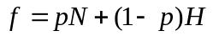,
in which N, H and p stand for the maximum number of the pans, the heat distribution uniformity, and the weight coefficient, respectively. Then, by assigning the rational range of sizes as the constraint condition and setting the integrated function as the objective function, the nonlinear integer programming is built. At last, the numerical experiment is carried out. In the experiment, 0.1 is set as the step size of p in [0.1, 0.9]. The result shows that f is maximized when the width to length ratio of the oven, the weight p equal 0.993, 0.7 respectively, and the corresponding 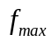 attains to 18.096. Model 2 is robust, and based on the model, the optimum pan can be designed once the size of the customer’s oven is given.
In addition, we also create an advertisement for the new Brownie Gourmet Magazine to promote the new product.

Keywords: Fourier’s heat conduction equation, Circular degree, The edge thermal distribution model, Nonlinear integer programming, Optimum pan

Content

- Introduction
  - Background
  - Restatement of the problem

- Assumptions

3 Our Model
3.1 The Edge Thermal Distribution Model (Model 1)
3.1.1 Heat Transfer Analysis
3.1.2 The heat Distribution f brownie pan
3.2 The Nonlinear integer programming Mode1 (Model 2)
    - Circular degree
    - Shapes in between
3.2.3 The establishment and solving of the model

4 The discussion of results

5 References

6 Advertisement for the new Brownie Gourmet Magazine

1. Introduction
1.1 Background
Heat is focused in corners and the product gets overcooked at the corners while baking in a rectangular pan, if not to such an extent, at the edges. By contrast, in a round one the heat is distributed evenly over the entire outer edge if the setting temperature is reasonable, and the product is not overcooked at the edges. However, since most ovens are rectangular in shape, consequently, when it comes to making use of the space in an oven, using round pans is not efficient.
1.2 Requirements of the Problem
In order to find the heat distribution rule in different shapes and design the Ultimate Brownie pan which matches the oven and product, some tasks need to be fulfilled.
The first task is to establish a model to demonstrate the distribution of heat across the outer edge of a pan for pans in different shapes, including rectangular, circular and other shapes in between .
The second task is to develop a model that can be used to select the best type of pan (shape) both take the using efficiency of the space in an oven and the heat distribution uniformity of the heating pan into consideration.
1.3 The analysis of the problem
At the first step, we need to make certain the temperature distribution of products in different shapes in an oven. Our plan is retrieve the data of experiments carried out before and build the first model according to the basic disciplines of thermodynamics and then deduce the rule of temperature distribution of rectangular , circular and shapes in between. According to the Fourier’s heat conduction equation, during the heat transfer process, the transmission rate is proportional to the driving force of the process and is inversely proportional to the resistance of the process .In the baking process the driving force is the temperature diversity between pan and product, while the resistance of the process means the thickness of the product. Afterwards, we need to consider the structure size of the pan under the condition of the temperature distribution rule obtained by the first model. In order to get the optimum structure size of the pan, we have to search for the average range of the structure size of the pan in online shops, and then develop a constrained programming model selecting the optimum pan.
1.4 Organization of the paper
In Section 2, some assumptions are given. In Section 3, two models are provided. Model 1 is built for analysing the heat distribution of the heated product. Model 2 is developed for finding the ultimate Brownie pan . In Section 4, we discuss the results of our models.
2. Assumptions
Some assumptions are given as follows:
1. The oven performs steadily in the working process. In other words, on one hand, the power supply of the oven in the working process is steady, excluding any emergency such as a power failure. On the other hand, all the parts of the oven works normally and there is no possibility that components break down.
2. The width and length of the pan can be regarded to be close to those of the oven. The assumption is made by considering the full use of the space in an oven. It is certain that the shapes of small and large pans can be different and generally, the shape of the small pan taken into account is between rectangular and circular.
3. The product can be baked to be ripe under the temperature set by the oven.
If the product in the oven fail to be ripe, it is possible that the highest temperature the oven can reach is too low or the product has an even higher requirement for temperature. It is of no meaning to discuss the temperature distribution in the oven and to design the optimum pan if the product can not be baked to be ripe.
3. Our Model
3.1 The edge thermal distribution model (Model 1)
While baking a product, it is a commonplace phenomenon that the product is not evenly heated and the space in an oven is not used efficiently. In this paper two models are thus established to determine the optimum pan for the purpose of making full use of the space in an oven under the condition that the product is not locally overcooked.
3.1.1 Heat transfer analysis
The common rule of transfer process in nature is that in the transfer process the rate is proportional to the driving force of the process and is inversely proportional to the resistance of the process. According to the Fourier’s heat conduction equation given by Fourier in 1882, heat conduction rate Q can be expressed as [1]:
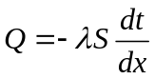. (3.1)
In the formula, stands for thermal conductivity, which depends on the characteristic of the material and temperature, and represents the sectional area of heat transmission. When the material of the wall is uniform, thermal conductivity varies little with the change of temperature. But in many cases the product not yet baked is not uniform in the combination of materials. For the purpose of showing this kind of change, we assign as linear with regard to. For a specific product, it is advised that an experiment should be implemented if possible to measure how changes when varies.
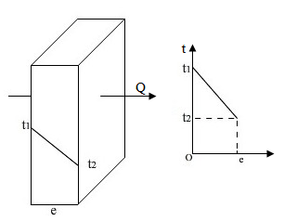

Figure 3.1: Singer-layer flat wall heat transfer
What the first picture in Figure 3.1 illustrates is the situation of single flat wall heat transfer, that is, heat transfers from side of high temperature to that of low temperature. By the equation (3.1), we can get:
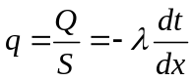. (3.2)
When change with linearly, we have:
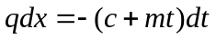 (3.3)
Where 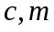 are constants. In this paper, we set c and m as 0.075w/(m.⁰C) and 0.0005w/m respectively. From the equation (3.3) and Figure 3.1, can be obtained as:
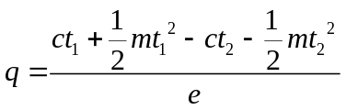. (3.4)
Replacing with and with , we can get the formula of single flat wall heat transfer:
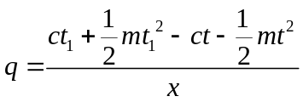. (3.5)
Figure 3.2 is three-dimensional objects thermal element. The larger cuboid is the product, and the smaller cuboid whose vertex is O is set as the subject being heated.
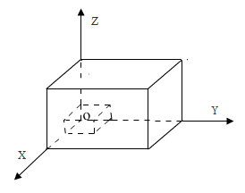
Figure 3.2: Three-dimensional objects thermal element
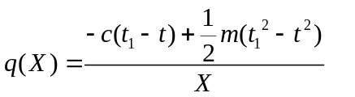 (3.6)

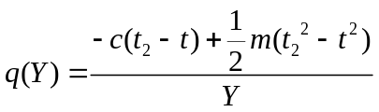 (3.7)
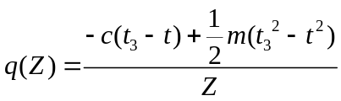 (3.8)
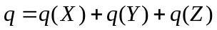 (3.9)

where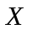,,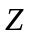 are three coordinates of any point in the small cuboid, and , , are the average temperatures of planes 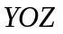,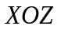,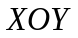 of the big cuboid. YOZ,,planes are the three contact surfaces of the pan and the product.
To simplify the process of heat transfer, we set as the room temperature.
3.1.2 The heat distribution of the Brownie pan
Using formulas (3.6), (3.7), (3.8), (3.9), where equals to 20°C, we write a Matlab codes [2] to show the distribution of heat for pans of different shapes, including rectangular, round and the shapes in between.
When Top and Bottom convective fan speeds are both 0, temperature is set as 180°C, and when the baking time is 6 min, temperatures of Top, Side, Bottom are 104,81,101 °C respectively [3]. The heat value of the point (X,Y,Z) can be obtained based on the formula above, and different values are painted by different colors. The simulation of heat distribution is then acquired by connecting all the points. In it, as heat rises, the color turns from blue to red.

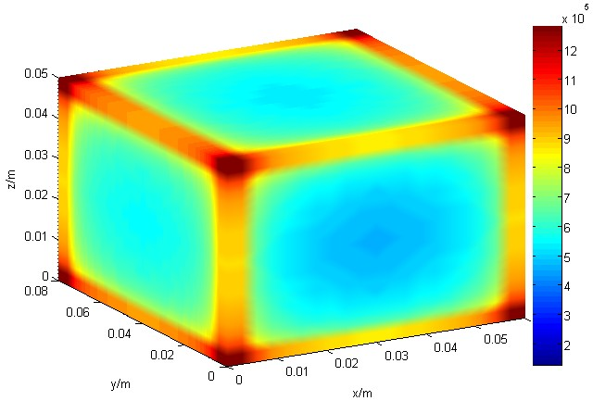
Figure 3.3: The rectangular product heat distribution
Figure 3.3 explicitly illustrates that in a rectangular pan, the four corners get more heat per unit area than other positions, so it can be concluded that the corners of the rectangular pan tend to be overheated locally. For baking a product, when the product is locally overheated, there are two possible results. If the baking time is too short, the part that is locally overheated will be ripe while other parts are not. If baked for too long a time, the product will be entirely overcooked. Consequently, local uneven heating is not a favorable result.
Table 1 The simulation results of heating the top plane of rectangular pan
 | 0.00 | 0.80 | 1.60 | 3.20 | 4.40 | 5.60 | 6.80 | 8.00
0.00 | 1579.26 | 1559.26 | 1529.26 | 1499.23 | 1479.23 | 1509.26 | 1539.26 | 1579.26
0.60 | 1094.45 | 861.35 | 721.49 | 686.52 | 674.87 | 694.85 | 744.80 | 1094.45
1.50 | 983.58 | 750.48 | 610.62 | 575.66 | 564.00 | 583.98 | 633.93 | 983.58
2.40 | 955.86 | 722.76 | 582.90 | 547.94 | 536.28 | 556.26 | 606.21 | 955.86
3.30 | 946.63 | 713.53 | 573.67 | 538.70 | 527.05 | 547.03 | 596.98 | 946.63
4.20 | 962.46 | 729.36 | 589.50 | 554.54 | 542.88 | 562.86 | 612.81 | 962.46
5.10 | 1002.06 | 768.96 | 629.10 | 594.13 | 582.48 | 602.46 | 652.41 | 1002.06
6.00 | 1279.23 | 1046.13 | 906.27 | 871.30 | 859.65 | 879.63 | 929.58 | 1279.23
From Table 1, we can know that on a plane, heat at the outer edge is higher than that of the inside part.
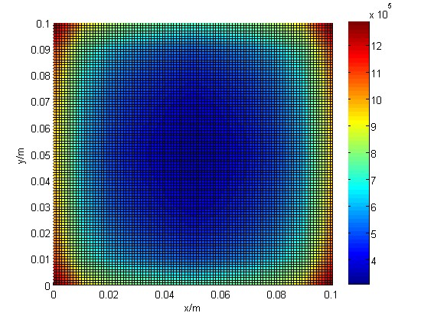
Figure 3.4: The section heat distribution of rectangular product

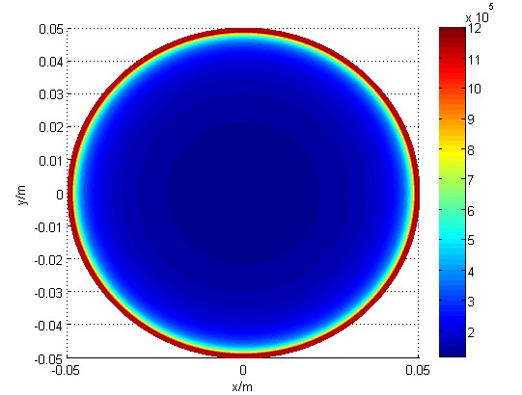
Figure 3.5:The section heat distribution of round product
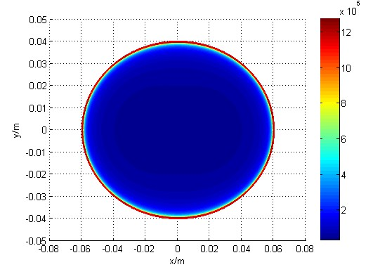
Figure 3.6:The section heat distribution of the shape between rectangular and round

By using Model 1, we have simulated the heat distribution of circular, rectangular and shapes in between. From the above figures, we can see that the heat distribution of shapes in between is evener than that of rectangular but not so even compared with circular.
3.2 The Nonlinear integer programming model (Model 2)
For one thing, the space of the two racks in the oven must be made full use of. For another, the uniformity of heating the product on the pan should also be taken into consideration. In a general way, the four corners of a product on a rectangular pan are easily overheated, which can be avoided by using a circular one. In other words, by using a circular pan, the product being baked can be heated more evenly. To quantify the index (namely, the uniformity of heating the product), we define the concept of circular degree.
3.2.1 Circular degree
In the principles of chemical industry, for an object of arbitrary shape, the sphericity of the object is defined as 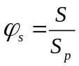, in which stands for the surface of the ball whose volume amounts to the object and 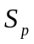 represents the surface of the object. Similarly, the circular degree can be defined.
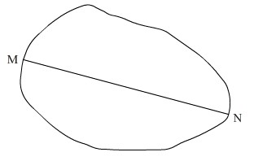
Figure 3.7: arbitrary shaped flat object

As Figure 3.7 shows, it is a flat object without thickness, on whose contour line the maximum value of distance between any two points is 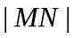, the circular degree is defined as 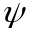=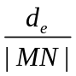, in which 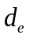 represents equivalent diameter and 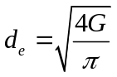,  stands for the area of the arbitrary shaped object. In a rectangular whose length is and width is , when cutting a sector of relatively small area, for convenience, the current circular degree is defined as 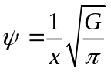. Based on the conclusion drawn by Model 1, the circular pan is heated more evenly than non-circular one. Therefore, the uniformity of heating 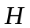 can be replaced by the circular degree.
3.2.2 Shapes between rectangular and round
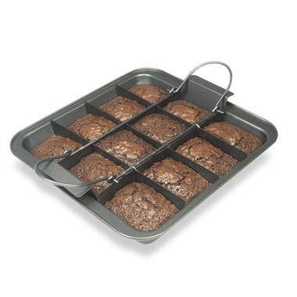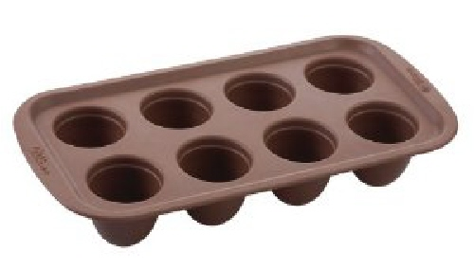
Figure 3.8: Rectangular Brownie pan Figure 3.9: Round Brownie pan
Figure 3.8 [4] presents a rectangular Brownie pan which overheats the product while baking. It is not the customer wants.
Figure 3.9 [5] shows a circular Brownie pan whose merit is that it heats the product evenly and it produces aesthetic food. The shortcoming of the round Brownie pan is that much space of the pan is not efficiently used.
As Figure 3.10 demonstrates, the length PQ of rectangular MPQN is 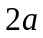, the width (MP) is 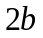, W and S are points of intersection of oval ACBD and rectangular MPQN in the first quadrant, and the horizontal ordinates of W and S are 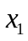 and 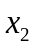(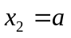) separately. The coordinate of point X1 is (,0),the coordinate of point X2 is (,0). WSQZZ’R’S’W’W are the shape between rectangular and circular. The equation of oval ACBD is:
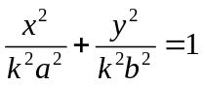 (3.10)
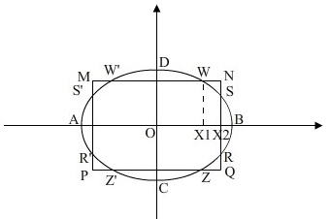
Figure 3.10: The shape between rectangular and round
In the equation (3.10), 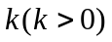is an undetermined parameter and the shape of WSQZZ’R’S’W’W varies when changes. When the value of is 1, WSQZZ’R’S’W’W becomes an oval, and if at the same time the value of equals to that of , WSQZZ’R’S’W’W transforms into a circular. Consequently, it is rational to use WSQZZ’R’S’W’W to signal shapes between rectangular and circular.
The length of SX₂ is assigned as , and the area of shape between rectangular and circular can be expressed as:
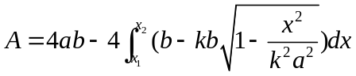 (3.11)
Additionally, since the points W and S are both on the oval, after plugging W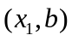 and S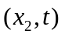 into the elliptic equation, an equation can be acquired as follows:
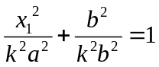 (3.12)
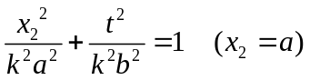 (3.13)
Then the area 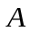 is equal to:
(3.14)
3.2.3 The developing and solving of the model
After consulting several online shops [6],[7],[8], the structure size of the pan can be listed in Table 2.
Table 2 The size range of the pan in the oven
Parameter | variation | Parameter | variation | Parameter | variation
L | 0.25—0.50m | a | 0.0025—0.06m | N1 | 1—10
W | 0.150—.30m | b | 0.15—0.04m | N2 | 1—10
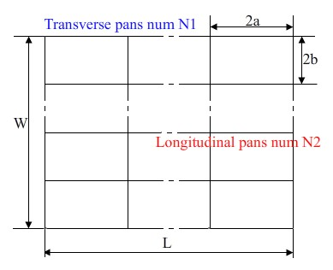
Figure 3.11: An explanation of the variations in Table 2
In the transverse direction of the pan, the total length of pans should be less than the length L of the pan. In the longitudinal direction, the total length of pans should be less than the total width W of pan. So these relations can be expressed as:
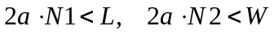 (3.15)
The total area of pans should be less than that of the pan. So we have the following inequality:
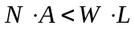 (3.16)
In order to maximize number of pans that can fit in the oven (N) and at the same time maximize even distribution of heat (H) for the pan, we define the combination function :
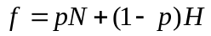 (3.17)
Based on the analysis above, we can develop the Nonlinear integer programming model below:
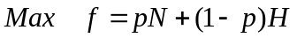
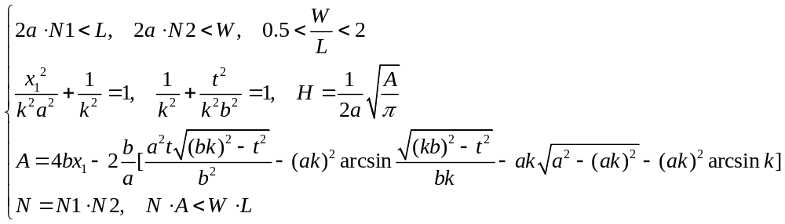
(3.18)
By solving the model (3.18) using the software 1stopt [9], we can know that how changed when 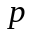 varies. The changes are illustrated in Table 3 below.
Table 3 The results of Nonlinear integer programming model
N | N1 | N2 | c | p | 1-p | W/L | f
6 | 6 | 1 | 3.05 | 0.1 | 0.9 | 0.775 | 3.345
15 | 3 | 5 | 2.66 | 0.2 | 0.8 | 0.654 | 5.128
10 | 2 | 5 | 2.33 | 0.3 | 0.7 | 0.588 | 4.631
18 | 9 | 2 | 2.92 | 0.4 | 0.6 | 0.586 | 8.952
16 | 2 | 8 | 2.43 | 0.5 | 0.5 | 0.915 | 9.215
21 | 3 | 7 | 2.76 | 0.6 | 0.4 | 0.839 | 13.704
24 | 6 | 4 | 4.32 | 0.7 | 0.3 | 0.993 | 18.096
21 | 7 | 3 | 1.79 | 0.8 | 0.2 | 1.786 | 17.158
18 | 3 | 6 | 3.62 | 0.9 | 0.1 | 0.618 | 16.562
The table above illustrates that the maximum value of is 18.096, and the optimum value of is 0.7. Currently, W/L is close to 1. It means that when the pan and the section of the oven are both close to square in shape, they are the best match.
At this time, the whole pan is divided into 24 smaller pans (the pattern is 6×4). Figure 3.12 is the one of optimum pan.

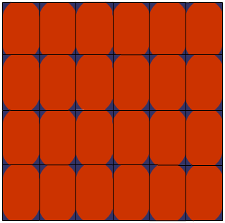
Figure 3.12: The ultimate Brownie pan pattern

4. The discussion of results
The pan designed according to our models are both practical and aesthetic, which may avoid locally overheating the product in the oven, in other words, to make the ripe product uniform in texture. At the same time, it is energy-saving and environment
-friendly to make use of the oven to the fullest.
Generally speaking, different oven owns different structure size, the optimum W/L obtained is not necessarily fitting to that of the customer’s oven. The optimum W/L obtained by Model 2 can work in designing matched ovens and pans. Moreover, if the customer only needs to purchase a pan, as long as he or she informs the manufacturer of the structure size of his own oven, the manufacturer can use Model 2 to determine the most suitable pan for him or her.
Of course, some weaknesses also exist in Models 1 and 2. For example, there is a lack of analysis on thermal radiation’s heating the product, and a deliberate study on the rule of temperature distribution in different ovens is not studied.
Overall, the models established succeed in providing a complete solution to designing the optimum pan, which can offer an effective theoretical basis for manufacturers to produce ovens as well as pans.

5.References
[1]T.N.Narasimhan. 1999.Fourier’s heat conduction equation: History, influence, and connections.Proceedings of the Indian Academy of Sciences - Earth and Planetary Sciences108:117-148.

[2]Kalechman Misza. Practical Matlab Applications for Engineers . CRC Press Inc .2008-09.
[3]P.Navaneethakrishnan,P.S.Srinivasan,S.Dhanapani.Numerical and experimental investigation of temperature distribution inside a heating oven.Journal of Food Processing and Preservation34:275-288.
[4]http://www.bedbathandbeyond.com/EnlargeProduct.asp?SKU=16034290&ZMPHT=380/11222116034290p.jpg.
[5]http://4.bp.blogspot.com/ZDY30OpBiUE/TjCxLrYcLaI/AAAAAAAACYA/mpnGj7X2zD4/s1600/brownie+bites+pan.jpg.
[6]http://www.bestbuy.com/site/Ranges/GasRanges/pcmcat196400050015.c?id=pcmcat196400050015.

[7] http://www.getprice.com.au/ovens.
[8] http://www.sears.com/appliances-wall-ovens.
[9] http://www.itprogramtutorial.com/531623/

6. Advertisement for the new Brownie Gourmet Magazine

More delicious ,More beautiful, More energy-saving
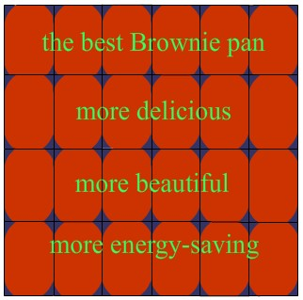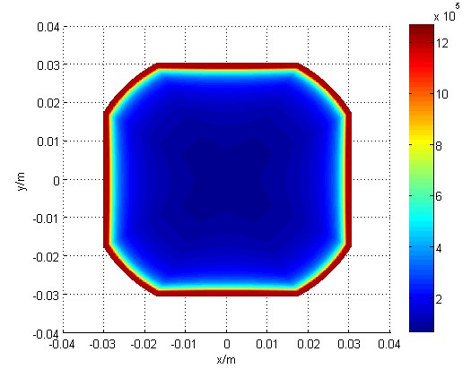
All could-be virtuous housewives, attention please! You are all desirous of catering to the appetites of your husband and children, aren’t you? Unfortunately, how could you live up to their expectation when you take out your “masterpiece”-a cake overcooked or not yet ripe from a conventional-style pan? You want to rebuild their trust in your cooking skill, right? Now your moment is coming! Why don’t you buy a new pan that matches your oven since you are elaborating on how to precisely adjust the baking time?
If you use a conventional-style pan that is not rationally designed with regard to its shape, there are two possible results when you finish baking. If the baking time is too short, the part that is locally overheated will be ripe while other parts are not. If baked for too long a time, the product will be entirely overcooked. Additionally, the space as well as the energy in the oven is not efficiently used. Can you, smart and thrifty, tolerate this cruel fact?
Recently, our team designed an optimum pan that matches the best to the oven based on the scientific law of heat transfer. To start with, the one-dimensional model of the heat transfer process is built by applying Fourier’s Heat Conduction Equation come up with by Fourier, a French mathematician, in 1882. Afterwards, the result is generalized to three-dimensional space and the model of heat transfer is hereby developed in three-dimensional space. Through the analysis on the three-dimensional model of heat transfer, the picture showing the distribution of heat of the product in pans of different shapes. This picture clearly presents that the rectangular pan will overcook the product while the circular one can evenly heat it. Regrettably, the oven is not efficiently made use of while using the circular pan. After considering all the factors comprehensively, a shape in between can be obtained to satisfy the customer’s need. When the ratio of width to length is 0.993, the pan is optimum (as the picture above illustrates). On this condition, the product it bakes is the most delicious and energy-saving.
The pan we designed integrates rectangular with circular and has an elegant appearance, which is the best choice for you who have a deep love for your family.

