Wondershare PDF Converter Sample

[**Wondershare PDF Converter**](http://www.wondershare.com/pdf-converter/) helps you convert PDF to most of the popular

document formats. You can reuse, modify or present content by converting PDF files

to familiar office formats easily, or convert PDF to EPUB for better reading

experience in mobile devices. For simplicity, speed, accuracy and flexibility, PDF

Converter can be your good assistant.

**(1) Convert PDF to popular formats accurately and flexibly**

**PDF to Office:** Still retyping the content from PDF to Microsoft Office? PDF

Converter can convert PDF to Word (.doc, .docx), PowerPoint (.ppt,.pptx) and

Excel(.xls,.xlsx) within seconds. It preserves the original text content, layouts, tables,

images and even hyperlinks after conversion. You can spend less time reformatting

the output document after conversion.

**PDF to EPUB:** EPUB is a reflowable format; you can convert PDF to EPUB and read

EPUB on mobile devices. It enables you enjoy reading your PDF by flipping the

pages like a book or adjusting the formats to fit the screen automatically. In addition,

PDF Converter provides advanced options that allow you to customize the output

EPUB files, such as the font size, background color, etc.

**PDF to HTML/Text:** PDF Converter converts PDF files to web-ready HTML pages

with all the elements precisely preserved. Or you can convert PDF to Text for reusing

text content easily.

1

Copyright © 2011 Wondershare Software Co., Ltd. All rights reserved.

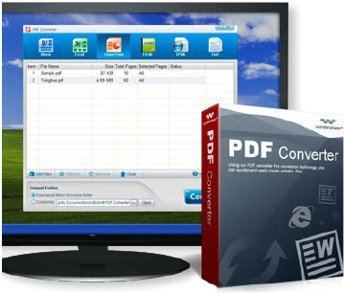

Wondershare PDF Converter Sample

**(2) 2 Efficient Conversion Modes**

Batch conversion---Convert as many as 200 PDF files at one time

Partial conversion---Select any pages from the multi-page PDF file to convert

**(3) Support Encrypted PDF Files Conversion**

If you are authorized, you can convert PDF files with copying and printing restrictions

directly. However, if the PDF requires open password, you need to enter the password

before conversion. Most of the PDF Converters fail to convert PDF with any kinds of

securities

**Pro version is available!**

[**Wondershare PDF Converter Pro**](http://www.wondershare.com/pdf-converter/) adds OCR (Optical character recognition)

technology on the basis of standard version. Spend less time retyping, you can extract

text from scanned PDF to make the content searchable and editable directly. Reusing

content can be much easier. Pro version provides you a smarter way to deal with PDF

documents.

2

Copyright © 2011 Wondershare Software Co., Ltd. All rights reserved.

