## Abstract

Firstly, we analyze the reasons why leaves have various shapes from the perspective of Genetics and Heredity.

Secondly, we take shape and phyllotaxy as standards to classify leaves and then innovatively build the Profile-quantitative Model based on five parameters of leaves and Phyllotaxy-quantitative Model based on three types of Phyllotaxy which make the classification standard precise.

Thirdly, to find out whether the shape ‘minimize’ the overlapping area, we build the model based on photosynthesis and come to the conclusion that the leaf shape have relation with the overlapping area. Then we use the Profile-quantitative Model to describe the leaf shape and Phyllotaxy-quantitative Model to describe the ‘distribution of leaves’, and use B-P Neural Network to solve the relation. Finally, we find that, when Phyllotaxy is determined, the leaf shape has certain choices.

Fourthly, based on Fractal Geometry, we assume that the profile of a leaf is similar to the profile of the tree. Then we build the tree-Profile-quantitative Model, and use SPSS to analyze the parameters between Profile-quantitative Model and tree-Profile-quantitative Model, and finally come to the conclusion that the profile of leaves has strong correlation to that of trees at certain general characteristics.

Fifthly, to calculate the total mass of leaves, the key problem is to find a reasonable geometry model through the complex structure of trees. According to the reference, the Fractal theory could be used to find out the relationship between the branches. So we build the Fractal Model and get the relational expression between the mass leaves of a branch and that of the total leaves. To get the relational expression between leaf mass and the size characteristics, the Fractal Model is again used to analyze the relation between branches and trunk. Finally get the relational expression between leaf mass and the size characteristics.

Key words：Leaf shape, Profile-quantitative Model, Phyllotaxy-quantitative Model, B-P Neural Network , Fractal,

## Content

The Leaves of a Tree 1

Abstract 1

Content 2

1. Problem Description 3

2. Problem Analyses 3

3. Solution 4

3.1. Problem 1 4

3.2. Problem 2 5

3.2.1 Classify by Profile_ Profile-quantitative Model 5

3.2.2 Classify by Phyllotaxy_ Phyllotaxy-quantitative Model 6

3.2.3 Classify by Size 7

3.3. Problem 3 7

3.3.1 Leaf Shape and Overlapping 7

3.3.2 The Relationship Between Phyllotaxy and Leaf Shape Based on B-P Neural Network 9

3.4. Problem 4 12

3.5. Problem 5 14

3.5.1 Estimate the Mass of the Leaves on A Tree 14

3.5.2 The Correlation Between the Leaf Mass and The Size Characteristics of The Tree 18

4. Letter 20

5. Reference 21

6. Appendix 22

Appendix1: 22

Appendix2: 28

# Problem Description

"How much do the leaves on a tree weigh?" How might one estimate the actual weight of the leaves (or for that matter any other parts of the tree)? How might one classify leaves? Build a mathematical model to describe and classify leaves. Consider and answer the following:

Why do leaves have the various shapes that they have?

Do the shapes “minimize” overlapping individual shadows that are cast, so as to maximize exposure? Does the distribution of leaves within the “volume” of the tree and its branches effect the shape?

Speaking of profiles, is leaf shape (general characteristics) related to tree profile/branching structure?

How would you estimate the leaf mass of a tree? Is there a correlation between the leaf mass and the size characteristics of the tree (height, mass, volume defined by the profile)?s

In addition to your one page summary sheet prepare a one page letter to an editor of a scientific journal outlining your key findings.

# Problem Analyses

In order to describe and classify the leaves, the first step is to make sure which characteristic of the leaf is apt to be observed. From the perspective of the individual leaf, the optional characteristics consist of the leaf’s shape, size and structure and so on. Besides, in term of the correlation among several leaves, the focus is on their distribution--that is, phyllotaxy, and with thinning, we could come out with the following branch structure.

Opposite Phyllotaxy

Phyllotaxy

Shape

Size

Structure

Alternate

Fascicled

Profile

Leaf margin

Thickness

Coniferous

Broad-leaf

**Figure 1 Different ways to describe leaves**



In the article, we choose the profile and the phyllotaxy as the breakthrough point and attempt to find the proper indexes to make the accurate description varying from the different leaves. And based on the index, we classify the leaves and find a proper correspondence between the two.

By now, 5 problems have been solved in this article:

1. The explanation to the existence of leaves having the various shapes.
2. The construction of the model to describe and classify the leaves.
3. The correlation between the shape of the leaf and the phyllotaxy.
   1. The principle to minimize overlapping individual shadows and maximize exposure, which is met by the leaves
   2. The effect the phyllotaxy may have on the shape of the leaf
4. The correlation between the shape of the leaf and the tree profile/branching structure.
5. The leaf mass of the tree.
   1. Via estimating the leaf mass of the tree.
   2. The related conclusion of the correlation between the leaf mass and the profile of the tree.

# Solution



## Problem 1

The shape of leaf is determined by the g[erm plasm](dict://key.0895DFE8DB67F9409DB285590D870EDD/germ%20plasm) and the living situation, which means the intrinsic and extrinsic factors. [1]So, we will discuss why different leaves have different shapes from three respects.

The intrinsic factors:

Different plants have different genetic information which results in various protein products. This phenomenon makes the leaves become different even they are in the same environment.

The extrinsic factors:

The leaves that grow on the [crown of a tree](dict://key.0895DFE8DB67F9409DB285590D870EDD/crown%20of%20a%20tree) will be exposed to the sun for a longer time than other leaves, which makes these leaves grow smaller. These leaves also have complicated limb, which makes these leaves lose heat quickly. The leaves under the crown of a tree are shaded a lot, which makes them become larger and more simply. This also enlarges the surface which absorbs lights.

The intrinsic and extrinsic factors:

According to the Darwin's theory of evolution, the plant will change its characteristic size, which also includes the process of leaf-changing, to adapt the environment in order to live. The shape of the leaves including the profile, thickness, and the leaf margin. Broad leaves, growing in the tropics and subtropics where light and water are sufficient and the temperature is high, are often found on the trees and they are thick and round to storage more nutrition because of the strong [photosynthesis](dict://key.0895DFE8DB67F9409DB285590D870EDD/photosynthesis). In the [temperate](app:ds:temperate) zone and the frigid [zone](app:ds:zone),as well as mountainous area, the light and water are insufficient and the temperature is low. So the surface of the leave will be small and narrow. Some of them even become acerose. They are also thinner and weaker, which makes them be more likely to fracture. [2]

## Problem 2



### Classify by Profile_ Profile-quantitative Model

The leaf profile is classified into 13 types. The Coniferous has 4 types - scale-like, awl-like, linear and needle-like and the Broad-leaf has 9 types - linear, oval, oblong, ovate, obovate, deltoid, cordate, elliptical and lanceolate.[3] But this description does not offer a standard based on quantification, so we build a model to offer a quantitative model to classify the leaves by profile.

* Symbol Definition

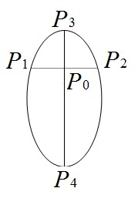

**Figure 2 A rough leaf model**

Assume thatis the axis of the leaf. Letbe leaf apex and be leaf bottom. Line segmentis vertical to. is either on the boundary of the leaf. Define the intersection of and when get its max value, set

、。

**parameter**: To quantize the position of . The range is 

**parameter**: To quantize the ratio ofto. The range is 

**parameter**: To distinguish leaf bottom. The range is

**parameter**: To distinguish leaf apex. The range is

**parameter**:The range is . 1represents simple leaf and 2 represents compound leaf.

By measuring the leaves of different shapes listed above, we can get the result as following.

 

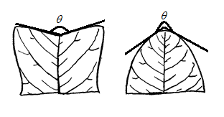

**Figure 3 Two types of leaf apex**

If  in Figure 2,. If ,

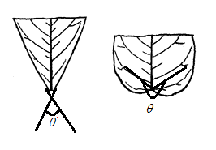

**Figure 4 Two types of leaf bottom**

If in Figure 3,. If ,

* **Classify the Shape**

Becauseeach represents a feature of a leaf, the sequencecan be used to represent the shape of a leaf and all the known leaf shapes can be interpreted into , and the table below lists part of the interpretation result.

|  |  |
| --- | --- |
| Leaf Shape |  |
| Eucryphia Glutinosa | 23212 |
| White Ash | 32212 |
| Silver Gum | 21121 |
| Indian Bean Tree | 32221 |
| Chilean Fire Bush | 13211 |
| ...... | ...... |

**Table 1 The interpretation from scientific names tosequences**

### Classify by Phyllotaxy_ Phyllotaxy-quantitative Model

The phyllotaxy of the leaves can be classified into 3 types - alternate, opposite and fascicled. [4] To quantize the phyllotaxy, we can set the value of each phyllotaxy as the following table shows.

|  |  |
| --- | --- |
| Phyllotaxy | Valu |
| Alternate | 0 |
| Opposite | 1 |
| Fascicled | 2 |

**Table 2** **The value of each phyllotaxy type**

### Classify by Size

The tree is classified into two types - coniferous tree and broad-leaf tree - according to whether its leaf is needle-like or broad. And leaves can be easily distinguished by this standard of classification just like Figure.

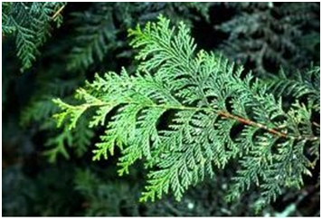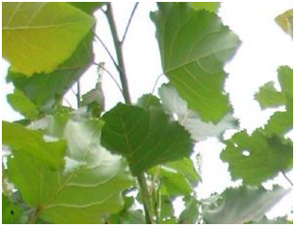

**Figure 5 the left part is coniferous tree and the right part is broad-leaf tree**

## Problem 3



### Leaf Shape and Overlapping

* **Problem Analyses**

Photosynthesis is “the most important chemical process on earth”[5] and it is a main function of the leaves, so the photosynthesis is taken into consideration to analyze if shapes “minimize” overlapping individual shadows that are cast.

* **Model Assumption**

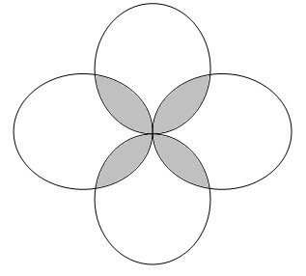

Figure 6 **Rough leaf model. The uncovered part (white part) is defined as and the overlapping part (gray part) is defined as **

1. The shape of the leaf before fully evolved follows that in Figure 6
2. The surroundings are invariable everyday

* **Symbol Definition**

 The length of a day

 The ratio of the effective time length of photosynthesis atpart to 

 The ratio of the effective time length of photosynthesis atto 

 The average rate of photosynthesis atpart, which is measured by the consuming rate of ()

 The average rate of photosynthesis atpart ()

 The average rate of respiration atpart, which is measured by the consuming rate of ()

 The total area of the leaf

 The area of part

 The area of part

 The absorption of per day

 The release of per day

 The net absorption of per day

* **Construction of the Model**

The expression of absorption of per day is



The expression of release of per day is



The expression of net absorption of per day is



It is obviously that 

Then the net absorption of CO2 per day satisfies the following expression:



* **Results Analyses**

We take  as an independent variable in the consideration of the overlapping individual shadows. Then , the net absorption of per day, is a linear function on the variable . And the slope of this linear function will be  of less than zero according to the data in the reference[6];

The equation tells us that the plant could gain more photosynthetic products if it minimized the overlapping individual shadows during the evolutionary process.

To minimize the overlapping part, the fully evolved leaf shapes should satisfy the following two requirements theoretically（Figure 7）：

1. The leaf bottom should be sharp, meaning that most leaves satisfy[1]
2. The widest part should be away from the leaf bottom, meaning that most leaves satisfy[2]

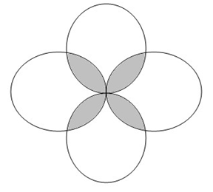

**Figure 7 The leaf part is the rough leaf model and the right part is the fully-evolved leaf**

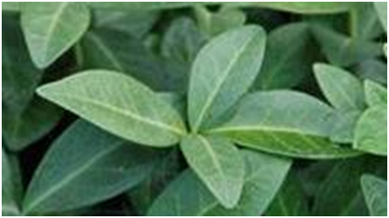

According to the data in Appendix 1, it is easily to get result: The average C is 2.32 and the average A is 1.87.

From the result above, the practical data fits the supposed theories, so we can come to the conclusion that ‘the shapes ‘minimize’ overlapping individual shadows cast, so as to maximize exposure’.

### The Relationship Between Phyllotaxy and Leaf Shape Based on B-P Neural Network

* **Problem Analyses**

This problem requires us to answer if the distribution of leaves effect the leaf shape. To quantize ‘the distribution of leaves’, we introduce the concept of ‘Phyllotaxy’[7] and use the standard written in 3.2.2. To quantize the leaf shape, we use the standard written in 3.2.1, and sum the value of Parameter and if the leaves belong to the same Genus and has the same. And part of the result is shown in Table3

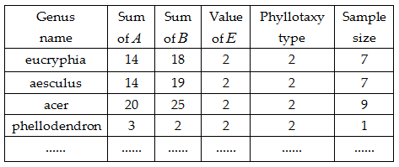

**Table 3**

According to the reference[4], the Phyllotaxy of each broad-leaf tree is Opposite or Fascicled, so if the Phyllotaxy is Alternate, the leaf shape should be needle-like. Then the core work fall on the research of the relationship between Phyllotaxy and leaf shape among broad-leaf trees.

* **Model Assumption**

Thesequences are mostly invariable if the Phyllotaxy and Parameterare both same among the identical Genus;

* **Construction of the Model**

1. **The extraction of characteristic and training-sample’s building**

By using the result of Table 3, we get the average value of Parameter and as Table 4 lists.

|  |  |  |  |  |
| --- | --- | --- | --- | --- |
| Genus name |  |  | value of | Phyllotaxy type |
| eucryphia | 2.0000 | 2.5714 | 2.0000 | 2 |
| aesculus | 2.0000 | 2.7143 | 2.0000 | 2 |
| acer | 2.2222 | 2.7778 | 2.0000 | 2 |
| phellodendron | 3.0000 | 2.0000 | 2.0000 | 2 |
| ...... | ...... | ...... | ...... |  |

**Table 4**

According to Table 4, we can get the input and output matrix (Figure 8) as the train-sample.

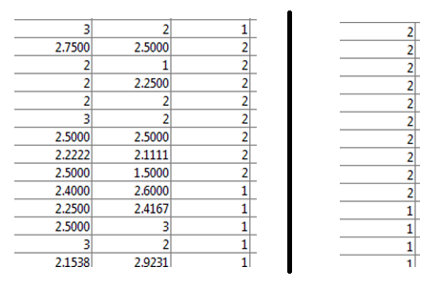

**Figure 8 The left part shows the input matrix and the right part shows the**

**output matrix.**

1. **Build and test the BP** **Neural Network**

Set the parameters for BP Neural Network as Table 5 shows

|  |  |  |
| --- | --- | --- |
| neuron numbers  on each layer | [transfer](app:ds:transfer) [function](app:ds:function) | training algorithm |
| [25,3] | {'logsig','purelin'} | 'trainlm' |

**Table 5 Parameters of the BP Neural Network**

Build B-P Neural Network through Matlab, and the get the error-changing curve as Figure 9 shows

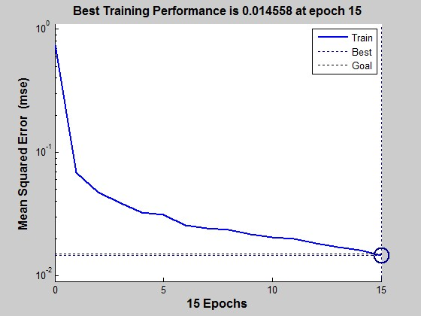

**Figure 9 Error-changing curve**

Use the testing data to simulate and get the result (in Figure 10). Through calculating, we can get the accuracy rate is 96.77%, so there is relationship between Phyllotaxy and leaf shape

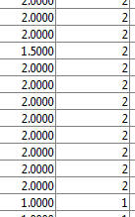

**Figure 10 part of the simulation result**

1. **Get the relationship between Phyllotaxy and leaf shape**

Give the definition of ’ABE-Standard Shape Matrix’:

Its format is and make up the full array of ABE.

Use ’ABE-Standard Shape Matrix’ as the input matrix and simulate through the B-P Neural Network above and then we get the relationship between Phyllotaxy and leaf shape as the Figure 11 shows.

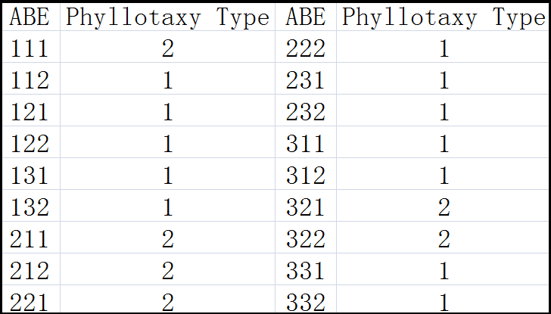

**Figure 11 Relationship between Phyllotaxy and leaf shape**

For Alternate, its corresponding leaf shape is needle-like, whose sequence is 23210.

Although it is impractical to infer the leaf shape just by Phyllotaxy, but we can get the range of the leaf shape according to the Figure 12? So we can come to the conclusion that ‘the distribution of leaves within the volume of the tree and its branches affect the shape’.

## Problem 4

* **Problem Analyses**

‘Methods of fractal geometry have been used by several investigators to draw fern-like shapes’[8]. If take the branches structure as fern-like shape, the theory of Fractal geometry can be used to find the relation between leaf shape and tree shape, and then the leaf shape and its tree shape will be self-similar. Like the definition of Parameter, we introduce the Parameterand to describe the profile of a tree. And the core work falls on finding whether there is a relationship between and of the same tree.

* **Symbol Definition**

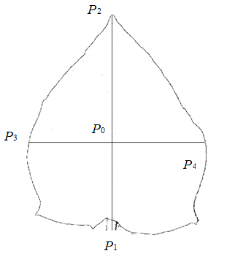

Figure 12 **Model of a tree profile**

Assume that P1P2 is the trunk of the tree; P1 is the intersection point of the tree profile and the P1P2; P2 is tree apex; P3P4 is vertical to P1P2. Define and 

Then we get the range of At and Bt

 

* **Construction of the Model**

According to the Appendix 2, collect the of the same tree and get the Table 6 below.

|  |  |  |  |  |
| --- | --- | --- | --- | --- |
| Scientific Name | A | B | At | Bt |
| Chinese Persimmon | 2 | 1 | 3 | 1 |
| Oleaster | 3 | 2 | 3 | 2 |
| Madrona | 2 | 2 | 2 | 2 |
| Eucommia Ulmoldes | 2 | 2 | 2 | 1 |
| Eucryphia Glutinosa | 2 | 3 | 2 | 3 |
| …… | …… | …… | …… | …… |

Table

Use SPSS to analyze the correlation of AB and At Bt and get the analyses results (Table7 and Table 8)[9]

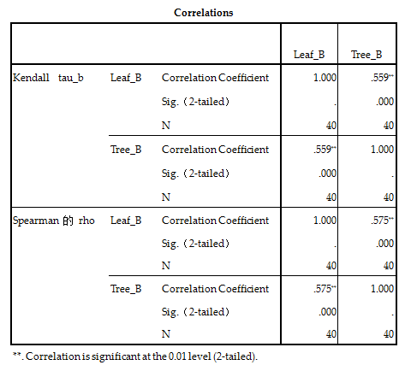

**Table 7 The correlation analyses between A and A**

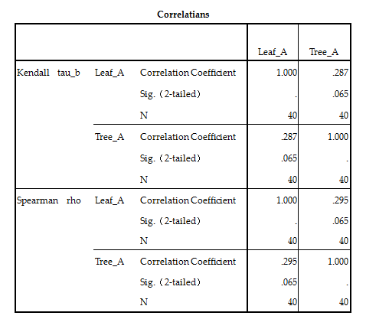

**Table 8 The correlation analyses between B and Bt**

* **Result Analyses**
* A and At

There is no strong correlation between A and At according to the result above. From the result analyses of 3.3.1, to most leaves, the inequalityindicates the requirement for full photosynthesis which won’t happen for At as a result of the requirement of lower bar center by the tree. So the result is reasonable.

* B and Bt

There is strong correlation between B and Bt according to the result above.

Consequently, we come to the conclusion that: Speaking of profiles, the leaf shape has strong relation with the tree profile on some general characteristics and has weak relation with certain characteristics, e.g. Parameter A due to the special requirement.

## Problem 5



### Estimate the Mass of the Leaves on A Tree

* **Model Analyses:**

The idea to estimate from the parts to the whole is a reasonable approach to estimate the mass of the leaves on a tree. Firstly, to get the exact mass of the part, and then, via the proportional relationship between the mass of the part and the whole, the mass of the integer can be calculated. Moreover, the concept of the part and the whole are both relatively called. For instance, according to the layer idea, the”part” of the upper layer could be regarded as the “whole”, from the lower one’s perspective. Following the clue, people could focus on the part that can be measured or counted exactly. And then, along with the contrary direction, based on the measuring result of the smallest part, the related result of the top layer could be evaluated layer by layer.

From the perspective of a tree, the correlation of the part and the whole mentioned above should take some related theory of the Fractal into account. In the nature, the way that the branches grow apart also meets the fractal structure, namely, meets the self-similarity among all the typical characteristics of the fractals, which is analyzed according to the document from the site[10]. And the self-similarity is just the similarity of the part and the whole. According to this feature, the following model could be established.

* **Model Assumption**

Based on the self-similarity of the Fractal, the following assumption could be safely made.

* The distribution of branches in the integer and the part is totally the same, as shown in Fig 3.1(and keep mind of the correspondence) that classifies the branches into different layers according to the age sequence of growing. For example, the main branch is called branch of Layer 0, and the sons of the main are called Layer 1, then the branch growing at Layer 1 is called Layer 2, and do on. And each two adjacent layers share the same distribution condition, that is, the distribution of Layer 2 at Layer 1 is just the same with the one of Layer 1 at Layer 0.
* Defining the relationship of the upper and lower layer as the “paternity”, we rate all the son branches of one parent branch. The one closer to the bottom of the parent branch would be rated as the lower class, and the ratio of the length of the class branch to that of the  class branch if they both share the same father.

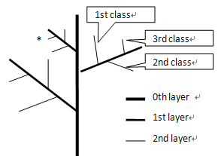

Figure

* **Symbol Definition**

 The length of the trunk

 The mass of the collected branch

 The length of the collected branch

 The layer of the collected branch

 ,represents the class of a branch

which is the ancestor[3]. of the collected branch and is at the 

layer. For instance, the branch “*” in Fig 3.1 above is (1, 3, 3).

 The ratio of the length of branch at thelayer to that of branch at thelayer

 The number of the nodes at the same layer

 The total mass of the leaves

* **Construction of the Model:**
* Measure the height of main branch with the certain method;
* Take two branches of one tree at random, and tap as 1, 2;
* Measure the corresponding indexes--,,--separately.

1. Calculating ******andvia the experimental data:

According to the model assumption on Fractal, the following correlation could be resulted.



Where 

Take the actual data of the two groups of branches selected above into the equation, and two equations related to******andas followed could be got. Thus, the value of******andcould be calculated.





1. Estimating the value of 

According to the self-similarity of the Fractal, we could know that the layers of son branches sharing the common father branch are the same, namely, each parent branch have the same amount of sons. Therefore, ’s range could be determined through the limit of the branches’ length at the layer.

The length of the branch in the******class at the layer:



Then, regardless of the effect the result have on the extremely tiny branches, and only taking the branches meet the requirement----into account, we have  based on the field observation.

And then 

Thus, we have 

1. Estimating the mass of leaves on the integral tree based on the data of any certain branch

Because the tree obeys the fractal structure, the branch should follow the recursive structure, that is, one branch’s parent is also a branch. Based on that, if we can get the parent’s information through one branch, we could repeat this process and get the greatest ancestor’s information, that is, the tree itself, finally. The flow chart is as followed.

Yes

Is 0th layer

branch?

Calculate the branch’s father branch

End

Input branch

No

Figure

The information of a branch consists of its layer, the total mass of leaves and the vector. And then, let’s calculate the information of the first class branch at the ******layer to get its parent’s information.

Given: the layer of the son branch is , the total mass of the leaves on this branch is , and its position vector is.

The layer of the first class branch which has the same parent with the one mentioned above is, the total mass of leaves on this branch is, and its position vector is ’.

The layer of their parent is, the total mass of the leaves on this parent is, and its position vector is.

And the branch’s mass is in direct proportion to the cube of its length.

Thus,



Consequently, we get the method of attaining the data of the certain branch’s parent, so we could use the recursion method to get the data of class branch at thelayer which contains the mass of the total leaves of this tree.

* **Optimization of the model**

Because only two groups of tree’s data are involved in the calculation, the exact height and direction of the two chosen branches may have a great effect on the tree’s data. To make the model more accurate, we’d better take more groups of data when doing the field observation to grantee the samples are taken at every possible height and direction. Only in this way would the value—******and —be more plausible comparing to the real values, and would the mass of leaves be more accurate.

### The Correlation Between the Leaf Mass and The Size Characteristics of The Tree

* **Model Analyses**

We can find that there are few differences between different species of leaves under the same genus of plants through referring to the plant database. So we can assume that the weight of a single leaf is the same to that of other different species. Thus, the total mass of leaves can be decided by the number of leaves. Besides, the number of leaves has a strong correlation to the size characteristics of the tree and the density of the leaves. As a result, it is clearly that there is a strong relationship between the total mass of leaves and the size characteristics of the tree. To get the specific relationship, we try to establish a model as following.

* **Model Assumption**

The total mass of branches is in direct proportion to the cube of the total length of the branches.

The density of leaves is only influenced by the total mass of the tree and the profile and volume of the tree

* **Symbol Definition**

 The total mass of the tree

 The total length of the trunk

 The total mass of the leaves

 The density index of the leaves

 The total volume of the tree

 The density of the trunk

* **Construction of the Model**

Firstly, that the density of the tree is assumed to be uniform and the total length of branches is. Then we get  according to the model and  under the theory of the Fractal (represents Fractal dimension). So there should be 1<x<2 because is one-dimensional parameter[11]. The following is the formula deriving of x.

Give that the density of the leaves is, according to the definition of density:



It is obviously that



. Then, define. The denser the branches are, the longer theis. Finally, the expression of total mass of leaves is

 

 

Expressionclearly shows the relation between the leaf mass and the size characteristics of the tree (height, mass, volume defined by the profile). As to the measurement of, we can choose a single tree and measure its height, mass and volume. By using the model mentioned in 3.5.1, we can calculate its total massand then we can get the value of by using the expression.

# Letter

Dear Editor,

After 4 days’ researching and modeling, we have built mathematical models to make the classification of leaves more quantitative and found that the leaf shape has relations to many other characteristics of the tree. And we also get the relational expression between the mass of leaves and the mass and height of a tree. The items listed below are out team’s key findings.

* We have built Profile-quantitative Model and Phyllotaxy-quantitative Model to make the classification standard precise.
* The leaf shape has change to produce more organic matter during the process of photosynthesis.
* There is a relation between the leaf shape and the distribution of leaves.
* Based on Fractal Theory, the profile of a leaf is similar to the tree to which it belongs.
* Based on Fractal Theory, we can estimate the total mass of leaves just by knowing the mass of one branch.

The nature is full of variation, and it is really a challenge to find the law in it. We hope that our findings would do you a favor.

Yours

sincerely.

---Members of Team 17031

# Reference

[1]Weier T E et al. 1982. Botany: An Introduction to Plant Biology(6th). John Wiley and Sons Inc

[2]Raven P H. Evert R et al. 1992. Biology of Plant(3th). New York: Worth Publishers

[3]<http://www.clemson.edu/extension/natural_resources/landowner/youth_environ_education/terminology.html>

[4]Allen J. Coombes. 1992. Trees. DK ADULT

[5] <http://www.doc88.com/p-50386868964.html>

[6] Xu Da-quan. 1986. The Relationship Between The Photosyntha Level and The Photosynthetic Rate

[7] Li Jing-gong. 1988. On The Plant Phyllotaxy

[8] Richard D. Campbell. 1994. Describing the Shapes of Fern Leaves: A Fractal Geometrical Approach

[9] Brian C. Cronk. 2008. How to Use SPSS: A Step-By-Step Guide to Analysis and Interpretation

[10] <http://www.yedoc.com/ContentFile.html?FileID=5836>

[11] [<http://baike.baidu.com/view/83243.htm>

# Appendix

### Appendix1:

|  |  |  |  |  |
| --- | --- | --- | --- | --- |
| Opposite Single leaf | | | | |
| Family | A | B | At | Bt |
| Cercis | 2 | 1 | 1 | 2 |
| 2 | 1 | 1 | 1 |
| 2 | 1 | 1 | 2 |
| Cornus | 1 | 2 | 2 | 1 |
| 2 | 2 | 2 | 1 |
| 1 | 2 | 2 | 1 |
| 2 | 3 | 2 | 1 |
| 1 | 2 | 2 | 1 |
| 2 | 2 | 2 | 1 |
| 2 | 3 | 2 | 1 |
| 2 | 2 | 2 | 1 |
| 1 | 2 | 2 | 1 |
| 3 | 3 | 2 | 1 |
| 2 | 2 | 2 | 1 |
| 3 | 2 | 2 | 1 |
| Morus | 3 | 2 | 2 | 1 |
| 3 | 2 | 2 | 1 |
| 2 | 1 | 1 | 2 |
| Embothrium | 2 | 3 | 2 | 1 |
| 1 | 3 | 2 | 1 |
| 1 | 2 | 2 | 1 |
| Diospyros | 1 | 2 | 2 | 1 |
| 3 | 3 | 2 | 1 |
| 2 | 3 | 2 | 1 |
| 3 | 2 | 2 | 1 |
| Quercus | 3 | 3 | 2 | 1 |
| 2 | 2 | 2 | 1 |
| 1 | 2 | 2 | 1 |
| 2 | 3 | 2 | 1 |
| 2 | 3 | 2 | 1 |
| 2 | 2 | 2 | 1 |
| 1 | 2 | 2 | 1 |
| 2 | 2 | 2 | 1 |
| 2 | 3 | 2 | 1 |
| 2 | 2 | 2 | 1 |
| 2 | 3 | 2 | 1 |
| 2 | 3 | 2 | 1 |
| 3 | 3 | 2 | 1 |
| 3 | 3 | 2 | 1 |
| 2 | 3 | 2 | 1 |
| 2 | 3 | 2 | 1 |
| 2 | 3 | 2 | 1 |
| 1 | 2 | 2 | 1 |
| 1 | 2 | 2 | 1 |
| 1 | 2 | 2 | 1 |
| 1 | 2 | 2 | 1 |
| 1 | 2 | 2 | 1 |
| 1 | 2 | 2 | 1 |
| 1 | 2 | 2 | 1 |
| 1 | 2 | 2 | 1 |
| 1 | 2 | 2 | 1 |
| 1 | 2 | 2 | 1 |
| 1 | 2 | 2 | 1 |
| 2 | 2 | 2 | 1 |
| 2 | 2 | 2 | 1 |
| 3 | 3 | 2 | 1 |
| 2 | 3 | 2 | 1 |
| 2 | 2 | 2 | 1 |
| 2 | 2 | 2 | 1 |
| 2 | 3 | 2 | 1 |
| Ilex | 2 | 3 | 2 | 1 |
| 2 | 3 | 2 | 1 |
| 2 | 3 | 2 | 1 |
| 2 | 3 | 2 | 1 |
| 2 | 2 | 2 | 1 |
| 2 | 2 | 2 | 1 |
| 2 | 2 | 2 | 1 |
| 1 | 2 | 2 | 1 |
| 1 | 2 | 2 | 1 |
| 1 | 2 | 2 | 1 |
| 1 | 2 | 2 | 1 |
| 1 | 2 | 2 | 1 |
| Arbutus | 2 | 2 | 2 | 1 |
| 1 | 2 | 2 | 1 |
| 2 | 2 | 2 | 1 |
| 3 | 2 | 2 | 1 |
| 2 | 2 | 2 | 1 |
| 1 | 2 | 2 | 1 |
| 2 | 3 | 2 | 1 |
| 2 | 3 | 2 | 1 |
| 2 | 2 | 2 | 1 |
| 2 | 2 | 2 | 1 |
| Eucalyptus | 3 | 3 | 2 | 1 |
| 3 | 3 | 2 | 1 |
| 3 | 3 | 2 | 1 |
| 3 | 3 | 2 | 1 |
| 3 | 3 | 2 | 1 |
| 2 | 3 | 2 | 1 |
| 3 | 3 | 2 | 1 |
| Lithocarpus | 3 | 3 | 1 | 1 |
| 2 | 3 | 2 | 1 |
| 3 | 2 | 1 | 1 |
| 2 | 3 | 2 | 1 |
| 2 | 3 | 2 | 1 |
| 3 | 2 | 2 | 1 |
| 2 | 2 | 2 | 1 |
| 2 | 2 | 2 | 1 |
| Magnolia | 2 | 2 | 2 | 1 |
| 3 | 2 | 2 | 1 |
| 1 | 2 | 2 | 1 |
| 1 | 2 | 2 | 1 |
| 2 | 3 | 2 | 1 |
| 2 | 3 | 2 | 1 |
| 2 | 2 | 2 | 1 |
| 2 | 2 | 2 | 1 |
| 2 | 2 | 2 | 1 |
| 1 | 2 | 2 | 1 |
| 1 | 2 | 2 | 1 |
| 1 | 2 | 2 | 1 |
| 1 | 2 | 2 | 1 |
| 1 | 2 | 2 | 1 |
| 2 | 3 | 2 | 1 |
| 2 | 3 | 2 | 1 |
| 1 | 2 | 2 | 1 |
| 1 | 2 | 2 | 1 |
| 1 | 2 | 2 | 1 |
| 1 | 2 | 2 | 1 |
| 1 | 2 | 2 | 1 |
| 1 | 2 | 2 | 1 |
| 2 | 2 | 2 | 1 |
| Alternation Compound Leaf | | | | |
| Rhus | 2 | 2 | 2 | 1 |
| 2 | 3 | 2 | 1 |
| 2 | 3 | 2 | 1 |
| 3 | 3 | 2 | 1 |
| 3 | 2 | 2 | 1 |
| Juglans | 2 | 2 | 2 | 1 |
| 2 | 2 | 2 | 1 |
| 2 | 2 | 2 | 1 |
| 3 | 2 | 2 | 1 |
| 3 | 2 | 2 | 1 |
| 3 | 2 | 2 | 1 |
| 3 | 2 | 2 | 1 |
| 3 | 3 | 2 | 1 |
| 2 | 3 | 2 | 1 |
| 2 | 3 | 2 | 1 |
| 1 | 3 | 2 | 1 |
| Sorbus | 2 | 3 | 2 | 1 |
| 2 | 3 | 2 | 1 |
| 2 | 3 | 2 | 1 |
| 2 | 3 | 2 | 1 |
| 2 | 3 | 2 | 1 |
| 2 | 3 | 2 | 1 |
| 2 | 3 | 2 | 1 |
| 1 | 3 | 2 | 1 |
| 1 | 2 | 2 | 1 |
| 3 | 3 | 1 | 1 |
| 3 | 2 | 2 | 1 |
| 1 | 2 | 2 | 1 |
| Sophora | 3 | 2 | 2 | 1 |
| 3 | 3 | 1 | 1 |
| 2 | 3 | 2 | 1 |
| Phellodendron | 3 | 2 | 2 | 1 |
| 3 | 3 | 2 | 1 |
| Controversa | 2 | 2 | 2 | 1 |
| 2 | 3 | 2 | 1 |
| 2 | 3 | 2 | 1 |
| 3 | 2 | 2 | 1 |
| Opposite Single Leaf | | | | |
| Euonymus | 2 | 2 | 2 | 1 |
| 3 | 3 | 2 | 1 |
| 3 | 2 | 2 | 1 |
| 3 | 2 | 2 | 1 |
| Chionanthus | 2 | 2 | 2 | 1 |
| 2 | 2 | 2 | 1 |
| 3 | 2 | 1 | 1 |
| 1 | 2 | 2 | 1 |
| Rhamnus | 3 | 2 | 2 | 1 |
| 3 | 2 | 2 | 1 |
| 3 | 2 | 2 | 1 |
| 3 | 2 | 2 | 1 |
| 3 | 2 | 1 | 1 |
| Macrophylla | 2 | 2 | 2 | 1 |
| 2 | 2 | 2 | 1 |
| 2 | 2 | 2 | 1 |
| 2 | 2 | 2 | 1 |
| 2 | 2 | 2 | 1 |
| 3 | 2 | 2 | 1 |
| 3 | 2 | 2 | 1 |
| 3 | 2 | 2 | 1 |
| 1 | 2 | 2 | 1 |
| Compound Leaf | | | | |
| Acer | 3 | 3 | 1 | 1 |
| 3 | 3 | 1 | 1 |
| 3 | 3 | 1 | 1 |
| 3 | 3 | 1 | 1 |
| 3 | 3 | 1 | 1 |
| 3 | 3 | 1 | 1 |
| 3 | 3 | 1 | 1 |
| 3 | 3 | 1 | 1 |
| 3 | 3 | 1 | 1 |
| 3 | 3 | 1 | 1 |
| 3 | 3 | 1 | 1 |
| 3 | 3 | 1 | 1 |
| 3 | 3 | 1 | 1 |
| 3 | 3 | 1 | 1 |
| 3 | 3 | 1 | 1 |
| 3 | 3 | 1 | 1 |
| 3 | 3 | 1 | 1 |
| 3 | 3 | 1 | 1 |
| 3 | 3 | 1 | 1 |
| 3 | 3 | 1 | 1 |
| 3 | 3 | 1 | 1 |
| 3 | 3 | 1 | 1 |
| 3 | 3 | 1 | 1 |
| 3 | 3 | 1 | 1 |
| 3 | 3 | 1 | 1 |
| 3 | 3 | 1 | 1 |
| 3 | 3 | 1 | 1 |
| 3 | 3 | 1 | 1 |
| 3 | 3 | 1 | 1 |
| 3 | 3 | 1 | 1 |
| 2 | 2 | 2 | 1 |
| 2 | 2 | 2 | 1 |
| 2 | 2 | 2 | 1 |
| 2 | 3 | 2 | 1 |
| 3 | 2 | 1 | 1 |
| 3 | 2 | 1 | 1 |
| 2 | 1 | 1 | 1 |
| Eucryphia | 2 | 1 | 1 | 1 |
| 2 | 3 | 2 | 1 |
| 2 | 3 | 2 | 1 |
| 2 | 3 | 2 | 1 |
| 2 | 3 | 2 | 1 |
| 2 | 3 | 2 | 1 |
| 2 | 2 | 2 | 1 |
| Aesculus | 2 | 3 | 2 | 1 |
| 2 | 2 | 2 | 1 |
| 2 | 2 | 2 | 1 |
| 1 | 2 | 2 | 1 |
| 1 | 2 | 2 | 1 |
| 3 | 3 | 2 | 1 |
| 3 | 3 | 2 | 1 |
| Fraxinus | 2 | 2 | 2 | 1 |
| 2 | 2 | 2 | 1 |
| 2 | 3 | 2 | 1 |
| 2 | 3 | 2 | 1 |
| 3 | 3 | 2 | 1 |
| 3 | 2 | 2 | 1 |
| 3 | 2 | 2 | 1 |
| 3 | 2 | 2 | 1 |

### Appendix2:

|  |  |  |  |  |
| --- | --- | --- | --- | --- |
| Tree Name | A | B | At | Bt |
| Chittamowood | 2 | 1 | 2 | 1 |
| Pawpaw | 1 | 2 | 3 | 1 |
| Highclere Holly | 2 | 2 | 2 | 2 |
| Devil's Walking Stick | 2 | 2 | 2 | 1 |
| Italian Alder | 3 | 2 | 3 | 2 |
| Indian Bean Tree | 3 | 1 | 3 | 1 |
| Common Box | 2 | 1 | 3 | 1 |
| Spindle Tree | 2 | 2 | 3 | 1 |
| Katsura Tree | 3 | 1 | 3 | 1 |
| Cornus Alternifolia | 2 | 1 | 3 | 1 |
| Chinese Persimmon | 2 | 1 | 3 | 1 |
| Oleaster | 3 | 2 | 3 | 2 |
| Madrona | 2 | 2 | 2 | 2 |
| Eucommia Ulmoldes | 2 | 2 | 2 | 1 |
| Eucryphia Glutinosa | 2 | 3 | 2 | 3 |
| American Chestnut | 2 | 2 | 2 | 2 |
| Idesia Polycarpa | 3 | 1 | 3 | 1 |
| California Buckeye | 2 | 2 | 3 | 1 |
| Bitter Nut | 2 | 3 | 2 | 3 |
| Bay laurel | 2 | 2 | 2 | 2 |
| Redbud | 3 | 1 | 3 | 1 |
| Magnolia | 2 | 1 | 2 | 1 |
| Mountain Ribbonwood | 2 | 2 | 2 | 2 |
| Toona Sinenis | 2 | 3 | 3 | 1 |
| Paper Mulberry | 3 | 1 | 2 | 1 |
| Mount Wellington Peppermint | 2 | 2 | 3 | 1 |
| Dove Tree | 3 | 1 | 2 | 1 |
| Fringe Tree | 2 | 1 | 2 | 1 |
| Pittosporum Tenuifolium | 2 | 1 | 2 | 1 |
| American Sycamore | 2 | 1 | 2 | 1 |
| Chilean Fire Bush | 2 | 3 | 2 | 2 |
| Common Buckthorn | 1 | 1 | 2 | 1 |
| Amelanchier Arborea | 1 | 1 | 2 | 1 |
| Amur Cork Tree | 2 | 2 | 2 | 1 |
| Balsam Poplar | 3 | 1 | 2 | 1 |
| Giolden Rain Tree | 3 | 2 | 3 | 1 |
| Pauloumia Tomentosa | 3 | 1 | 3 | 1 |
| Tree of Heaven | 3 | 2 | 2 | 1 |
| Snowdrop Tree | 2 | 3 | 3 | 1 |
| Silk Comellia | 2 | 2 | 2 | 2 |

1. C: Definition is in Problem 2
2. A: Definition is in Problem 2
3. Douglas B. West. Introduction to Graph Theory New Jersey: Prentice Hall，1995