**Project Title:** The Airbnb Analysis

**Project Description:** The Airbnb analysis project focuses on analyzing data from the traveling agency and industry for gaining insights, by using SQL queries and MS SQL server management.

**Used tools:**

* For data selection I use “U.S. Airbnb Open Data” dataset from Kaggle

Link: <https://www.kaggle.com/datasets/kritikseth/us-airbnb-open-data>

* For data cleaning and preprocessing I used Jupyter Notebook.
* For query I use MS SQL server.

**Key Insights:**

**Cities with total hosts:**

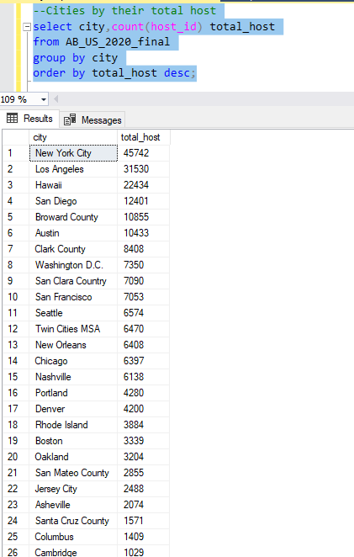

Insights:

* Most of the hosts are from New York City
* Los Angeles holds the second position and the third is Hawaii
* These indicates that because of the popularity and demand for short-term rentals in major cities like NYC and LA appears in the dominant position of these areas in the Airbnb market.

**Different rooms by their prices:**

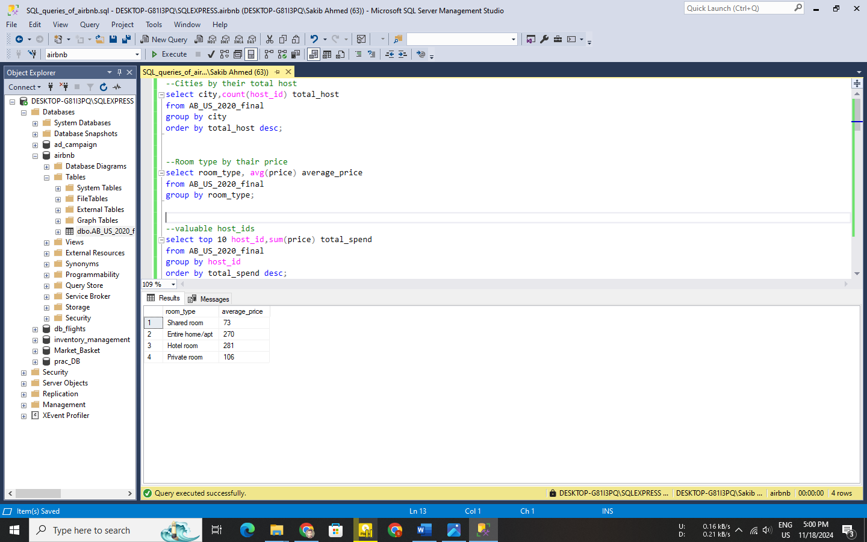

Insights:

* Hotel rooms and entire homes are the premium categories. So that high-budget travelers choose this type of room.
* Shared rooms are chosen by those whose budgets are cheap.

**Busy room types:**

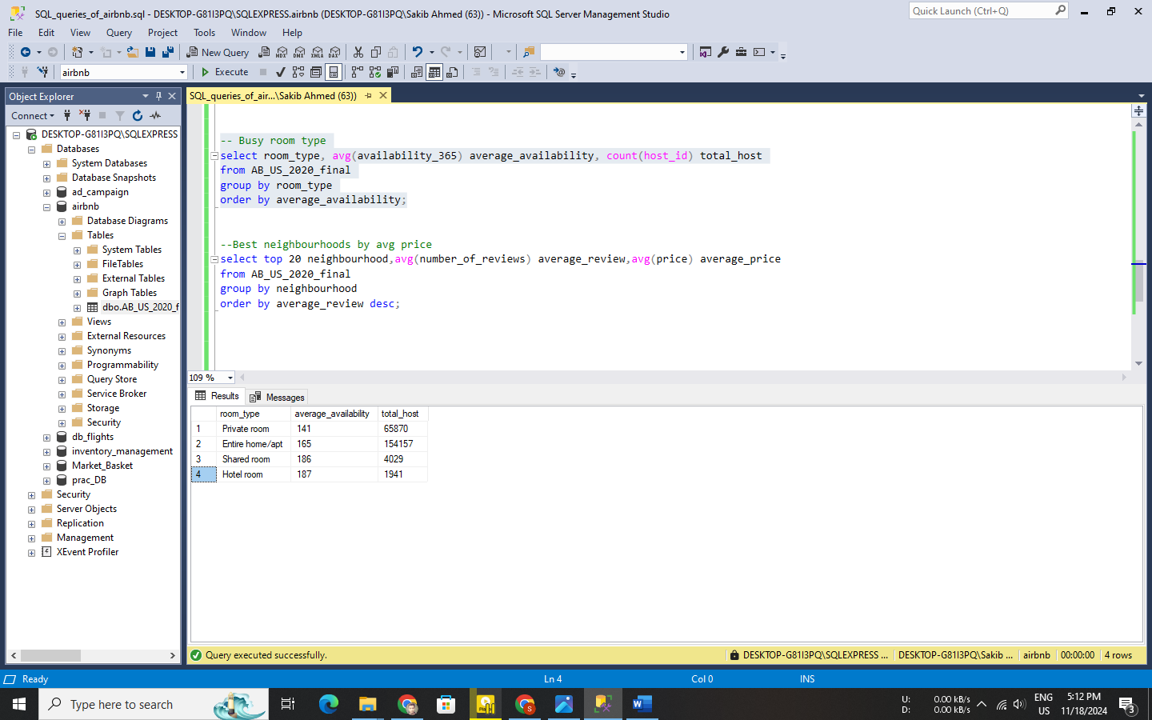

Insights:

* Shared and Hotel rooms are available most of the day in the year, which indicates that host has less love to choose these types of room
* Entire homes/apartments dominate in popularity and availability, which means these are ideal for families or groups.
* Availability and total host indicate that private rooms booked for multiple days

**Best neighborhoods with their average price:**

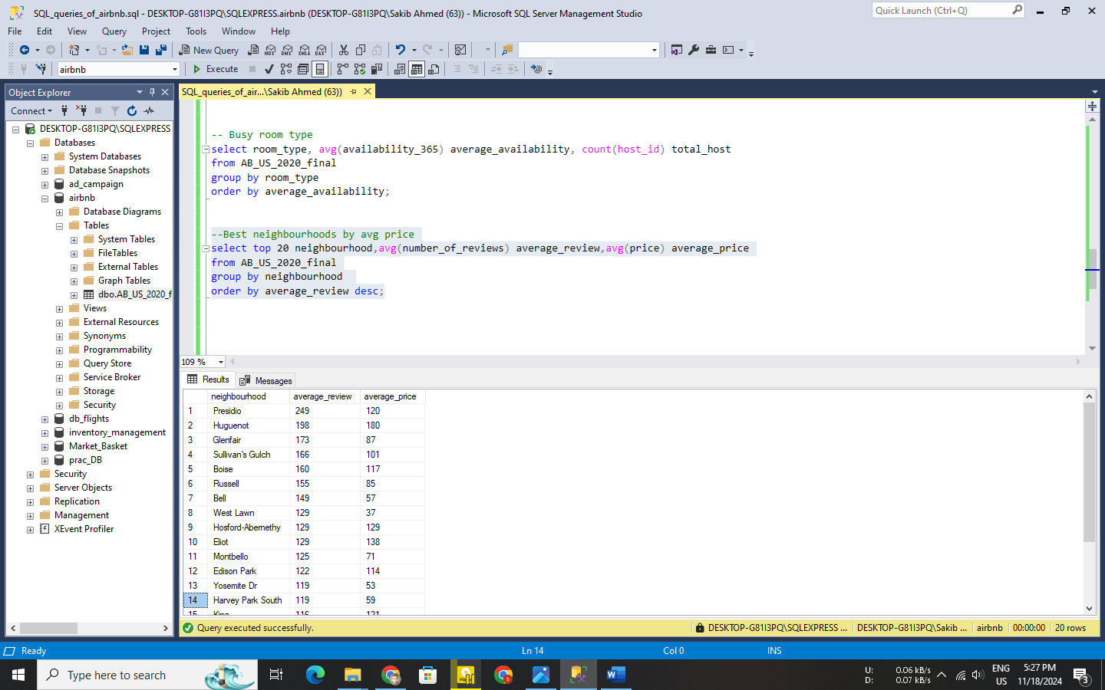

Insights:

* The average review indicates that Presidio is the host's favorite neighborhood. Presidio may have good facilities, or these areas are vibrant and attract repeat travelers.
* With it's higher price and high average review, Huguenot is in high demand even at higher prices.
* Glenfair, Sullivan's Gulch, and Boise have moderately high reviews and prices, suggesting steady popularity and value
* In places like West Lawn, lower review numbers and costs could indicate unfulfilled potential or low participation from visitors.

**Best in average cost:**

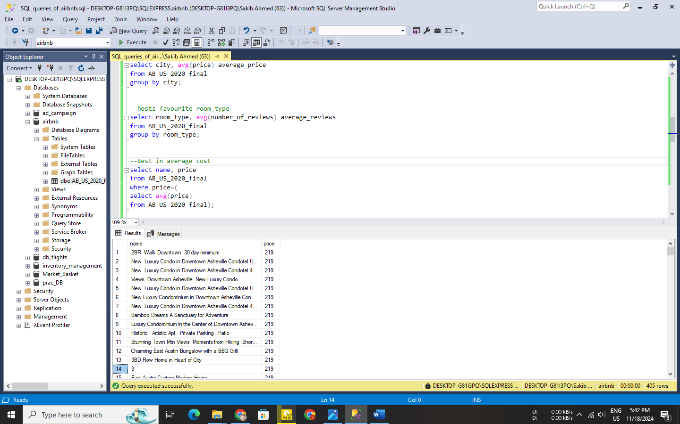

Insights:

* These listings probably target middle-class visitors who are looking for good deals without choosing between the budget or premium categories.

**Most busy rooms (availability=0):**

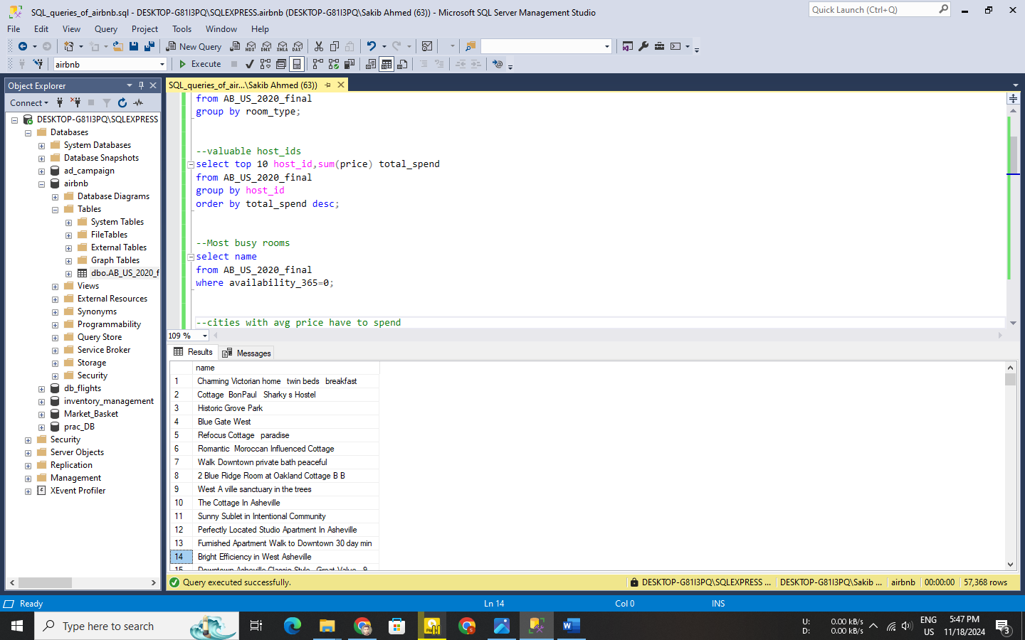

Insights:

* Availability 0 days in the year indicates these rooms are listed but not available for any bookings throughout the year, or it could be a point to misreported availability.

**Cities with average price spend:**

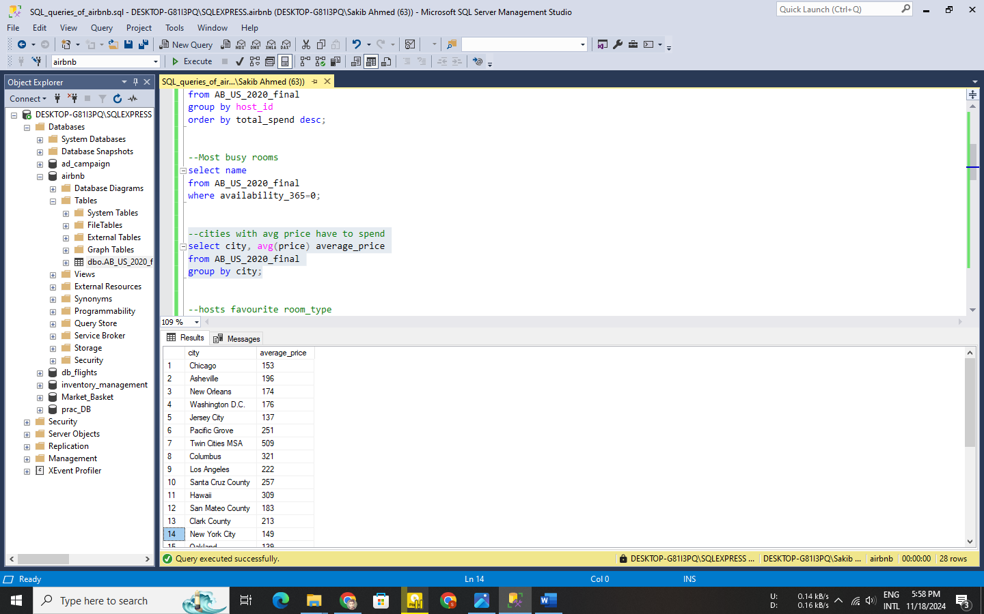

Insights:

* Santa Cruz, Pacific Grove, Hawaii are premium vacation areas, which causes their greater costs.
* Twin cities MSA is the most expensive city for their political, cultural, and economic capital of the Upper Midwest
* Chicago Asheville cities cater to both budget and premium travelers, offering diverse accommodation types.

**Room types by average reviews:**

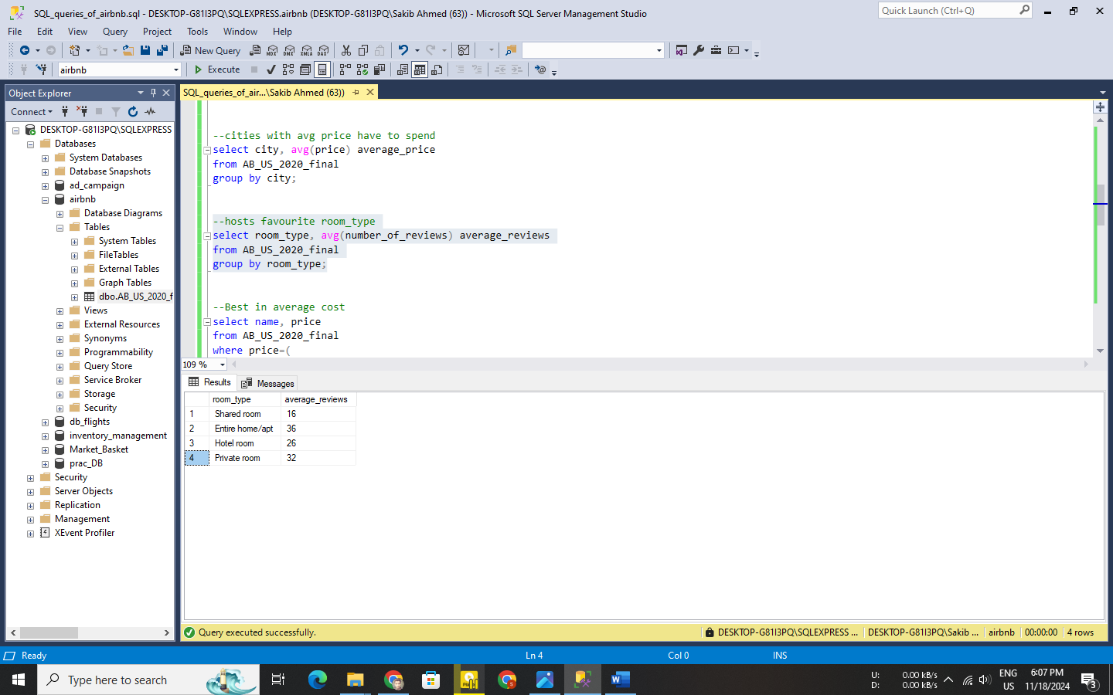

Insights:

* Entire homes/Apartment have the a most average review which is the host loves this type of room because of maybe facilities
* Average reviews show that shared rooms are less favored by people because of their various conditions or limited appeal.

**Conclusions:** The Airbnb analysis reveals significant trends in the U.S. short-term rental market, emphasizing the dominance of cities like New York and Los Angeles in hosting activity. Entire homes/apartments emerge as the most popular and reviewed room type, catering to families and groups, while shared rooms show limited appeal. Premium vacation spots like Hawaii and Santa Cruz command higher prices, reflecting their luxury appeal. Overall, the data provides valuable insights for hosts, travelers, and the industry to better understand market dynamics and traveler preferences.