**Project title:** Supply Chain Management

**Project description:** This project is for optimizing products manufacturing, and enhancing transportation systems. Also, focus on products and supplier management. Improve Warehouse productivity is mandatory.

**Data preprocessing:**

* Import necessary libraries and load dataset on Jupyter notebook
* Checking Data columns and null values. Delete some columns and fill null values with perfect match of those data.
* Then dealing with some duplicates data.

**Analytical part**

**Supplier analysis:**

Suppliers with their average lead times:

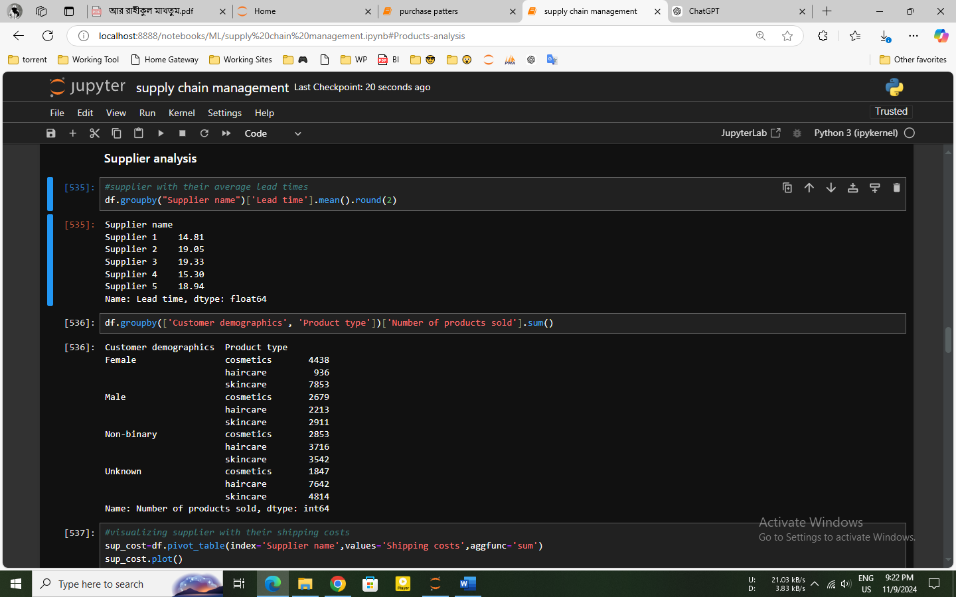

Insights:

* Supplier 1 has the shortest average lead time. So that, Supplier 1 could be prioritized items for quicker restocking.
* Supplier 3 has the longest lead time. Inventory control may be affected by his longer lead time, especially for items with high demand.
* lead times for other suppliers (2, 4, and 5) range from 15.30 to 19.05 days

Suppliers with their average shipping costs:

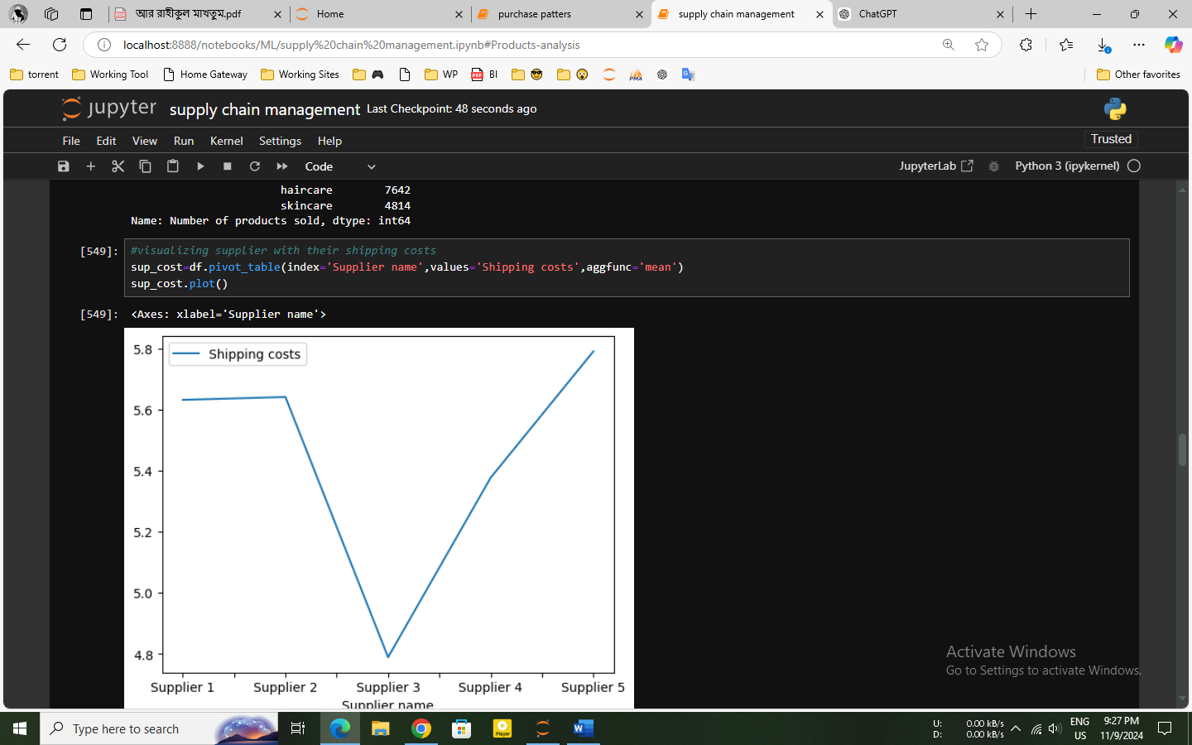

Insights:

* Suppliers 1 and 2 have similar shipping costs.They can offer moderate shipping costs. So, they can be economical choices if shipping cost is a priority.
* Supplier 5 has the highest shipping cost, which may impact profitability

Supplier’s orders by different transport:

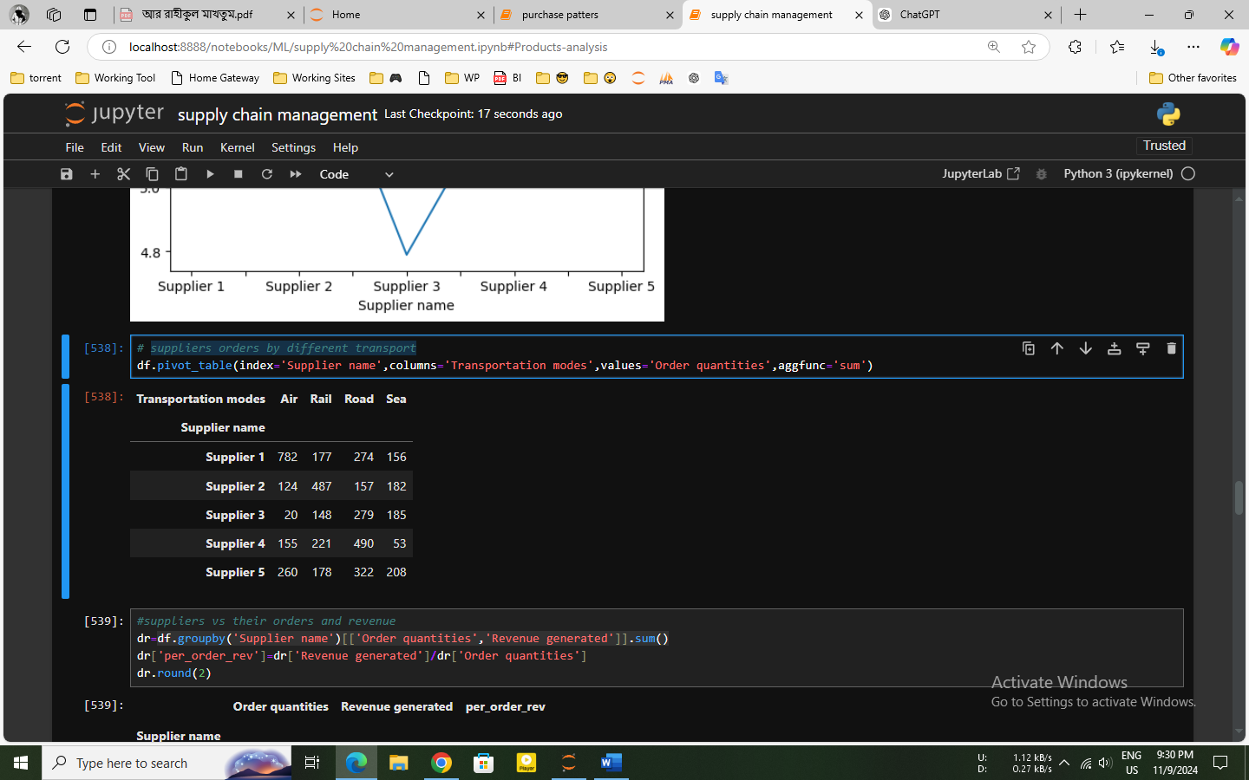

Insights:

* Supplier 1 supply products maximum by air which is typically faster but more expensive, also used for time-sensitive shipments
* Supplier 3 relies mostly on rail, which could be a cost-effective method for bulk shipments, especially if lead time is not a critical factor.
* Suppliers are less interested to shipping in sea. Because sea shipping is generally slower but economical. For huge no of items.

Supplier Revenue per Order:

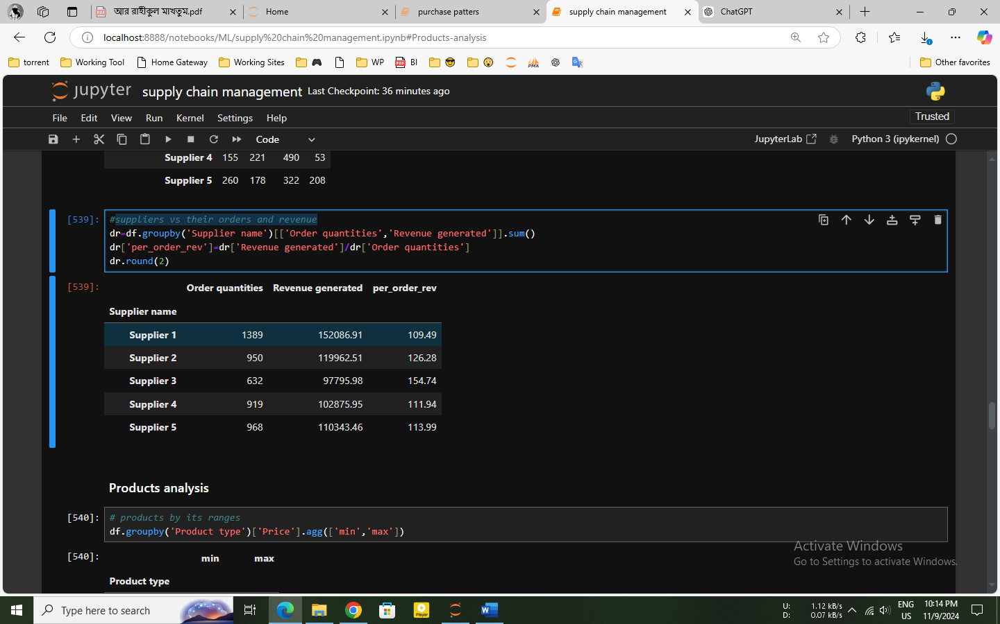

Insights:

* Except supplier 3, all suppliers have similar average revenue per order values, indicating they likely handle mid-value products.
* For supplier 3, he may be used for high-margin products.

**Products analysis:**

Products by its min and max price range

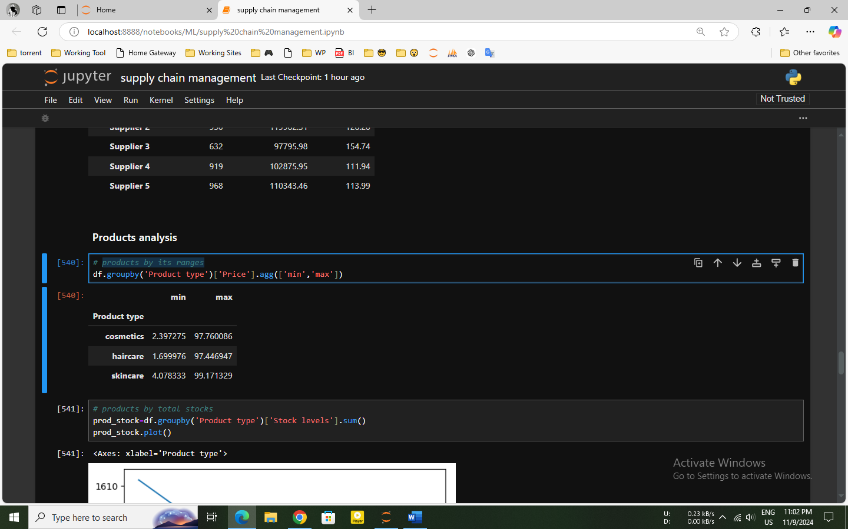

Insights:

* Skincare items have maximum price range. So, these products expensive from other type products.

Product stock levels by their type:

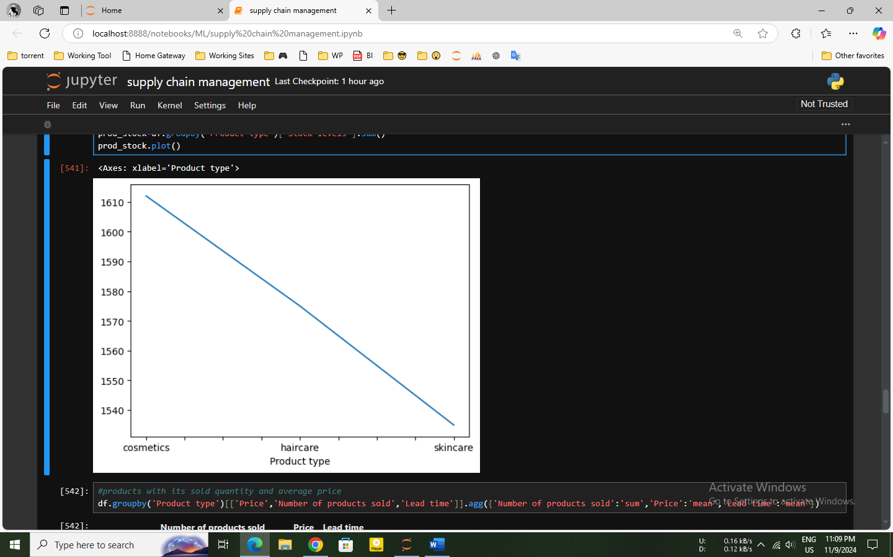

Insights:

* Cosmetics have the highest stock levels by 3857 units, suggest a larger demand or a more extensive product range in this category.
* Skincare has the lowest stock levels by 872 units. The low stock for skincare might be for high turnover or lower demand.

Products with its manufacturing processes:

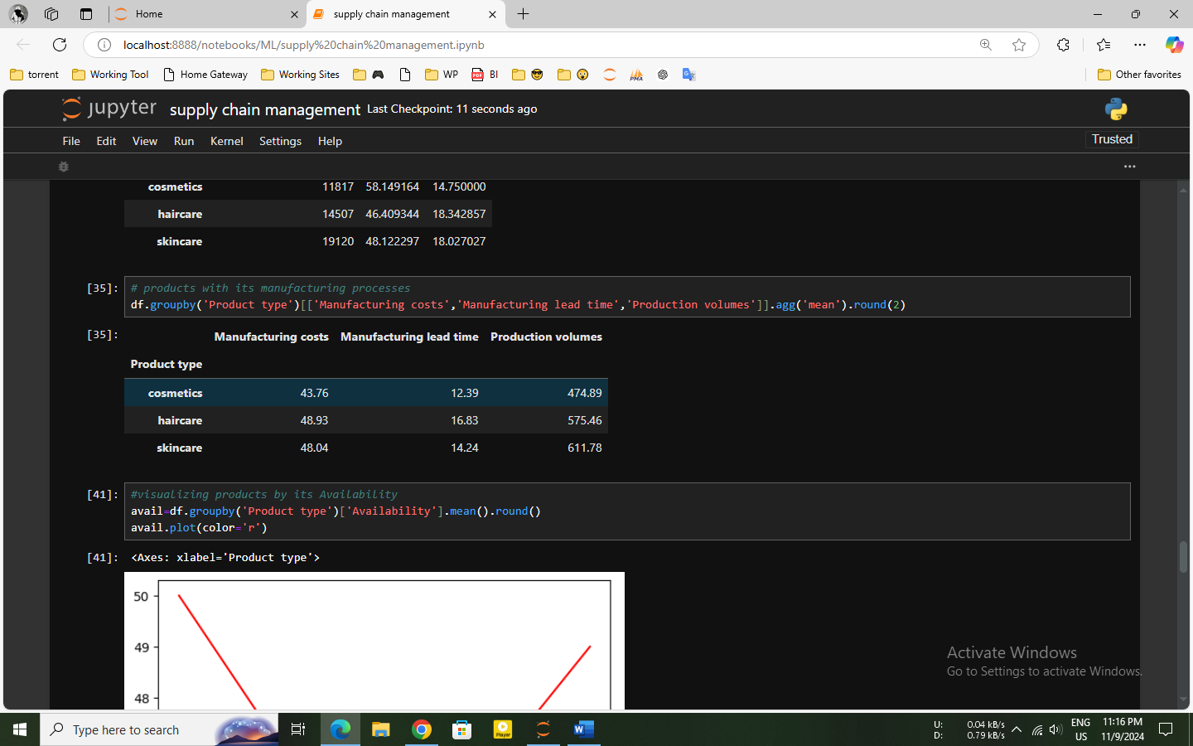

Insights:

* Cosmetics have the shortest manufacturing lead time of 43.56 days and the highest production volume of 4170 units. which is suggest that its high demand.
* Skincare has the longest manufacturing lead time at 48.79 days and the lowest production volume of 871 units. The longer manufacturing lead time for skincare could be a factor in its lower stock levels which is remind in previous.

Inspection Results by Product Type

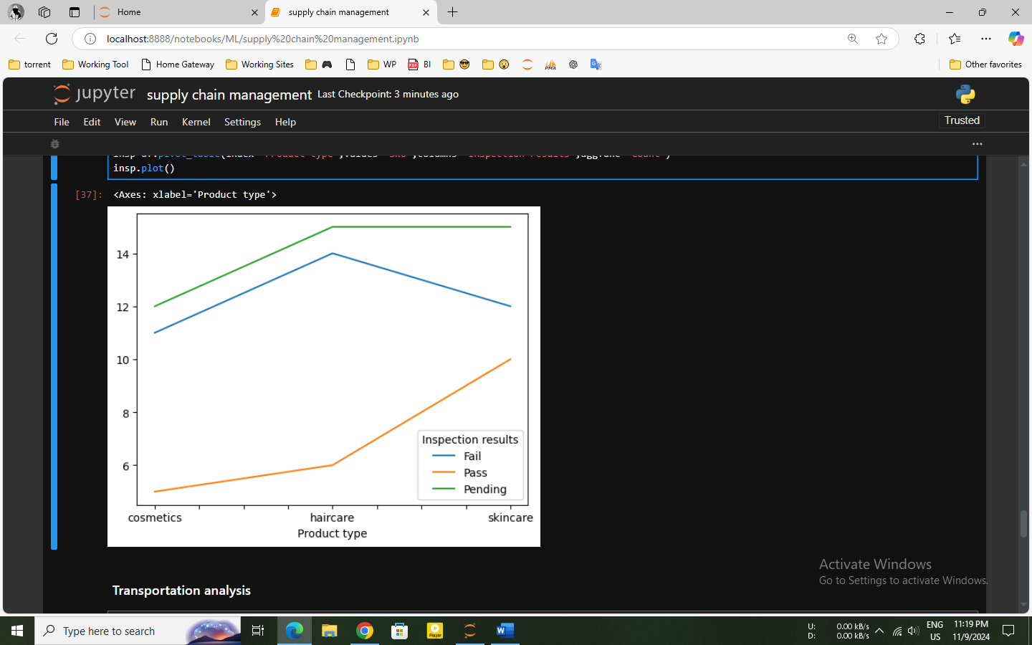

Insights:

* Cosmetics and skincare products have relatively high pass rates, while haircare products have a lower pass rate.
* As seen in the first plot, haircare products have the highest failure rate, which may be a factor in their decreasing availability.

**Transportation analysis:**

Transports by its average lead time

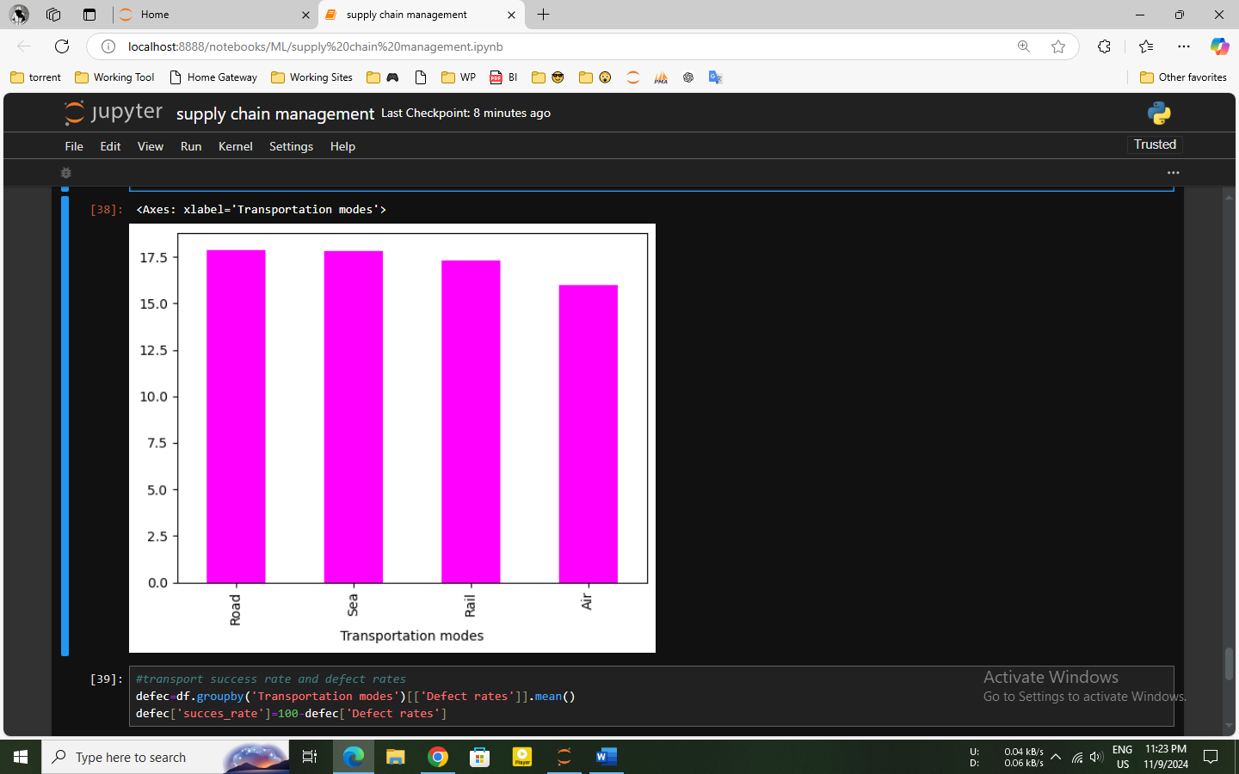

Insights:

* The bar graph shows Air is more costly than other kinds of transport, but it is good for urgent shipments because it has the lowest lead time.
* Road, Rail, and Sea may suggest potential optimization opportunities, especially if the goal is to reduce transit times.

Transports success rate and defect rates:

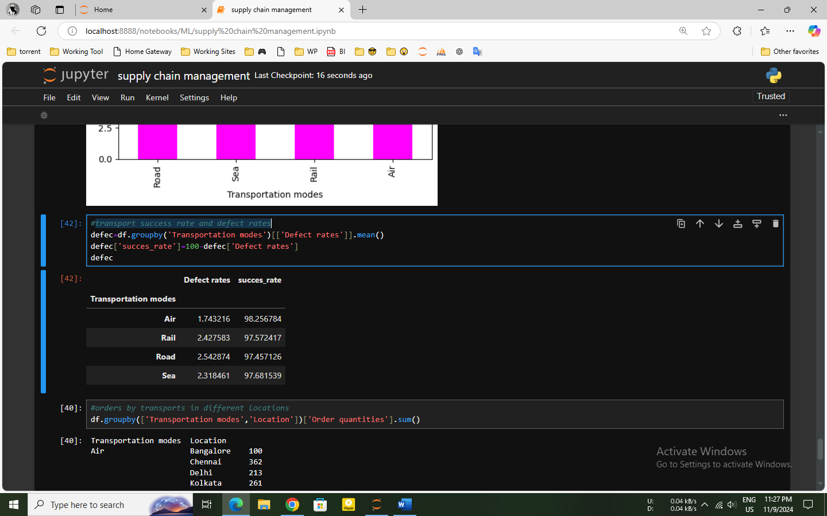

Insights:

* Air has the highest success rate (98.26%) and lowest defect rate (1.74%), making it the most secure way for transporting goods with minimal issues, especially for fragile or high-value items.
* The higher defect rates (2.54%) on roads suggest that there is a greater chance of problems with the items being delivered by these modes.

Order quantities by transportation mode in different locations:

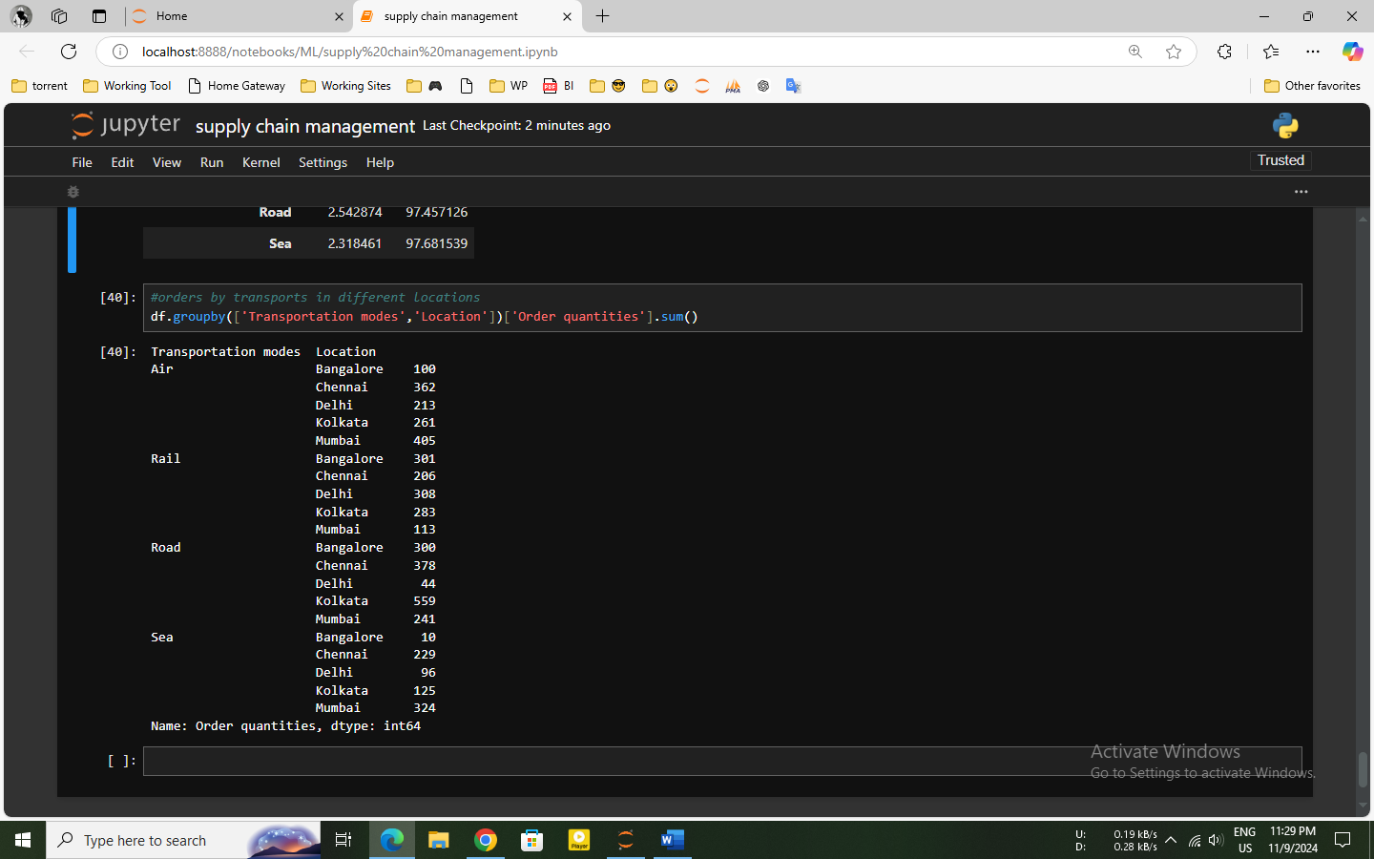

Insights:

* Locations in Bangalore, Delhi, and Mumbai are the most frequently used air routes, suggesting that these can be high-priority or high-demand locations.
* Less urgent deliveries are indicated by the common use of rail and sea for a range of places.
* In Delhi, where rail and air travel are most common, road usage is lower.

**Conclusion:**

In this supply chain management project, Air transport is suggested for urgent, high-value shipments because of its low failure rate, while Supplier 1 is best for faster restocking because of its lowest lead time. Cosmetics have high demand and stock levels, while skincare faces challenges with longer lead times and lower stock. For high-demand locations like Bangalore, Delhi, and Mumbai, air transport is prioritized, with rail and sea serving less time-sensitive deliveries.

All resources are given in this link: https://github.com/sakib007q/supply_chain_management.git