BPA Tool

Introduction
BPA (Bloodstain Pattern Analysis) Automation is a specialized, high-security web application engineered for forensic investigators, researchers, and students. The system serves as a digital bridge between traditional serology techniques and modern Artificial Intelligence, focusing on the objective classification of complex bloodstain patterns using state-of-the-art vision-language models.

The Problem Statement
Traditional Bloodstain Pattern Analysis (BPA) often relies on manual observation, which can be susceptible to human error, subjective bias, and time constraints during the critical "Golden Hour" of an investigation. Furthermore, physical evidence lacks context without the investigator's on-scene observations. There is a growing need for accessible, preliminary tools that can instantly synthesize both visual evidence and field notes while maintaining the strict privacy standards required for forensics.

The Solution
By leveraging the NVIDIA Nemotron Nano 12B Vision Language Model, this application automates the interpretation of intricate morphological data combined with investigator field notes. The AI analyzes specific fluid dynamics indicators—such as spines, satellites, and wave cast-offs—and cross-references them with the provided case context to generate a standardized Preliminary Forensic Report. This ensures a consistent, data-driven baseline for analysis before evidence undergoes intensive laboratory testing.

Technicalities
The project is built on a Zero-Server Architecture, prioritizing data privacy and the forensic "Chain of Custody".
- Client-Side Processing: All operations, including image handling, API key management, and text parsing, occur strictly within the user's browser. No evidence is stored on external databases.
- Direct API Integration: The application communicates directly with the OpenRouter API endpoint via encrypted HTTPS.
- Multi-modal AI Engine: The tool merges image data (base64) with user-defined context boundaries (up to 100 words) to feed a comprehensive prompt to the model.
- Technology Stack:
  - Frontend: HTML5, CSS3 (Obsidian Glassmorphism palette), and Vanilla JavaScript.
  - Libraries: Marked.js (for secure Markdown-to-HTML rendering).
  - AI Model: NVIDIA Nemotron Nano 12B-v2-VL (via OpenRouter).
  - Animations: Custom HTML5 Canvas particle engine representing neural reasoning.

Complete Project Code

1. Interface (index.html)

HTML

<!DOCTYPE html>
<html lang="en">
<head>
<meta charset="UTF-8">
<meta name="viewport" content="width=device-width, initial-scale=1.0">
<title>Forensic BPA Automation</title>
<link href="https://fonts.googleapis.com/css2?family=Inter:wght@300;400;500;600&family=JetBrains+Mono:wght@400;500&display=swap" rel="stylesheet">
<script src="https://cdn.jsdelivr.net/npm/marked/marked.min.js"></script>
<link href="static/styles.css" rel="stylesheet">
</head>
<body>
<div id="toastContainer" class="toast-container"></div>
<header class="header">
<div class="container header-content">
<div class="logo-group">
<span class="logo-icon">🔬</span>
<div>
<h1>BPA Tool</h1>
<p>Powered by NVIDIA Nemotron & OpenRouter</p>
</div>
</div>
<div class="system-status">
<span class="pulse-dot"></span> System Online
</div>
</div>
</header>
<main class="container">
<div class="grid-layout">
<!-- Left Column: Inputs -->
<div class="input-column">
<div class="card glass-panel">
<h2>
<div class="header-with-status">
<span class="status-indicator" id="apiStatus"></span>
<span>Security & Credentials</span>
</div>
</h2>
<div class="input-group">
<label for="apiKey">OpenRouter API Key</label>
<input type="password" id="apiKey" placeholder="sk-or-v1-..." autocomplete="off">
<p class="hint-text">Keys are processed locally. Requires standard <code>sk-or-</code> format.</p>
</div>
</div>
<div class="card glass-panel">
<h2>
<div class="header-with-status">
<span class="status-indicator ready" style="background-color: var(--accent-primary); box-shadow: 0 0 8px var(--accent-primary);"></span>
<span>Case Context <span class="optional-badge">Optional</span></span>
</div>
</h2>
<div class="input-group">
<label for="caseContext">Investigator Notes</label>
<textarea id="caseContext" placeholder="E.g., Victim found on tile floor, suspected blunt force trauma, no signs of arterial damage..." rows="3"></textarea>
<div class="word-counter" id="wordCounter">0 / 100 words</div>
</div>
</div>
<div class="card glass-panel">
<h2>
<div class="header-with-status">
<span class="status-indicator" id="imageStatus"></span>
<span>Evidence Upload</span>
</div>
</h2>
<div class="file-upload" id="dropZone">
<div id="uploadPlaceholder" class="upload-placeholder">
<svg class="upload-icon" xmlns="http://www.w3.org/2000/svg" width="32" height="32" viewBox="0 0 24 24" fill="none" stroke="currentColor" stroke-width="2" stroke-linecap="round" stroke-linejoin="round"><rect x="3" y="3" width="18" height="18" rx="2" ry="2"></rect><circle cx="8.5" cy="8.5" r="1.5"></circle><polyline points="21 15 16 10 5 21"></polyline></svg>
<p>Drag & drop evidence here<br>or <span class="highlight-text">browse files</span></p>
<p class="hint-text">JPG, PNG, WEBP (Max 5MB)</p>
</div>
<input type="file" id="imageInput" accept="image/jpeg, image/png, image/webp">
<div class="preview-wrapper">
<img id="previewImage" class="preview-image" style="display: none;" alt="Evidence Preview">
<button id="removeImageBtn" class="remove-btn" style="display: none;" title="Clear Image">
<svg xmlns="http://www.w3.org/2000/svg" width="16" height="16" viewBox="0 0 24 24" fill="none" stroke="currentColor" stroke-width="2" stroke-linecap="round" stroke-linejoin="round"><line x1="18" y1="6" x2="6" y2="18"></line><line x1="6" y1="6" x2="18" y2="18"></line></svg>
</button>
</div>
</div>
</div>
<button class="btn btn-primary" id="analyzeBtn" disabled>
<svg xmlns="http://www.w3.org/2000/svg" width="18" height="18" viewBox="0 0 24 24" fill="none" stroke="currentColor" stroke-width="2" stroke-linecap="round" stroke-linejoin="round"><circle cx="11" cy="11" r="8"></circle><line x1="21" y1="21" x2="16.65" y2="16.65"></line></svg>
Initiate Analysis
</button>
</div>
<!-- Right Column: Results & Loading -->
<div class="output-column">
<div class="empty-state card glass-panel" id="idleState">
<svg class="empty-icon" xmlns="http://www.w3.org/2000/svg" width="48" height="48" viewBox="0 0 24 24" fill="none" stroke="currentColor" stroke-width="1" stroke-linecap="round" stroke-linejoin="round"><path d="M14 2H6a2 2 0 0 0-2 2v16a2 2 0 0 0 2 2h12a2 2 0 0 0 2-2V8z"></path><polyline points="14 2 14 8 20 8"></polyline><line x1="16" y1="13" x2="8" y2="13"></line><line x1="16" y1="17" x2="8" y2="17"></line><polyline points="10 9 9 9 8 9"></polyline></svg>
<h3>Awaiting Parameters</h3>
<p>Provide credentials and evidence to generate a forensic report.</p>
</div>
<div class="loading-container card glass-panel" id="loadingContainer">
<canvas id="particleCanvas" width="200" height="200"></canvas>
<h3 class="loading-title">AI Processing Engine Active</h3>
<p class="loading-text" id="dynamicLoadingText">Initializing models...</p>
<div class="progress-bar-container">
<div class="progress-bar" id="progressBar"></div>
</div>
</div>
<div class="results-container" id="resultsContainer">
<div class="card glass-panel result-box">
<div class="result-header">
<div class="result-title-group">
<svg xmlns="http://www.w3.org/2000/svg" width="20" height="20" viewBox="0 0 24 24" fill="none" stroke="currentColor" stroke-width="2"><path d="M14 2H6a2 2 0 0 0-2 2v16a2 2 0 0 0 2 2h12a2 2 0 0 0 2-2V8z"></path><polyline points="14 2 14 8 20 8"></polyline></svg>
<h3>Preliminary Report</h3>
</div>
<div class="result-actions">
<button class="btn btn-icon" onclick="copyToClipboard('reportContent', this)" title="Copy to Clipboard">
<svg xmlns="http://www.w3.org/2000/svg" width="16" height="16" viewBox="0 0 24 24" fill="none" stroke="currentColor" stroke-width="2"><rect x="9" y="9" width="13" height="13" rx="2" ry="2"></rect><path d="M5 15H4a2 2 0 0 1-2-2V4a2 2 0 0 1 2-2h9a2 2 0 0 1 2 2v1"></path></svg>
</button>
<button class="btn btn-icon" onclick="resetAnalysis()" title="New Analysis">
<svg xmlns="http://www.w3.org/2000/svg" width="16" height="16" viewBox="0 0 24 24" fill="none" stroke="currentColor" stroke-width="2"><path d="M3 12a9 9 0 1 0 9-9 9.75 9.75 0 0 0-6.74 2.74L3 8"></path><path d="M3 3v5h5"></path></svg>
</button>
</div>
</div>
<div class="disclaimer-box">
<svg xmlns="http://www.w3.org/2000/svg" width="16" height="16" viewBox="0 0 24 24" fill="none" stroke="currentColor" stroke-width="2"><path d="M10.29 3.86L1.82 18a2 2 0 0 0 1.71 3h16.94a2 2 0 0 0 1.71-3L13.71 3.86a2 2 0 0 0-3.42 0z"></path><line x1="12" y1="9" x2="12" y2="13"></line><line x1="12" y1="17" x2="12.01" y2="17"></line></svg>
<span><strong>CONFIDENTIAL:</strong> AI-generated content is probabilistic. Must be verified by a certified human analyst prior to formal submission.</span>
</div>
<div id="reportContent" class="markdown-content"></div>
</div>
</div>
</div>
</div>
</main>
<script src="static/script.js"></script>
</body>
</html>

2. Styling (static/styles.css)

CSS

:root {
--bg-base: #0a0a0c;
--bg-surface: #141417;
--bg-surface-hover: #1c1c21;
--border-color: #27272a;
--border-highlight: #3f3f46;
--text-main: #e4e4e7;
--text-muted: #a1a1aa;
--accent-primary: #818cf8;
--accent-hover: #6366f1;
--accent-glow: rgba(129, 140, 248, 0.15);
--danger: #f87171;
--success: #34d399;
--warning: #fbbf24;
--radius-sm: 8px;
--radius-md: 12px;
--shadow-subtle: 0 4px 20px rgba(0, 0, 0, 0.4);
--font-sans: 'Inter', sans-serif;
--font-mono: 'JetBrains Mono', monospace;
}
* { box-sizing: border-box; margin: 0; padding: 0; }
body {
background-color: var(--bg-base);
color: var(--text-main);
font-family: var(--font-sans);
line-height: 1.6;
min-height: 100vh;
background-image: radial-gradient(circle at 50% 0%, #1a1a24 0%, var(--bg-base) 50%);
background-attachment: fixed;
}
.container { max-width: 1100px; margin: 0 auto; padding: 0 20px; }
.header { padding: 2rem 0; border-bottom: 1px solid var(--border-color); background: rgba(10, 10, 12, 0.8); backdrop-filter: blur(12px); margin-bottom: 2rem; position: sticky; top: 0; z-index: 100;}
.header-content { display: flex; justify-content: space-between; align-items: center; }
.logo-group { display: flex; align-items: center; gap: 1rem; }
.logo-icon { font-size: 2rem; }
.logo-group h1 { font-size: 1.5rem; font-weight: 600; letter-spacing: -0.5px; margin-bottom: 2px; }
.logo-group p { font-size: 0.85rem; color: var(--text-muted); }
.system-status { display: flex; align-items: center; gap: 8px; font-size: 0.85rem; color: var(--text-muted); font-family: var(--font-mono); background: var(--bg-surface); padding: 6px 12px; border-radius: 20px; border: 1px solid var(--border-color); }
.pulse-dot { width: 8px; height: 8px; background-color: var(--success); border-radius: 50%; box-shadow: 0 0 8px var(--success); animation: pulse 2s infinite; }
.grid-layout { display: grid; grid-template-columns: 350px 1fr; gap: 2rem; align-items: start; }
@media (max-width: 850px) { .grid-layout { grid-template-columns: 1fr; } }
.glass-panel { background-color: var(--bg-surface); border: 1px solid var(--border-color); border-radius: var(--radius-md); box-shadow: var(--shadow-subtle); transition: border-color 0.3s ease; }
.card { padding: 1.5rem; margin-bottom: 1.5rem; }
.card h2 { font-size: 1.1rem; font-weight: 500; margin-bottom: 1.2rem; color: var(--text-main); display: flex; align-items: center; gap: 10px; }
.header-with-status { display: flex; align-items: center; width: 100%; }
.status-indicator { width: 10px; height: 10px; border-radius: 50%; background-color: #3f3f46; margin-right: 10px; transition: all 0.3s ease; }
.status-indicator.waiting { background-color: var(--warning); box-shadow: 0 0 8px rgba(251, 191, 36, 0.5); animation: pulse 2s infinite; }
.status-indicator.ready { background-color: var(--success); box-shadow: 0 0 8px rgba(52, 211, 153, 0.5); }
.status-indicator.processing { background-color: var(--accent-primary); box-shadow: 0 0 8px var(--accent-primary); animation: pulse 0.8s infinite; }
.status-indicator.error { background-color: var(--danger); box-shadow: 0 0 8px rgba(248, 113, 113, 0.5); }
@keyframes pulse { 0%, 100% { opacity: 1; } 50% { opacity: 0.5; } }
.input-group label { display: block; margin-bottom: 6px; font-size: 0.9rem; color: var(--text-muted); }
.input-group input { width: 100%; padding: 12px 14px; background-color: var(--bg-base); border: 1px solid var(--border-color); border-radius: var(--radius-sm); color: var(--text-main); font-family: var(--font-mono); font-size: 0.9rem; transition: all 0.2s; }
.input-group input:focus { outline: none; border-color: var(--accent-primary); box-shadow: 0 0 0 3px var(--accent-glow); }
.input-group input:disabled { opacity: 0.5; cursor: not-allowed; }
.hint-text { color: var(--text-muted); font-size: 0.8rem; margin-top: 8px; }
.hint-text code { font-family: var(--font-mono); background: #27272a; padding: 2px 4px; border-radius: 4px; color: var(--text-main); }
/* Textarea & Context Styling */
.optional-badge { font-size: 0.65rem; background-color: var(--border-highlight); color: var(--text-muted); padding: 2px 6px; border-radius: 4px; text-transform: uppercase; letter-spacing: 0.5px; margin-left: 8px; vertical-align: middle; }
textarea { width: 100%; padding: 12px 14px; background-color: var(--bg-base); border: 1px solid var(--border-color); border-radius: var(--radius-sm); color: var(--text-main); font-family: var(--font-sans); font-size: 0.9rem; transition: all 0.2s; resize: vertical; min-height: 80px; max-height: 200px; }
textarea:focus { outline: none; border-color: var(--accent-primary); box-shadow: 0 0 0 3px var(--accent-glow); }
textarea:disabled { opacity: 0.5; cursor: not-allowed; }
.word-counter { text-align: right; font-size: 0.75rem; color: var(--text-muted); margin-top: 6px; font-family: var(--font-mono); transition: color 0.3s; }
textarea::-webkit-scrollbar { width: 8px; }
textarea::-webkit-scrollbar-track { background: var(--bg-base); }
textarea::-webkit-scrollbar-thumb { background: var(--border-highlight); border-radius: 4px; }
.file-upload { border: 1px dashed var(--border-color); border-radius: var(--radius-sm); padding: 2rem 1rem; text-align: center; background-color: rgba(10, 10, 12, 0.4); cursor: pointer; transition: all 0.2s ease; position: relative; }
.file-upload:hover, .file-upload.dragover { border-color: var(--accent-primary); background-color: var(--bg-surface-hover); }
.file-upload.disabled { opacity: 0.5; pointer-events: none; }
.file-upload input { display: none; }
.upload-icon { color: var(--text-muted); margin-bottom: 12px; transition: color 0.2s; }
.file-upload:hover .upload-icon { color: var(--accent-primary); }
.highlight-text { color: var(--accent-primary); font-weight: 500; }
.preview-wrapper { position: relative; display: inline-block; width: 100%; }
.preview-image { width: 100%; border-radius: var(--radius-sm); border: 1px solid var(--border-color); object-fit: cover; max-height: 200px; }
.remove-btn { position: absolute; top: -10px; right: -10px; background: var(--bg-surface); border: 1px solid var(--border-color); color: var(--text-main); border-radius: 50%; width: 28px; height: 28px; display: flex; align-items: center; justify-content: center; cursor: pointer; transition: all 0.2s; box-shadow: var(--shadow-subtle); }
.remove-btn:hover { background: var(--danger); border-color: var(--danger); color: #fff; transform: scale(1.1); }
.btn { border: none; padding: 12px 20px; font-size: 0.95rem; font-weight: 500; font-family: var(--font-sans); border-radius: var(--radius-sm); cursor: pointer; transition: all 0.2s ease; display: flex; align-items: center; justify-content: center; gap: 8px; width: 100%; }
.btn-primary { background-color: var(--text-main); color: var(--bg-base); font-weight: 600; }
.btn-primary:hover:not(:disabled) { background-color: #fff; transform: translateY(-1px); box-shadow: 0 4px 12px rgba(255,255,255,0.1); }
.btn-primary:disabled { opacity: 0.5; cursor: not-allowed; background-color: var(--border-color); color: var(--text-muted); }
.btn-icon { width: auto; padding: 6px; background: transparent; border: 1px solid transparent; color: var(--text-muted); border-radius: 6px; }
.btn-icon:hover { background: var(--bg-base); border-color: var(--border-color); color: var(--text-main); }
.empty-state { display: flex; flex-direction: column; align-items: center; justify-content: center; height: 100%; text-align: center; color: var(--text-muted); min-height: 400px; }
.empty-icon { color: var(--border-color); margin-bottom: 1rem; width: 64px; height: 64px; }
.empty-state h3 { color: var(--text-main); margin-bottom: 8px; font-weight: 500; }
.loading-container { display: none; text-align: center; padding: 3rem 2rem; min-height: 400px; flex-direction: column; align-items: center; justify-content: center; }
.loading-container.active { display: flex; }
#particleCanvas { width: 150px; height: 150px; border-radius: 50%; margin-bottom: 1.5rem; }
.loading-title { font-weight: 500; margin-bottom: 8px; letter-spacing: -0.5px; }
.loading-text { color: var(--text-muted); font-family: var(--font-mono); font-size: 0.85rem; height: 20px; transition: opacity 0.3s; }
.progress-bar-container { width: 100%; max-width: 250px; height: 4px; background: var(--bg-base); border-radius: 2px; margin-top: 1.5rem; overflow: hidden; position: relative; }
.progress-bar { width: 30%; height: 100%; background: var(--accent-primary); border-radius: 2px; position: absolute; left: -30%; animation: slide 1.5s infinite ease-in-out; }
@keyframes slide { 100% { left: 100%; } }
.results-container { display: none; }
.results-container.active { display: block; animation: fadeIn 0.4s ease-out; }
@keyframes fadeIn { from { opacity: 0; transform: translateY(10px); } to { opacity: 1; transform: translateY(0); } }
.result-header { display: flex; justify-content: space-between; align-items: center; border-bottom: 1px solid var(--border-color); padding-bottom: 1rem; margin-bottom: 1rem; }
.result-title-group { display: flex; align-items: center; gap: 10px; color: var(--text-main); }
.result-actions { display: flex; gap: 5px; }
.disclaimer-box { display: flex; align-items: flex-start; gap: 10px; background-color: rgba(245, 158, 11, 0.1); border: 1px solid rgba(245, 158, 11, 0.2); border-left: 3px solid var(--warning); padding: 12px; font-size: 0.85rem; color: #d4d4d8; border-radius: var(--radius-sm); margin-bottom: 1.5rem; }
.disclaimer-box svg { color: var(--warning); flex-shrink: 0; margin-top: 2px; }
.markdown-content { font-size: 0.95rem; line-height: 1.7; color: #d4d4d8; }
.markdown-content h1, .markdown-content h2, .markdown-content h3 { color: var(--text-main); margin-top: 1.5rem; margin-bottom: 0.75rem; font-weight: 600; letter-spacing: -0.5px; }
.markdown-content h1 { font-size: 1.4rem; border-bottom: 1px solid var(--border-color); padding-bottom: 8px; }
.markdown-content h2 { font-size: 1.2rem; }
.markdown-content strong { color: var(--accent-primary); font-weight: 600; }
.markdown-content ul { padding-left: 1.2rem; margin-bottom: 1rem; }
.markdown-content li { margin-bottom: 0.4rem; }
.markdown-content li::marker { color: var(--text-muted); }
.markdown-content code { font-family: var(--font-mono); background: var(--bg-base); border: 1px solid var(--border-color); padding: 2px 6px; border-radius: 4px; font-size: 0.85em; color: var(--text-main); }
.markdown-content blockquote { border-left: 3px solid var(--accent-primary); padding-left: 1rem; margin-left: 0; color: var(--text-muted); background: rgba(129, 140, 248, 0.05); padding: 0.5rem 1rem; border-radius: 0 8px 8px 0; }
.toast-container { position: fixed; bottom: 24px; right: 24px; z-index: 1000; display: flex; flex-direction: column; gap: 10px; pointer-events: none; }
.toast { background-color: var(--bg-surface); border: 1px solid var(--border-color); color: var(--text-main); padding: 14px 20px; border-radius: var(--radius-sm); box-shadow: var(--shadow-subtle); transform: translateX(120%) scale(0.95); opacity: 0; transition: all 0.4s cubic-bezier(0.175, 0.885, 0.32, 1.275); display: flex; align-items: center; gap: 12px; font-weight: 500; font-size: 0.9rem; pointer-events: auto; }
.toast.show { transform: translateX(0) scale(1); opacity: 1; }
.toast svg { flex-shrink: 0; }
.toast.success svg { color: var(--success); }
.toast.error svg { color: var(--danger); }
.toast.info svg { color: var(--accent-primary); }

3. Logic (static/script.js)

JavaScript

const apiKeyInput = document.getElementById('apiKey');
const caseContextInput = document.getElementById('caseContext');
const wordCounter = document.getElementById('wordCounter');
const imageInput = document.getElementById('imageInput');
const dropZone = document.getElementById('dropZone');
const previewImage = document.getElementById('previewImage');
const uploadPlaceholder = document.getElementById('uploadPlaceholder');
const removeImageBtn = document.getElementById('removeImageBtn');
const analyzeBtn = document.getElementById('analyzeBtn');
const idleState = document.getElementById('idleState');
const loadingContainer = document.getElementById('loadingContainer');
const resultsContainer = document.getElementById('resultsContainer');
const dynamicLoadingText = document.getElementById('dynamicLoadingText');
const apiStatus = document.getElementById('apiStatus');
const imageStatus = document.getElementById('imageStatus');
const reportContent = document.getElementById('reportContent');
const toastContainer = document.getElementById('toastContainer');
let selectedImage = null;
let selectedImageDataUrl = null;
let loadingInterval = null;
const WORD_LIMIT = 100;
const loadingPhases = [
"Establishing secure API tunnel...",
"Extracting morphological features...",
"Calculating directional vectors...",
"Evaluating velocity models...",
"Formulating reconstruction hypothesis...",
"Finalizing markdown payload..."
];
// Event Listeners
apiKeyInput.addEventListener('input', checkReadyState);
caseContextInput.addEventListener('input', () => {
let text = caseContextInput.value.trim();
let words = text.length === 0 ? [] : text.split(/\s+/);
if (words.length > WORD_LIMIT) {
words = words.slice(0, WORD_LIMIT);
caseContextInput.value = words.join(' ') + ' ';
}
wordCounter.textContent = `${words.length} / ${WORD_LIMIT} words`;
if (words.length >= WORD_LIMIT) wordCounter.style.color = 'var(--warning)';
else if (words.length >= WORD_LIMIT * 0.8) wordCounter.style.color = '#fb923c';
else wordCounter.style.color = 'var(--text-muted)';
});
dropZone.addEventListener('click', (e) => {
if(e.target !== removeImageBtn && e.target.closest('.remove-btn') === null) imageInput.click();
});
dropZone.addEventListener('dragover', (e) => {
e.preventDefault();
if (!dropZone.classList.contains('disabled')) dropZone.classList.add('dragover');
});
dropZone.addEventListener('dragleave', () => dropZone.classList.remove('dragover'));
dropZone.addEventListener('drop', (e) => {
e.preventDefault();
dropZone.classList.remove('dragover');
if (!dropZone.classList.contains('disabled') && e.dataTransfer.files.length > 0) {
handleFile(e.dataTransfer.files[0]);
}
});
imageInput.addEventListener('change', (e) => {
if (e.target.files.length > 0) handleFile(e.target.files[0]);
});
removeImageBtn.addEventListener('click', (e) => {
e.stopPropagation();
resetImage();
});
analyzeBtn.addEventListener('click', runAnalysis);
// Core Functions
function showToast(message, type = 'info') {
const toast = document.createElement('div');
toast.className = `toast ${type}`;
let iconSvg = '';
if (type === 'success') iconSvg = `<svg xmlns="http://www.w3.org/2000/svg" width="20" height="20" viewBox="0 0 24 24" fill="none" stroke="currentColor" stroke-width="2"><path d="M22 11.08V12a10 10 0 1 1-5.93-9.14"></path><polyline points="22 4 12 14.01 9 11.01"></polyline></svg>`;
else if (type === 'error') iconSvg = `<svg xmlns="http://www.w3.org/2000/svg" width="20" height="20" viewBox="0 0 24 24" fill="none" stroke="currentColor" stroke-width="2"><circle cx="12" cy="12" r="10"></circle><line x1="15" y1="9" x2="9" y2="15"></line><line x1="9" y1="9" x2="15" y2="15"></line></svg>`;
else iconSvg = `<svg xmlns="http://www.w3.org/2000/svg" width="20" height="20" viewBox="0 0 24 24" fill="none" stroke="currentColor" stroke-width="2"><circle cx="12" cy="12" r="10"></circle><line x1="12" y1="16" x2="12" y2="12"></line><line x1="12" y1="8" x2="12.01" y2="8"></line></svg>`;
toast.innerHTML = `${iconSvg} <span>${message}</span>`;
toastContainer.appendChild(toast);
requestAnimationFrame(() => requestAnimationFrame(() => toast.classList.add('show')));
setTimeout(() => {
toast.classList.remove('show');
toast.addEventListener('transitionend', () => toast.remove());
}, 4500);
}
function handleFile(file) {
const validTypes = ['image/jpeg', 'image/png', 'image/webp'];
if (!validTypes.includes(file.type)) {
showToast('Invalid format. Please upload JPG, PNG, or WEBP.', 'error');
imageStatus.className = 'status-indicator error';
return;
}
if (file.size > 5 * 1024 * 1024) {
showToast('File too large. Maximum size is 5MB.', 'error');
imageStatus.className = 'status-indicator error';
return;
}
selectedImage = file;
const reader = new FileReader();
reader.onload = (e) => {
previewImage.src = e.target.result;
previewImage.style.display = 'block';
uploadPlaceholder.style.display = 'none';
removeImageBtn.style.display = 'flex';
selectedImageDataUrl = e.target.result;
showToast('Evidence securely loaded.', 'success');
checkReadyState();
};
reader.onerror = () => showToast('Failed to parse file data.', 'error');
reader.readAsDataURL(file);
}
function resetImage() {
selectedImage = null;
selectedImageDataUrl = null;
imageInput.value = '';
previewImage.style.display = 'none';
removeImageBtn.style.display = 'none';
uploadPlaceholder.style.display = 'block';
checkReadyState();
}
function checkReadyState() {
const apiKey = apiKeyInput.value.trim();
const hasImage = selectedImageDataUrl !== null;
const isValidKey = apiKey.startsWith('sk-or-') && apiKey.length > 30;
apiStatus.className = apiKey === '' ? 'status-indicator waiting' : (isValidKey ? 'status-indicator ready' : 'status-indicator error');
imageStatus.className = hasImage ? 'status-indicator ready' : 'status-indicator waiting';
analyzeBtn.disabled = !(isValidKey && hasImage);
}
function switchOutputState(state) {
idleState.style.display = state === 'idle' ? 'flex' : 'none';
loadingContainer.classList.toggle('active', state === 'loading');
resultsContainer.classList.toggle('active', state === 'results');
}
function startLoadingFeedback() {
let phaseIndex = 0;
dynamicLoadingText.style.opacity = 0;
setTimeout(() => {
dynamicLoadingText.textContent = loadingPhases[0];
dynamicLoadingText.style.opacity = 1;
}, 300);
loadingInterval = setInterval(() => {
phaseIndex = (phaseIndex + 1) % loadingPhases.length;
dynamicLoadingText.style.opacity = 0;
setTimeout(() => {
dynamicLoadingText.textContent = loadingPhases[phaseIndex];
dynamicLoadingText.style.opacity = 1;
}, 300);
}, 3000);
}
async function runAnalysis() {
apiStatus.className = 'status-indicator processing';
imageStatus.className = 'status-indicator processing';
dropZone.classList.add('disabled');
apiKeyInput.disabled = true;
caseContextInput.disabled = true;
analyzeBtn.disabled = true;
removeImageBtn.style.display = 'none';
switchOutputState('loading');
initParticleAnimation();
startLoadingFeedback();
showToast('Initiating visual analysis...', 'info');
try {
const apiKey = apiKeyInput.value.trim();
const contextData = caseContextInput.value.trim();
const report = await getForensicReport(apiKey, selectedImageDataUrl, contextData);
reportContent.innerHTML = marked.parse(report);
showToast('Analysis complete. Report generated.', 'success');
switchOutputState('results');
} catch (error) {
dropZone.classList.remove('disabled');
apiKeyInput.disabled = false;
caseContextInput.disabled = false;
if(selectedImageDataUrl) removeImageBtn.style.display = 'flex';
switchOutputState('idle');
if (error.message.includes('401') || error.message.includes('auth')) {
showToast('Authentication rejected. Verify OpenRouter Key.', 'error');
apiStatus.className = 'status-indicator error';
} else {
showToast(`Engine Error: ${error.message}`, 'error');
}
checkReadyState();
} finally {
clearInterval(loadingInterval);
}
}
async function getForensicReport(apiKey, imageDataUrl, contextData) {
const contextInjection = contextData ?
`\n\n> **INVESTIGATOR NOTES & SCENE CONTEXT:**\n> "${contextData}"\n> *Please integrate this context into your analysis where relevant while remaining scientifically objective.*` : '';
const prompt = `
Act as a Senior Forensic Bloodstain Pattern Analyst. Analyze the provided image and generate a highly professional 'Preliminary Forensic Report.'${contextInjection}
Use Markdown format exclusively. Maintain a clinical, objective, scientific tone.
# Preliminary FORENSIC REPORT
## 1. MORPHOLOGICAL ANALYSIS
* **Edge Characteristics:** [Analyze edges/spines]
* **Directionality:** [Identify angles/vectors]
* **Satellite/Mist Presence:** [Identify surrounding spatter]
## 2. CLASSIFICATION
* **Primary Pattern:** [e.g., Passive, Expirated, Cast-off, Arterial Gush]
* **Velocity Impact:** [e.g., Low, Medium, High Velocity]
## 3. RECONSTRUCTION HYPOTHESIS
* **Mechanism:** [Scientific physical mechanism]
* **Probable Source/Interaction:** [Type of event/object]
## 4. CONCLUSIONS
* **Summary:** [Final summary and explicitly state the limitations of image-only analysis]
`;
const response = await fetch("https://openrouter.ai/api/v1/chat/completions", {
method: "POST",
headers: {
"Authorization": `Bearer ${apiKey}`,
"Content-Type": "application/json",
"HTTP-Referer": window.location.href,
"X-Title": "Obsidian BPA Tool"
},
body: JSON.stringify({
"model": "nvidia/nemotron-nano-12b-v2-vl:free",
"messages": [
{
"role": "user",
"content": [
{ "type": "text", "text": prompt },
{ "type": "image_url", "image_url": { "url": imageDataUrl } }
]
}
]
})
});
const result = await response.json();
if (!response.ok) throw new Error(result.error?.message || `HTTP ${response.status}`);
if (!result.choices || !result.choices[0] || !result.choices[0].message) throw new Error("Invalid response schema from OpenRouter.");
return result.choices[0].message.content;
}
function copyToClipboard(elementId, btnElement) {
const textToCopy = document.getElementById(elementId).innerText;
navigator.clipboard.writeText(textToCopy).then(() => {
const originalHTML = btnElement.innerHTML;
btnElement.innerHTML = `<svg xmlns="http://www.w3.org/2000/svg" width="16" height="16" viewBox="0 0 24 24" fill="none" stroke="var(--success)" stroke-width="2"><polyline points="20 6 9 17 4 12"></polyline></svg>`;
showToast('Report copied to clipboard', 'success');
setTimeout(() => { btnElement.innerHTML = originalHTML; }, 2000);
}).catch(() => showToast("Clipboard write access denied.", "error"));
}
function resetAnalysis() {
dropZone.classList.remove('disabled');
apiKeyInput.disabled = false;
caseContextInput.disabled = false;
resetImage();
switchOutputState('idle');
}
function initParticleAnimation() {
const canvas = document.getElementById('particleCanvas');
if(!canvas) return;
const ctx = canvas.getContext('2d');
let points = [], velocity2 = 0.8, radius = 2,
boundaryX = canvas.width, boundaryY = canvas.height;
function createPoint() {
let point = {};
point.x = Math.random() * boundaryX;
point.y = Math.random() * boundaryY;
point.vx = (Math.random() * 2 - 1) * Math.sqrt(velocity2);
let vx2 = Math.pow(point.vx, 2);
let vy2 = velocity2 - vx2;
point.vy = Math.sqrt(vy2) * (Math.random() < 0.5 ? -1 : 1);
points.push(point);
}
for (let i = 0; i < 25; i++) createPoint();
for (let i = 0; i < points.length; i++) points[i].buddy = i === 0 ? points[points.length - 1] : points[i - 1];
function draw() {
ctx.clearRect(0, 0, boundaryX, boundaryY);
for (let i = 0; i < points.length; i++) {
let p = points[i];
p.x += p.vx; p.y += p.vy;
if (p.x < radius) { p.vx *= -1; p.x = radius; }
if (p.x > boundaryX - radius) { p.vx *= -1; p.x = boundaryX - radius; }
if (p.y < radius) { p.vy *= -1; p.y = radius; }
if (p.y > boundaryY - radius) { p.vy *= -1; p.y = boundaryY - radius; }
ctx.beginPath(); ctx.arc(p.x, p.y, radius, 0, 2 * Math.PI);
ctx.fillStyle = '#818cf8'; ctx.fill();
ctx.beginPath(); ctx.moveTo(p.x, p.y); ctx.lineTo(p.buddy.x, p.buddy.y);
ctx.strokeStyle = 'rgba(129, 140, 248, 0.2)'; ctx.stroke();
}
if (loadingContainer.classList.contains('active')) requestAnimationFrame(draw);
}
draw();
}

Run Results & Reporting
Upon execution, the application securely processes both the uploaded image and the provided Case Context through the NVIDIA Nemotron Vision model. The system outputs a clinical, objective Preliminary Forensic Report structured as follows:
- Morphological Analysis: Identifies critical physical traits of the bloodstain, including Edge Characteristics, Directionality, and the presence of Satellite/Mist spatter.
- Classification: Categorizes the pattern based on velocity and origin, such as Passive Drip, Expirated, or Cast-off.
- Reconstruction Hypothesis: Contextualizes the morphological data against the Investigator Notes to generate a scientifically sound physical mechanism and likely interaction.
- Conclusions: Provides a high-level summary of findings while strictly noting the limitations of AI analysis to ensure professional caution.
- Portability: Results are dynamically rendered into formatted HTML via Marked.js, featuring a seamless one-click "Copy" function for integration into digital case files.

Interface (UI/UX) Design
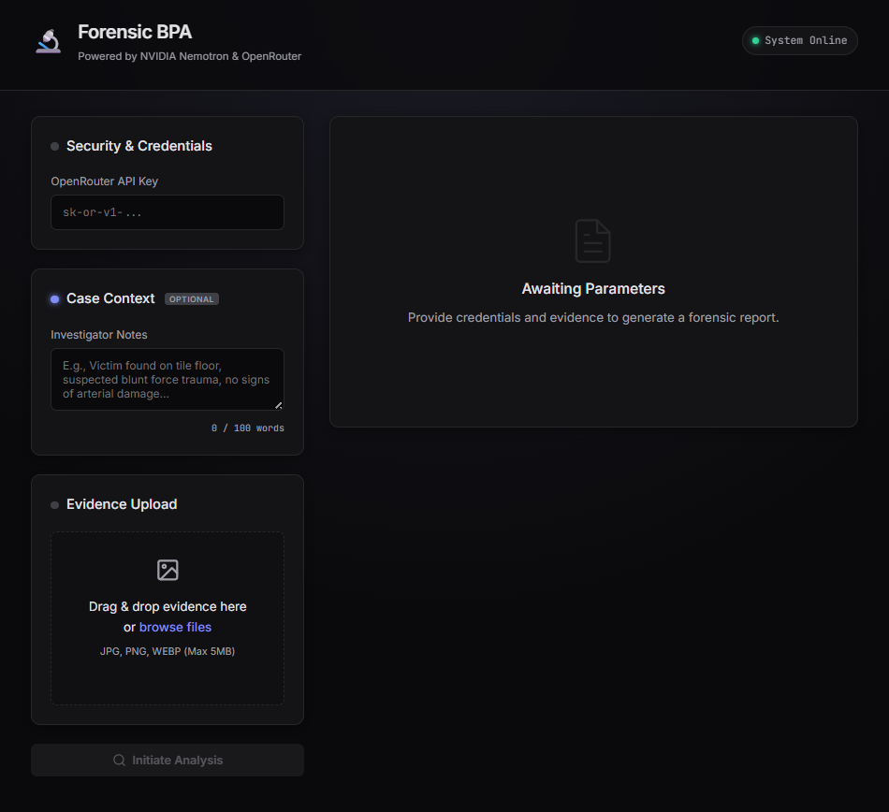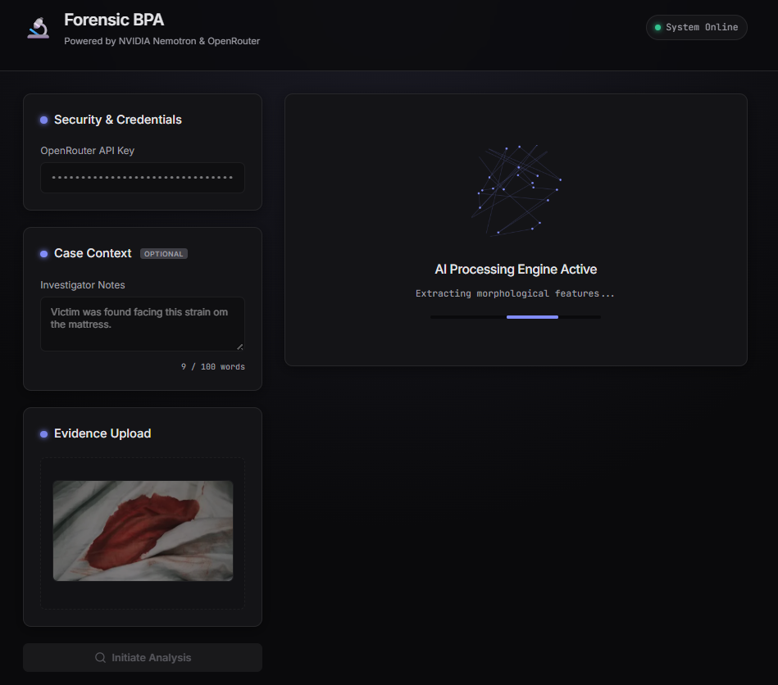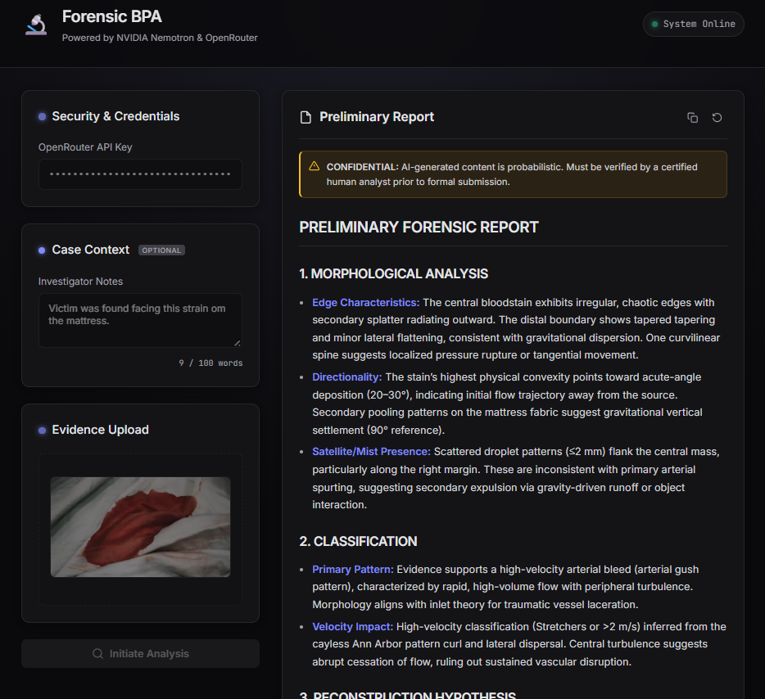
The interface is engineered to mimic a modern, premium desktop application, prioritizing clarity and status awareness.

Visual Identity
- Thematic Palette: The UI utilizes an "Obsidian-Inspired" aesthetic—deep blacks (#0a0a0c), sleek slate grays (#141417), and subtle indigo accents (#818cf8)—to reflect a high-tech forensic domain.
- Aesthetic & Typography: The typography pairs the clean Inter sans-serif font for readability with JetBrains Mono for technical inputs and code, reducing eye strain during deep analysis.

Real-Time Feedback & State Management
The application employs robust state-management to guide the user:
- Status Indicators: Visual glowing dots provide immediate feedback:
  - Waiting (Yellow Pulse): Required data is missing.
  - Ready (Green): System is securely primed for analysis.
  - Processing (Indigo Pulse): AI is actively reasoning.
  - Error (Red): Issues with API authentication or file constraints.
- Toast Notifications: A stacked, sliding toast notification system replaces standard alerts, providing non-intrusive feedback on successes, warnings, and errors.

Interactive Engagement
- Glassmorphism Panels: UI cards utilize subtle transparency and blur effects, offering a modern sense of depth.
- Custom Particle Engine: During the AI reasoning period, a custom HTML5 Canvas animation mimics an interconnected neural network in indigo and slate, providing functional and thematic visual feedback.
- Dynamic Loading States: The system cycles through forensic processing phrases (e.g., "Extracting morphological features...") alongside an animated progress bar to confirm active system status.

Applications and Use Cases

Real-Time Field Investigation
Designed to function as a frontline tool during the "Golden Hour" of a criminal investigation.
- Contextual Input: Investigators can immediately cross-reference their on-scene notes (up to 100 words) with photo evidence to shape the AI's preliminary hypothesis.
- Chain of Custody & Privacy: Thanks to the Zero-Server Architecture, sensitive evidence images never leave the user's device.
- Secure Authentication: Direct integration with the OpenRouter API ensures that credentials are handled strictly locally.

Specialized Educational Resource
An interactive laboratory for students of forensic science and fluid dynamics.
- Visualizing Mechanics: The application helps students understand the physics behind spines and satellite spatter by providing clinical, markdown-formatted explanations.
- Safe Simulation: Provides a risk-free environment for students to practice interpreting complex patterns before moving to actual biological samples.

Research and Objective Standardization
Reduces the variability inherent in human observation.
- Standardized Reporting: Enforces a strict Markdown report format, ensuring findings are documented consistently across different cases.
- Bias Mitigation: Provides an objective, data-driven second opinion that can minimize cognitive bias in initial pattern interpretation.

