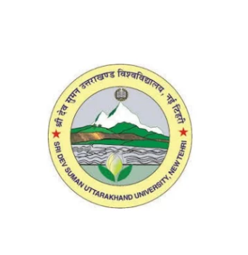
Department of Botany
Pt. Lalit Mohan Sharma Campus, Rishikesh
Sridev Suman Uttarakhand University

Department of Botany: Brief Introduction

The Department of Botany, marked by its glorious past, is the leading centre of teaching and learning in the field of plant science. Since its inception the department has been dedicated to imparting quality education in Botany and nurturing scientific temper among students. Adopting and implementing curricula aligned with National Education Policy (NEP)-2020, the department emphasizes teaching, research and extension activities. The department offers undergraduate (B.Sc.), post-graduate (M.Sc.) and doctoral (Ph.D.) programmes in Botany, providing to students a comprehensive understanding of varied fields of botany, such as microbiology, ecology, plant physiology, phytochemistry, cytogenetics, taxonomy, economic botany, plant pathology etc. with equal emphasis on fundamental and applied aspects.
The faculty members are actively engaged in research and supervision of undergraduate, post-graduate and Ph.D. students concurrent with teaching. With specialization in different fields of botany, such as microbiology, phycology, plant physiology, cytogenetics, ecology, agrotechnology, mycology and plant pathology, taxonomy and ethnobotany, the research activities of faculty members are marked by their considerable number of publications in form of research papers/articles, books and book chapters as well as patents. Presently, there are three Professors, namely Prof. V.D. Pandey (serving as Head of the Department), Prof. G.K. Dhingra and Prof. N.K. Sharma, one Associate Professor, namely Dr. Shalini Rawat, two Assistant Professor, namely Dr. S.K. Kuriyal and Dr. Preeti Khanduri, and one Guest Lecturer, namely Dr. Dinesh Singh. As one of the teaching departments of the newly established campus (Pt. Lalit Mohan Sharma Campus) of the university, the department is in the process of development in terms of infrastructure, physical resources and conducive facilities.

