Pt. Lalit Mohan Sharma Campus, Rishikesh Uttrakhand.
Affiliated to : Shri Dev Suman Uttrakhand University.
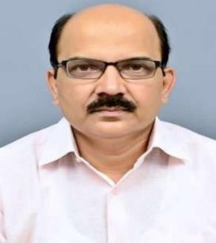
- ) Department Of Botany :
a.) Dr. Vidya Dhar Pandey
Designation: Professor, HOD
Dept. Of Botany.
E-mail : pandeyvidya2@gmail.com
Contact : +91 7895607411

b) Dr. Gulshan Kumar Dhingra 
Desgnation : Professor,
Director (IQAC, Academics, R&D Cell),
Coordinator (Microbiology & Dept. of Medical Lab Technology).
Dept. Of Botany.
Email: gulshan_k_dhingra@yahoo.com
Contact: +917017976632

c) DR. NAVEEN KUMAR SHARMA 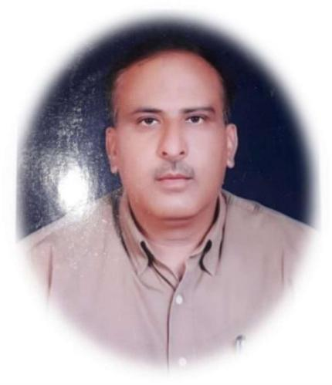
DESIGNATION: Professor, Dept. Of Botany.
EMAIL: drnksharma69@gmail.com
Contact: +919412961991

d) Dr. SHALINI RAWAT 
Designtion : Associate Professor, Department of Botany
Contact. +919411575844
email: rawatshalini18041975@gmail.com

e) Dr. Suniti Kumar Kuriyal
Designation : Assistant Professor,
Department of Botany
Email: suniti02kuriyal@gmail.com
Contact: +91-9456556249

- Dr. Preeti Khanduri 
Senior Assistant Professor, Department of Botany
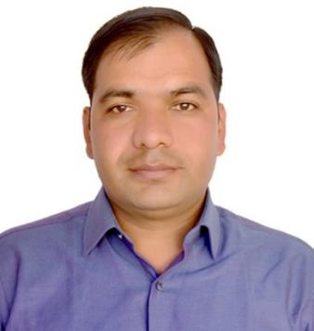
Email: khanduripreeti23@gmail.com
Contact: +91 9690308081

- Name : Dr. Dinesh Singh
Designation: Guest Teacher, Dept. of Botany,
Email : dsrwt7@rediffmail.com, dsrwt7@gmail.com
Contact : +919456359137, +918279941800

