Pt. Lalit Mohan Sharma Campus, Rishikesh Uttrakhand.
Affiliated to : Shri Dev Suman Uttrakhand University.

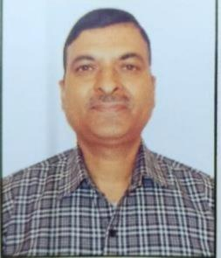
- ) Department of Chemistry :
a) Dr. SHANTI PRAKASH SATI (M.Sc., D.Phil.)
Designation : Professor & Head, Department of Chemistry
Email: satisp22@gmail.com
Contact : +917579110111



b) Dr. Vibha Kumar
Designation : Associate Professor, Department of Chemistry,
Email : vibhasingh25@gmail.com
Contact :

c) Dr. Ashish Kumar Sharma 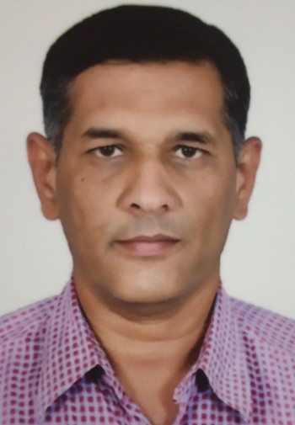
Designation : Professor, Department of Chemistry
Email :
Contact :

d) Dr. Seema
Designation : Associate Professor, Department of Chemistry
Mobile: +91-9258138438
Email: sbaniwal1974@gmail.com , sbaniwal@rediffmail.com

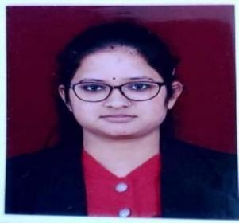

e) DR. NEHA BHATT
Designation : Assistant Professor (Guest), Department of Chemistry
Email : nehagairola1992@gmail.com

Contact : +91-8384818010, +91-9760655758

f) Dr. RAKESH KUMAR JOSHI (M.Sc., D.Phil.)
Designation : Assistant Professor, Department of Chemistry
Email : joshirk12@gmail.com
Contact : +919412441598

g) HITENDRA SINGH

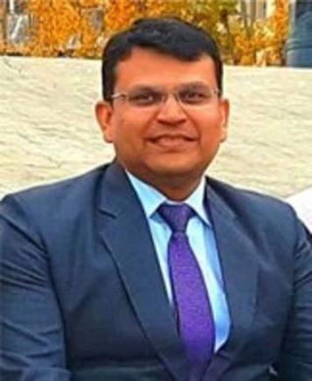
Designation : Professor, Department of Chemistry,

Email:hitensingh25@gmail.com
Contact :

h) Dr. NEETA JOSHI (M.Sc., Ph.D.) 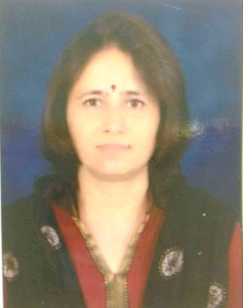
Designation : Professor, Department of Chemistry
Contact: +91-9412982875
Email: neeta_joshi000@yahoo.co.in

