Pt.L.M.S. Campus Rishikesh,
Affiliated to Sridev Suman Uttarakhand University

- ) Department of English :
a.) Dr. PARUL MISHRA
Designation : Assistant Professor, Department of English.
Contact No: +919412935163 , +918004440687
email: dparulbhu@gmail.com

b.) Dr. Hemant Kumar Shukla 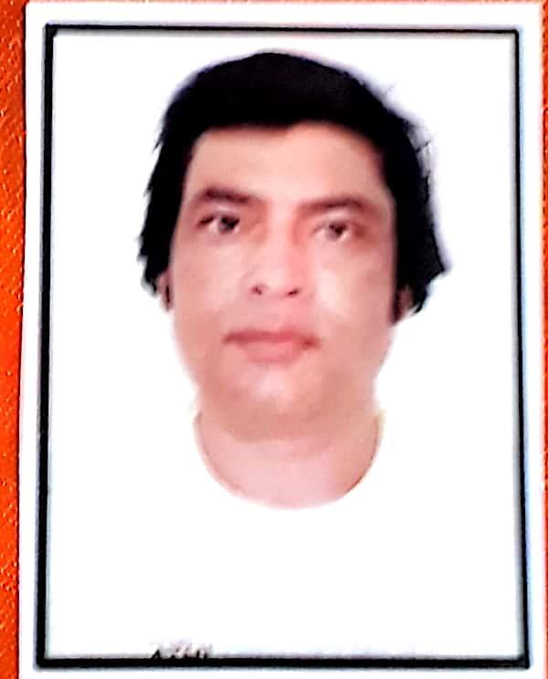
Designation : Prof. & H.O.D., Department of English
Contact No. : +917500784114 , +91 9897438142
E-mail : hemantkumar.shukla1@gmail.com

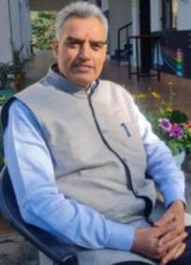
c.) Dr. Pramod Kumar Kukreti
Designation : Professor, Department of English Literature
Email: parmodkukreti3@gmail.com
Contact No.: +919528379117

