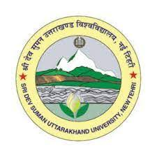
Department of English
Sri Dev Suman Uttarakhand University; Badshahithaul, Tehri-Garhwal
Pt. L.M.S. University Campus, Rishikesh (Uttarakhand)-249201
E-mail: hemantkumar.shukla1@gmail.com, Contact No. 7500784114,9897438142
Dated: 17.01.26
Brief Introduction
The University has Pt. Lalit Mohan Sharma University Campus at Rishikesh, Uttarakhand. It offers various undergraduate and postgraduate programmes across Arts, Commerce, and Science streams.
The campus offers English as both a subject and degree program:
  - B.A. (English): a three-year undergraduate program where English is a core subject.
  - M.A. (English): a two-year postgraduate degree is also offered at the college
  - Ph.D. (English)
These programmes train students in English language and literature, and typically include topics like language proficiency, literature from different periods, and writing skills-similar to other university English departments. Much of the academic structure (course content, faculty, and events) for English department generally involves language, literature, and communication skills.
Students in English programmes typically engage in Literature study (British, American, Indian writing), Language and communication skills (Through GE, SEC, AEC), Critical analysis and writing, and Preparations for careers in teaching, writing, etc.
The Department of English at Rishikesh is a well-established centre for academic excellence and literary inquiry. It is committed to fostering rigorous engagement with the English language, literature, and allied critical practices. As noted, the department offers carefully structured undergraduate and postgraduate programmes in English Language and Literature, designed to cultivate research-oriented skills. These programmes thoughtfully integrate the study of canonical texts with contemporary literary theory, critical methodologies, and evolving language practices.
The Department of English has following faculty members:
- Prof. Hemant Kumar Shukla
- Prof. Pramod Kumar Kukreti
- Dr. Parul Mishra

