Pt.L.M.S. Campus Rishikesh,
Affiliated to Sridev Suman Uttarakhand University
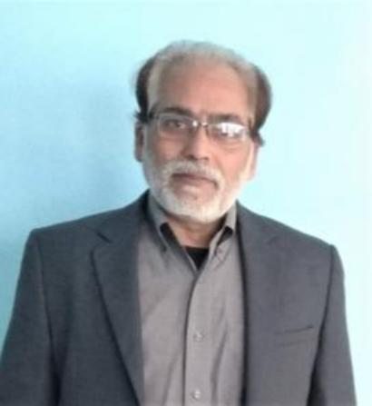
- ) Department of Hindi :
- ) DR. ADHEER KUMAR (M.A., M.Phil. NET (JRF), Ph.D)
Designation : PROFESSOR, DEPARTMENT OF HINDI.
Contact No. - +919411166951
Email ID - adheerkumar@gmail.com

