Pt.L.M.S. Campus Rishikesh,
Affiliated to Sridev Suman Uttarakhand University

- ) Department of History :
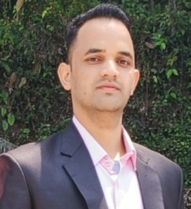
- ARJUN SINGH
Designation : Assistant Professor (Guest Faculty),
Department of History.
Contact : +917500884084
- Mail : arjunarjun4727@gmail.com

- Prof. SANGEETA MISHRA 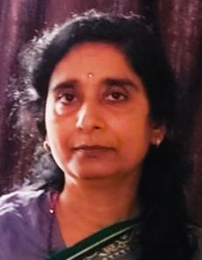
Designation : HOD, Department of History
Email : sangeetamishra450@gmail.com
Contact : +919412965832 , +919412965832

