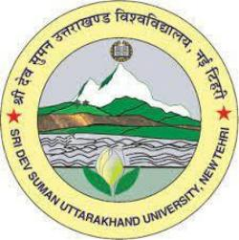
SRI DEV SUMAN UTTARAKHAND UNIVERSITY
Pt. L.M.S. Campus, Rishikesh
History Department
Email :- sdsuvrishikesh@gmail.com

Brief Introduction of History Department

In the Pundit Lalit Mohan Sharma Campus Rishikesh, currently two faculty are working, Professor & Head Dr. Sangeeta Mishra and Dr. Arjun Singh (Guest faculty). Professor Sangeeta Mishra has more than 30 years of experience, while Dr. Arjun Singh has 3 years of experience. Currently, in the History department, more than 440 students are enrolled from B.A. first semester to M.A. third semester, while three research scholars are conducting research under the guidance of Professor Sangeeta Mishra.
