Pt.L.M.S. Campus Rishikesh,
Affiliated to Sridev Suman Uttarakhand University

- ) Department of Home Science
- ) Dr. Vandana Bhandari 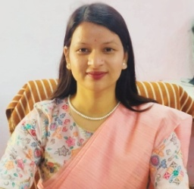
Designation : Assistant Professor (guest faculty), Department of Home Science
Email : bhandarivandana2016@gmail.com
Contact :

