Pt.L.M.S. Campus Rishikesh,
Affiliated to Sridev Suman Uttarakhand University
- ) Department of Political Science :
A.) Dr. Dinesh Sharma 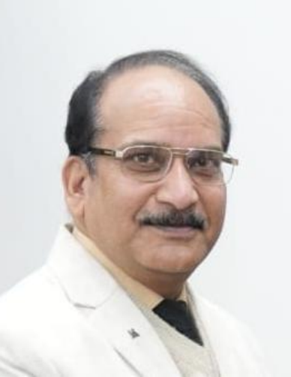
Designation : Professor, Department of Political Science.
Email: dineshshrm772@gmail.com
Mobile no.: +917417784525

- ) Prof.(Dr.) Durga Kant Pd. Chaudhary 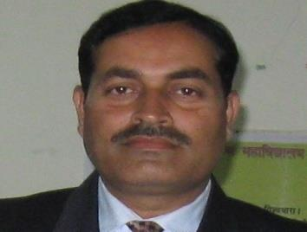
Designation : Professor, Department of Political Science
Email: dkpchaudhary@gmail.com , dkpchaudhary@rediffmail.com
Contact : 9411346372

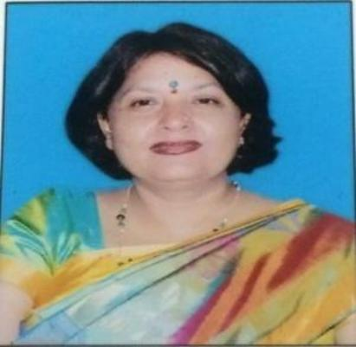
- Prof. Dr. HEMLATA MISHRA
Designation : Professor & Head, Department of Political Science
Mobile No. : +919411166952
E-Mail : hemlata80@gmail.com

