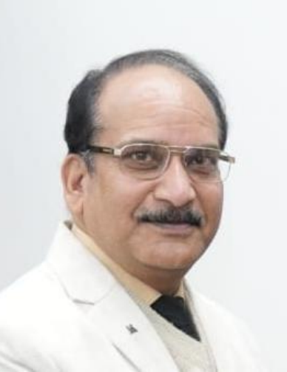 | Dr. Dinesh Sharma Professor | Department of Political Science

Educational Qualification:

Examination | Year | Board/University
BA (Hons) | 1988 | BHU
MA | 1990 | BHU
Ph.D. | 2003 | Purvancahl University
UGC NET | 1992 | UGC

• Seminar/ Conference/Symposium Paper Presentation

S. No | Title of the Paper | Title of Conference/ Seminar | Organising Institution
1 | “Autocracy and the People’s Power” | International Conference on “Challenges of Democracy and Development in Nepal” | The Centre for the Study of Nepal, BHU on 18 and 19 Dec 2006
2 | “New Trends in  Parliamentary System in India: Coalition  Government” | National Seminar on “Vartman Vaishvik Sandarbh me Bharat” | GSH PG College,  Bijnor on 17 & 18 Feb 2007
4 | “Indo- China Border Dispute” | National Seminar on “Bharat ki Rashtriya Suraksha ke  Pariprekshay me Himalayi  Kshetra ka Strategic Mahattva” | LSM Govt PG College, Pithioragarh on 08 & 09  June 2010
5 | “Women  Empowerment and Development  Paradigm” | National Seminar on “Gender Equality: Human Rights  Perspective” | SRS Mahila Mahavidyalaya, Bareilly on 20 & 21 Dec 2010
6 | “Good Governance in the Age of  Globalisation” | Swami Shukdevanand  International Seminar on  “Impact of Globalisation on Managerial Skill” | Swami Shukdevenand PG College, Shahjahanpur on 26 & 27 Feb 2011
7 | “Scientific Temper,  Secularism and Nation Building in India” | National Seminar on “Role of Mathematical and Physical  Sciences in Engineering and Technology” | Government Degree  College, Karanprayag  (Chamoli) on 21& 22 Oct 2011
8 | “Technological  Breakthrough in India’s Defence Sector” | National Seminar on “Role of Mathematical and Physical Sciences in Engineering and Technology” | Government Degree  College, Karanprayag  (Chamoli) on 21& 22 Oct 2011
9 | “The Role of  Nanotechnology in Social Welfare” | National Conference on “Recent Trends in Material Science and Nano Structure (RTMSNS-12)” | SBS Government PG College, Rudrapur (USN) on 03 & 04 Jan 2012
10 | “Rare Earth Materials in India: An Assessment of Scope and Policy” | National Seminar on “Recent Trends in Material Science  and Nano Structure (RTMSNS-12)” | SBS Government PG College, Rudrapur (USN) on 03 & 04 Jan 2012

-

• Publications:

- Research paper/ article on “Indo- China Border Dispute” in “Bharat ki Rashtriya Suraksha ke Pariprekshya me Himalayee Kshetra ka Strategic Mahattva”, edited by Narvadeshwar Shukl and Gulab Chandra Dixit, Mohit Publications, N Delhi, 2012

2. Research paper/ article on “Feminist Perspective on Development” in
International Journal Shodh Drishti, Srijan Samiti Publication, Varanasi, July- Sept. 2013

3. Research paper/ article on “Global Warming and India’s Energy Security” in International Journal Anukriti, Srijan Samiti Publication, Varanasi, July- Sept.
2013

4. Research paper/ article on “State, Development and Globalisation” in “Globalisation Environment and Quality of Life”, edited by Dr Anchalesh Kumar, Vivek Prakashan, N Delhi, 2015

5. Research paper/ article on “Hydro Power in Uttarakhand: An Environmental Assessment” in “Uttarakhand: Treasures and Tears”, edited by Dr M C Pandey, Ankit Prakashan, Haldwani, 2015

6. Research paper/ article on “The Naga Insurgency” in “National Integration in India: Issues and Challenges”, edited by Dr Anchalesh Kumar, Jagdamba
Publishing Company, N Delhi, 2015

7. Research paper/ article on “The Challenge of the Naxal Problem”, Peer
Reviewed and Refereed UGC approved International Journal (40908)
Shodhmanthan, ISSN: (P) 0976-5255, (E) 2454-339X, Impact Factor, 6.726 (SJIF), Anu Books, Delhi, Meerut, N Delhi, May 2019

8. Research paper/ article on “Political Empowerment of Women in Gram
Panchayat with Reference to Women’s Representation in Panchayats of
Uttarakhand” in Multidisciplinary Peer Reviewed International Journal
JournalNX, ISSN 2581-4230, Novateur Publication, M.S. India, Vol 8, Issue I, Jan 2022, 159-165

9. Research paper/ article on “Political Empowerment of Rural Women in
Gram Panchayats (A Study with Reference to Gram Panchayats in
Champawat District of Uttarakhand)” in Multidisciplinary Peer Reviewed International Journal JournalNX, ISSN 2581-4230, Novateur Publication, M.S. India, Vol VIII, Issue VIII, August 2022, pp. 135-141

10. Research paper/ article on “Shiksha ka Adhikaar evam Samaveshi Skiksha”, in UGC approved CARE listed International Journal Education and Society,
Hindi Indian Institute of Education, Pune, ISSN 2278-6864, Special Issue Vol. II, Feb 2023,pp. 15-22

