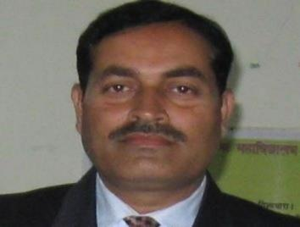

Prof.(Dr.) Durga Kant Pd. Chaudhary

Educational Qualifications: Ph.D.

Fields of Interest/ Expertise: Public Administration, Human Rights.

Submitted Research Projects:
1. UGC-Minor Project on „Impact Evaluation of Electronic Governance in Uttarakhand‟.
2. ICSSR Project on „Revenue Policing in Uttarakhand: The Perspective and Prospective ‟

Research Paper Published:
1. “Socio-Political Change as Continuity in Uttarakhand: Critical Reflections”
Published by Vishvanatha Kaviraja Institute, New Delhi. (ISBN-978-81-945995-9-3)
2. “Contemporary Social, Political and Economic Issues in India ”
Published by Taneesha Publishers, Bengaluru. (ISBN-978-93-48037-17-6)
3. “भारतीय प्राच्य ज्ञान सम्ऩदा: शाश्वत ज्ञान से आननक वश्व कल्याण तक”
Published by Motilal Banarasidass, Patna.
4. “भारतीय ज्ञान सम्ऩदा में राजनीनतक वमशश : अभज्ञान एवं नसंरचना”
Published by Motilal Banarasidass, Patna.

Membership of Professional Bodies :
1. Life Member, Indian Institute of Public Administration (L-11870)
2. Life Member, Indian Political Science Association (No.-2117)

Awards won :
LIFE ACHIEVEMENT AWARD 2020 - 2021: Novel Research Academy, Puducherry
Member,Advisory/Editorial Boards :
1. Navjyot Journal (Bi-annual International Academic Journal).
2. The Journal of Acharya Narendra Dev Research Institute
3. The Anusandhanika (Bi-annual International Academic Journal).
4. A Journal of Asia for Democracy and Development (Quarterly International Academic Journal)
5. Vichar Vimarsh(Bi-annual International Academic Journal).

Areas of Interest:
Police and Police Reforms, Governance and Emerging patterns, Analysis of socio-economic disparities, Human Resource Development, Constitutional system in India and other
related areas.
Engaged in social activities like literacy campaign programmes.

