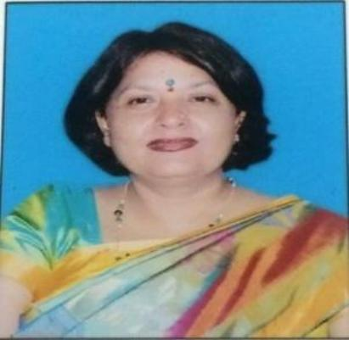
Prof. Dr. HEMLATA MISHRA

Name (in Block letters) Hemlata Mishra
Name of the Department POLITICAL SCIENCE
Present Designation Professor & Head
Member of Curriculum Preparation Committee of SDSU, Member of Exam Committee 2021-2025, Convener of Cultural Committee, Member of Women Harassment Redressal Cell.

Field of specialization and super specialization : International politics

. Research, Publications and Academic Contributions Published Papers in Journals:

S.No. | Title with page nos. | Journal | Whether  peer  reviewed impact  factor ,if any | No. of Co-  autho r | Whether  you are the main author
1. | Anne Besant Adhyatm se Rashtra  Nirman ki or | Pragya | No |  | Sole author
2. | Dakshina asia me Nepal ka Shanti-Kshetra Prastav | Manviki  Vimarsh | No |  | Sole author
3 | Rashtra ewan Sabhyata ke Ubharta Sandarsh:  21wi Satabdi ka Sandarbh | eJournal LMS  Campus | No |  | Sole Author

Articles /Chapters published in Books :

S. No. | Title with page nos. | Book Title ,editor &publisher | ISSN/IS  BN No. | Whethe  r peer  reviewe d  impact factor ,if any | No. of Co-  auth or | Whethe  r you  are the main  author
1 | Samajik Prashasan ke Siddhant | 3 chapters*5 Uttarakhand Open University | 978-93-  84433-  87-1 | Yes | Own | Main  Author
2. | Manwadhikaar  Samkaleen Mudde aur Chunoutiya | 1 Chapter Mekhala Publishers, New Delhi | 978-93-  81415-  83-2 | Yes | Own | Main  author
3 | Shanti Nirman: Bhartiya  Pariprekshya me | Adhunik  Paridrishya me Bharatiya Gyan  Sampada Vol 2 | ISBN:  978-93-  6729-  165-8 | yes | own | Main  Author

. One Major research work on the topic of “Identifying shift in Living Standard of Women Unorganised Labours in a Decade in Region of Nainital District in Uttarakhand : a wage Differential Method” which was provided/assigned/sponsored by the ICSSR has been completed from 01.05.2012 to 01.05.2014.

Publications
1. India’s nuclear policy References book.

2. Human Rights recent issues and challenges Book in Hindi.

3. Article- Unorganized workers condition and living standard.

4. Chapter in book Reconstructing History in changing Socio-Cultural Scenario.

5. Article-chapters in social welfare.

