DEPARTMENT OF SANSKRIT
Sri Dev Suman Uttarakhand University

Pt.LMS Campus,Rishikesh,Dehradun(Uttarakhand)

SUBJECT: BRIEF INTRODUCTION OF SANSKRIT DEPARTMENT
The Department of Sanskrit at Pandit Lalit Mohan Sharma Campus,Rishikesh, Sri Dev Suman Uttarakhand Vishwavidyalaya,is dedicated to the academic study, preservation and dissemination of Sanskrit language and literature.The department is presently served by a single faculty member, Prof.Poonam
Pathak, who oversees teaching,research,and academic administration.
The department offers academic programmes at the Undergraduate,
Postgraduate,and Doctoral (Ph.D.)levels.Approximately 100 students are enrolled in the Department of Sanskrit and are actively pursuing their studies.In addition to the core curriculum,the department also conducts various Skill Development Courses,Ability Enhancement Courses and Value Addition Courses at the undergraduate level, in accordance with contemporary educational frameworks.These initiatives aim to enhance student’s intellectual capacity,professional competence and overall academic development,while maintaining the traditional scholarly rigor of Sanskrit studies.
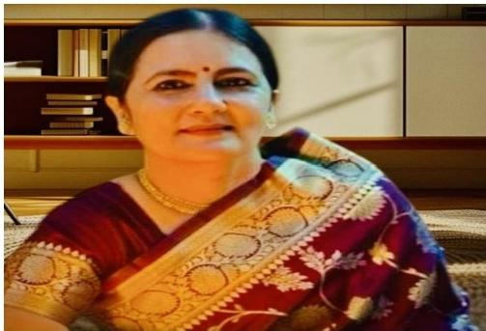

Prof.Poonam Pathak

H.O.D, Department of Sanskrit

