Pt.L.M.S. Campus Rishikesh,
Affiliated to Sridev Suman Uttarakhand University
- ) Department of Sanskrit :

A.) Prof. Poonam Pathak 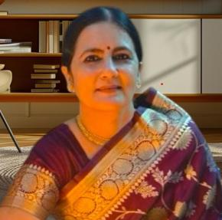
Designation : Professor, HOD, Department of Sanskrit
Email: poonampathak2304@gmail.com
Contact no.:

