Pt.L.M.S. Campus Rishikesh,
Affiliated to Sridev Suman Uttarakhand University
- ) Department of Sociology :

A.) Prof. (Dr.) Prashant Kumar Singh 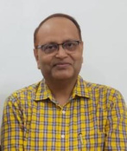
Designation : Professor , Head and Dean Faculty of Arts, Department of Sociology,
Email: drprashant1970@gmail.com
Mobile no.: +919412138154

- )Dr. Kiran Fartiyal 
Designation: Assistant Professor (Guest Faculty), Department of Sociology
Email: fartiyalkiran@gmail.com
Contact : +918279441322

