SRI DEV SUMAN UTTARAKHAND VISHWAVIDYALAYA

Pt. L.M.S Campus. Rishikesh

Department of Sociology
The Department of Sociology, Pandit Lalit Mohan Sharma Campus, Rishikesh, functions with a strong academic and research orientation under the guidance of two dedicated faculty members, Prof. (Dr.) Prashant Kumar Singh and Dr. Kiran Fartiyal.
Prof. (Dr.) Prashant Kumar Singh, Professor and Head of the Department of Sociology and Dean, Faculty of Arts, Sri Dev Suman Uttarakhand University, Rishikesh, is a distinguished academician and sociologist with extensive teaching and administrative experience across various government degree and postgraduate colleges in Uttarakhand, including leadership roles as Principal. He has made significant contributions to sociological research, having published 22 research papers in reputed journals and successfully completed six Minor Research Projects. Under his supervision, two Ph.D. scholars have been awarded doctoral degrees, while four Ph.D. scholars are currently pursuing their research. He has also actively supervised MSW students in their research project work. Prof. Singh is a Life Member of the Uttarakhand Sociological Association and the Indian Sociological Society, and a Founder Member of the Bihar Sociological Society, reflecting his active engagement in the sociological community at regional and national levels.
Dr. Kiran Fartiyal, Assistant Professor (Guest Faculty) in the Department of Sociology, has teaching experience at reputed institutions, including Chandrawati Tiwari Girls PG College, Kashipur. She has published nine research papers in recognized journals and has actively contributed to research activities. She has worked as an Investigator in an ICSSR-sponsored research project and is presently serving as Co-Coordinator in an ongoing ICSSR research project. She has also supervised MSW students in completing their research project work. Her academic excellence has been recognized through prestigious honours, including the National Research Paper Award (2024) for her research on “Empowering Women through Digital Literacy” and the International Eminent Young Scientist Award (2024—25). She has completed the NEP 2020 Orientation and Sensitization Programme under the UGC Malaviya Mission Teacher Training Programme (MM-TTP) and holds additional academic qualifications, including computer proficiency (A Grade) andA & B NSS Certificates.
The department caters to a substantial student strength, with over 350 undergraduate students and more than 35 postgraduate students currently enrolled. In addition, the department is actively engaged in research supervision, with four Ph.D. research scholars pursuing their doctoral studies under faculty guidance. The Department of Sociology remains committed to quality teaching, meaningful research, and academic mentoring, contributing significantly to sociological education and research at the university.

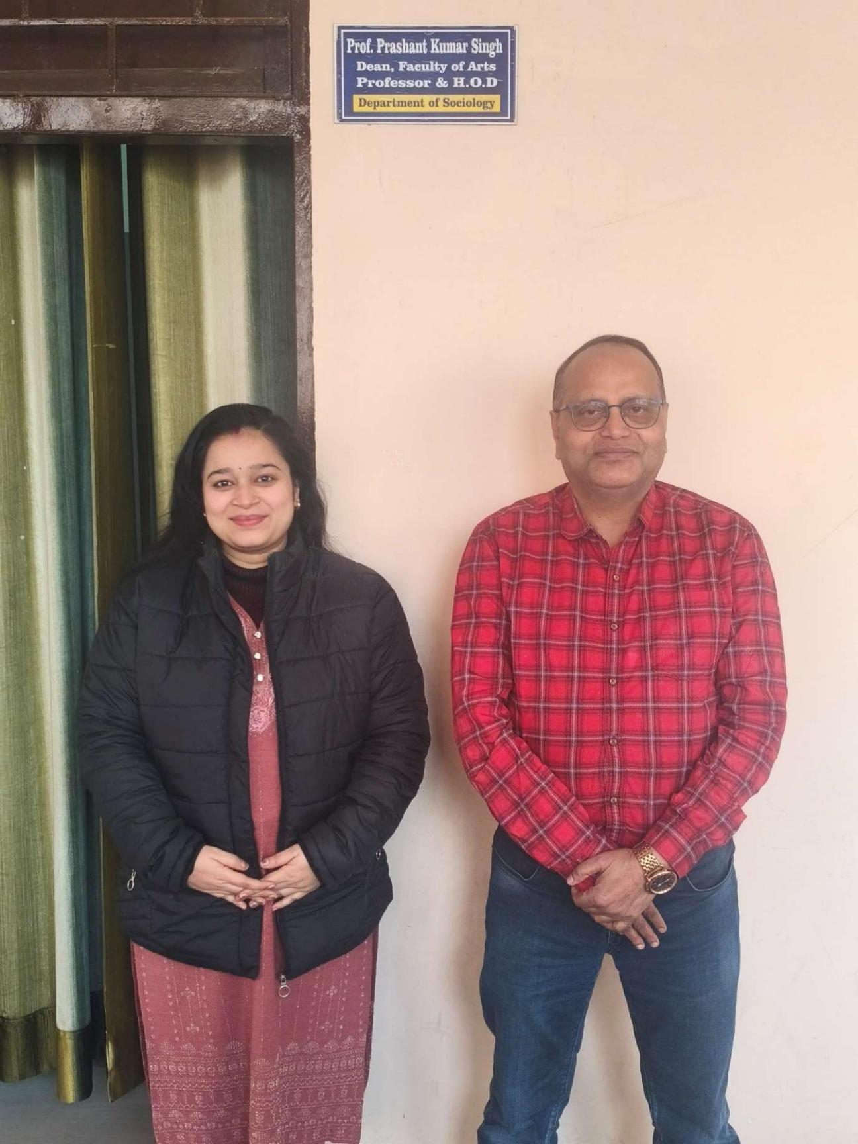

1. Prof. Prashant Kumar Singh (HOD, Department of Sociology and Dean, Faculty of Arts).

2. Dr. Kiran Fartiyal (Guest Faculty), Department of Sociology.

