Kafka Order Processing System
Test Execution Report
Project | Event-driven order processing with Spring Boot microservices and Apache Kafka
Tested by | Mohammed Sakib
Test date | 30 September 2026
Environment | Local. Kafka broker in Docker (localhost:9092), Order Service on localhost:8081, MySQL, Postman for requests
Services covered | Order Service, Payment Service (Delivery and Notification are outside this report)

1. Summary of results
Six scenarios were run against the Order and Payment services. Each one below has the objective, the steps, the expected result and the captured evidence.
# | Scenario | What it proves | Result
1 | Basic successful order | REST call, DB write and ORDER_CREATED publish | PASS
2 | Order status changes to PAID | payment-success is consumed by Order Service | PASS
3 | Duplicate event (idempotency) | Same eventId gives only one payment | PASS
4 | Failure and retry | Consumer retries a failing message | PASS
5 | Dead Letter Topic | Exhausted messages land in the DLT | PASS
6 | Payment Service down | Kafka retains messages and consumer resumes | PENDING: add screenshots

2. Test 1: Basic successful order
Objective | Create an order through the REST API and confirm the ORDER_CREATED event is published to Kafka.
Request | POST http://localhost:8081/orders
Expected | HTTP 200 with a new orderId and status CREATED; the Order Service logs the publish to topic order-created.
Actual | HTTP 200 OK in 1.23 s. Response: orderId 56, status CREATED.

Request and response
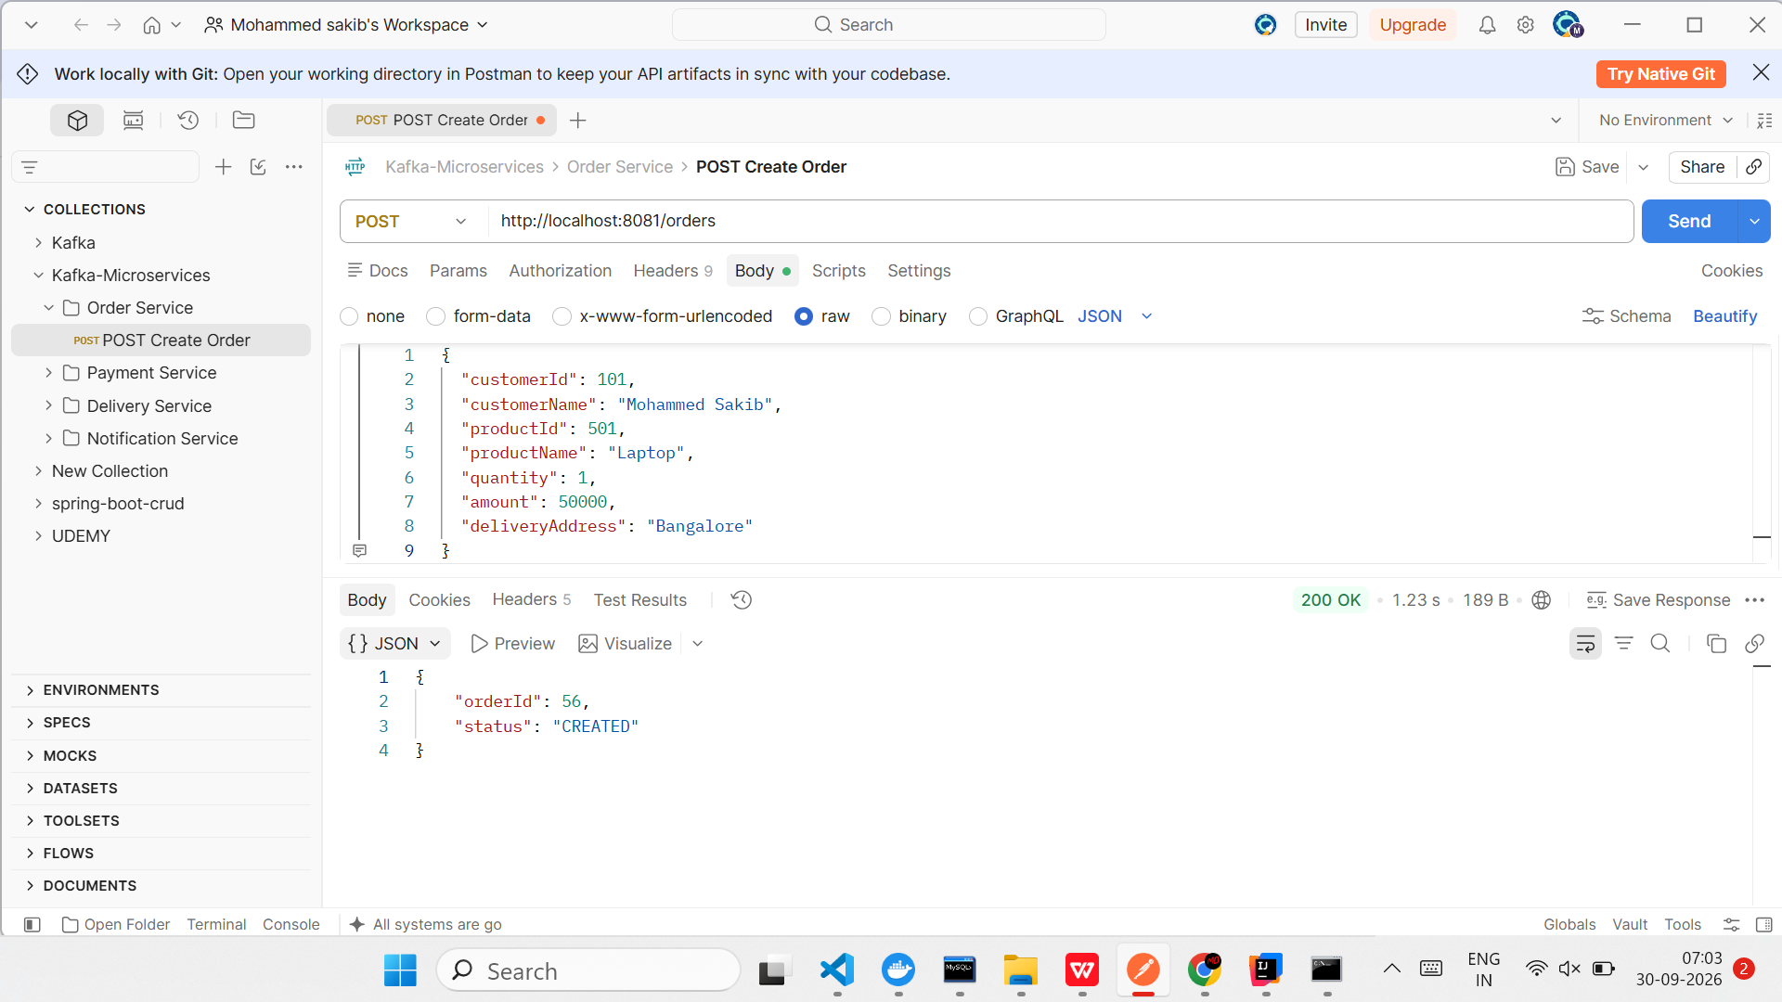
Figure 1. Postman: POST /orders returns 200 OK with orderId 56 and status CREATED

Order Service log
The producer log confirms the event was published for order 56 (customer 101, amount 50000.0) to topic order-created. When payment-success arrives, the service loads the order and updates its status to PAID.
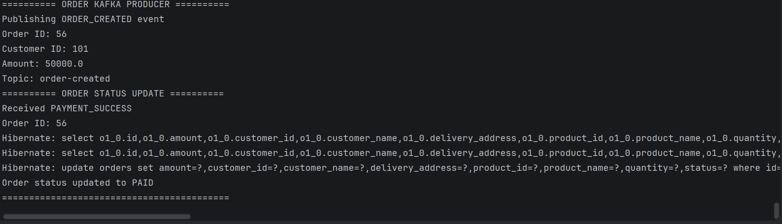
Figure 2. Order Service console: ORDER_CREATED published, then PAYMENT_SUCCESS received and status set to PAID

3. Test 2: Order status changes to PAID
Objective | Confirm the Order Service consumes payment-success and updates the order.
Listener | topic payment-success, groupId order-service-payment-group
Expected log | Received PAYMENT_SUCCESS, Order ID, then "Order status updated to PAID"
Expected in MySQL | The order row shows status PAID
Actual | Log output matches (see Figure 2). Order 56 was updated to PAID.

Listener configuration
@KafkaListener(
topics = "payment-success",
groupId = "order-service-payment-group"
)

Verification query
SELECT id, status
FROM orders
WHERE id = 56;

Event flow demonstrated
Payment Service
↓ Kafka topic: payment-success
↓ Order Service
↓ Order status = PAID

4. Test 3: Duplicate event (idempotency)
Objective | Show that the same event delivered twice creates only one payment.
Approach | Application-level idempotency. Before processing ORDER_CREATED, the Payment Service looks up the eventId in the processed_events table. If it exists, the event is ignored.
Expected | One payment row for the event; the second delivery logs "Duplicate event ignored".
Actual | Order 57 was published twice with the same eventId 694c103d-0fef-43a8-be1c-de2d172b0895. The first delivery saved the payment (SUCCESS); the second was ignored.

Order Service: event published twice
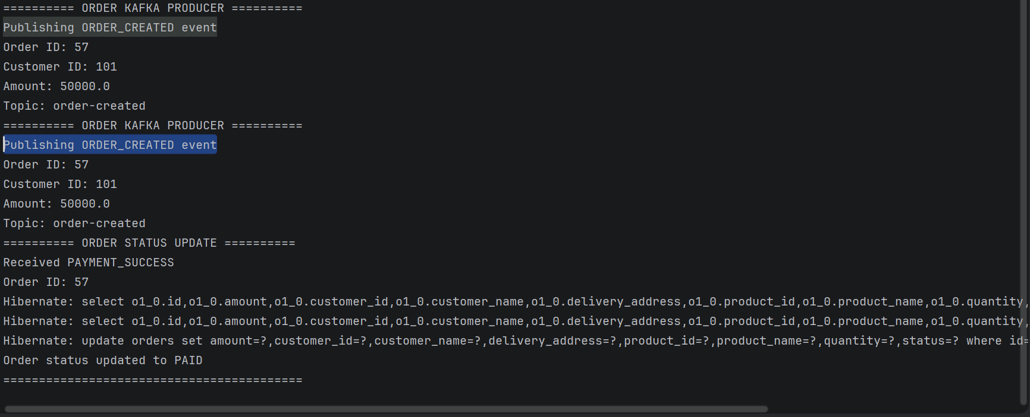
Figure 3. Order Service: ORDER_CREATED for order 57 published twice

Payment Service: duplicate ignored
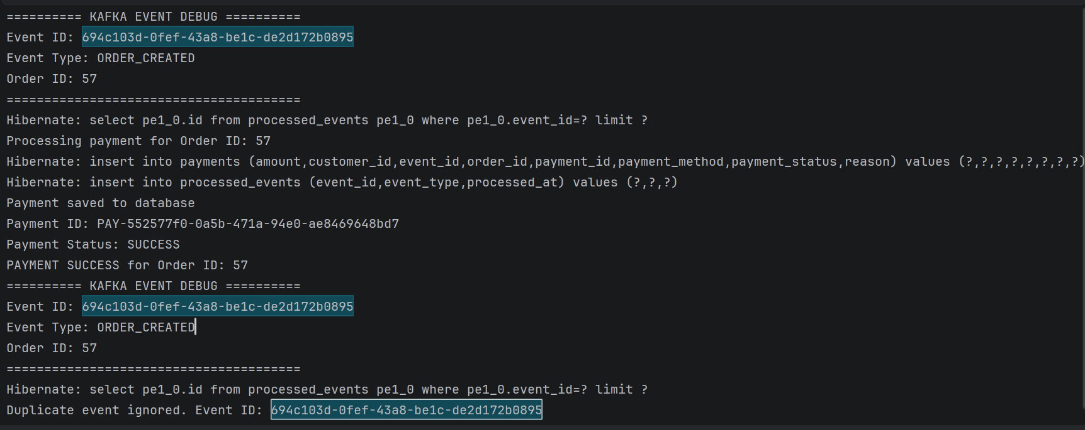
Figure 4. Payment Service: first delivery inserts payment and processed_events row; second logs "Duplicate event ignored"
Result: one payment exists for the event, not two. Idempotency achieved.

5. Test 4: Failure and retry
Objective | Verify that a failing consumer triggers Kafka retries.
Setup | The Payment Service was made to throw a deliberate "TEST FAILURE" while processing order 61 (customer 105, amount 55555.0).
Expected | The same event (same eventId) is redelivered several times before being given up on.
Actual | Event 2e947e6b-291f-4cd4-9414-a29613137c31 was processed at least three times. The retry log lines are about 2 seconds apart (07:29:41 and 07:29:43).

Order created
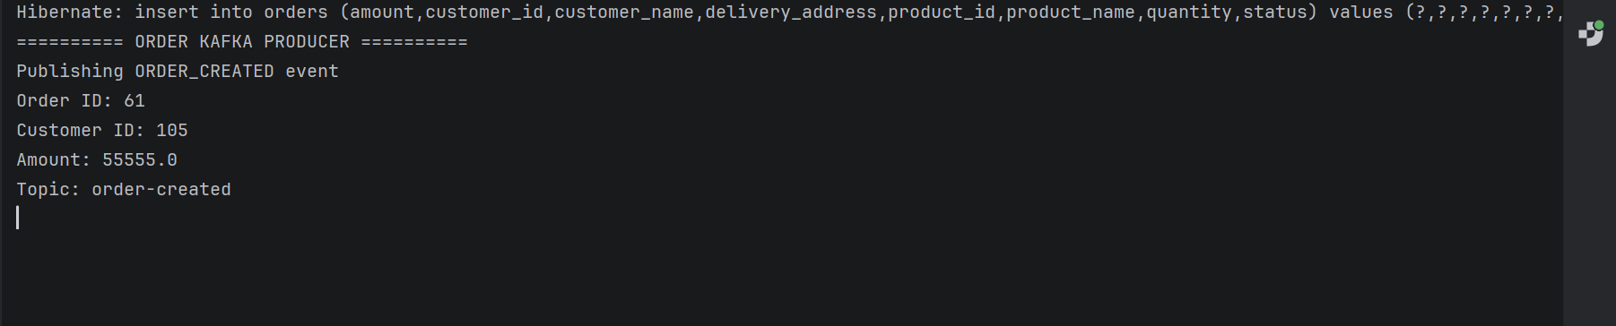
Figure 5. Order Service publishes ORDER_CREATED for order 61

Retry attempts in the Payment Service
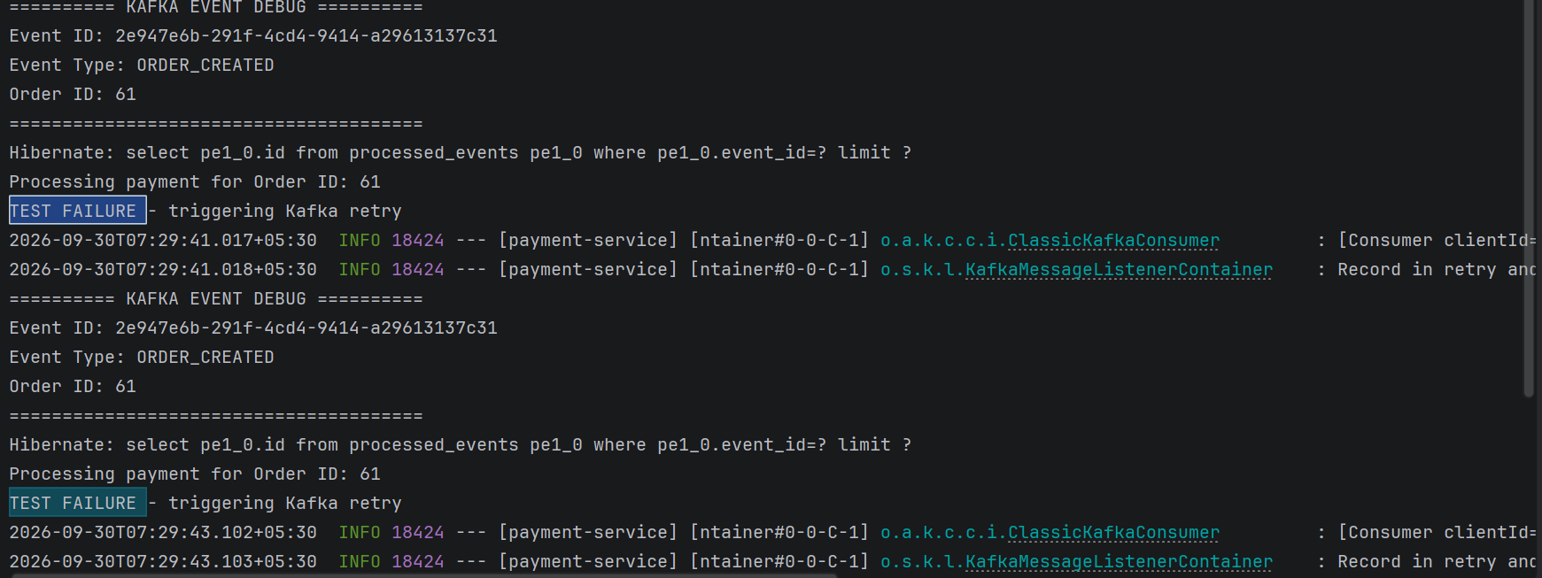
Figure 6. Payment Service: TEST FAILURE triggers a Kafka retry, and the event is redelivered
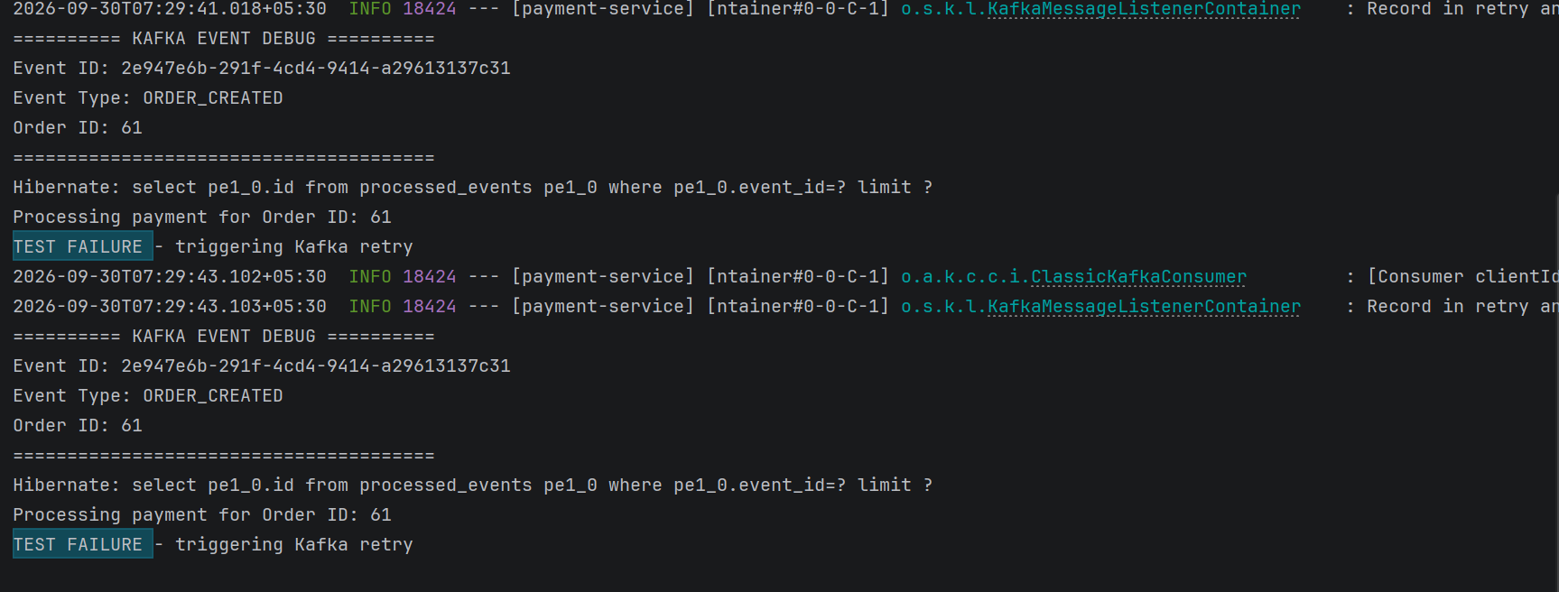
Figure 7. Payment Service: further attempts for the same eventId

6. Test 5: Dead Letter Topic
Objective | Confirm that messages which keep failing end up in a Dead Letter Topic.
Command | kafka-console-consumer.sh on topic payment-success.DLT, from the beginning, printing key and partition
Expected | The failed ORDER_CREATED events appear in the DLT.
Actual | The DLT holds the failed events, including order 61 from Test 4, all on partition 0.

Command used
docker exec -it kafka /opt/kafka/bin/kafka-console-consumer.sh \
--bootstrap-server localhost:9092 \
--topic payment-success.DLT --from-beginning \
--property print.key=true --property print.partition=true
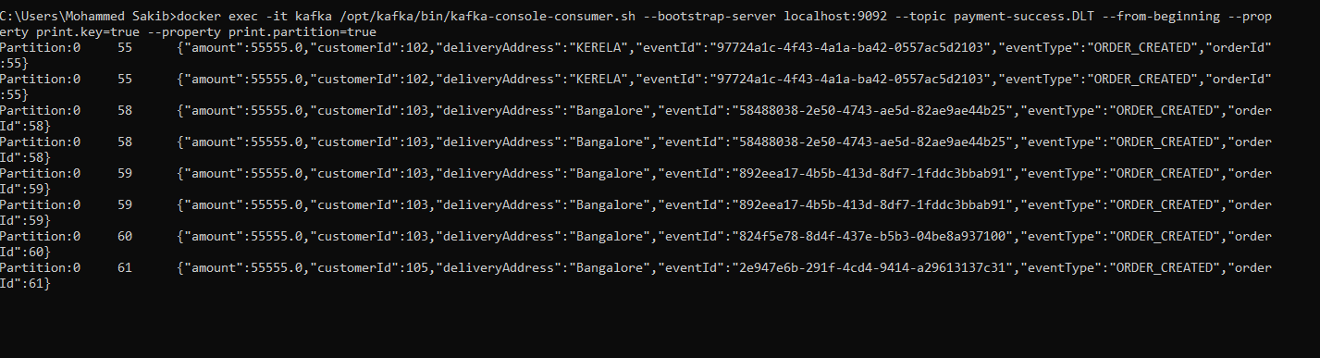
Figure 8. Messages read from payment-success.DLT (orders 55, 58, 59, 60 and 61)

Observations
- Repeated entries. Orders 55, 58 and 59 each appear twice in the DLT. Check whether the failure handler publishes the record more than once, or whether earlier test runs left duplicates.
- Topic name. The DLT is called payment-success.DLT, but the messages in it are ORDER_CREATED events. Dead-letter names normally follow the topic the failing consumer reads (order-created.DLT). Confirm this naming is what you intend.

7. Test 6: Payment Service down (durability)
Objective | Show that Kafka keeps messages while a consumer is offline and delivers them when it returns.
Steps | 1. Stop the Payment Service. 2. Create an order. 3. Start the Payment Service.
Expected | The Order Service saves the order and publishes the event. The message stays in Kafka. After restart the Payment Service consumes it from its last committed offset.
Status | Steps documented; screenshots not yet captured.

Order Service
↓ Kafka
↓ Payment Service DOWN
↓ Message remains in Kafka
↓ Payment Service START
↓ Message consumed

To complete this test, add: (a) the Order Service log after the order is created while Payment is stopped, (b) the Payment Service log after restart showing the event processed, and optionally (c) the consumer group lag before and after.

8. Conclusion
- The order flow works end to end for the Order and Payment services: order creation, event publishing and status update to PAID.
- Idempotency is enforced through the processed_events table, so duplicate deliveries do not create duplicate payments.
- Failed messages are retried and then routed to a Dead Letter Topic.
- Open items: capture Test 6 evidence and review the two DLT observations in section 6.

