**Description**

You are developers at a software development company. You have been contacted by Smart Solutions inc., they have a project called *SmartHome*, they describe their project below:

>>>>>>>>>>>>>>>>>>>>>>>>>>>>>>>>>>>>>>>>>>>>>>>>>>>>>>>>>>>>>>>>>>>>>>>>>>>>>>

* *SmartHome+* is a smart-home platform for home users to automate daily home tasks,  reduce energy waste,  and provide home security, and alerts in case of water leaking, fire, etc.
* The main users are the owners of the house, their children and their pets
* **The functions of this product will be divided into six categories**: accessibility (highly desired by the customer); environmental considerations (provide a safe environment to live by monitoring quality of air and water); energy efficiency: live in an efficient way by reducing utility bill costs by waste of energy; security is important to the homeowners to keep their home safe; media and entertainment; automation which require taking as much of the home inhabitants out of routine tasks as possible.  The summation and harmonization of all the six categories of SmartHome+ will provide for a truly rewarding living experience for the SmartHome+ users.

**Description of tasks involved in the assignment**

This assignment has 4 main tasks that are all to be performed in your assigned team of Moodle.

The purposes of the tasks are to give you hands-on practice software engineering requirements elicitation, specification, and prioritization. We also require you to do a postmortem analysis of the techniques you used and to evaluate your work and processes. Below the description of each task:

**Task 0 - Logging**

During all of the work you do on this assignment you must log how much time you spend on each activity and which person(s) in your group does what. Your log should be added as an appendix to your post mortem report described below.  It is highly recommended to create your manuscript using latex and place it in a version control system like Github to track changes, participation of team members, discussion, etc.   In this way, you do not need to spend additional time on task 0.   If you are not familiar with Latex, you could opt for Google docs, which offers the possibility of team collaboration, and history.  However, extracting that information for the purpose of writing the logging must be done manually, while in Git and latex you can always export statistics, generate diff versions of the files, etc.

**Task 1 – Vision Document (section 1)**

Complete the Vision document using  the UP template.  It is important that you add this document to your repository as it must be updated with the information derived from the **previous deliveries from the recommendations of the TAs**

**Task 2 – Use case model (section 2)**

Fill  a UCM template (UP process, [Appendix B](https://docs.google.com/document/d/e/2PACX-1vSa871KnfcLthdSi6GkiEkngCkmGte1NB9XVK8FvhAQMB6B4HW6VaD5qyPll5QDqEZPN4EpW4yu_7y3/pub?embedded=true#h.51v46jfj7x2u)) for each  use case using*essential style.* There is no limit on the number of use cases, but a reasonable delivery will include **1 use case for each category** ([see description](https://docs.google.com/document/d/e/2PACX-1vSa871KnfcLthdSi6GkiEkngCkmGte1NB9XVK8FvhAQMB6B4HW6VaD5qyPll5QDqEZPN4EpW4yu_7y3/pub?embedded=true#h.u7u03i5ddrq1)).

To complement the use case model section, include the following diagrammatic notations:

* 1 UML use case diagram to describe  the overall system
* 1 UML sequence diagrams to illustrate interaction between actors for a critical process
* 1 UML activity diagrams to model sequential and parallel activities in a critical process
* 1 UML state machine diagrams to model the behaviour of any of the smart devices you want to deploy (e.g., Window movement system, coffee machine, pet feeder, irrigation system, etc.)

Remember to validate that your use cases pass the*Boss test*, *EBP test*. While there is not a fixed size for the number of steps in the use cases , keep them between 5 to 15.

**Task 3 - Supplementary Specification and glossary (section 3)**

Fill the supplementary specification template (UP process).  Remember that the use-case model section will contain most of the functional requirements for the system, and you will supplement the use-case model section of your SRS with these additional requirements (80-20 rule).

**Final remarks**.  Remember that all sections in the SRS document have to be consistent with each other and for sections 1 and 3 must be linked with a use case in section 2, where applicable.  [See Appendix A](https://docs.google.com/document/d/e/2PACX-1vSa871KnfcLthdSi6GkiEkngCkmGte1NB9XVK8FvhAQMB6B4HW6VaD5qyPll5QDqEZPN4EpW4yu_7y3/pub?embedded=true#h.8behdmevipk4) for further reference.

**Task 4 - Post mortem**

You should conduct a post mortem analysis of the software requirements engineering activities and the whole project of your group assignment. The post mortem should be reported in a separate document from your SRS. It should, in detail, answer the following questions:

1. Which process did you follow for your requirements activities in tasks 1-3 of this assignment? Show all the steps in time, describe what they constituted and the motivation for why you chose this technique/step at that point of your overall process.
2. Based on the process description from question 1 and the detailed logging information you should summarize how much time was spent (in total and by each group member) on the steps/activities involved as well as for the project as a whole? Note that this information will in no way be used for any grading; you do not even know if we think being more efficient (doing more in less time) is better or worse than being more effective (having a better resulting SRS).
3. For each of the requirements documentation techniques you used  (use case, diagrammatic notations, etc.)  answer the following  questions:
4. What was the advantage of this technique based on your experience in this assignment?
5. What was the disadvantage of this technique based on your experience in this assignment?
6. How efficient was the technique, i.e. how good requirements did it help uncover given the time it took to use?
7. In which situations would you use this technique in a future project? In which situations would you not use this technique in a future project?
8. For your next project, which set of techniques (that you used here or that you have not used here but know from theory or other projects) would you use for specifying requirements? Why? Clearly motivate your selected set of techniques and discuss how they complement each other. Consider both the quality of requirements it helps create and how much time is needed to effectively use the technique.
9. What (other than the specification techniques) worked well in how you worked in this project?
10. What (other than the specification techniques) did not work well in how you worked in this project?
11. How did you work together as a group in the project? What worked and not in your interaction(s)? What would you do differently in the future, with a similar project?

**Evaluation Criteria**

See grading scheme.  **Total 9 points**

**Note: Deliveries submit after the due date will be penalized by 0.5 points for each day of delay without exception**

**Appendix A.**

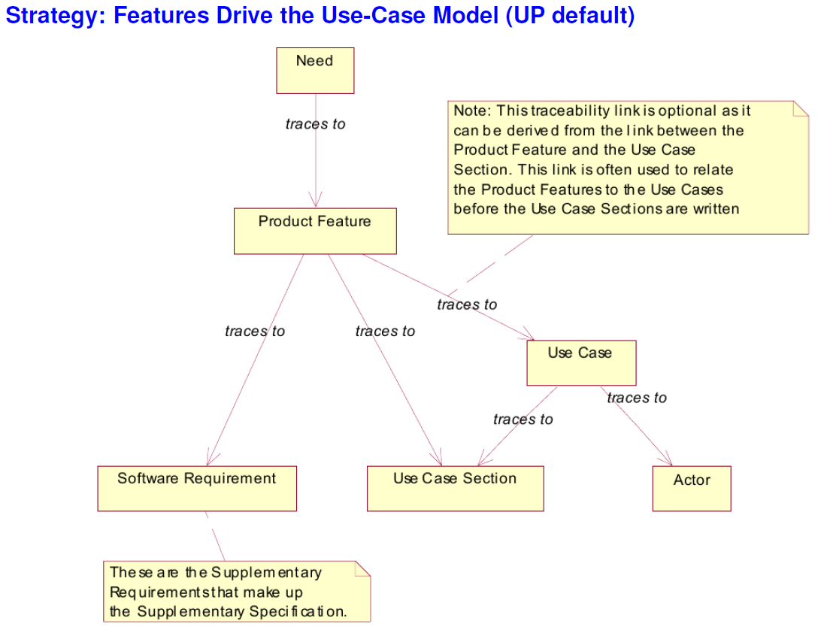

**Appendix B.  Use case packages**

Use Case Packages – represent the contextual hierarchy between the use cases. This artifact contributes to the differentiation of the different use case levels as well as enhancing readability by grouping of use cases by subject. Use case packages can also be used to divide the work between the different teams.

