**Task 3 – Post-Mortem Report**

This document presents a detailed analysis of software requirement analysis activities conducted by Team 26. The first artifact we created during the analysis is a vision document. Following is the discussion in details:

1. Questions and answers for the elicitation artefacts used in this delivery:
2. **Which process did you follow for your requirements activities in tasks 1-3 of this assignment? Show all the steps in time, describe what they constituted and the motivation for why you chose this technique/step at that point of your overall process.**
   * Task 1 – Revisions: Initial vision document was constructed for SmartHome+ in assignment 1. There were changes made to the document to accommodate new requirements incorporating the changes from requirements evaluation phase for assignment 2(different point of time). Post Assignment 2, this document was reviewed by stakeholder to suggest some changes, which triggered a new version of the same document. As Every Cycle of Assignment is producing a new Vision Document, we preferred to use this method.
     + Version 1- initial draft of vision document created on 6th July 2020
     + Version 2- updated vision document incorporating the changes from requirements
     + Version 3- updated vision document with changes from stakeholders on 30th July 2020.
   * Task 2 - Unified Process and UML: Task 2 involved creating Use cases for our product. Unified process provides a template to define use cases which all requirement engineers must follow. We chose Unified process because of the standard template making it consistent. To Complement our template, we used UML Diagrams which are pictorial representation of the Use Cases which would make it more readable. We identified the critical features based on user requirements to come up with the UML diagrams.
     + Version 1 - First Draft - Derive the Use Cases from Needs and requirements of vision document.
     + Version 2 – Each person authored use cases to elaborate more about them.
     + Version 3 – Changes were made after reviewing each use case and resolving the conflicts
   * Task 3 – Unified Process: Task 3 involved creating the additional requirement which were not covered in the use cases that would supplement our Use Cases along with glossary of terms used. We Chose Unified process for this because it provides a standard template which can be used by all requirements engineer.
     + Version 1 - First Draft - Derive the additional requirements from the section 5(Other product requirements) of the vision document.
     + Version 2 – Changes were made after reviewing all the requirements and resolving the conflicts and maintain consistency.
3. **Based on the process description from question 1 and the detailed logging information you should summarize how much time was spent (in total and by each group member) on the steps/activities involved as well as for the project as a whole? Note that this information will in no way be used for any grading; you do not even know if we think being more efficient (doing more in less time) is better or worse than being more effective (having a better resulting SRS).**

**Note:** Times are in **Minutes** scale

|  |  |  |  |  |  |  |
| --- | --- | --- | --- | --- | --- | --- |
| **Spend time for Delivery-3** | | | | | | |
| **Task Sub** | **Task** | **Apoorv** | **Divya** | **Manik** | **Nikhil** | **Sakib** |
| **Vision Document** | Communication | **25** | **15** | **15** | **45** | **15** |
| Documentation | **20** | **15** | **15** | **60** | **15** |
| Review | **35** | **15** | **30** | **45** | **30** |
| **Use Case Model** | Communication | **90** | **90** | **60** | **45** | **80** |
| Documentation | **180** | **180** | **50** | **45** | **150** |
| Review | **200** | **180** | **60** | **30** | **150** |
| **Supplementary and Glossary** | Communication | **35** | **30** | **30** | **30** | **40** |
| Documentation | **180** | **240** | **30** | **35** | **100** |
| Review | **120** | **120** | **60** | **25** | **30** |
| **Post-mortem** | Communication | **15** | **15** | **60** | **60** | **30** |
| Documentation | **15** | **15** | **45** | **120** | **15** |
| Review | **25** | **30** | **30** | **45** | **30** |

|  |  |
| --- | --- |
| **Spend time for complete project (delivery # 1-3)** | |
| **Group Members** | **Times (Delivery # 1+ 2 +3) in Mins** |
| **Apoorv** | **2575** |
| **Divya** | **2725** |
| **Manik** | **2165** |
| **Nikhil** | **2313** |
| **Sakib** | **1940** |

1. **What was the advantage of this technique based on your experience in this assignment?** 
   * Easily Comprehensible: These techniques made it easier to represent our product in a more readable way to all the stakeholders.
   * Abundance of UML Tools which can be used for automation.
   * Develop Software iteratively: These techniques emphasis on iterative development of the high critical software component throughout the software development cycle.
   * Control Changes: These Techniques also provide good traceability mechanisms to control the changes made to the software.
2. **What was the disadvantage of this technique based on your experience in this assignment?**
   * Complex: These techniques could turn out to be a little more complex and redundant for a small project. This also made the technique a little time consuming for documentation.
   * Requires Expertise: These Techniques need the team member to be expert in their fields.
3. **How efficient was the technique, i.e. how good requirements did it help uncover given the time it took to use?**
   * Unified process: This Technique made use to document all the use cases in standardize way. When we tried to create use cases with main success scenario, we were able to find many alternative paths which in turn added some new requirements. This Technique also has traceability which made it for us to trace back to the original requirement when there were conflicts and add some new requirements to avoid them.
   * UML: This Technique helped us to outline actor present out of the scope of the system and their possible additional requirements.
4. **In which situations would you use this technique in a future project? In which situations would you not use this technique in a future project?**
   * We would use these techniques when we have a good understanding of the project to document it better and in a more standard way.
   * We would not use these techniques during the initial phase of the requirements gathering and even when the project is small since these techniques are complex.
5. **For your next project, which set of techniques (that you used here or that you have not used here but know from theory or other projects) would you use for specifying requirements? Why? Clearly motivate your selected set of techniques and discuss how they complement each other. Consider both the quality of requirements it helps create and how much time is needed to effectively use the technique**

We have used Unified process which comprises of Use Case Model, Supplementary requirements and Glossary term for requirements specification. The most important motivation for using Unified Process was that it had standardize templates for specifying requirements with iterative and incremental software development process. In this set of techniques, the use case model will consist of most of the functional requirements which are complemented by Supplementary requirements (80-20 rule). Finally, we have Glossary of terms to complement both the artifacts. Apart from this we have used different UML Diagrams for specifying our Use cases in a graphic way to make it more visualizable. This process is slight time consuming and a little complex as well, but this also has a good traceability to manage changes.

As an alternative, we would have preferred Z specification Formal language, because of its ease of automation and it takes into consideration about invariants, pre and post conditions. This model provides a Logic-based specification for requirements, assumptions, and domain properties.

1. **What (other than the specification techniques) worked well in how you worked in this project?**
   * Distribution of work amongst the team members.
   * Brainstorming among the team members.
   * Splitting more coarse-grained tasks to smaller manageable tasks.
   * Peer review.
2. **What (other than the specification techniques) did not work well in how you worked in this project?**
   * Longer Decision times: we had various conflicting ideas which made it a little longer to come to conclusion.
3. **How did you work together as a group in the project? What worked and not in your interaction(s)? What would you do differently in the future, with a similar project?**
   * Collaboration: Used GitHub and Google Docs together to collaborate and maintain versions. For drafting report and brainstorming we mainly used Google docs. For writing final report we used GitHub as it can be used to better track and log changes.
   * Communication: Almost everyday Zoom meetings around 1-2 hours and WhatsApp group for offline group chat to know the working status of each other and avoiding the merge conflict on GitHub. We planned to move our meeting on Microsoft teams in future as free Zoom account has 40 mins meeting constraints for each call, but we could not move because of technical problem (i.e., microphone) in Team Microsoft.
   * Reviews: Reviews happened online during meeting with all the members. We also offline/individual reviews and discussed only the outcome/comments during the meetings.
   * Management: Peer monitoring and contributing in pair helped to manage the tasks effectively as well as efficiently. Again, a time tracking tool named “Toggl” like delivery-1 is used to track time for zoom meetings and tasks. By using Google doc for drafting report and brainstorming each task and then writing final copy of this report help us efficiently to manage each task (i.e., task-1 to task-5) properly. We planned to use Kanban/SCRUM style agile management process for this delivery-2 but could not afford to manage everything due to time constraints.

**Appendix**

**Appendix A**

Final report for delivery-3 commit history on GitHub:

<https://github.com/sakibshuvo/SOEN-6481-SRS>

**Appendix B**

Time tracking report for delivery-3 generated by Toggl time tracker:

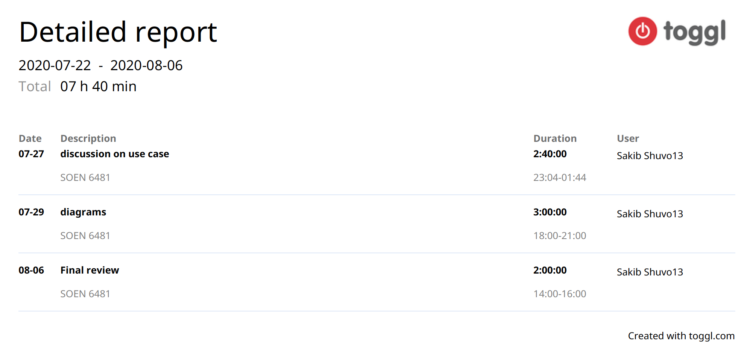

**Appendix C**

Time tracking report for full delivery (1-3) generated by Toggl time tracker on GitHub: <https://github.com/sakibshuvo/SOEN-6481-SRS/blob/master/Deliverable-3/work%20logs/full%20work%20log/Toggl_time_entries_2020-06-25_to_2020-08-06.pdf>

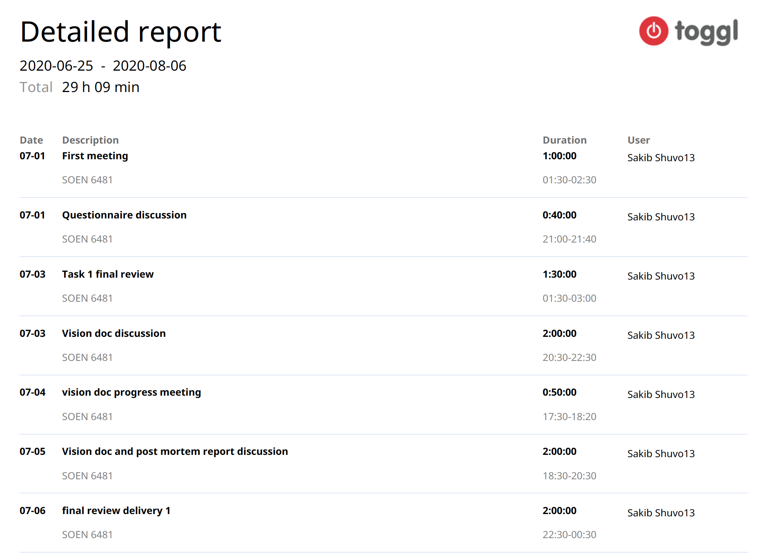

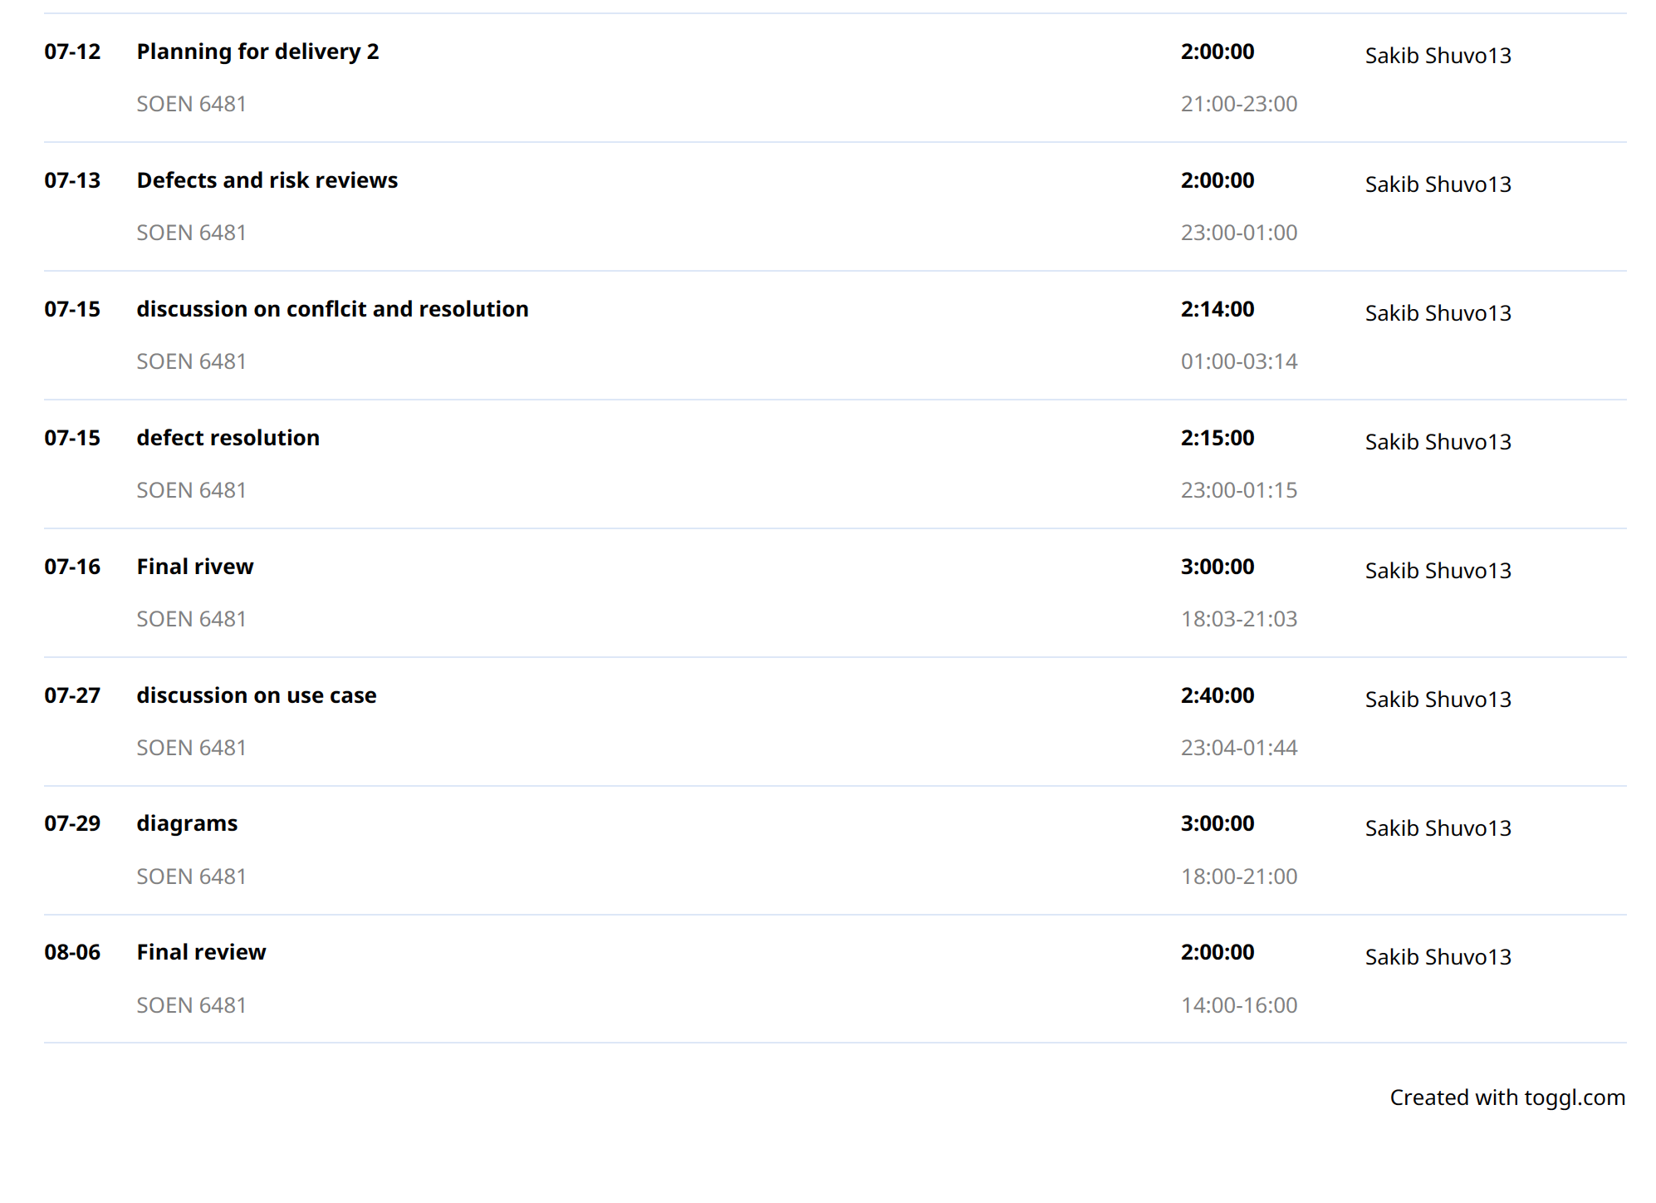

**Appendix D**

Git-Hub Contribution:

